AWS Cloud Internship Project
Custom VPC + EC2 Web Application + S3 Storage + IAM Roles + CloudWatch Monitoring + Automated Backup and Cost Control
Prepared by Sakshi Nangare
AWS Region: ap-south-1 (Mumbai)

1. Project Overview
This project demonstrates the design and deployment of a small, secure, and cost-conscious web application environment on Amazon Web Services (AWS).
The project uses a custom Virtual Private Cloud (VPC) with a public subnet, Internet Gateway, route table, and security group. An Ubuntu EC2 instance hosts a Student Portal web application using Apache Web Server.
Amazon S3 is used for project storage, while an IAM role allows the EC2 instance to access the project S3 bucket without storing AWS access keys on the server.
CloudWatch monitors the EC2 instance through CPU and status-check alarms, with Amazon SNS configured for email notifications. An EBS snapshot provides a backup of the EC2 storage, and an AWS Budget is configured to monitor project costs.
A sample web-access log dataset is also analyzed using Python to identify frequently accessed pages, HTTP errors, unique IP addresses, and peak traffic hours.
The project was designed with AWS Free Tier and cost control in mind, avoiding expensive services such as NAT Gateway, Application Load Balancer, RDS, and Auto Scaling.

2. Project Objectives
- Design a custom VPC with a public subnet, Internet Gateway, route table, and security group.
- Deploy an Ubuntu EC2 Linux web server and Apache Student Portal.
- Implement IAM users, groups, a custom project policy, and an EC2 IAM role.
- Provide secure EC2-to-S3 access without hardcoded credentials.
- Configure CloudWatch CPU and status-check alarms with SNS email notifications.
- Create and test an EBS backup and restore workflow.
- Analyze a sample 500-record web-access dataset using Python.
- Configure AWS Budget and Free Tier-focused cost controls.
- Validate security through restricted SSH and least-privilege access tests.

3. AWS Architecture
Region: Asia Pacific (Mumbai) — ap-south-1
VPC: InternshipProject-VPC — 10.0.0.0/16
Public Subnet: InternshipProject-PublicSubnet — 10.0.1.0/24 — ap-south-1a
Internet Gateway: InternshipProject-IGW
Route Table: InternshipProject-PublicRT
Security Group: InternshipProject-WebSG
EC2: InternshipProject-WebServer — Ubuntu — t3.micro
IAM Role: InternshipEC2S3Role
S3 Bucket: internship-aws-project-sakshi-2026
Monitoring: CloudWatch + SNS
Backup: EBS Snapshot
Cost Control: AWS Budget
Traffic flow:
Internet → Internet Gateway → Public Subnet → Security Group → EC2 → Apache → Student Portal
EC2 uses an IAM role to access the designated S3 bucket. CloudWatch monitors EC2 metrics and sends alarm notifications through SNS. The EBS root volume is protected by a snapshot.
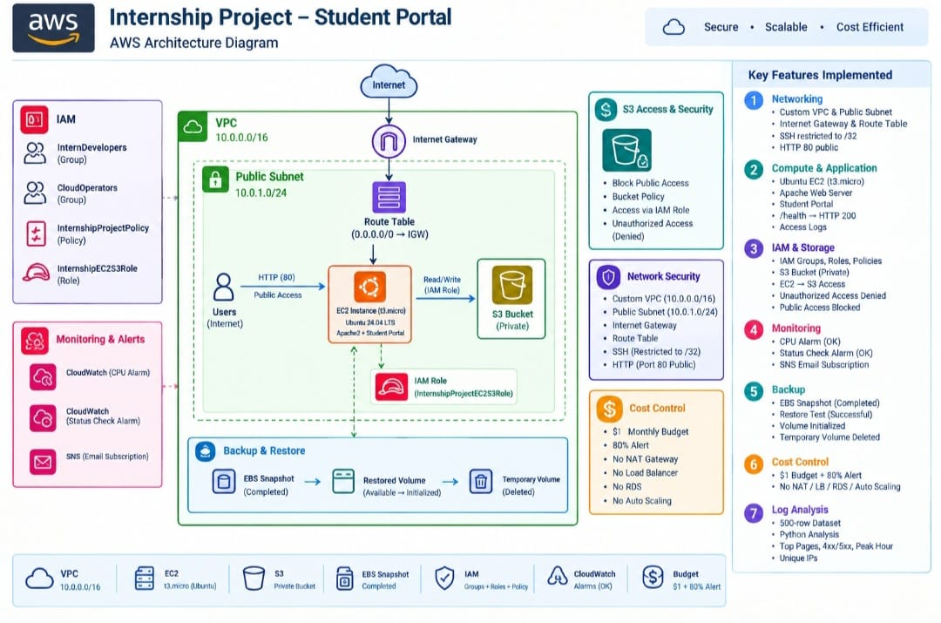
Figure 1 : AWS Project Architecture Overview.

4. IAM & Security
Root MFA was enabled and no active root access keys were configured. IAM groups included InternDevelopers and CloudOperators. The project user sakshi-cloud-admin was added to InternDevelopers, which uses the customer-managed InternshipProjectPolicy.
The EC2 role InternshipEC2S3Role uses InternshipS3AccessPolicy to list the project bucket and read/write project objects. AWS credentials were not hardcoded on the server.
Least-privilege validation succeeded: the project S3 bucket was accessible, while an unrelated S3 bucket returned AccessDenied.
Network security used HTTP port 80 from the Internet and SSH port 22 restricted to the administrator's IP /32. The S3 bucket remained private with Block Public Access enabled

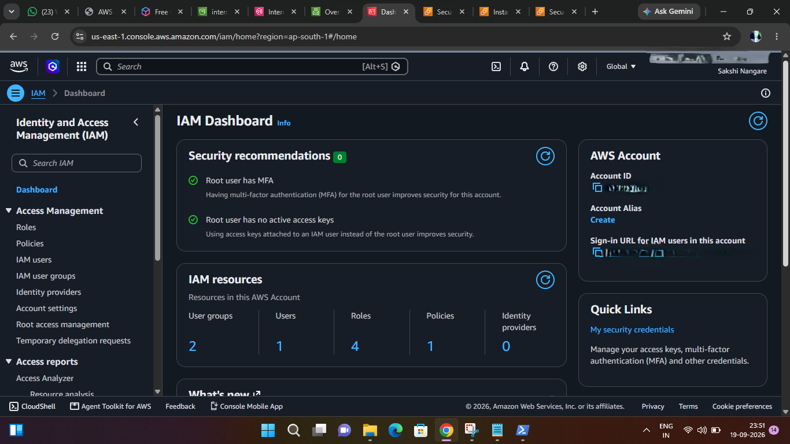
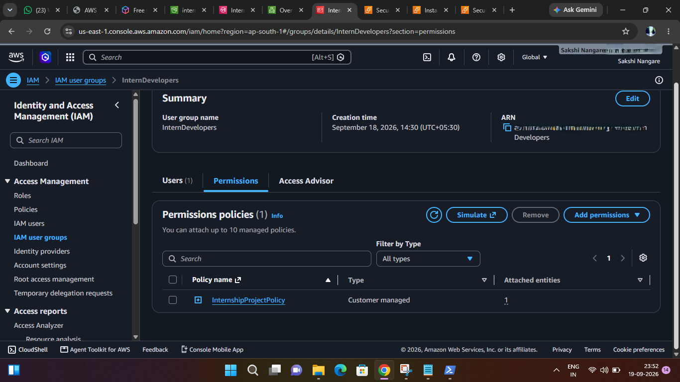
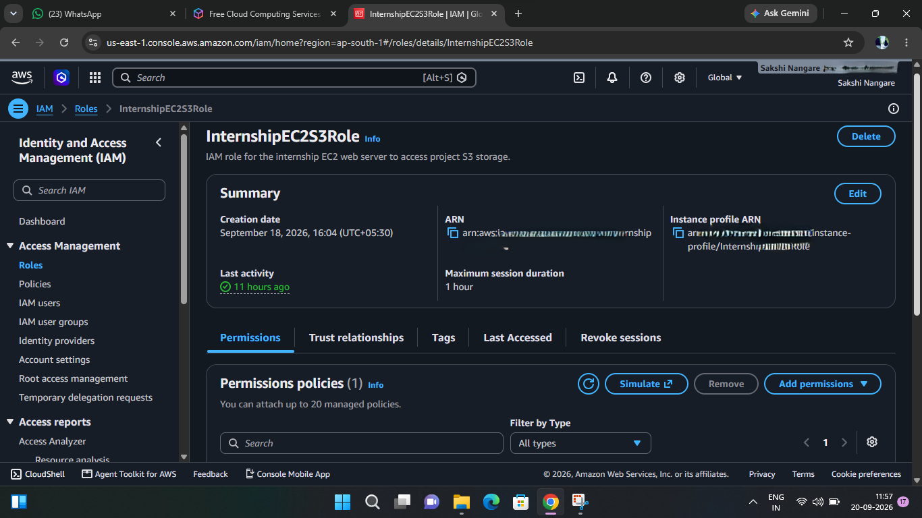
Figure 2 : IAM & Security

5. VPC & Networking
The custom VPC uses CIDR 10.0.0.0/16. The public subnet uses 10.0.1.0/24 in ap-south-1a. The Internet Gateway is attached to the VPC.
The public route table contains the default route 0.0.0.0/0 to the Internet Gateway and is associated with the public subnet.
The InternshipProject-WebSG security group allows HTTP 80 from 0.0.0.0/0 and SSH 22 only from the administrator's current public IP /32.
The design intentionally avoids NAT Gateway, load balancers, Auto Scaling, and multi-AZ infrastructure to remain simple and cost-conscious.
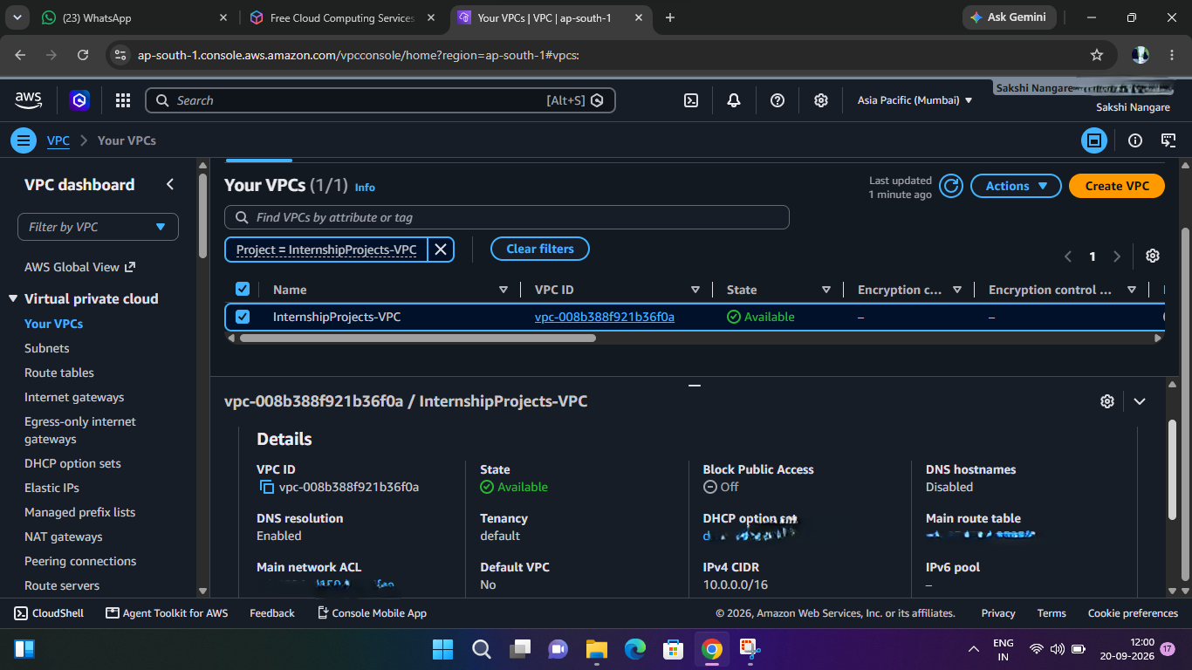
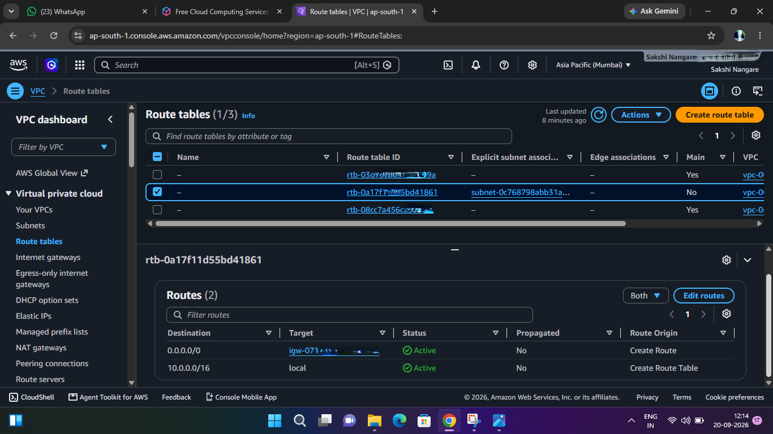
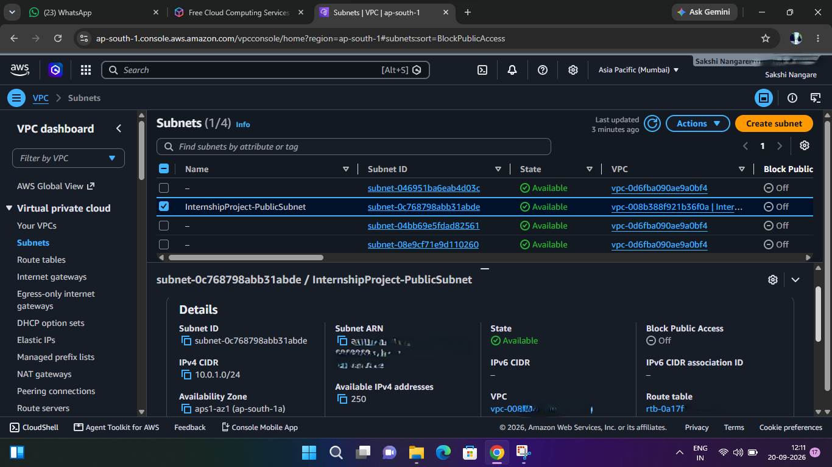
Figure 3 : VPC & Networking.

6. EC2 & Student Portal
The project web server is an Ubuntu t3.micro EC2 instance in the custom VPC and public subnet, with an 8 GiB gp3 root volume and InternshipEC2S3Role attached.
Apache HTTP Server was installed, started, and enabled. The application is deployed at /var/www/html/student-portal/.
Application structure:
student-portal/
├── index.html
├── css/style.css
├── js/script.js
└── web-access-logs.csv
The Student Portal was successfully accessed externally. A /student-portal/health endpoint returned HTTP 200 OK and the message: OK - AWS Internship Student Portal is healthy.
Apache access logs were inspected to verify requests and status codes.
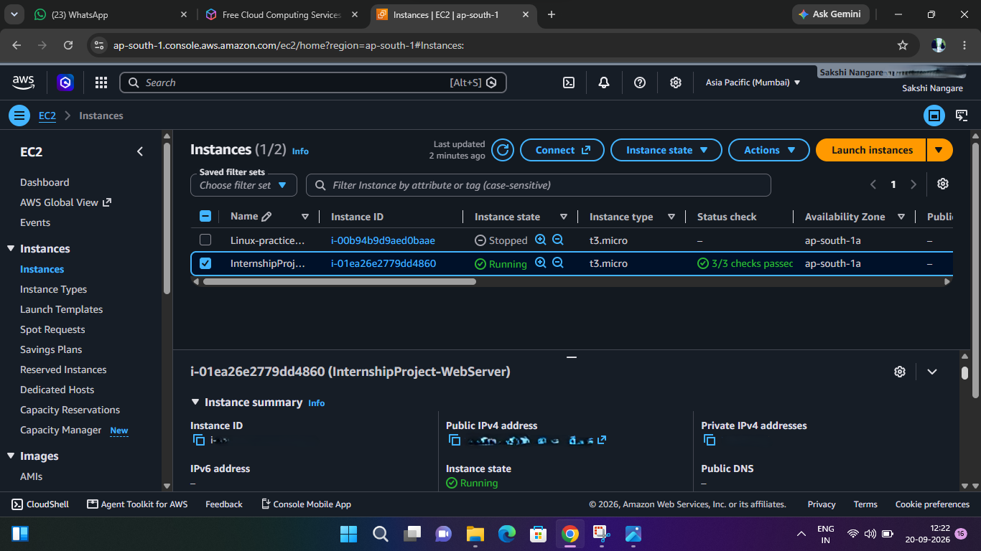
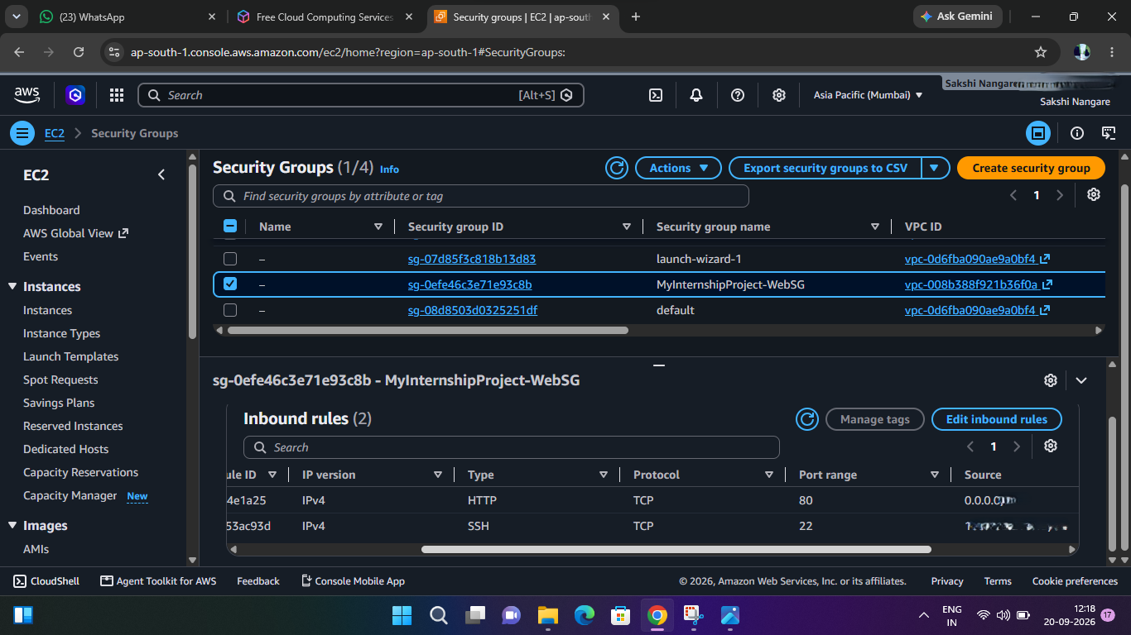
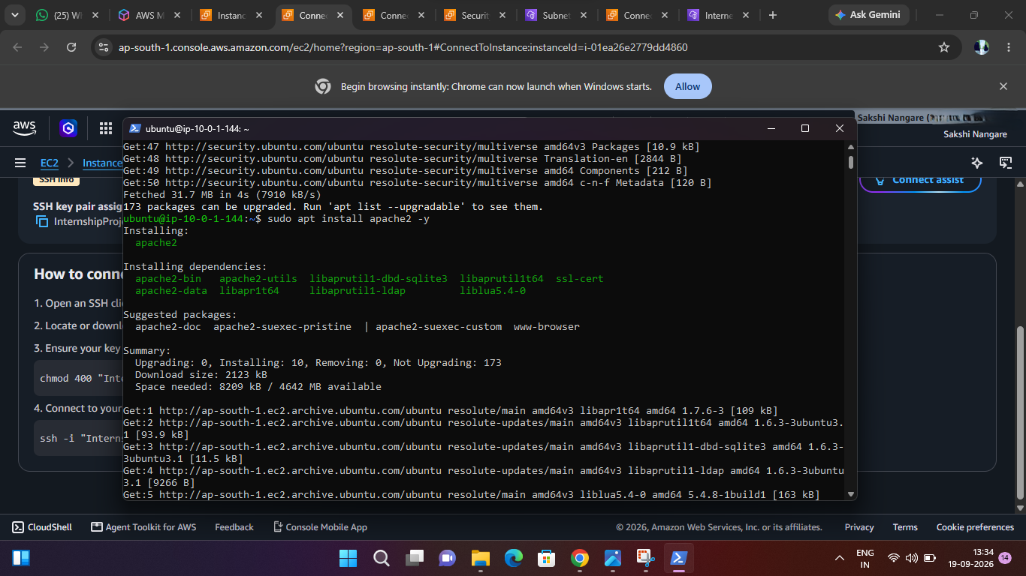
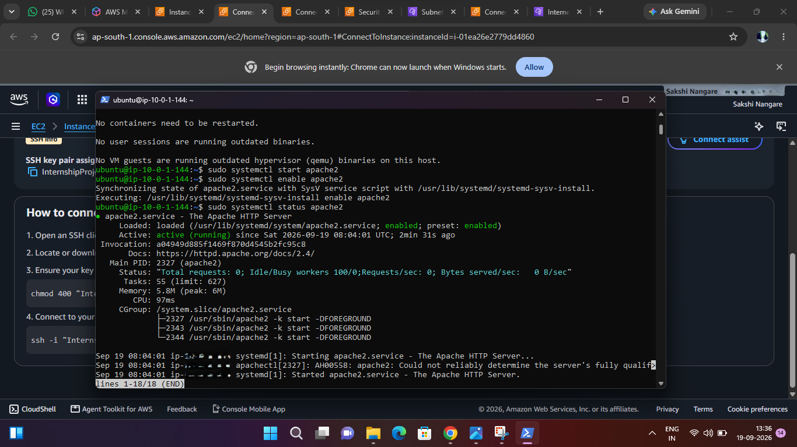
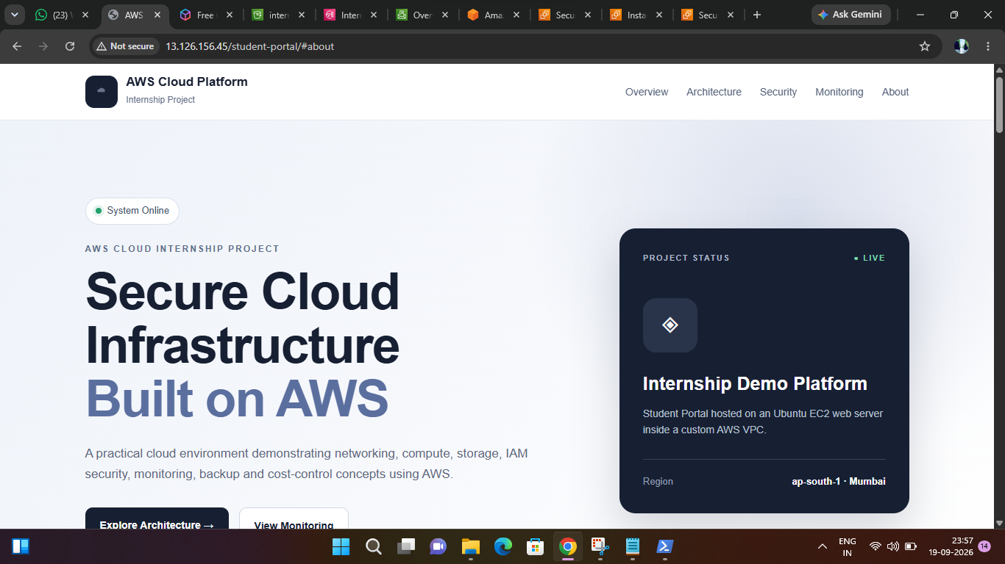
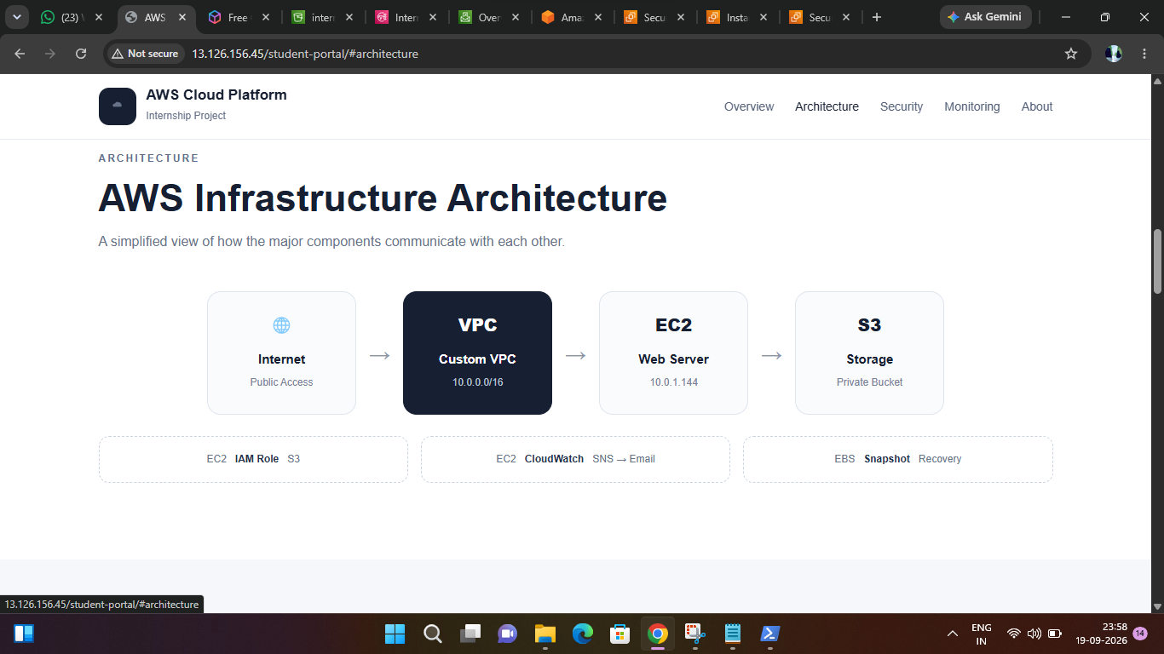
Figure 4 : EC2 & Student Portal & Apache installation

7. S3 Storage & IAM Integration
S3 bucket: internship-aws-project-sakshi-2026
Region: ap-south-1
Access: Private
Encryption: Amazon S3-managed encryption
Object Ownership: Bucket owner enforced
Public Access: Blocked
The test object s3-test.txt was successfully uploaded from EC2 using the IAM role.
Validation:
aws s3 ls s3://internship-aws-project-sakshi-2026
Upload:
aws s3 cp ./s3-test.txt s3://internship-aws-project-sakshi-2026
An unrelated bucket access attempt returned AccessDenied, demonstrating least privilege.
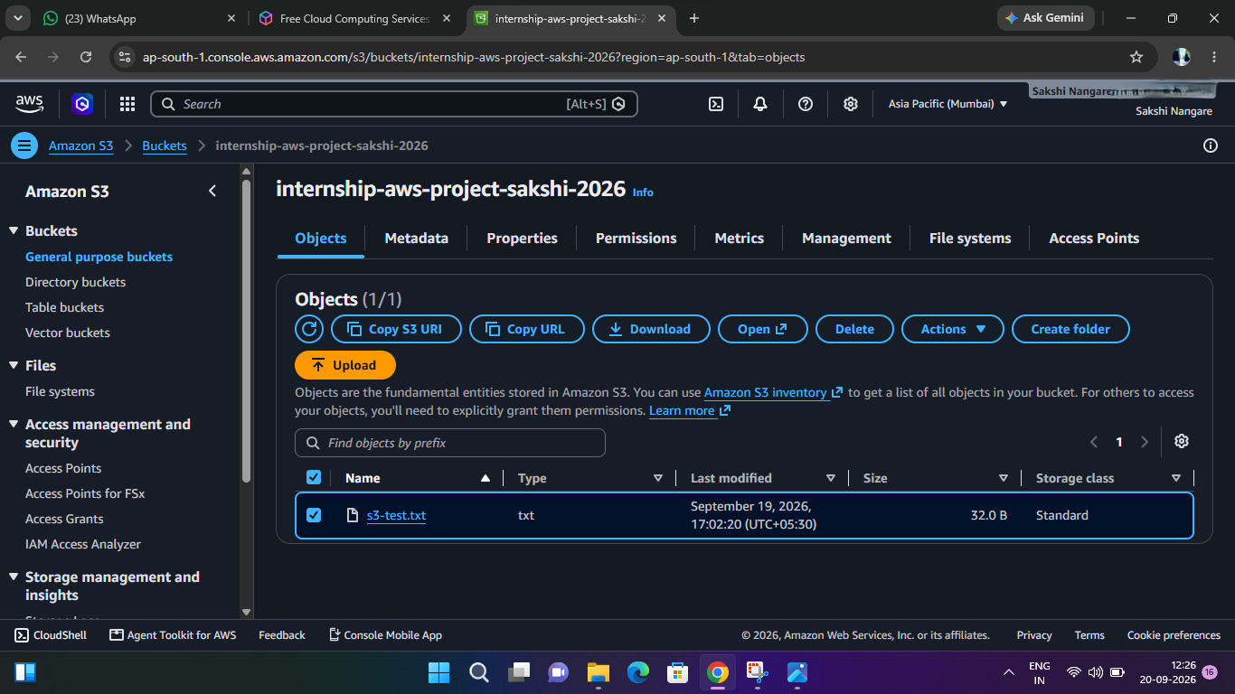
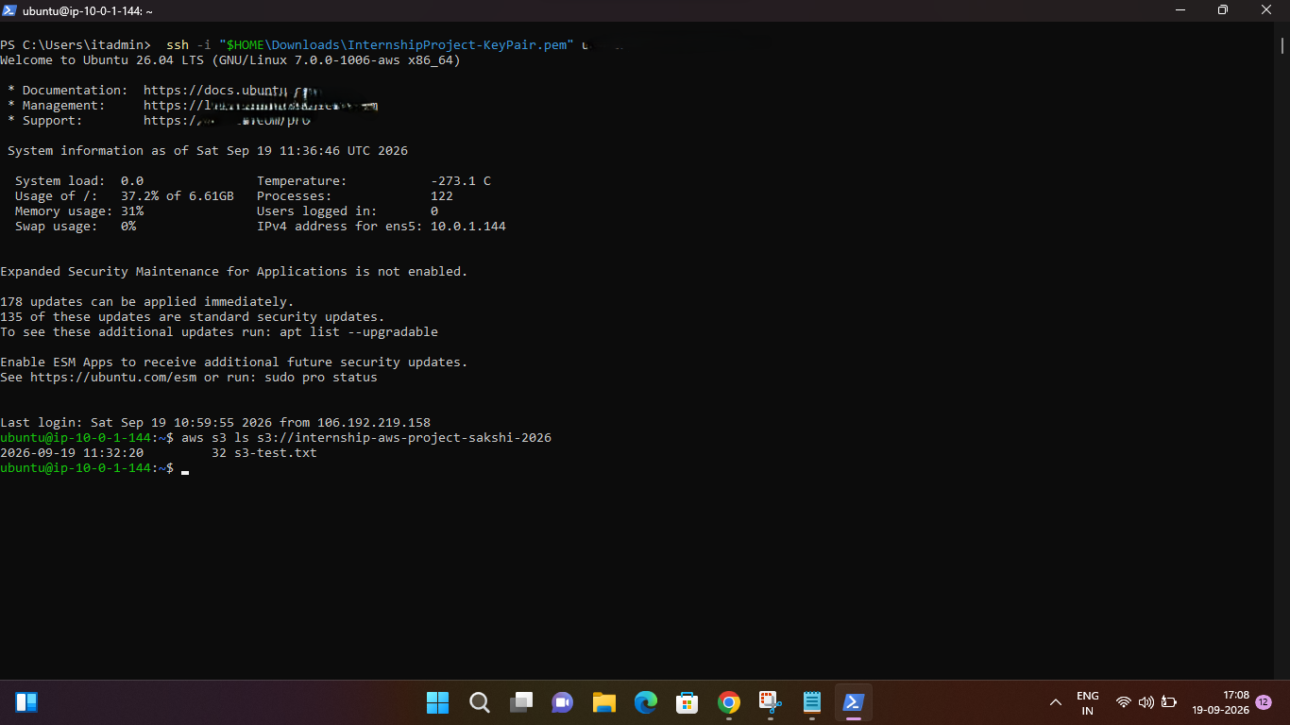
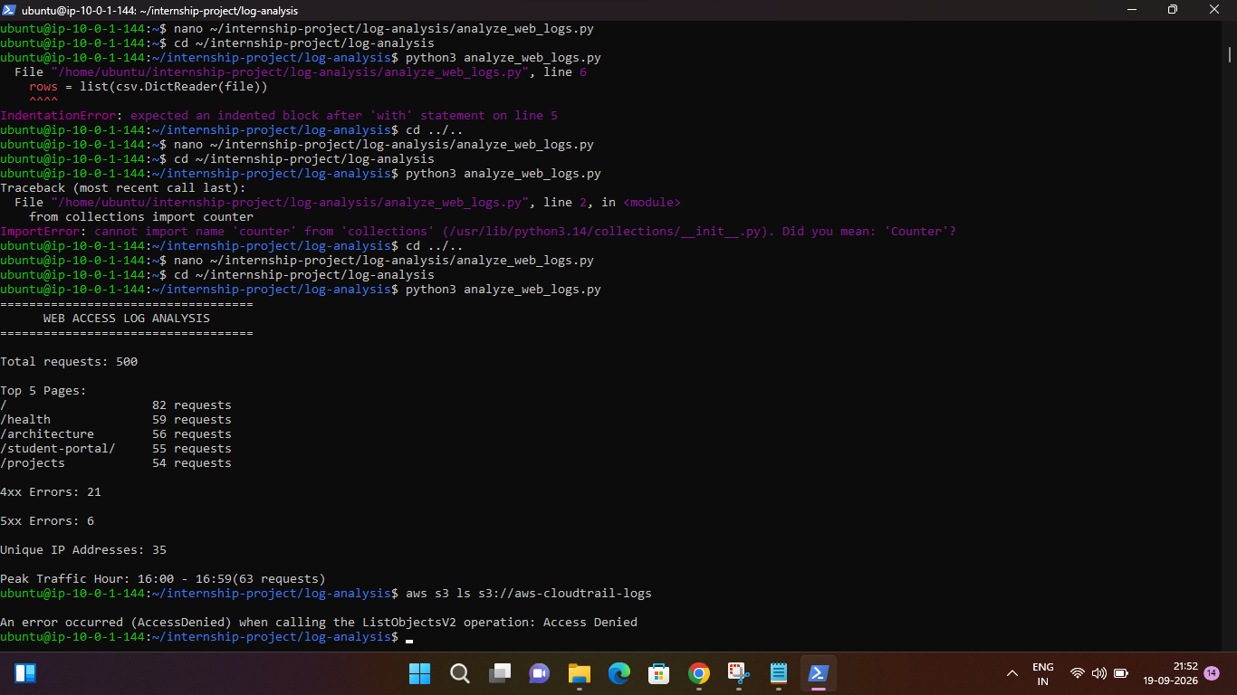
Figure 5 : S3 Storage & IAM Intigration

8. CloudWatch Monitoring & SNS
CloudWatch alarms:
- InternshipProject-EC2-HighCPU — CPUUtilization Average, 5-minute period, threshold >70%.
- InternshipProject-EC2-StatusCheck — StatusCheckFailed Maximum, 5-minute period, threshold >=1.
Both alarms were verified in the OK state.
SNS topic: InternshipProject-Alerts
Email subscription status: Confirmed
Monitoring flow:
EC2 → CloudWatch Metric → CloudWatch Alarm → SNS Topic → Email Notification
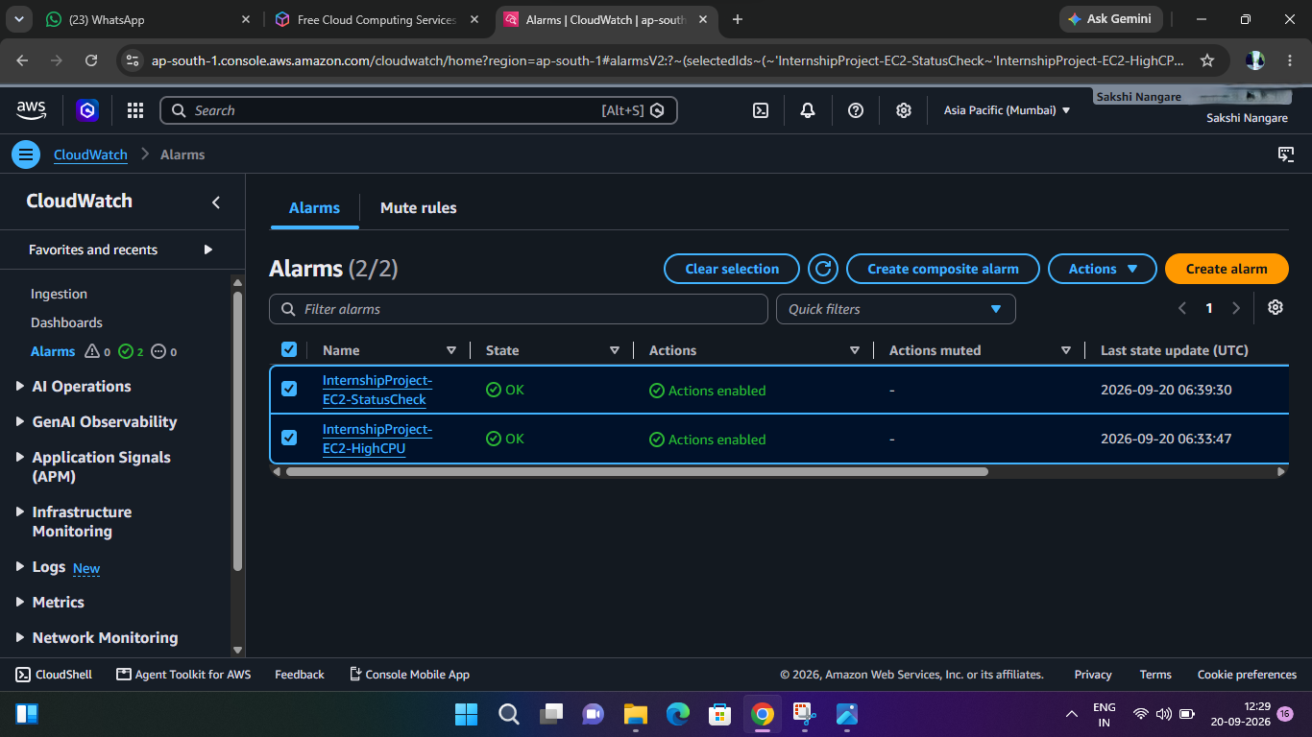
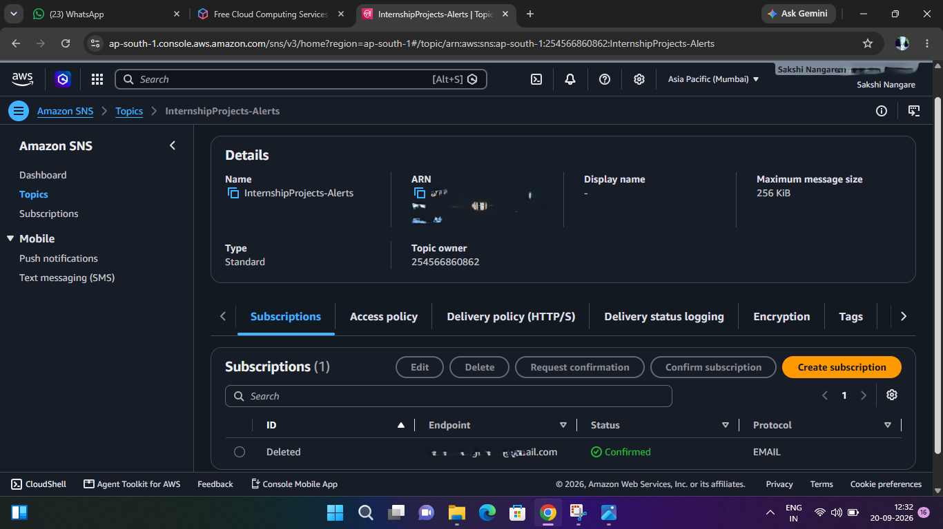
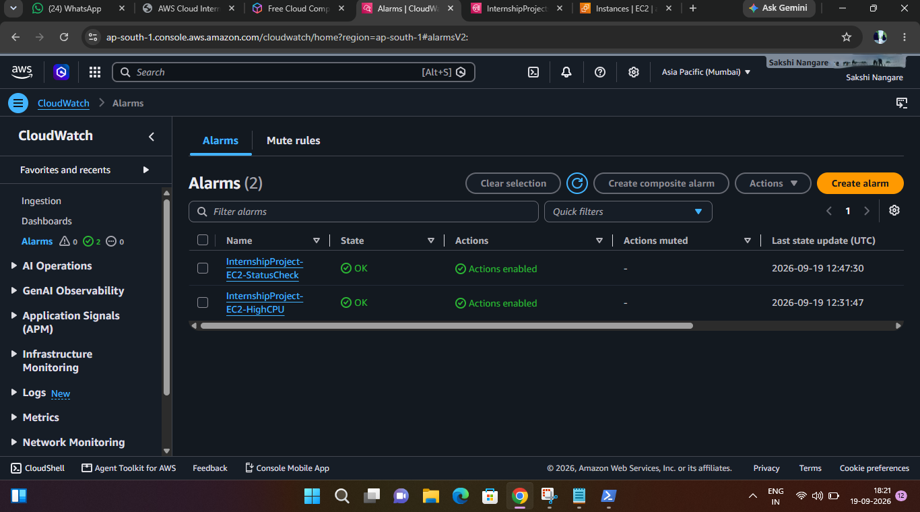
Figure 6 : CloudWatch & SNS

9. EBS Backup & Restore
The EC2 root EBS volume was backed up using snapshot InternshipProject-EC2-Backup. The snapshot reached Completed state.
A new 8 GiB gp3 volume was created from the snapshot in ap-south-1a. The restored volume initialized successfully. After verification, the temporary restored volume was deleted to avoid unnecessary cost.
Recovery process:
1. Identify the snapshot.
2. Create a new volume from it.
3. Select the correct Availability Zone.
4. Attach the volume to an EC2 instance.
5. Verify restored data and recover the required storage.
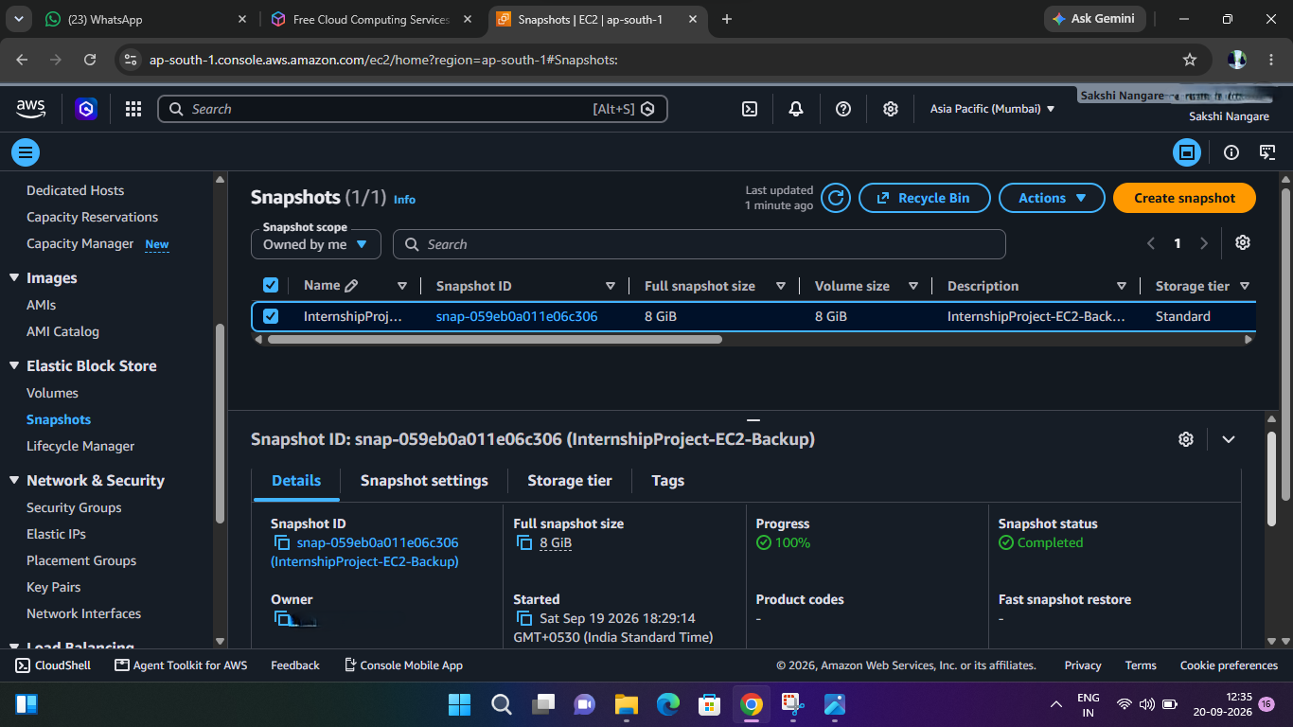

Figure 7 : EBS Backup & Restore.

10. Web Log Analysis
A 500-record web-access CSV dataset was analyzed using Python. Fields included timestamp, IP, method, path, status, bytes, and user_agent.
Results:
- Total requests: 500
- Top pages: / (82), /health (59), /architecture (56), /student-portal/ (55), /projects (54)
- 4xx errors: 21
- 5xx errors: 6
- Unique IP addresses: 35
- Peak traffic hour: 16:00–16:59 with 63 requests
The Python script used the csv, collections.Counter, and datetime standard-library modules.
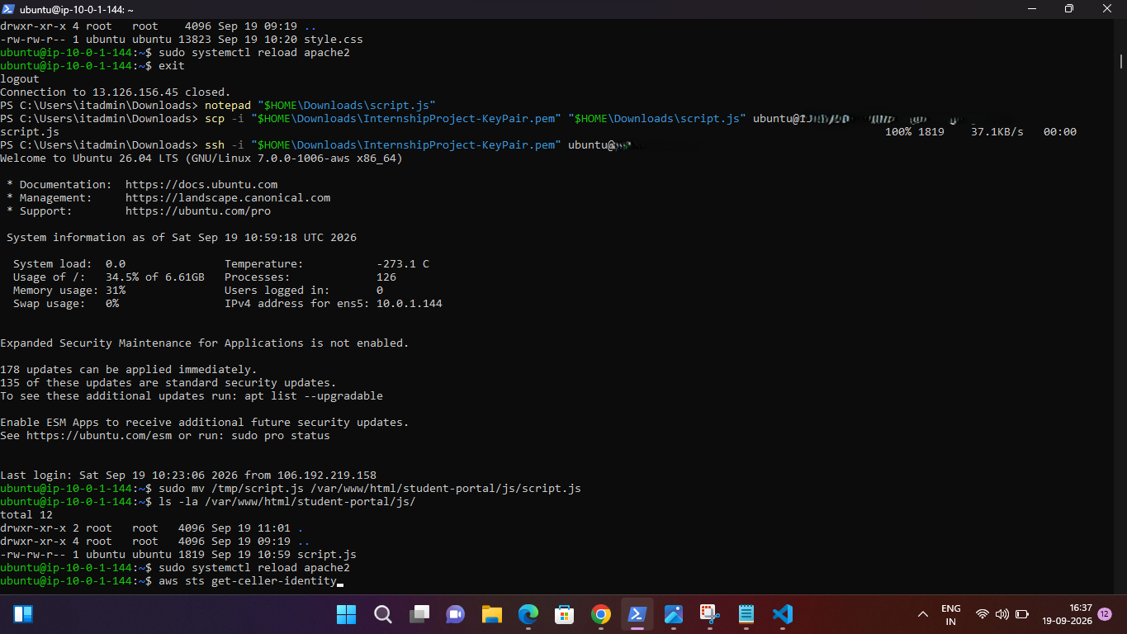
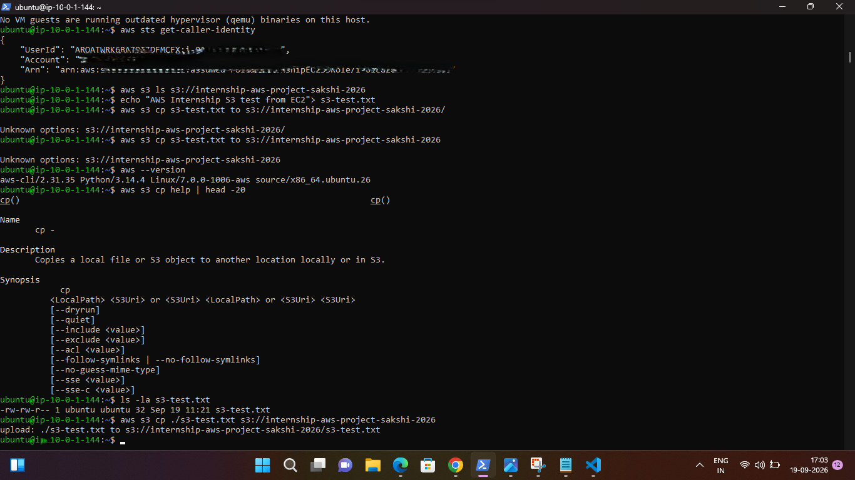
Figure 8 : Web Log Analysis.

11. Cost Control & Free Tier
AWS Budget: InternshipProject-Monthly-Budget
Budget type: Monthly
Budget amount: $1
Alert threshold: 80% actual spend
Email notification: Configured
Automatic actions: Not configured
The budget is an alert mechanism, not a spending cap.
The project uses a small EC2 instance, small EBS storage, one snapshot, a small private S3 bucket, basic CloudWatch monitoring, and SNS email notification.
NAT Gateway, load balancers, RDS, Auto Scaling, Kubernetes/EKS, and other unnecessary paid infrastructure were avoided. The temporary restored EBS volume was deleted after testing. Free Tier and billing usage were checked before completion.
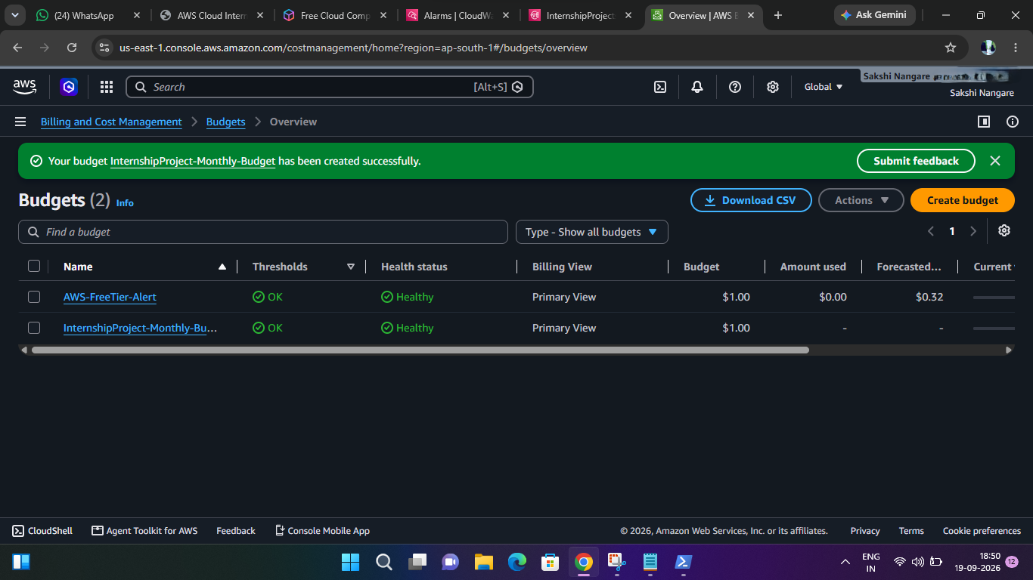
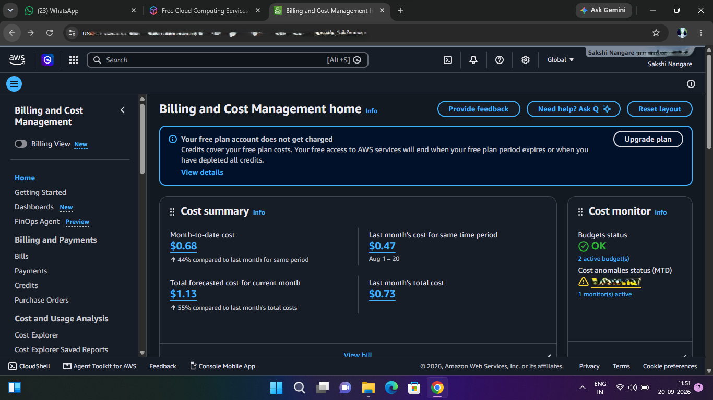
Figure 9 : Cost Control & Free Tire

12. Testing & Validation
IAM security — Passed
VPC/network — Passed
EC2 configuration — Passed
Student Portal — Passed
Health endpoint — HTTP 200 OK
S3 access — Passed
Least-privilege test — AccessDenied for unrelated bucket
CloudWatch alarms — Passed; both OK
SNS — Confirmed
EBS snapshot — Completed
EBS restore test — Passed
Log analysis — Passed
AWS Budget — Passed
Free Tier/billing check — Completed
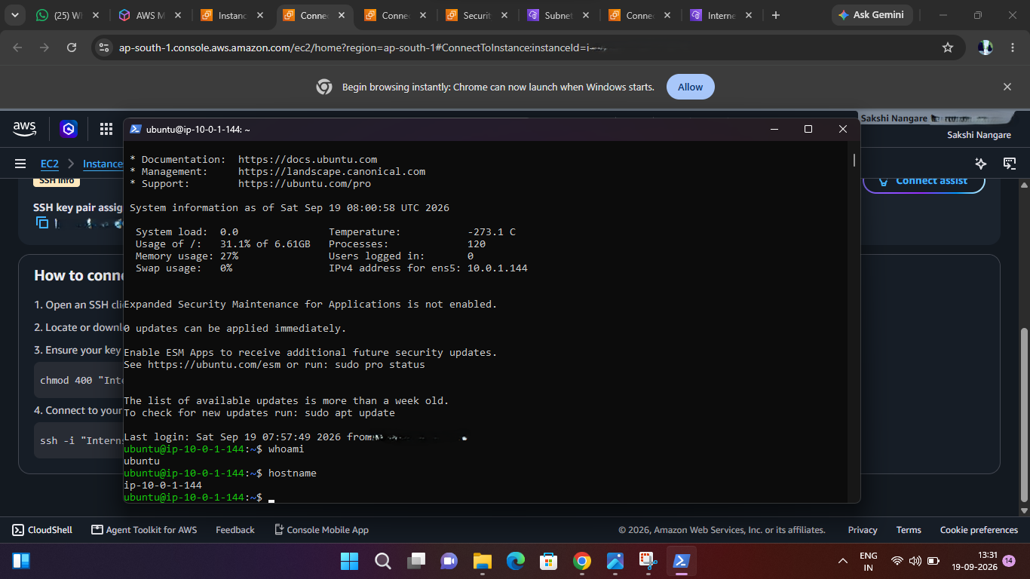
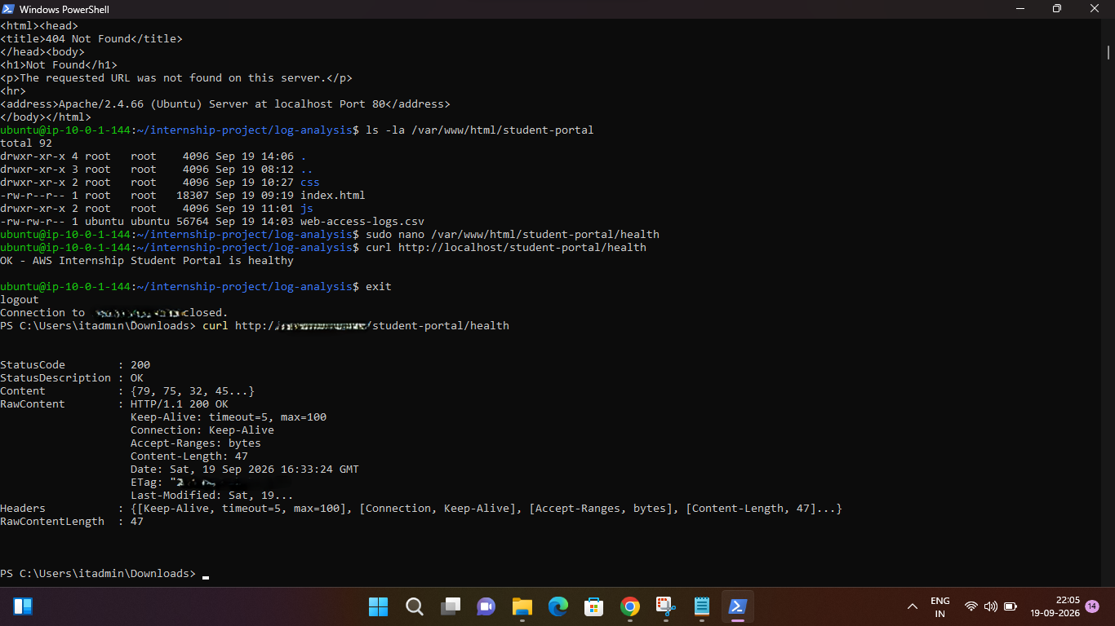
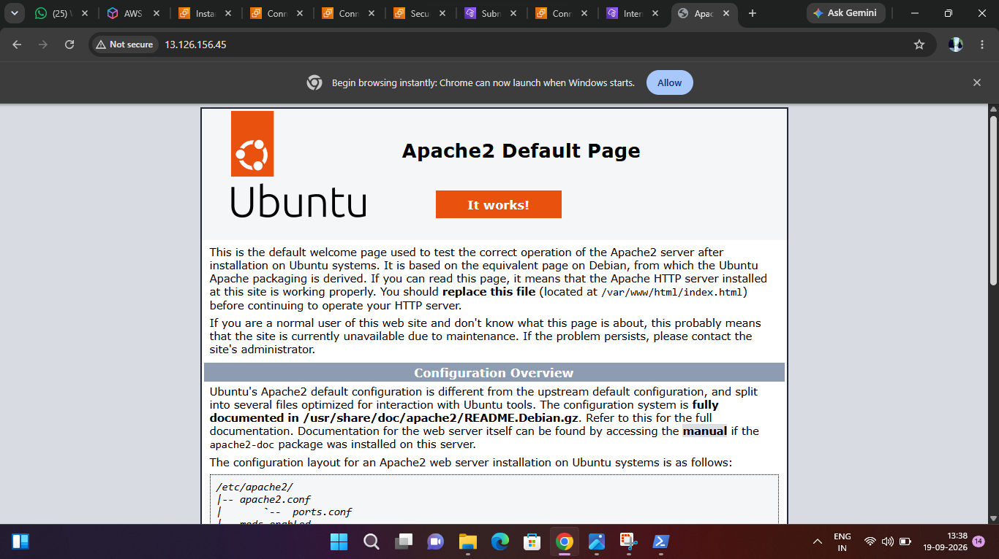

Figure 10 : Validation

13. Challenges & Solutions
Key challenges included ensuring the final EC2 instance was launched in the correct custom VPC, restricting SSH access, configuring EC2-to-S3 authentication without access keys, proving least privilege with an AccessDenied test, deploying and validating Apache, testing the health endpoint, validating EBS restore capability, configuring monitoring/SNS, and controlling costs.
Solutions included careful VPC verification, /32 SSH rules, the InternshipEC2S3Role, dedicated S3 permissions, external health checks, snapshot restore testing, CloudWatch/SNS configuration, AWS Budget alerts, and cleanup of temporary resources.

14. Final Outcome & Skills Demonstrated
The project successfully combines AWS Cloud, Linux administration, security, Python log analysis, monitoring, backup, and cost management.
AWS skills: EC2, S3, VPC, Internet Gateway, route tables, security groups, IAM, CloudWatch, SNS, EBS, AWS Budgets.
Linux skills: Ubuntu administration, Apache, services, files/directories, logs, AWS CLI, troubleshooting.
Security skills: IAM roles, least privilege, root MFA, restricted SSH, private S3, Block Public Access, IMDSv2.
Operations: monitoring, alarms, notifications, health checks, access logs, backup/restore, resource cleanup.

15. Future Improvements & Conclusion
Future production-oriented improvements could include private subnets, multi-AZ deployment, load balancing, Auto Scaling, a managed database, Infrastructure as Code using Terraform or CloudFormation, CI/CD, advanced CloudWatch dashboards, automated backups, and richer log analytics.
Conclusion:
The project provided practical experience in designing, deploying, securing, monitoring, backing up, and analyzing a small AWS cloud environment. It converted the internship requirements into a working and validated cloud deployment while maintaining a simple, cost-conscious architecture.

