===== File 1 =====
কাথ

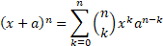
Question 1
What is (a + b)² ?
Marks: 2
Answer 1
(a + b)² = a² + 2ab + b²
ಖಾಸಗಿ
End of file 1

