Problem:

We have a dataset of sales of different TV sets across different locations.
Records look like:
Samsung|Optima|14|Madhya Pradesh|132401|14200
The fields are arranged like:
Company Name|Product Name|Size in inches|State|Pin Code|Price
There are some invalid
records which contain 'NA' in either Company Name or Product Name.
2. Write a Map Reduce program to calculate the total units sold for each Company.
3. Write a Map Reduce program to calculate the total units sold in
each state for Onida
company

Input File:
Samsung|Optima|14|Madhya Pradesh|132401|14200
Onida|Lucid|18|Uttar Pradesh|232401|16200
Akai|Decent|16|Kerala|922401|12200
Lava|Attention|20|Assam|454601|24200
Zen|Super|14|Maharashtra|619082|9200
Samsung|Optima|14|Madhya Pradesh|132401|14200
Onida|Lucid|18|Uttar Pradesh|232401|16200
Onida|Decent|14|Uttar Pradesh|232401|16200
Onida|NA|16|Kerala|922401|12200
Lava|Attention|20|Assam|454601|24200
Zen|Super|14|Maharashtra|619082|9200
Samsung|Optima|14|Madhya Pradesh|132401|14200
NA|Lucid|18|Uttar Pradesh|232401|16200
Samsung|Decent|16|Kerala|922401|12200
Lava|Attention|20|Assam|454601|24200
Samsung|Super|14|Maharashtra|619082|9200
Samsung|Super|14|Maharashtra|619082|9200
Samsung|Super|14|Maharashtra|619082|9200

Program for task 2:

Driver program:
package assignment4;

import org.apache.hadoop.fs.Path;
import org.apache.hadoop.conf.*;
import org.apache.hadoop.mapreduce.Job;
import org.apache.hadoop.mapreduce.lib.input.FileInputFormat;
import org.apache.hadoop.mapreduce.lib.input.TextInputFormat;
import org.apache.hadoop.mapreduce.lib.output.FileOutputFormat;
import org.apache.hadoop.mapreduce.lib.output.TextOutputFormat;
import org.apache.hadoop.io.IntWritable;
import org.apache.hadoop.io.Text;

public class Task2 {
@SuppressWarnings("deprecation")
public static void main(String[] args) throws Exception {
Configuration conf = new Configuration();
Job job = new Job(conf, "assignment4");
job.setJarByClass(Task2.class);

job.setMapOutputKeyClass(Text.class);
job.setMapOutputValueClass(IntWritable.class);

job.setOutputKeyClass(Text.class);
job.setOutputValueClass(IntWritable.class);
job.setMapperClass(Task2Mapper.class); //setting reducer class
job.setReducerClass(Task2Reducer.class);

job.setInputFormatClass(TextInputFormat.class); //text format
job.setOutputFormatClass(TextOutputFormat.class);

FileInputFormat.addInputPath(job, new Path(args[0])); //getting file location
FileOutputFormat.setOutputPath(job,new Path(args[1]));

/*
Path out=new Path(args[1]);
out.getFileSystem(conf).delete(out);
*/

job.waitForCompletion(true);
}
}

Task2Mapper.java:
package assignment4;

import java.io.IOException;

import org.apache.hadoop.io.IntWritable;
import org.apache.hadoop.io.LongWritable;
import org.apache.hadoop.io.Text;
import org.apache.hadoop.mapreduce.*;

public class Task2Mapper extends Mapper<LongWritable, Text, Text, IntWritable> {
Text outKey = new Text();
IntWritable outValue = new IntWritable();

public void map(LongWritable key, Text value, Context context)
throws IOException, InterruptedException {
String[] lineArray = value.toString().split("\\|"); //splitting file into key,value
outKey.set(lineArray[0]);
outValue.set(1);
context.write(outKey, outValue); //output to reducer
}
}

Task2Reducer:
package assignment4;

import java.io.IOException;

import org.apache.hadoop.io.IntWritable;
import org.apache.hadoop.io.Text;
import org.apache.hadoop.mapreduce.Reducer;
import org.apache.hadoop.mapreduce.Reducer.Context;

public class Task2Reducer extends Reducer<Text, IntWritable, Text, IntWritable>
{
IntWritable outValue = new IntWritable();

public void reduce(Text key, Iterable<IntWritable> values,Context context) throws IOException, InterruptedException
{
int sum = 0;
for (IntWritable value : values) { //calculating total units for sold
sum += value.get();
}

outValue.set(sum);
context.write(key, outValue); //sending value to output file
}
}

Result:
command:
hadoop jar /home/acadgild/hadoop/assignment4.jar assignment4.Task2 /user/acadgild/hadoop/datase.txt /user/acadgild/hadoop/Assignment2task1

snapshot:
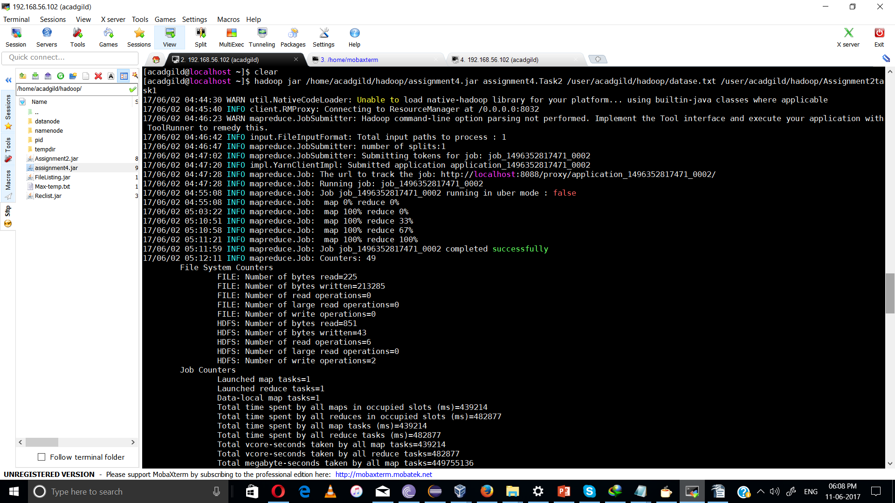
result:
Outputfile:
Akai 1
Lava 3
NA 1
Onida 4
Samsung 7
Zen 2

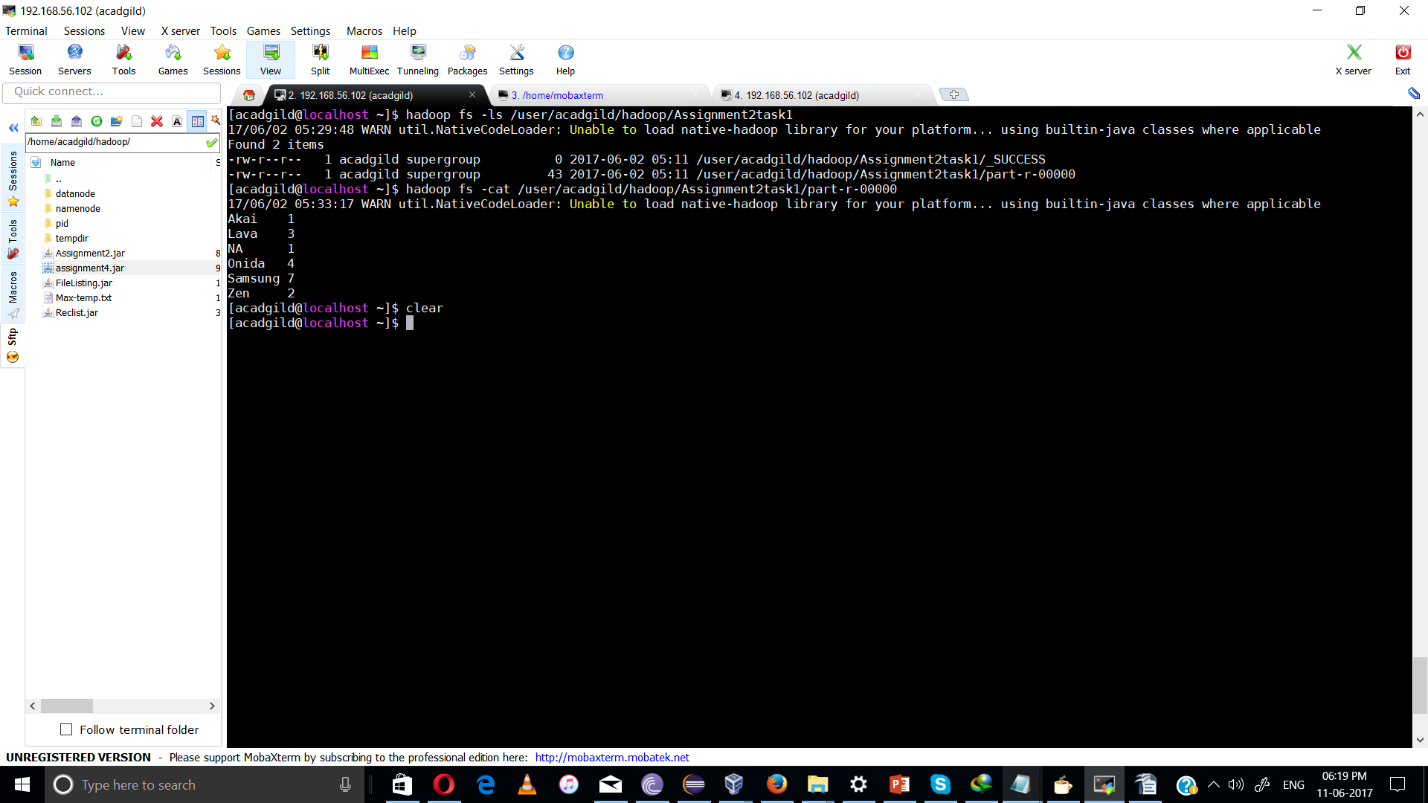

program for task 3:

Task2:
package assignment4;

import org.apache.hadoop.fs.Path;
import org.apache.hadoop.conf.*;
import org.apache.hadoop.mapreduce.Job;
import org.apache.hadoop.mapreduce.lib.input.FileInputFormat;
import org.apache.hadoop.mapreduce.lib.input.TextInputFormat;
import org.apache.hadoop.mapreduce.lib.output.FileOutputFormat;
import org.apache.hadoop.mapreduce.lib.output.TextOutputFormat;
import org.apache.hadoop.io.IntWritable;
import org.apache.hadoop.io.Text;

public class Task3 {
@SuppressWarnings("deprecation")
public static void main(String[] args) throws Exception {
Configuration conf = new Configuration();
Job job = new Job(conf, "AssignmentTask3");
job.setJarByClass(Task3.class);

job.setMapOutputKeyClass(Text.class);
job.setMapOutputValueClass(IntWritable.class);

job.setOutputKeyClass(Text.class);
job.setOutputValueClass(IntWritable.class);
job.setMapperClass(Task3Mapper.class);
job.setReducerClass(Task3Reducer.class);

job.setInputFormatClass(TextInputFormat.class);
job.setOutputFormatClass(TextOutputFormat.class);

FileInputFormat.addInputPath(job, new Path(args[0]));
FileOutputFormat.setOutputPath(job,new Path(args[1]));

/*
Path out=new Path(args[1]);
out.getFileSystem(conf).delete(out);
*/

job.waitForCompletion(true);
}
}

Task2Mapper:
package assignment4;

import java.io.IOException;

import org.apache.hadoop.io.IntWritable;
import org.apache.hadoop.io.LongWritable;
import org.apache.hadoop.io.Text;
import org.apache.hadoop.mapreduce.*;

public class Task3Mapper extends Mapper<LongWritable, Text, Text, IntWritable> {
Text outKey = new Text();
IntWritable outValue = new IntWritable();

public void map(LongWritable key, Text value, Context context)
throws IOException, InterruptedException {
String[] lineArray = value.toString().split("\\|");
if(lineArray[0].equalsIgnoreCase("ONIDA")) {
outKey.set("ONIDA" + "\t" + lineArray[3]);//getting value for product onida
outValue.set(1);
context.write(outKey, outValue);
}
}
}

Task3Reducer:

package assignment4;

import java.io.IOException;

import org.apache.hadoop.io.IntWritable;
import org.apache.hadoop.io.Text;
import org.apache.hadoop.mapreduce.Reducer;

public class Task3Reducer extends Reducer<Text, IntWritable, Text, IntWritable>
{
IntWritable outValue = new IntWritable();

public void reduce(Text key, Iterable<IntWritable> values,Context context) throws IOException, InterruptedException
{
int sum = 0;
for (IntWritable value : values) { //getting value from Task3Mapper(product=onida)
sum += value.get();
}

outValue.set(sum);
context.write(key, outValue);
}
}

Result:
command:
hadoop jar /home/acadgild/hadoop/assignment4.jar assignment4.Task3 /user/acadgild/hadoop/datase.txt /user/acadgild/hadoop/Assignment2task2

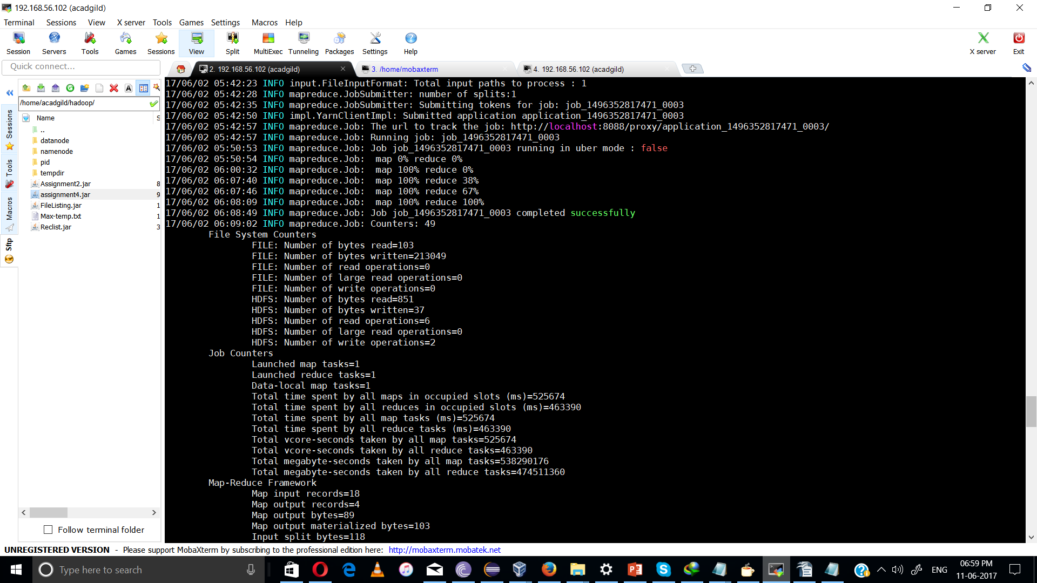

Output:

ONIDA Kerala 1
ONIDA Uttar Pradesh 3

