Explain the below concepts with an example in brief.
●Hive Data Definitions

Hive Data Definition Language (DDL) is a subset of Hive SQL statements that describe the data structure in Hive by creating, deleting, or altering schema objects such as databases, tables, views, partitions, and buckets.

Examples:
Create Database Statement

A database in Hive is a namespace or a collection of tables.

hive> CREATE SCHEMA acadgild1;
hive> SHOW DATABASES;

Drop database

hive> DROP DATABASE IF EXISTS userdb;
Creating Hive Tables

Create a table called Sonoo with two columns, the first being an integer and the other a string.

hive> CREATE TABLE HIVE_TABLE (foo INT, bar STRING) PARTITIONED BY (ds STRING);

Browse the table

hive> Show tables;

Altering and Dropping Tables

hive> ALTER TABLE HIVE_TABLE RENAME TO HIVE_TAB;
hive> ALTER TABLE HIVE_TAB ADD COLUMNS (col INT);
hive> ALTER TABLE HIVE_TABADD COLUMNS (col INT COMMENT 'a comment');

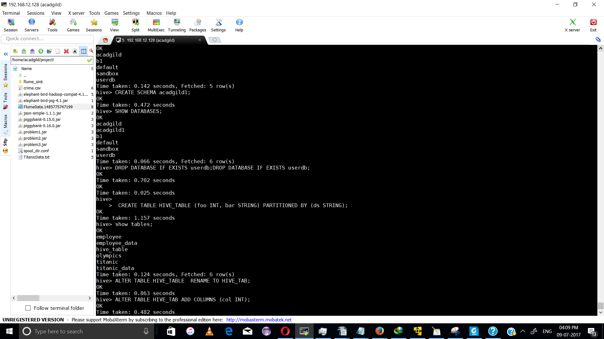
●Hive Data Manipulations

Loadng data:

hive (acadgild)> LOAD DATA LOCAL INPATH 'hadoop/olympix_data.csv' INTO table olympics;
Loading data to table acadgild.olympics
Table acadgild.olympics stats: [numFiles=1, totalSize=518669]
OK
Time taken: 2.846 seconds

displaying result using SELECT Command:

select sum(Total), Country, Sport from olympics where Sport like 'Swimming' group by Country,Sport ;

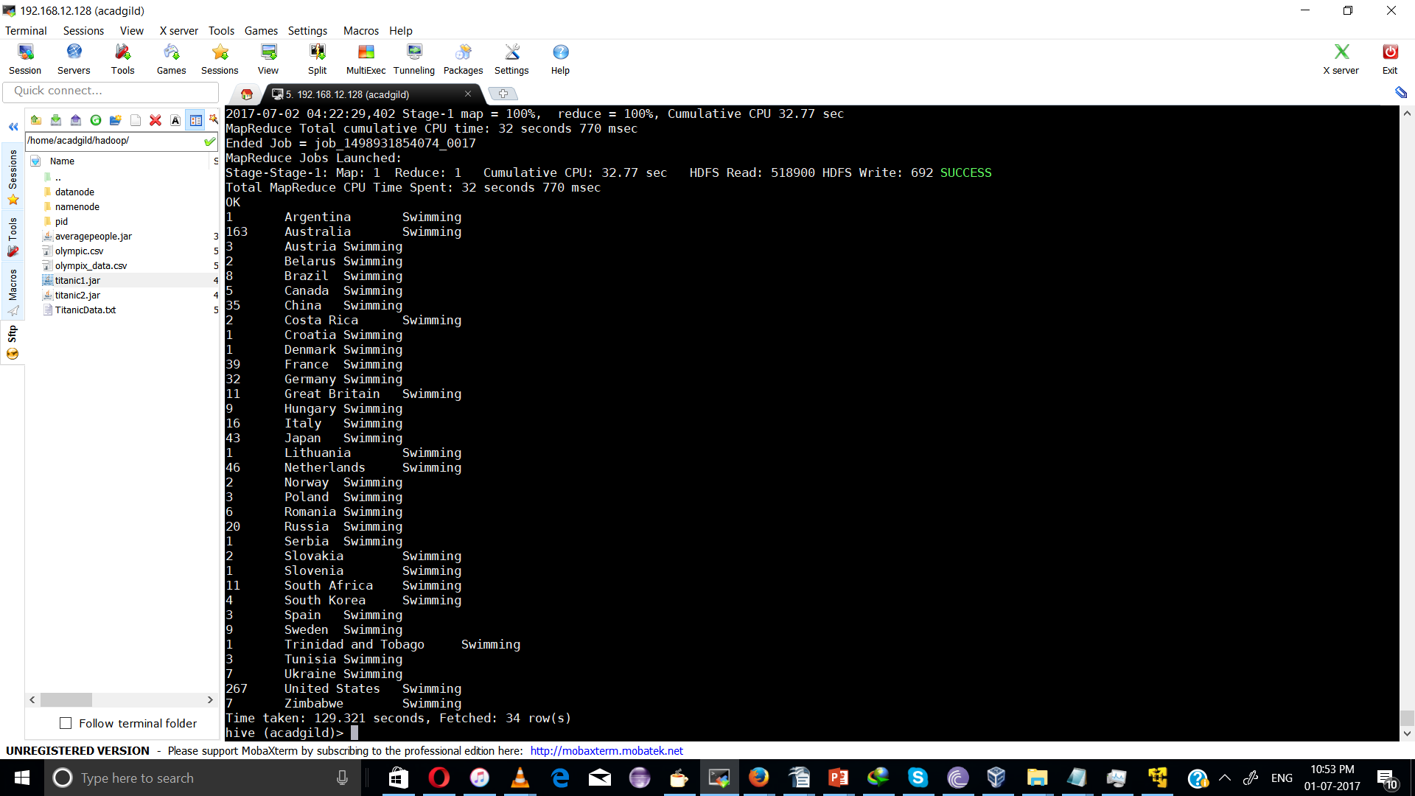

USING Filter and group by funtion

select SUM(Total),Year,Country from olympics where Country ='India' group by Year,Country;

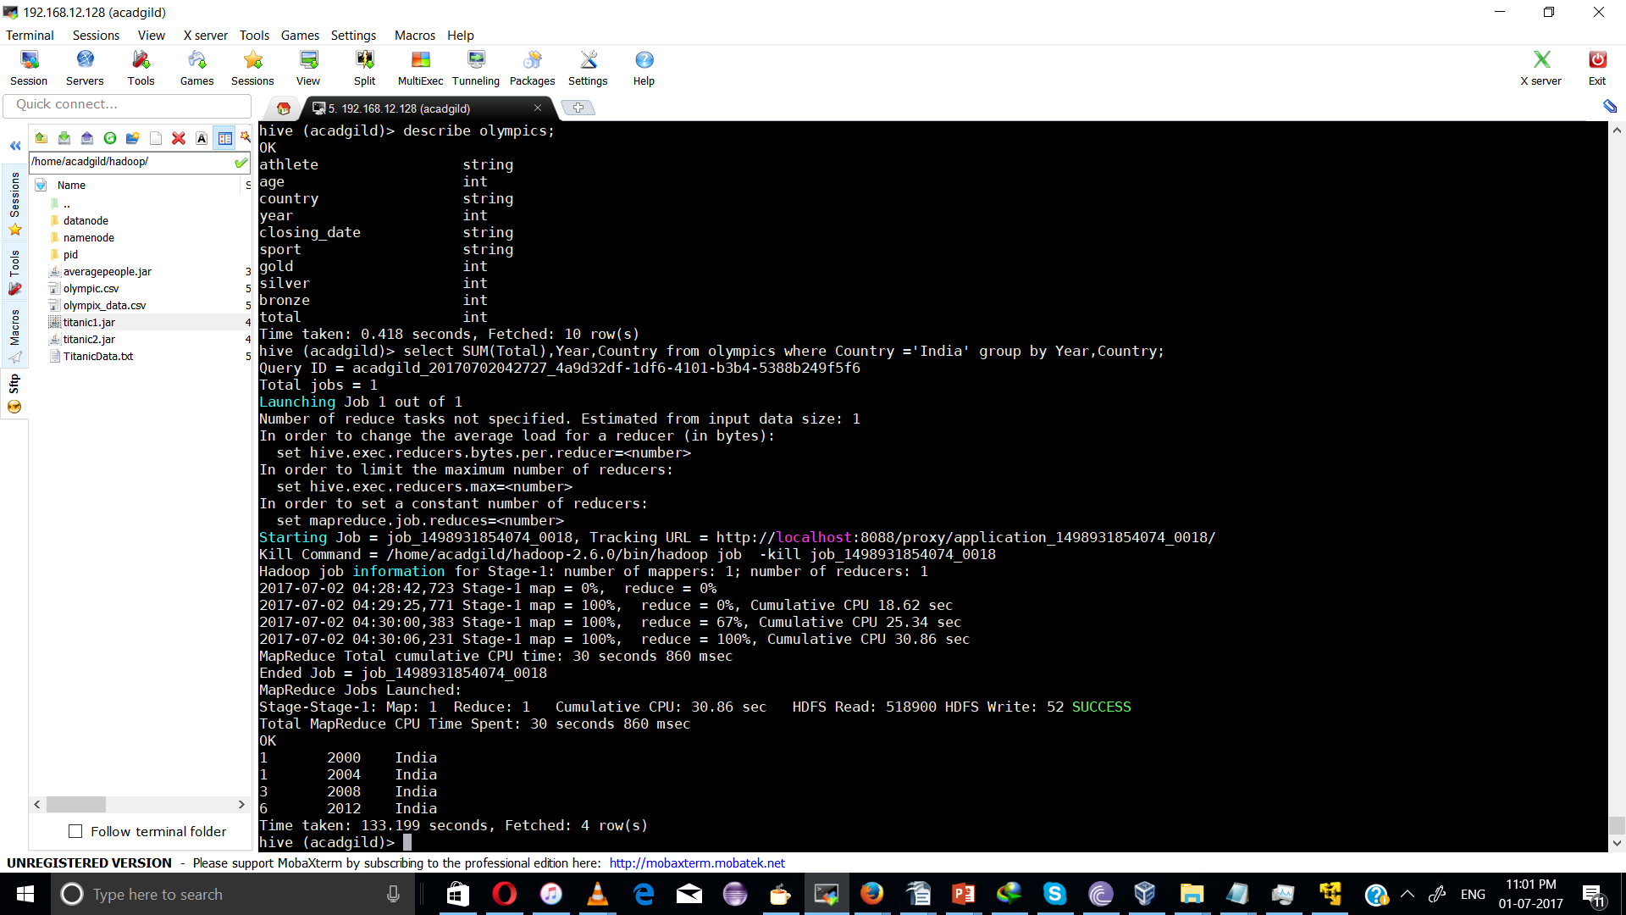

using Order by class
select SUM(Total) as sum,Country from olympics group by Country order by sum;

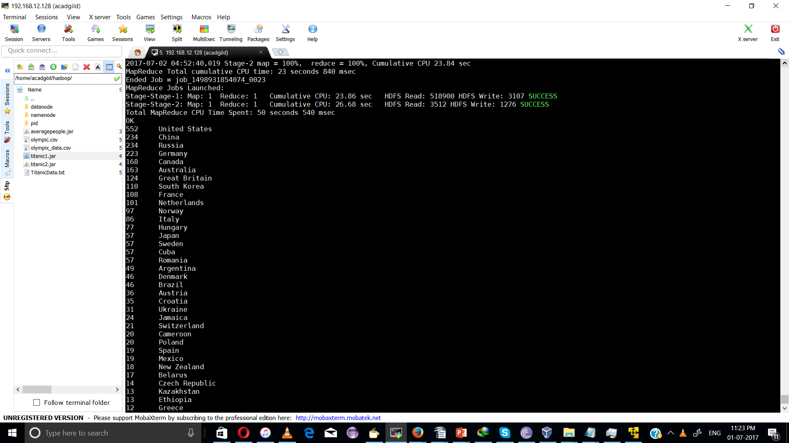

●HiveQL Manipulations

Hive defines a simple SQL-like query language to querying and managing large datasets called Hive-QL ( HQL ). It’s easy to use if you’re familiar with SQL Language.Hive allows programmers who are familiar with the language to write the custom MapReduce framework to perform more sophisticated analysis.

ggregation :
Select count (DISTINCT category) from tablename;
This command will count the different category of ‘cate’ table. Here there are 3 different categories.
Suppose there is another table cate where f1 is field name of category.

Grouping :
Group command is used to group the result-set by one or more columns.
Select category, sum( amount) from txt records group by category
It calculates the amount of same category.

The result one table is stored in to another table.
Create table newtablename as select * from oldtablename;

Join Command :
Here one more table is created in the name ‘mailid’

Join Operation:
A Join operation is performed to combining fields from two tables by using values common to each.

Left Outer Join:
The result of a left outer join (or simply left join) for tables A and B always contains all records of the “left” table (A), even if the join-condition does not find any matching record in the “right” table (B).

Right Outer Join:
A right outer join (or right join) closely resembles a left outer join, except with the treatment of the tables reversed. Every row from the “right” table (B) will appear in the joined table at least once.

Full Join:
The joined table will contain all records from both tables, and fill in NULLs for missing matches on either side.

Once done with hive we can use quit command to exit from the hive shell.

