DATA SET:

101 Amitabh 200 cs
102 Shahrukh 100 ee
103 Akshay 110 SM
104 Anubhav 50 ad
105 Pawan 99 MA
106 Aamir 98 cs
107 Salman 175 ee
108 Ranbir 140 SM
109 Katrina 100 ad
110 Priyanka 89 MA
111 Tushar 500 cs
112 Ajay 5000 ee
113 Jubeen 1000 cs
114 Madhuri 2000 ee

creating the table
create table employee_data(eid int,name String ,sal int ,department String)
row format delimited fields terminated by '\t' lines terminated by '\n' stored as textfile

loading the data into folder

load data local inpath 'employees_detail.txt' into table employee_data;

a)

SELECT eid, name, sal, department, (lead_sal - sal) AS diff_salary FROM
(
SELECT eid, name, sal, department, LEAD(sal) OVER (PARTITION BY department ORDER BY sal) AS lead_sal
from employee_data
) temp where lead_sal -sal <100;

result:

OK
110 Priyanka 89 MA 10
103 Akshay 110 SM 30
104 Anubhav 50 ad 50
102 Shahrukh 100 ee 75
Time taken: 133.663 seconds, Fetched: 4 row(s)

snapshot:

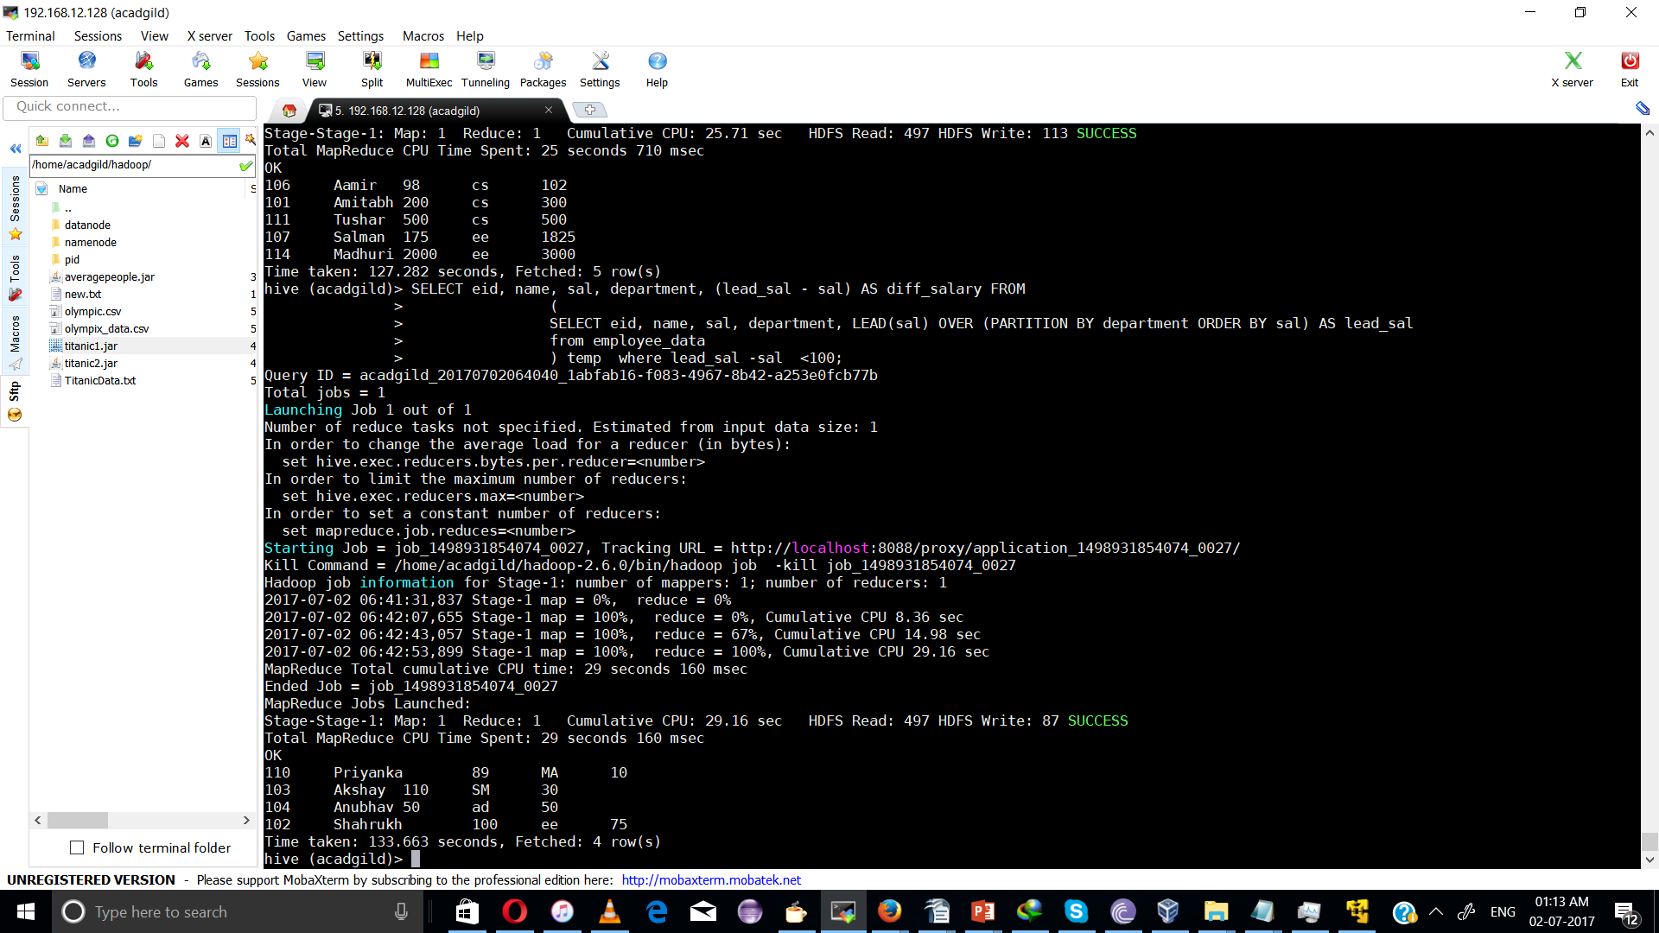

b)

SELECT name, sal, department,avg_salary
FROM
(
SELECT avg(sal) OVER (PARTITION BY department) AS avg_salary, eid, name, sal, department
FROM employee_data
) temp
WHERE sal > avg_salary;

output:

Pawan 99 MA 94.0
Ranbir 140 SM 125.0
Katrina 100 ad 75.0
Jubeen 1000 cs 449.5
Tushar 500 cs 449.5
Madhuri 2000 ee 1818.75
Ajay 5000 ee 1818.75

Snapshot:
