Let’s perform some row-level transactions available in Hive 0.14. Before creating a Hive table that supports transactions, the transaction features present in Hive needs to be turned on, as by default they are turned off.
The below properties needs to be set appropriately in hive shell , order-wise to work with transactions in Hive:
1  2  3  4  5  6  7  8  9  10  11 | hive>set hive.support.concurrency = true;  hive>set hive.enforce.bucketing = true;  hive>set hive.exec.dynamic.partition.mode = nonstrict;  hive>set hive.txn.manager = org.apache.hadoop.hive.ql.lockmgr.DbTxnManager;  hive>set hive.compactor.initiator.on = true;  hive>set hive.compactor.worker.threads = a positive number on at least one instance of the Thrift metastore service;
If the above properties are not set properly, the ‘Insert’ operation will work but ‘Update’ and ‘Delete’ will not work and you will receive the following error:
1 | FAILED: SemanticException [Error 10294]: Attempt to do update or delete usingtransaction manager thatdoes not support these operations.

Creating a Table That Supports Hive Transactions
1 | CREATE TABLE college(clg_id int,clg_name string,clg_loc string) clustered by (clg_id) into 5 buckets stored as orc TBLPROPERTIES('transactional'='true');
The above syntax will create a table with name ‘college’ and the columns present in the table are ‘clg_id, clg_name, clg_loc’. We are bucketing the table by ‘clg_id’ and the table format is ‘orc’, also we are enabling the transactions in the table by specifying it inside the TBLPROPERTIES as ‘transactional’=’true’
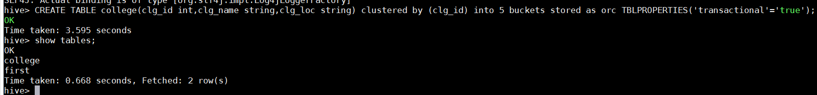
We have successfully created a table with name ‘college’ which supports row-level transactions of Hive.
The create table can be checked using the command show tables.

Inserting Data into a Hive Table
1 | INSERT INTO table college values(1,'nec','nlr'),(2,'vit','vlr'),(3,'srm','chen'),(4,'lpu','del'),(5,'stanford','uk'),(6,'JNTUA','atp'),(7,'cambridge','us');
The above command is used to insert row wise data into the Hive table. Here, each row is seperated by ‘( )’ brackets.
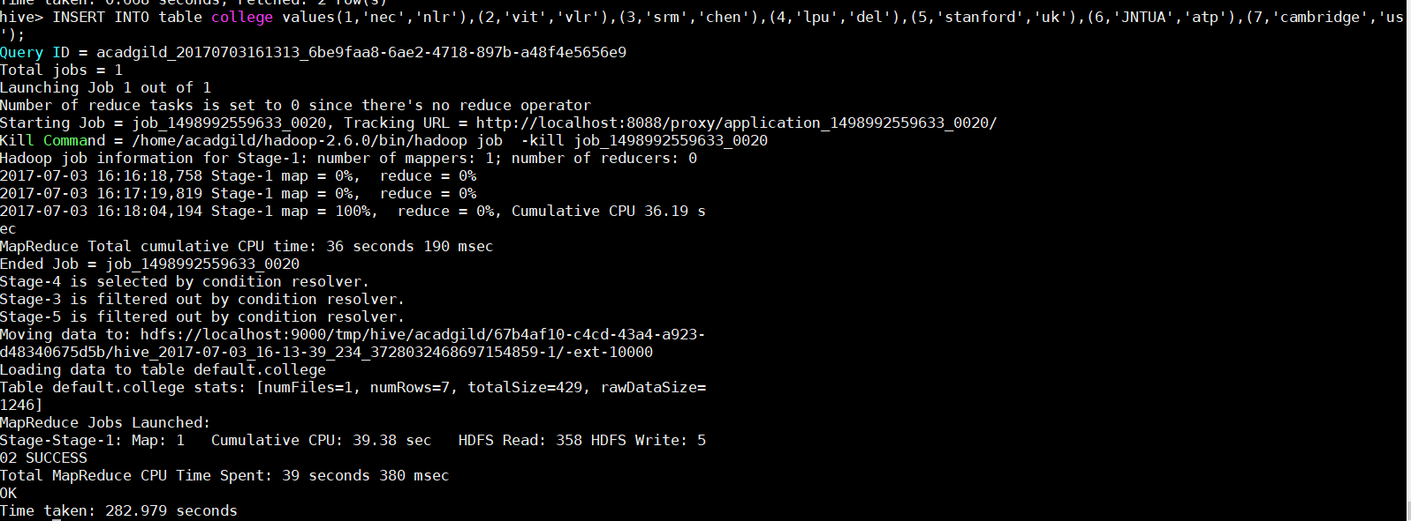
Now, we have successfully inserted the data into the Hive table.
The contents of the table can be viewed using the command select * from college

From the above image, we can see that the data has been inserted successfully into the table.
Now if we try to re-insert the same data again, it will be appended to the previous data as shown below:
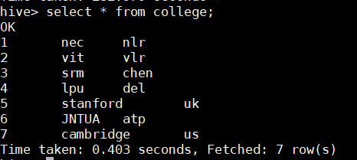

Updating the Data in Hive Table
1 | UPDATE college set clg_id = 8 where clg_id = 7;
The above command is used to update a row in Hive table.
From the above image, we can see that we have received an error message. This means that the Update command is not supported on the columns that are bucketed.
In this table, we have bucketed the ‘clg_id’ column and performing the Update operation on the same column, so we have go the error
FAILED: SemanticException[Error 10302]: Updating values of bucketing columns is not supported. Column clg_id
Now let’s perform the update operation on Non bucketed column
1 | UPDATE college set clg_name = 'IIT' where clg_id = 6;

Deleting a Row from Hive Table
1 | delete from college where clg_id=5;
The above command will delete a single row in the Hive table.

We have now successfully deleted a row from the Hive table. This can be checked using the command select * from college.

We can see that there is no row with clg_id =1. This means that we have successfully deleted the row from the Hive table.
This is how the transactions or row-wise operations are performed in Hive.

