Command: hadoop fs -ls /user

the directory /user/acadgild/hadoop exists

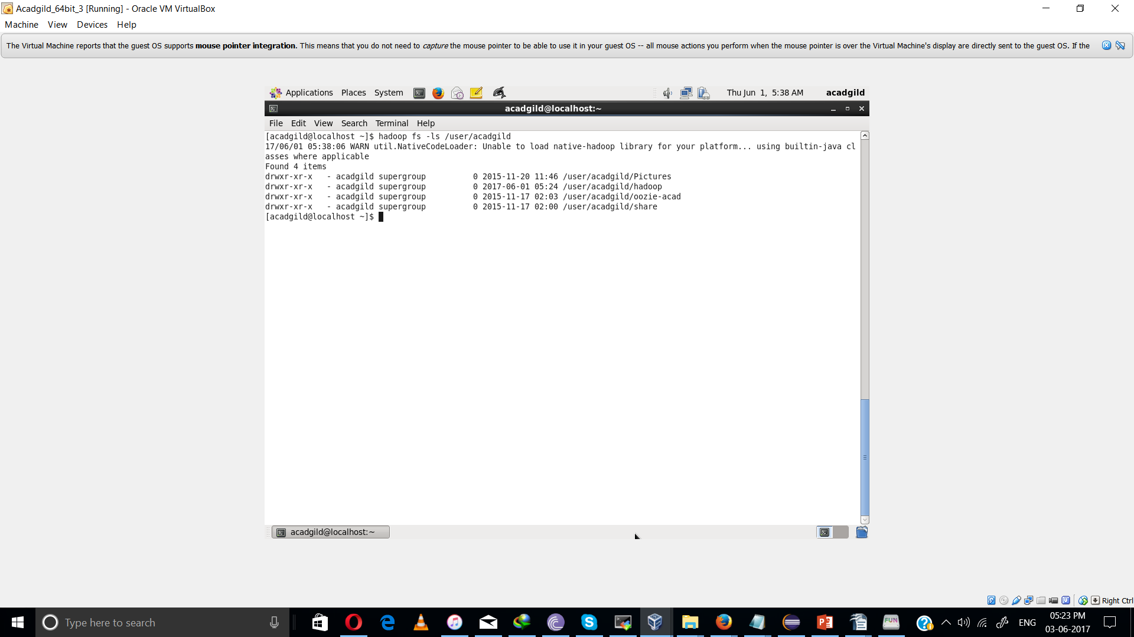

task 2 :

echo “ i am working in CTS” | hadoop fs -appendToFile - /user/acadgild/hadoop/Word-count.txt

