Moving file from Local to HDFS

Source :/home/acdgild/max-temp.txt
target:/user/acadgild/hadoop/max-text.txt

Command used:
hadoop fs -moveFromLocal max-temp.txt /user/acadgild/max-text.txt

screenshot:
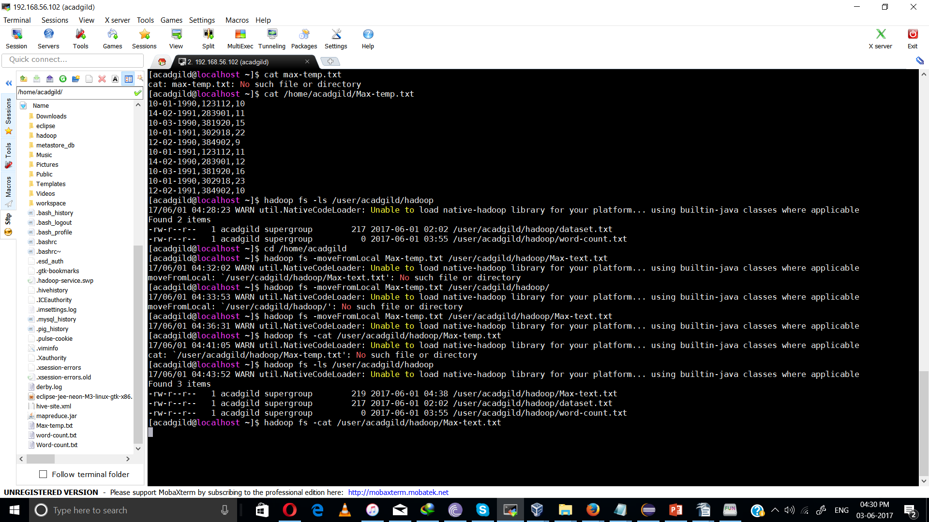

task 2:
Changing permission to only the owner and the group members have full control over the file

Command
hadoop fs -chmod 770 /user/acadgild/hadoop/max-text.txt

permission changed to -rwxrwx---
