Explain the below linux commands with an example. Share the screenshot of each
command with the output :
1.pwd
display the current file path

2.vi
open text editor in linux

3.touch:create new file with zero length
4.mkdir: creating a new directory in linux
Ex: mkdir /home/acadgild/hadoop2

5.rm: remove directory and file in filesyatem
ex:rm -r hadoop2

6.ls: list the contents of the cuurent directory
7.echo: display contents in the screen
ex:echo “working with linux”
8.cat: display contents of a file
cat word-count.txt
9.who: who command to display users who are currently logged in your server
10.cd: to change the directory
ex. cd /
11.date :display system date
12.cal: display current month calender
13.mv: move folder from one location to another
14.cp: copy file from one location to another
15.which:excutable file in the path

Screenshot :1
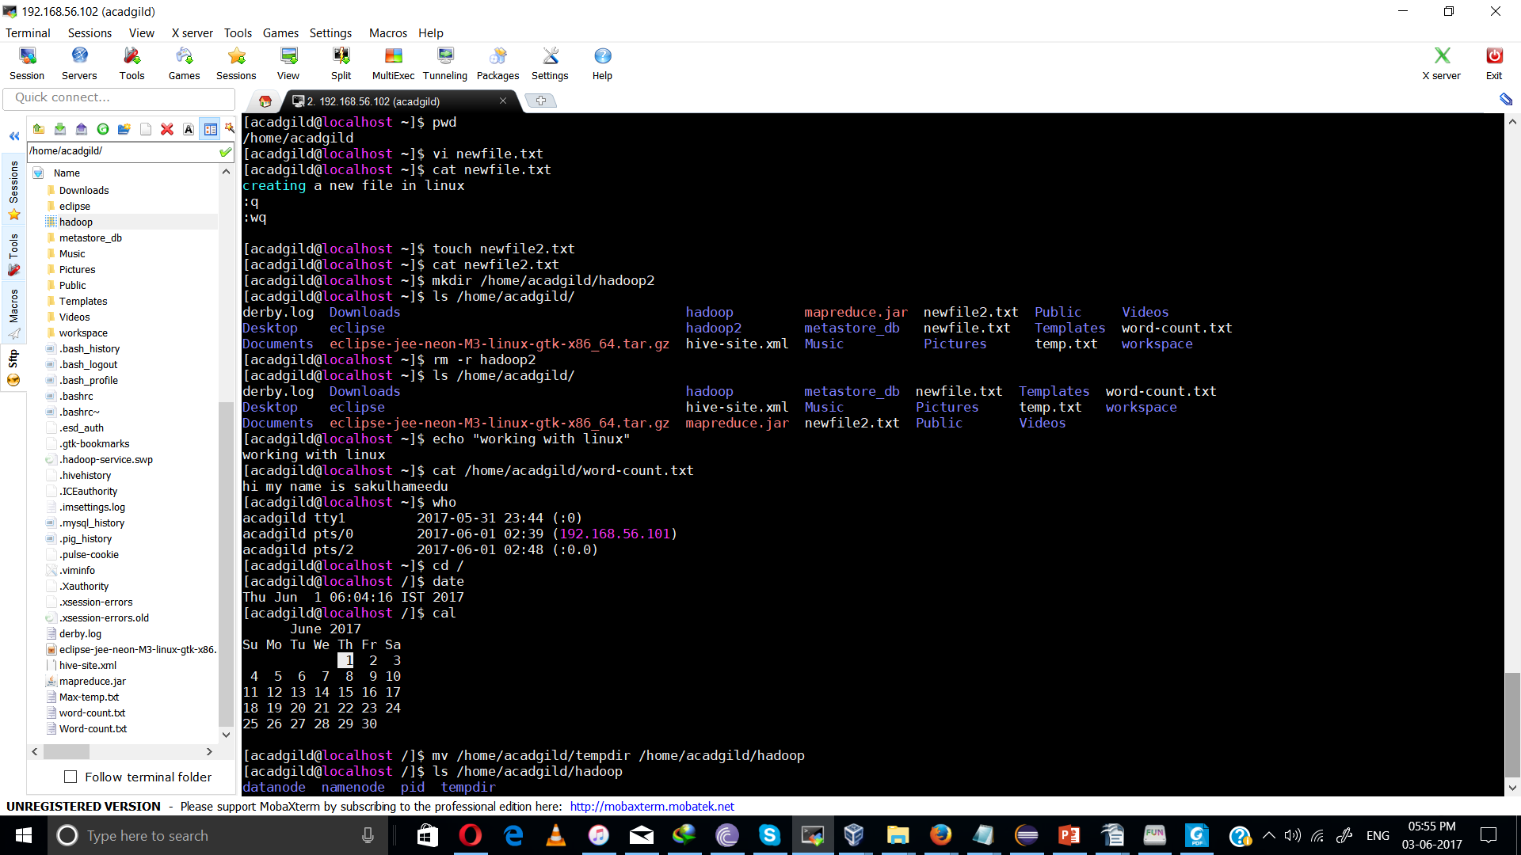
screenshot:2

