Problem:

We have a dataset of sales of different TV sets across different locations.

Records look like:

Samsung|Optima|14|Madhya Pradesh|132401|14200

The fields are arranged like:

Company Name|Product Name|Size in inches|State|Pin Code|Price

4. Write a Map Reduce program to modify Task 2 (refer session 4, assignment 2) to use a

custom partitioner with 4 reducers.

Make sure that all records whose company name starts with A-F (upper or lower case) should

go to 1st reducer,

those starting with G-L to 2nd reducer, those starting with M-R to 3rd reducer and others to 4th

reducer.

5. Modify Task 2 (refer session 4, assignment 2) to take advantage of Combiner.

Input File:
Samsung|Optima|14|Madhya Pradesh|132401|14200
Onida|Lucid|18|Uttar Pradesh|232401|16200
Akai|Decent|16|Kerala|922401|12200
Lava|Attention|20|Assam|454601|24200
Zen|Super|14|Maharashtra|619082|9200
Samsung|Optima|14|Madhya Pradesh|132401|14200
Onida|Lucid|18|Uttar Pradesh|232401|16200
Onida|Decent|14|Uttar Pradesh|232401|16200
Onida|NA|16|Kerala|922401|12200
Lava|Attention|20|Assam|454601|24200
Zen|Super|14|Maharashtra|619082|9200
Samsung|Optima|14|Madhya Pradesh|132401|14200
NA|Lucid|18|Uttar Pradesh|232401|16200
Samsung|Decent|16|Kerala|922401|12200
Lava|Attention|20|Assam|454601|24200
Samsung|Super|14|Maharashtra|619082|9200
Samsung|Super|14|Maharashtra|619082|9200
Samsung|Super|14|Maharashtra|619082|9200

Program for task 5:
Task5.java
Driver program:
package assignment5;

import org.apache.hadoop.fs.Path;
import org.apache.hadoop.conf.*;
import org.apache.hadoop.mapreduce.Job;
import org.apache.hadoop.mapreduce.lib.input.FileInputFormat;
import org.apache.hadoop.mapreduce.lib.input.TextInputFormat;
import org.apache.hadoop.mapreduce.lib.output.FileOutputFormat;
import org.apache.hadoop.mapreduce.lib.output.TextOutputFormat;
import org.apache.hadoop.io.IntWritable;
import org.apache.hadoop.io.Text;

public class Task5 {
@SuppressWarnings("deprecation")
public static void main(String[] args) throws Exception {
Configuration conf = new Configuration();
Job job = new Job(conf, "AssignmentTask5");
job.setJarByClass(Task5.class);

job.setMapOutputKeyClass(Text.class); //mapper key class as TEXT
job.setMapOutputValueClass(IntWritable.class);//mapper vlaue as IntWritable

job.setOutputKeyClass(Text.class);
job.setOutputValueClass(IntWritable.class);
job.setMapperClass(Task5Mapper.class);
job.setReducerClass(Task5Reducer.class);
job.setCombinerClass(Task5Reducer.class);//using combiner class

job.setInputFormatClass(TextInputFormat.class); //File format
job.setOutputFormatClass(TextOutputFormat.class);

FileInputFormat.addInputPath(job, new Path(args[0])); //input path
FileOutputFormat.setOutputPath(job,new Path(args[1])); //output path

/*
Path out=new Path(args[1]);
out.getFileSystem(conf).delete(out);
*/

job.waitForCompletion(true);
}
}

Reducer class:

Task5Reducer.java
package assignment5;

import java.io.IOException;

import org.apache.hadoop.io.IntWritable;
import org.apache.hadoop.io.Text;
import org.apache.hadoop.mapreduce.Reducer;

public class Task5Reducer extends Reducer<Text, IntWritable, Text, IntWritable>
{
IntWritable outValue = new IntWritable();

public void reduce(Text key, Iterable<IntWritable> values,Context context) throws IOException, InterruptedException
{
int sum = 0;
for (IntWritable value : values) {
sum += value.get(); //getting totalunits sold
}

outValue.set(sum);
context.write(key, outValue); //output to file
}
}

Mapper class
Task5Mapper.java

package assignment5;

import java.io.IOException;

import org.apache.hadoop.io.IntWritable;
import org.apache.hadoop.io.Text;
import org.apache.hadoop.mapreduce.Reducer;

public class Task5Reducer extends Reducer<Text, IntWritable, Text, IntWritable>
{
IntWritable outValue = new IntWritable();

public void reduce(Text key, Iterable<IntWritable> values,Context context) throws IOException, InterruptedException
{
int sum = 0;
for (IntWritable value : values) {
sum += value.get(); //getting totalunits sold
}

outValue.set(sum);
context.write(key, outValue); //output to file
}
}

Command
hadoop jar assignment5.jar assignment5.Task5 /user/acadgild/hadoop/datase.txt /user/acadgild/hadoop/assignm5

snapshot:
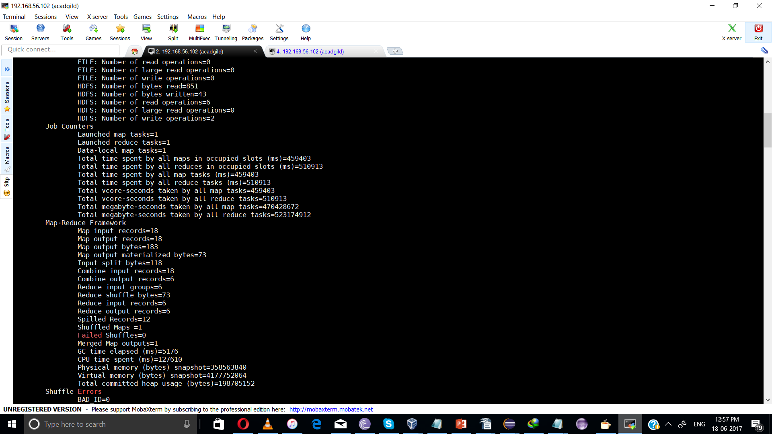

result:

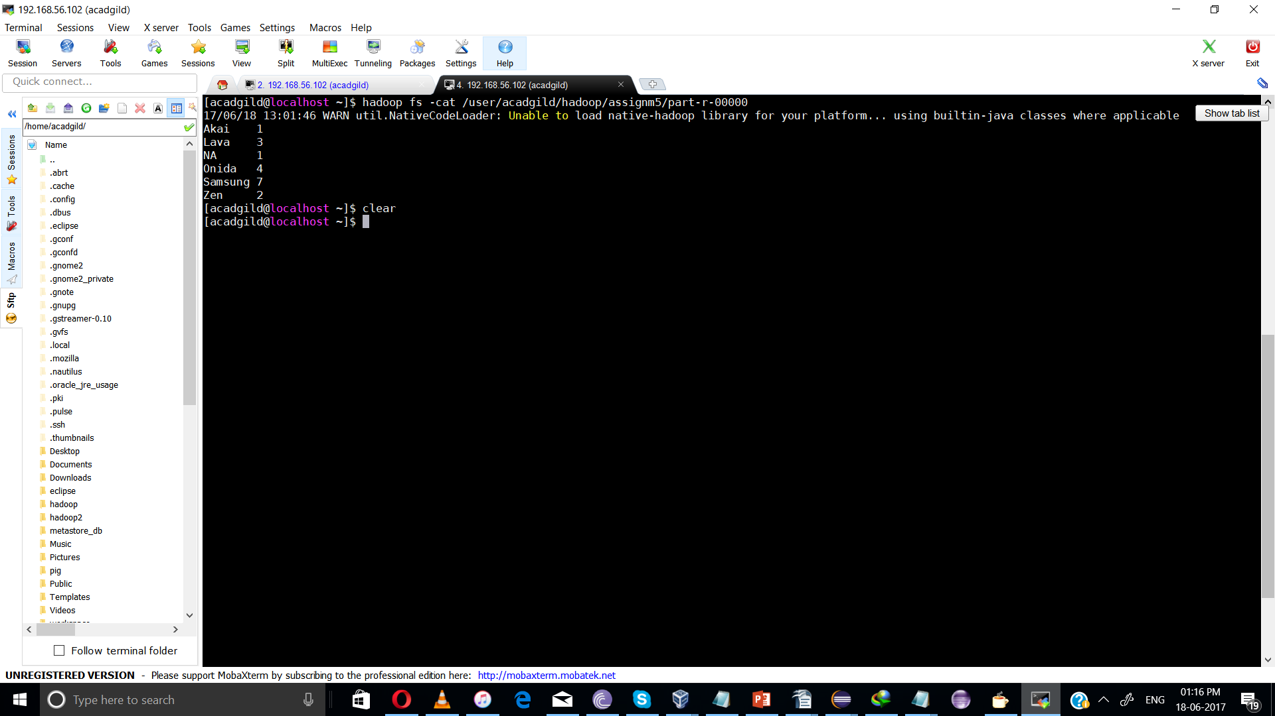

Task 4:

Using Partitioner program:

Task4.java
package assignment5;

import org.apache.hadoop.conf.Configuration;
import org.apache.hadoop.fs.Path;
import org.apache.hadoop.fs.FileSystem;
import org.apache.hadoop.io.IntWritable;
import org.apache.hadoop.io.Text;
import org.apache.hadoop.mapreduce.Job;
import org.apache.hadoop.mapreduce.lib.partition.*;
import org.apache.hadoop.mapreduce.lib.input.FileInputFormat;
import org.apache.hadoop.mapreduce.lib.input.TextInputFormat;
import org.apache.hadoop.mapreduce.lib.output.FileOutputFormat;
import org.apache.hadoop.mapreduce.lib.output.TextOutputFormat;

public class Task4
{
public static void main(String[] args) throws Exception
{
Configuration conf = new Configuration();
conf.addResource(new Path("/usr/lib/hadoop/etc/hadoop/core-site.xml"));
conf.addResource(new Path("/usr/lib/hadoop/etc/hadoop/hdfs-site.xml"));
//create an instance of FileSystem that holds Filesystem namespace
FileSystem fs = FileSystem.get(conf);
//variables to hold path of input file and output directory
String inPath;
String outPath;

if (args.length != 2)
{
System.err.println("Usage: Seq File Example <input file> <output dir>");
System.out.println("Using default file: seqfile");
inPath = "/user/acadgild/television";
outPath = "/user/acadgild/validtv";
}
else
{
inPath = args[0];
outPath = args[1];
}
//create an instance of job
Job job = new Job(conf, "assignment4");
job.setJarByClass(Task4.class);
job.setMapperClass(Task4Mapper.class);
job.setPartitionerClass(Task4Partitioner.class);
job.setReducerClass(Task4Reducer.class);

job.setMapOutputKeyClass(Text.class);
job.setMapOutputValueClass(IntWritable.class);

job.setOutputKeyClass(Text.class);
job.setOutputValueClass(IntWritable.class);

job.setInputFormatClass(TextInputFormat.class);
job.setOutputFormatClass(TextOutputFormat.class);

FileInputFormat.addInputPath(job, new Path(inPath));
if (fs.exists(new Path(outPath)))
{
fs.delete(new Path(outPath), true);
}
FileOutputFormat.setOutputPath(job, new Path(outPath));
System.exit(job.waitForCompletion(true) ? 0 : 1);

}
}

Task4Mapper.java

package assignment5;

import java.io.IOException;
import org.apache.hadoop.io.IntWritable;
import org.apache.hadoop.io.LongWritable;
import org.apache.hadoop.io.Text;
import org.apache.hadoop.mapreduce.Mapper;

public class Task4Mapper extends Mapper<LongWritable, Text, Text, IntWritable>
{
private Text company = new Text();
public void map(LongWritable key, Text value, Context context) throws IOException, InterruptedException
{
System.out.println("mapper Input key = " + key.toString() + " Input value = " + value.toString());
String[] token = value.toString().split("\\|");
int flag=0;
if (token[0].equals("NA") || token[1].equals("NA"))
{
flag = 1;
System.out.println("flag set company "+ token[0]+" product "+token[1] );
}
if (flag == 0)
{
company .set(token[0]);
context.write(company,new IntWritable(1));
System.out.println("writing..company "+ token[0]+" product "+token[1] );
}
}
}

Task4Reducer.java
package assignment5;

import java.io.IOException;
import org.apache.hadoop.io.IntWritable;
import org.apache.hadoop.io.Text;
import org.apache.hadoop.mapreduce.Reducer;

public class Task4Reducer extends Reducer<Text,IntWritable,Text,IntWritable>
{
private IntWritable units_sold = new IntWritable();
public void reduce(Text key, Iterable<IntWritable> values, Context context) throws IOException, InterruptedException
{
int sum = 0;
System.out.println("reducer Input key = " + key.toString() );
for(IntWritable val : values)
{
sum = sum + val.get();
System.out.println("sum = " + sum ); //calculating total Units sold
}
units_sold.set(sum);
context.write(key, units_sold);
}
}

Task4Partitioner.java

package assignment5;

import org.apache.hadoop.io.IntWritable;
import org.apache.hadoop.io.Text;
import org.apache.hadoop.mapreduce.Partitioner;

public class Task4Partitioner extends Partitioner<Text, IntWritable>{

public int getPartition(Text key,IntWritable value , int numPartitions)
{
String[] items = key.toString().split("");
System.out.println("Partioner: item is "+ items[0]);
if(items[0].compareTo("A") < 0 && items[0].compareTo("F")>0 )
return 0; //sending to reducer 1
if(items[0].compareTo("G") < 0 && items[0].compareTo("L")>0 )
return 1; //sending to reducer 2
if(items[0].compareTo("M") < 0 && items[0].compareTo("R")>0 )
return 2; //sending to reducer 3
else
return 3; //sending to reducer4
}

}

Command:
hadoop jar assignment5.jar assignment5.Task4 /user/acadgild/hadoop/datase.txt /user/acadgild/hadoop/assignm5_2

snapshot:

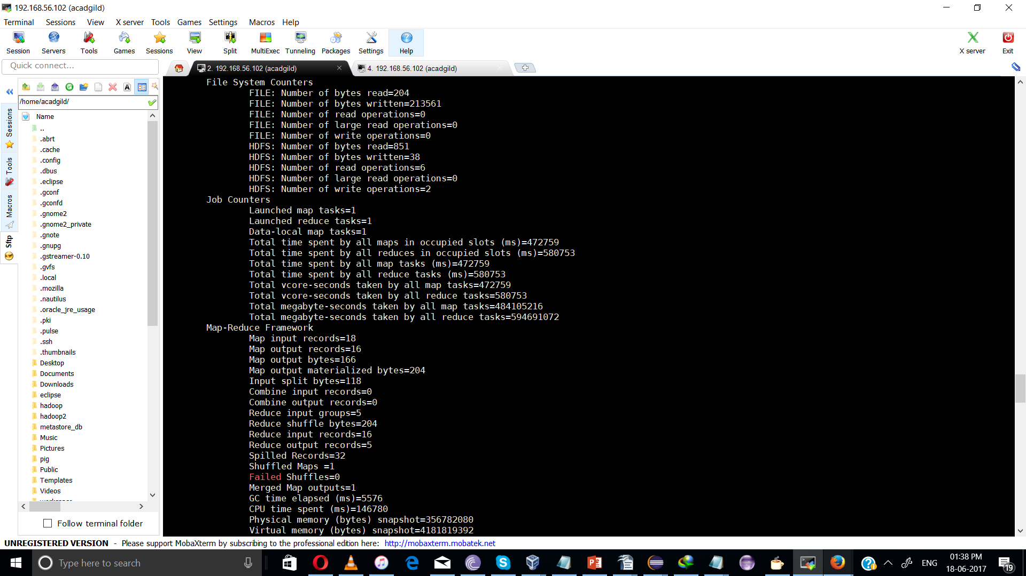

Result:

part-r-00000

Akai 1

part-r-00001
lava 3
part-r-00002
Onida 3

part-r-00003

samsung 7
Zen 2

