Weblog Analysis using Apache Pig
We have Sample_log file. Use MR mode while running Pig and write Pig Latin script to get

below results:

1)Find out the most viewed page

2)Find total hits per unique day

Below are the steps:
Step 1) First and foremost, we have to register the Piggybank jar to use its classes.

grunt> register '/home/acadgild/pig/piggybank-0.15.0.jar'

Step 2) Next, load the data using CombinedLogLoader() and specify the schema.

Loading File
webdata = LOAD '/home/acadgild/pig/sample_log' USING org.apache.pig.piggybank.storage.apachelog.CombinedLogLoader() AS (ipaddr: chararray, logmame: chararray,temp0: chararray, time: chararray, temp1: chararray, temp2: chararray, temp3: chararray, temp4: chararray, temp5: chararray, pagelink:chararray, temp6:chararray);

Step 3) Group the data by page link to count the page hits of each unique link.
grouping by pagelink:
grunt> groupbypage = group webdata by pagelink;

Step 4) For every grouped data (grouped by link) we have to generate the link and its total count. Here, we have used flatten() to explode the tuples and then count the hits.
count of pages:
pagehits = FOREACH groupbypage GENERATE group as id, flatten($0), COUNT($1) as pagecount;

Step 5) Once COUNT is received, we need to order it in descending order and generate the only first result.
grunt> ord = order pagehits by pagecount DESC;

grunt> ordlimit = LIMIT ord 1
Step 6) use dump to get the desired result.

grunt>dump odlimit;

Snapshot:
;

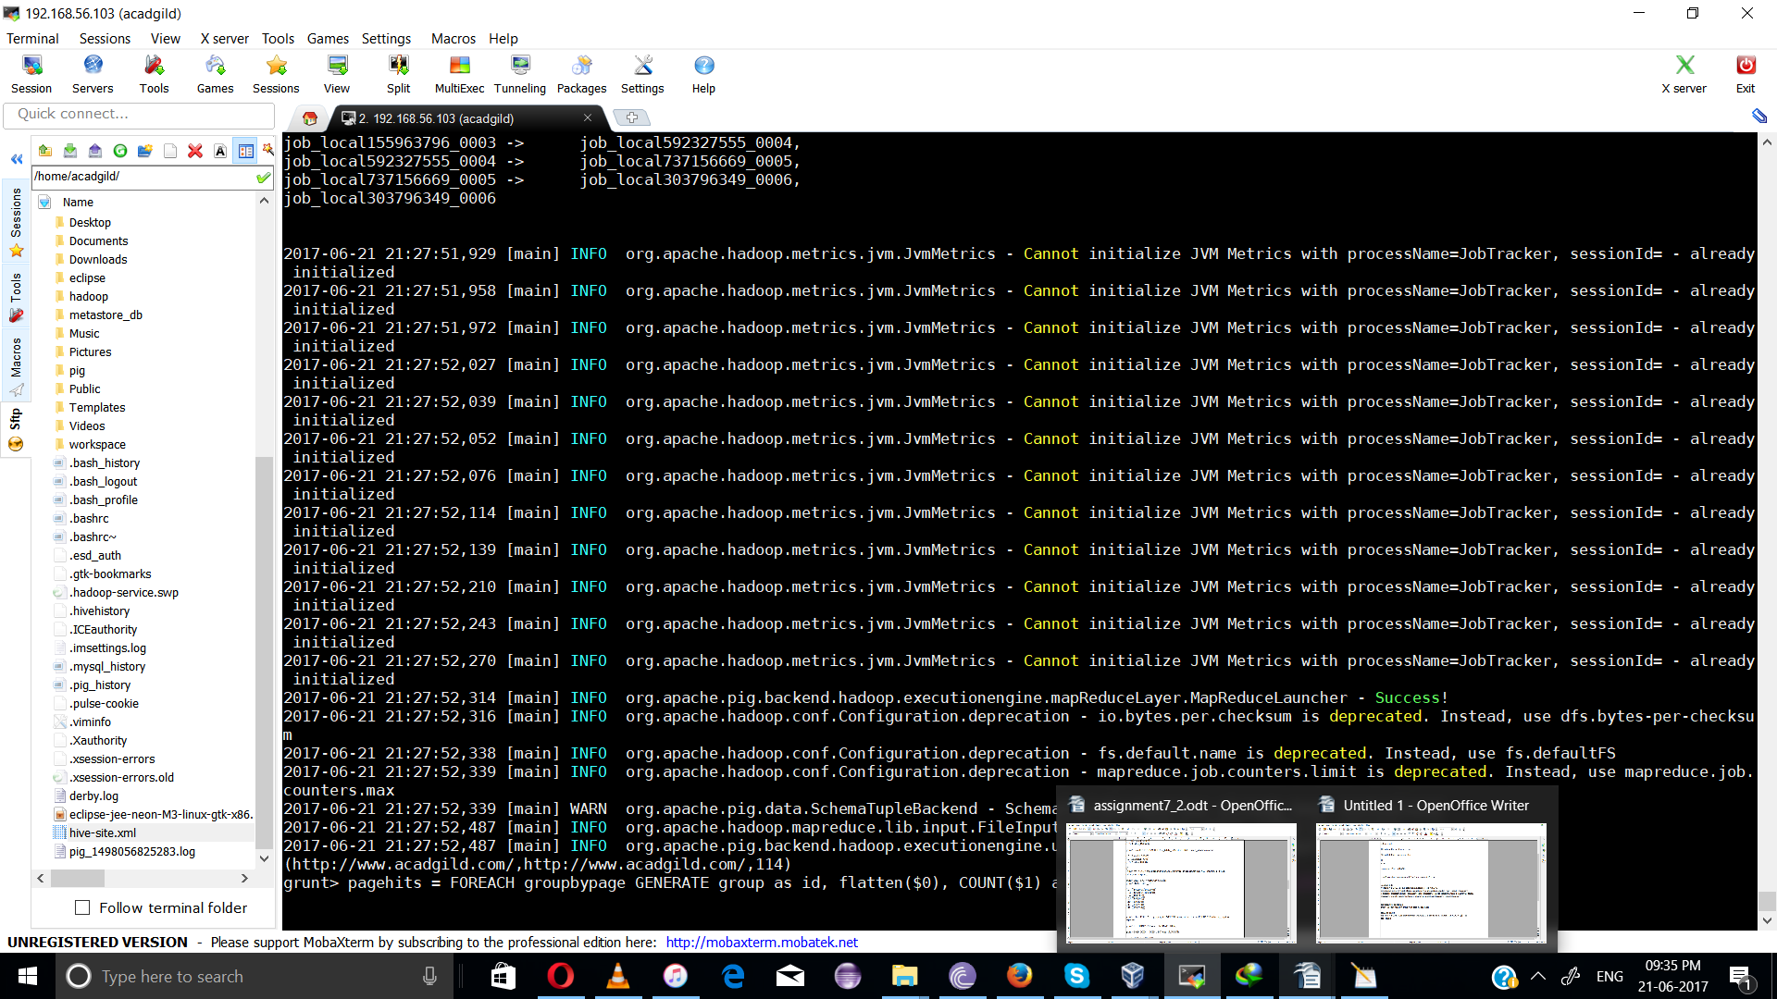

2)
Step 1) Define the DateExtractor() in the Pig Grunt shell as shown below:
grunt> DEFINE DATE_EXTRACT org.apache.pig.piggybank.evaluation.util.apachelogparser.DateExtractor('dd/MMM/yyyy:HH:mm:ss Z','dd');
grunt>
Step 2) Use the above class defined to extract the day and group by it.
runt> grpd = GROUP webdata by DATE_EXTRACT(time);
Step 3) To find the unique hits per day, run the below command.

grunt> hits = foreach grpd GENERATE flatten($0), COUNT($1);

Step 4) Dump the result and see the output.

grunt> dump hits;

snapshot:

