Executive Summary
1.1 Project Overview
To develop the System to analyze the log data (In XML format) of government progress of
various development activities.
1.2 Purpose and Scope of this Specification
The purpose of this project is to capture the data for analyzing the progress of various
activities.
In scope
The following requirement will be addressed in phase 1 of Project:
• Developing system to handle the incoming log feed and store the information in Hadoop
Cluster (Flume)
• Analyze the data and understand the progress
• Store the results in Hbase/RDBMS
Out of scope
We can use this data and visualization and get more insights

Priority Definitions

The following definitions are intended as a guideline to prioritize requirements.
• Priority 1 – Create FLUME job for fetching log files from spool directory the data
• Priority 2 – MapReduce/pig job to preprocess

Priority 1:

Step 1:
Copy dataset from local file system to HDFS using flume.
Filecopy.conf
agent1.sources = mysrc
agent1.sinks = hdfsdest
agent1.channels = mychannel

agent1.sources.mysrc.type = exec
agent1.sources.mysrc.command = hadoop dfs -put /home/acadgild/StatewiseDistrictwisePhysicalProgress.xml /user/acadgild/flumeflume_import

agent1.sinks.hdfsdest.type = hdfs
agent1.sinks.hdfsdest.hdfs.path = hdfs://localhost:9000/user/acadgild/flume

agent1.channels.mychannel.type = memory

agent1.sources.mysrc.channels = mychannel
agent1.sinks.hdfsdest.channel = mychannel

Command:
flume-ng agent -n agent -c conf -f filecopy.conf

Snapshot of Flume execution:
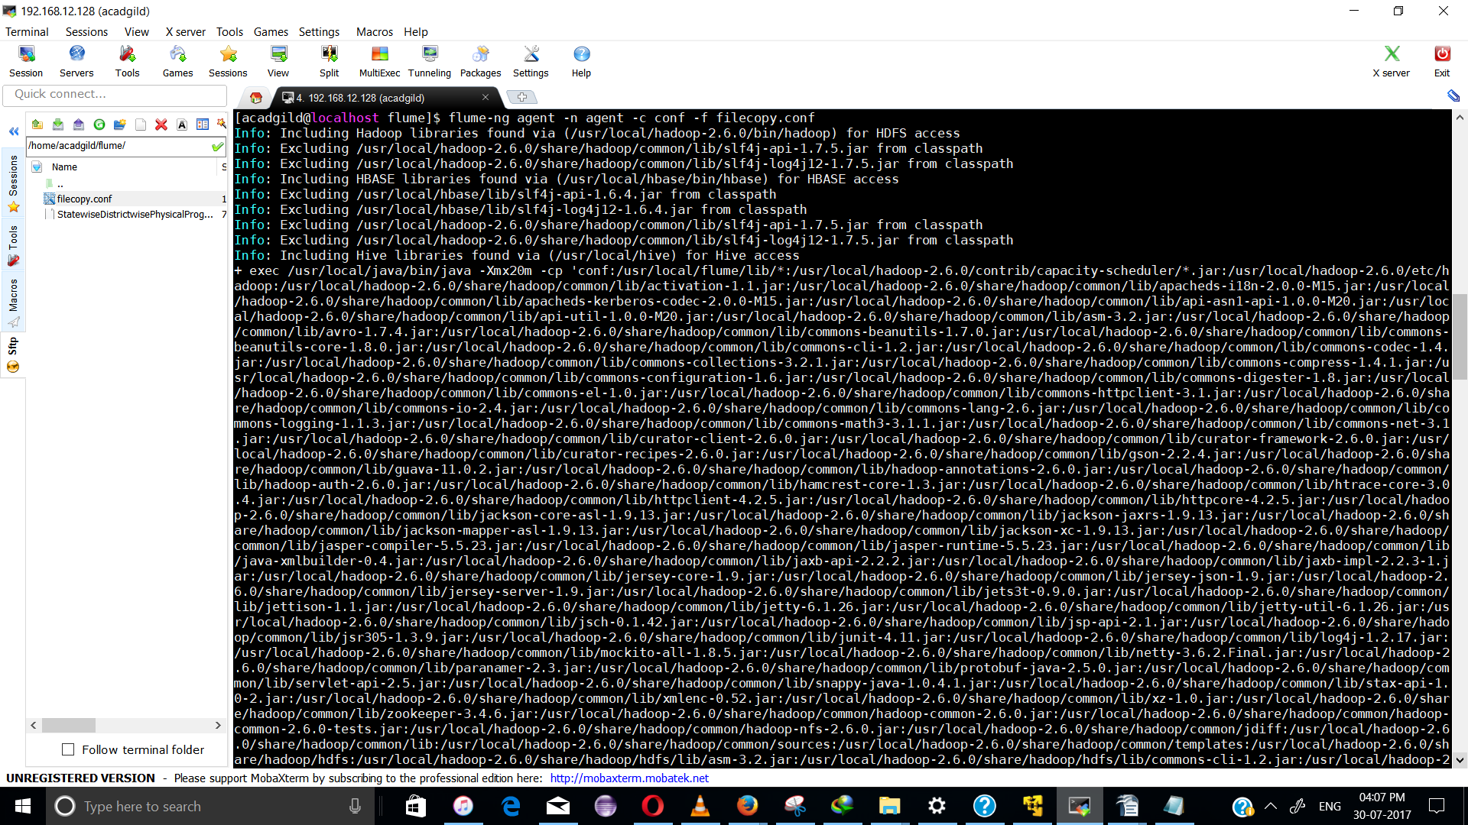
File copied after flume execution:
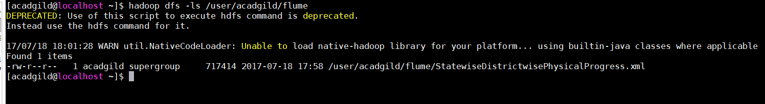

Priority 2:

Problem 1:
1. Find out the districts who achieved 100 percent objective in BPL cards
Export the results to mysql using sqoop

PIG commands:
REGISTER /home/acadgild/flume/piggybank-0.15.0.jar;

DEFINE XPath org.apache.pig.piggybank.evaluation.xml.XPath();

Data = LOAD '/home/acadgild/flume/StatewiseDistrictwisePhysicalProgress.xml' using org.apache.pig.piggybank.storage.XMLLoader('row') as (x:chararray);
StateDet = FOREACH Data GENERATE XPath(x, 'row/State_Name') AS statename, XPath(x, 'row/District_Name') AS disname,XPath(x, 'row/Project_Objectives_IHHL_BPL') AS BPL,XPath(x, 'row/Project_Objectives_IHHL_TOTAL') AS total ;
ObjFiltered = FILTER StateDet BY BPL == total;

STORE ObjFiltered INTO 'hdfs://localhost:9000/flume_import_out' USING PigStorage(',');

The File has been loaded into path:

hdfs://localhost:9000/flume_import_out

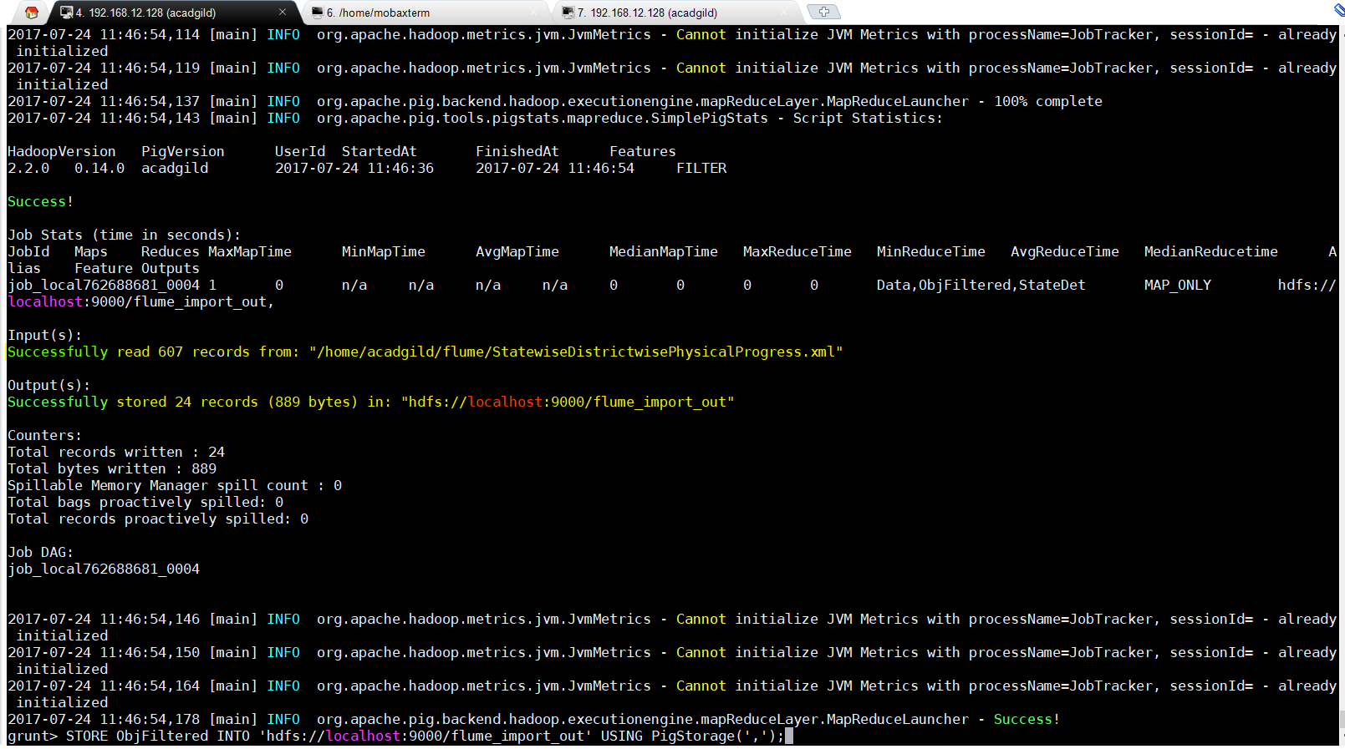
File Location:
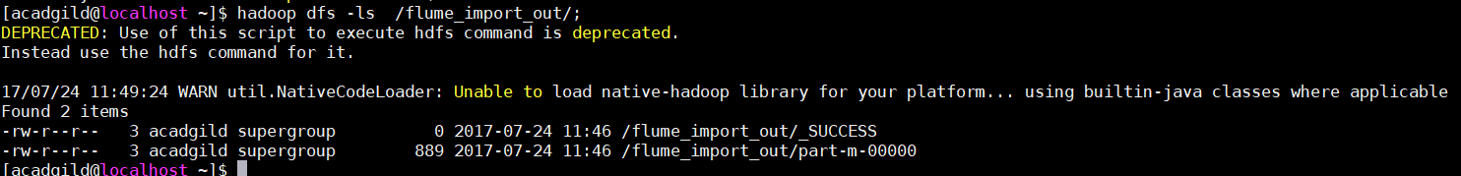
Starting MYSQL:
sudo service mysqld start;

Create a new Database:
mysql>create database DistrictDB;
mysql>use state;

Create a table similar to the structure of the output file contents:
mysql>create table BPLObjectivesMet (State varchar(20), district varchar(50), BPL int, total int);
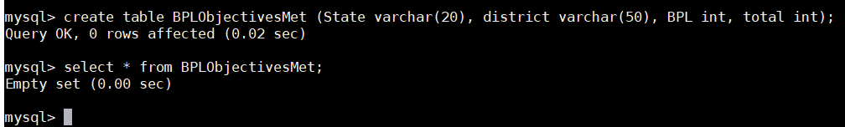

In Terminal1, run the sqoop command to Export the Pig Script analysis from HDFS to MySQL:

sqoop export --connect jdbc:mysql://localhost:3306/districtdb --table BPLObjectivesMet -m 1 --export-dir /flume_import_out/

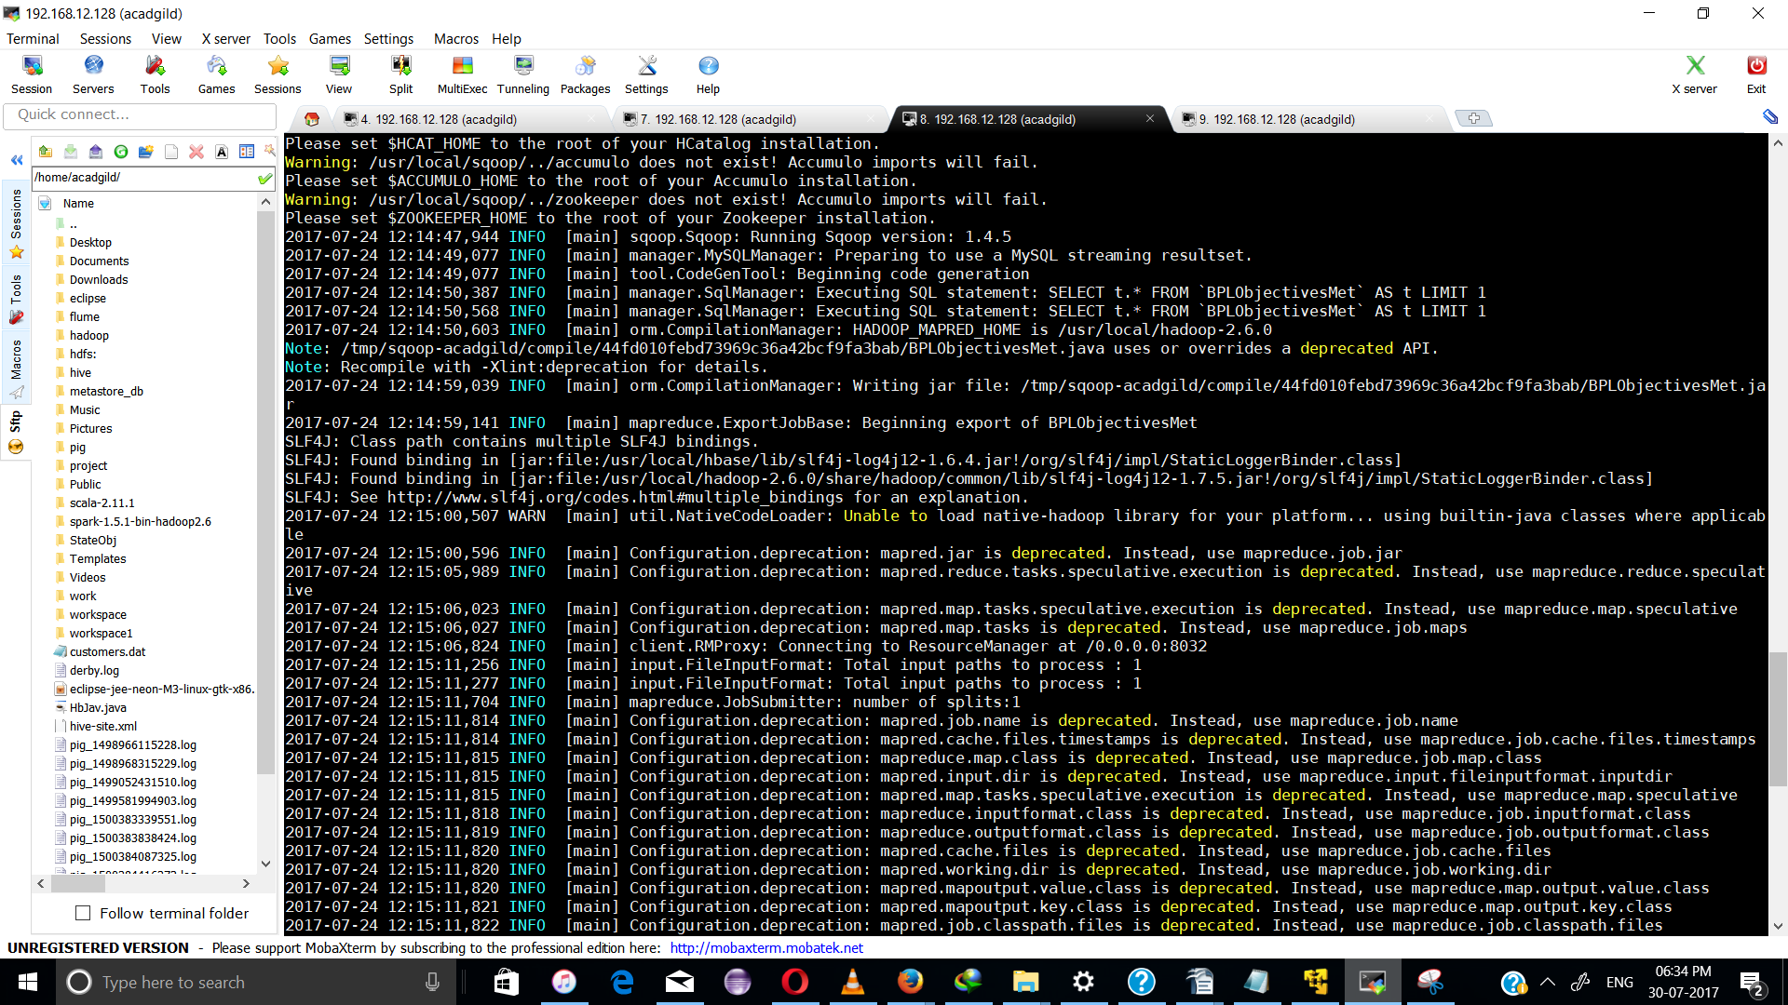

In Terminal2, check for if the Tables have been populated with data:
mysql> select * from BPLObjectivesMet;
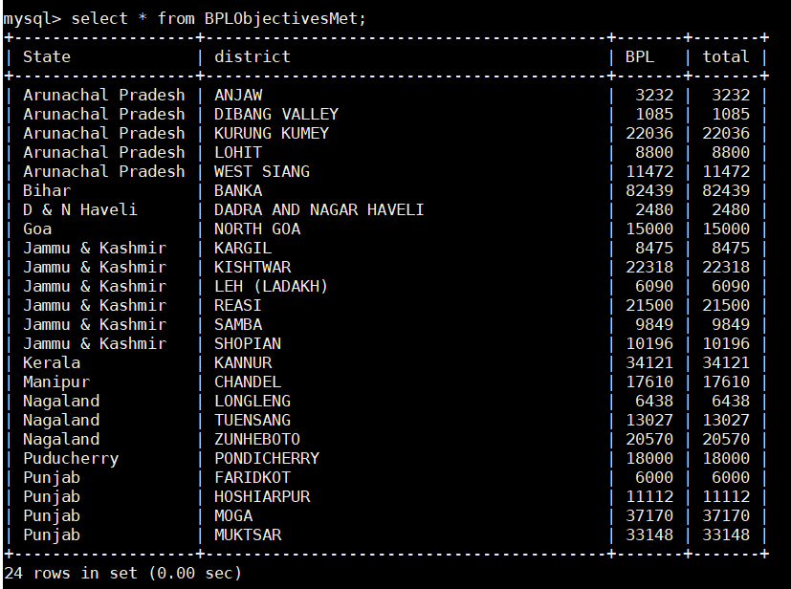

All statements for problem 1 has been sucessfully completed.

Problem 2:

Create a Pig UDF Filter function to calculate districts that have met 80% or more of the BPL card Objectives.
Convert it into a Jar file to implement as a UDF filter in Pig Script

To create the Jar File, Open eclipse, Create a new java Project: CalcPC.java and add external jar Files from
------------------------------------------------------------------------------------------------------------
1) /usr/local/pig
2) /usr/local/hadoop-2.6.0/share/hadoop/common/lib
3) /usr/local/hadoop-2.6.0/share/hadoop/common
4) /usr/local/pig/lib/hadoop1-runtime

CalcPC.java
------------
import java.io.IOException;
import org.apache.pig.FilterFunc;
import org.apache.pig.data.Tuple;

public class CalcPc extends FilterFunc {
public Boolean exec (Tuple input) throws IOException
{
try
{
int value1 = Integer.parseInt((String) input.get(0));
int value2 = Integer.parseInt((String) input.get(1));

if (value1 == 0 || value2 == 0 )
{
System.out.println("zero values");
System.exit(1);
}
return ((value1/value2)>=0.8);
}
catch (Exception e)
{
System.out.println("something wrong"+e.getMessage());
}
return null;
}

Export the java class to state1.jar

state.pig
----------
REGISTER /home/acadgild/state1.jar;
REGISTER /home/acadgild/flume/piggybank-0.15.0.jar;

DEFINE XPath org.apache.pig.piggybank.evaluation.xml.XPath();

Data = LOAD '/home/acadgild/flume/StatewiseDistrictwisePhysicalProgress.xml' using org.apache.pig.piggybank.storage.XMLLoader('row') as (x:chararray);

StateDet = FOREACH Data GENERATE XPath(x, 'row/State_Name') AS statename, XPath(x, 'row/District_Name') AS disname,XPath(x, 'row/Project_Objectives_IHHL_BPL') AS BPL,XPath(x, 'row/Project_Objectives_IHHL_TOTAL') AS total ;
FilteredData = FILTER StateDet BY project.CalcPc(BPL,total);
STORE FilteredData INTO 'hdfs://localhost:9000/flume_import_out2' USING PigStorage(',');

SnapShot:
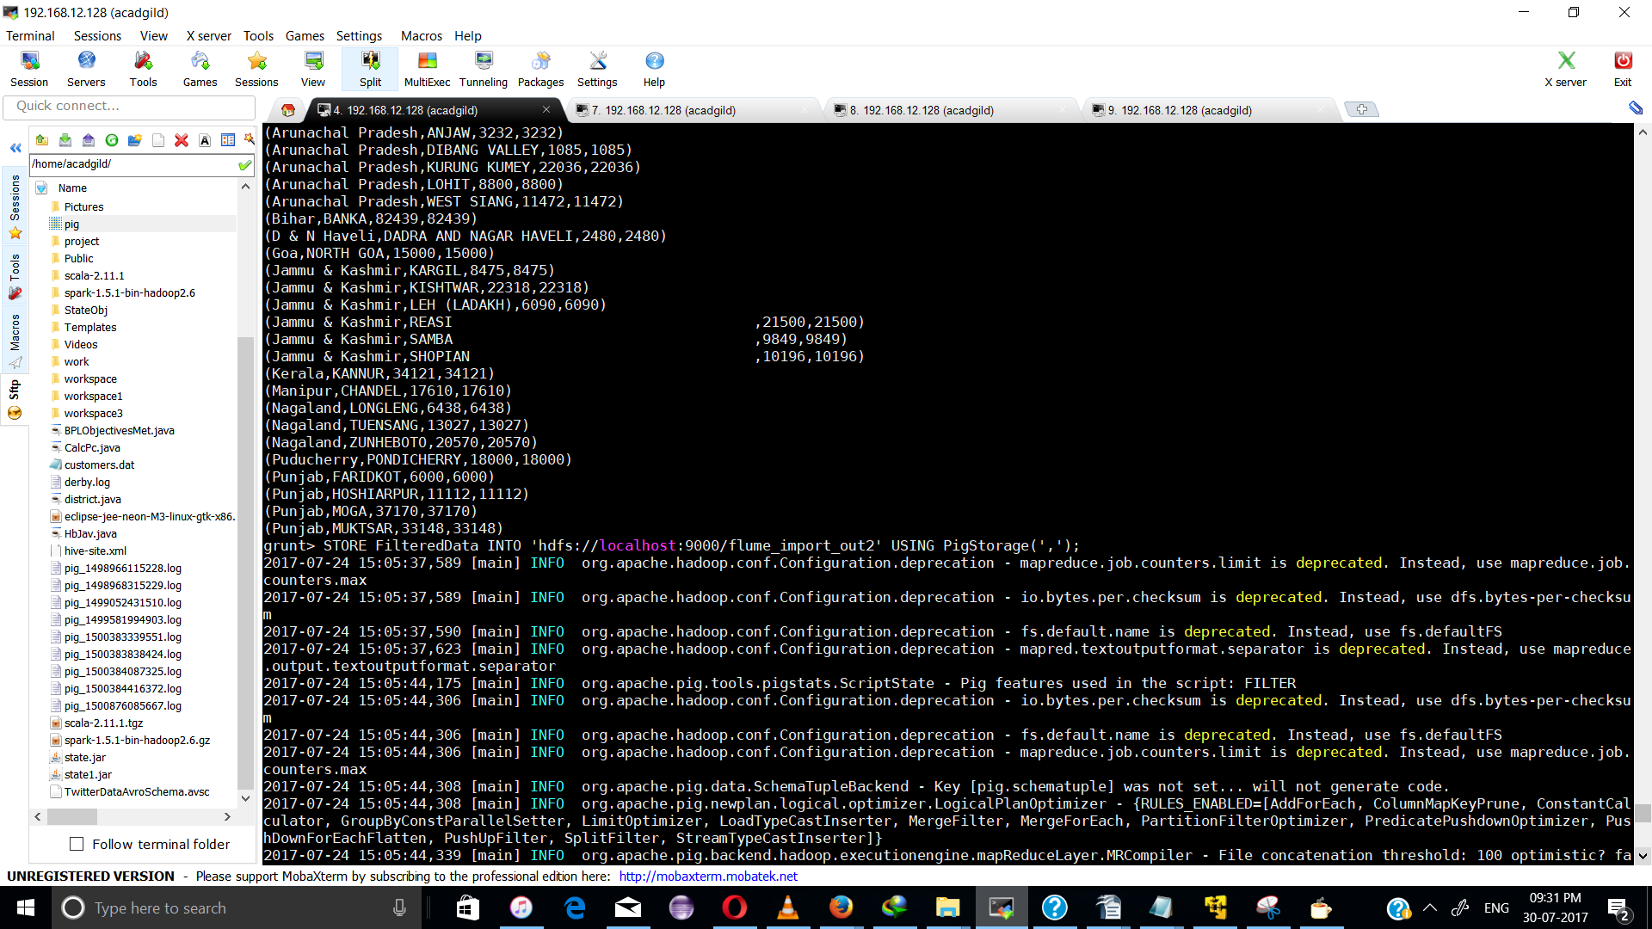
File Present in the HDFS path hdfs://localhost:9000/flume_import_out2
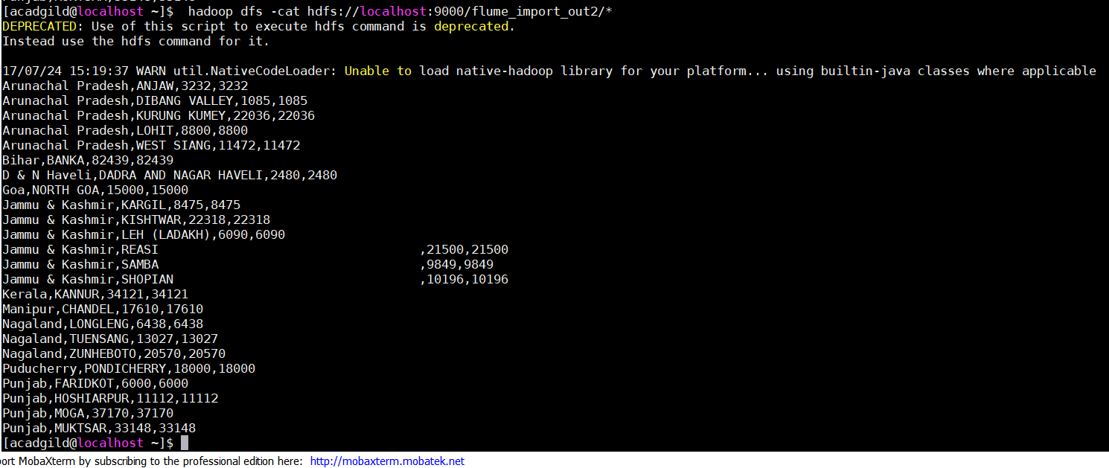

Creating table for Probelm2

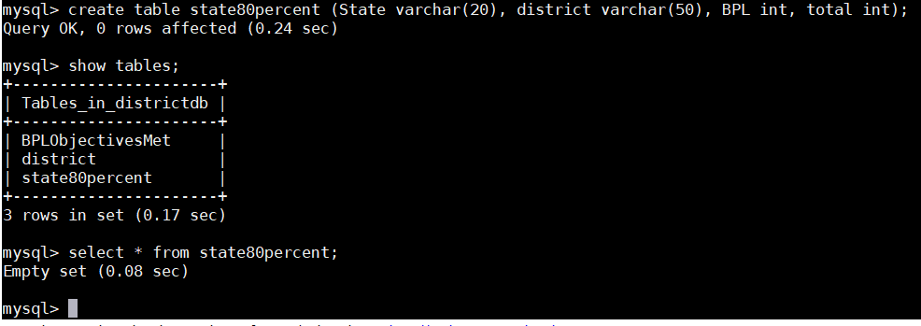

In terminal1, run the sqoop export command to transfer output from hdfs to MySQL
---------------------------------------------------------------------------------

sqoop export --connect jdbc:mysql://localhost:3306/districtdb --table state80percent -m 1 --export-dir /flume_import_out2/

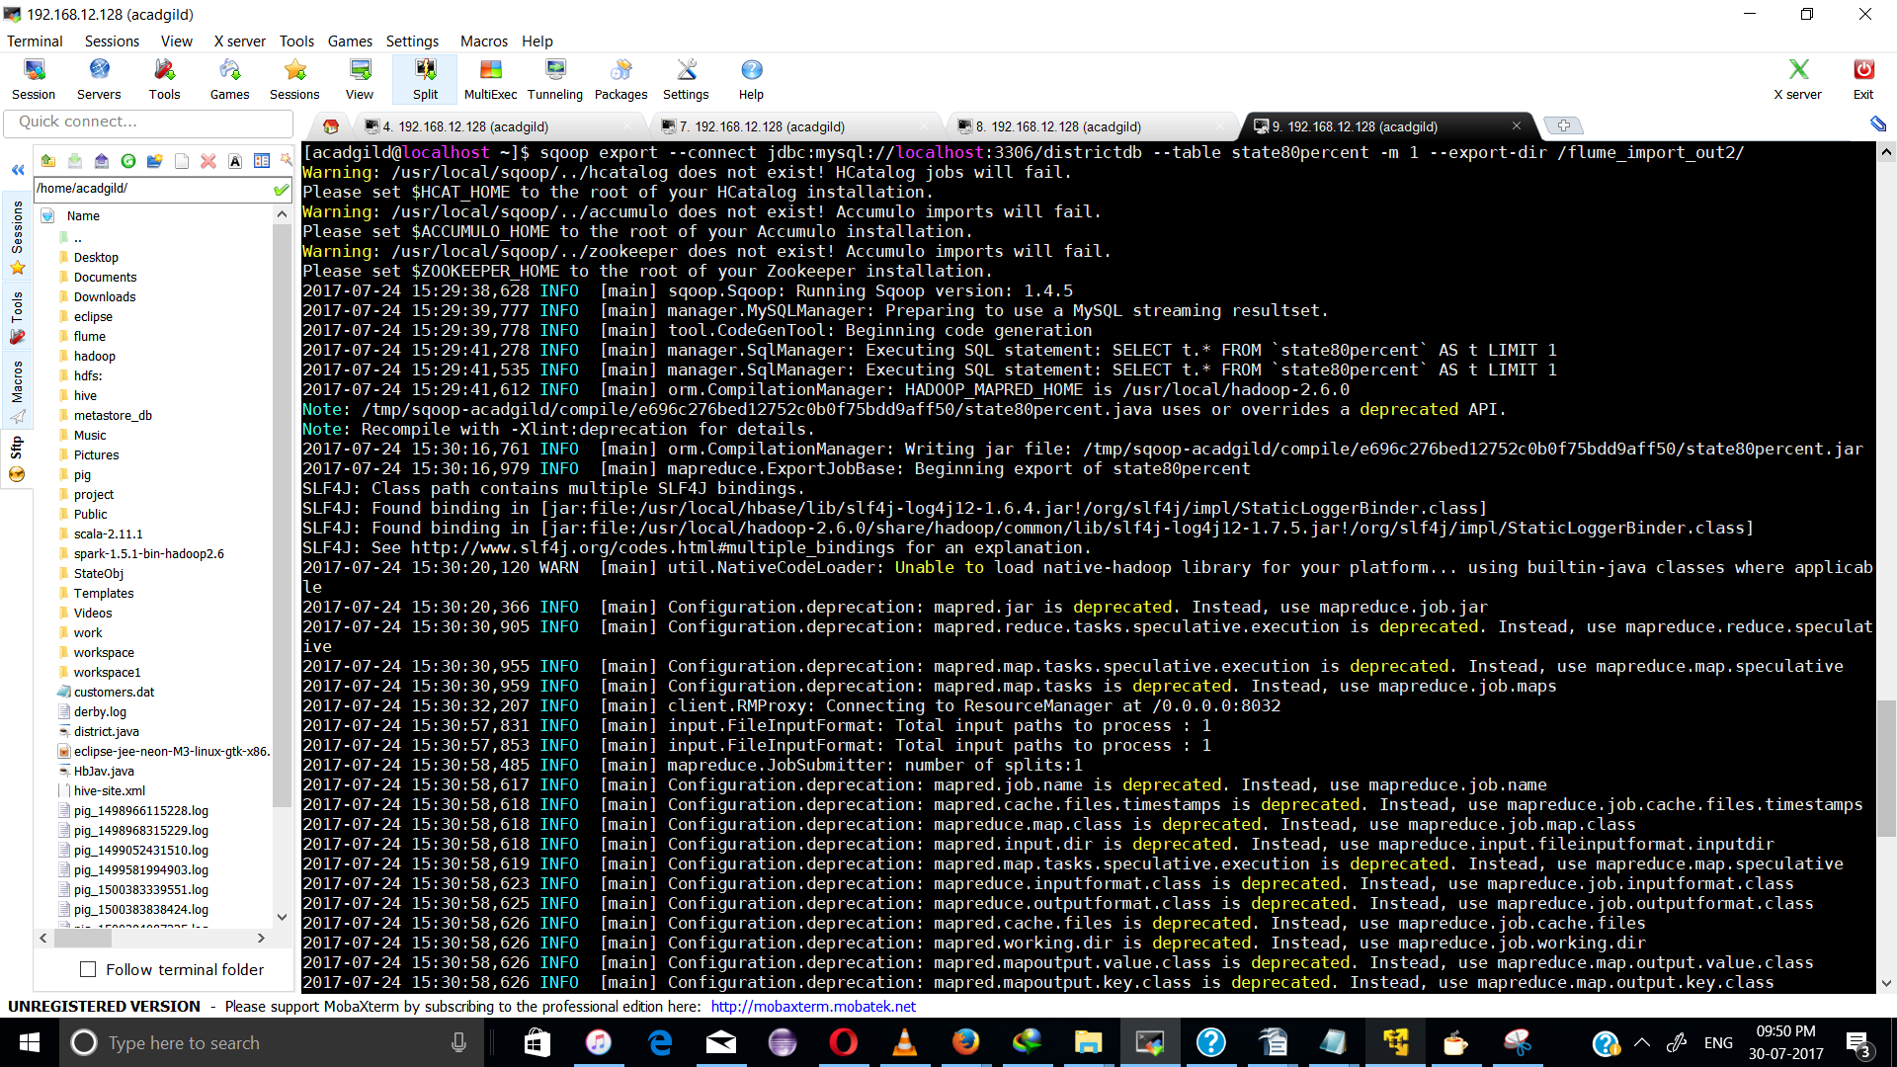

In terminal2, check if the table has been populated with data
mysql> select * from state80percent;

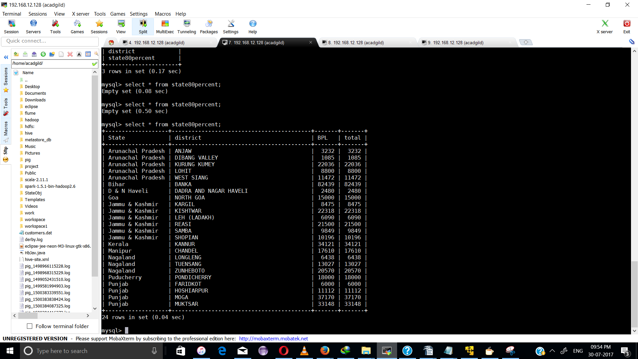

the problem 2 statement has been comleted

