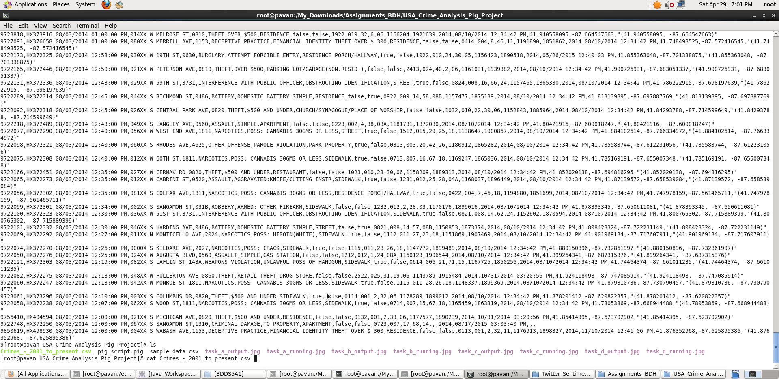
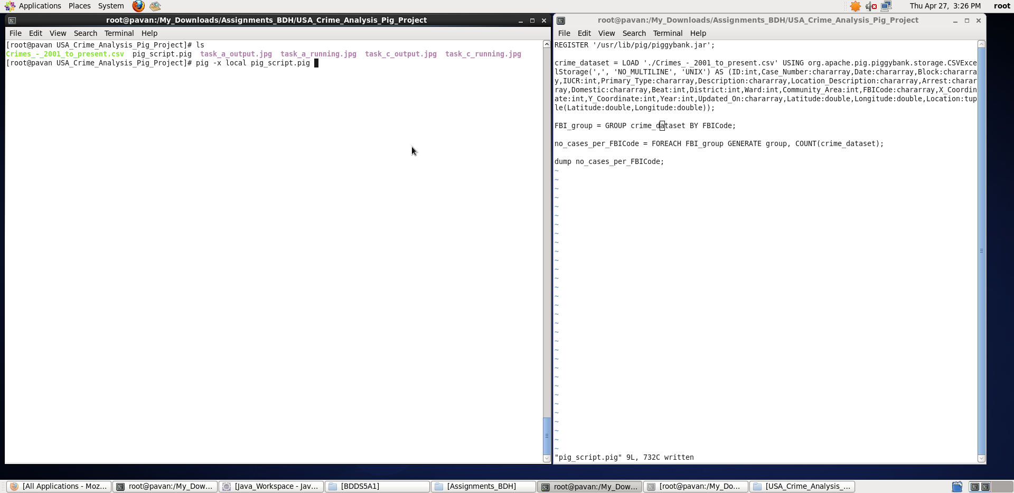
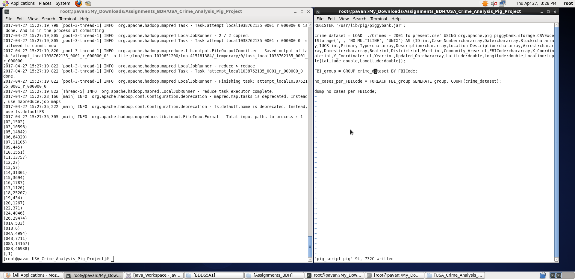
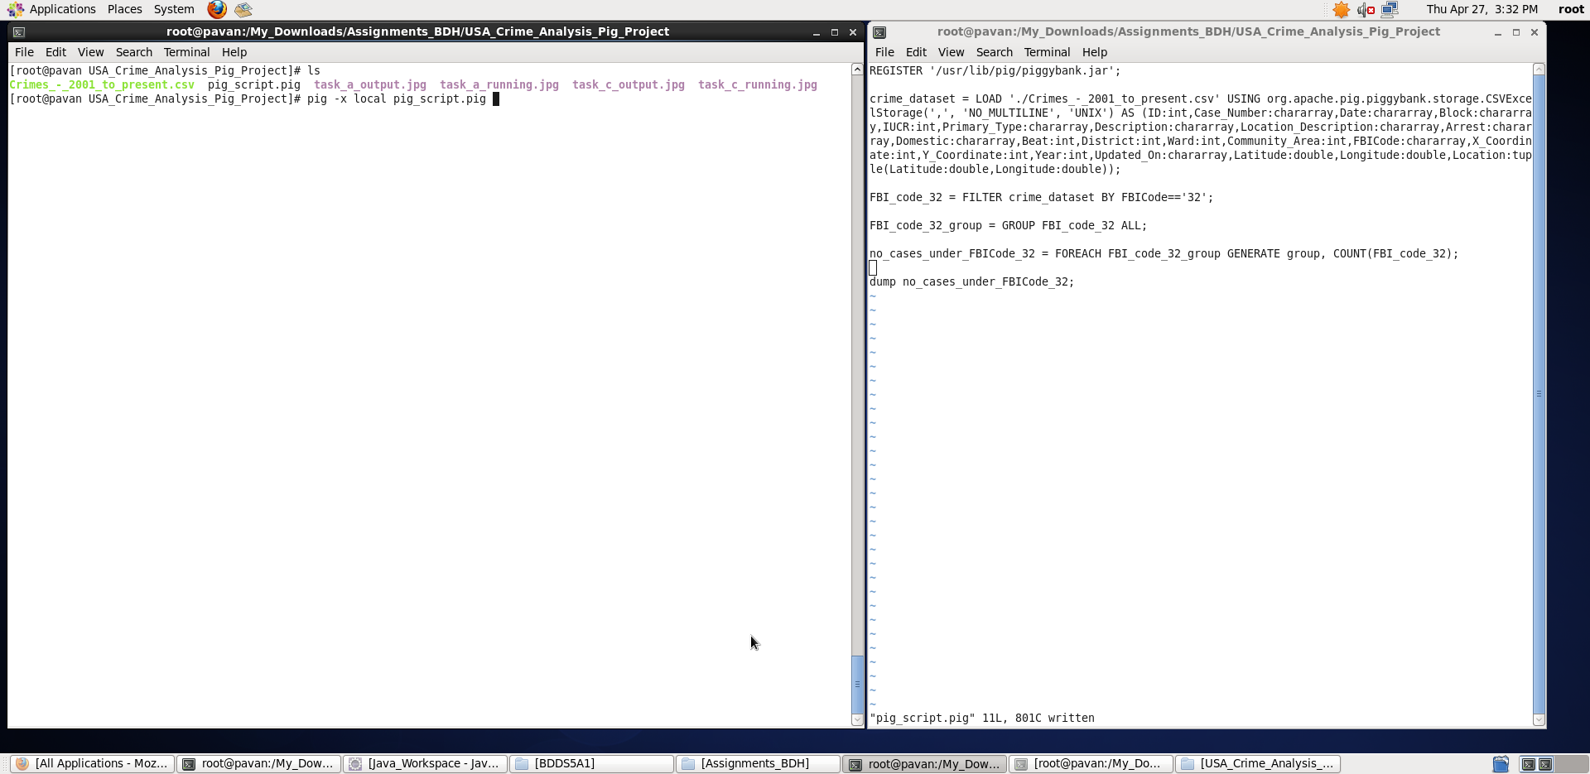
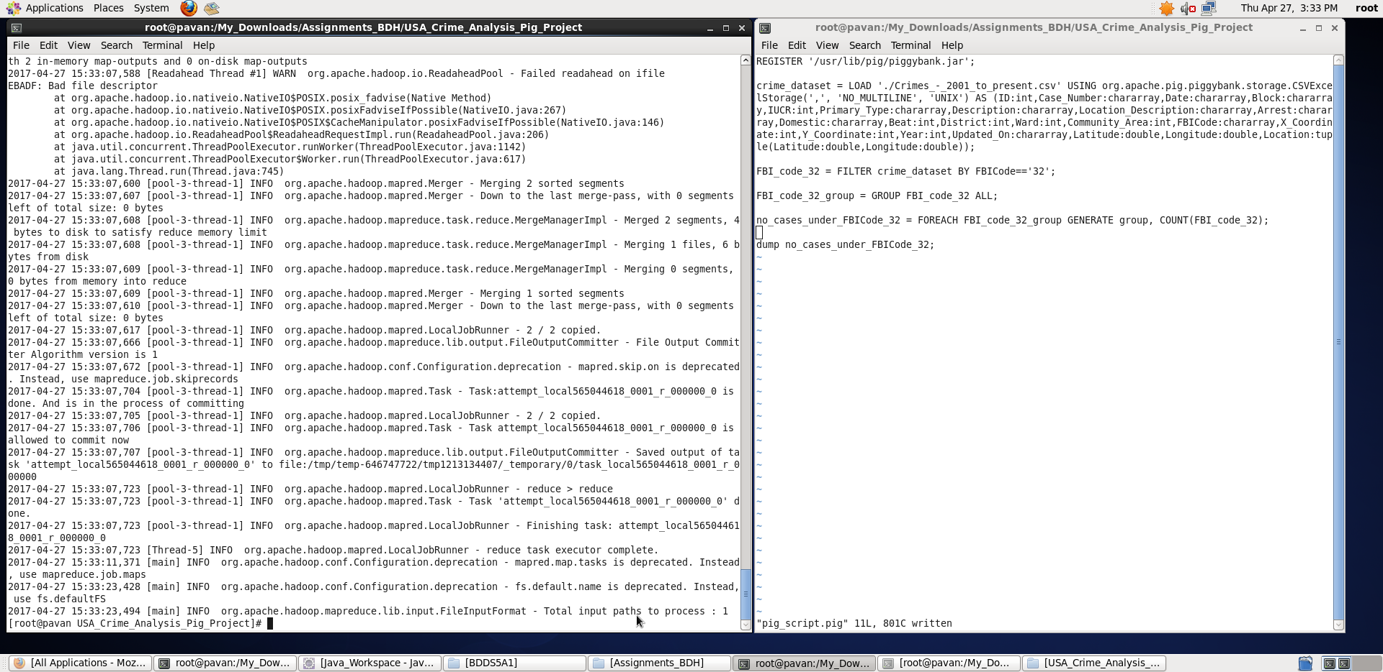
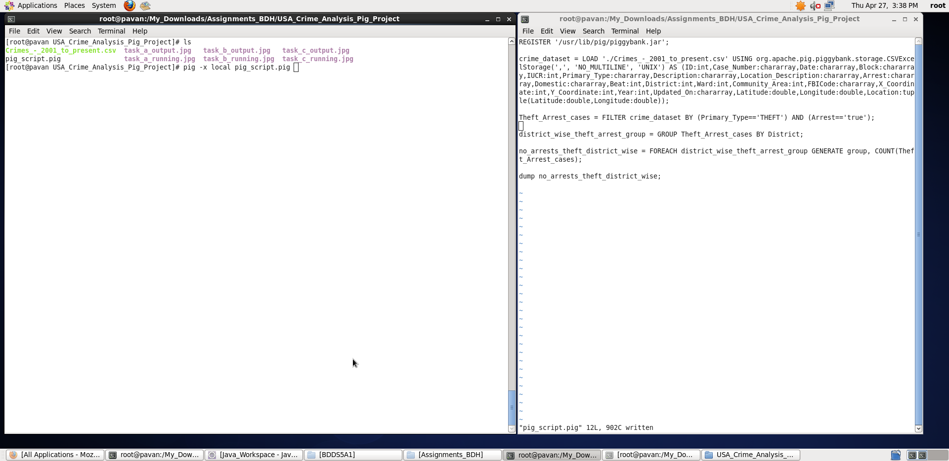
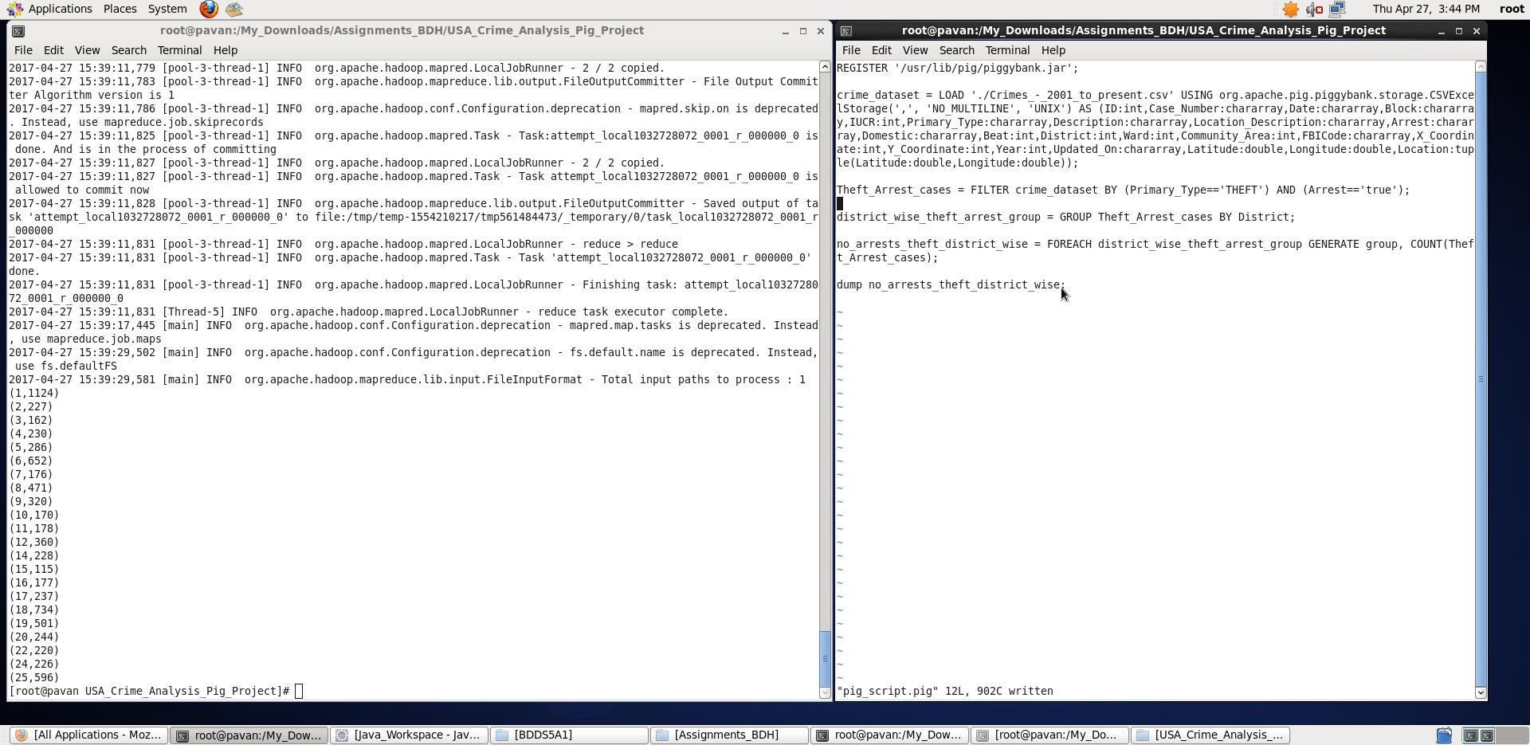
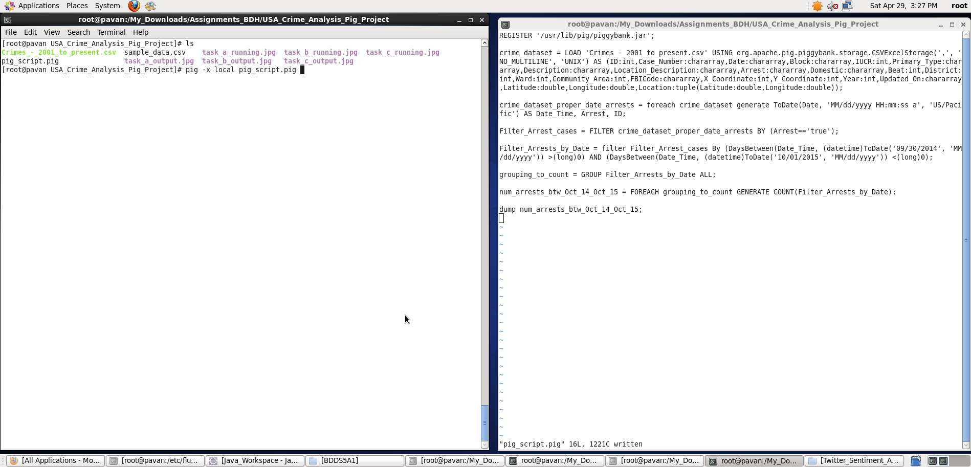
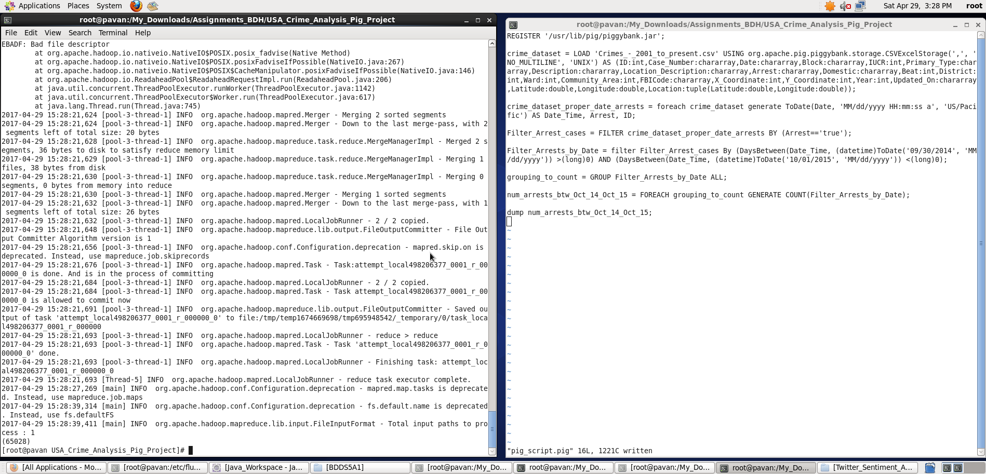
Big Data Hadoop Training

Project: USA Crime Analysis Solution

Dataset Description:
ID,Case Number,Date,Block,IUCR,Primary Type,Description,Location Description,Arrest,Domestic,Beat,District,Ward,Community Area,FBICode,X Coordinate,Y Coordinate,Year,Updated On,Latitude,Longitude,Location

This dataset contains attributes related to crimes taking place in various areas like type of crime, FBI code related to that criminal case, arrest frequency, location of crime etc.
It is a .csv file.

Input Dataset stored in '/home/acadgild/project/crime.csv' using mobaxterm

Loadig data into table from CSV file
- Registering Piggybank.jar file to access CSV file
REGISTER '/home/acadgild/project/piggybank-0.15.0.jar';

- Loading data into relation 'uscrime' from crime.csv file from local using CSVExcelStorage()
uscrime = LOAD 'crime.csv' USING org.apache.pig.piggybank.storage.CSVExcelStorage()
AS (ID: int, CaseNumber: chararray ,Date: chararray, Block: chararray,IUCR: chararray,PrimaryType: chararray,Description: chararray, LocationDescription: chararray,
Arrest: chararray,Domestic: chararray,Beat: int,District: chararray,Ward: chararray,CommunityArea: chararray,FBICode: chararray,
XCoordinate: chararray, YCoordinate: chararray,Year: chararray,UpdatedOn: chararray,
Latitude: chararray,Longitude: chararray,Location: chararray );

- The Above relations description can be seen with the help of DESCRIBE command
  - grunt> DESCRIBE uscrime;
  - uscrime: {ID: int,Case_Number: chararray,Date: chararray,Block: chararray,IUCR: int,Primary_Type: chararray,Description: chararray,Location_Description: chararray,Arrest: chararray,Domestic: chararray,Beat: int,District: int,Ward: int,Community_Area: int,FBICode: chararray,X_Coordinate: int,Y_Coordinate: int,Year: int,Updated_On: chararray,Latitude: double,Longitude: double,Location: (Latitude: double,Longitude: double)}
  - grunt>

(a) Write a pig program to calculate the number of cases investigated under each FBI code

Commands:

FBI_group = GROUP uscrime BY FBICode;

no_cases_per_FBICode = FOREACH FBI_group GENERATE group, COUNT(uscrime);

dump no_cases_per_FBICode;

Explanation :
- Loaded data from crimes.csv into “uscrime” relation. Here ‘,’ is the delimiter and schema is provided as mentioned in the question
- Then, all records are grouped on basis of FBICode.
- For each FBICode (group-key) , we calculated the values – number of cases investigated under that particular FBICode using COUNT function.
- Outputting only “FBICode and number of cases investigated under that FBICode” as per Question using dump command.

Screenshots

Output displayed: <FBICode> <number_of_cases>
Note : We can store the output if required in a file using “store” command.
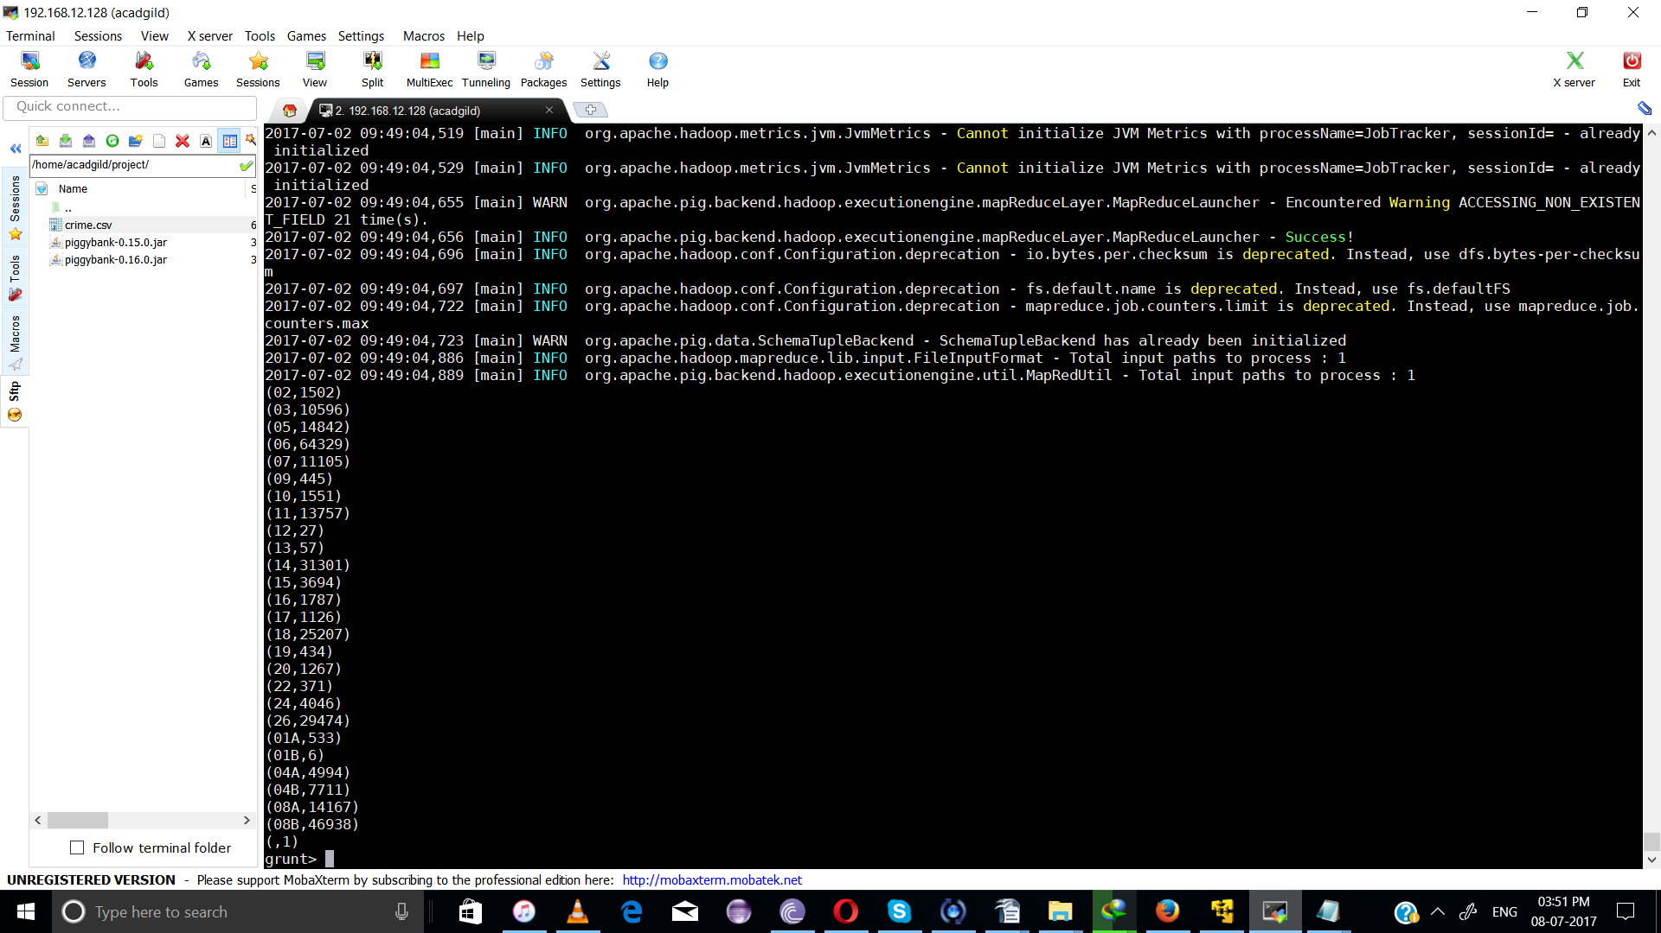

P.S: There is one invalid (last) entry (only ID = 9 it has) in the dataset with no FBICode – the last ( ,1) corresponds to that which can be neglected .
b) Write a pig program to calculate the number of cases investigated under FBI code 32.

Pig Latin Script:

FBI_code_32 = FILTER uscrime BY FBICode=='32';

FBI_code_32_group = GROUP FBI_code_32 ALL;

no_cases_under_FBICode_32 = FOREACH FBI_code_32_group GENERATE group, COUNT(FBI_code_32);

dump no_cases_under_FBICode_32;

Explanation :
- Loaded data from crime.csv into “uscrime” relation. Here ‘,’ is the delimiter and schema is provided as mentioned in the question
- Then, all records are filtered on the basis of expression FBICode==’32’.
- Now, for counting the number of cases investigated under FBICode 32, we group all the above filtered records and then using COUNT function, we calculate the number of cases investigated under FBICode 32.
- Outputting only “FBICode 32 and the number of cases investigated under FBICode 32” as per Question using dump command.

Screenshots

Output displayed: <FBICode (i.e. 32)> < the number of cases investigated under FBICode 32>
Note: We can store the output if required in a file using “store” command.
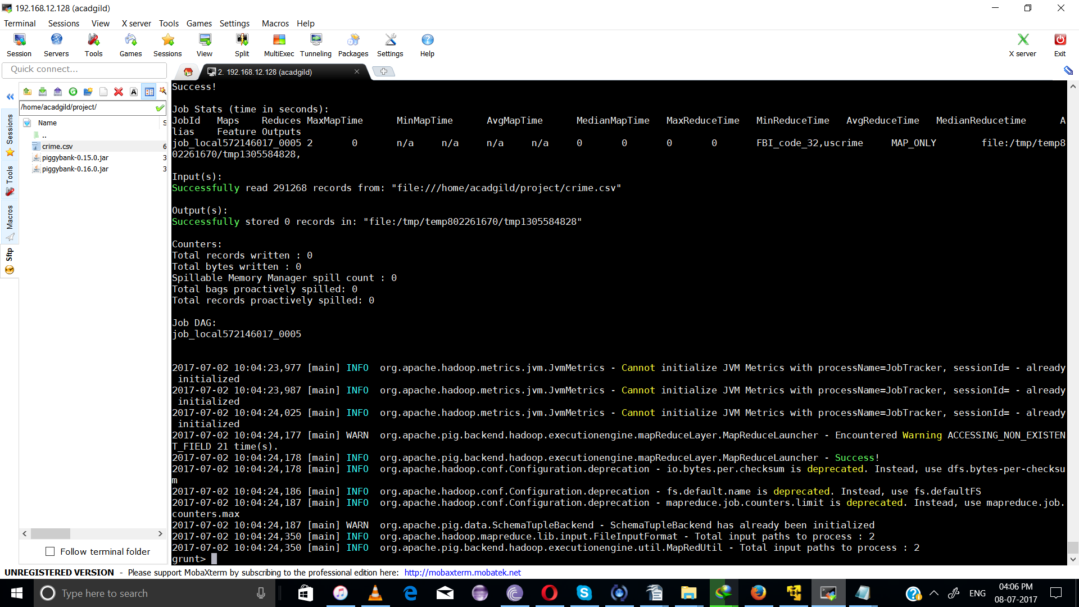

Observe, there is no output indicating there are no cases investigated under FBICode 32.
c) Write a pig program to calculate the number of arrests in theft district wise

Pig Latin Script:

Theft_Arrest_cases = FILTER uscrime BY (PrimaryType=='THEFT') AND (Arrest=='true');
district_wise_theft_arrest_group = GROUP Theft_Arrest_cases BY District;
no_arrests_theft_district_wise = FOREACH district_wise_theft_arrest_group GENERATE group, COUNT(Theft_Arrest_cases);

dump no_arrests_theft_district_wise;

Explanation :
- Loaded data from crime.csv into “uscrime” relation. Here ‘,’ is the delimiter and schema is provided as mentioned in the question
- All the records are filtered based on the conditions – PrimaryType == THEFT and Arrest==’true’. This gives us all theft cases in which arrest has been happened.
- Now, grouping the theft_arrest_cases with respect to District.
- Then, foreach key in the group, we calculated the number of values – theft_arrest_cases that happened corresponding to that District using COUNT function.
- Outputting only “District and corresponding number of theft arrest cases” as per Question using dump command.

Screenshots

Output displayed: <District> <number of theft arrest cases in that particular district>
Note : We can store the output if required in a file using “store” command.

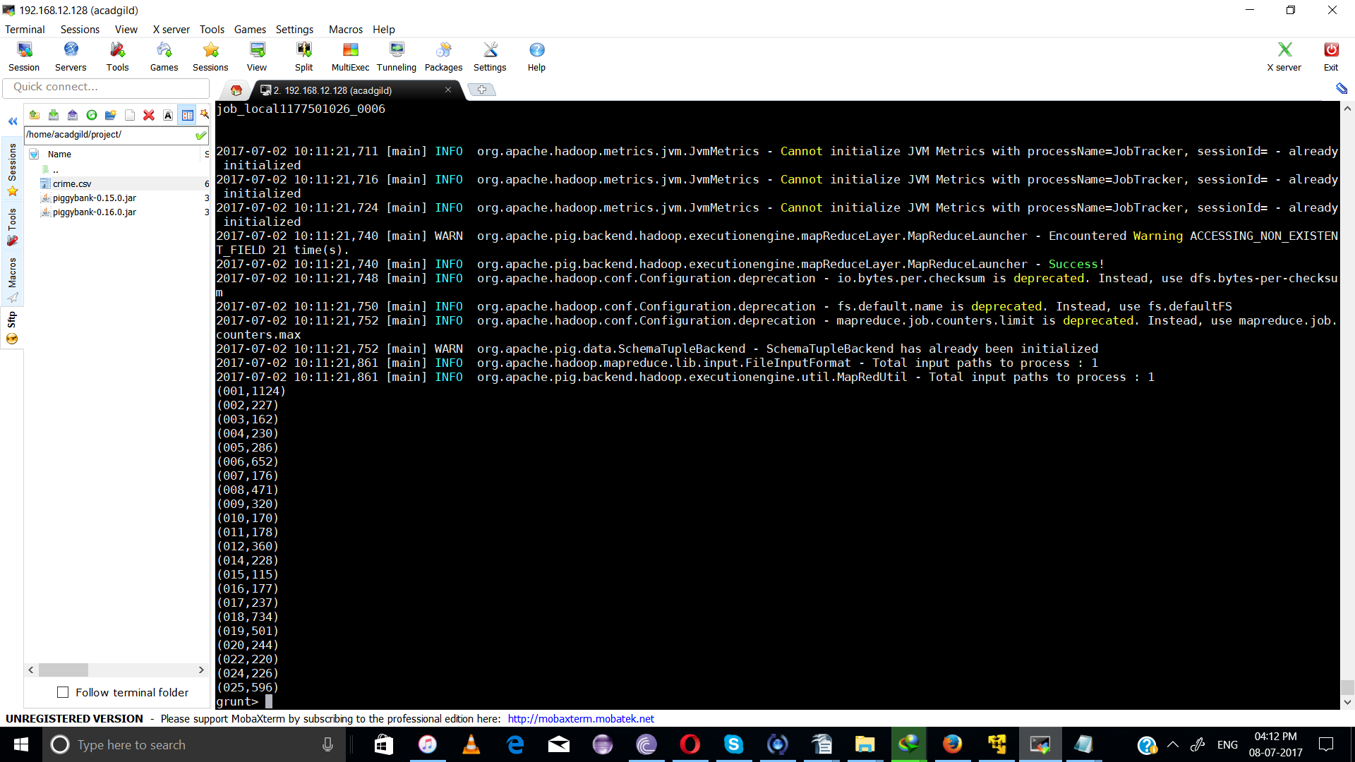

d) Write a pig program to calculate the number of arrests done between october 2014 and october 2015.

Pig Latin Script:

uscrime_proper_date_arrests = foreach uscrime generate ToDate(Date, 'MM/dd/yyyy HH:mm:ss a', 'US/Pacific') AS Date_Time, Arrest, ID;

Filter_Arrest_cases = FILTER uscrime_proper_date_arrests BY (Arrest=='true');
Filter_Arrests_by_Date = filter Filter_Arrest_cases By (DaysBetween(Date_Time, (datetime)ToDate('09/30/2014', 'MM/dd/yyyy')) >(long)0) AND (DaysBetween(Date_Time, (datetime)ToDate('10/01/2015', 'MM/dd/yyyy')) <(long)0);
grouping_to_count = GROUP Filter_Arrests_by_Date ALL;
num_arrests_btw_Oct_14_Oct_15 = FOREACH grouping_to_count GENERATE COUNT(Filter_Arrests_by_Date);

dump num_arrests_btw_Oct_14_Oct_15;

Explanation :
- Loaded data from crime.csv into “uscrime” relation. Here ‘,’ is the delimiter and schema is provided as mentioned in the question
- For performing operations on Date, a DateTime object is required. So, with the help of ToDate() function we generated a DateTime object from the input uscrime. Here, since dataset is from USA_Crimes, I have specified timezone to be “US/Pacific” and input date format is ‘MM/dd/yyyy HH:mm:ss a’ observed from dataset.
- Now, we first filtered the records based on Arrest==’true’ condition.
- Then with the help of DaysBetween() function which accepts two date-time objects(dt1 and dt2) and calculates the number of days(positive days if dt1 occurred after dt2 and negative days if dt1 occurred before dt2 ) between the two given date-time objects, I have filtered the arrest cases such that they are done between October 2014 and October 2015 i.e. our input Date should be after '09/30/2014' and before ‘10/01/2015’.
- Now, for counting the number of arrests happened, we group all the above filtered records and then using COUNT function, we calculate the number of arrests done in between October 2014 and October 2015.
- Outputting only the “number of arrest cases” as per Question using dump command.

Screenshots

Output displayed: <num_of_arrests_btw_Oct_214_Oct_2015>
Note : We can store the output if required in a file using “store” command.
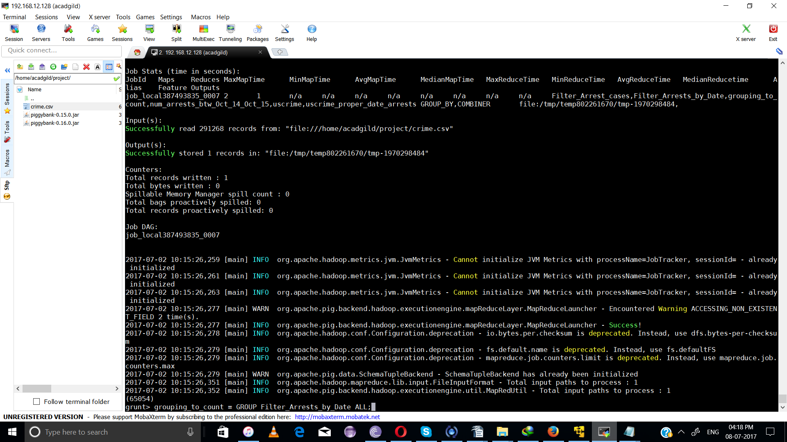

Thus, with the help of Pig programme we have displayed output for all 4 problems

