1st after starting hive created database ‘acadgildemp’.
then used the database as:
hive> use acadgildemp
hive>set hive.cli.print.current.db=true;
Created table ‘employee’ and loaded the data from ‘emp_details.txt’ into this this table.
And calculating the number of employees corresponding to each skill from the table ‘employee’:
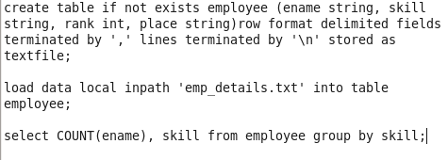
Output:
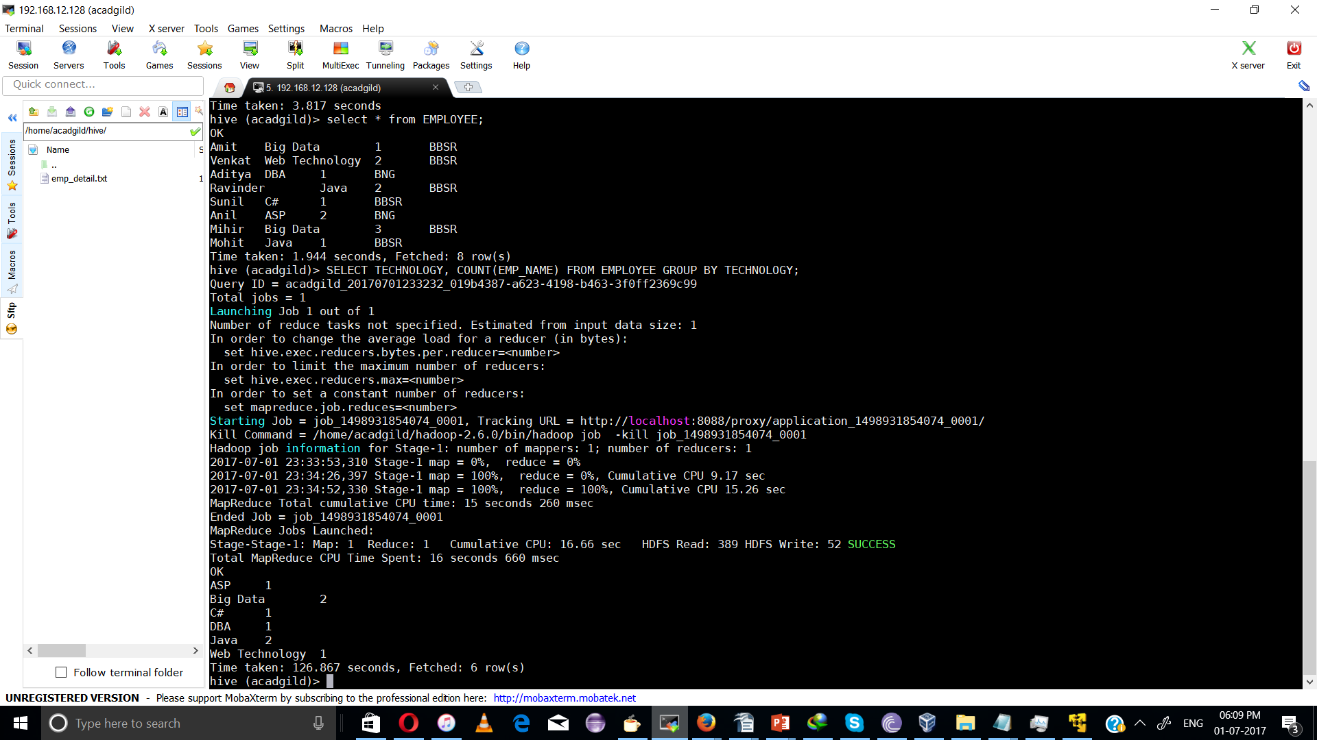
ASP 1
Big Data 2
C# 1
DBA 1
Java 2
Web Technology 1

screen shot:

