Problem Statement

Creating table schema:

hive (acadgild)> create table olympics (
> Athlete String,
> Age int,
> Country String,
> Year int,
> Closing_date String,
> Sport String,
> Gold int,
> Silver int,
> Bronze int,
> Total int
> )
> row format delimited fields terminated by ',';
OK
Time taken: 2.017 seconds

Loadng data:

hive (acadgild)> LOAD DATA LOCAL INPATH 'hadoop/olympix_data.csv' INTO table olympics;
Loading data to table acadgild.olympics
Table acadgild.olympics stats: [numFiles=1, totalSize=518669]
OK
Time taken: 2.846 seconds

1. Write a Hive program to find the number of medals won by each country in swimming.

Command:
select sum(Total), Country, Sport from olympics where Sport like 'Swimming' group by Country,Sport ;

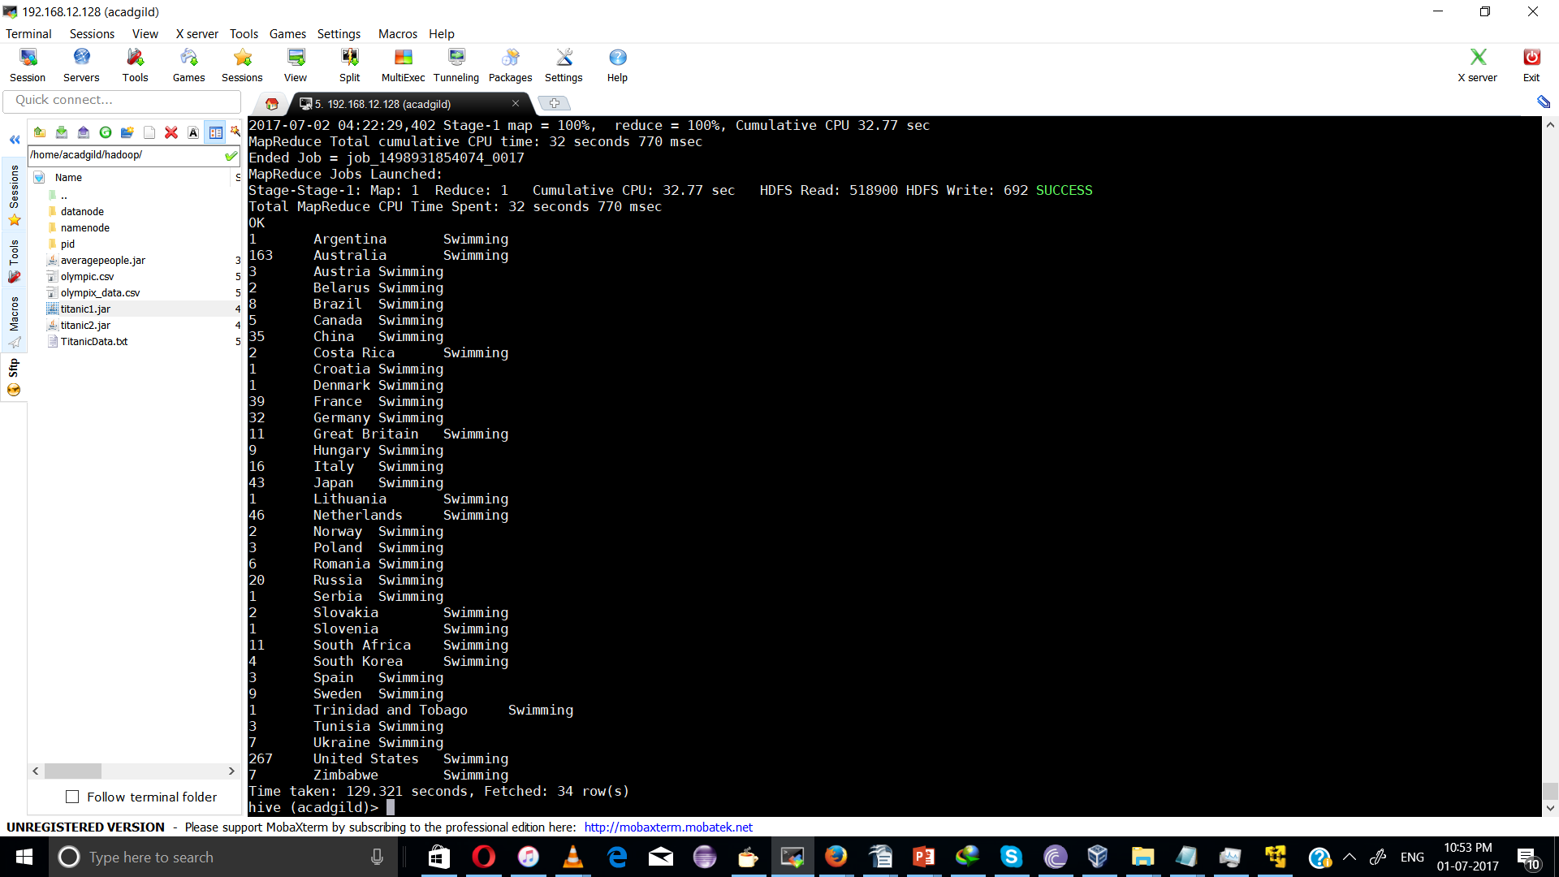
2. Write a Hive program to find the number of medals that India won year wise.

select SUM(Total),Year,Country from olympics where Country ='India' group by Year,Country;

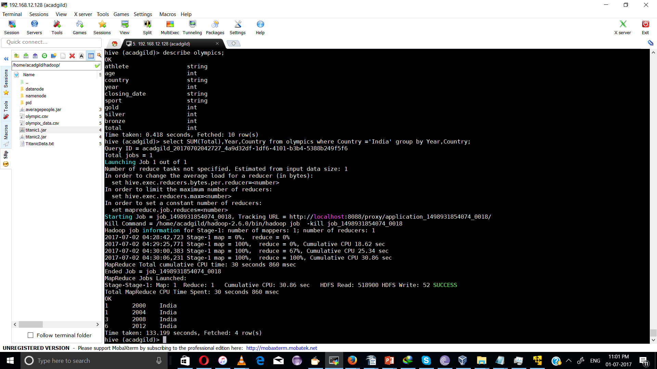

3. Write a Hive Program to find the total number of medals each country won.

select SUM(Total) as sum,Country from olympics group by Country order by sum;

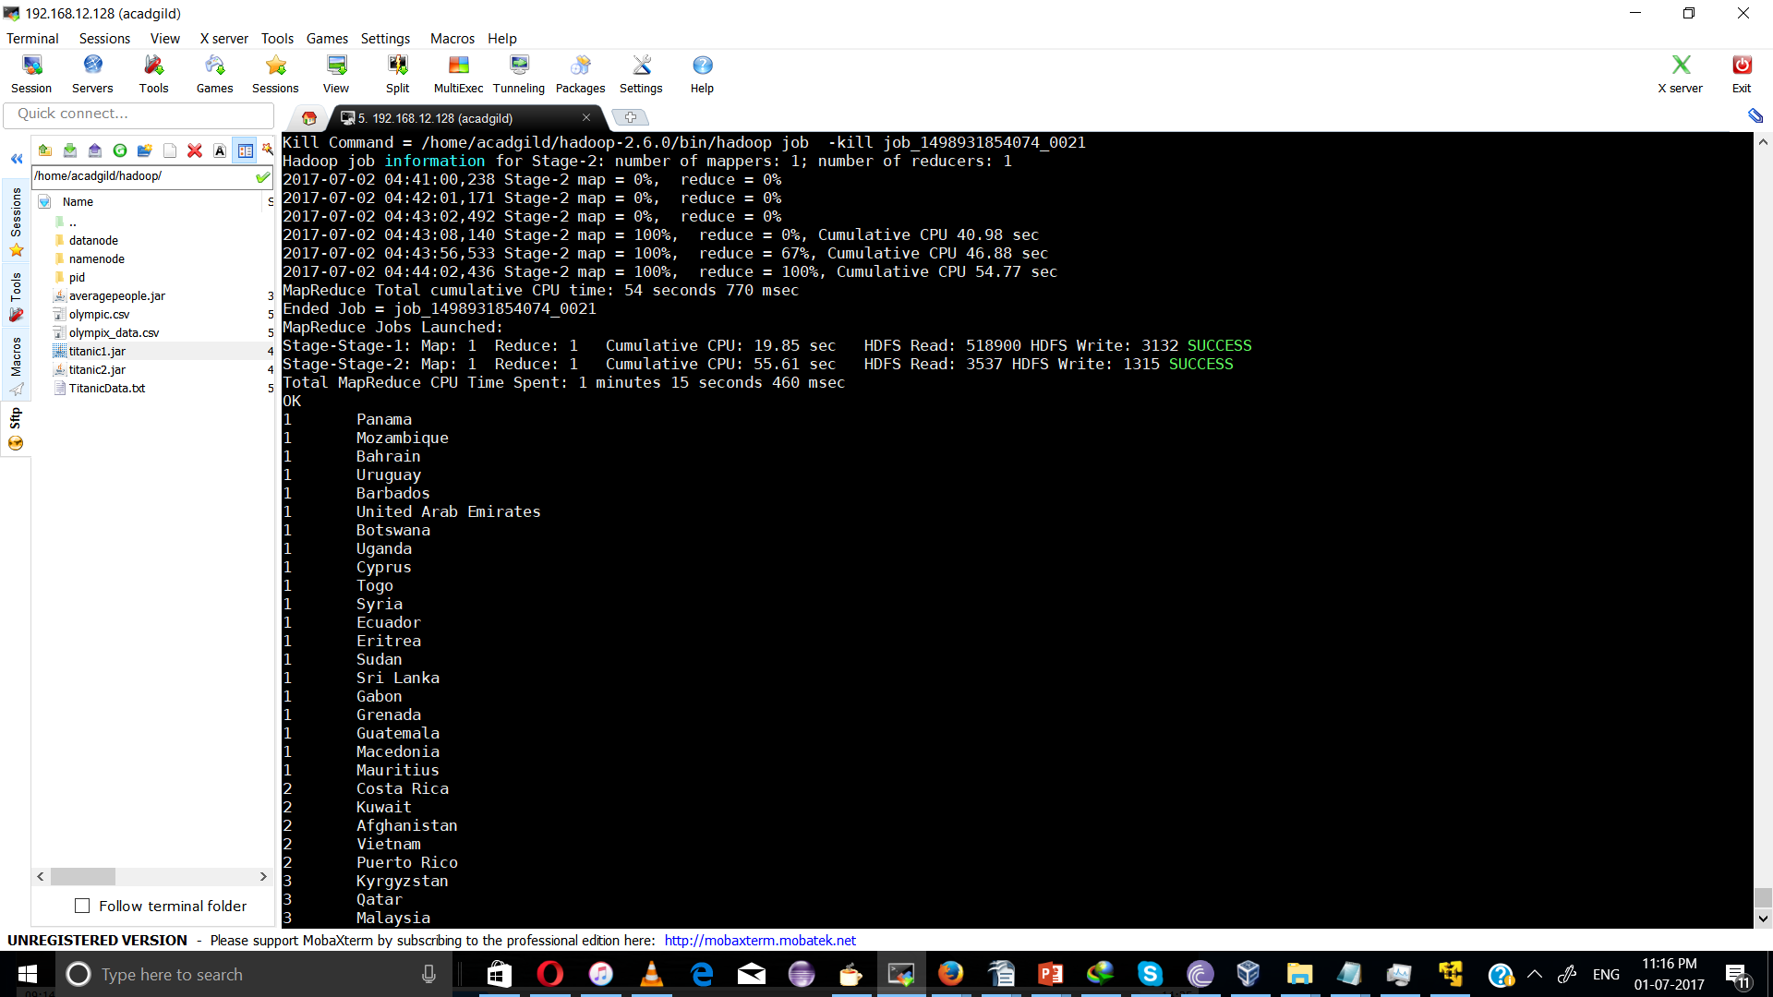

- Write a Hive program to find the number of gold medals each country won.

select sum(Gold) as sum, Country group by Country sort by sum desc;

