Associated Data Files:

https://drive.google.com/file/d/0Bxr27gVaXO5sa0JBamZXdkpYUFk/view?usp=sharing

Problem Statement and solutions:

• Fetch date and temperature from temperature_data where zip code is greater than

300000 and less than 399999.

solution:
hive (custom)> select * from temp_data where zipcode >300000 and zipcode < 399999;
OK
10-03-1990 381920 15
10-01-1991 302918 22
12-02-1990 384902 9
10-03-1991 381920 16
10-01-1990 302918 23
12-02-1991 384902 10
10-03-1993 381920 16
10-01-1994 302918 23
12-02-1991 384902 10
10-03-1991 381920 16
10-01-1990 302918 23
12-02-1991 384902 10
Time taken: 1.487 seconds, Fetched: 12 row(s)

• Calculate maximum temperature corresponding to every year from temperature_data

table.

Solution:

hive> SELECT year(from_unixtime(unix_timestamp(TEMP_DATE,'dd-MM-yyyy'))) AS YEAR, MAX(TEMPERATURE) FROM TEMPERATURE_DATA GROUP BY year(from_unixtime(unix_timestamp(TEMP_DATE,'dd-MM-yyyy')));

OK
otal MapReduce CPU Time Spent: 2 minutes 22 seconds 600 msec
OK
1990 23
1991 22
1993 16
1994 23
Time taken: 1455.126 seconds, Fetched: 4 row(s)

• Calculate maximum temperature from temperature_data table corresponding to those

years which have at least 2 entries in the table.

• Create a view on the top of last query, name it temperature_data_vw.

hive> CREATE VIEW TEMPERATURE_DATA_VW AS SELECT year(from_unixtime(unix_timestamp(TEMP_DATE,'dd-MM-yyyy'))) AS YEAR, MAX(TEMPERATURE) FROM TEMPERATURE_DATA GROUP BY year(from_unixtime(unix_timestamp(TEMP_DATE,'dd-MM-yyyy'))) HAVING COUNT(year(from_unixtime(unix_timestamp(TEMP_DATE,'dd-MM-yyyy')))) >=2;

Select * from TEMPERATURE_DATA_VW

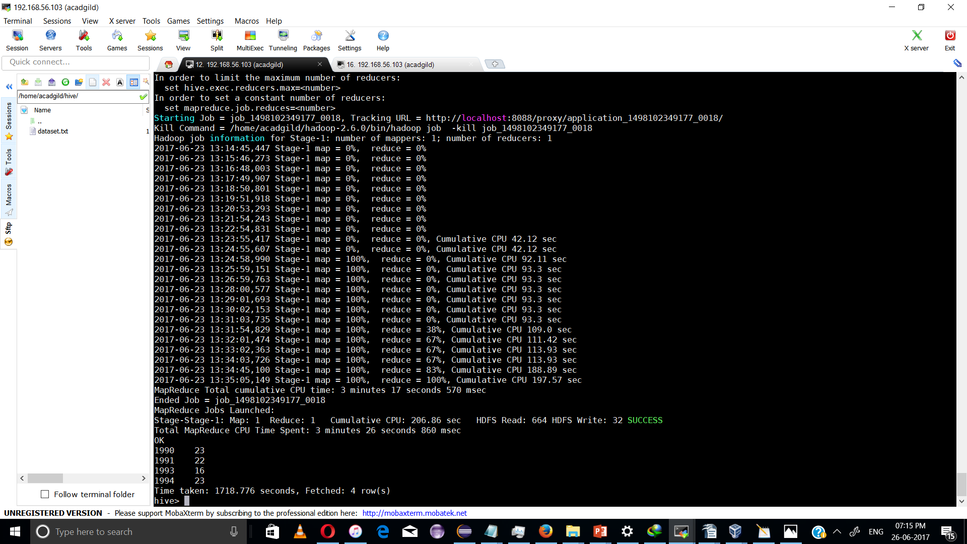

• Export contents from temperature_data_vw to a file in local file system, such that each

file is '|' delimited.

hive> INSERT OVERWRITE LOCAL DIRECTORY '/home/acadgild/hadoop/hive/temp' ROW FORMAT DELIMITED FIELDS TERMINATED BY '|' LINES TERMINATED BY '\n' SELECT * FROM TEMPERATURE_DATA_VW;

Output :::

1990|23
1991|22
1993|16
1994|23

snapshot:

