Problem:

Problem statement 1:

Find the number of ratings given by each user.

Problem statement 2:

Find the number of ratings received by each movie.

Input File:
https://drive.google.com/open?id=0Bxr27gVaXO5sbGdjUWFSRUxUMXM

Program for task 2:

Driver program:
package assignment4;

import org.apache.hadoop.fs.Path;
import org.apache.hadoop.conf.*;
import org.apache.hadoop.mapreduce.Job;
import org.apache.hadoop.mapreduce.lib.input.FileInputFormat;
import org.apache.hadoop.mapreduce.lib.input.TextInputFormat;
import org.apache.hadoop.mapreduce.lib.output.FileOutputFormat;
import org.apache.hadoop.mapreduce.lib.output.TextOutputFormat;
import org.apache.hadoop.io.IntWritable;
import org.apache.hadoop.io.Text;

public class Task2 {
@SuppressWarnings("deprecation")
public static void main(String[] args) throws Exception {
Configuration conf = new Configuration();
Job job = new Job(conf, "assignment4");
job.setJarByClass(Task2.class);

job.setMapOutputKeyClass(Text.class);
job.setMapOutputValueClass(IntWritable.class);

job.setOutputKeyClass(Text.class);
job.setOutputValueClass(IntWritable.class);
job.setMapperClass(Task2Mapper.class); //setting reducer class
job.setReducerClass(Task2Reducer.class);

job.setInputFormatClass(TextInputFormat.class); //text format
job.setOutputFormatClass(TextOutputFormat.class);

FileInputFormat.addInputPath(job, new Path(args[0])); //getting file location
FileOutputFormat.setOutputPath(job,new Path(args[1]));

/*
Path out=new Path(args[1]);
out.getFileSystem(conf).delete(out);
*/

job.waitForCompletion(true);
}
}

Task2Mapper.java:
package assignment4;

import java.io.IOException;

import org.apache.hadoop.io.IntWritable;
import org.apache.hadoop.io.LongWritable;
import org.apache.hadoop.io.Text;
import org.apache.hadoop.mapreduce.*;

public class Task2Mapper extends Mapper<LongWritable, Text, Text, IntWritable> {
Text outKey = new Text();
IntWritable outValue = new IntWritable();

public void map(LongWritable key, Text value, Context context)
throws IOException, InterruptedException {
String[] lineArray = value.toString().split(" "); //splitting file into key,value
outKey.set(lineArray[0]);
outValue.set(1);
context.write(outKey, outValue); //output to reducer
}
}

Task2Reducer:
package assignment4;

import java.io.IOException;

import org.apache.hadoop.io.IntWritable;
import org.apache.hadoop.io.Text;
import org.apache.hadoop.mapreduce.Reducer;
import org.apache.hadoop.mapreduce.Reducer.Context;

public class Task2Reducer extends Reducer<Text, IntWritable, Text, IntWritable>
{
IntWritable outValue = new IntWritable();

public void reduce(Text key, Iterable<IntWritable> values,Context context) throws IOException, InterruptedException
{
int sum = 0;
for (IntWritable value : values) { //calculating total units for sold
sum += value.get();
}

outValue.set(sum);
context.write(key, outValue); //sending value to output file
}
}

Result:
command:
hadoop jar /home/acadgild/hadoop/assignment4_3.jar assignment4.Task2 /user/acadgild/hadoop/datase.txt /user/acadgild/hadoop/Assignment4_3

snapshot:
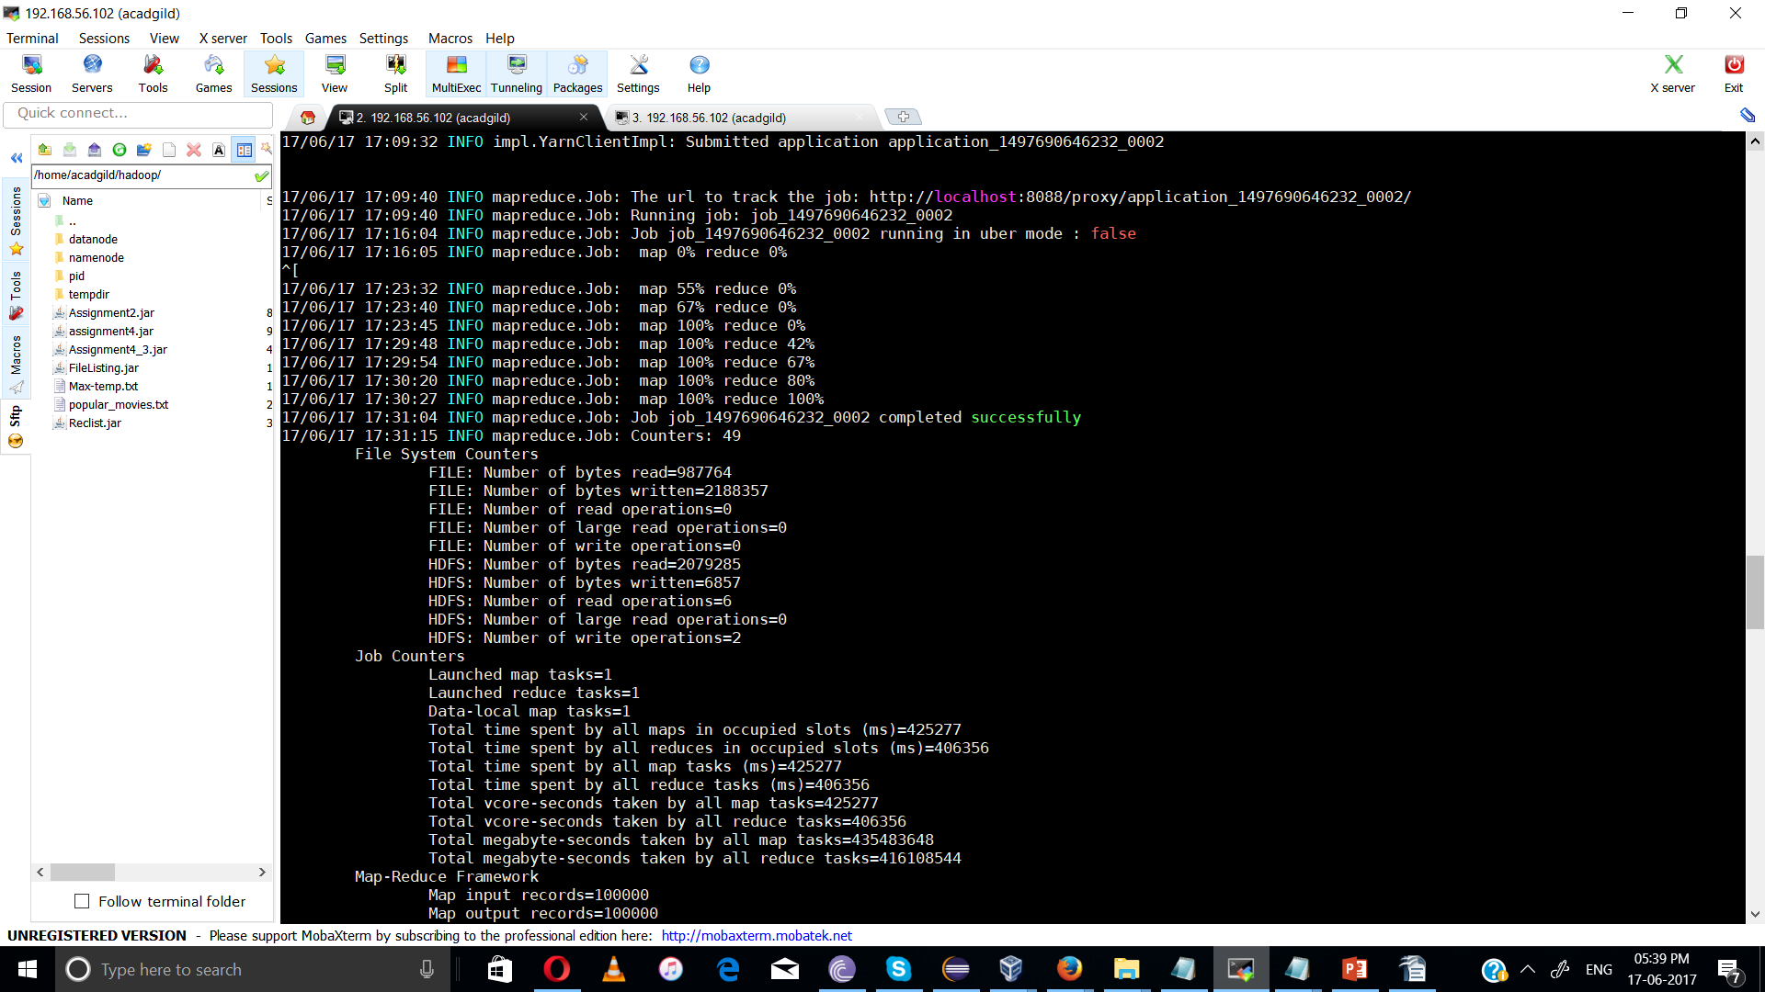

Result:

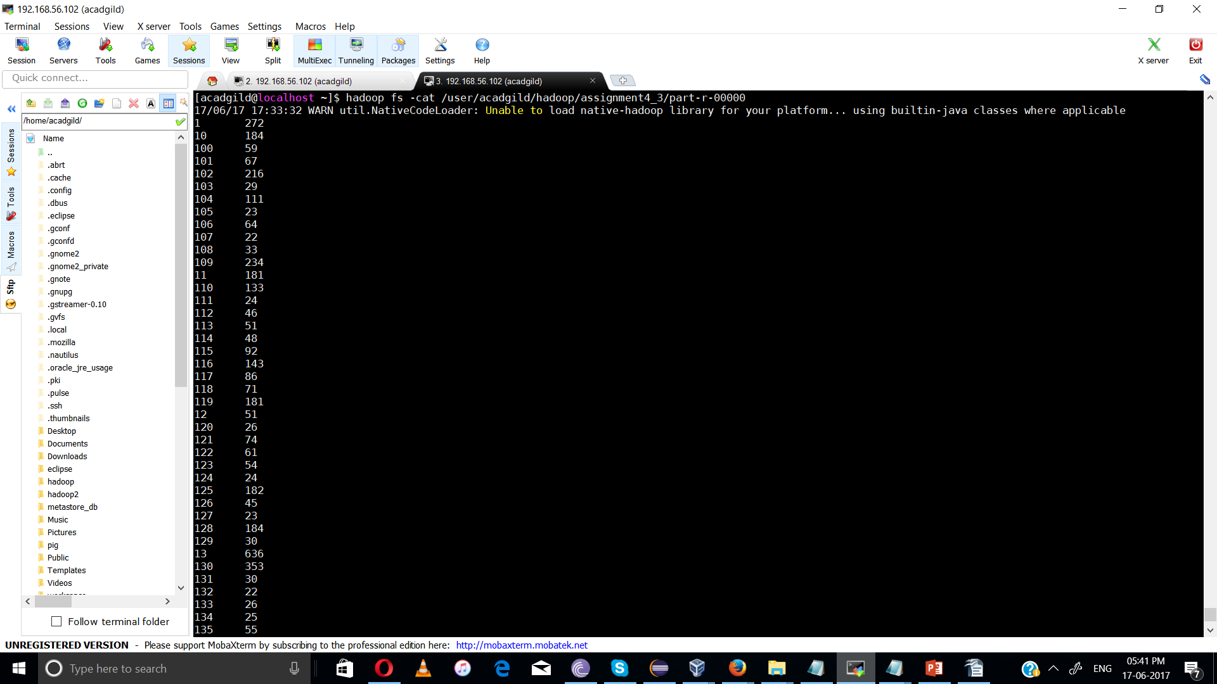

program for task 2:
package assignment4;

import org.apache.hadoop.fs.Path;
import org.apache.hadoop.conf.*;
import org.apache.hadoop.mapreduce.Job;
import org.apache.hadoop.mapreduce.lib.input.FileInputFormat;
import org.apache.hadoop.mapreduce.lib.input.TextInputFormat;
import org.apache.hadoop.mapreduce.lib.output.FileOutputFormat;
import org.apache.hadoop.mapreduce.lib.output.TextOutputFormat;
import org.apache.hadoop.io.IntWritable;
import org.apache.hadoop.io.Text;

public class Task2 {
@SuppressWarnings("deprecation")
public static void main(String[] args) throws Exception {
Configuration conf = new Configuration();
Job job = new Job(conf, "assignment4");
job.setJarByClass(Task2.class);

job.setMapOutputKeyClass(Text.class);
job.setMapOutputValueClass(IntWritable.class);

job.setOutputKeyClass(Text.class);
job.setOutputValueClass(IntWritable.class);
job.setMapperClass(Task2Mapper.class); //setting reducer class
job.setReducerClass(Task2Reducer.class);

job.setInputFormatClass(TextInputFormat.class); //text format
job.setOutputFormatClass(TextOutputFormat.class);

FileInputFormat.addInputPath(job, new Path(args[0])); //getting file location
FileOutputFormat.setOutputPath(job,new Path(args[1]));

/*
Path out=new Path(args[1]);
out.getFileSystem(conf).delete(out);
*/

job.waitForCompletion(true);
}
}

Mapper program Task2Mapper.java
package assignment4;

import java.io.IOException;

import org.apache.hadoop.io.IntWritable;
import org.apache.hadoop.io.LongWritable;
import org.apache.hadoop.io.Text;
import org.apache.hadoop.mapreduce.*;

public class Task2Mapper extends Mapper<LongWritable, Text, Text, IntWritable> {
Text movie = new Text();
IntWritable rating = new IntWritable();

public void map(LongWritable key, Text value, Context context)
throws IOException, InterruptedException {
String[] lineArray = value.toString().split(" ");
movie.set(lineArray[1]); //key
rating.set(Integer.parseInt(lineArray[2])); //value
context.write(movie, rating);// input to reducer
}
}

Task2Reducer:
package assignment4;

import java.io.IOException;

import org.apache.hadoop.io.IntWritable;
import org.apache.hadoop.io.Text;
import org.apache.hadoop.mapreduce.Reducer;
import org.apache.hadoop.mapreduce.Reducer.Context;

public class Task2Reducer extends Reducer<Text, IntWritable, Text, IntWritable>
{
IntWritable outValue = new IntWritable();

public void reduce(Text key, Iterable<IntWritable> values,Context context) throws IOException, InterruptedException
{
int sum = 0;
for (IntWritable value : values) { //calculating total units for sold
sum += value.get();
}

outValue.set(sum);
context.write(key, outValue); //sending value to output file
}
}

Result:
command:hadoop jar Assignment4_3.jar assignment4_2.Task2 /user/acadgild/hadoop/data /user/acadgild/hadoop/assignment4_4

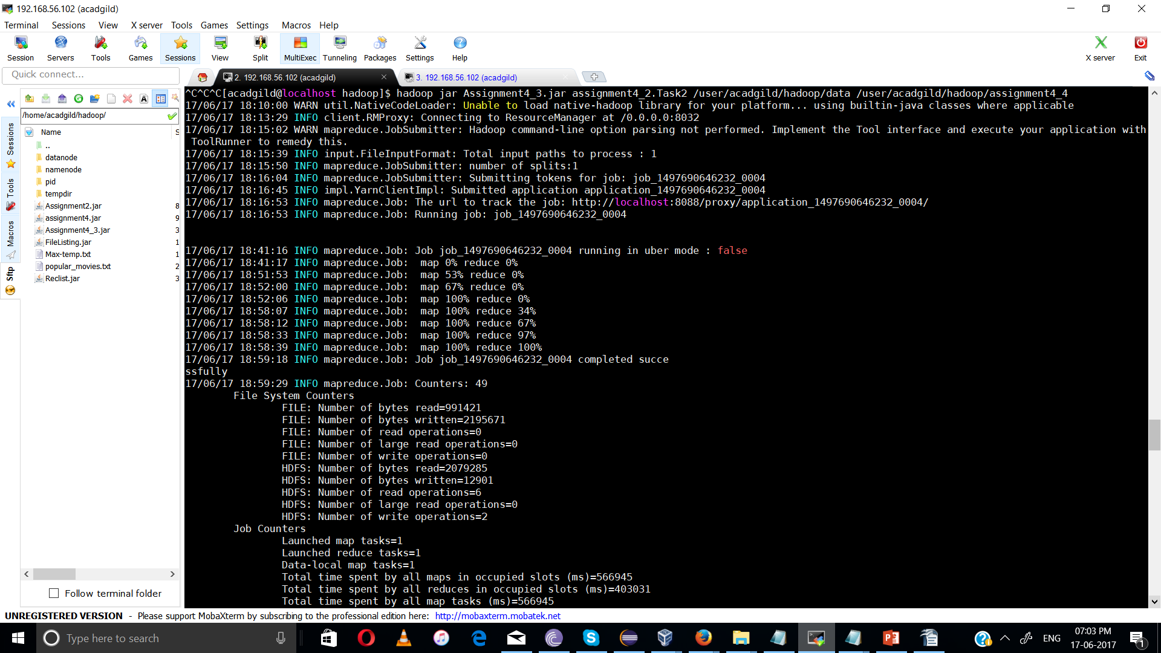

Output:
