package assignment6;

import org.apache.hadoop.fs.Path;
import org.apache.hadoop.conf.*;
import org.apache.hadoop.mapreduce.Job;
import org.apache.hadoop.mapreduce.lib.input.FileInputFormat;
import org.apache.hadoop.mapreduce.lib.input.TextInputFormat;
import org.apache.hadoop.mapreduce.lib.output.FileOutputFormat;
import org.apache.hadoop.mapreduce.lib.output.TextOutputFormat;
import org.apache.hadoop.io.IntWritable;
import org.apache.hadoop.io.Text;

public class Task9 {
@SuppressWarnings("deprecation")
public static void main(String[] args) throws Exception {
Configuration conf = new Configuration();

Job job = new Job(conf, "DemoTask9");
job.setJarByClass(Task9.class);

job.setMapOutputKeyClass(Text.class);
job.setMapOutputValueClass(IntWritable.class);

job.setOutputKeyClass(Text.class);
job.setOutputValueClass(IntWritable.class);

job.setMapperClass(Task9Mapper.class);
job.setReducerClass(Task9Reducer.class);
a
job.setInputFormatClass(TextInputFormat.class);
job.setOutputFormatClass(TextOutputFormat.class);

FileInputFormat.addInputPath(job, new Path(args[0]));
FileOutputFormat.setOutputPath(job,new Path(args[1]));

/*
Path out=new Path(args[1]);
out.getFileSystem(conf).delete(out);
*/

job.waitForCompletion(true);
}
}

Task9Mapper.java
package assignment6;

import java.io.IOException;

import org.apache.hadoop.io.IntWritable;
import org.apache.hadoop.io.LongWritable;
import org.apache.hadoop.io.Text;
import org.apache.hadoop.mapreduce.*;

public class Task9Mapper extends Mapper<LongWritable, Text, Text, IntWritable> {

Text outKey = new Text();
IntWritable outValue = new IntWritable(1);

public void map(LongWritable key, Text value, Context context)
throws IOException, InterruptedException {
String[] words = value.toString().split(" ");
for (String word : words) {
outKey.set(word);
context.write(outKey, outValue);
}
}
}

Task9Reducer.java

package assignment6;

import java.io.IOException;

import org.apache.hadoop.io.IntWritable;
import org.apache.hadoop.io.Text;
import org.apache.hadoop.mapreduce.Reducer;

public class Task9Reducer extends Reducer<Text, IntWritable, Text, IntWritable>
{
IntWritable outValue = new IntWritable();

public void reduce(Text key, Iterable<IntWritable> values,Context context) throws IOException, InterruptedException
{
int sum = 0;
for (IntWritable value : values) {
sum += value.get();
}
outValue.set(sum);
context.write(key, outValue);
}
}

Commands:
hadoop jar assign6.jar assignment6.Task9 /user/acadgild/hadoop/dataset.txt /hadoop/acadgild/hadoop/Task9
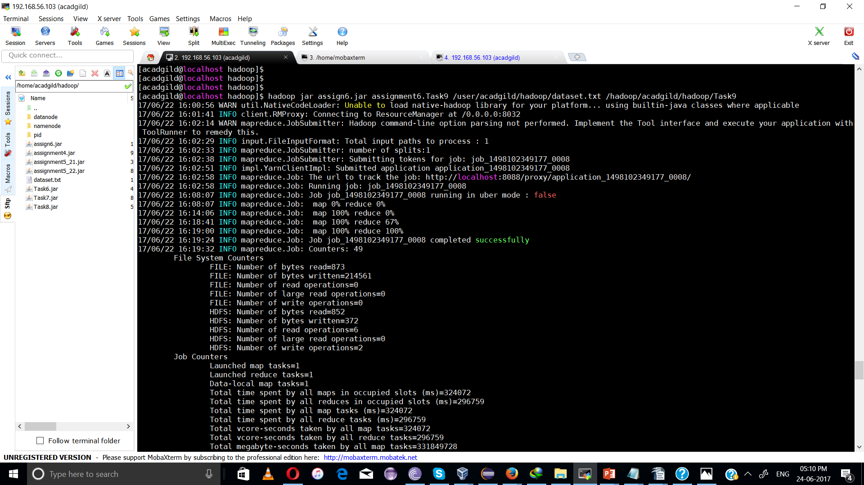
snapshot:
hadoop fs -cat /hadoop/acadgild/hadoop/Task9/part-r-00000

