Problem:

1. Find the number of students who scored less than 5(50%).

2. List the name of students who are from Alaska.

3. How many government collages are there in Alabama?

4.List the name of students who are from Oregon and persuing BE.

1)
Student = LOAD '/home/acadgild/pig/studentDS.txt' USING PigStorage(',') AS (name:chararray,undertaken:chararray,dob:chararray,stream:chararray,grade:float,state:chararray,city:chararray);
grunt> LESS_GRADE = FILTER Student by grade < 5;

B = GROUP LESS_GRADE by all;

C = FOREACH B GENERATE COUNT(LESS_GRADE.name);

DUMP C;

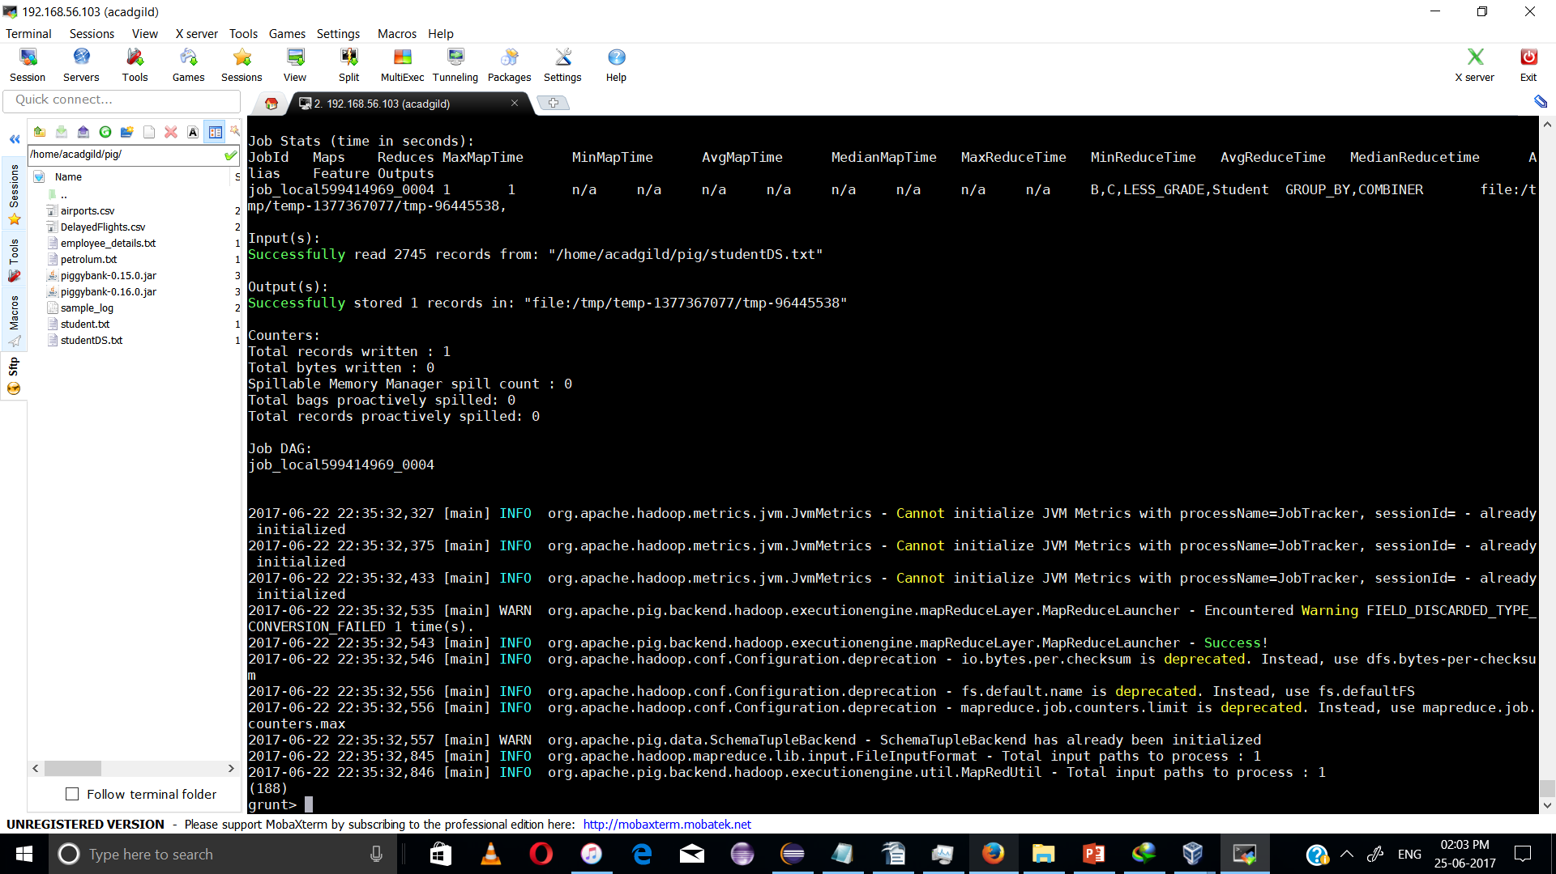

2)
B = FILTER Student by state=='alaska';

C= GROUP B ALL;

D = FOREACH C GNERATE Student.name;
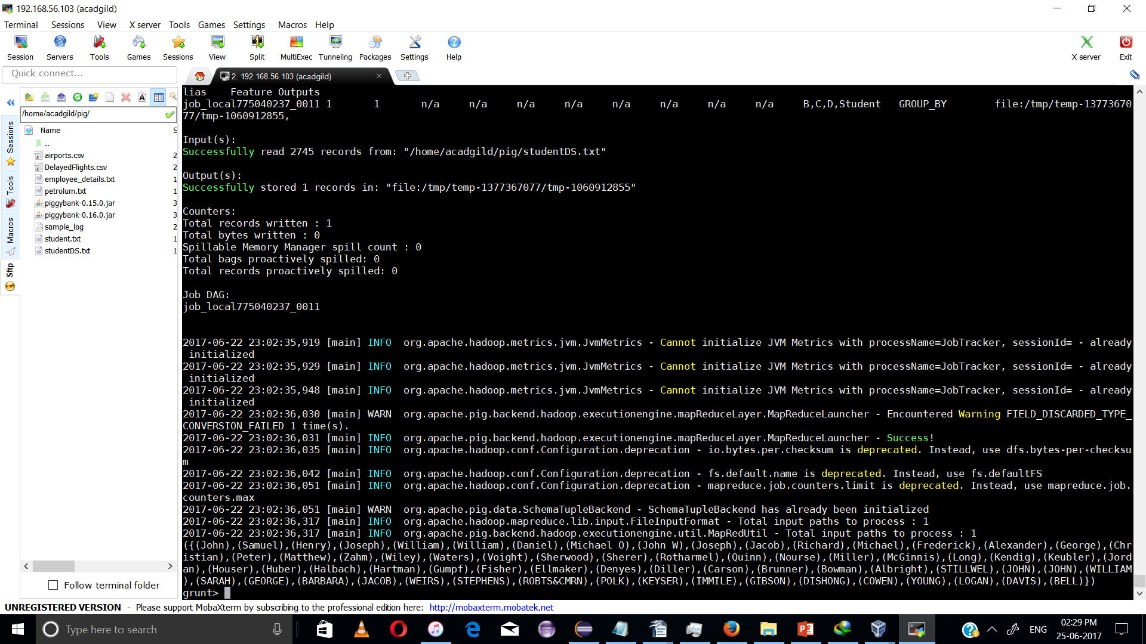

DUMP D;

3)

GOVT_COL = FILTER Student BY undertaken=='goverenment' AND state=='alabama';
b
B = GROUP GOVT_COL ALL;
C = FOREACH B GENERATE COUNT(GOVT_COL.name);

DUMP C:

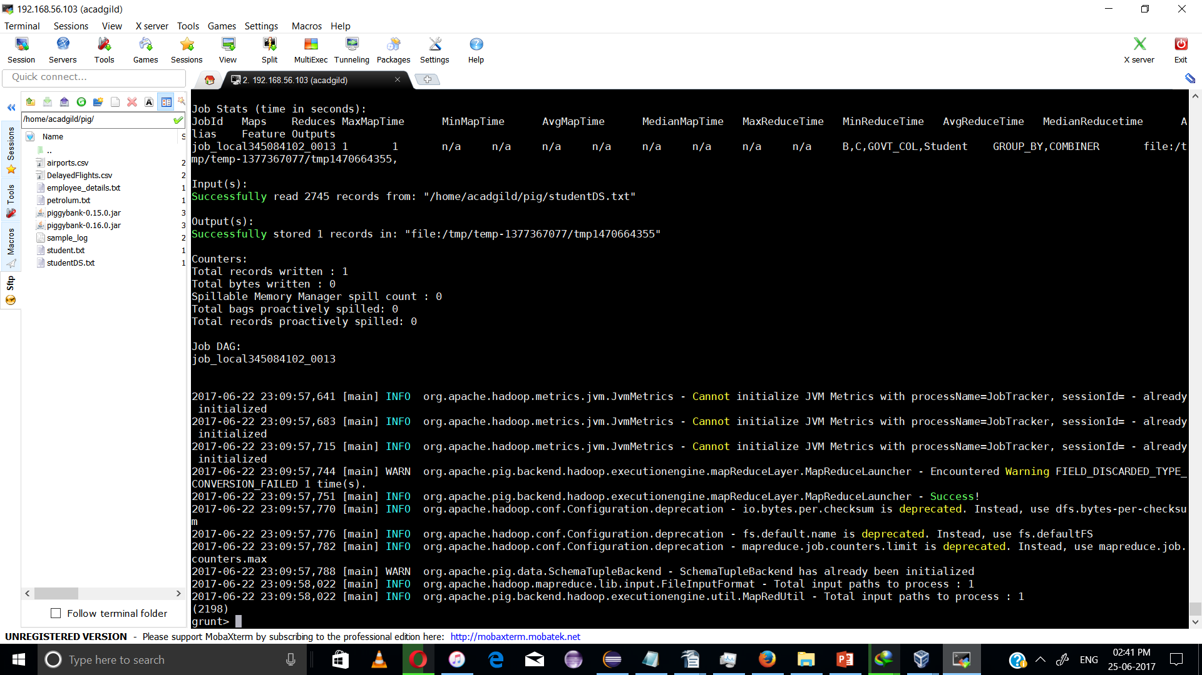

4)

b = Filter Student by state =='oregon' AND $3 =='BE';
C= GROUP b ALL:

D = FOREACH C GENERATE FLATTEN(b.name);
DUMP D;

