PETROL = LOAD '/home/acadgild/hadoop/PetrolDataset.txt' USING PigStorage(',') AS (District:chararray,DistName:chararray,buy:chararray,sell:chararray,volumeIN:int,volumeOUT:int,year:int);

1)

GRP_PETROL = GROUP PETROL BY DistName;

SUM_PETROL = FOREACH GRP_PETROL GENERATE PETROL.District AS DistributorID, (chararray)$0 AS Distributor, SUM(PETROL.volumeOUT) AS soldPetrol;

DUMP SUM_PETROL;

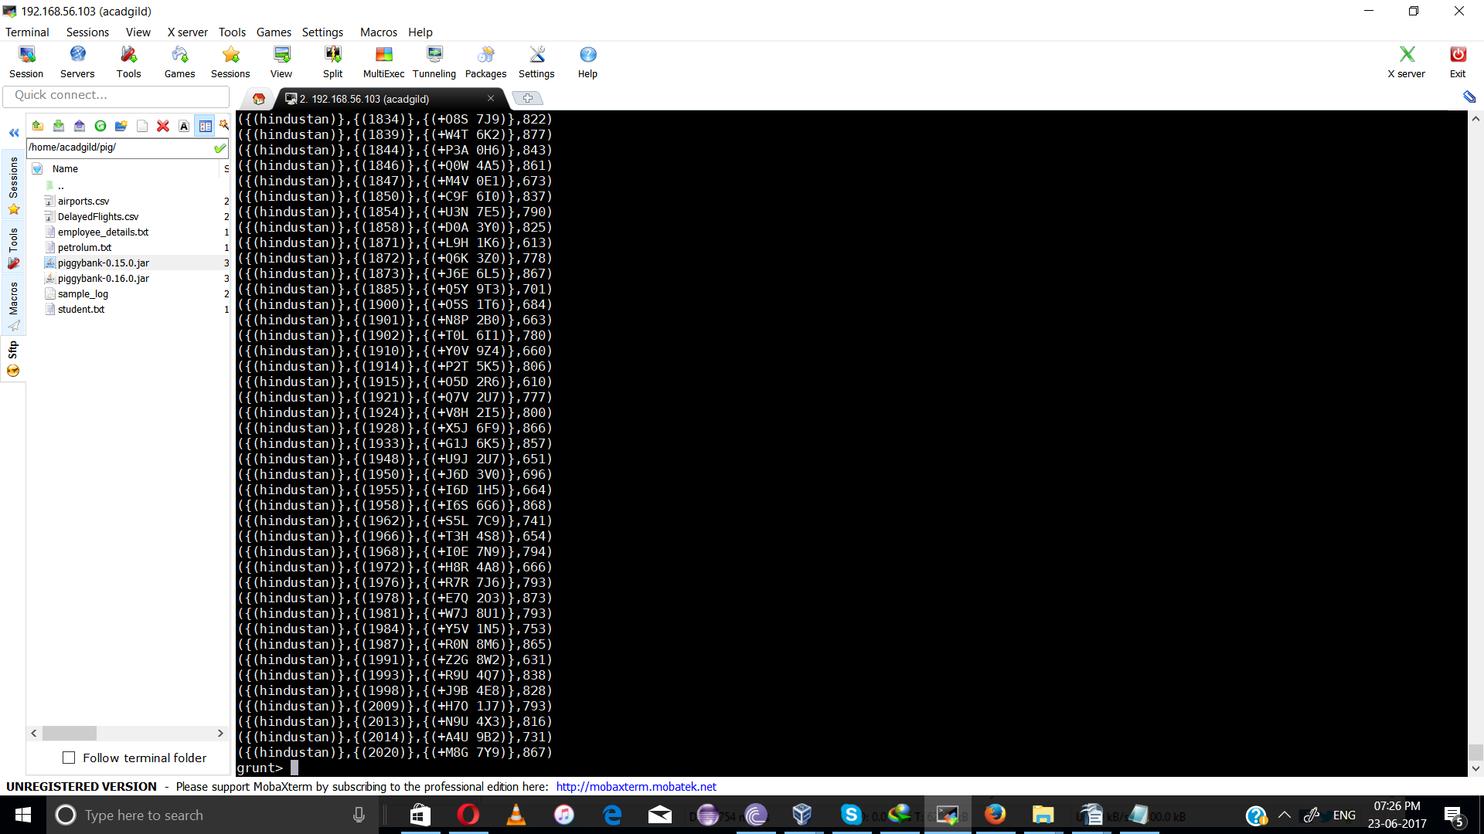
2)

PETROL = LOAD '/home/acadgild/pig/petrolum.txt' USING PigStorage(',') AS (ID:chararray,DistName:chararray,buy:chararray,sell:chararray,volumeIN:int,volumeOUT:int,year:int);
B = GROUP PETROL BY (ID,DistName,year);
C = FOREACH B generate PETROL.ID,PETROL.DistName,SUM(PETROL.volumeOUT) as volume;
D = ORDER C BY volume DESC;
E = LIMIT D 10;

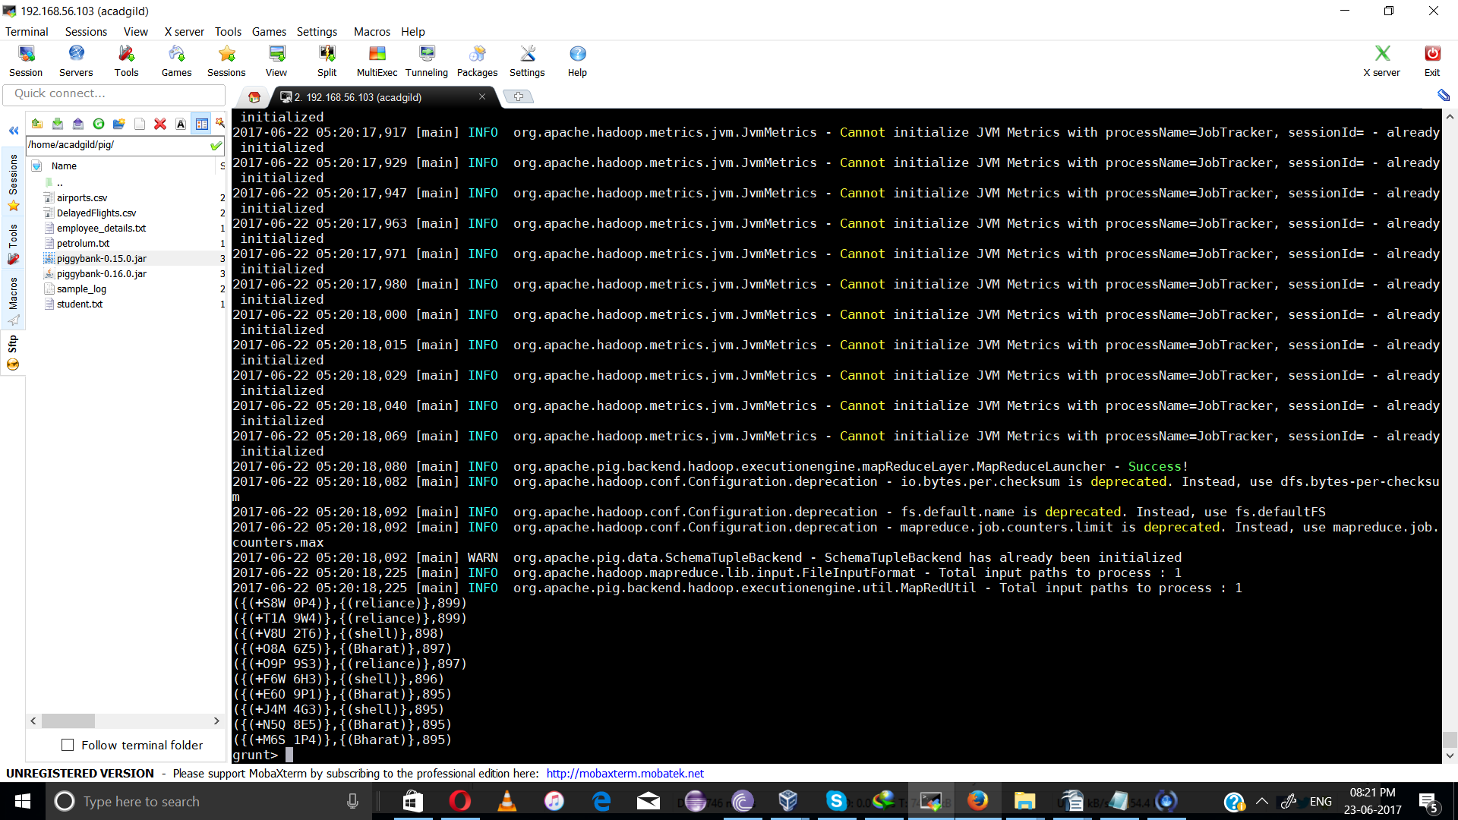

3)
grunt> C = FOREACH B generate PETROL.ID,PETROL.DistName,PETROL.year,SUM(PETROL.volumeOUT) as volume,SUM(PETROL.volumeIN) as receive;
grunt> D = ORDER C BY receive;
grunt> D = ORDER C BY receive DESC;
grunt> E = LIMIT D 10;
grunt> DUMP E;

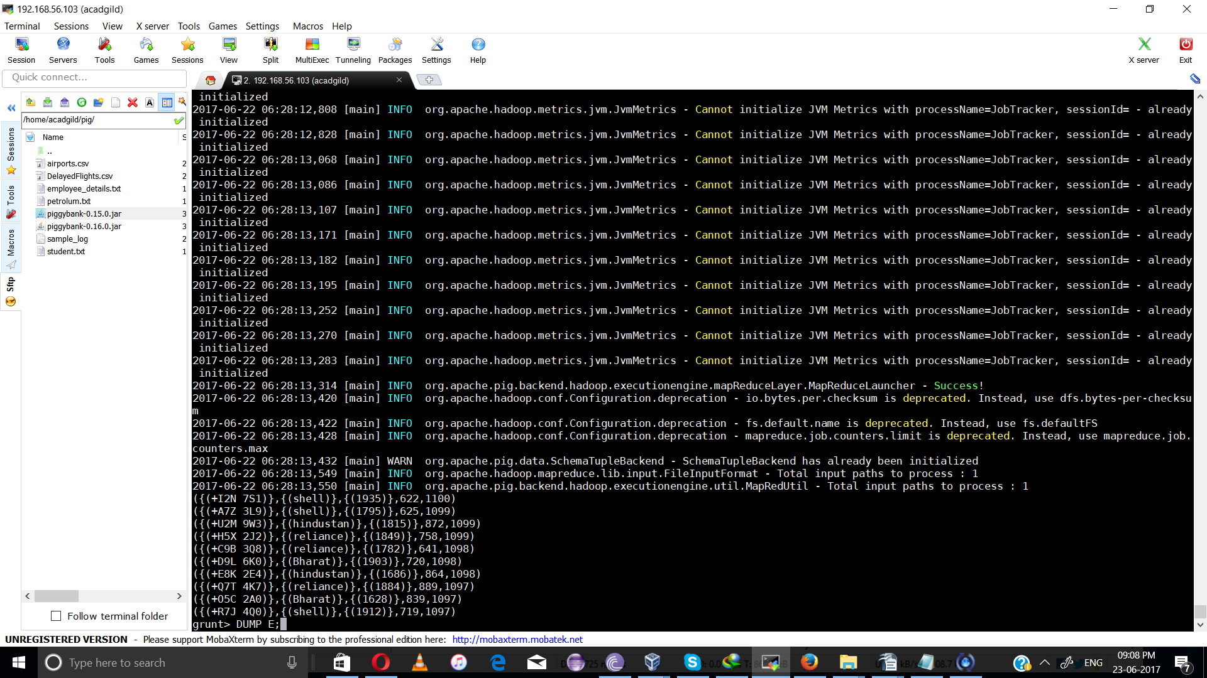
4)

grunt>C = GROUP PETROL BY DistName;
grunt> D = FOREACH C GENERATE group,SUM(PETROL.volumeOUT) as volume;
grunt> E = ORDER D BY volume ASC;
grunt> F = LIMIT E 1;
grunt> DUMP F;

