Streaming Twitter Data
To stream data to our database from twitter we should have the following pre-requisites.
- Twitter account
- Hadoop cluster
If both prerequisites are available we can move to our further step.
Step 1:
Login to the twitter account

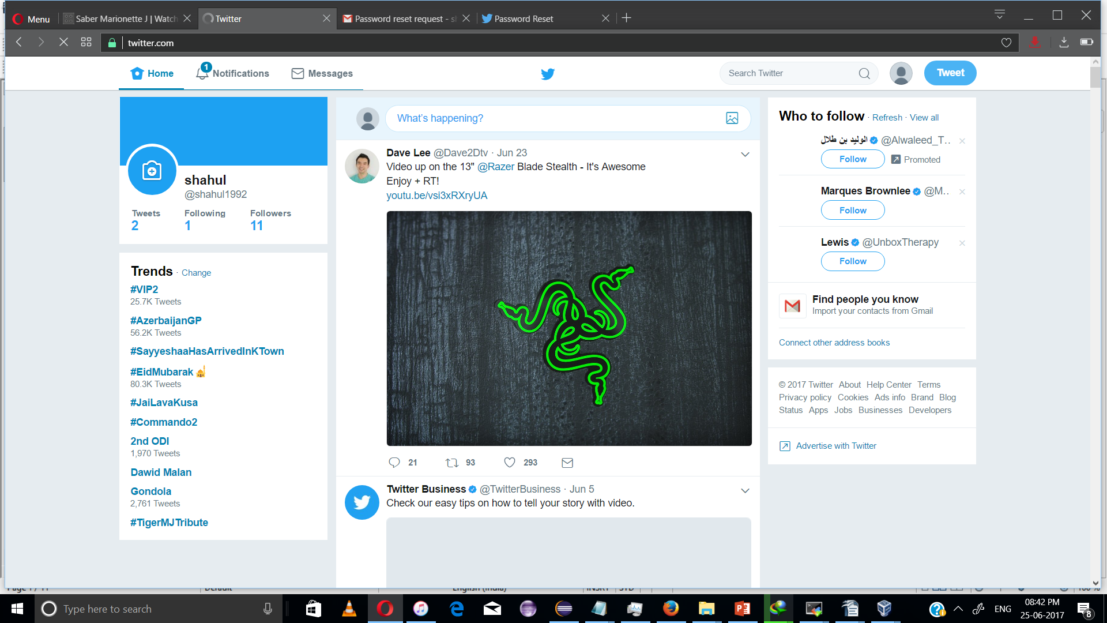

Step 2:
Go to the following link and click the ‘create new app’ button.
https://apps.twitter.com/app

Step 3:
Enter the necessary details.

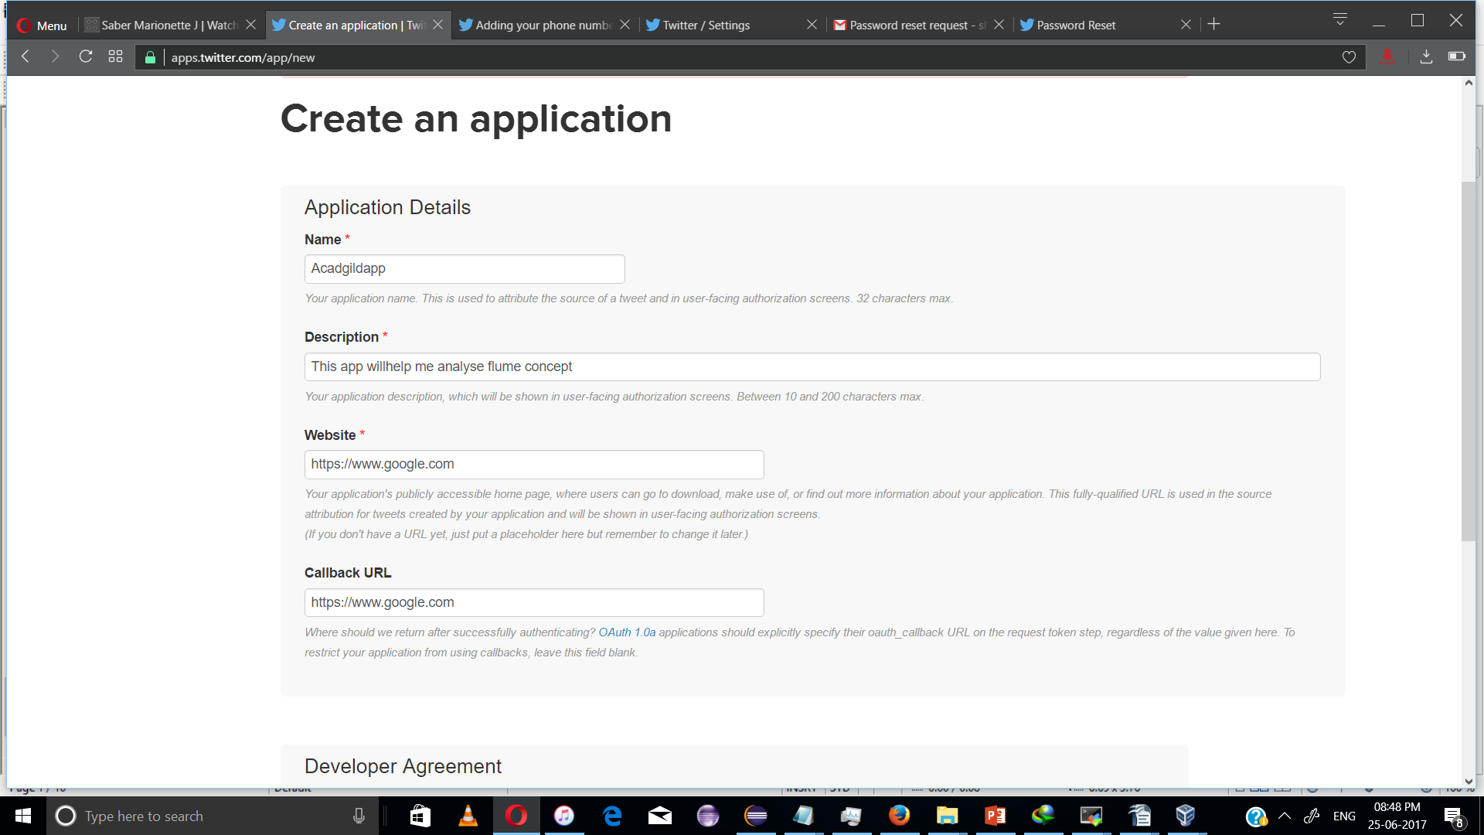
Step 4:
Accept the developer agreement and select the ‘create your Twitter application’ button.
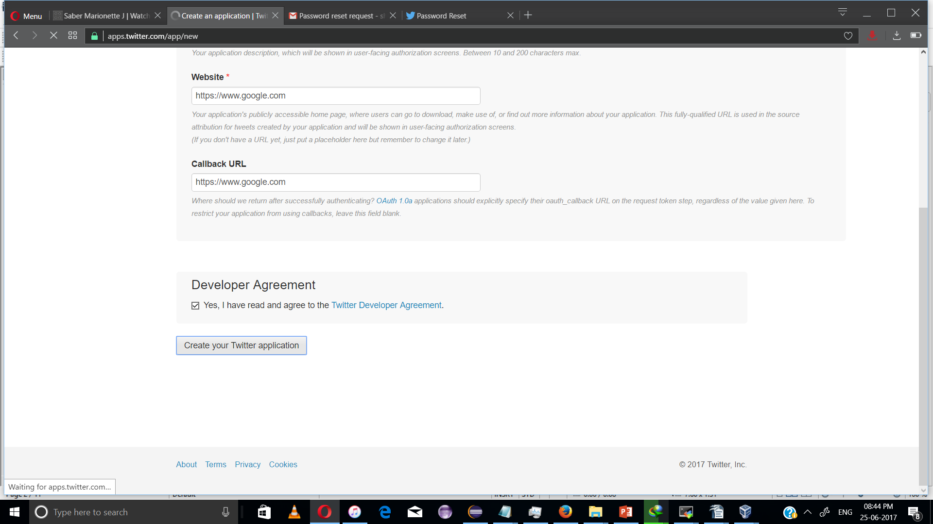
Step 5:
Select the ‘Keys and Access Token’ tab.
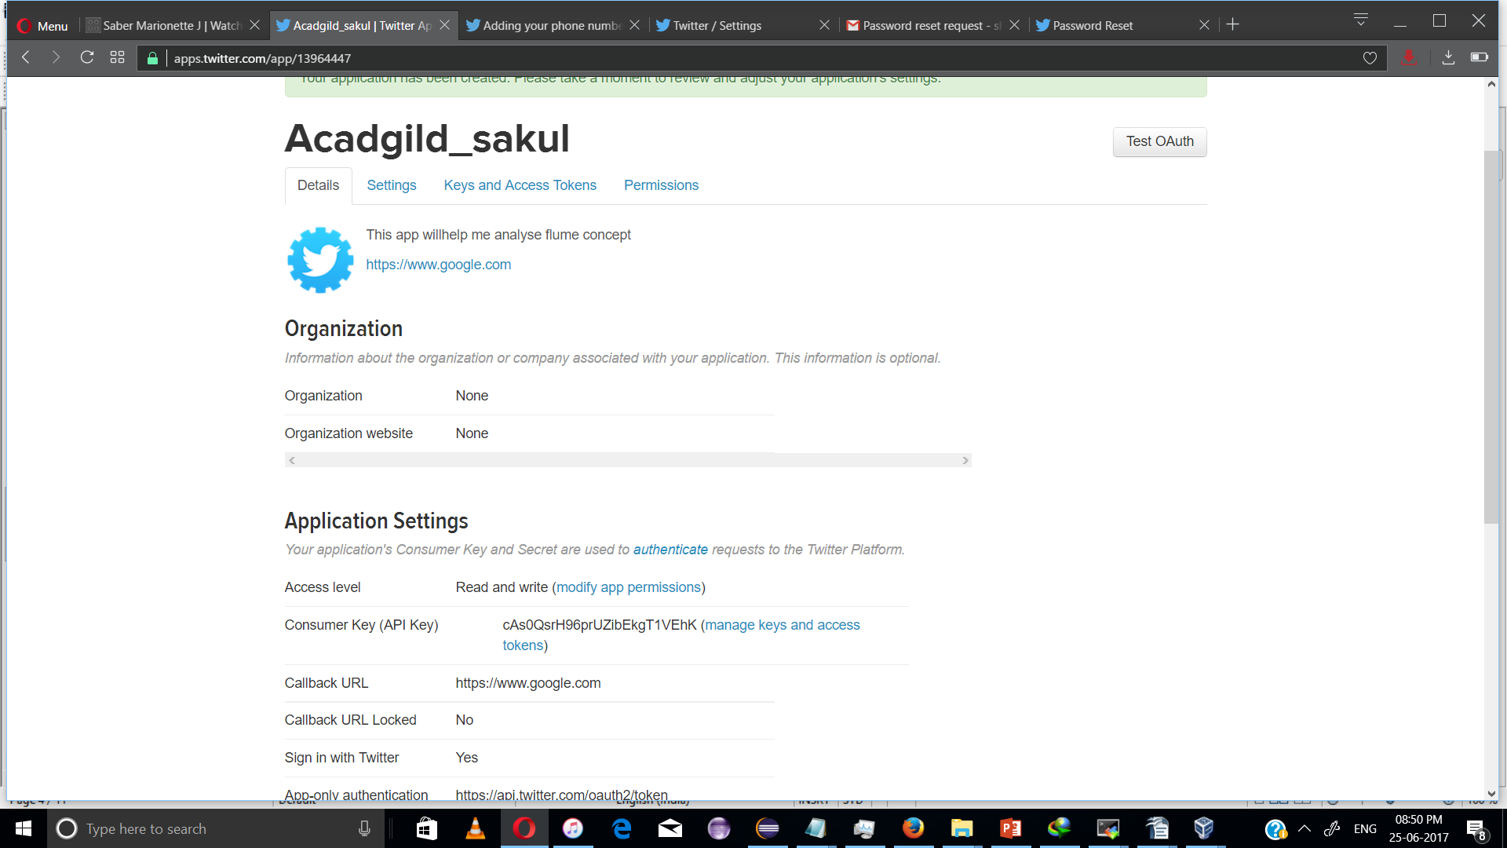

Step 6:
Copy the consumer key and the consumer secret code.
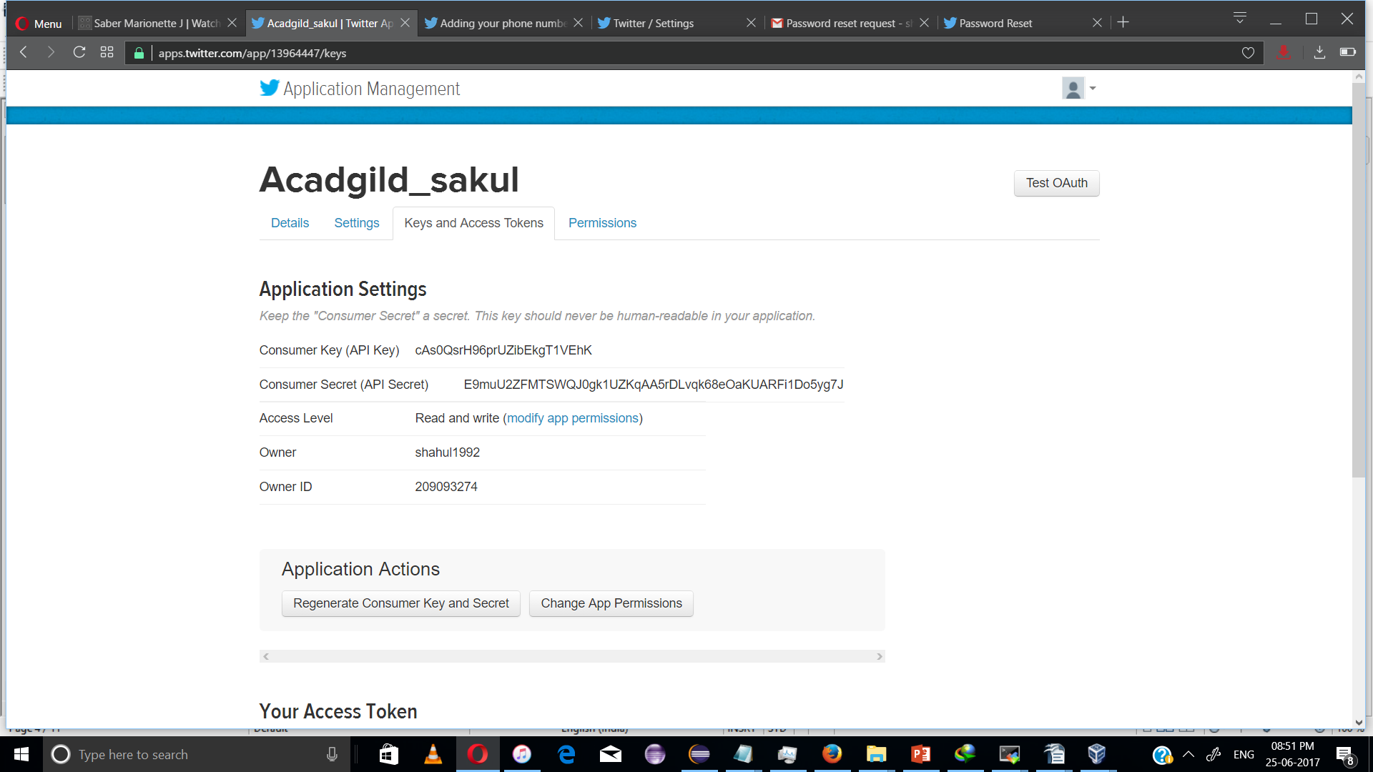

Step 7:
Scroll down further and select the ‘create my access token’ button.
Now, you will receive a message stating “that you have successfully generated your application access token”.
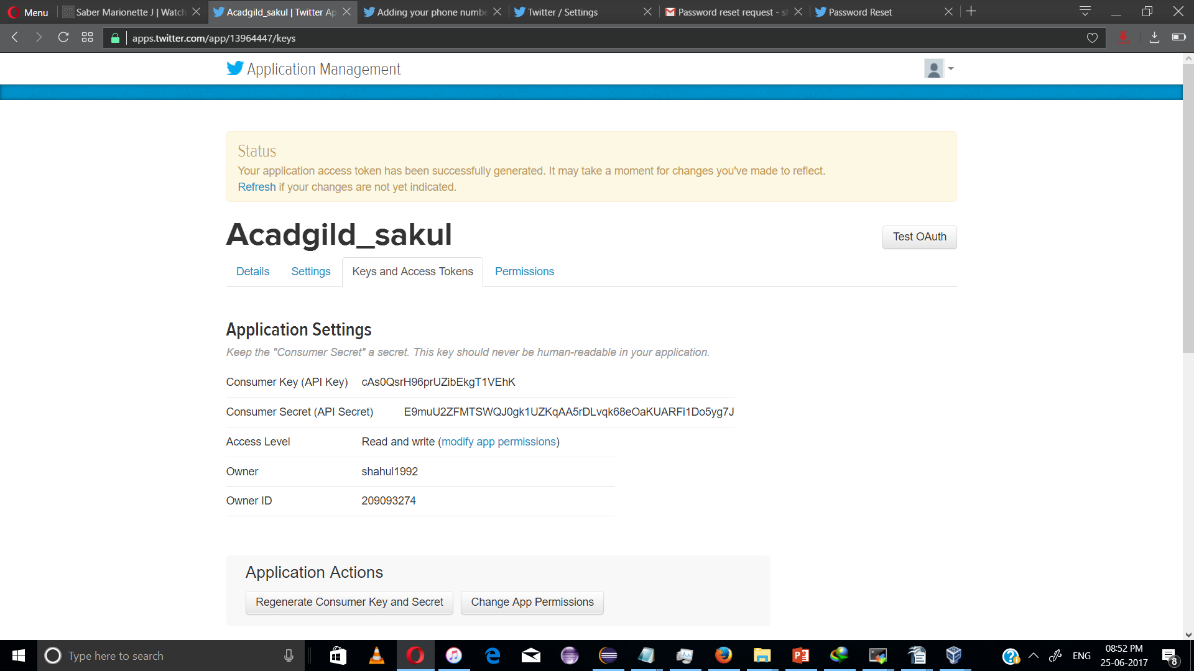

Step 8:
Copy the Access Token and Access token Secret code.

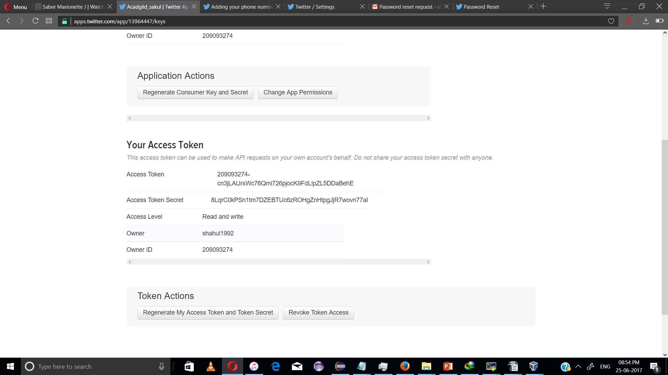

Follow Step 9 and Step 10 to install Apache flume
Step 9: Download flume tar file from below link and extract it.
https://drive.google.com/drive/u/0/folders/0B1QaXx7tpw3SWkMwVFBkc3djNFk
Right click on the downloaded flume tar file and select the option as Extract Here to untar the flume directory and update the path of extracted flume directory in the .bashrc file as mentioned in the below image.
NOTE: keep the path same as where the extracted file exists.

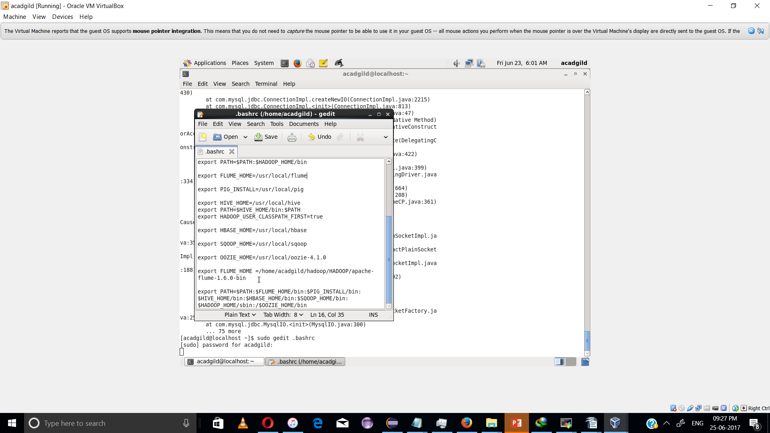
After setting the path of flume directory, save and close the .bashrc file. And then in the terminal type the below command to update the .bashrc file.
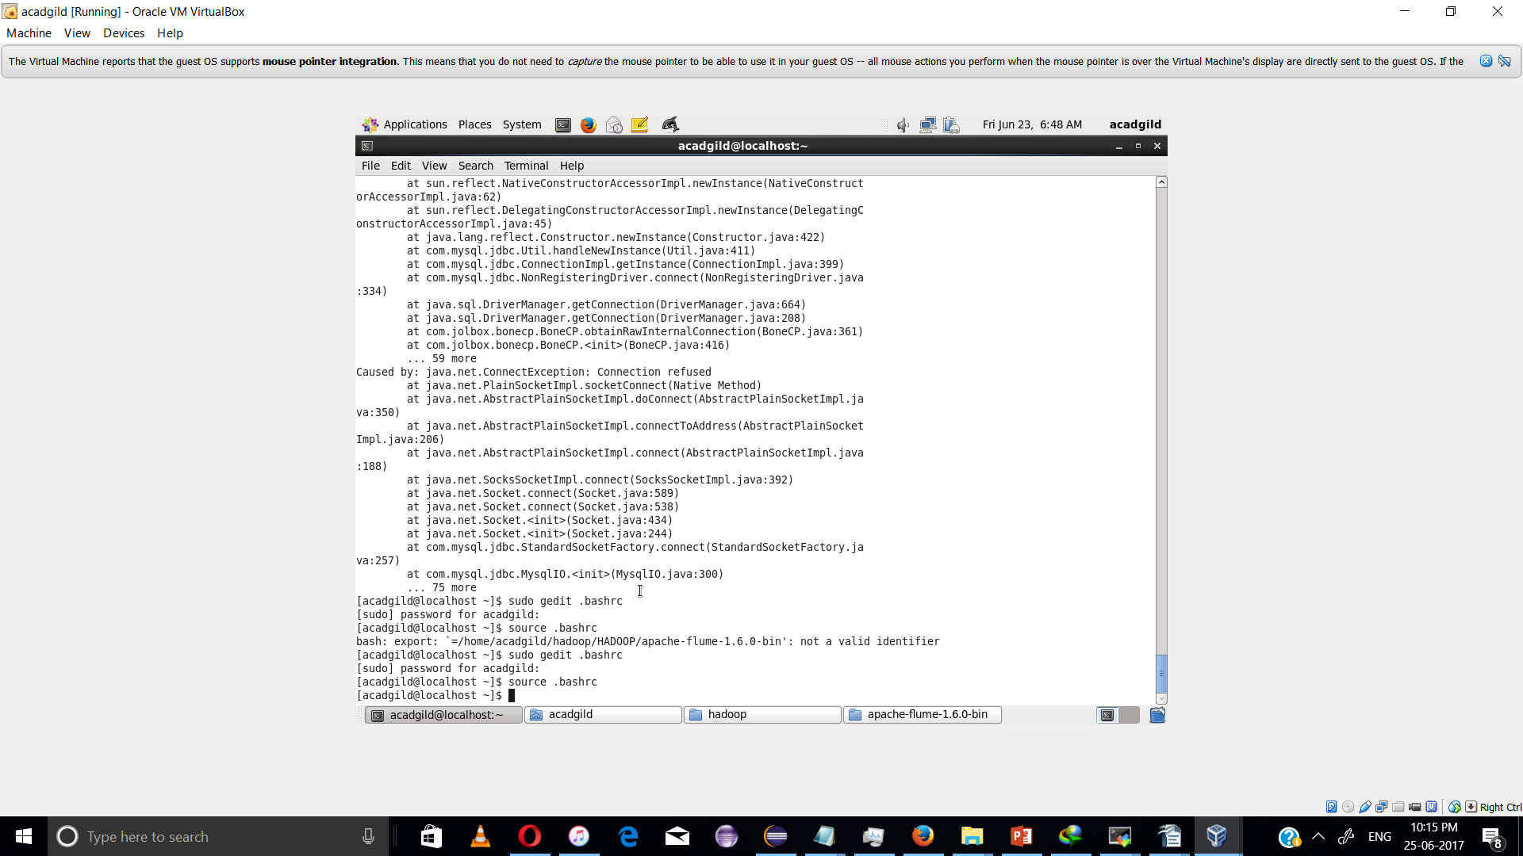

Step 10:
Create a new file inside the conf directory inside the Flume-extracted directory.
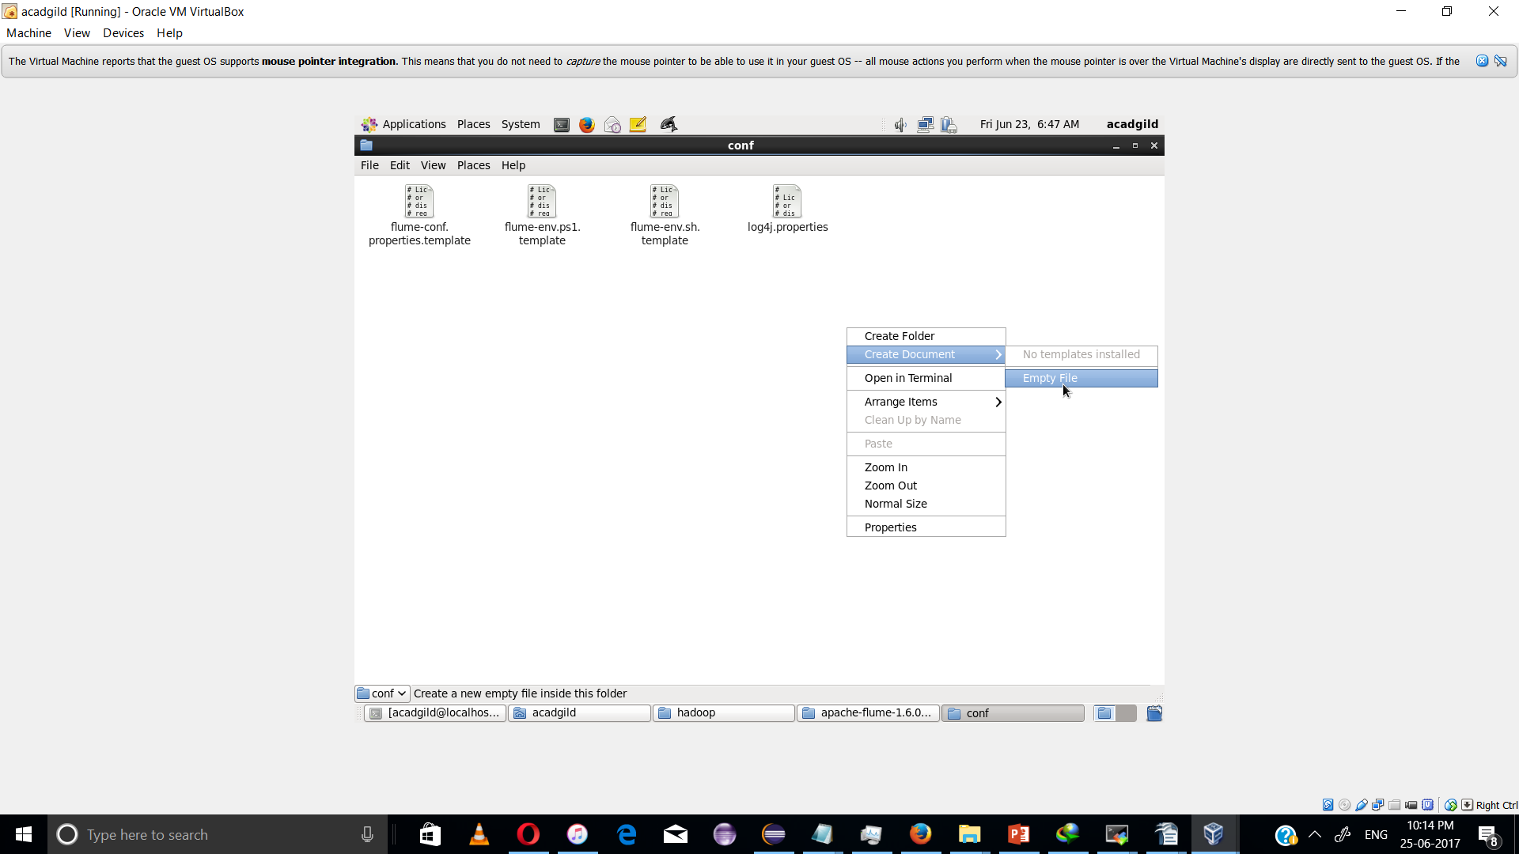

Step 11:
Copy the flume configuration code from the below link and paste it in the newly created file.
https://drive.google.com/open?id=0B1QaXx7tpw3Sb3U4LW9SWlNidkk
Step 12:
Change the twitter api keys with the keys generated as shown in the step no 6 and step number 8.
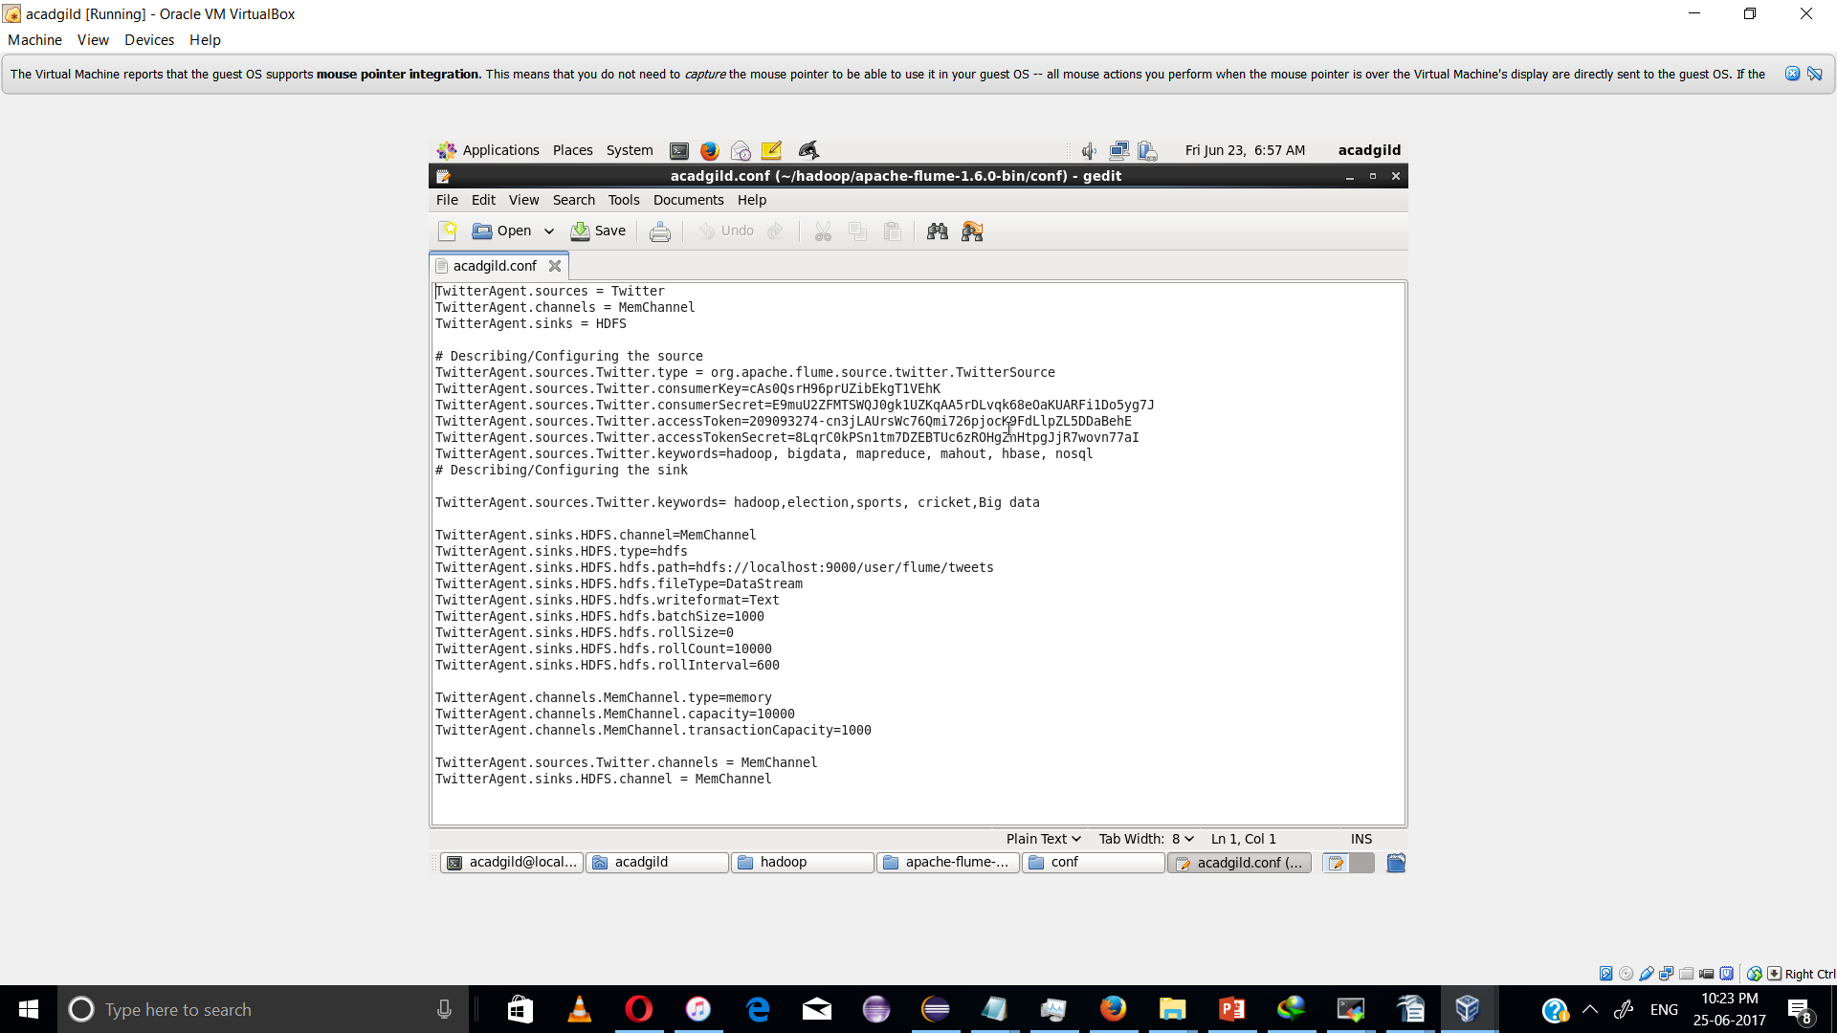

Step 13:
We have to decide which keywords tweet data to be collected from the twitter application. So, you can change the keywords in the TwitterAgent.sources.Twitter.keywords command.
In our example, we are fetching tweet data related to Hadoop, election, sports, cricket and Big data.
Step 14:
Open a new terminal and start all the Hadoop daemons, before running the flume command to fetch the twitter data.
Use the ‘jps’ command to see the running Hadoop daemons.
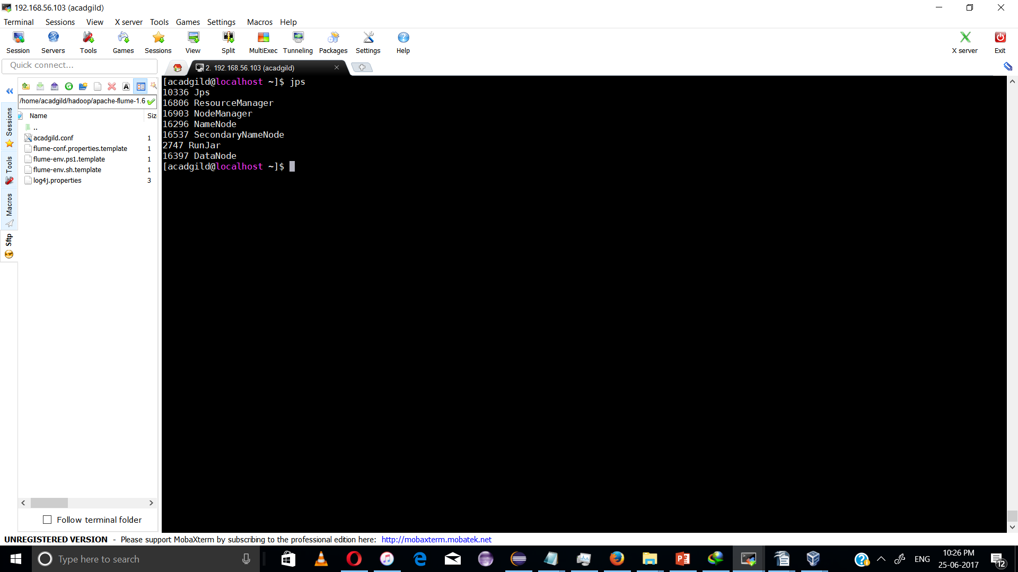

Step 15:
Create a new directory inside HDFS path, where the Twitter tweet data should be stored.
Hadoop dfs –mkdir –p /user/flume/tweets
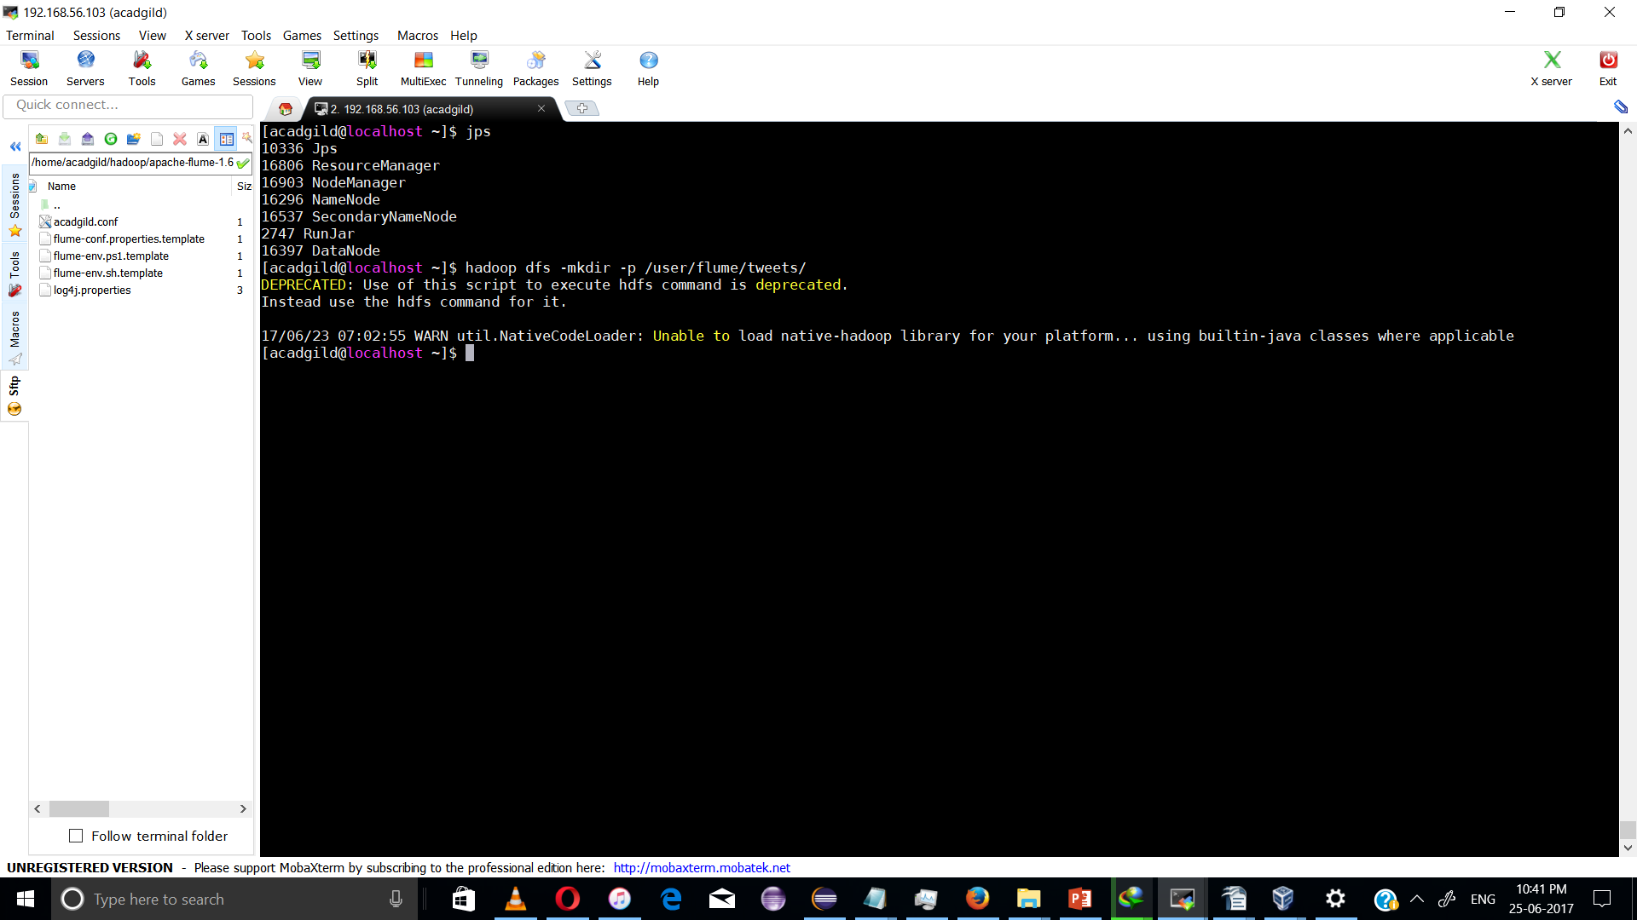
tep 16:
For fetching data from Twitter, Use the below command to fetch the twitter tweet data into the HDFS cluster path.
flume-ng agent --conf /etc/flume-ng/conf/ -f /home/acadgild/hadoop/apache-flume-1.6.0-bin/conf/acadgild.conf - Dflume.root.logger=DEBUG,console -n TwitterAgent;
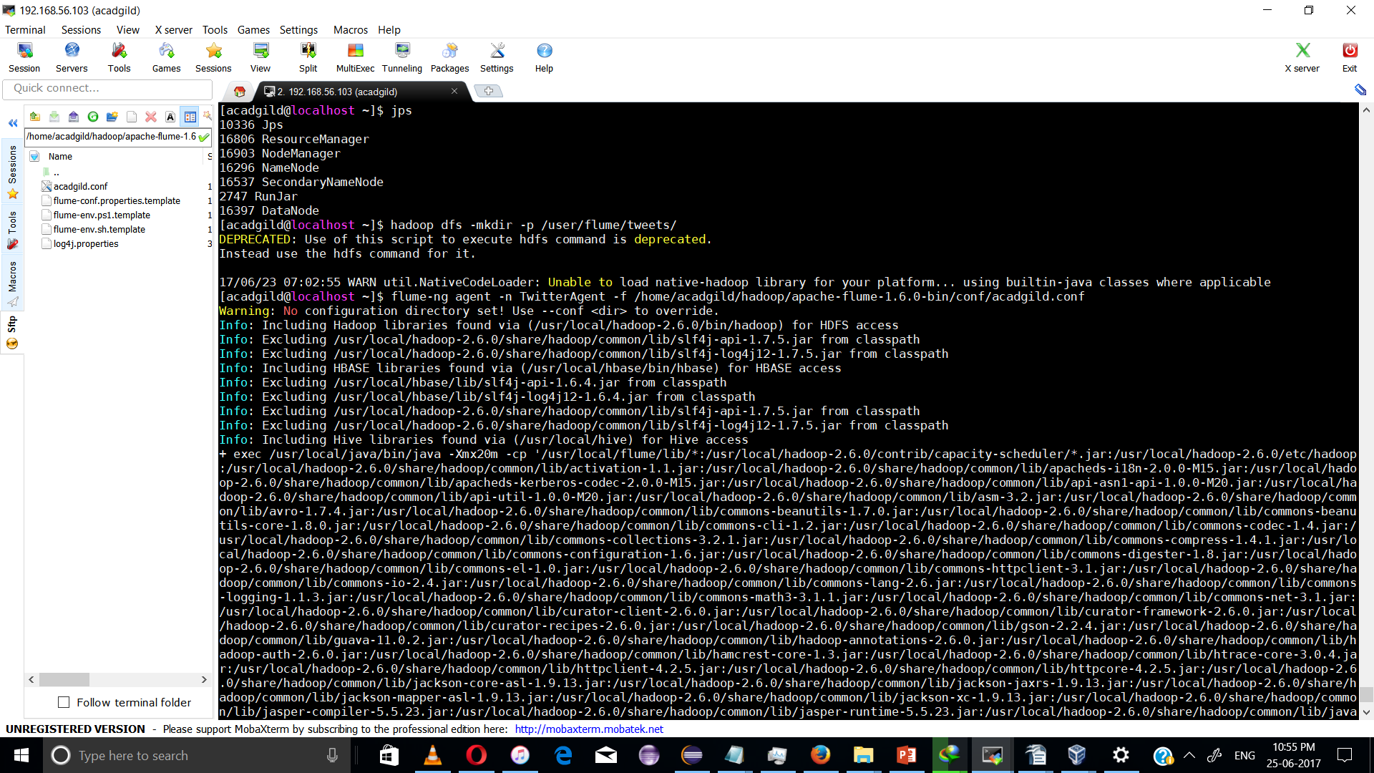
The above command will start fetching data from Twitter and steams it into the HDFS given path.
Once, the tweet data started streaming it into the given HDFS path we can use ‘Ctrl+c’ command to stop the streaming process.
Step 17:
To check the contents of the tweet data we can use the following command:
hadoop dfs –ls /user/flume/tweets
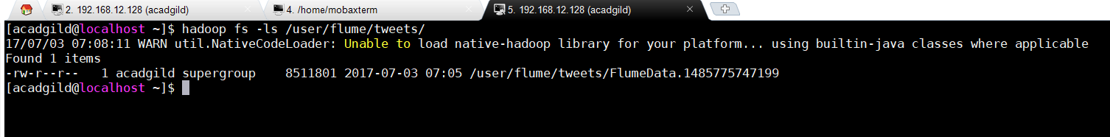
Step 18:
We can use the ‘cat’ command to display the tweet data inside the /user/flume/tweets/FlumeData.148* path.
hadoop dfs –cat /us er/flume/tweets/FlumeData.145*
We can observe from the above image that we have successfully fetched twitter data into our HDFS cluster directory. Once the tweets have been successfully stored in your database, you can manipulate the tweet data to fit the needs of our future projects. You can follow the above steps for the same.
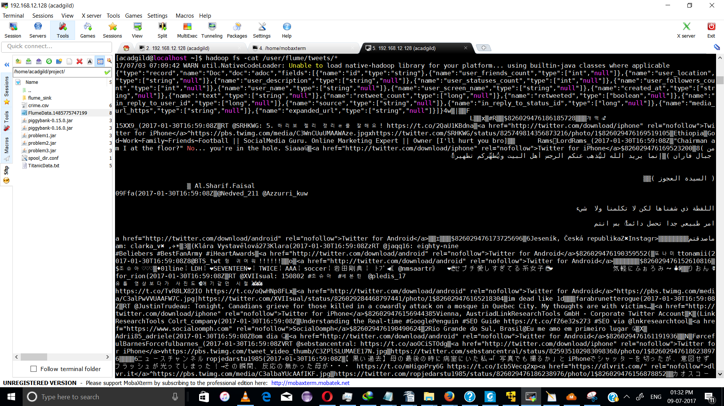

Data analysis;

The data from Twitter is in ‘Avro’ format, so a hive is required to load the data into Pig. You need to download the required jars for the JsonLoader from the below link:

Creating table:

hive> use acadgild;
OK
Time taken: 0.19 seconds
hive> CREATE TABLE tweets
> ROW FORMAT SERDE
> 'org.apache.hadoop.hive.serde2.avro.AvroSerDe'
> STORED AS INPUTFORMAT
> 'org.apache.hadoop.hive.ql.io.avro.AvroContainerInputFormat'
> OUTPUTFORMAT
> 'org.apache.hadoop.hive.ql.io.avro.AvroContainerOutputFormat'
> TBLPROPERTIES ('avro.schema.url'='file:///home/acadgild/TwitterDataAvroSchema.avsc') ;
OK
Time taken: 2.434 seconds
hive> show tables;
OK
emp_proj
employee
employee_data
hive_tab
olympics
titanic
titanic_data
tweets
Time taken: 0.192 seconds, Fetched: 8 row(s)
hive> desc tweets;
OK
id string from deserializer
user_friends_count int from deserializer
user_location string from deserializer
user_description string from deserializer
user_statuses_count int from deserializer
user_followers_count int from deserializer
user_name string from deserializer
user_screen_name string from deserializer
created_at string from deserializer
text string from deserializer
retweet_count bigint from deserializer
retweeted boolean from deserializer
in_reply_to_user_id bigint from deserializer
source string from deserializer
in_reply_to_status_id bigint from deserializer
media_url_https string from deserializer
expanded_url string from deserializer
Time taken: 0.9 seconds, Fetched: 17 row(s)

Loading Data into Hive table
hive> LOAD DATA INPATH '/home/acadgild/project/FlumeData.*' OVERWRITE INTO TABLE tweets;
FAILED: SemanticException Line 1:17 Invalid path ''/home/acadgild/project/FlumeData.*'': No files matching path hdfs://localhost:9000/home/acadgild/project/FlumeData.*
hive> LOAD DATA local INPATH "/home/acadgild/project/FlumeData.1485775747199" OVERWRITE INTO TABLE tweets;
Loading data to table acadgild.tweets
Table acadgild.tweets stats: [numFiles=1, numRows=0, totalSize=8511801, rawDataSize=0]
OK
Time taken: 8.548 seconds
hive> select * from tweets LIMIT 10;
OK
826029476186185728 195 NULL NULL 8775 11 개떡💫 15XX9_ 2017-01-30T16:59:08Z RT @SRHKWG: 5. 하리보 젤리 정리ㄹ를 잘해요! https://t.co/2QaU1KBdna 0 true -1 <a href="http://twitter.com/download/iphone" rel="nofollow">Twitter for iPhone</a> -1 https://pbs.twimg.com/media/C3WnCUuUMAAWAze.jpg https://twitter.com/SRHKWG/status/825749814356873216/photo/1
826029476169519105 369 Ethiopia God~Work~Family~Friends~Football || SocialMedia Guru. Online Marketing Expert || Owner [I'll hurt you bro] 10272 600 Rams LordRams_ 2017-01-30T16:59:08Z "Chairman am I at the floor?" No... you're in the hole. Siaaa😂 0 false -1 <a href="http://twitter.com/download/iphone" rel="nofollow">Twitter for iPhone</a> -1 NULL NULL
826029476169523200 488 ( من جبال فاران ) ‏‏‏‏‏‏‏‏‏‏‏‏‏‏‏‏‏‏‏‏إنما يريد الله ليُذهب عنكم الرجس أهل البيت ويُطهّركم تطهيراً

( السيدة العجوز ) 97939 1815 Al.Sharif.Faisal 09Ffa 2017-01-30T16:59:08Z @Nedved_211 @Azzurri_kuw

اللقطة ذي شفناها لكن لاتكلمنا ولا شيء

امر طبيعي جدا تحصل دائماً بس انتم

ماصدقتم 0 false 701444523990323201 <a href="http://twitter.com/download/android" rel="nofollow">Twitter for Android</a> 826024488496164867 NULL NULL
826029476173725696 119 Jeseník, Česká republika ✖️Instagram: clarka_v✖️ ,✈️☀️ 3316 84 Klára Vystavělová 273Klara 2017-01-30T16:59:08Z RT @jaqq16: eighty-nine
#Beliebers #BestFanArmy #iHeartAwards 0 true -1 <a href="http://twitter.com/download/android" rel="nofollow">Twitter for Android</a> -1 NULL NULL
826029476190359552 20 NULL NULL 234 3 또나미 ttonamii 2017-01-30T16:59:08Z @BTS_twt 헝 귀여워!!!!!! 0 false 335141638 <a href="http://twitter.com/download/android" rel="nofollow">Twitter for Android</a> 826027485640863744 NULL NULL
826029476152610816 1687 조슈아♡♡♡ ♦01line￤LDH￤❤SEVENTEEN❤￤TWICE￤AAA￤soccer￤岩田剛典￤ ﾄﾌﾟ◀《@nmsaartr》 ❤👰セブチ愛しすぎてる系女子👰❤ 気軽にふぉろみ〜👤🌹 1514 1338 りおん🌷 for_rion 2017-01-30T16:59:08Z RT @XVIIsual: 150802 #조슈아 #세븐틴 @pledis_17
유툽 영상보다가 사진도🌸애기같던 시절🐰🐰🐰
https://t.co/TvR8LX82IO https://t.co/oQwHNp8FLx 0 true -1 <a href="http://twitter.com/download/android" rel="nofollow">Twitter for Android</a> -1 https://pbs.twimg.com/media/C3alPwVVUAAFW7C.jpg https://twitter.com/XVIIsual/status/826029284468797441/photo/1
826029476165218304 935 NULL im dead like 1d 129521 3216 fara brunetterogue 2017-01-30T16:59:08Z RT @JustinTrudeau: Tonight, Canadians grieve for those killed in a cowardly attack on a mosque in Quebec City. My thoughts are with victims… 0 true -1 <a href="http://twitter.com/download/iphone" rel="nofollow">Twitter for iPhone</a> -1 NULL NULL
826029476156944385 515 Vienna, Austria LinkResearchTools GmbH - Corporate Twitter Account 4831 468 LinkResearchTools Co lrt_company 2017-01-30T16:59:08Z Understanding the Real-time #GooglePenguin #SEO Guide https://t.co/fZ6e32s273 #SEO via @lnkresearchtool 0 false -1 <a href="https://www.socialoomph.com" rel="nofollow">SocialOomph</a> -1 NULL NULL
826029476190490624 228 Rio Grande do Sul, Brasil Eu me amo em primeiro lugar 😘 5690 259 Adrii 85_adriele 2017-01-30T16:59:08Z Bom dia 😴 0 false -1 <a href="http://twitter.com/download/android" rel="nofollow">Twitter for Android</a> -1 NULL NULL
826029476161191936 1008 NULL NULL 5020 328 FørcefulBarnes Forcefulbarnes_ 2017-01-30T16:59:08Z RT @sebstancentral: https://t.co/aoOCiSTOdg 0 true -1 <a href="http://twitter.com/download/iphone" rel="nofollow">Twitter for iPhone</a> -1 https://pbs.twimg.com/tweet_video_thumb/C3ZPlSLUMAEE17N.jpg https://twitter.com/sebstancentral/status/825935102983098368/photo/1
Time taken: 2.102 seconds, Fetched: 10 row(s)
hive> select id,retweet_count from tweets LIMIT 10;
OK
826029476186185728 0
826029476169519105 0
826029476169523200 0
826029476173725696 0
826029476190359552 0
826029476152610816 0
826029476165218304 0
826029476156944385 0
826029476190490624 0
826029476161191936 0
Time taken: 0.385 seconds, Fetched: 10 row(s)
Snapshot:

