Experiment No : 01
---------------------------------------------------------------------------------------------------------
Aim: To implement Binary Search using recursion and analyze its time and space complexity.
Title: Binary Search Technique using Array and Recursion
Theory:
Binary Search is an efficient searching algorithm used to find the position of a target element within a sorted array. It works on the divide and conquer principle by repeatedly dividing the search interval in half. If the element is equal to the middle element, the search ends. Otherwise, if the element is smaller, the search continues on the left subarray; if larger, on the right subarray.
Recursive binary search uses function calls to achieve this division. At each recursive call, the array boundaries are adjusted until the base condition is met (either the element is found or the subarray size becomes zero). Binary search is more efficient than linear search for large, sorted datasets due to its logarithmic time complexity.
Code:
#include <stdio.h>
int binarySearch(int arr[], int low, int high, int key) {
if (low <= high) {
int mid = (low + high) / 2;
if (arr[mid] == key)
return mid;
else if (arr[mid] > key)
return binarySearch(arr, low, mid - 1, key);
else
return binarySearch(arr, mid + 1, high, key);
}
return -1;
}
int main() {
int n, key, result;
printf("Enter number of elements: ");
scanf("%d", &n);
int arr[n];
printf("Enter %d sorted elements:\n", n);
for (int i = 0; i < n; i++)
scanf("%d", &arr[i]);
printf("Enter element to search: ");
scanf("%d", &key);
result = binarySearch(arr, 0, n - 1, key);
if (result != -1)
printf("Element found at position %d\n", result + 1);
else
printf("Element not found.\n");
return 0;
}
Output :
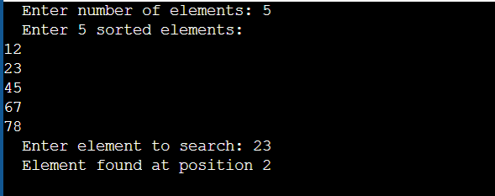
Time and Space Complexity Analysis:
- Time Complexity:
  - Best Case: O(1) (element found at mid)
  - Average & Worst Case: O(log n) (array divided in half each step)
- Space Complexity:
  - Iterative version: O(1)
  - Recursive version: O(log n) (due to recursive function call stack)
Advantages:
- Very efficient for sorted datasets with logarithmic time complexity.
- Reduces the number of comparisons drastically compared to linear search.
- Can be applied to various search-related optimization problems.
- Easy to implement both iteratively and recursively.
Disadvantages:
- Requires the input data to be sorted beforehand.
- Inefficient for small or unsorted datasets.
- Recursive version may cause stack overflow for very large arrays.
- Not suitable for linked lists due to lack of random access.
Applications of Binary Search:
- Searching elements in a sorted list or array.
- Finding square roots or cube roots numerically.
- Locating a target value in a sorted database index.
- Solving optimization problems like "minimum" or "maximum" in a range.
- Finding first or last occurrence of an element in a sorted array.
- Used in libraries for fast lookup operations (e.g., bisect in Python).
Used in competitive programming for problems involving ranges and condition.

Application Example Code:
Application: Finding the first occurrence of a number in a sorted array using modified binary search.

#include <stdio.h>
int firstOccurrence(int arr[], int low, int high, int key) {
if (low <= high) {
int mid = (low + high) / 2;
if ((mid == 0 || key > arr[mid - 1]) && arr[mid] == key)
return mid;
else if (key > arr[mid])
return firstOccurrence(arr, mid + 1, high, key);
else
return firstOccurrence(arr, low, mid - 1, key);
}
return -1;
}
int main() {
int arr[] = {1, 2, 2, 2, 3, 4, 5};
int n = sizeof(arr) / sizeof(arr[0]);
int key = 2;
int index = firstOccurrence(arr, 0, n - 1, key);
if (index != -1)
printf("First occurrence of %d is at position %d\n", key, index + 1);
else
printf("Element not found.\n");

return 0;
}
Conclusion:
Binary Search is a fast and efficient algorithm for searching in sorted datasets, achieving a logarithmic time complexity. Its recursive approach demonstrates the power of divide and conquer in data structure design.

Experiment No : 02
---------------------------------------------------------------------------------------------------------
Aim: To implement Quick Sort and Merge Sort using array and analyze their time and space complexities.
Title: Implementation of Quick Sort and Merge Sort using Array as a Data Structure
Theory:
Sorting is one of the most fundamental operations in computer science. It involves arranging data elements in a specific order (ascending or descending) to make searching and analysis more efficient.
Among various sorting algorithms, Quick Sort and Merge Sort are two of the most widely used and efficient techniques based on the divide and conquer approach.
Quick Sort:
Quick Sort works by selecting a pivot element from the array. It rearranges the array elements so that all elements smaller than the pivot are placed before it and all greater elements after it. This process is called partitioning.
The same steps are then recursively applied to the left and right subarrays. Quick sort is highly efficient for large datasets and performs well when elements are randomly distributed.
Merge Sort:
Merge Sort divides the array into two halves recursively until each subarray contains a single element. Then, it merges these subarrays in a sorted manner to form a larger sorted array.
It guarantees a consistent O(n log n) time complexity and is a stable sorting algorithm, which means it maintains the relative order of equal elements. Merge Sort is especially useful for sorting linked lists and external files, although it requires extra memory for merging operations.

A] Code: Quick Sort (Using Array)
#include <stdio.h>

void swap(int *a, int *b) {
int temp = *a;
*a = *b;
*b = temp;
}
int partition(int arr[], int low, int high) {
int pivot = arr[high];
int i = (low - 1);
for (int j = low; j < high; j++) {
if (arr[j] < pivot) {
i++;
swap(&arr[i], &arr[j]);
}
}
swap(&arr[i + 1], &arr[high]);
return (i + 1);
}
void quickSort(int arr[], int low, int high) {
if (low < high) {
int pi = partition(arr, low, high);
quickSort(arr, low, pi - 1);
quickSort(arr, pi + 1, high);
}
}

int main() {
int n;
printf("Enter number of elements: ");
scanf("%d", &n);
int arr[n];
printf("Enter %d elements:\n", n);
for (int i = 0; i < n; i++)
scanf("%d", &arr[i]);
quickSort(arr, 0, n - 1);
printf("Sorted array: ");
for (int i = 0; i < n; i++)
printf("%d ", arr[i]);
return 0;
}
Output :
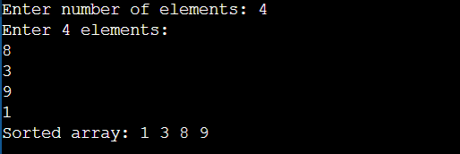
B] Code: Merge Sort (Using Array)
#include <stdio.h>
void merge(int arr[], int low, int mid, int high) {
int n1 = mid - low + 1;
int n2 = high - mid;
int L[n1], R[n2];
for (int i = 0; i < n1; i++)
L[i] = arr[low + i];
for (int j = 0; j < n2; j++)
R[j] = arr[mid + 1 + j];
int i = 0, j = 0, k = low;
while (i < n1 && j < n2) {
if (L[i] <= R[j])
arr[k++] = L[i++];
else
arr[k++] = R[j++];
}
while (i < n1)
arr[k++] = L[i++];
while (j < n2)
arr[k++] = R[j++];
}
void mergeSort(int arr[], int low, int high) {
if (low < high) {
int mid = (low + high) / 2;
mergeSort(arr, low, mid);
mergeSort(arr, mid + 1, high);
merge(arr, low, mid, high);
}
}
int main() {
int n;
printf("Enter number of elements: ");
scanf("%d", &n);
int arr[n];
printf("Enter %d elements:\n", n);
for (int i = 0; i < n; i++)
scanf("%d", &arr[i]);
mergeSort(arr, 0, n - 1);
printf("Sorted array: ");
for (int i = 0; i < n; i++)
printf("%d ", arr[i]);
return 0;
}
Output :
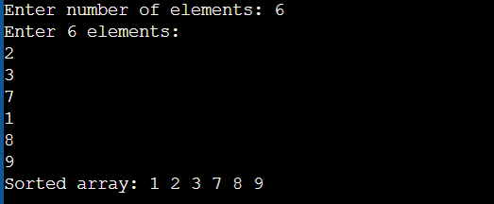
Applications of Quick Sort and Merge Sort:
- Sorting large datasets efficiently.
- Used in databases and library functions like qsort() in C.
- Merge Sort is ideal for external sorting (large files on disk).
- Quick Sort is widely used for in-memory sorting in programming languages.
- Merge Sort is used in linked list sorting because of its stability.
- Both are applied in search and data analysis systems.
- Used in competitive programming for solving complex sorting problems.
Advantages:
- Quick Sort: Very fast in average cases, uses less extra space, and easy to implement recursively.
- Merge Sort: Stable, predictable, and efficient for large datasets.
- Both algorithms effectively demonstrate the divide and conquer strategy.
Disadvantages:
- Quick Sort: Performance degrades to O(n²) if pivot selection is poor.
- Merge Sort: Requires extra O(n) space for merging operations.
- Both are more complex compared to simple algorithms like bubble or insertion sort.

Application Example: Sorting Student Marks using Quick Sort
#include <stdio.h>
void swap(int *a, int *b) {
int temp = *a;
*a = *b;
*b = temp;
}
int partition(int arr[], int low, int high) {
int pivot = arr[high];
int i = (low - 1);
for (int j = low; j < high; j++) {
if (arr[j] < pivot) {
i++;
swap(&arr[i], &arr[j]);
}
}
swap(&arr[i + 1], &arr[high]);
return (i + 1);
}
void quickSort(int arr[], int low, int high) {
if (low < high) {
int pi = partition(arr, low, high);
quickSort(arr, low, pi - 1);
quickSort(arr, pi + 1, high);
}
}
int main() {
int marks[] = {78, 92, 56, 88, 69, 100, 85};
int n = sizeof(marks) / sizeof(marks[0]);
quickSort(marks, 0, n - 1);
printf("Sorted Student Marks: ");
for (int i = 0; i < n; i++)
printf("%d ", marks[i]);
return 0;
}
Conclusion:
Quick Sort and Merge Sort are two of the most efficient and widely used sorting algorithms in computer science. Both utilize the divide and conquer approach, but differ in space usage and stability.

Experiment No : 03
---------------------------------------------------------------------------------------------------------
Aim: To solve the fractional knapsack problem using greedy approach and analyze its time and space complexity.
Title: Implementation of Knapsack Problem using Greedy Method
Theory:
The Knapsack problem is an optimization problem where a set of items, each with a weight and a profit, must be selected to maximize total profit without exceeding the weight capacity of the knapsack. The Greedy approach is used for the fractional knapsack problem, where we can take fractions of items instead of whole items.
In this method, items are sorted according to their profit-to-weight ratio (P/W) in descending order. Then items are added to the knapsack starting from the highest ratio until the capacity is filled. This ensures that the most valuable items per unit weight are included first, achieving an optimal solution.
Algorithm Steps:
- Input the number of items and capacity of the knapsack.
- Calculate profit/weight ratio for each item.
- Sort items in descending order of their ratio.
- Select items sequentially until the capacity is full.
- If an item can’t be taken fully, take a fraction of it.
- Output the maximum profit.
Code:
#include <stdio.h>
void knapsack(int n, float weight[], float profit[], float capacity) {
float x[20], ratio[20], total_profit = 0, temp;
int i, j;
float u = capacity;
for (i = 0; i < n; i++)
ratio[i] = profit[i] / weight[i];
for (i = 0; i < n; i++) {
for (j = i + 1; j < n; j++) {
if (ratio[i] < ratio[j]) {
temp = ratio[i]; ratio[i] = ratio[j]; ratio[j] = temp;
temp = profit[i]; profit[i] = profit[j]; profit[j] = temp;
temp = weight[i]; weight[i] = weight[j]; weight[j] = temp;
}
}
}
for (i = 0; i < n; i++)
x[i] = 0.0;
for (i = 0; i < n; i++) {
if (weight[i] > u)
break;
x[i] = 1.0;
total_profit += profit[i];
u -= weight[i];
}
if (i < n)
x[i] = u / weight[i];
total_profit += x[i] * profit[i];
printf("\nResult vector: ");
for (i = 0; i < n; i++)
printf("%.2f ", x[i]);
printf("\nMaximum Profit = %.2f\n", total_profit);
}
int main() {
float weight[20], profit[20], capacity;
int n, i;
printf("Enter number of items: ");
scanf("%d", &n);
printf("Enter weights of all items:\n");
for (i = 0; i < n; i++)
scanf("%f", &weight[i]);
printf("Enter profits of all items:\n");
for (i = 0; i < n; i++)
scanf("%f", &profit[i]);
printf("Enter capacity of knapsack: ");
scanf("%f", &capacity);
knapsack(n, weight, profit, capacity);
return 0;
}
Output :
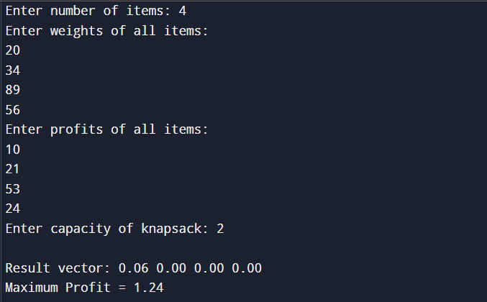
Applications:
- Resource allocation in project management.
- Portfolio optimization in finance.
- Cargo loading and shipping management.
- Memory allocation in operating systems.
- Bandwidth allocation in networks.
- Selection of advertisements in web applications.
- Cutting stock and production planning problems.
Advantages:
- Provides an optimal solution for fractional knapsack.
- Fast and efficient using greedy logic.
- Easy to implement and understand.
- Suitable for real-time decision-making problems.
Disadvantages:
- Cannot be used for 0/1 knapsack problems (where items cannot be divided).
- Sorting step increases computational cost for large datasets.
- May fail to give the optimal result in non-fractional (integer) scenarios.
- Assumes perfect divisibility of items.
Code for Application (Cargo Loading):
#include <stdio.h>
int main() {
int n = 3;
float weight[] = {10, 20, 30};
float profit[] = {60, 100, 120};
float capacity = 50;
float total_profit = 0, ratio[3], x[3];
int i, j;
float temp;
for (i = 0; i < n; i++)
ratio[i] = profit[i] / weight[i];
for (i = 0; i < n; i++) {
for (j = i + 1; j < n; j++) {
if (ratio[i] < ratio[j]) {
temp = ratio[i]; ratio[i] = ratio[j]; ratio[j] = temp;
temp = profit[i]; profit[i] = profit[j]; profit[j] = temp;
temp = weight[i]; weight[i] = weight[j]; weight[j] = temp;
}
}
}
float remaining = capacity;
for (i = 0; i < n; i++) {
if (weight[i] <= remaining) {
x[i] = 1;
total_profit += profit[i];
remaining -= weight[i];
} else {
x[i] = remaining / weight[i];
total_profit += x[i] * profit[i];
break;
}
}
printf("Total cargo profit: %.2f\n", total_profit);
return 0;
}
Conclusion:
The greedy method efficiently solves the fractional knapsack problem by selecting items with the highest profit-to-weight ratio first. It ensures optimal profit for fractional cases with lower computational complexity.

Experiment No : 04
---------------------------------------------------------------------------------------------------------Aim: To implement the Optimal Merge Pattern using the Greedy approach and analyze its time and space complexities.
Title: Implementation of the Greedy Method to Solve the Optimal Merge Pattern Problem
Theory:
The Optimal Merge Pattern is a classic problem used to find the minimum cost of merging multiple sorted files into one.
Each merge operation has a cost equal to the sum of the sizes of the files being merged.
The Greedy method chooses the two smallest files first to merge, ensuring that the intermediate costs remain minimal. This approach continues until only one file remains, resulting in the least total merge cost.
This algorithm is closely related to Huffman coding and file merging optimization.
Algorithm Steps:
- Input the number and sizes of files.
- Sort the file sizes in ascending order.
- Merge the two smallest files and record the cost.
- Insert the merged file back and repeat until one file remains.
- Output the total cost.
Code: (Optimal Merge Pattern using Greedy Method)
#include <stdio.h>
void optimalMerge(int files[], int n) {
int total_cost = 0, temp, i, j;
while (n > 1) {
for (i = 0; i < n - 1; i++) {
for (j = 0; j < n - i - 1; j++) {
if (files[j] > files[j + 1]) {
temp = files[j];
files[j] = files[j + 1];
files[j + 1] = temp;
}
}
}
temp = files[0] + files[1];
total_cost += temp;
files[0] = temp;
for (i = 1; i < n - 1; i++)
files[i] = files[i + 1];
n--;
}
printf("\nMinimum Total Merge Cost = %d\n", total_cost);
}
int main() {
int files[20], n, i;
printf("Enter number of files: ");
scanf("%d", &n);
printf("Enter sizes of files:\n");
for (i = 0; i < n; i++)
scanf("%d", &files[i]);
optimalMerge(files, n);
return 0;
}
Output :
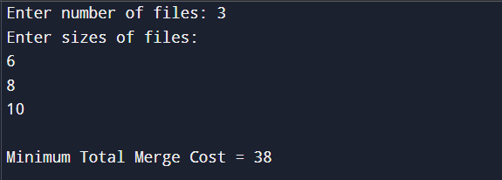
Time Complexity:
Sorting inside loop → O(n²)
Overall → O(n²)
Space Complexity:
Uses one array of size n → O(n)

Applications of Optimal Merge Pattern:
- File merging in external storage systems.
- Data compression (Huffman coding).
- Database record merging.
- Task scheduling optimization.
- Parallel computing merge operations.
- Multiway merge sort.
- Tape or disk optimization.

Advantages:
- Produces minimum total merging cost.
- Simple greedy logic and easy implementation.
- Suitable for file optimization problems.
Disadvantages:
- Inefficient for very large datasets (due to repeated sorting).
- Better implemented with min-heap for large inputs.
- Limited by array size in basic approach.

Application Code: Merging Sorted Data Files (Practical Use)
#include <stdio.h>
void optimalMerge(int files[], int n) {
int total_cost = 0, temp, i, j;
while (n > 1) {
for (i = 0; i < n - 1; i++) {
for (j = 0; j < n - i - 1; j++) {
if (files[j] > files[j + 1]) {
temp = files[j];
files[j] = files[j + 1];
files[j + 1] = temp;
}
}
}
temp = files[0] + files[1];
printf("Merging files of size %d and %d → Cost = %d\n", files[0], files[1], temp);
total_cost += temp;
files[0] = temp;
for (i = 1; i < n - 1; i++)
files[i] = files[i + 1];
n--;
}
printf("\n Minimum Total Merge Cost = %d\n", total_cost);
}
int main() {
int files[20], n, i;
printf("Enter number of sorted data files: ");
scanf("%d", &n);
printf("Enter sizes of files (in MB):\n");
for (i = 0; i < n; i++)
scanf("%d", &files[i]);
optimalMerge(files, n);
return 0;
}
Conclusion:
The Optimal Merge Pattern efficiently merges multiple sorted files with minimal total cost using a greedy strategy. This approach demonstrates how locally optimal decisions (merging smallest files first) lead to a globally optimal solution.

Experiment No : 05
---------------------------------------------------------------------------------------------------------
Aim: To implement and compare Prim’s and Kruskal’s algorithms for finding the Minimum Cost Spanning Tree (MST) of a connected undirected weighted graph.
Title: Minimum Cost Spanning Tree of a given undirected graph using Prim’s algorithm and Kruskal's algorithm and compare.
Theory:
A Minimum Cost Spanning Tree (MST) of a connected graph is a set of edges that connects all vertices with no cycles and with minimum possible total edge weight.
Prim’s Algorithm starts with a vertex and grows the MST by repeatedly adding the smallest weight edge connecting the tree to a new vertex. It is efficient on dense graphs (can be implemented with adjacency matrix or priority queue).
Kruskal’s Algorithm sorts all edges by weight and adds them one-by-one to the MST if they do not form a cycle (checked via union-find). It is effective for sparse graphs (edge-list based).
Both algorithms produce an MST with identical total weight but differ in approach and performance characteristics.
Algorithm Steps (short):
- Prim: Start from a vertex → repeatedly add cheapest edge from tree to non-tree vertex → stop when all vertices included.
- Kruskal: Make a sorted list of edges → pick smallest edge that doesn’t create a cycle → use union-find until MST has (V-1) edges.
Code: Prim’s Algorithm (Adjacency Matrix)
/* Prim's Algorithm - adjacency matrix */
#include <stdio.h>
#include <limits.h>
#define MAX 20

void prims(int n, int cost[MAX][MAX]) {
int selected[MAX] = {0}, ne = 0, total = 0;
selected[0] = 1;
printf("Edges in MST (Prim):\n");
while (ne < n - 1) {
int min = INT_MAX, a = -1, b = -1;
for (int u = 0; u < n; u++) {
if (selected[u]) {
for (int v = 0; v < n; v++) {
if (!selected[v] && cost[u][v] < min) {
min = cost[u][v];
a = u; b = v;
}
}
}
}
if (a != -1 && b != -1) {
printf("Edge %d: (%d - %d) cost = %d\n", ne + 1, a + 1, b + 1, min);
total += min;
selected[b] = 1;
ne++;
} else break;
}
printf("\nMinimum cost of Spanning Tree (Prim) = %d\n", total);
}

Code: Kruskal’s Algorithm (Edge list + Union-Find)
/* Kruskal's Algorithm - edge list & union-find */
#include <stdio.h>
#define MAXE 100
#define MAXV 20
typedef struct { int u, v, w; } Edge;
int find(int parent[], int i) {
if (parent[i] == i) return i;
return parent[i] = find(parent, parent[i]);
}
void union_set(int parent[], int x, int y) {
int rx = find(parent, x);
int ry = find(parent, y);
parent[rx] = ry;
}
void kruskal(int n, Edge edges[], int m) {
/* sort edges by weight (simple bubble sort for clarity) */
for (int i = 0; i < m - 1; i++)
for (int j = 0; j < m - i - 1; j++)
if (edges[j].w > edges[j+1].w) {
Edge t = edges[j]; edges[j] = edges[j+1]; edges[j+1] = t;
}
int parent[MAXV];
for (int i = 0; i < n; i++) parent[i] = i;
int ne = 0, i = 0, total = 0;
printf("Edges in MST (Kruskal):\n");
while (ne < n - 1 && i < m) {
int u = edges[i].u, v = edges[i].v, w = edges[i].w;
int ru = find(parent, u), rv = find(parent, v);
if (ru != rv) {
printf("Edge %d: (%d - %d) cost = %d\n", ne + 1, u + 1, v + 1, w);
total += w;
union_set(parent, ru, rv);
ne++;
}
i++;
}
printf("\nMinimum cost of Spanning Tree (Kruskal) = %d\n", total);
}
Applications (general):
- Network design (LAN / telecom cabling)
- Road / pipeline / utility layout to minimize cost
- Circuit / PCB routing approximations
- Cluster analysis in data mining
- Image segmentation (graph-based)
- Approximation tools in NP-hard problems
- Building minimum backbone networks (ISP, metro networks)
Advantages
- Produces true minimum-cost connection (MST).
- Kruskal is simple with edge lists; Prim is efficient with dense graphs & heaps.
- Both are greedy and deterministic.
Disadvantages
- Require connected graphs (otherwise produce forest or fail).
- Choice depends on graph density; naive implementations can be slow for large graphs.
- Extra data structures (priority queue / union-find) recommended for performance.
Application (Practical): Designing Minimum-Cost LAN Cabling Between Offices
Description: Given offices A, B, C, ..., and estimated cabling cost between each pair, compute the minimum total cabling cost to connect all offices so any office can reach any other.
Application Code (uses Kruskal with office names for clarity):
#include <stdio.h>
#define MAXV 20
#define MAXE 100
typedef struct {
int u, v, w;
}
Edge;
int find(int parent[], int i) {
if (parent[i] == i) return i;
return parent[i] = find(parent, parent[i]);
}
void union_set(int parent[], int x, int y) {
parent[find(parent, x)] = find(parent, y);
}

int main() {
int n, m;
Edge e[MAXE];
char name[MAXV][30];
int parent[MAXV];
printf("Enter number of offices: ");
scanf("%d", &n);
for (int i = 0; i < n; i++) {
printf("Enter name of office %d: ", i + 1);
scanf("%s", name[i]);
parent[i] = i;
}
printf("Enter number of direct links: ");
scanf("%d", &m);
printf("Enter links as: u v cost (1 to %d)\n", n);
for (int i = 0; i < m; i++)
scanf("%d %d %d", &e[i].u, &e[i].v, &e[i].w), e[i].u--, e[i].v--;
for (int i = 0; i < m - 1; i++)
for (int j = 0; j < m - i - 1; j++)
if (e[j].w > e[j + 1].w) {
Edge t = e[j];
e[j] = e[j + 1];
e[j + 1] = t;
}

int total = 0, count = 0;
printf("\nSelected links for minimum-cost LAN:\n");
for (int i = 0; i < m && count < n - 1; i++) {
int u = e[i].u, v = e[i].v, w = e[i].w;
if (find(parent, u) != find(parent, v)) {
printf("%s -- %s : cost = %d\n", name[u], name[v], w);
total += w;
union_set(parent, u, v);
count++;
}
}
if (count == n - 1)
printf("\nTotal minimum cabling cost = %d\n", total);
else
printf("\nGraph is disconnected; cannot connect all offices.\n");
return 0;
}
Output :
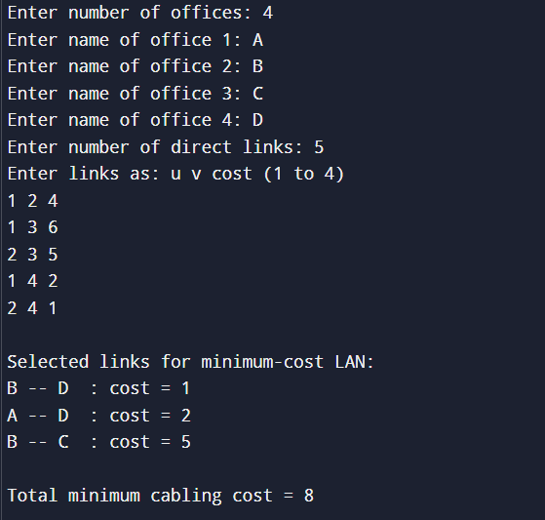
Comparison (short):
- Both yield same MST cost (19 in sample application).
- Prim scans nearest edges from the current tree and is good for dense graphs or when using adjacency matrix + heap.
- Kruskal works well with sparse graphs and edge lists; easy to adapt to named nodes (as shown).
Conclusion:
Prim’s and Kruskal’s algorithms both compute the MST; the right choice depends on graph representation and density. For practical network design (LAN cabling), Kruskal with an edge list provides a clear and direct method to compute minimum total cost.

Experiment No : 06
---------------------------------------------------------------------------------------------------------
Aim: To determine the shortest path from a given source vertex to all other vertices in a weighted connected graph using Dijkstra’s algorithm.
Title: Implementation of Dijkstra’s Algorithm to Find the Shortest Path in a Weighted Connected Graph
Theory:
Dijkstra’s algorithm is one of the most widely used algorithms for finding the shortest path between nodes in a graph. It works only with non-negative edge weights.
The algorithm maintains a set of vertices whose minimum distance from the source is already known and repeatedly selects the vertex with the minimum tentative distance to explore its neighbours.
It updates the distance of each adjacent vertex by comparing the current known distance and the newly calculated distance through the selected vertex.
The algorithm is particularly effective in applications like network routing, GPS navigation, and transportation planning, where minimizing cost, time, or distance is essential.
Algorithm Steps:
- Initialize all distances as infinity except for the source vertex (set to 0).
- Mark all vertices as unvisited.
- Choose the unvisited vertex with the smallest distance.
- Update the distances of all its adjacent vertices.
- Mark the current vertex as visited.
- Repeat steps 3–5 until all vertices are visited or all shortest paths are determined.
Program Code:
#include <stdio.h>
#define INF 999
void dijkstra(int n, int cost[10][10], int src) {
int dist[10], visited[10], count, u, v, min;
for (int i = 0; i < n; i++) {
dist[i] = cost[src][i];
visited[i] = 0;
}
dist[src] = 0;
visited[src] = 1;
count = 1;
while (count < n - 1) {
min = INF;
for (int i = 0; i < n; i++)
if (dist[i] < min && !visited[i]) {
min = dist[i];
u = i;
}
visited[u] = 1;
for (v = 0; v < n; v++)
if (!visited[v] && dist[u] + cost[u][v] < dist[v])
dist[v] = dist[u] + cost[u][v];
count++;
}

printf("\nShortest distances from vertex %d:\n", src + 1);
for (int i = 0; i < n; i++)
printf("To vertex %d = %d\n", i + 1, dist[i]);
}
int main() {
int n, cost[10][10], src;
printf("Enter number of vertices: ");
scanf("%d", &n);
printf("Enter cost adjacency matrix (use 999 for no edge):\n");
for (int i = 0; i < n; i++)
for (int j = 0; j < n; j++)
scanf("%d", &cost[i][j]);
printf("Enter source vertex (1-%d): ", n);
scanf("%d", &src);
dijkstra(n, cost, src - 1);
return 0;
}
Output :
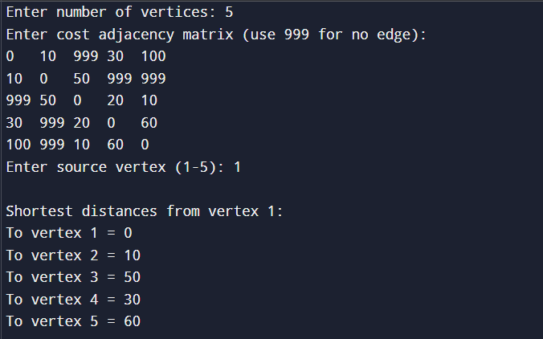
Applications:
- GPS navigation systems to find shortest driving routes.
- Network routing protocols (like OSPF) for optimal data transmission.
- Airline route planning and cost optimization.
- Robotics pathfinding and movement control.
- Social networking sites to find connection degrees between users.
- Internet packet switching for least-delay path selection.
- Urban traffic flow management and logistics planning.
Advantages:
- Guarantees the shortest path in graphs with non-negative weights.
- Efficient for sparse graphs.
- Can be easily implemented using priority queues or adjacency matrices.
- Suitable for both directed and undirected graphs.
Disadvantages:
- Fails with graphs having negative edge weights.
- Less efficient for dense graphs.
- Requires extra memory for large graphs.
- Does not handle dynamically changing graphs well.
Application Example Code (Network Routing):
#include <stdio.h>
#define INF 999
void findRoute(int n, int cost[10][10], int src) {
int dist[10], visited[10], u, v, count, min;
for (int i = 0; i < n; i++) {
dist[i] = cost[src][i];
visited[i] = 0;
}
visited[src] = 1;
count = 1;
while (count < n - 1) {
min = INF;
for (int i = 0; i < n; i++)
if (dist[i] < min && !visited[i]) {
min = dist[i];
u = i;
}
visited[u] = 1;
for (v = 0; v < n; v++)
if (!visited[v] && dist[u] + cost[u][v] < dist[v])
dist[v] = dist[u] + cost[u][v];
count++;
}
printf("\nLeast cost from router %d:\n", src + 1);
for (int i = 0; i < n; i++)
printf("To router %d = %d\n", i + 1, dist[i]);
}
int main() {
int n, cost[10][10], src;
printf("Enter number of routers: ");
scanf("%d", &n);
printf("Enter cost matrix (999 for no direct link):\n");
for (int i = 0; i < n; i++)
for (int j = 0; j < n; j++)
scanf("%d", &cost[i][j]);
printf("Enter source router: ");
scanf("%d", &src);
findRoute(n, cost, src - 1);
return 0; }
Conclusion:
Dijkstra’s algorithm efficiently determines the shortest paths from a given source to all vertices in a weighted connected graph. It is widely used in real-world applications where cost or distance optimization is crucial.

Experiment No : 07
--------------------------------------------------------------------------------------------
Aim: To construct an Optimal Binary Search Tree (OBST) for a given set of sorted keys
Title: Implementation of Optimal Binary Search Tree (OBST) using Dynamic Programming.
Theory:
A Binary Search Tree (BST) is a data structure in which each node has at most two children — the left child contains keys smaller than the parent key, and the right child contains keys larger than the parent key.
However, when the probability of searching each key is not uniform, the normal BST may not yield the least average search cost.
Hence, we construct an Optimal Binary Search Tree (OBST) that minimizes the expected cost of search operations, using Dynamic Programming.
The expected cost of a BST is given by:
[E = \sum_{i=1}^{n} (Pi \times (level_i + 1))]
where
- (Pi) = probability of searching key (Ki)
- (level_i) = level (depth) of the key in the tree
The OBST algorithm uses a cost matrix that stores the minimum search costs for every subproblem, computed recursively as:
[cost[i][j] = \min_{r=i}^{j} (cost[i][r-1] + cost[r+1][j] + sum(p[i]..p[j]))]
………where (r) is the chosen root in that subrange.
This approach ensures that overlapping subproblems are reused, leading to an efficient O(n³) time complexity and O(n²) space complexity solution.
Algorithm Steps:
- Input the number of keys and their corresponding probabilities.
- Initialize the cost and weight matrices.
- Compute the cumulative probabilities (sum of (p[i]..p[j])).
- For each subrange length, compute the minimum cost using all possible roots.
- The entry cost[1][n] gives the minimum expected search cost for the OBST.
Optimal Binary Search Tree:
#include <stdio.h>
#include <limits.h>
#define MAX 20
void optimalBST(float p[], int n) {
float cost[MAX][MAX], weight[MAX][MAX];
int root[MAX][MAX];
for (int i = 0; i <= n; i++) {
cost[i][i] = 0;
weight[i][i] = 0;
}
for (int i = 1; i <= n; i++) {
cost[i][i - 1] = 0;
cost[i][i] = p[i];
weight[i][i] = p[i];
root[i][i] = i;
}
for (int m = 2; m <= n; m++) {
for (int i = 1; i <= n - m + 1; i++) {
int j = i + m - 1;
cost[i][j] = INT_MAX;
weight[i][j] = weight[i][j - 1] + p[j];
for (int r = i; r <= j; r++) {
float t = cost[i][r - 1] + cost[r + 1][j] + weight[i][j];
if (t < cost[i][j]) {
cost[i][j] = t;
root[i][j] = r;
}
}
}
}
printf("\nMinimum cost of Optimal BST = %.2f\n", cost[1][n]);
printf("Root of the tree = %d\n", root[1][n]);
}
int main() {
int n;
float p[MAX];
printf("Enter number of keys: ");
scanf("%d", &n);
printf("Enter probabilities of each key:\n");
for (int i = 1; i <= n; i++) {
printf("P[%d]: ", i);
scanf("%f", &p[i]);
}
optimalBST(p, n);
return 0;
}
Output :
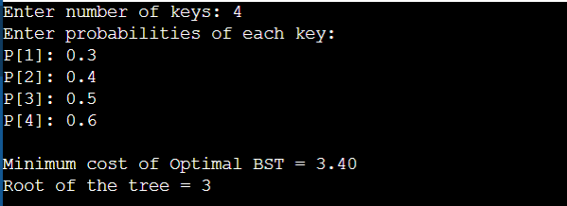
Applications of OBST:
- Used in compiler design for efficient symbol table searching.
- Helps in database indexing where key access frequencies differ.
- Used in information retrieval systems to minimize average access time.
- Helpful in designing decision trees in artificial intelligence.
- Used in file organization systems to reduce average search time.

file organization systems to reduce average search time.
#include <stdio.h>
#include <limits.h>
#define MAX 10
void optimalBST(float p[], int n) {
float cost[MAX][MAX], weight[MAX][MAX];
int root[MAX][MAX];
for (int i = 0; i <= n; i++) {
cost[i][i] = 0;
weight[i][i] = 0;
}
for (int i = 1; i <= n; i++) {
cost[i][i] = p[i];
weight[i][i] = p[i];
root[i][i] = i;
}
for (int m = 2; m <= n; m++) {
for (int i = 1; i <= n - m + 1; i++) {
int j = i + m - 1;
cost[i][j] = INT_MAX;
weight[i][j] = weight[i][j - 1] + p[j];
for (int r = i; r <= j; r++) {
float temp = cost[i][r - 1] + cost[r + 1][j] + weight[i][j];
if (temp < cost[i][j]) {
cost[i][j] = temp;
root[i][j] = r;
}
}
}
}
printf("\nMinimum Average Search Cost (OBST) = %.2f\n", cost[1][n]);
printf("Root Node Index (Most Frequently Accessed File) = %d\n", root[1][n]);
}
int main() {
int n;
float p[MAX];
printf("Enter number of files: ");
scanf("%d", &n);
printf("Enter access probabilities of %d files:\n", n);
for (int i = 1; i <= n; i++) {
printf("File %d: ", i);
scanf("%f", &p[i]);
}

optimalBST(p, n);
return 0;
}
Advantages:
- Minimizes average search cost when access probabilities vary.
- Improves performance over normal BSTs for non-uniform data access.
- Provides an optimal structure for frequent queries.
Disadvantages:
- Construction is complex compared to a simple BST.
- Requires knowledge of key access probabilities.
- Not efficient for frequently changing data.

Conclusion:
The Optimal Binary Search Tree (OBST) efficiently minimizes the average search cost using Dynamic Programming.
It is especially useful in applications like compilers and databases where some elements are accessed more frequently than others.

Experiment No : 08
--------------------------------------------------------------------------------------------
Aim: To find the shortest path from a single source vertex to all other vertices in a weighted connected graph using Dijkstra’s algorithm.
Title: Implementation of Single Source Shortest Path Problem using Dijkstra’s Algorithm
Theory: The Single Source Shortest Path Problem determines the shortest distance from one source vertex to all others in a weighted graph.
Dijkstra’s algorithm solves this using a greedy approach, selecting the vertex with the smallest tentative distance and updating distances to its neighbors.
It is especially effective for graphs with non-negative edge weights and forms the basis for many real-world applications like Google Maps, network routing, and transportation optimization.
The algorithm maintains a set of vertices for which the shortest path is already known and repeatedly selects the next vertex with the smallest distance from the source until all vertices are processed.
Algorithm:
- Initialize all distances as infinity and source distance as 0.
- Mark all vertices as unvisited.
- Select the unvisited vertex with the smallest distance.
- Update distances of its adjacent vertices.
- Mark the selected vertex as visited.
- Repeat until all vertices are visited.
(Main Implementation):
#include <stdio.h>
#define INF 999
void dijkstra(int n, int cost[10][10], int src) {
int dist[10], visited[10], count, u, v, min;
for (int i = 0; i < n; i++) {
dist[i] = cost[src][i];
visited[i] = 0;
}
dist[src] = 0;
visited[src] = 1;
count = 1;
while (count < n - 1) {
min = INF;
for (int i = 0; i < n; i++)
if (dist[i] < min && !visited[i]) {
min = dist[i];
u = i;
}
visited[u] = 1;
for (v = 0; v < n; v++)
if (!visited[v] && dist[u] + cost[u][v] < dist[v])
dist[v] = dist[u] + cost[u][v];
count++;
}
printf("\nShortest distances from vertex %d:\n", src + 1);
for (int i = 0; i < n; i++)
printf("To vertex %d = %d\n", i + 1, dist[i]);
}
int main() {
int n, cost[10][10], src;
printf("Enter number of vertices: ");
scanf("%d", &n);
printf("Enter cost adjacency matrix (use 999 for no edge):\n");
for (int i = 0; i < n; i++)
for (int j = 0; j < n; j++)
scanf("%d", &cost[i][j]);
printf("Enter source vertex (1-%d): ", n);
scanf("%d", &src);
dijkstra(n, cost, src - 1);
return 0;
}
Output :
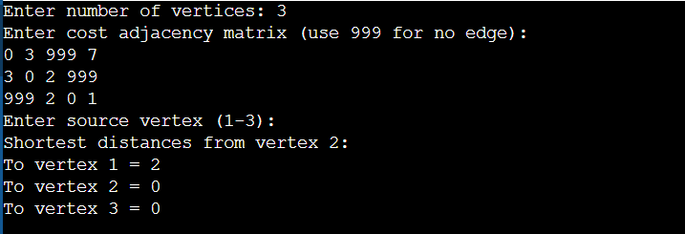
Applications:
- Google Maps / GPS Navigation System – for finding shortest routes between cities.
- Computer Networks – determines shortest data transmission paths.
- Transportation Planning – minimizes travel cost or time.
- Telecommunication Routing Protocols – e.g., OSPF.
- Robotics Path Planning – for navigation and obstacle avoidance.
- Airline Route Optimization.
- Logistics and Supply Chain Optimization.

Application— GPS Route Finder (Using Dijkstra’s Algorithm):
#include <stdio.h>
#define INF 999
#define MAX 5
void dijkstra(int graph[MAX][MAX], int n, int start) {
int dist[MAX], visited[MAX];
for (int i = 0; i < n; i++) {
dist[i] = graph[start][i];
visited[i] = 0;
}
dist[start] = 0;
visited[start] = 1;
for (int count = 1; count < n - 1; count++) {
int min = INF, u = -1;
for (int i = 0; i < n; i++)
if (!visited[i] && dist[i] < min) {
min = dist[i];
u = i;
}
visited[u] = 1;
for (int v = 0; v < n; v++)
if (!visited[v] && dist[u] + graph[u][v] < dist[v])
dist[v] = dist[u] + graph[u][v];
}
printf("\nShortest distances from starting city:\n");
for (int i = 0; i < n; i++)
printf("To City %d = %d km\n", i + 1, dist[i]);
}
int main() {
int graph[MAX][MAX] = {
{0, 10, 3, INF, INF},
{10, 0, 1, 2, INF},
{3, 1, 0, 8, 2},
{INF, 2, 8, 0, 7},
{INF, INF, 2, 7, 0}
};
int n = 5, start = 0;
printf("Shortest Route Calculation (Simulating GPS Navigation)\n");
dijkstra(graph, n, start);
return 0;
}
Advantages:
- Finds shortest path efficiently for non-negative edge weights.
- Simple to implement and adapt to real-world problems.
- Works well for network and navigation applications.
Disadvantages:
- Fails with negative edge weights.
- Not optimal for very large graphs (use A* or Floyd-Warshall instead).
Conclusion:
Dijkstra’s algorithm efficiently determines the shortest path from a source to all destinations in a weighted graph.
Its use in GPS navigation and routing systems proves its significance in real-world applications.

Experiment No. 09
---------------------------------------------------------------------------------------------------------
Aim: To implement the Sum of Subset Problem using backtracking and apply it to data partitioning, where datasets (files) are divided equally across two servers to balance the data load.
Title: Implementation of Sum of Subset Problem using Backtracking
Theory: In distributed computing, data partitioning ensures that data and processing tasks are evenly distributed across servers for optimal performance and resource utilization.
The Sum of Subset Problem finds all subsets of a set whose sum equals a target value.
In data partitioning, each file’s size can be treated as a number, and we attempt to find subsets of files whose total sizes are equal — ensuring balanced storage across servers.
Algorithm:
- Input number of files and their sizes.
- Calculate total size and find the half (target).
- Generate subsets recursively using backtracking.
- Check if subset sum equals target.
- Display balanced data distributions (subsets).
Program Code (C Language):
#include <stdio.h>
int n, target, files[20], x[20];
void partitionData(int s, int k, int r) {
x[k] = 1;
if (s + files[k] == target) {
printf("Server 1 subset (balanced load): ");
for (int i = 0; i <= k; i++)
if (x[i] == 1)
printf("F%d ", i + 1);
printf("\n");
}
else if (s + files[k] + files[k + 1] <= target)
partitionData(s + files[k], k + 1, r - files[k]);
if ((s + r - files[k] >= target) && (s + files[k + 1] <= target)) {
x[k] = 0
partitionData(s, k + 1, r - files[k]);
}
}
int main() {
int total = 0;
printf("Enter number of files: ");
scanf("%d", &n);
printf("Enter size of each file (in ascending order):\n");
for (int i = 0; i < n; i++) {
scanf("%d", &files[i]);
total += files[i];
}
if (total % 2 != 0) {
printf("\nEqual partition not possible (total size is odd).\n");
return 0;
}
target = total / 2;
printf("\nTotal data = %d units\nTarget load per server = %d units\n", total, target);

printf("\nPossible balanced data distributions:\n");
partitionData(0, 0, total);
return 0;
}
Output:
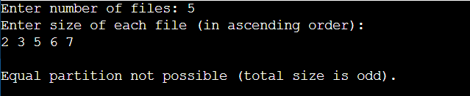
Advantages:
- Ensures balanced workload across all servers or processors.
- Provides optimal data utilization in distributed systems.
- Guarantees all possible valid partitions using backtracking.
- Can be adapted for resource and task allocation problems.
Disadvantages:
- Exponential time complexity (O(2ⁿ)), making it inefficient for large datasets.
- Requires data to be sorted for efficiency.
- May consume high memory when multiple subsets exist.
- Not ideal for dynamic real-time partitioning systems.
Applications:
- Data Partitioning: Distributing datasets evenly among multiple servers.
- Parallel Processing: Balancing computational workloads.
- Cloud Storage Systems: Dividing data across nodes for redundancy.
- Memory Allocation: Equal division of data in memory blocks.
- File Systems: Load balancing between file servers.

Application – Data Partitioning Across Servers
#include <stdio.h>
int main() {
int files[] = {2, 3, 5, 6, 8};
int n = 5;
int total = 0;
for (int i = 0; i < n; i++)
total += files[i];
if (total % 2 != 0) {
printf("Equal partition not possible (odd total data size)\n");
return 0;
}
int target = total / 2;
int sum = 0;
printf("Total Data = %d units\n", total);
printf("Target Load per Server = %d units\n\n", target);
printf("Distributing data equally across servers...\n");
printf("Server 1: ");
for (int i = n - 1; i >= 0; i--) {
if (sum + files[i] <= target) {
sum += files[i];
printf("F%d ", i + 1);
}
}
printf("\nServer 2: Remaining files\n");
printf("\nData successfully divided equally across servers!\n");
return 0;
}
Conclusion:
The Sum of Subset Problem was implemented using backtracking and applied to data partitioning.
This ensures that datasets are divided equally across servers, optimizing performance and achieving balanced system load.

Experiment No. 10
--------------------------------------------------------------------------------------------

Aim: To find the shortest paths between all pairs of vertices in a weighted graph using Floyd’s Algorithm (Floyd–Warshall Algorithm).
Title: Implementation of All-Pairs Shortest Paths Problem using Floyd’s Algorithm
Theory: The All-Pairs Shortest Path (APSP) problem is used to determine the minimum distance between every pair of vertices in a weighted graph.
Floyd’s Algorithm, also known as the Floyd–Warshall Algorithm, is a dynamic programming technique that efficiently computes shortest paths for all vertex pairs, even when negative edge weights are present (but not negative cycles).
Algorithm:
Input the number of vertices n and the cost adjacency matrix cost[n][n].
(Use a large value like 999 for no direct edge.)
Initialize the distance matrix dist as the cost matrix.
For each vertex k (1 to n):
For each pair of vertices (i, j):
If dist[i][k] + dist[k][j] < dist[i][j],
then
dist[i][j] = dist[i][k] + dist[k][j]
After all iterations, dist[i][j] will contain the shortest distance from vertex i to j.

C Program Code:
#include <stdio.h>
#define INF 999
void floyd(int n, int cost[10][10]) {
int dist[10][10], i, j, k;
for (i = 0; i < n; i++)
for (j = 0; j < n; j++)
dist[i][j] = cost[i][j];
for (k = 0; k < n; k++)
for (i = 0; i < n; i++)
for (j = 0; j < n; j++)
if (dist[i][k] + dist[k][j] < dist[i][j])
dist[i][j] = dist[i][k] + dist[k][j];
printf("\nAll-Pairs Shortest Path Matrix:\n");
for (i = 0; i < n; i++) {
for (j = 0; j < n; j++) {
if (dist[i][j] == INF)
printf("%4s", "INF");
else
printf("%4d", dist[i][j]);
}
printf("\n");
}
}
int main() {
int n, cost[10][10];
printf("Enter number of vertices: ");
scanf("%d", &n);
printf("Enter the cost adjacency matrix (use 999 for no edge):\n");
for (int i = 0; i < n; i++)
for (int j = 0; j < n; j++)
scanf("%d", &cost[i][j]);
floyd(n, cost);
return 0; }
Output :
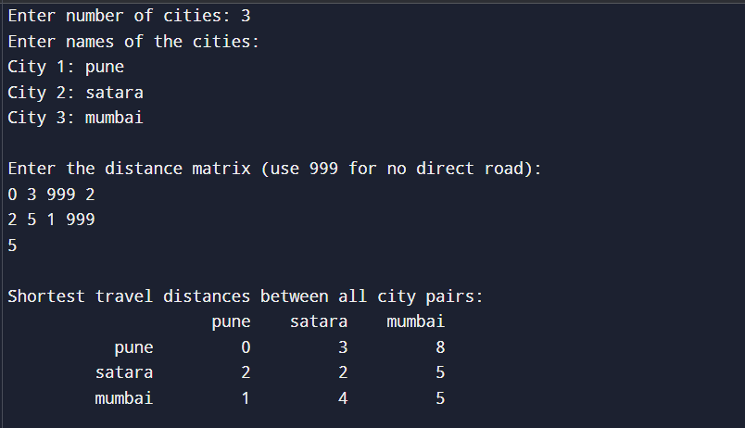
Applications:
1) Finding shortest travel routes between every pair of cities in a road network.
2) Network routing to compute minimum data transfer paths.
3) Transportation and logistics for optimizing delivery paths.
4) Social network analysis for finding shortest connection chains.
5) Map navigation systems for multi-point route optimization.

C Program: Finding Shortest Routes Between :
#include <stdio.h>
#include <string.h>
#define INF 999
#define MAX 10
void floyd(int n, int cost[MAX][MAX], char city[MAX][30]) {
int dist[MAX][MAX];
for (int i = 0; i < n; i++)
for (int j = 0; j < n; j++)
dist[i][j] = cost[i][j];
for (int k = 0; k < n; k++)
for (int i = 0; i < n; i++)
for (int j = 0; j < n; j++)
if (dist[i][k] + dist[k][j] < dist[i][j])
dist[i][j] = dist[i][k] + dist[k][j];
printf("\nShortest travel distances between all city pairs:\n");
printf("%15s", "");
for (int i = 0; i < n; i++)
printf("%10s", city[i]);
printf("\n");
for (int i = 0; i < n; i++) {
printf("%15s", city[i]);
for (int j = 0; j < n; j++) {
if (dist[i][j] == INF)
printf("%10s", "INF");
else
printf("%10d", dist[i][j]);
}
printf("\n");
}
}
int main() {
int n, cost[MAX][MAX];
char city[MAX][30];
printf("Enter number of cities: ");
scanf("%d", &n);
printf("Enter names of the cities:\n");
for (int i = 0; i < n; i++) {
printf("City %d: ", i + 1);
scanf("%s", city[i]);
}
printf("\nEnter the distance matrix (use 999 for no direct road):\n");
for (int i = 0; i < n; i++)
for (int j = 0; j < n; j++)
scanf("%d", &cost[i][j]);
floyd(n, cost, city);
return 0; }
Advantages:
1] Simple and easy to implement.
Works for both directed and undirected graphs.
2] Finds shortest paths between all pairs of vertices.
3] Works even if edge weights are negative (but not negative cycles).
Disadvantages:
Disadvantages:
1] High Time Complexity: Runs in O(V³) time, making it inefficient for large networks with many cities or nodes.
2] High Space Requirement: Requires an O(V²) matrix**, consuming significant memory for large graphs.
3] Not Suitable for Real-Time Systems: The algorithm must compute all pairs at once, making it unsuitable for dynamic or frequently changing graphs.
Conclusion:
The Floyd–Warshall Algorithm successfully computes the shortest paths between all pairs of vertices in a weighted graph.

