Supplemental Material

Association of central adiposity indices with cognitive impairment in elderly populations: Development and validation of a risk prediction nomogram using NHANES and CHARLS cohorts

Supplemental Table 1. Descriptions and assessments of the variables from CHARLS.
Variable | Description and assessment
Cognitive impairment | Cognitive function was evaluated using a comprehensive battery of assessments, including episodic memory, the 10-item Telephone Interview for Cognitive Status (TICS), and a figure-drawing task. Episodic memory was assessed by asking participants to recall a list of 10 Chinese nouns immediately after hearing them (immediate recall) and again after a four-minute delay (delayed recall). The average of the immediate and delayed recall scores (range: 0–10) was computed. The TICS included 10 questions evaluating temporal orientation (e.g., identifying the current season and date) and cognitive performance, such as serial subtraction of 7 from 100, repeated up to five times. Additionally, participants were shown an image of two overlapping pentagons and were instructed to replicate it (scored as 0 = failure or 1 = success). The total cognitive function score, ranging from 0 to 21, was calculated by summing the results of these three tests. Cognitive impairment was defined as a total score at least 1.0 standard deviation below the mean cognitive function score.
ABSI | $ABSI ={WC}/{\left({BMI}^{2/3} × {BH}^{1/2}\right)}$,  $$BMI = {BW}/{{BH}^{2}}$$
Stroke | Self-reported medical histories.
Diabetes mellitus | Self-reported medical histories.
Depression | The 10-item Centre for Epidemiological Studies, Depression Scale (CES-D-10) is widely used in epidemiological surveys to screen out subjects with depressive symptoms for further examination and diagnosis. The CES-D-10 is a short version of the scale, which has been validated in Chinese middle-aged and older adults with good reliability and validity. There are 10 items in the CES-D-10, with each item ranging from 0 (little) to 3 (most of the time). The total score ranges from 0 to 30, ≥10 suggests a risk of depressive symptoms.
ABSI: a body size index

Supplemental Table 2. Variance inflation factors between variables.
Variable | GVIF | Df | GVIF^(1/(2*Df))
ABSI
ABSI | 1.221 | 1 | 1.105
Age | 1.673 | 2 | 1.137
Gender | 1.362 | 1 | 1.167
Race | 1.991 | 4 | 1.09
Marital status | 1.232 | 2 | 1.053
Education level | 1.268 | 2 | 1.061
PIR | 1.246 | 1 | 1.116
PA | 1.082 | 2 | 1.02
BMI | 1.265 | 2 | 1.061
Smoking status | 1.386 | 2 | 1.085
Drinking status | 1.267 | 2 | 1.061
Hypertension | 1.075 | 1 | 1.037
Stroke | 1.054 | 1 | 1.027
CHD | 1.068 | 1 | 1.033
DM | 1.107 | 1 | 1.052
Depression | 1.099 | 1 | 1.048
WWI
WWI | 1.521 | 1 | 1.233
Age | 1.677 | 2 | 1.138
Gender | 1.392 | 1 | 1.18
Race | 2.063 | 4 | 1.095
Marital status | 1.233 | 2 | 1.054
Education level | 1.268 | 2 | 1.061
PIR | 1.25 | 1 | 1.118
PA | 1.086 | 2 | 1.021
BMI | 1.478 | 2 | 1.103
Smoking status | 1.379 | 2 | 1.084
Drinking status | 1.266 | 2 | 1.061
Hypertension | 1.075 | 1 | 1.037
Stroke | 1.055 | 1 | 1.027
CHD | 1.068 | 1 | 1.033
DM | 1.109 | 1 | 1.053
Depression | 1.1 | 1 | 1.049
CoI
CI | 1.426 | 1 | 1.194
Age | 1.665 | 2 | 1.136
Gender | 1.363 | 1 | 1.167
Race | 1.981 | 4 | 1.089
Marital status | 1.233 | 2 | 1.054
Education level | 1.269 | 2 | 1.061
PIR | 1.248 | 1 | 1.117
PA | 1.085 | 2 | 1.021
BMI | 1.491 | 2 | 1.105
Smoking status | 1.381 | 2 | 1.084
Drinking status | 1.267 | 2 | 1.061
Hypertension | 1.075 | 1 | 1.037
Stroke | 1.055 | 1 | 1.027
CHD | 1.068 | 1 | 1.033
DM | 1.116 | 1 | 1.056
Depression | 1.1 | 1 | 1.049
BRI
BRI | 2.829 | 1 | 1.682
Age | 1.659 | 2 | 1.135
Gender | 1.355 | 1 | 1.164
Race | 1.903 | 4 | 1.084
Marital status | 1.237 | 2 | 1.055
Education level | 1.268 | 2 | 1.061
PIR | 1.252 | 1 | 1.119
PA | 1.088 | 2 | 1.021
BMI | 2.89 | 2 | 1.304
Smoking status | 1.387 | 2 | 1.085
Drinking status | 1.27 | 2 | 1.062
Hypertension | 1.077 | 1 | 1.038
Stroke | 1.056 | 1 | 1.027
CHD | 1.068 | 1 | 1.033
DM | 1.101 | 1 | 1.049
Depression | 1.1 | 1 | 1.049
WtHR
WtHR | 3.207 | 1 | 1.791
Age | 1.659 | 2 | 1.135
Gender | 1.359 | 1 | 1.166
Race | 1.918 | 4 | 1.085
Marital status | 1.235 | 2 | 1.054
Education level | 1.267 | 2 | 1.061
PIR | 1.251 | 1 | 1.119
PA | 1.09 | 2 | 1.022
BMI | 3.229 | 2 | 1.34
Smoking status | 1.388 | 2 | 1.085
Drinking status | 1.269 | 2 | 1.061
Hypertension | 1.077 | 1 | 1.038
Stroke | 1.055 | 1 | 1.027
CHD | 1.068 | 1 | 1.033
DM | 1.105 | 1 | 1.051
Depression | 1.1 | 1 | 1.049
GVIF: generalized variance inflation factor; Df: degrees of freedom; ABSI: a body size index; WWI: weight-adjusted waist circumference index; CoI: conicity index; BRI: body roundness index; WHtR: waist-to-height ratio; PIR: poverty income ratio; PA: physical activity; CHD: coronary heart disease; DM: diabetes mellitus; BMI: body mass index

Supplemental Table 3. Association of five obesity-based anthropometric indices with p-MCI after multiple imputation.
 |  | Model 1 |  |  | Model 2 |  |  | Model 3
 | n.event_% | OR (95%CI) | p | OR (95%CI) |  | p | OR (95%CI) |  | p
ABSI Z-score | 468 (17) | 1.33 (1.2~1.47) | <0.001 | 1.33 (1.18~1.49) |  | <0.001 | 1.22 (1.07~1.39) |  | 0.004
WWI Z-score | 468 (17) | 1.38 (1.25~1.52) | <0.001 | 1.4 (1.24~1.57) |  | <0.001 | 1.36 (1.18~1.58) |  | <0.001
CoI Z-score | 468 (17) | 1.24 (1.12~1.37) | <0.001 | 1.23 (1.1~1.38) |  | <0.001 | 1.22 (1.05~1.41) |  | 0.008
BRI Z-score | 468 (17) | 1.09 (0.99~1.2) | 0.093 | 1.12 (1~1.25) |  | 0.047 | 1.18 (0.97~1.44) |  | 0.103
WHtR Z-score | 468 (17) | 0.86 (0.78~0.96) | 0.007 | 0.88 (0.78~1) |  | 0.044 | 0.8 (0.63~1.02) |  | 0.078
Model 1 included no covariate adjustments. Model 2 was adjusted for age, gender, and race. Model 3 was adjusted for age, gender, race, marital status, education level, PIR, smoking status, drinking status, PA, BMI, hypertension, stroke, CHD, DM, depression.
p-MCI: psychometric mild cognitive impairment; OR: odds ratio; 95% CI: 95% confidence interval; ABSI: a body size index; WWI: weight-adjusted waist circumference index; CoI: conicity index; BRI: body roundness index; WHtR: waist-to-height ratio; PIR: poverty income ratio; PA: physical activity; CHD: coronary heart disease; DM: diabetes mellitus; BMI: body mass index.

Supplemental Table 4. The characteristics of 10 predictors between training set and external validation set.
Characteristic | Training set  (N = 1725) | External validation set  (N = 536) | p
Age, y, n (%) |  |  | <0.001
60–69 | 940 (54.5) | 342 (63.8)
70–79 | 520 (30.1) | 173 (32.3)
≥ 80 | 265 (15.4) | 21 (3.9)
Gender, n (%) |  |  | 0.616
Male | 854 (49.5) | 272 (50.7)
Female | 871 (50.5) | 264 (49.3)
Race, n (%) |  |  | <0.001
Non-Hispanic White | 852 (49.4) | 0 (0)
Non-Hispanic Black | 400 (23.2) | 0 (0)
Mexican American | 149 (8.6) | 0 (0)
Other Hispanic | 169 (9.8) | 0 (0)
Other Races | 155 (9) | 536 (100)
Education level, n (%) |  |  | <0.001
Below high school | 407 (23.6) | 425 (79.3)
High school or equivalent | 395 (22.9) | 72 (13.4)
Above high school | 923 (53.5) | 39 (7.3)
PIR, n (%) |  |  | <0.001
≤ 1.3 | 513 (29.7) | 146 (27.2)
1.3–3.5 | 658 (38.1) | 283 (52.8)
> 3.5 | 554 (32.1) | 107 (20)
PA, n (%) |  |  | <0.001
Inactive | 572 (33.2) | 64 (11.9)
Insufficiently active | 286 (16.6) | 60 (11.2)
Sufficiently active | 867 (50.3) | 412 (76.9)
Stroke, n (%) |  |  | 0.022
No | 1615 (93.6) | 516 (96.3)
Yes | 110 (6.4) | 20 (3.7)
DM, n (%) |  |  | <0.001
No | 1318 (76.4) | 470 (87.7)
Yes | 407 (23.6) | 66 (12.3)
Depression, n (%) |  |  | <0.001
No | 1569 (91) | 357 (66.6)
Yes | 156 (9) | 179 (33.4)
p-MCI, n (%) |  |  | 0.63
No | 1441 (83.5) | 443 (82.6)
Yes | 284 (16.5) | 93 (17.4)
ABSI, Mean ± SD | 0.084 ± 0.005 | 0.085 ± 0.006 | 0.002
ABSI: a body size index; DM: diabetes mellitus; PA: physical activity; PIR: poverty income ratio; p-MCI: psychometric mild cognitive impairment

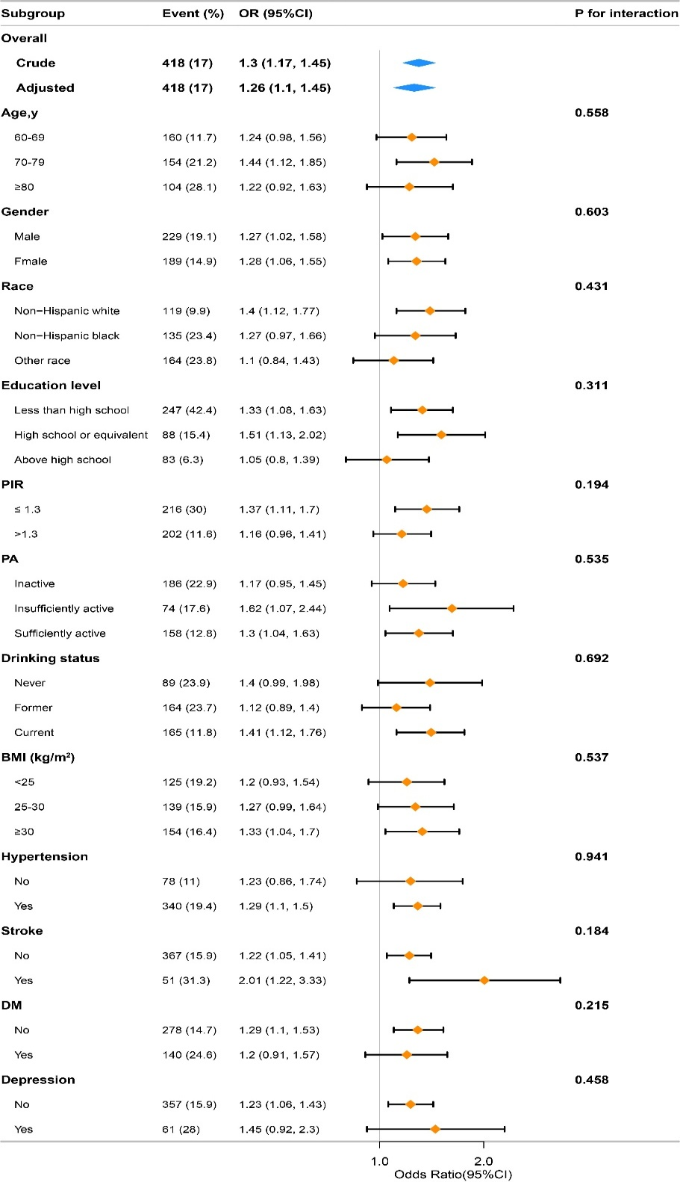
Supplemental Figure 1. Subgroup analysis of the association between the ABSI and p-MCI.
p-MCI: psychometric mild cognitive impairment; OR: odds ratio; 95% CI: 95% confidence interval; ABSI: a body size index; PIR: poverty income ratio; PA: physical activity; DM: diabetes mellitus; BMI: body mass index.
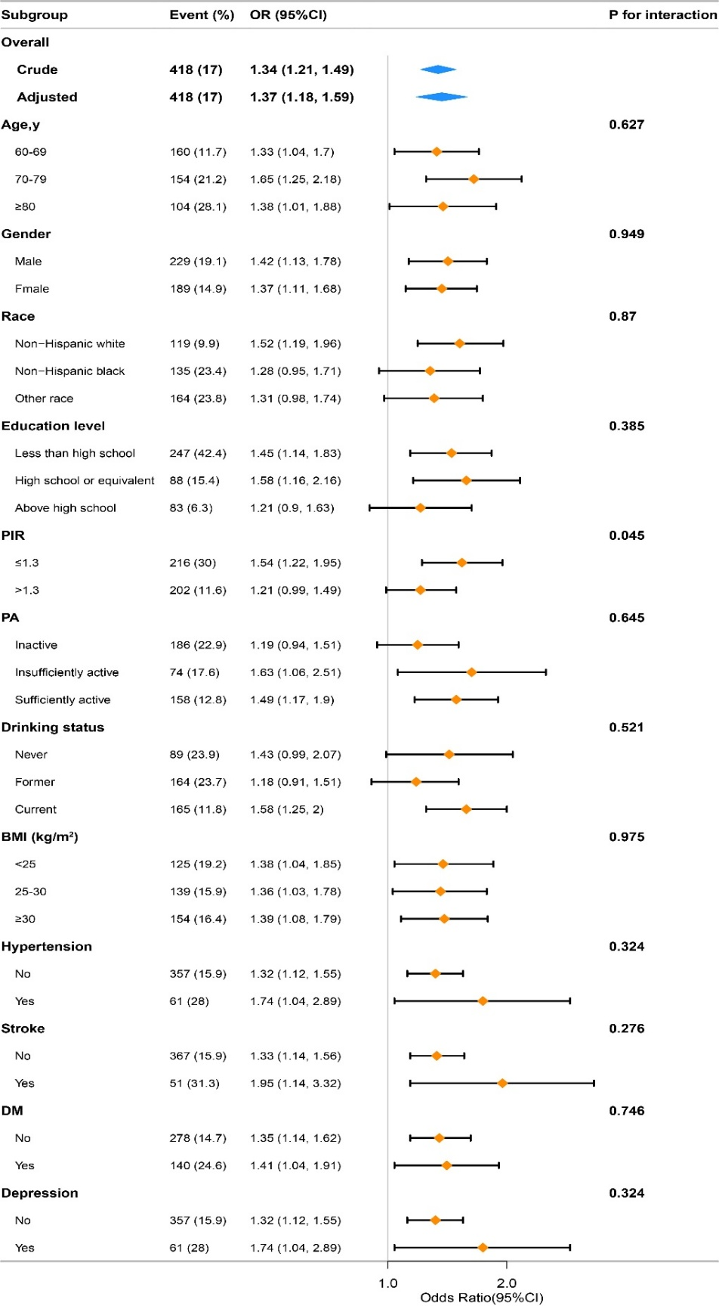
Supplemental Figure 2. Subgroup analysis of the association between the WWI and p-MCI.
p-MCI: psychometric mild cognitive impairment; OR: odds ratio; 95% CI: 95% confidence interval; WWI: weight-adjusted waist circumference index; PIR: poverty income ratio; PA: physical activity; DM: diabetes mellitus; BMI: body mass index.
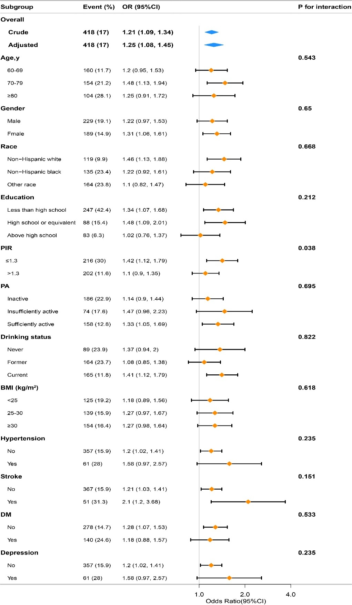
Supplemental Figure 3. Subgroup analysis of the association between the CoI and p-MCI.
p-MCI: psychometric mild cognitive impairment; OR: odds ratio; 95% CI: 95% confidence interval; CoI,: conicity index; PIR: poverty income ratio; PA: physical activity; DM: diabetes mellitus; BMI: body mass index.

