paper_42898695_t2dm_mimic_eicu
先图后表，共 39 项。标题为原文编号加中文图题或表题。
1. Figure 1，受试者筛选与匹配流程图
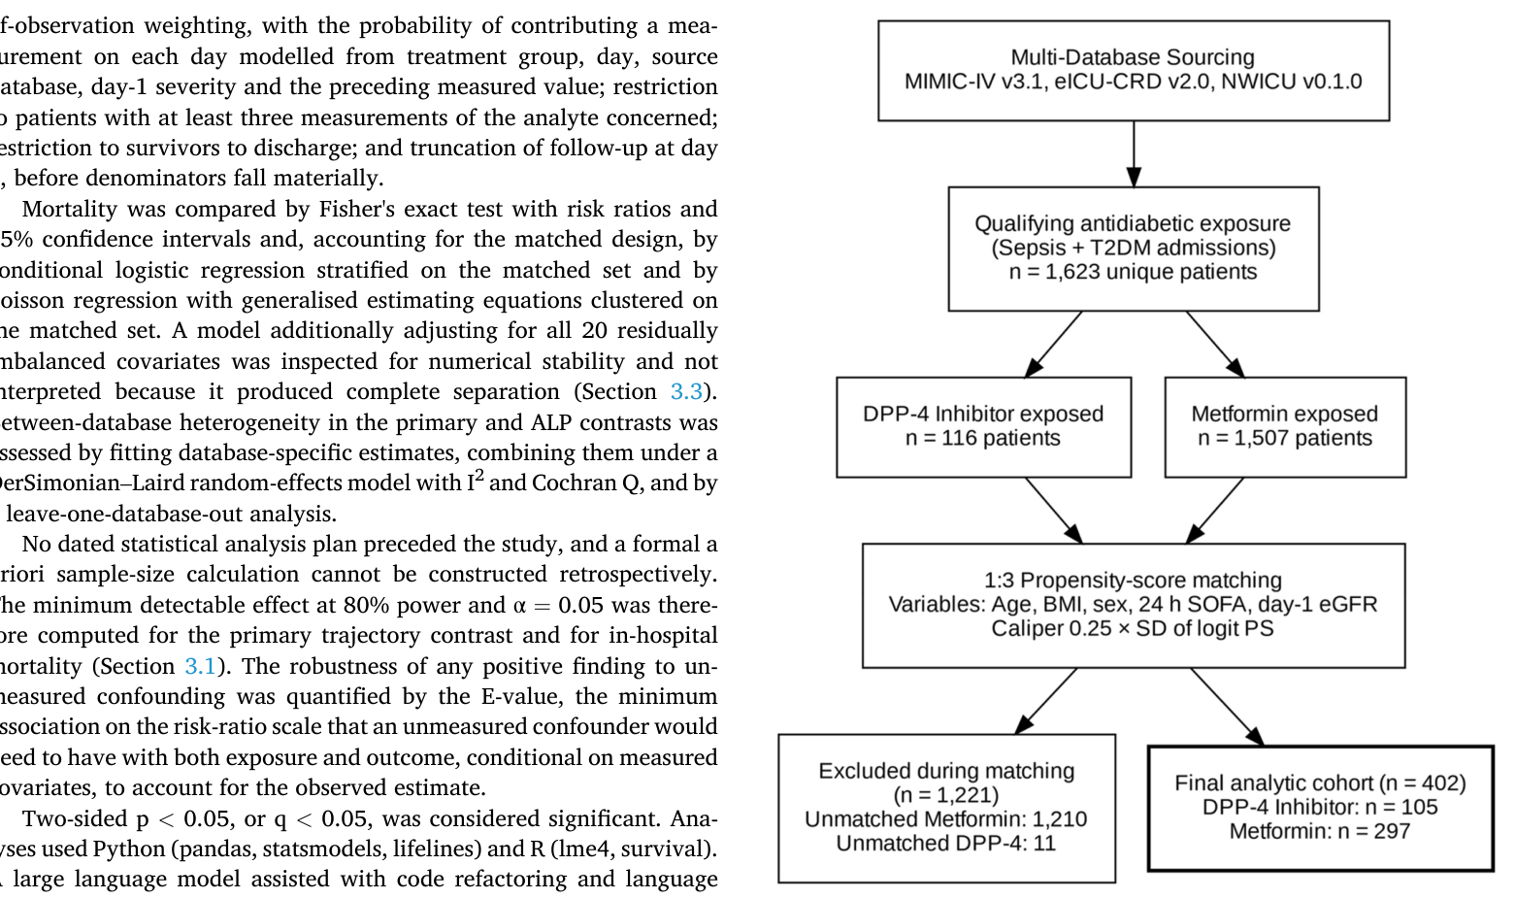
2. Figure 2，肝生化指标第1–7日轨迹（总胆红素、ALP、AST、ALT）
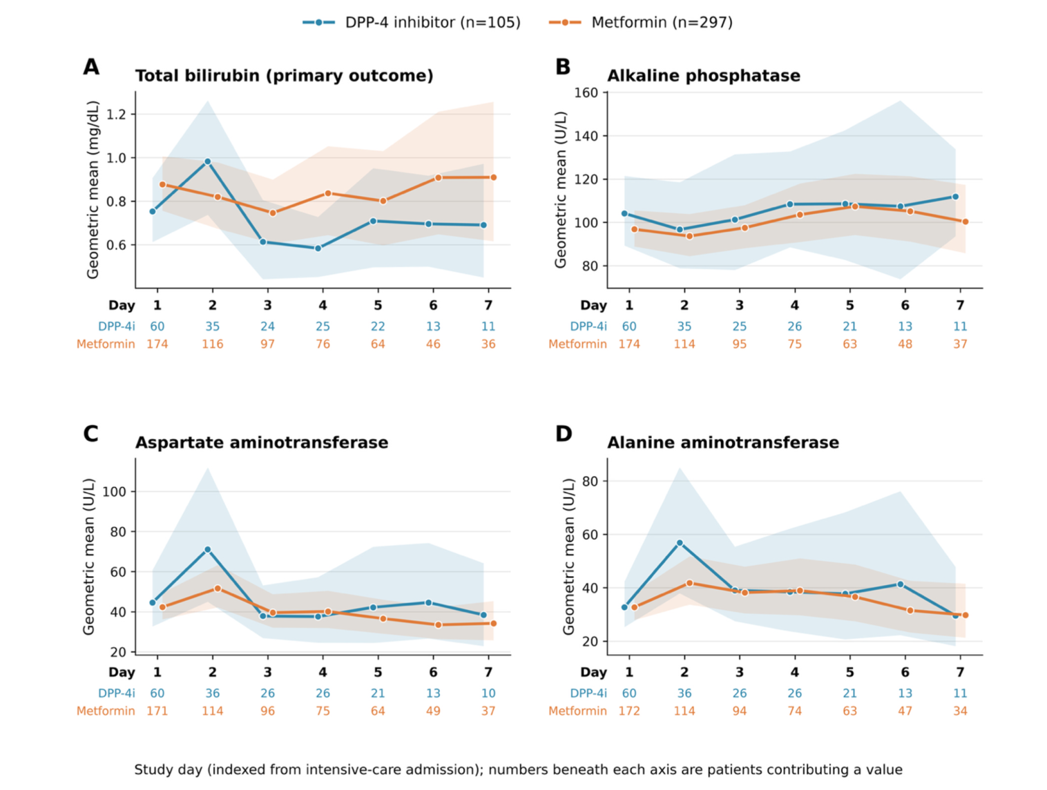
3. Figure 3，单库90天生存 Kaplan-Meier 曲线（按暴露分组）
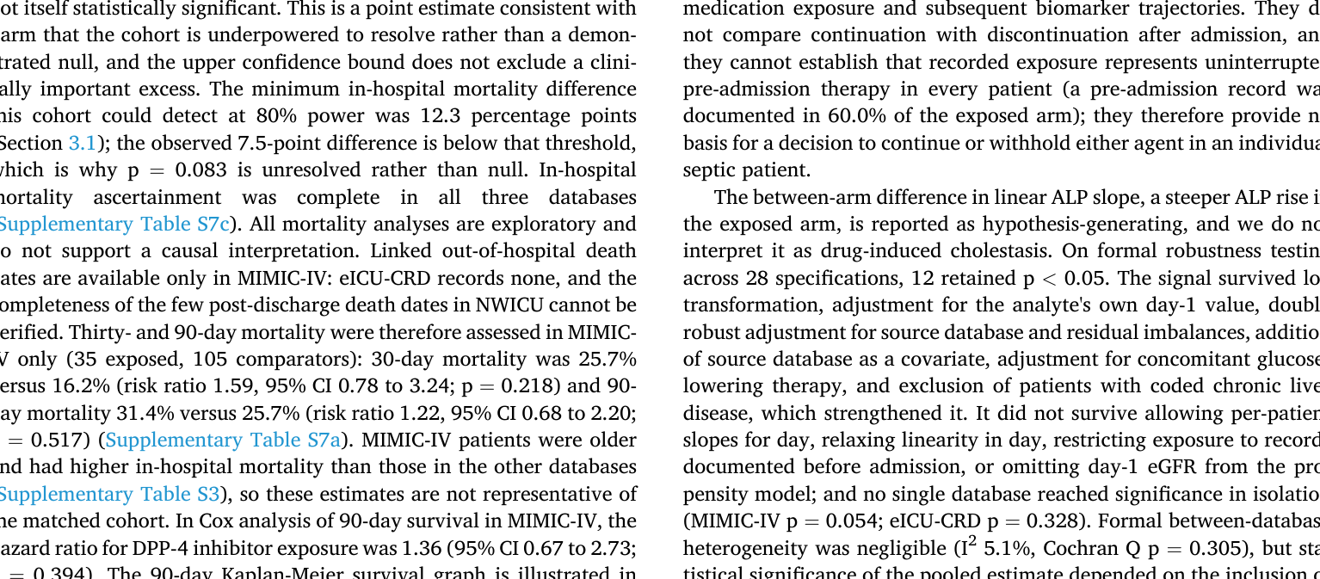
4. Table 1，倾向评分匹配后暴露组与对照的基线特征
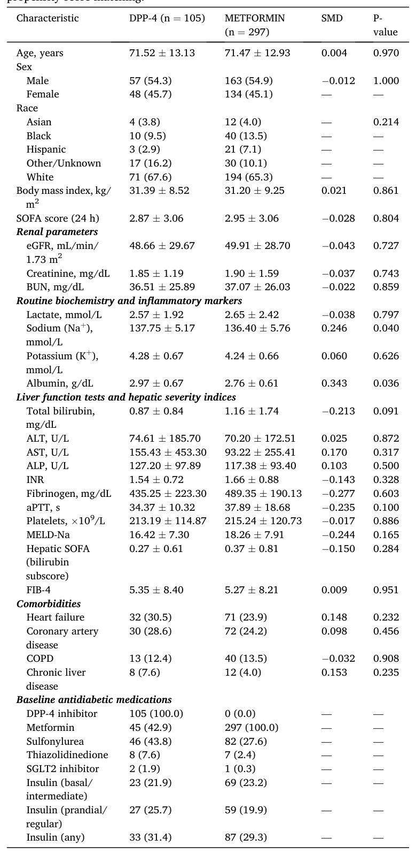
5. Table 2，第1–7日肝生化轨迹的线性混合效应模型结果
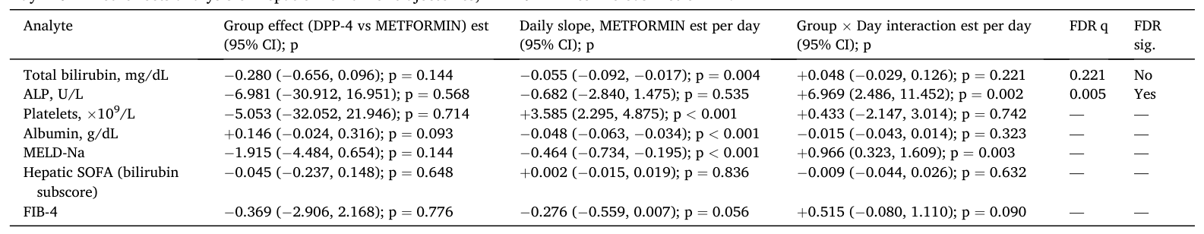
6. Table S0a，Table S0a. Operational definitions of sepsis, type 2 diabetes and the analysis unit in each database.Table S0a. Table S0a. Operational definitions of sepsis, type 2 diabetes and the analysis unit in each database.Operational definitions of sepsis, type 2 diabetes and the analysis unit in each database.
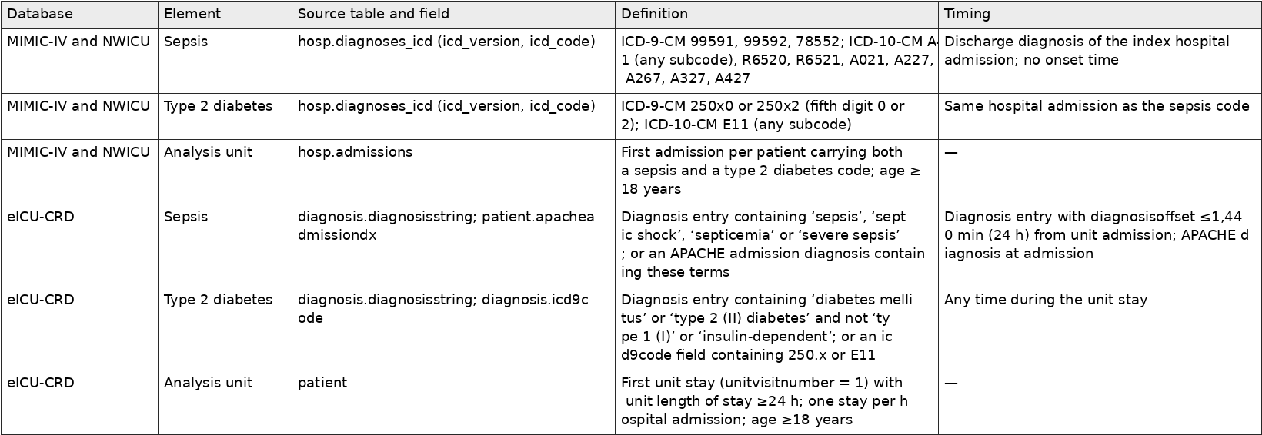
7. Table S0b，Table S0b. Codes that qualified the matched patients, MIMIC-IV and NWICU.Table S0b. Table S0b. Codes that qualified the matched patients, MIMIC-IV and NWICU.Codes that qualified the matched patients, MIMIC-IV and NWICU.
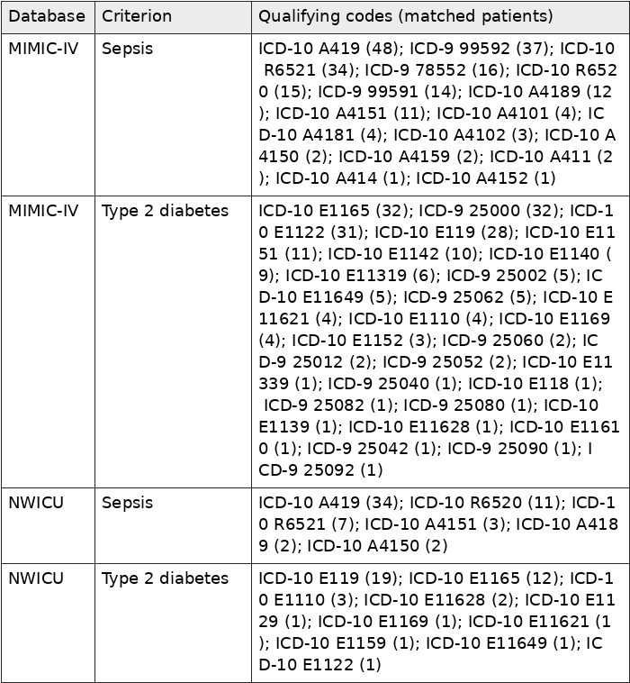
8. Table S0c，Table S0c. Verification that the code-based definitions behaved identically in MIMIC-IV and NWICU.Table S0c. Table S0c. Verification that the code-based definitions behaved identically in MIMIC-IV and NWICU.Verification that the code-based definitions behaved identically in MIMIC-IV and NWICU.
9. Table S1，Table S1. Standardised mean differences and arm means for every measured covariate, before (1,623 eligible) and after (402 matched) propensity-score matching.Table S1. Table S1. Standardised mean differences and arm means for every measured covariate, before (1,623 eligible) and after (402 matched) propensity-score matching.Standardised mean differences and arm means for every measured covariate, before (1,623 eligible) and after (402 matched) propensity-score matching.
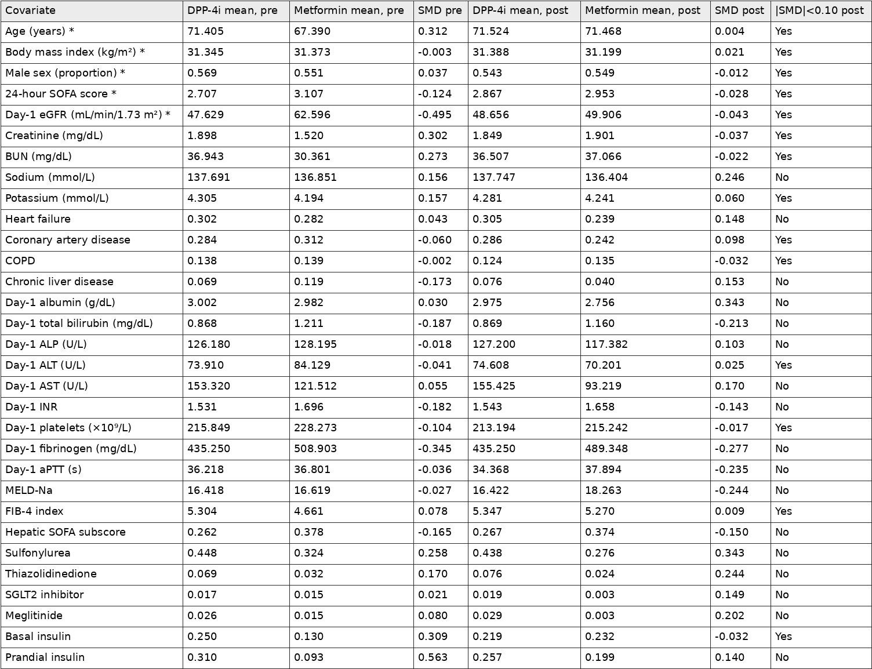
10. Table S2a，Table S2a. Exposure ascertainment by source database.Table S2a. Table S2a. Exposure ascertainment by source database.Exposure ascertainment by source database.
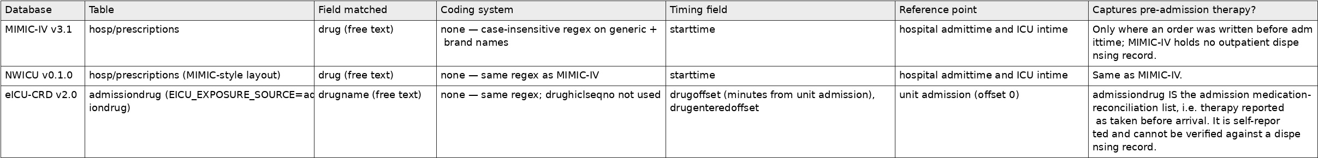
11. Table S2b，Table S2b. Timing of the first DPP-4 inhibitor record, by source database.Table S2b. Table S2b. Timing of the first DPP-4 inhibitor record, by source database.Timing of the first DPP-4 inhibitor record, by source database.
12. Table S2c，Table S2c. Distribution of the first-record timestamp relative to admission, by source database.Table S2c. Table S2c. Distribution of the first-record timestamp relative to admission, by source database.Distribution of the first-record timestamp relative to admission, by source database.
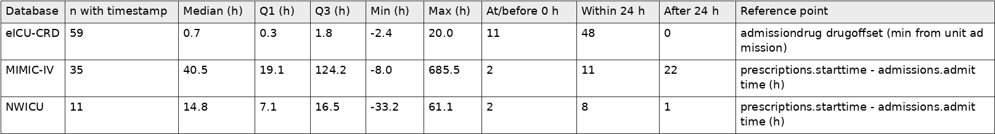
13. Table S2d，Table S2d. DPP-4 inhibitor agents in the exposed arm (n=105).Table S2d. Table S2d. DPP-4 inhibitor agents in the exposed arm (n=105).DPP-4 inhibitor agents in the exposed arm (n=105).
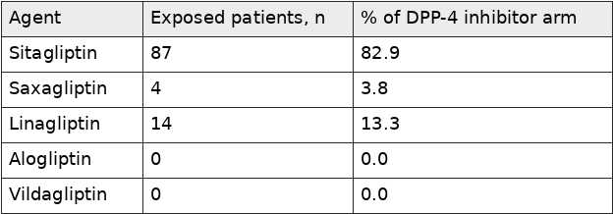
14. Table S3，Table S3. Database-specific cohort summary before and after matching.Table S3. Table S3. Database-specific cohort summary before and after matching.Database-specific cohort summary before and after matching.
15. Table S3a，Table S3a. Matched-set structure.Table S3a. Table S3a. Matched-set structure.Matched-set structure.
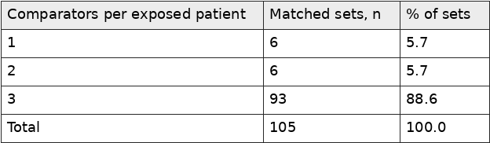
16. Table S3b，Table S3b. Database-specific group-by-day interaction estimates, log(x+1) scale.Table S3b. Table S3b. Database-specific group-by-day interaction estimates, log(x+1) scale.Database-specific group-by-day interaction estimates, log(x+1) scale.
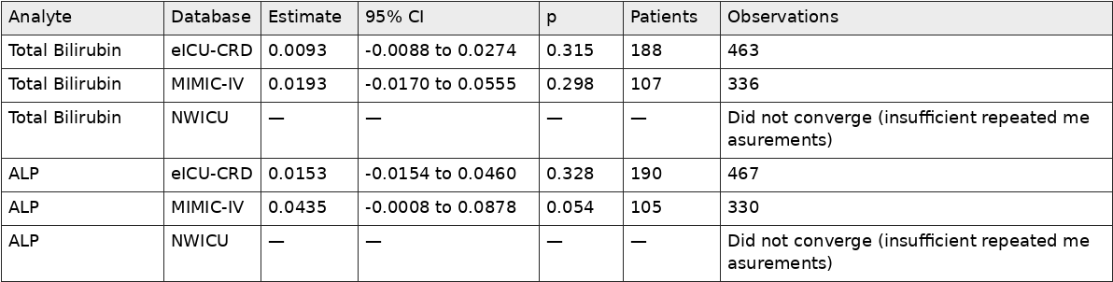
17. Table S3c，Table S3c. Between-database heterogeneity and random-effects pooling (DerSimonian–Laird), log(x+1) scale.Table S3c. Table S3c. Between-database heterogeneity and random-effects pooling (DerSimonian–Laird), log(x+1) scale.Between-database heterogeneity and random-effects pooling (DerSimonian–Laird), log(x+1) scale.
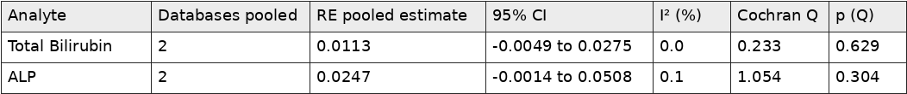
18. Table S3d，Table S3d. Leave-one-database-out estimates, log(x+1) scale.Table S3d. Table S3d. Leave-one-database-out estimates, log(x+1) scale.Leave-one-database-out estimates, log(x+1) scale.
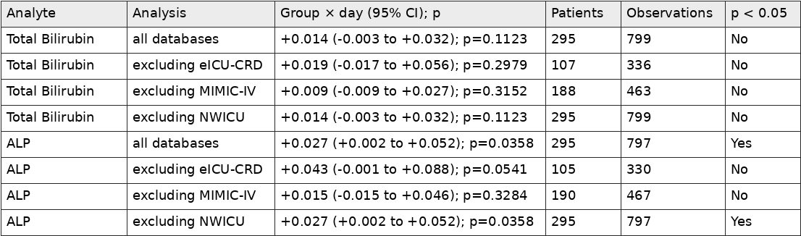
19. Table S3e，Table S3e. Admission year by source database and arm (de-identified, date-shifted years).Table S3e. Table S3e. Admission year by source database and arm (de-identified, date-shifted years).Admission year by source database and arm (de-identified, date-shifted years).
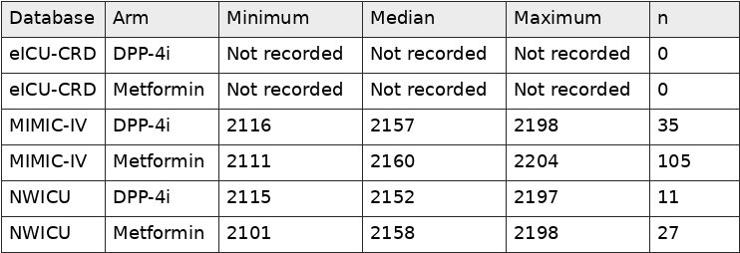
20. Table S4，Table S4. Outcome estimates under three propensity-score specifications, log(x+1) scale.Table S4. Table S4. Outcome estimates under three propensity-score specifications, log(x+1) scale.Outcome estimates under three propensity-score specifications, log(x+1) scale.
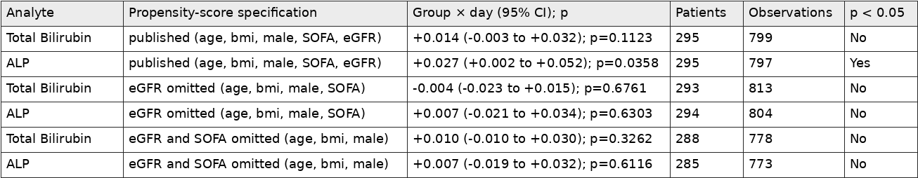
21. Table S4a，Table S4a. Matched cohort under three propensity-score specifications.Table S4a. Table S4a. Matched cohort under three propensity-score specifications.Matched cohort under three propensity-score specifications.
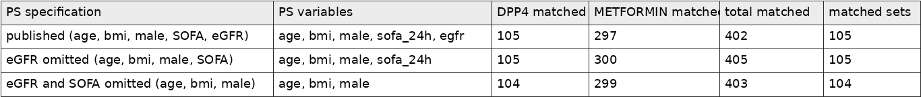
22. Table S4b，Table S4b. Estimand and exposure-window sensitivity analyses, log(x+1) scale.Table S4b. Table S4b. Estimand and exposure-window sensitivity analyses, log(x+1) scale.Estimand and exposure-window sensitivity analyses, log(x+1) scale.
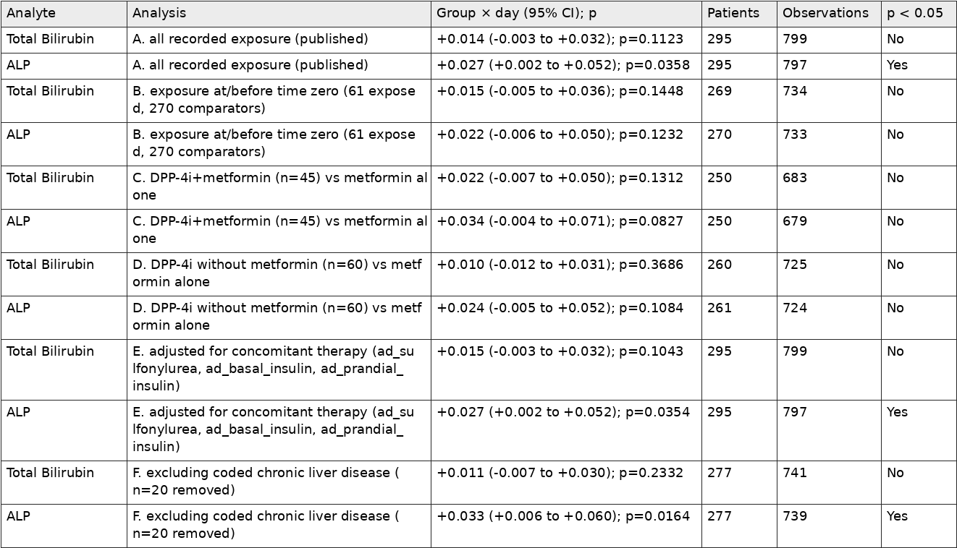
23. Table S4c，Table S4c. Post-matching standardised mean differences under each propensity-score specification.Table S4c. Table S4c. Post-matching standardised mean differences under each propensity-score specification.Post-matching standardised mean differences under each propensity-score specification.
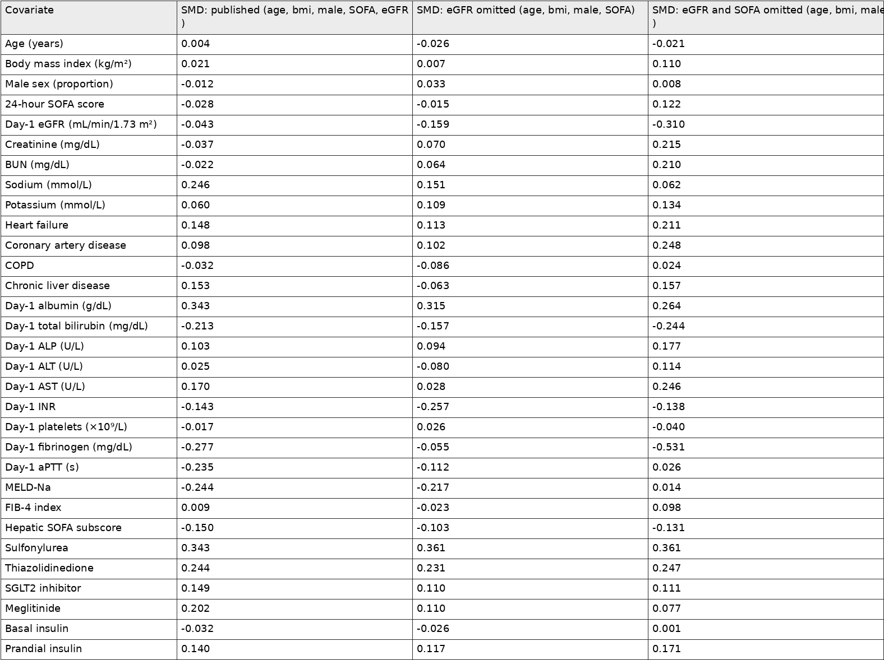
24. Table S5，Table S5. Group × day interaction under ten model specifications.Table S5. Table S5. Group × day interaction under ten model specifications.Group × day interaction under ten model specifications.
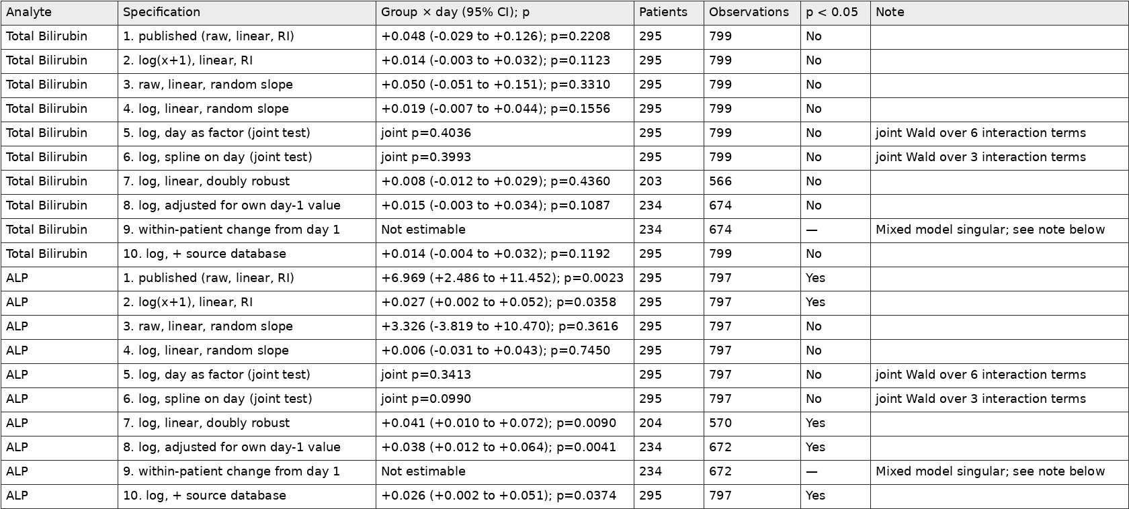
25. Table S5b，Table S5b. All trajectory outcomes with Benjamini–Hochberg correction across the full family, log(x+1) scale.Table S5b. Table S5b. All trajectory outcomes with Benjamini–Hochberg correction across the full family, log(x+1) scale.All trajectory outcomes with Benjamini–Hochberg correction across the full family, log(x+1) scale.
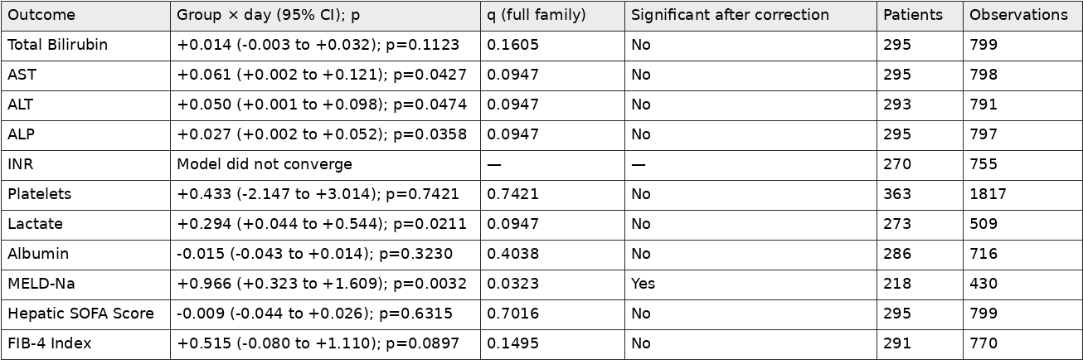
26. Table S6，Table S6. Patients contributing a value on each study day, by analyte and arm.Table S6. Table S6. Patients contributing a value on each study day, by analyte and arm.Patients contributing a value on each study day, by analyte and arm.
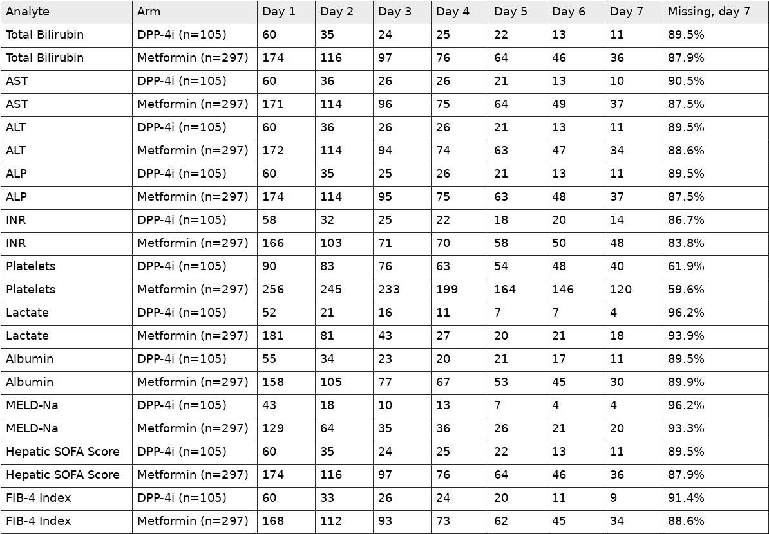
27. Table S6b，Table S6b. Observation model: predictors of contributing a measurement on a given day.Table S6b. Table S6b. Observation model: predictors of contributing a measurement on a given day.Observation model: predictors of contributing a measurement on a given day.
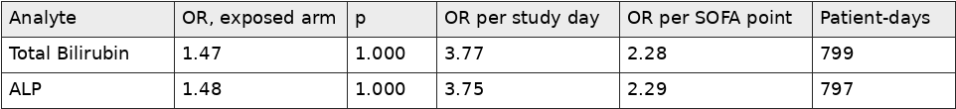
28. Table S6c，Table S6c. Informative-observation sensitivity analyses, log(x+1) scale.Table S6c. Table S6c. Informative-observation sensitivity analyses, log(x+1) scale.Informative-observation sensitivity analyses, log(x+1) scale.
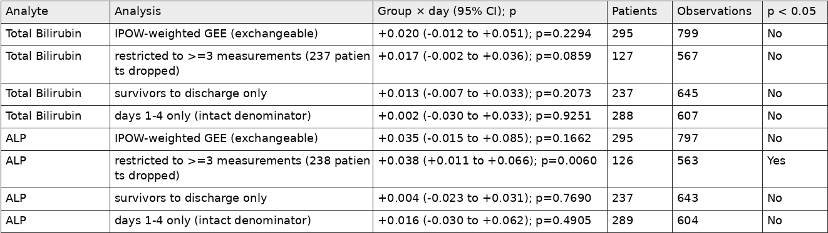
29. Table S7a，Table S7a. Mortality by endpoint, with risk ratios, confidence intervals and E-values.Table S7a. Table S7a. Mortality by endpoint, with risk ratios, confidence intervals and E-values.Mortality by endpoint, with risk ratios, confidence intervals and E-values.
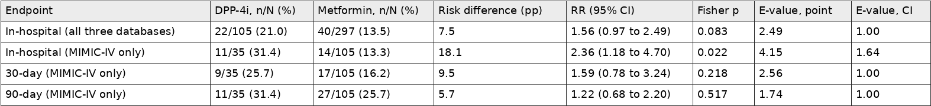
30. Table S7b，Table S7b. In-hospital mortality accounting for the matched design.Table S7b. Table S7b. In-hospital mortality accounting for the matched design.In-hospital mortality accounting for the matched design.
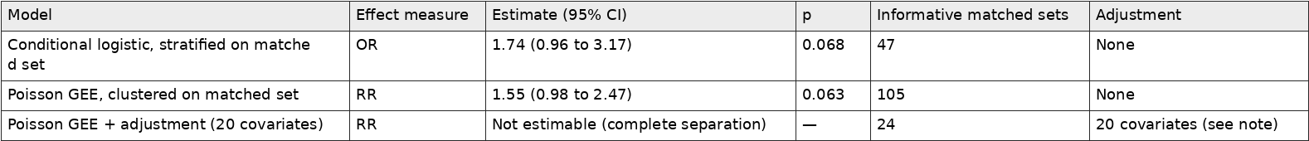
31. Table S7c，Table S7c. Mortality ascertainment by source database.Table S7c. Table S7c. Mortality ascertainment by source database.Mortality ascertainment by source database.
32. Table S7e，Table S7e. In-hospital mortality restricted to documented pre-admission exposure.Table S7e. Table S7e. In-hospital mortality restricted to documented pre-admission exposure.In-hospital mortality restricted to documented pre-admission exposure.
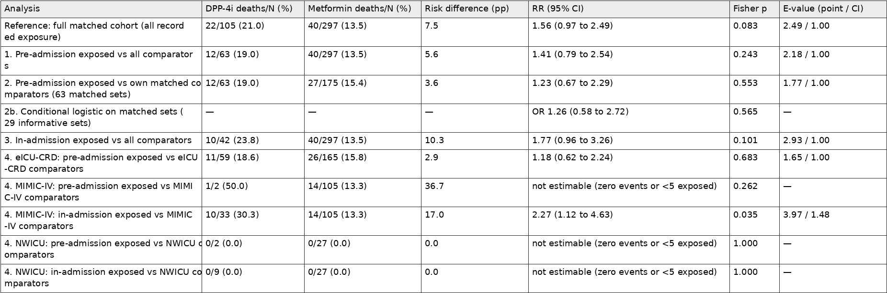
33. Table S8，Table S8. Primary raw-scale mixed-model output for every trajectory analyte (the full version of Table 2).Table S8. Table S8. Primary raw-scale mixed-model output for every trajectory analyte (the full version of Table 2).Primary raw-scale mixed-model output for every trajectory analyte (the full version of Table 2).
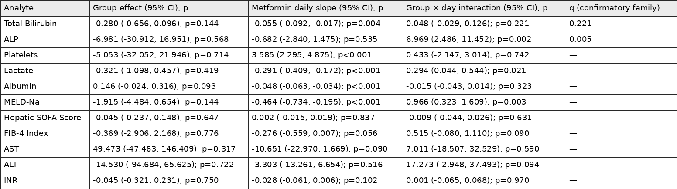
34. Table S8a，Table S8a. Every ALP estimate produced for the revision.Table S8a. Table S8a. Every ALP estimate produced for the revision.Every ALP estimate produced for the revision.
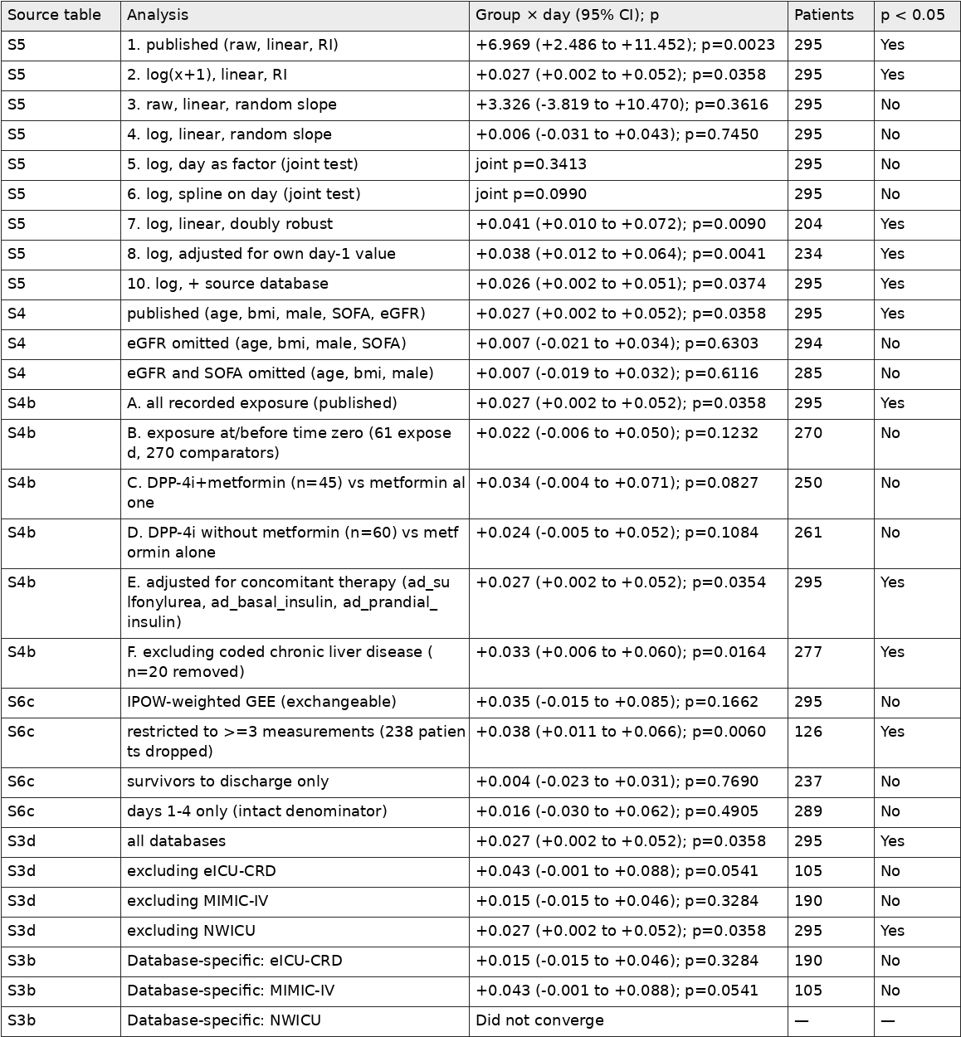
35. Table S8b，Table S8b. Every total-bilirubin (primary outcome) estimate produced for the revision.Table S8b. Table S8b. Every total-bilirubin (primary outcome) estimate produced for the revision.Every total-bilirubin (primary outcome) estimate produced for the revision.
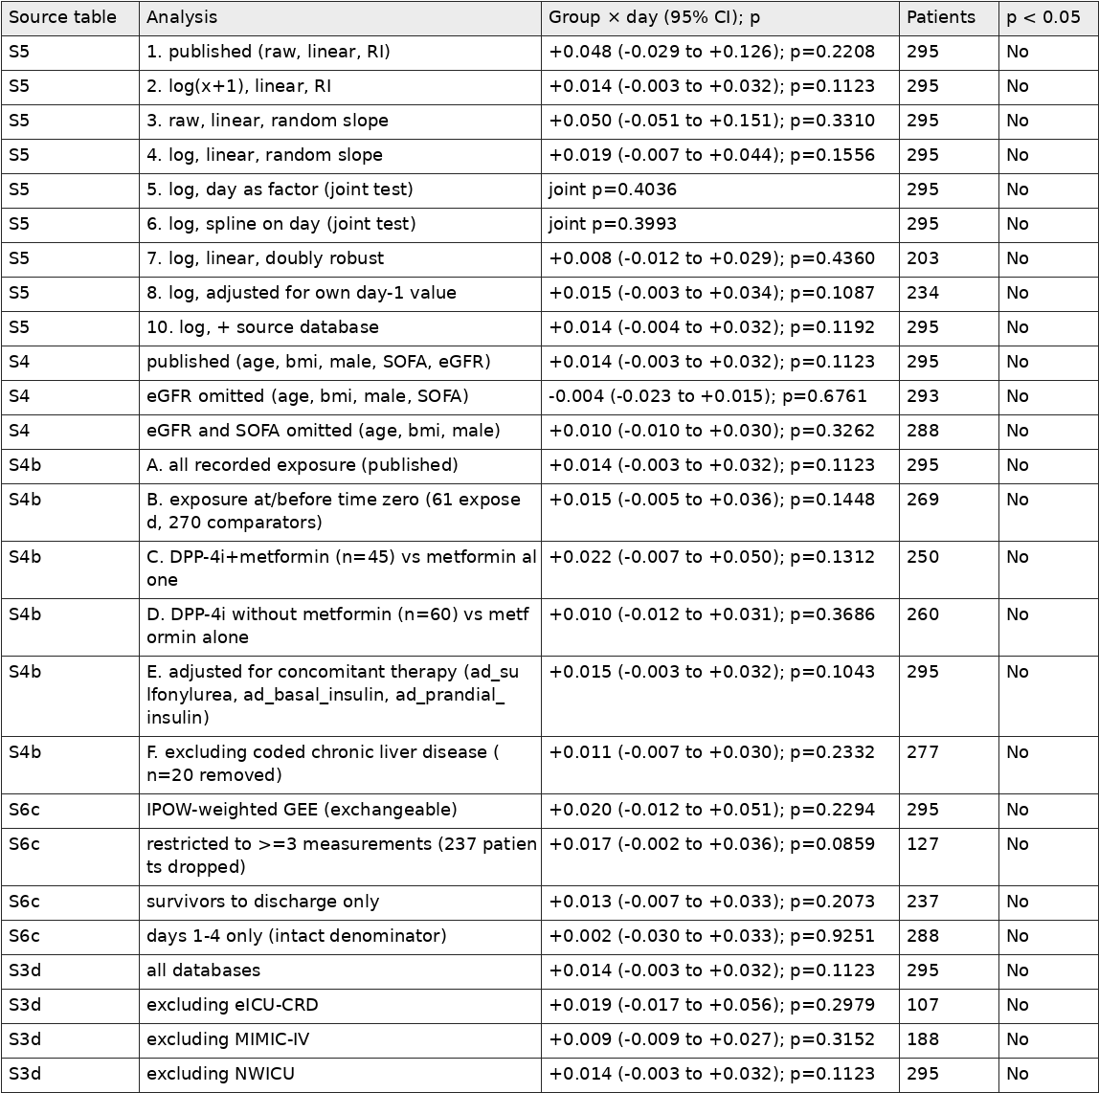
36. Table S9a，Table S9a. Minimum detectable group × day effect at 80% power and α = 0.05, raw scale.Table S9a. Table S9a. Minimum detectable group × day effect at 80% power and α = 0.05, raw scale.Minimum detectable group × day effect at 80% power and α = 0.05, raw scale.
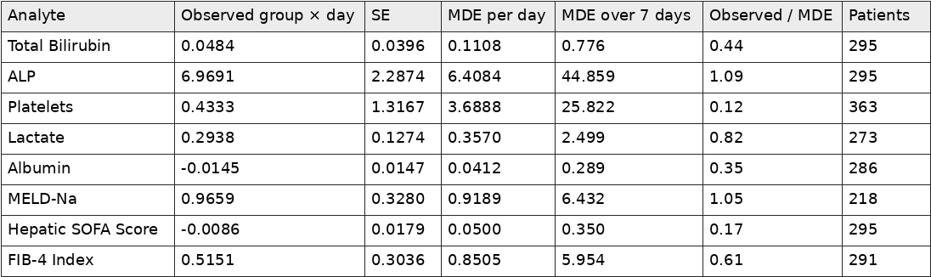
37. Table S9b，Table S9b. Minimum detectable in-hospital mortality effect at 80% power and α = 0.05.Table S9b. Table S9b. Minimum detectable in-hospital mortality effect at 80% power and α = 0.05.Minimum detectable in-hospital mortality effect at 80% power and α = 0.05.
38. Table S9c，Table S9c. E-values for the reported positive findings.Table S9c. Table S9c. E-values for the reported positive findings.E-values for the reported positive findings.
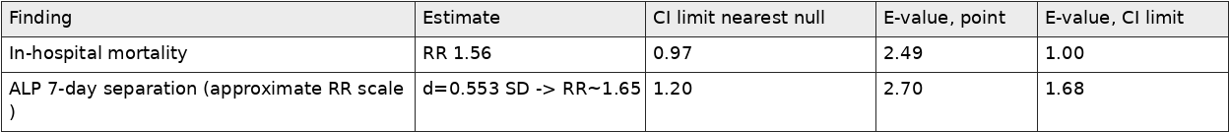
39. Table S10，Table S10. Peak and nadir values over study days 1–7.Table S10. Table S10. Peak and nadir values over study days 1–7.Peak and nadir values over study days 1–7.


