Additional file 1

Contents
Text S1. Methods of measurement of absolute educational mobility 1
Table S1. Description of survey design and methodology of six cohorts 2
Table S2. STROBE Statement—checklist of items that should be included in reports of observational studies 4
Table S3. Education information of participants and their parents collected in each study 6
Table S4. Education measures across countries based on absolute educational attainment 8
Table S5. Education categories across countries based on absolute educational attainment 9
Table S6. Education categories across countries based on relative educational attainment 10
Table S7. Description of mediators and childhood conditions across six aging studies 11
Table S8. Percent of missing data in covariates and mediators before imputation, by country in longitudinal analysis 16
Table S9. Differences in relative educational mobility by gender across cohorts in the cross-sectional analysis and longitudinal analysis 17
Table S10. Country specific and childhood conditions of study participants across cohorts in the cross-sectional analysis 18
Table S11. Country specific and childhood conditions of study participants across cohorts in the longitudinal analysis 20
Table S12. Sensitivity analysis adding an interaction term between educational mobility and gender in the cross-sectional and longitudinal analysis 22
Table S13. Group differences in mediators - educational mobility interaction effects in mediation analysis 24
Table S14. Sensitivity analysis using inverse probability of censoring weights analysis, sampling weights adjustment analysis, model analysis without childhood conditions, and stably high group as reference group 25
Table S15. Sensitivity analysis using a causal destination-as-treatment approach 27
Figure S1. Flow chart of analytical sample 28
Figure S2. Association between relative educational mobility and depressive symptoms in cohort-specific and pooled cross-sectional meta-analyses of men (n= 41,624). 29
Figure S3. Association between relative educational mobility and depressive symptoms in cohort-specific and pooled cross-sectional meta-analyses of women (n= 53,031). 30
Figure S4. Association between relative educational mobility and depressive symptoms in cohort-specific and pooled longitudinal meta-analyses of men (n= 26,932). 31
Figure S5. Association between relative educational mobility and depressive symptoms in cohort-specific and pooled longitudinal meta-analyses of women (n= 29,885). 32
Figure S6. The results of mediation analysis 33
Figure S7. The robustness of mediation analysis revealed by bootstrap analysis 40
Figure S8. Association between absolute educational mobility and depressive symptoms in cohort-specific and pooled cross-sectional meta-analyses (n=94,655). 44
Figure S9. Association between absolute educational mobility and depressive symptoms in cohort-specific and pooled longitudinal meta-analyses (n=56,550). 45

Text S1. Methods of measurement of absolute educational mobility.
We harmonized educational attainment across the countries under study using the 2011 International Standard of Education (ISCED), categorizing both participants and their parents into three standardized levels: low (less than upper secondary education), middle (upper secondary and vocational training), and high (tertiary education) (Tables S5 and S6). Mobilities were then classified using the same five-group framework. In Mexico, parental educational attainment was reported using only four broad categories: none, some primary, primary, and beyond primary education. To align as closely as possible with ISCED levels, we grouped "none" and "some primary" as low, "primary" as middle, and "beyond primary" as high.

Table S1. Description of survey design and methodology of six cohorts.
Country | US | England | European countries | South Korea | Mexico | China
Cohort name | The United States Health and Retirement study (HRS) | English Longitudinal Study of Aging (ELSA) | Survey of Health, Ageing and Retirement in Europe (SHARE) | The Korean Longitudinal Study of Aging (KLoSA) | The Mexican Health and Aging Study (MHAS) | China Health and Retirement Longitudinal Study (CHARLS)
Start Year of the Cohort | 1992 | 2002 | 2004 | 2006 | 2001 | 2011
Waves Used for Our Study | 5 waves: 2010–2019 | 5 waves: 2010–2019 | 5 waves: 2011-2020 | 5 waves: 2010-2018 | 3 waves: 2012–2018 | 4 waves: 2011–2018
Main sampling and survey method | The HRS is a longitudinal panel study employing a multi-stage area probability design, involving geographical stratification and clustering, with oversampling of African-American, Hispanic, and Florida households. It targets individuals aged 51 and older, along with their spouses, providing longitudinal data on retirement, health, economic well-being, and related policies. Initially, the HRS sample consisted of individuals born between 1931 and 1941, recruited between 1992 and 1993. Another sample, AHEAD, targeted individuals born before 1924 and merged with HRS in 1998. HRS uses a steady-state design, replenishing the sample every six years with younger cohorts. Interviews are conducted face-to-face or via telephone, with enhanced face-to-face interviews including health assessments every four years. | The English Longitudinal Study of Ageing (ELSA) is a panel survey of individuals aged 50 and older, along with their partners, living in private households in England. The initial sample was recruited in 2002/03 from households that had participated in the Health Survey for England (HSE) in 1998, 1999, and 2001. ELSA collects data on demographics, income, assets, health, cognition, family structure, and more, using computer-assisted personal interviews every two years. The study also employs self-completed questionnaires and nurse visits to gather comprehensive information. The sample has been refreshed at waves 3, 4, 6, 7, and 9 to maintain age representation. ELSA aims to provide an interdisciplinary data resource on health, economic position, and quality of life as people age. | The SHARE target population consists of all persons aged 50 years and over at the time of sampling who have their regular domicile in the respective SHARE country (Austria, Belgium, Czech Republic, Denmark, Estonia, France, Germany, Greece, Hungary, Ireland, Israel, Italy, Netherlands, Poland, Portugal, Sweden, Slovenia, Spain and Switzerland). Panel tracking since 2004, with follow-up interviews in 2006, 2008, 2011, 2013, 2015, 2017, 2019. SHARE includes a great variety of information: health variables, physical measures and biomarkers, psychological variables, economic variables and social support variables as well as social network information. The interviewers used computer-assisted personal interviewing (CAPI) to collect most of the data in all waves. In addition, self-administered questionnaires (drop-off) were handed out in Waves 1, 2 and 4 after completion of the CAPI. | The Korean Longitudinal Study of Aging (KLoSA) is a panel survey of people aged 45 years and older and their partners, living in private households in Korea. The initial sample was recruited in 2006 using a stratified, multistage probability sampling of households in all geographic areas except for. Interview mode has been in person interviews, so called, computer-assisted personal interviews for baseline surveys, with follow-up interviews in 2008, 2010, 2012, 2014, 2016, 2018, 2020. The survey elicits information about demographics, family structure, health, health care use, cognition, job status and history, income, and assets. | The Mexican Health and Aging Study (MHAS) is a longitudinal study of individuals aged 50 and older, along with their partners, living in private households in Mexico. It aims to examine the aging process and disease burden from a wide socioeconomic perspective, similar to the U.S. Health and Retirement Study (HRS). The study collects data on demographics, health, migration, family structure, healthcare use, income, assets, housing, and cognition. The initial sample was recruited in 2001, with follow-up interviews in 2003, 2012, 2015, 2018, and 2021. MHAS uses face-to-face interviews with computer-assisted personal interviewing (CAPI) since 2012. New cohorts were added in 2012 and 2018 to refresh the sample, ensuring representation across all 32 Mexican states, including both rural and urban areas. In later waves, a subsample provided biomarker data and underwent cognitive assessments. | CHARLS employs multistage probability sampling, involving mapping and listing operations to create a sampling frame within each village-level unit. This nationally representative survey targets individuals aged 45 and older across 28 provinces in China. The baseline survey was conducted in 2011-2012, followed by waves in 2013, 2015, 2018, and 2020. Although CHARLS initially excludes institutionalized elderly, it continues to track respondents if they move into institutions later. The sample is refreshed every 2-3 years; however, some villages were not surveyed in 2020 due to COVID-19 restrictions.
Eligibility criteria of study participant recruitment | The HRS includes individuals aged 51 and older, along with their spouses or partners, regardless of the spouse's age. The study targets people living in private households in the United States, with an emphasis on oversampling African-American, Hispanic, and Florida households. Initially, the HRS focused on individuals born between 1931 and 1941, and later merged with other cohorts, such as AHEAD, which targeted those born before 1924. | The ELSA recruit participants aged 50 and older, along with their partners, living in private households in England. The initial sample was drawn from households that participated in the Health Survey for England (HSE) in 1998, 1999, and 2001, where at least one person agreed to follow-up. Partners were also invited to participate, regardless of age. | The SHARE target population consists of all persons aged 50 years. In wave 1 all household members born 1954 or earlier are eligible for an interview. Starting in wave 2, for new countries or refreshment samples, there is only one selected respondent per household who has to be born 1956 or earlier in wave 2, 1960 or earlier in wave 4, 1962 or earlier in wave 5, 1964 or earlier in wave 6, 1966 or earlier in wave 7, 1969 or earlier in wave 8, and 1971 or earlier in wave 9. | The initial main survey sample of the year 2006 is approximately 10,000 adults who are 45 or older (born in 1961 or earlier) and reside in Korea not inclusive of Jeju Island. KLoSA extends its population to those aged between 45 and 49 because career changes in these middle ages have become an important social issue since the financial crisis in late 1990s, with many people in their late 1940s having been laid off from their career jobs. In 2014, KLoSA recruited a new cohort of 1,000 Korean Baby Boomers (1962–1963), not included in the first baseline survey | The MHAS targets individuals aged 50 and older, along with their spouses or partners, living in private households in Mexico. The study includes households with at least one resident aged 50 or older, with one age-eligible member randomly selected. Spouses or partners are also included, regardless of age. | CHARLS targets individuals aged 45 and older, along with their spouses, living in private households across China. One age-eligible member per household is randomly selected, and their spouse is also included, regardless of age. The study excludes institutionalized elderly at baseline but continues to track them if they move into institutions later.
Data accessibility | Publicly available at: https://hrs.isr.umich.edu/ | Publicly available at: https://www.elsa-project.ac.uk/ | Publicly available at: http://www.share-project.org | Publicly available at: https://survey.keis.or.kr/eng/klosa/klosa01.jsp | Publicly available: https://www.mhasweb.org/Home/index.aspx | Publicly available: https://charls.pku.edu.cn/en/

Table S2. STROBE Statement—checklist of items that should be included in reports of observational studies.
 | Item No | Recommendation | Page
Title and abstract | 1 | (a) Indicate the study’s design with a commonly used term in the title or the abstract | 1
Title and abstract | 1 | (b) Provide in the abstract an informative and balanced summary of what was done and what was found | 2
Introduction
Background/rationale | 2 | Explain the scientific background and rationale for the investigation being reported | 3
Objectives | 3 | State specific objectives, including any prespecified hypotheses | 3-4
Methods
Study design | 4 | Present key elements of study design early in the paper | 4
Setting | 5 | Describe the setting, locations, and relevant dates, including periods of recruitment, exposure, follow-up, and data collection | 4-5
Participants | 6 | (a) Give the eligibility criteria, and the sources and methods of selection of participants | 4
Variables | 7 | Clearly define all outcomes, exposures, predictors, potential confounders, and effect modifiers. Give diagnostic criteria, if applicable | 4-6
Data sources/ measurement | 8* | For each variable of interest, give sources of data and details of methods of assessment (measurement). Describe comparability of assessment methods if there is more than one group | 4-6
Bias | 9 | Describe any efforts to address potential sources of bias | 4-7
Study size | 10 | Explain how the study size was arrived at | 4
Quantitative variables | 11 | Explain how quantitative variables were handled in the analyses. If applicable, describe which groupings were chosen and why | 4-7
Statistical methods | 12 | (a) Describe all statistical methods, including those used to control for confounding | 6-7
Statistical methods | 12 | (b) Describe any methods used to examine subgroups and interactions | 6
Statistical methods | 12 | (c) Explain how missing data were addressed | 6
Statistical methods | 12 | (d) If applicable, describe analytical methods taking account of sampling strategy | 6
Statistical methods | 12 | (e) Describe any sensitivity analyses | 6-7
Results
Participants | 13* | (a) Report numbers of individuals at each stage of study—e.g. numbers potentially eligible, examined for eligibility, confirmed eligible, included in the study, completing follow-up, and analyzed | 7
Participants | 13* | (b) Give reasons for non-participation at each stage | 4
Participants | 13* | (c) Consider use of a flow diagram | S 28
Descriptive data | 14* | (a) Give characteristics of study participants (e.g. demographic, clinical, social) and information on exposures and potential confounders | 7
Descriptive data | 14* | (b) Indicate number of participants with missing data for each variable of interest | S 16
Outcome data | 15* | Report numbers of outcome events or summary measures | S 44-45
Main results | 16 | (a) Give unadjusted estimates and, if applicable, confounder-adjusted estimates and their precision (e.g., 95% confidence interval). Make clear which confounders were adjusted for and why they were included | 7-8
Main results | 16 | (b) Report category boundaries when continuous variables were categorized | 7
Main results | 16 | (c) If relevant, consider translating estimates of relative risk into absolute risk for a meaningful time period | NA
Other analyses | 17 | Report other analyses done—e.g. analyses of subgroups and interactions, and sensitivity analyses | 8
Discussion
Key results | 18 | Summarize key results with reference to study objectives | 8-9
Limitations | 19 | Discuss limitations of the study, taking into account sources of potential bias or imprecision. Discuss both direction and magnitude of any potential bias | 11
Interpretation | 20 | Give a cautious overall interpretation of results considering objectives, limitations, multiplicity of analyses, results from similar studies, and other relevant evidence | 9
Generalizability | 21 | Discuss the generalizability (external validity) of the study results | 9-11
Other information
Funding | 22 | Give the source of funding and the role of the funders for the present study and, if applicable, for the original study on which the present article is based | 12

Table S3. Education information of participants and their parents collected in each study.
US | England | European countries | South Korea | Mexico | China
Health and Retirement study (HRS) | English Longitudinal Study on Ageing (ELSA) | Survey of Health, Ageing and Retirement in Europe (SHARE) | The South Korean Longitudinal Study of Aging (KLoSA) | Mexican Health and Aging Study (MHAS) | China Health and Retirement Longitudinal Study (CHARLS)
Participants’ education information
Years of schooling:  0-16 years, 17 years and over | Years of schooling:  0.none, 1.age 14 or under, 2.age 15, 3.age 16, 4.age 17, 5.age 18, 6.age 19 or over (Age finished school) | Years of schooling:  0-25 years | Years of schooling:  Not provided | Years of schooling:  0-22 years | Years of schooling:  Not provided
Education attainments:  0.No degree, 1.GED, 2.HS, 3.HS/GED, 4.AA/Lt BA, 5.BA, 6.MA/MBA, 7.Law/MD/PhD, 8.Other | Education attainments:  1.Less than high school, 3.high school graduate, 4.some college, and 5.college and above | Education attainments:  0.None, 1. Primary education, 2. Lower secondary education, 3. Upper secondary education, 4. Post-secondary non-tertiary education, 5. First stage of tertiary education, 6. Second stage of tertiary education | Education attainments:  1.No education (illiterate), 2.No education (reading), 3.Elementary school, 4.Middle school, 5.High school, 6.Two year college, 7.College grad, 8.Post college (Master) and 9.Post college(PhD). | Education attainments:  0 (no education), 3 (primary school), 7 (secondary technical/commercial school), 10 (preparatory/high school), 11 (basic teaching school), 14 (college), 18 (graduate). If the respondent reports a level completed and a grade completed, then a base value is assigned for the level completed and the grade is added. The base values are assigned as follows: 0 (no education or primary school), 6 (secondary or technical/commercial school), 9 (preparatory/high school or basic teaching school), 12 (college), 16 (graduate school) | Education attainments:  1.No Formal Education (Illiterate), 2.Did Not Finish Primary School but can Read, 3.Sishu (Private Tutoring), 4.Elementary School, 5.Middle School, 6.High School, 7.Vocational School, 8.Two/three-year college, 9.College Grad and 10.Post-graduate degree
Parental education information
Years of schooling:  0-16 years, 17 years and over | Years of schooling:  0.none, 1.age 14 or under, 2.age 15, 3.age 16, 4.age 17, 5.age 18, 6.age 19 or over (Age finished school) | Years of schooling:  Not provided | Years of schooling:  Not provided | Years of schooling:  Not provided | Years of schooling:  Not provided
Education attainments:  Not provided | Education attainments:  Not provided | Education attainments:  0.None, 1.Primary education, 2.Lower secondary education, 3.Upper secondary education, 4.Post-secondary non-tertiary education, 5.First stage of tertiary education, 6.Second stage of tertiary education | Education attainments:  1.No formal education (illiterate), 2.No formal education (capable of reading), 3.Elementary school, 4.Middle School, 5.High School, 6.Two-year college, 7.College grad, 8.Post college (Master), and 9.Post college (PhD). | Education attainments:  A code of 1 indicates no education; a code of 2 indicates 'some primary'; a code of 3 indicates 'primary'; and a code of 4 indicates 'more than primary' | Education attainments:  1.No formal education (illiterate), 2.Did not finish primary school but capable of reading and/or writing, 3.Sishu, 4.Elementary school, 5.Middle school, 6.High school, 7.Vocational school, 8.Two/Three Year College/Associate degree, 9.Four years college/Bachelor's degree, 10.Post-graduate (Master) and 11.Post-graduate (PhD)

Table S4. Education measures across countries based on absolute educational attainment.
Educational attainment | ISCED codes | US | England | European countries | South Korea | Mexico | China
Low | Less than upper secondary education | Less than high school education | Education up to high school | No education, or primary education, or lower secondary education | No education (illiterate or reading), or finished elementary or middle school | Educational level equivalent to no school, primary school, secondary school, or technical or commercial school | Education below lower secondary level: “no formal education (illiterate)”, “not completed elementary school but literate”, “tutored”, “elementary school “or “middle school”
Middle | Upper secondary & vocational training | High school and vocational training (GED, high school or some college graduation) | High School and Vocational Training | Upper secondary education, or post-secondary non-tertiary education | High school or two-year college | Educational level equivalent to preparatory or high school | Upper secondary and vocational training: education level “upper secondary” or “vocational school”
High | Tertiary education | Higher education (college and above) | Higher Education | First stage of tertiary education, or second stage of tertiary education | College or post college (master or PhD) | Educational level equivalent to college or graduate school | Higher education: educational attainment of “two-year/three-year college”, “college graduate” or “graduate degree”
Footnote: Educational attainment (low, middle, high) were defined based on the 2011 International Standard Classification of Education (ISCED).

Table S5. Education categories across countries based on absolute educational attainment.
 |  | US |  | England |  | European countries |  | South Korea |  | Mexico |  | China
 | Participants
Educational attainment | ISCED codes | N | % | N | % | N | % | N | % | N | % | N | %
Low | Less than upper secondary education | 1,290 | 12.6 | 1,373 | 25.8 | 8,016 | 35.8 | 2,465 | 56.8 | 6,150 | 82.8 | 5,943 | 86.8
Middle | Upper secondary & vocational training | 6,059 | 59.3 | 2,800 | 52.5 | 8,974 | 40.1 | 1,392 | 32.1 | 299 | 4.0 | 758 | 11.1
High | Tertiary education | 2,865 | 28.1 | 1156 | 21.7 | 5,402 | 24.1 | 479 | 11.1 | 982 | 13.2 | 147 | 2.1
 | Parents
Educational attainment | ISCED codes | N | % | N | % | N | % | N | % | N | % | N | %
Low | Less than upper secondary education | 3,926 | 38.4 | 4,612 | 86.5 | 12,893 | 57.6 | 4,060 | 93.6 | 5,651 | 76.0 | 6,601 | 96.4
Middle | Upper secondary & vocational training | 4,751 | 46.5 | 369 | 6.9 | 6,848 | 30.6 | 185 | 4.3 | 1,062 | 14.3 | 179 | 2.6
High | Tertiary education | 1,537 | 12.1 | 348 | 6.6 | 2,651 | 11.8 | 91 | 2.1 | 718 | 9.7 | 68 | 1.0
Footnote: Educational attainment (low, middle, high) was defined based on the 2011 International Standard Classification of Education (ISCED). In Mexico, parental educational attainment was reported using only four broad categories: none, some primary, primary, and beyond primary education. To align as closely as possible with ISCED levels, we grouped "none" and "some primary" as low, "primary" as middle, and "beyond primary" as high.

Table S6. Education categories across countries based on relative educational attainment.
 | US |  |  | England |  |  | European countries |  |  | South Korea |  |  | Mexico |  |  | China
 | Participants
Educational attainment | Years of schooling | N | % | Years of schooling | N | % | Years of schooling | N | % | Education level | N | % | Education level | N | % | Years of schooling | N | %
Low | 0-12 | 2,635 | 25.1 | 15 or under | 1,365 | 25.6 | 0-9 | 6,166 | 27.5 | Less than high school | 1,669 | 38.5 | 0-1 | 1,947 | 26.2 | Less than primary school | 2,127 | 31.1
Middle | 13-16 | 5,232 | 49.9 | 16 | 2,648 | 49.7 | 10-14 | 10,698 | 47.8 | Less than 2-year college | 2,118 | 48.9 | 2-6 | 3,798 | 51.1 | Less than middle school | 3,385 | 49.4
High | 17 | 2,614 | 25.0 | 17 or over | 1,316 | 24.7 | 15-25 | 5,528 | 24.7 | College graduate and above | 5,49 | 12.7 | 7-19 | 1,686 | 22.7 | High school and upper | 1,336 | 19.5
 | Parents
Educational attainment | Years of schooling | N | % | Age of finishing education | N | % | Education level | N | % | Education level | N | % | Education level | N | % | Education level | N | %
Low | 0-8 | 2,665 | 25.4 | Age 14 or under | 2,233 | 41.9 | None | 7,345 | 32.8 | No formal education | 2,522 | 58.2 | None | 2,039 | 27.4 | No formal education | 2,122 | 31.0
Middle | 9-12 | 5,317 | 50.7 | Age 15 | 1,767 | 33.2 | Less than upper secondary education | 10,836 | 48.4 | Less than middle school | 1,270 | 29.3 | Some primary education | 3,545 | 47.7 | Less than elementary school | 3,303 | 48.2
High | 13-17 | 2,499 | 23.9 | At age 19 or over | 1,329 | 24.9 | Post-secondary non-tertiary education and above | 4,211 | 18.8 | Elementary school and upper | 544 | 12.6 | Primary and upper education | 1,847 | 24.9 | Elementary school and upper | 1,423 | 20.8
Footnote: Educational attainment (low, middle, high) were defined separately for participants and their parents using within-country percentile rankings: low (bottom 25%), middle (25–75%), and high (top 25%). Due to frequent ties, these groupings approximate quartiles while maintaining meaningful distinctions.

Table S7. Description of mediators and childhood conditions across six aging studies.
US | England | European countries | South Korea | Mexico | China
Mediators
Household wealth: high vs. low  Wealth was adjusted for household size using the Organization for Economic Co-operation and Development (OECD) equivalence scale, and then the equivalized wealth is divided by 1,000 and divided into 2 categories using the median split (<50% or ≥50%) of equivalized wealth. | Household wealth: high vs. low  Wealth was adjusted for household size using the Organization for Economic Co-operation and Development (OECD) equivalence scale, and then the equivalized wealth is divided by 1,000 and divided into 2 categories using the median split (<50% or ≥50%) of equivalized wealth. | Household wealth: high vs. low  Wealth was adjusted for household size using the Organization for Economic Co-operation and Development (OECD) equivalence scale, and then the equivalized wealth is divided by 1,000 and divided into 2 categories using the median split (<50% or ≥50%) of equivalized wealth. | Household wealth: high vs. low  Wealth was adjusted for household size using the Organization for Economic Co-operation and Development (OECD) equivalence scale, and then the equivalized wealth is divided by 1,000 and divided into 2 categories using the median split (<50% or ≥50%) of equivalized wealth. | Household wealth: high vs. low  Wealth was adjusted for household size using the Organization for Economic Co-operation and Development (OECD) equivalence scale, and then the equivalized wealth is divided by 1,000 and divided into 2 categories using the median split (<50% or ≥50%) of equivalized wealth. | Household wealth: high vs. low  Wealth was adjusted for household size using the Organization for Economic Co-operation and Development (OECD) equivalence scale, and then the equivalized wealth is divided by 1,000 and divided into 2 categories using the median split (<50% or ≥50%) of equivalized wealth.
Social activeness: yes vs. no  whether the respondent participates monthly in any social activities, these activities include:  - caring for a sick or disabled adult  - doing activities with grandchildren, nieces/nephews, or neighborhood children  - doing volunteer work with children or young people  - doing any other volunteer or charity work  - attending an education or training course  - going to a sport, social, or other club  - attending meetings of nonreligious organizations, such as political, community, or other interest groups | Social activeness: yes vs. no  whether the respondent is a member of an organization, club or society and attends at least one committee meeting in a year. The list of organizations, clubs or societies include:  - Political party, trade union or environmental groups  - Tenants group, resident groups neighborhood watch  - Church or other religious groups  - Charitable associations  - Education, arts or music groups or evening classes  - Social clubs  - Sports clubs, gyms, exercise classes  - Any other organizations, clubs or societies | Social activeness: yes vs. no  whether the respondent participates in these social activities in the past 12 months.  The social activities listed include:  - Done voluntary or charity work  - Attended an educational or training course  - Gone to a sport, social or other kind of club  - Taken part in activities of a religious organization (church, synagogue, mosque etc.)  - Taken part in a political or community-related organization. | Social activeness: yes vs. no  whether the respondent participates in weekly social activities. The social activities include church or other religious groups, social clubs, sports clubs, arts or music groups or classes for seniors, alumni society, society for people from the same hometown, family councils, volunteer groups, political party, NGOs, interest groups, or other groups. | Social activeness: yes vs. no  whether the respondent participates weekly in these social activities.  The social activities listed include:  - Caring for a sick or disabled adult', 'Caring for children under 12 years old  - Work(ing) as a volunteer or help with a non-profit organization without pay or compensation  - Attend(ing) a lecture, seminar or class  - Attend(ing) a sport or social club | Social activeness: yes vs. no  whether the respondent participated in any social activities in the past month.  The social activities listed include:  - Interacted with friends  - Played Ma-jong, played chess, played cards, or went to community club  - Went to a sport, social, or other kind of club  - Took part in a community-related organization  - Done voluntary or charity work
Multimorbidity status: yes vs. no  Sum of indicators for whether a doctor has ever told the Respondent that s/he has ever had a particular disease. The eight included diseases are: 1.high blood pressure, 2.diabetes, 3.cancer, 4.lung disease, 5.heart disease, 6.stroke, 7.psychiatric problems, and 8.arthritis. The score was categorized into two groups: 0 or 1(no diseases or one disease), and ≥2 (two or more diseases). | Multimorbidity status: yes vs. no  Whether a doctor had ever diagnosed participants with any of the following diseases: 1..hypertension, 2.diabetes, 3.cancer, 4.lung disease, 5.heart disease, 6.stroke, 7.psychiatric disorders, or 8.arthritis. The total number of diagnosed diseases was categorized into two groups: 0 or 1(no diseases or one disease), and ≥2 (two or more diseases). | Multimorbidity status: yes vs. no  Whether a doctor had ever diagnosed participants with any of the following diseases: 1.hypertension, 2.diabetes, 3.cancer, 4.lung disease, 5.heart disease, 6.stroke, 7.psychiatric disorders, or 8.arthritis. The total number of diagnosed diseases was categorized into two groups: 0 or 1(no diseases or one disease), and ≥2 (two or more diseases). | Multimorbidity status: yes vs. no  Whether a doctor had ever diagnosed participants with any of the following diseases: 1.hypertension, 2.diabetes, 3.cancer, 4.lung disease, 5.heart disease, 6.stroke, 7.psychiatric disorders, or 8.arthritis. The total number of diagnosed diseases was categorized into two groups: 0 or 1(no diseases or one disease), and ≥2 (two or more diseases). | Multimorbidity status: yes vs. no  Whether a doctor had ever diagnosed participants with any of the following diseases: 1.hypertension, 2.diabetes, 3.cancer, 4.lung disease, 5.heart disease, 6.stroke or 7.arthritis. The total number of diagnosed diseases was categorized into two groups: 0 or 1(no diseases or one disease), and ≥2 (two or more diseases). | Multimorbidity status: yes vs. no  Whether a doctor had ever diagnosed participants with any of the following diseases: 1.hypertension, 2.diabetes, 3.cancer, 4.lung disease, 5.heart disease, 6.stroke, 7.psychiatric disorders, or 8.arthritis. The total number of diagnosed diseases was categorized into two groups: 0 or 1(no diseases or one disease), and ≥2 (two or more diseases).
Childhood conditions
Any childhood stress events:  - Before you were 18 years old, were you ever in trouble with the police?  - Before you were 18 years old, did either of your parents drink or use drugs so often that it caused problems in the family?  - Before you were 18 years old, were you ever physically abused by either of your parents?  - Before you were 18 years old, did you have to do a year of school over again?  Any answered “No” was categorized as “No”, others were categorized as “Yes”. | Any childhood stress events (before age 16):  - Whether the respondent has ever been in a major fire, flood, earthquake or other natural disaster  - Whether the respondent has ever fired a weapon in combat or been fired upon in combat  - Whether the respondent was a victim of a serious physical attack or assault  - Whether the respondent has ever had a life-threatening illness or accident  - Whether the respondent ever experienced severe financial hardship  - Whether the respondent was physically abused by either of their parents  - Whether either of the respondent's parents drank excessively, took drugs or had mental health problems  - Whether the respondent missed a month or more of school because of a health condition  - Whether the respondent experienced a difficult living arrangement  10.Whether the respondent’s parents separated or divorced  11.Whether the respondent was ever separated from their mother for more than 6 months.  Any answered “No” was categorized as “No”, others was categorized as “Yes”. | Any childhood stress events (before age 16):  - Count of childhood stressful events  When answered equals 0, it should be categorized as "No"; when it is greater than 0, it should be categorized as "Yes". | Any childhood stress events:  Not provided | Any childhood stress events:  Not provided | Any childhood stress events (before age 16):  - Whether the respondent's female guardian was an alcoholic or had a drug problem.  - Whether the respondent's male guardian was an alcoholic or had a drug problem.  - Whether either of the respondent's guardians was an alcoholic nor had a drug problem.  - Whether the respondent has ever received medical treatment as the result of a traffic accident or another kind of major accidental injury.  - whether the respondent ever missed a month or more of school because of a health condition.  Any answered “No” was categorized as “No”, others were categorized as “Yes”.
Good childhood health status:  Consider your health while you were growing up, before you were 16 years old. Would you say that your health during that time was excellent, very good, good, fair, or poor?  The answered of “excellent”, “very good” or “good” was categorized as “Same or Healthier”; “fair”, or “poor” was categorized as “Less healthy”. | Good childhood health status:  The respondent's self-rated health status before the age of 16. The answered of “excellent”, “very good” or “good” was categorized as “Same or Healthier”; “fair”, “poor” or “health varied a great deal” was categorized as “Less healthy”. | Good childhood health status:  The respondent's self-rated health status before the age of 16. The answered of “excellent”, “very good” or “good” was categorized as “Same or Healthier”; “fair”, “poor” or “health varied a great deal” was categorized as “Less healthy”. | Good childhood health status:  Not provided | Good childhood health status:  Not provided | Good childhood health status:  The respondent's self-rated health condition before age 16 compared to the other  children of the same age.  Respondent answered with “Much healthier”, “Somewhat healthier” or “About average” was categorized as “Same or Healthier”; “Somewhat less healthy” or “Much less healthy” was categorized as “Less healthy”.
Good childhood financial status:  1.Now think about your family when you were growing up, from birth to age 16. Would you say your family during that time was pretty well off financially, about average, or poor?  2.While you were growing up, before age 16, did financial difficulties ever cause you or your family to move to a different place?  3.Before age 16, was there a time when you or your family received help from relatives because of financial difficulties?  Any answered “No” was categorized as “Worse”, others were categorized as “Same or better”. | Good childhood financial status:  Not provided | Good childhood financial status:  Not provided in 95.1% participants | Good childhood financial status:  Not provided | Good childhood financial status:  Not provided | Good childhood financial status:  The respondent's self-rated family financial situation before age 17 compared  to the average family in the same community/village. Respondent answered with “A lot better off than them”, “Somewhat better off than them” or “Same as them” was categorized as “Same or better”; “Somewhat worse off than them” or “A lot worse off than them” was categorized as “Worse”.
Parental warmth:  1.Please tell us how much you agree or disagree with each statement for you personally. I had a good relationship with my mother/father before age 18.  2.How much time and attention did your mother give you when you needed it?  3.How much effort did your mother put into watching over you and making sure you had a good upbringing?  4.How much did you mother teach you about life?  The answer was categorized to "Same or better" if both parents have top level relationship and at least two maternal care indicators at highest level, and others were categorized as “Worse”. | Parental warmth (before the age of 16):  It is based on the following components:  - How much the respondent agrees that their mother (mother figure) and father (father figure) let them do the things they liked doing  - How much the respondent agrees that their mother (mother figure) and father (father figure) seemed emotionally cold to them  - How much the respondent agrees that their mother (mother figure) and father (father figure) appeared to understand their problems and worries  - How much the respondent agrees that their mother (mother figure) and father (father figure) liked them to make their own decisions  - How much the respondent agrees that their mother (mother figure) and father (father figure) made them feel they were not wanted.  A threshold is set at 1.5 standard deviations below the mean of the scores. Values below threshold was labeled as "Worse" and at or above threshold was labeled "Same or better". | Parental warmth:  Whether either of the respondent's parents/guardians drank heavily/had mental health problems during childhood.  The answered were categorized as “Worse” when the relevant event exists, and “Same or better” when it did not. | Parental warmth:  Not provided | Parental warmth (before the age of 16):  Not provided | Parental warmth (before the age of 16):  - The respondent's judgement of how much effort their female guardian put into watching them.  - The respondent's judgement of how much love and affection their female guardian gave them.  - The respondent’s self-rated relationship with their female guardian.  - The respondent’s self-rated relationship with their male guardian.  When the respondent answered with “A lot” or “Some” in question 1 or 2 and answered with “Excellent”, “Very good” or “Good” in question 3 or 4 was categorized as “Same or better”; Answer “A little” or “Not at all” in in question 1 or 2 and answered with “Excellent”, “Fair” or “Poor;” in question 3 or 4 was categorized as “Worse”.

Table S8. Percent of missing data in covariates and mediators before imputation, by country in longitudinal analysis.
 | USA | England | European countries | South Korea | Mexico | China
 | % | % | % | % | % | %
Age | 0.0 | 0.0 | 0.0 | 0.0 | 0.0 | 0.0
Gender | 0.0 | 0.0 | 0.0 | 0.0 | 0.0 | 0.0
Country specific characteristics
Race and ethnicity | 0.1 | - | - | - | - | -
Race | - | 0.0 | - | - | - | -
Nativity | - | - | 0.5 | - | -
Hukou | - | - | - | - | - | 0.0
Urbanicity | 0.4 | - | 4.3 | 0.0 | 0.0 | 0.0
Childhood conditions
Height | 55.7 | 16.9 | 1.9 | 1.5 | 7.8 | 14.0
Any childhood stress events | 15.7 | 32.8 | 11.9 | - | - | 30.8
Good childhood health status | 0.0 | 32.8 | 0.4 | - | - | 10.2
Good childhood financial status | 1.2 | - | - | - | - | 29.3
Parental warmth | 70.2 | 42.3 | 60.8 | - | - | 17.5
Mediators between educational mobility and depressive symptoms
Household Wealth | 0.0 | 1.6 | 0.5 | 0.6 | 0.0 | 29.4
Social activeness | 58.3 | 13.0 | 0.8 | 0.0 | 0.0 | 0.0
Multimorbidity | 0.1 | 0.0 | 0.0 | 0.0 | 2.4 | 2.1

Table S9. Differences in relative educational mobility by gender across cohorts in the cross-sectional analysis and longitudinal analysis.
Panel A. the Cross-sectional Analysis
Country | US |  |  | England |  |  | European countries |  |  | South Korea |  |  | Mexico |  |  | China
 | Men  (n, %) | Women  (n, %) | P | Men  (n, %) | Women  (n, %) | P | Men  (n, %) | Women  (n, %) | P | Men  (n, %) | Women  (n, %) | P | Men  (n, %) | Women  (n, %) | P | Men  (n, %) | Women  (n, %) | P
Stably  low | 898 (12.22) | 1,412 (14.37) | <0.001 | 691 (19.81) | 798 (19.04) | 0.13 | 2,380 (14.59) | 3,170 (14.88) | <0.001 | 330 (10.13) | 958 (22.51) | <0.001 | 665 (12.68) | 1,085 (15.08) | <0.001 | 389 (10.40) | 686 (22.09) | <0.001
Downwardly mobile | 1,690 (23.00) | 2,211 (22.50) | <0.001 | 574 (16.46) | 759 (18.11) | 0.13 | 2,939 (18.02) | 4,457 (20.92) | <0.001 | 435 (13.36) | 1,266 (29.75) | <0.001 | 1,051 (20.04) | 1,872 (26.01) | <0.001 | 708 (18.92) | 1,056 (34.00) | <0.001
Stably middle | 2,052 (27.93) | 3,089 (31.44) | <0.001 | 765 (21.93) | 970 (23.14) | 0.13 | 3,968 (24.33) | 5,763 (27.05) | <0.001 | 774 (23.76) | 1,065 (25.03) | <0.001 | 1,380 (26.32) | 2,040 (28.35) | <0.001 | 1,157 (30.92) | 720 (23.18) | <0.001
Upwardly mobile | 1,910 (26.00) | 2,217 (22.56) | <0.001 | 1,025 (29.39) | 1,185 (28.27) | 0.13 | 5,406 (33.15) | 6,160 (28.91) | <0.001 | 1,153 (35.40) | 649 (15.25) | <0.001 | 1,455 (27.75) | 1,487 (20.66) | <0.001 | 1,216 (32.50) | 478 (15.39) | <0.001
Stably  high | 797 (10.85) | 896 (9.12) | <0.001 | 433 (12.41) | 480 (11.45) | 0.13 | 1,615 (9.90) | 1,757 (8.25) | <0.001 | 565 (17.35) | 317 (7.45) | <0.001 | 693 (13.22) | 713 (9.91) | <0.001 | 272 (7.27) | 166 (5.34) | <0.001
Panel B. the Longitudinal Analysis
Country | US |  |  | England |  |  | European countries |  |  | South Korea |  |  | Mexico |  |  | China
 | Men  (n, %) | Women  (n, %) | P | Men | Women | P | Men  (n, %) | Women  (n, %) | P | Men  (n, %) | Women  (n, %) | P | Men  (n, %) | Women  (n, %) | P | Men  (n, %) | Women  (n, %) | P
Stably  low | 516 (11.56) | 773 (12.85) | <0.001 | 463 (18.26) | 502 (17.97) | 0.35 | 1,573 (14.77) | 1,558 (13.27) | <0.001 | 193 (9.70) | 502 (21.40) | <0.001 | 456 (12.85) | 549 (14.14) | <0.001 | 646 (10.80) | 1,408 (22.51) | <0.001
Downwardly mobile | 1,020 (22.84) | 1,419 (23.59) | <0.001 | 432 (17.04) | 524 (18.75) | 0.35 | 1,956 (18.36) | 2,586 (22.03) | <0.001 | 257 (12.91) | 656 (27.96) | <0.001 | 706 (19.89) | 1,045 (26.92) | <0.001 | 1285 (21.49) | 2,261 (36.15) | <0.001
Stably middle | 1,232 (27.59) | 1,821 (30.27) | <0.001 | 549 (21.66) | 627 (22.44) | 0.35 | 2,635 (24.74) | 3,264 (27.80) | <0.001 | 476 (23.92) | 655 (27.92) | <0.001 | 1,003 (28.26) | 1,084 (27.92) | <0.001 | 1,871 (31.29) | 1,480 (23.66) | <0.001
Upwardly mobile | 1,115 (24.97) | 1,383 (22.99) | <0.001 | 754 (29.74) | 800 (28.63) | 0.35 | 3,398 (31.90) | 3,281 (27.94) | <0.001 | 708 (35.58) | 348 (14.83) | <0.001 | 905 (25.50) | 764 (19.68) | <0.001 | 1,689 (28.24) | 801 (12.81) | <0.001
Stably  high | 582 (13.03) | 620 (10.31) | <0.001 | 337 (13.29) | 341 (12.20) | 0.35 | 1,089 (10.22) | 1,052 (8.96) | <0.001 | 356 (17.89) | 185 (7.89) | <0.001 | 479 (13.50) | 440 (11.33) | <0.001 | 489 (8.18) | 305 (4.88) | <0.001

Table S10. Country specific and childhood conditions of study participants across cohorts in the cross-sectional analysis.
 | US  (HRS 2010) | England  (ELSA 2010) | European countries  (SHARE 2011) | South Korea  （KLOSA 2010） | Mexico  (MHAS 2012) | China  (CHARLS 2011)
N | 17,172 | 7,680 | 37,615 | 7,512 | 12,441 | 12,235
Country specific characteristics
Race and ethnicity (n, %)
Non-Hispanic White | 11,289 (65.74) | - | - | - | - | -
Non-Hispanic Black | 3,173 (18.48) | - | - | - | - | -
Hispanic | 2,182 (12.71) | - | - | - | - | -
Others | 528 (3.07) | - | - | - | - | -
Race (n, %)
White | - | 7,447 (96.97) | - | - | - | -
Non-White | - | 233 (3.03) | - | - | - | -
Nativity (n, %)
Foreign-born | - | - | 3,736 (9.93) | - | - | -
Native-born | - | - | 33,879 (90.07) | - | - | -
Hukou (n, %)*
Agricultural | - | - | - | - | - | 9,413 (76.94)
Non-agricultural | - | - | - | - | - | 2,822 (23.06)
Urbanicity (n, %)
Rural | 4,842 (28.20) | - | 13,142 (34.94) | 1,928 (25.67) | 3,690 (29.66) | 7,371 (60.25)
Urban | 12,330 (71.80) | - | 24,473 (65.06) | 5,584 (74.33) | 8,751 (70.34) | 4,864 (39.75)
Childhood conditions
Height (median, IQR) | 1.65 (1.59, 1.73) | 1.65 (1.58, 1.73) | 1.65 (1.59, 1.73) | 1.60 (1.55, 1.68) | 1.60 (1.53, 1.66) | 1.58 (1.52, 1.64)
Any childhood stress events (n, %)
No | 10,952 (63.78) | 3,157 (41.11) | 31,564 (83.91) | - | - | 8,703 (71.13)
Yes | 6,220 (36.22) | 4,523 (58.89) | 6,051 (16.09) | - | - | 3,532 (28.87)
Good childhood health status (n, %)
Less healthy | 1,149 (6.69) | 935 (12.17) | 4,413 (11.73) | - | - | 1,628 (13.31)
Same or Healthier | 16,023 (93.31) | 6,745 (87.83) | 33,202 (88.27) | - | - | 10,607 (86.69)
Good childhood financial status (n, %)
Worse | 6,922 (40.31) | - | 4,413 (11.73) | - | - | 2,559 (20.92)
Same or better | 10,250 (59.69) | - | 15,532 (41.29) | - | - | 9,676 (79.08)
Parental warmth (n, %)
Worse | 2,812 (16.38) | 564 (7.34) | 2,638 (7.01) | - | - | 5,878 (48.04)
Same or better | 14,360 (83.62) | 7,116 (92.66) | 34,977 (92.99) | - | - | 6,357 (51.96)
* In China, the Hukou system is a household registration system that classifies individuals as agricultural or non-agricultural residents, shaping access to education, employment, health care, and other social services.

Table S11. Country specific and childhood conditions of study participants across cohorts in the longitudinal analysis.
 | US  (HRS 2010) | England  (ELSA 2010) | European countries  (SHARE 2011) | South Korea  （KLOSA 2010） | Mexico  (MHAS 2012) | China  (CHARLS 2011)
N | 10,481 | 5,329 | 22,392 | 4,336 | 7,431 | 6,848
Country specific characteristics
Race and ethnicity (n, %)
Non-Hispanic White | 7,113 (67.87) | - | - | - | - | -
Non-Hispanic Black | 1,800 (17.17) | - | - | - | - | -
Hispanic | 1,266 (12.08) | - | - | - | - | -
Others | 302 (2.88) | - | - | - | - | -
Race (n, %)
White | - | 5,184 (97.28) | - | - | - | -
Non-White | - | 145 (2.72) | - | - | - | -
Native (n, %)
Foreign-born | - | - | 1,928 (8.61) | - | - | -
Native-born | - | - | 20,464 (91.39) | - | - | -
Hukou (n, %)*
Agricultural | - | - | - | - | - | 5,065 (73.96)
Non-agricultural | - | - | - | - | - | 1,783 (26.04)
Urbanicity (n, %)
Rural | 2,874 (27.42) | - | 7,927 (35.40) | 1,069 (24.65) | 2,140 (28.80) | 3,915 (57.17)
Urban | 7,607 (72.58) | - | 14,465 (64.60) | 3,267 (75.35) | 5,291 (71.20) | 2,933 (42.83)
Childhood conditions
Height (median, IQR) | 1.66 (1.59, 1.73) | 1.66 (1.59, 1.73) | 1.68 (1.63, 1.75) | 1.60 (1.56, 1.68) | 1.60 (1.54, 1.68) | 1.59 (1.53, 1.65)
Any childhood stress events (n, %)
No | 6,923 (66.05) | 2,339 (43.89) | 18,635 (83.22) | - | - | 5,183 (75.69)
Yes | 3,558 (33.95) | 2,990 (56.11) | 3,757 (16.78) | - | - | 1,665 (24.31)
Good childhood health status (n, %)
Less healthy | 557 (5.31) | 574 (10.77) | 2,210 (9.87) | - | - | 753 (11.00)
Same or Healthier | 9,924 (94.69) | 4,755 (89.23) | 20,182 (90.13) | - | - | 6,095 (89.00)
Good childhood financial status (n, %)
Worse | 3,952 (37.71) | - | 11,940 (53.32) | - | - | 5,424 (79.21)
Same or better | 6,529 (62.29) | - | 10,452 (46.68) | - | - | 1,424 (20.79)
Parental warmth (n, %)
Worse | 1,388 (13.24) | 449 (8.43) | 1,637 (7.31) | - | - | 3,678 (53.71)
Same or better | 9,093 (86.76) | 4,880 (91.57) | 20,755 (92.69) | - | - | 3,170 (46.29)
* In China, the Hukou system is a household registration system that classifies individuals as agricultural or non-agricultural residents, shaping access to education, employment, health care, and other social services.

Table S12. Sensitivity analysis adding an interaction term between educational mobility and gender in the cross-sectional and longitudinal analysis.
 | Panel A. the Cross-sectional Analysis
 | US |  |  | England |  |  | European countries |  |  | South Korea |  |  | Mexico |  |  | China
Predictors | OR | 95% CI | P | OR | 95% CI | P | OR | 95% CI | P | OR | 95% CI | P | OR | 95% CI | P | OR | 95% CI | P
Stably low | Ref | Ref | Ref | Ref | Ref | Ref | Ref | Ref | Ref | Ref | Ref | Ref | Ref | Ref | Ref | Ref | Ref | Ref
Downwardly mobile | 1.08 | 0.89 – 1.32 | 0.44 | 0.61 | 0.46 – 0.82 | 0.001 | 0.88 | 0.77 – 1.01 | 0.07 | 0.83 | 0.60 – 1.13 | 0.24 | 0.85 | 0.68 – 1.06 | 0.15 | 0.83 | 0.68 – 1.02 | 0.08
Stably middle | 0.67 | 0.55 – 0.83 | <0.001 | 0.64 | 0.48 – 0.84 | 0.001 | 0.83 | 0.73 – 0.94 | 0.00 | 0.66 | 0.49 – 0.88 | 0.00 | 0.7 | 0.56 – 0.86 | 0.001 | 0.89 | 0.73 – 1.09 | 0.25
Upwardly mobile | 0.55 | 0.45 – 0.68 | <0.001 | 0.65 | 0.50 – 0.83 | 0.001 | 0.85 | 0.75 – 0.96 | 0.01 | 0.57 | 0.43 – 0.75 | <0.001 | 0.65 | 0.52 – 0.80 | <0.001 | 0.69 | 0.57 – 0.85 | <0.001
Stably high | 0.52 | 0.39 – 0.69 | <0.001 | 0.38 | 0.26 – 0.55 | <0.001 | 0.60 | 0.50 – 0.71 | <0.001 | 0.51 | 0.38 – 0.70 | <0.001 | 0.36 | 0.27 – 0.48 | <0.001 | 0.51 | 0.38 – 0.67 | <0.001
Men | Ref | Ref | Ref | Ref | Ref | Ref | Ref | Ref | Ref | Ref | Ref | Ref | Ref | Ref | Ref | Ref | Ref | Ref
Women | 1.81 | 1.50 – 2.19 | <0.001 | 1.24 | 0.97 – 1.60 | 0.09 | 2.32 | 2.05 – 2.64 | <0.001 | 0.98 | 0.73 – 1.32 | 0.91 | 2.28 | 1.85 – 2.82 | <0.001 | 1.62 | 1.33 – 1.98 | <0.001
Downwardly mobile × women | 0.67 | 0.53 – 0.86 | 0.001 | 1.39 | 0.97 – 2.01 | 0.08 | 0.68 | 0.58 – 0.81 | <0.001 | 1.23 | 0.85 – 1.76 | 0.27 | 0.87 | 0.67 – 1.13 | 0.29 | 1.07 | 0.84 – 1.36 | 0.61
Stably middle × women | 0.86 | 0.68 – 1.09 | 0.22 | 1.30 | 0.93 – 1.82 | 0.13 | 0.73 | 0.63 – 0.86 | <0.001 | 1.03 | 0.73 – 1.46 | 0.85 | 1.02 | 0.79 – 1.32 | 0.88 | 0.88 | 0.69 – 1.12 | 0.29
Upwardly mobile × women | 0.88 | 0.68 – 1.13 | 0.30 | 1.14 | 0.82 – 1.58 | 0.43 | 0.82 | 0.70 – 0.95 | 0.01 | 1.26 | 0.89 – 1.79 | 0.19 | 0.85 | 0.65 – 1.10 | 0.22 | 1.14 | 0.87 – 1.48 | 0.34
Stably high × women | 0.85 | 0.60 – 1.20 | 0.35 | 1.33 | 0.84 – 2.14 | 0.22 | 0.74 | 0.60 – 0.92 | 0.01 | 1.15 | 0.76 – 1.75 | 0.50 | 0.77 | 0.54 – 1.10 | 0.14 | 1.06 | 0.71 – 1.58 | 0.76
 | Panel B. the Longitudinal Analysis
 | US |  |  | England |  |  | European countries |  |  | South Korea |  |  | Mexico |  |  | China
Predictors | OR | 95% CI | P | OR | 95% CI | P | OR | 95% CI | P | OR | 95% CI | P | OR | 95% CI | P | OR | 95% CI | P
Stably low | Ref | Ref | Ref | Ref | Ref | Ref | Ref | Ref | Ref | Ref | Ref | Ref | Ref | Ref | Ref | Ref | Ref | Ref
Downwardly mobile | 0.85 | 0.71 – 1.02 | 0.09 | 0.96 | 0.71 – 1.31 | 0.81 | 0.88 | 0.79 – 0.97 | 0.01 | 0.86 | 0.77 – 0.95 | 0.001 | 0.79 | 0.63 – 1.00 | 0.05 | 0.78 | 0.64 – 0.96 | 0.02
Stably middle | 0.73 | 0.60 – 0.90 | 0.001 | 0.99 | 0.75 – 1.31 | 0.96 | 0.90 | 0.82 – 0.99 | 0.03 | 0.86 | 0.78 – 0.95 | 0.001 | 0.73 | 0.59 – 0.91 | 0.001 | 0.80 | 0.66 – 0.96 | 0.02
Upwardly mobile | 0.64 | 0.51 – 0.81 | <0.001 | 0.93 | 0.71 – 1.23 | 0.62 | 0.87 | 0.79 – 0.95 | 0.001 | 0.82 | 0.74 – 0.90 | <0.001 | 0.62 | 0.49 – 0.78 | <0.001 | 0.76 | 0.63 – 0.92 | 0.001
Stably high | 0.61 | 0.44 – 0.83 | 0.00 | 0.68 | 0.48 – 0.96 | 0.03 | 0.80 | 0.71 – 0.91 | <0.001 | 0.74 | 0.65 – 0.84 | <0.001 | 0.51 | 0.38 – 0.68 | <0.001 | 0.69 | 0.52 – 0.91 | 0.01
Men | Ref | Ref | Ref | Ref | Ref | Ref | Ref | Ref | Ref | Ref | Ref | Ref | Ref | Ref | Ref | Ref | Ref | Ref
Women | 1.44 | 1.21 – 1.71 | <0.001 | 1.75 | 1.32 – 2.31 | <0.001 | 1.73 | 1.56 – 1.92 | <0.001 | 1.71 | 1.54 – 1.90 | <0.001 | 1.47 | 1.17 – 1.83 | 0.00 | 1.22 | 1.01 – 1.47 | 0.04
Downwardly mobile × women | 0.99 | 0.80 – 1.22 | 0.93 | 0.93 | 0.64 – 1.36 | 0.72 | 0.86 | 0.75 – 0.98 | 0.03 | 0.85 | 0.74 – 0.98 | 0.02 | 0.91 | 0.69 – 1.21 | 0.51 | 1.23 | 0.97 – 1.56 | 0.10
Stably middle × women | 0.93 | 0.73 – 1.19 | 0.56 | 0.79 | 0.56 – 1.10 | 0.17 | 0.83 | 0.74 – 0.94 | 0.001 | 0.85 | 0.75 – 0.97 | 0.01 | 0.97 | 0.74 – 1.27 | 0.82 | 1.16 | 0.92 – 1.47 | 0.21
Upwardly mobile × women | 0.99 | 0.75 – 1.32 | 0.97 | 0.84 | 0.59 – 1.18 | 0.31 | 0.88 | 0.78 – 1.00 | 0.05 | 0.88 | 0.78 – 1.00 | 0.05 | 1.00 | 0.74 – 1.34 | 0.98 | 1.15 | 0.89 – 1.48 | 0.28
Stably high × women | 1.21 | 0.83 – 1.75 | 0.33 | 0.68 | 0.44 – 1.07 | 0.10 | 0.90 | 0.77 – 1.06 | 0.23 | 0.93 | 0.79 – 1.10 | 0.42 | 0.83 | 0.57 – 1.22 | 0.34 | 0.85 | 0.56 – 1.29 | 0.44

Table S13. Group differences in mediators - educational mobility interaction effects in mediation analysis.
 |  | US
 |  | NIE |  |  | NDE |  |  | Proportion
Mediators | Educational mobility | Est. | 95% CI | P | Est. | 95% CI | P | Est. | 95% CI | P
Household Wealth | Stably low (ref) | -0.02 | -0.03, -0.01 | <0.001 | -0.05 | -0.08, -0.02 | 0.00 | 0.34 | 0.15, 0.60 | <0.001
Household Wealth | Stably high | 0.00 | -0.02, 0.01 | 0.84 | -0.04 | -0.06, -0.01 | 0.01 | 0.03 | -0.21, 0.39 | 0.84
 |  | England
 |  | NIE |  |  | NDE |  |  | Proportion
Mediators | Educational mobility | Est. | 95% CI | P | Est. | 95% CI | P | Est. | 95% CI | P
Household Wealth | Stably low (ref) | -0.03 | -0.04, -0.02 | <0.001 | 0.05 | -0.06, -0.02 | <0.001 | 0.63 | 0.36, 1.01 | <0.001
Household Wealth | Stably high | 0.00 | -0.01, 0.01 | 0.74 | -0.02 | -0.03, 0.00 | 0.06 | -0.05 | -0.34, 0.31 | 0.74
Multimorbidity | Stably low (ref) | -0.01 | -0.01, -0.01 | <0.001 | -0.04 | -0.06, -0.03 | <0.001 | 0.21 | 0.13, 0.32 | <0.001
Multimorbidity | Stably high | 0.00 | -0.01, 0.00 | 0.12 | -0.03 | -0.05, -0.02 | <0.001 | 0.05 | -0.01, 0.16 | 0.12
 |  | European countries
 |  | NIE |  |  | NDE |  |  | Proportion
Mediators | Educational mobility | Est. | 95% CI | P | Est. | 95% CI | P | Est. | 95% CI | P
Household Wealth | Stably low (ref) | -0.01 | -0.02, -0.01 | <0.001 | --0.05 | -0.08, -0.01 | 0.01 | 0.20 | 0.10, 0.45 | <0.001
Household Wealth | Stably high | -0.01 | -0.02, 0.00 | 0.07 | -0.04 | -0.07, -0.01 | 0.01 | 0.15 | -0.01, 0.49 | 0.07
 |  | China
 |  | NIE |  |  | NDE |  |  | Proportion
Mediators | Educational mobility | Est. | 95% CI | P | Est. | 95% CI | P | Est. | 95% CI | P
Household Wealth | Stably low (ref) | 0.00 | -0.00, 0.00 | 0.19 | 0.03 | -0.05, 0.00 | 0.05 | 0.05 | -0.03, 0.24 | 0.20
Household Wealth | Stably middle | -0.01 | -0.01, 0.00 | 0.01 | -0.03 | -0.05, -0.01 | 0.01 | 0.16 | 0.02, 0.71 | 0.03
Footnote: The natural direct effect (NDE) represents the portion of the total effect that is independent of the mediator. The natural indirect effect (NIE) represents the portion of the total effect that can be explained by the mediator. The mediation proportion was calculated by NIE / (NDE + NIE) × 100%.

Table S14. Sensitivity analysis using inverse probability of censoring weights analysis, sampling weights adjustment analysis, model analysis without childhood conditions, and stably high group as reference group.
 | Panel A. Inverse Probability of Censoring Weights Analysis
 | US |  |  | England |  |  | European countries |  |  | South Korea |  |  | Mexico |  |  | China
Predictors | OR | 95% CI | P | OR | 95% CI | P | OR | 95% CI | P | OR | 95% CI | P | OR | 95% CI | P | OR | 95% CI | P
Stably low | Ref | Ref | Ref | Ref | Ref | Ref | Ref | Ref | Ref | Ref | Ref | Ref | Ref | Ref | Ref | Ref | Ref | Ref
Downwardly mobile | 0.86 | 0.75 – 0.99 | 0.03 | 0.75 | 0.57 – 0.99 | 0.04 | 0.80 | 0.75 – 0.86 | <0.001 | 1.00 | 0.85 – 1.18 | 1.00 | 0.75 | 0.64 – 0.86 | <0.001 | 0.90 | 0.73 – 1.10 | 0.31
Stably middle | 0.71 | 0.62 – 0.82 | <0.001 | 0.75 | 0.57 – 0.98 | 0.03 | 0.81 | 0.76 – 0.86 | <0.001 | 0.93 | 0.79 – 1.09 | 0.37 | 0.72 | 0.62 – 0.83 | <0.001 | 0.86 | 0.70 – 1.06 | 0.15
Upwardly mobile | 0.68 | 0.60 – 0.78 | <0.001 | 0.80 | 0.62 – 1.04 | 0.09 | 0.81 | 0.76 – 0.86 | <0.001 | 0.86 | 0.73 – 1.03 | 0.10 | 0.61 | 0.52 – 0.71 | <0.001 | 0.82 | 0.67 – 1.01 | 0.06
Stable high | 0.67 | 0.57 – 0.79 | <0.001 | 0.49 | 0.35 – 0.67 | <0.001 | 0.75 | 0.69 – 0.82 | <0.001 | 0.91 | 0.74 – 1.12 | 0.39 | 0.46 | 0.38 – 0.57 | <0.001 | 0.73 | 0.54 – 0.97 | 0.03
 | Panel B. Sampling Weights Adjustment Analysis
 | US |  |  | England |  |  | European countries |  |  | South Korea |  |  | Mexico |  |  | China
Predictors | OR | 95% CI | P | OR | 95% CI | P | OR | 95% CI | P | OR | 95% CI | P | OR | 95% CI | P | OR | 95% CI | P
Stably low | Ref | Ref | Ref | Ref | Ref | Ref | Ref | Ref | Ref | Ref | Ref | Ref | Ref | Ref | Ref | Ref | Ref | Ref
Downwardly mobile | 0.75 | 0.62 – 0.92 | 0.01 | 0.79 | 0.60 – 1.04 | 0.10 | 0.84 | 0.74 – 0.95 | 0.01 | 1.00 | 0.83 – 1.21 | 1.00 | 0.77 | 0.48 – 1.24 | 0.29 | 0.92 | 0.74 – 1.14 | 0.44
Stably middle | 0.66 | 0.55 – 0.80 | <0.001 | 0.78 | 0.59 – 1.04 | 0.09 | 0.86 | 0.75 – 0.97 | 0.02 | 0.99 | 0.82 – 1.20 | 0.91 | 0.67 | 0.42 – 1.05 | 0.08 | 0.89 | 0.71 – 1.11 | 0.29
Upwardly mobile | 0.64 | 0.52 – 0.77 | <0.001 | 0.82 | 0.63 – 1.07 | 0.14 | 0.81 | 0.73 – 0.90 | <0.001 | 0.85 | 0.69 – 1.03 | 0.10 | 0.54 | 0.34 – 0.88 | 0.01 | 0.87 | 0.70 – 1.07 | 0.19
Stable high | 0.70 | 0.56 – 0.88 | 0.00 | 0.49 | 0.34 – 0.71 | <0.001 | 0.68 | 0.57 – 0.82 | <0.001 | 0.91 | 0.71 – 1.17 | 0.48 | 0.35 | 0.18 – 0.66 | 0.00 | 0.77 | 0.53 – 1.13 | 0.19
 | Panel C. Model Analysis without Childhood Conditions
 | US |  |  | England |  |  | European countries |  |  | South Korea |  |  | Mexico |  |  | China
Predictors | OR | 95% CI | P | OR | 95% CI | P | OR | 95% CI | P | OR | 95% CI | P | OR | 95% CI | P | OR | 95% CI | P
Stably low | Ref | Ref | Ref | Ref | Ref | Ref | Ref | Ref | Ref | Ref | Ref | Ref | Ref | Ref | Ref | Ref | Ref | Ref
Downwardly mobile | 0.82 | 0.71 – 0.94 | <0.05 | 0.89 | 0.74 – 1.07 | 0.22 | 0.77 | 0.72 – 0.82 | <0.001 | 1.01 | 0.86 – 1.19 | 0.93 | 0.74 | 0.65 – 0.85 | <0.001 | 0.89 | 0.79 – 1.00 | 0.06
Stably middle | 0.67 | 0.59 – 0.77 | <0.001 | 0.83 | 0.69 – 0.99 | 0.04 | 0.78 | 0.73 – 0.83 | <0.001 | 0.94 | 0.80 – 1.10 | 0.46 | 0.71 | 0.62 – 0.81 | <0.001 | 0.86 | 0.76 – 0.98 | 0.02
Upwardly mobile | 0.65 | 0.57 – 0.74 | <0.001 | 0.80 | 0.67 – 0.94 | 0.01 | 0.76 | 0.72 – 0.81 | <0.001 | 0.87 | 0.74 – 1.04 | 0.12 | 0.61 | 0.53 – 0.71 | <0.001 | 0.80 | 0.71 – 0.91 | 0.00
Stable high | 0.60 | 0.51 – 0.71 | <0.001 | 0.49 | 0.39 – 0.62 | <0.001 | 0.69 | 0.64 – 0.75 | <0.001 | 0.94 | 0.77 – 1.14 | 0.51 | 0.44 | 0.36 – 0.54 | <0.001 | 0.62 | 0.50 – 0.77 | <0.001
 | Panel D. Stably High as Reference Group
 | US |  |  | England |  |  | European countries |  |  | South Korea |  |  | Mexico |  |  | China
Predictors | OR | 95% CI | P | OR | 95% CI | P | OR | 95% CI | P | OR | 95% CI | P | OR | 95% CI | P | OR | 95% CI | P
Stably high | Ref | Ref | Ref | Ref | Ref | Ref | Ref | Ref | Ref | Ref | Ref | Ref | Ref | Ref | Ref | Ref | Ref | Ref
Upward mobility | 0.91 | 0.76 – 1.08 | 0.28 | 1.54 | 1.25 – 1.91 | <0.001 | 1.19 | 0.99 – 1.43 | 0.06 | 0.92 | 0.73 – 1.16 | 0.50 | 1.36 | 1.13 – 1.63 | 0.00 | 1.26 | 1.03 – 1.54 | 0.03
Stably middle | 0.94 | 0.79 – 1.12 | 0.48 | 1.59 | 1.27 – 1.98 | <0.001 | 1.26 | 1.04 – 1.53 | 0.02 | 1.08 | 0.86 – 1.35 | 0.50 | 1.57 | 1.31 – 1.88 | <0.001 | 1.32 | 1.08 – 1.62 | 0.01
Downward mobility | 1.07 | 0.89 – 1.28 | 0.46 | 1.71 | 1.37 – 2.14 | <0.001 | 1.24 | 1.02 – 1.49 | 0.03 | 1.09 | 0.87 – 1.37 | 0.44 | 1.64 | 1.37 – 1.97 | <0.001 | 1.36 | 1.11 – 1.66 | 0.00
Stably low | 1.42 | 1.13 – 1.79 | 0.00 | 1.86 | 1.48 – 2.33 | <0.001 | 1.47 | 1.22 – 1.77 | <0.001 | 1.09 | 0.85 – 1.40 | 0.48 | 2.20 | 1.81 – 2.67 | <0.001 | 1.51 | 1.22 – 1.87 | <0.001

Table S15. Sensitivity analysis using a causal destination-as-treatment approach.
 |  | US |  |  | England |  |  | European countries |  |  | South Korea |  |  | Mexico |  |  | China
Reference Group | Mobility Type | OR | 95% CI | P | OR | 95% CI | P | OR | 95% CI | P | OR | 95% CI | P | OR | 95% CI | P | OR | 95% CI | P
Stable Low | Low → Middle | 0.71 | 0.60 - 0.85 | <0.001 | 0.76 | 0.63 – 0.93 | 0.01 | 0.91 | 0.84 - 0.98 | 0.01 | 0.85 | 0.69 - 1.06 | 0.16 | 0.71 | 0.60 – 0.84 | <0.001 | 0.83 | 0.68 – 1.02 | 0.07
Stable Low | Low → High | 0.46 | 0.31 - 0.70 | <0.001 | 0.58 | 0.42 – 0.80 | 0.00 | 0.82 | 0.72 - 0.92 | <0.001 | 0.98 | 0.63 - 1.51 | 0.92 | 0.72 | 0.50 – 1.06 | 0.09 | 0.57 | 0.30 – 1.09 | 0.09
Stable Middle | Middle → Low | 1.23 | 1.08 - 1.40 | 0.00 | 1.20 | 0.95 – 1.53 | 0.13 | 1.04 | 0.97 - 1.12 | 0.25 | 1.15 | 0.94 - 1.40 | 0.17 | 1.24 | 1.07 – 1.43 | 0.00 | 1.03 | 0.88 – 1.20 | 0.71
Stable Middle | Middle → High | 0.78 | 0.63 - 0.96 | 0.02 | 1.19 | 0.93 – 1.52 | 0.16 | 0.86 | 0.80 - 0.93 | <0.001 | 0.82 | 0.66 - 1.03 | 0.09 | 0.59 | 0.48 – 0.73 | <0.001 | 0.93 | 0.78 – 1.12 | 0.47
Stable High | High → Middle | 1.23 | 1.00 - 1.51 | 0.05 | 1.58 | 1.22 – 2.06 | 0.00 | 1.01 | 0.91 - 1.12 | 0.83 | 1.12 | 0.88 - 1.43 | 0.36 | 1.21 | 0.96 – 1.52 | 0.10 | 1.15 | 0.88 – 1.51 | 0.30
Stable High | High → Low | 1.22 | 0.94 - 1.59 | 0.14 | 1.96 | 1.30 – 2.94 | 0.00 | 1.04 | 0.90 - 1.20 | 0.61 | 1.18 | 0.76 - 1.84 | 0.46 | 2.03 | 1.37 – 3.02 | <0.001 | 1.48 | 1.03 – 2.12 | 0.03

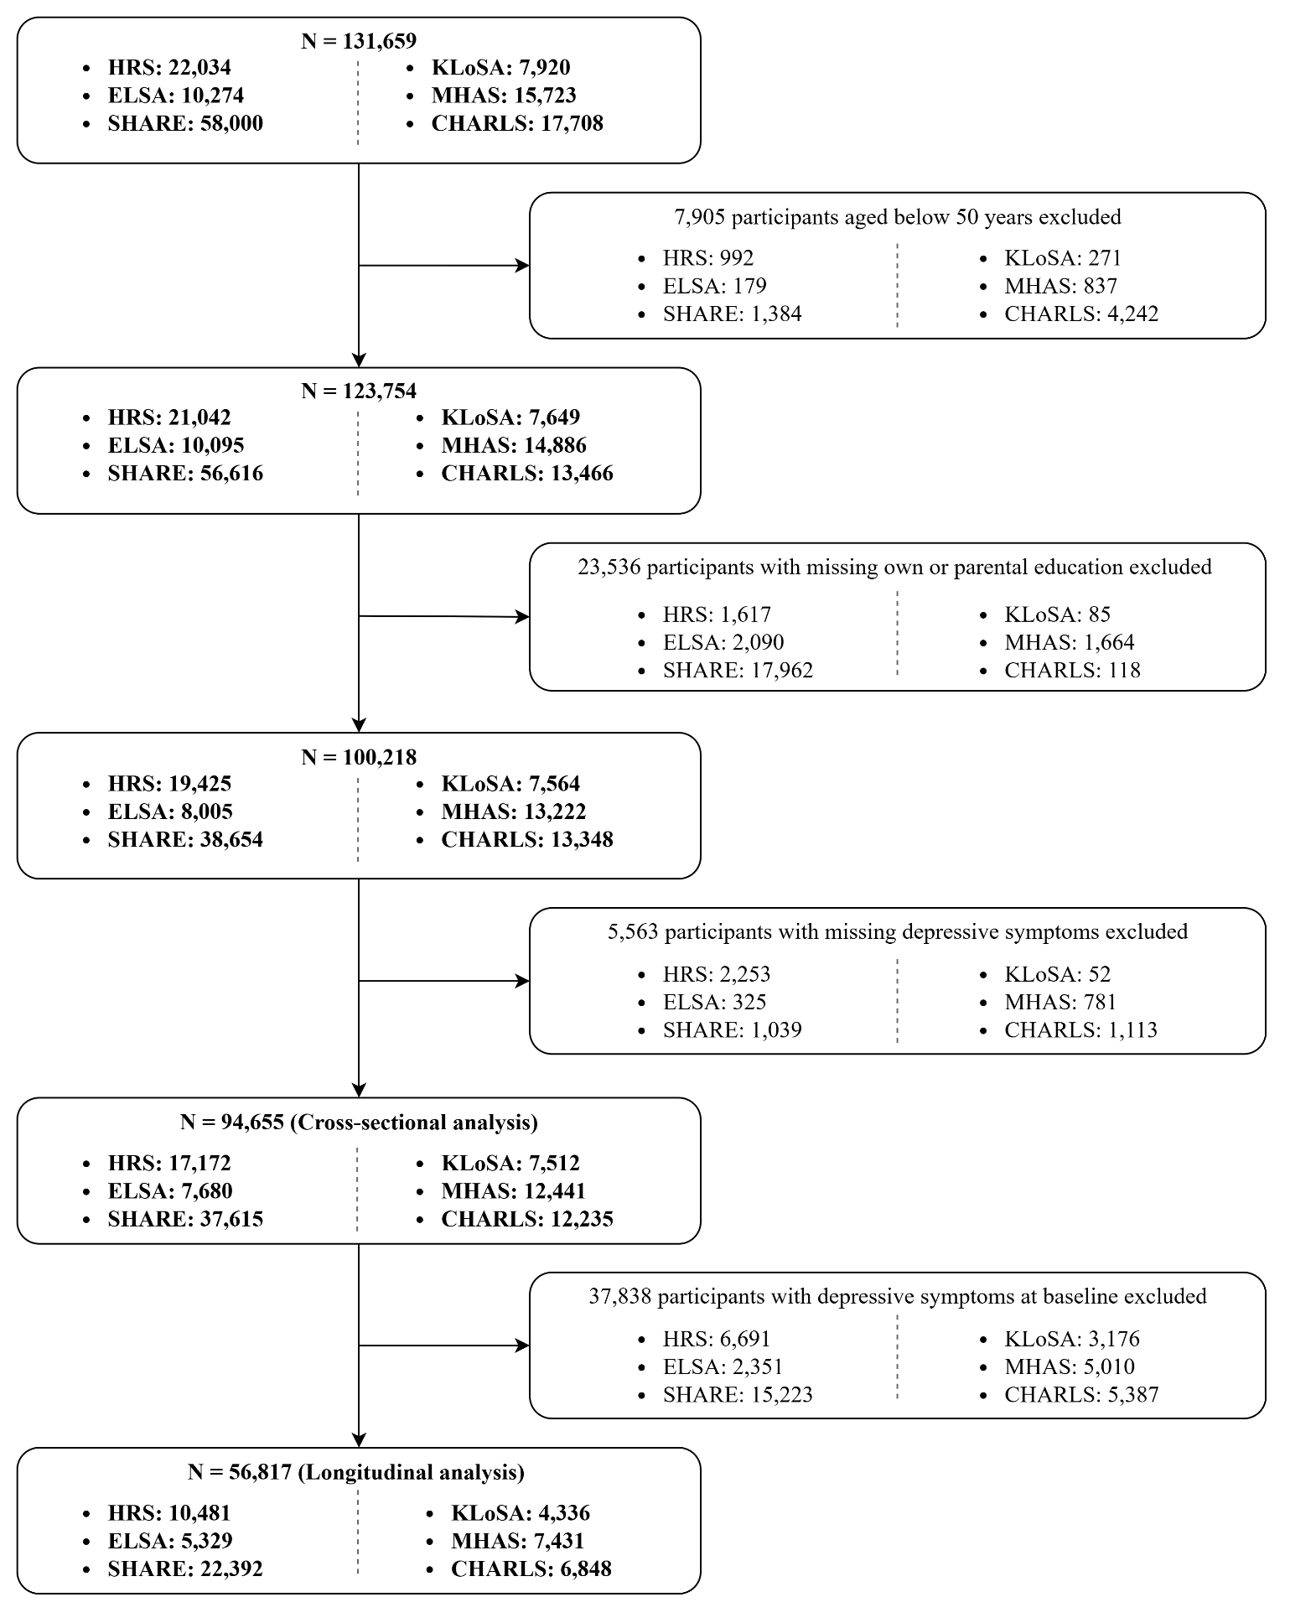
Figure S1. Flow chart of analytical sample.

Figure S2. Association between relative educational mobility and depressive symptoms in cohort-specific and pooled cross-sectional meta-analyses of men (n= 41,624).
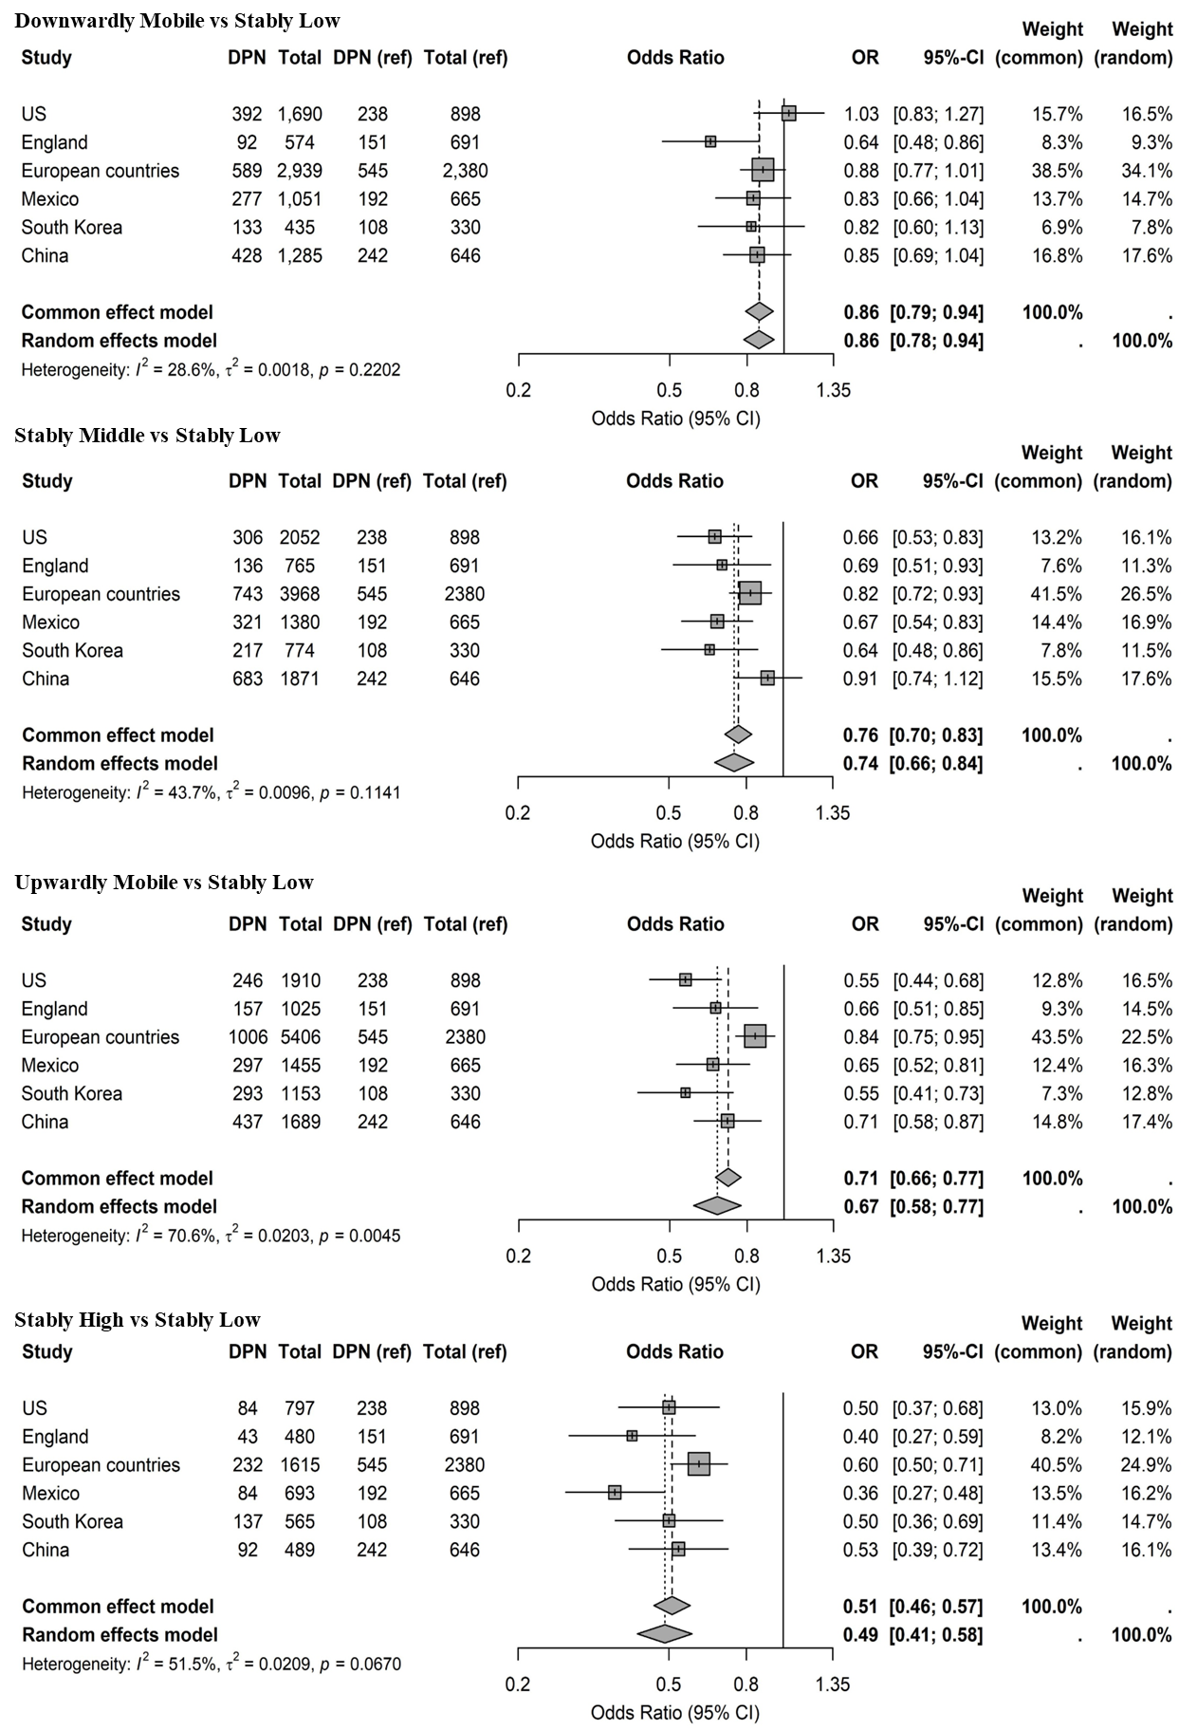
Footnote: DPN, the number of individuals with depressive symptoms; Total, the total number of participants in mobile group. The position of each square represents the association estimate, and the horizontal bars indicate 95% CIs. Size of square represents the weight of each study. In each plot, vertical dashed lines and solid diamonds are summary effect estimates either based on common-effect or random-effects model. All estimates were generated using GLM model and the stably low group as the reference group. All models were fully adjusted.

Figure S3. Association between relative educational mobility and depressive symptoms in cohort-specific and pooled cross-sectional meta-analyses of women (n= 53,031).
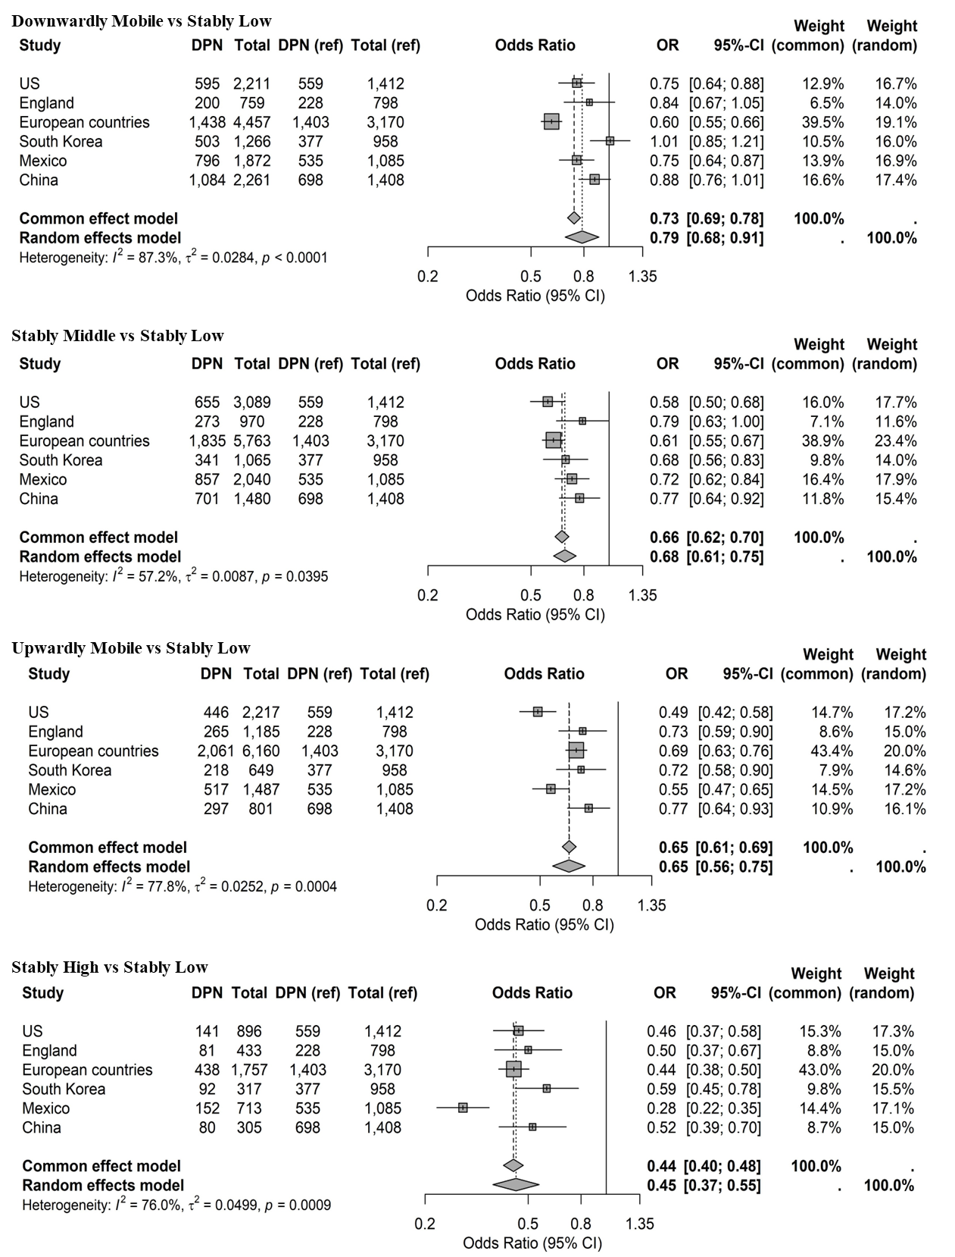
Footnote: DPN, the number of individuals with depressive symptoms; Total, the total number of participants in mobile group. The position of each square represents the association estimate, and the horizontal bars indicate 95% CIs. Size of square represents the weight of each study. In each plot, vertical dashed lines and solid diamonds are summary effect estimates either based on common-effect or random-effects model. All estimates were generated using GLM model and the stably low group as the reference group. All models were fully adjusted.

Figure S4. Association between relative educational mobility and depressive symptoms in cohort-specific and pooled longitudinal meta-analyses of men (n= 26,932).
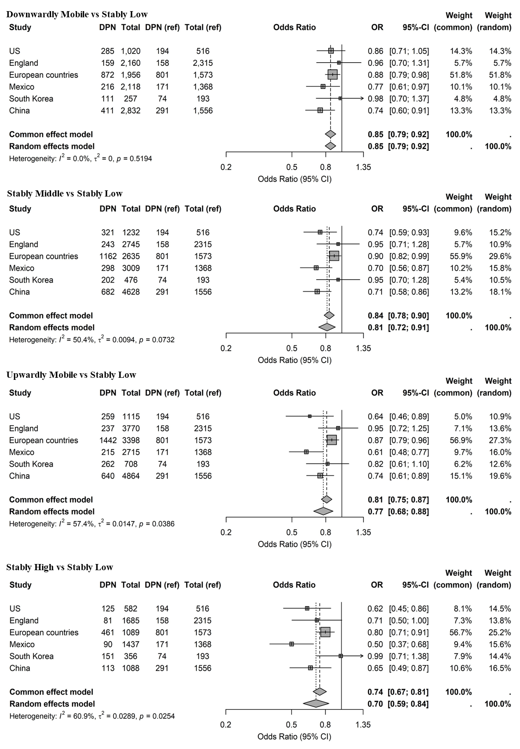
Footnote: DPN, the number of individuals with depressive symptoms; Total, the total number of participants in mobile group. The position of each square represents the association estimate, and the horizontal bars indicate 95% CIs. Size of square represents the weight of each study. In each plot, vertical dashed lines and solid diamonds are summary effect estimates either based on common-effect or random-effects model. All estimates were generated using GEE model and the stably low group as the reference group. All models were fully adjusted.

Figure S5. Association between relative educational mobility and depressive symptoms in cohort-specific and pooled longitudinal meta-analyses of women (n= 29,885).
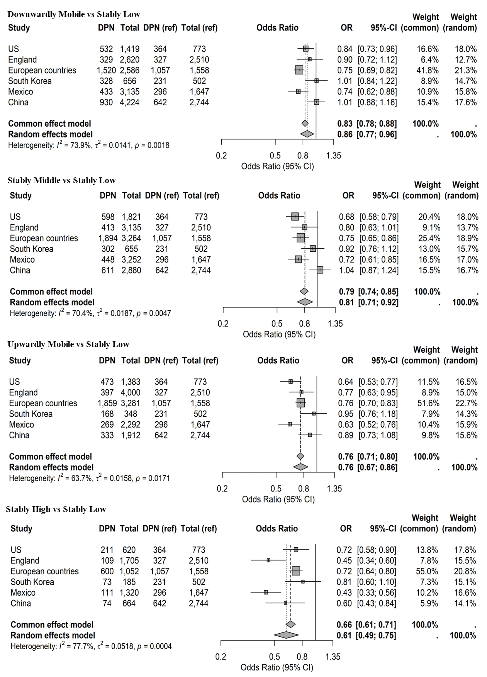
Footnote: DPN, the number of individuals with depressive symptoms; Total, the total number of participants in mobile group. The position of each square represents the association estimate, and the horizontal bars indicate 95% CIs. Size of square represents the weight of each study. In each plot, vertical dashed lines and solid diamonds are summary effect estimates either based on common-effect or random-effects model. All estimates were generated using GEE model and the stably low group as the reference group. All models were fully adjusted.

Figure S6. The results of mediation analysis.
A. US
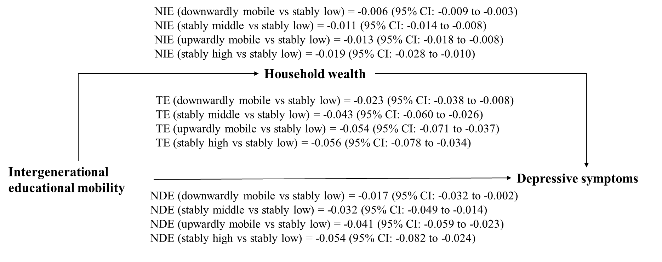
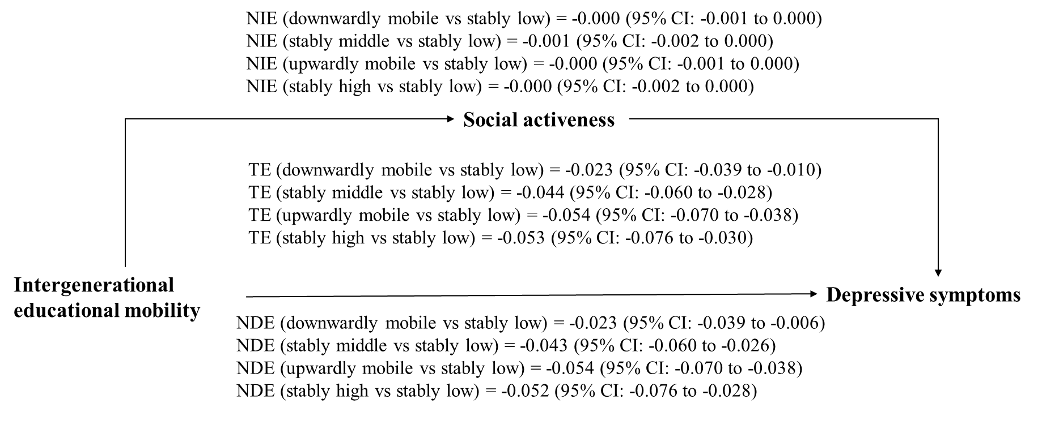
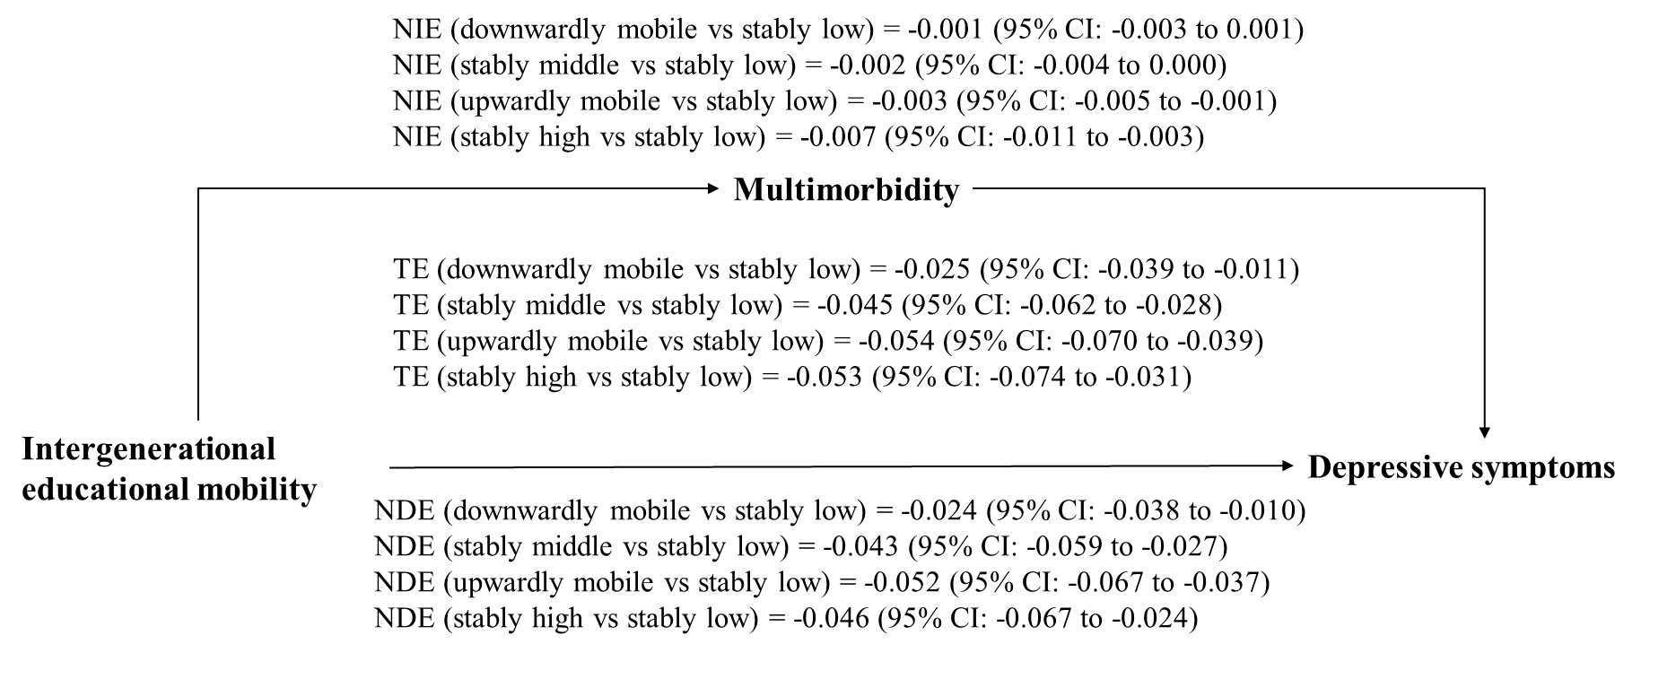
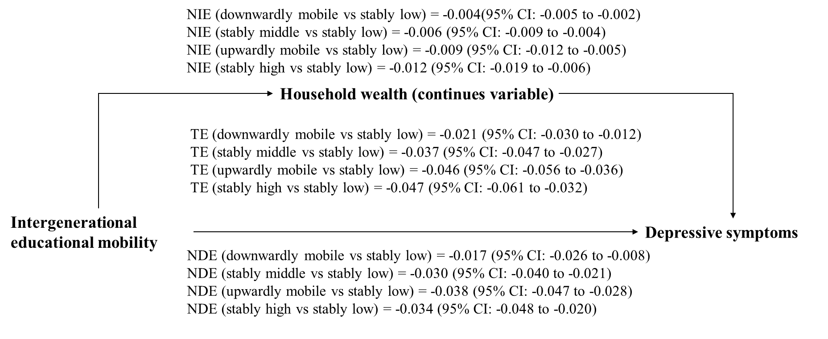
B. England
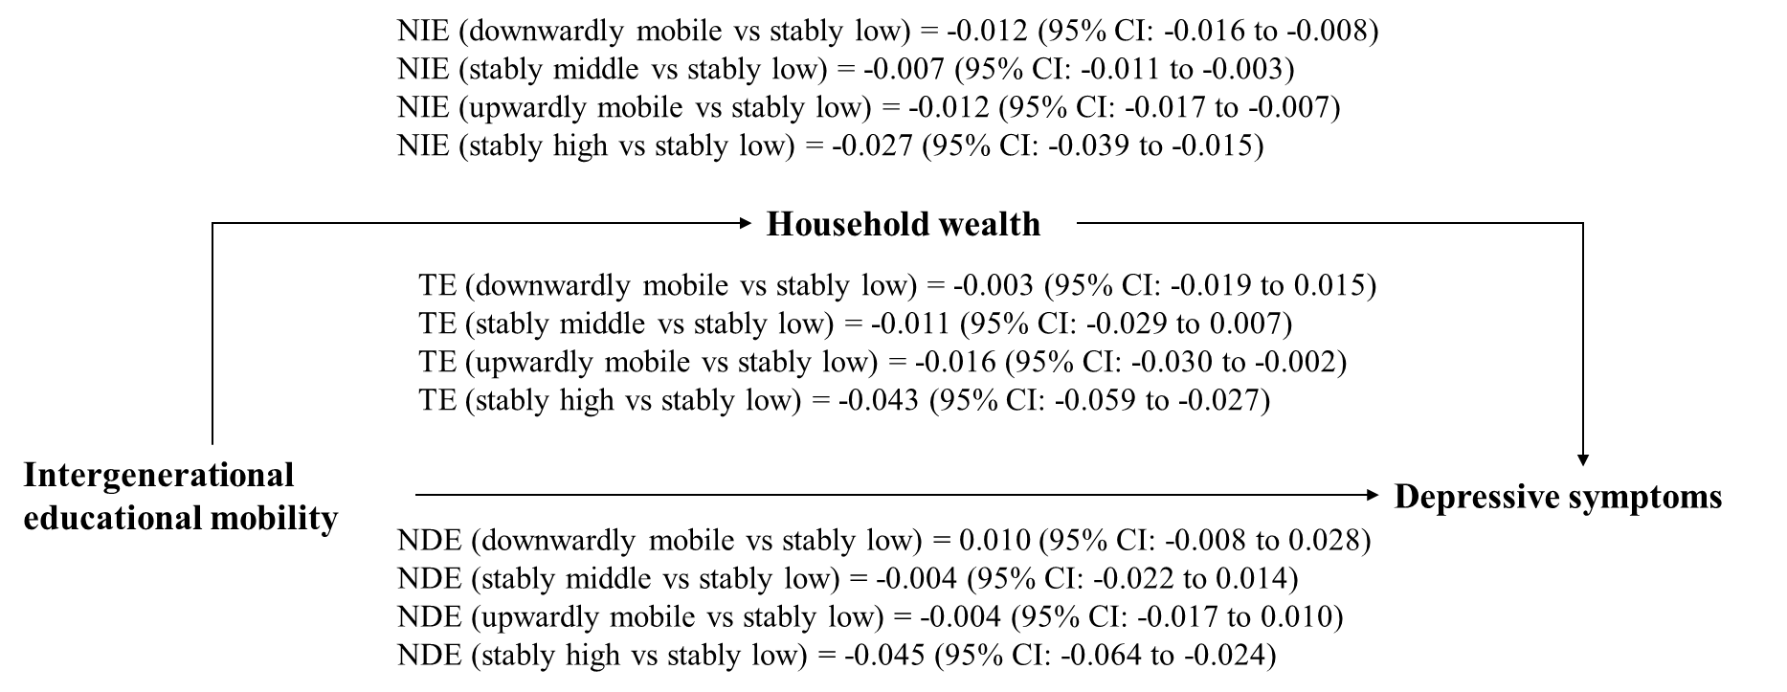
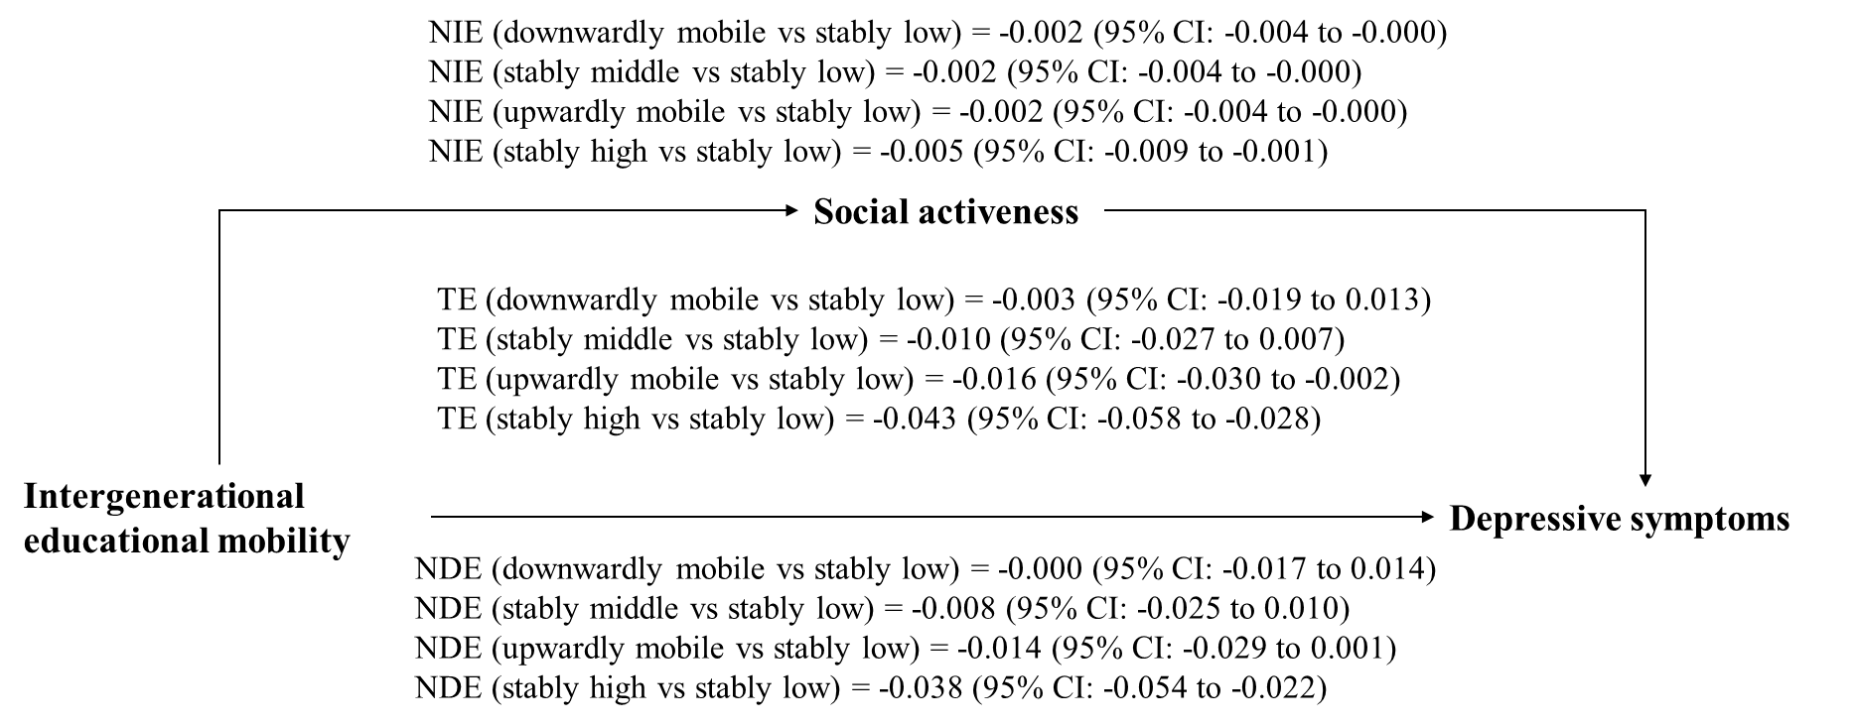
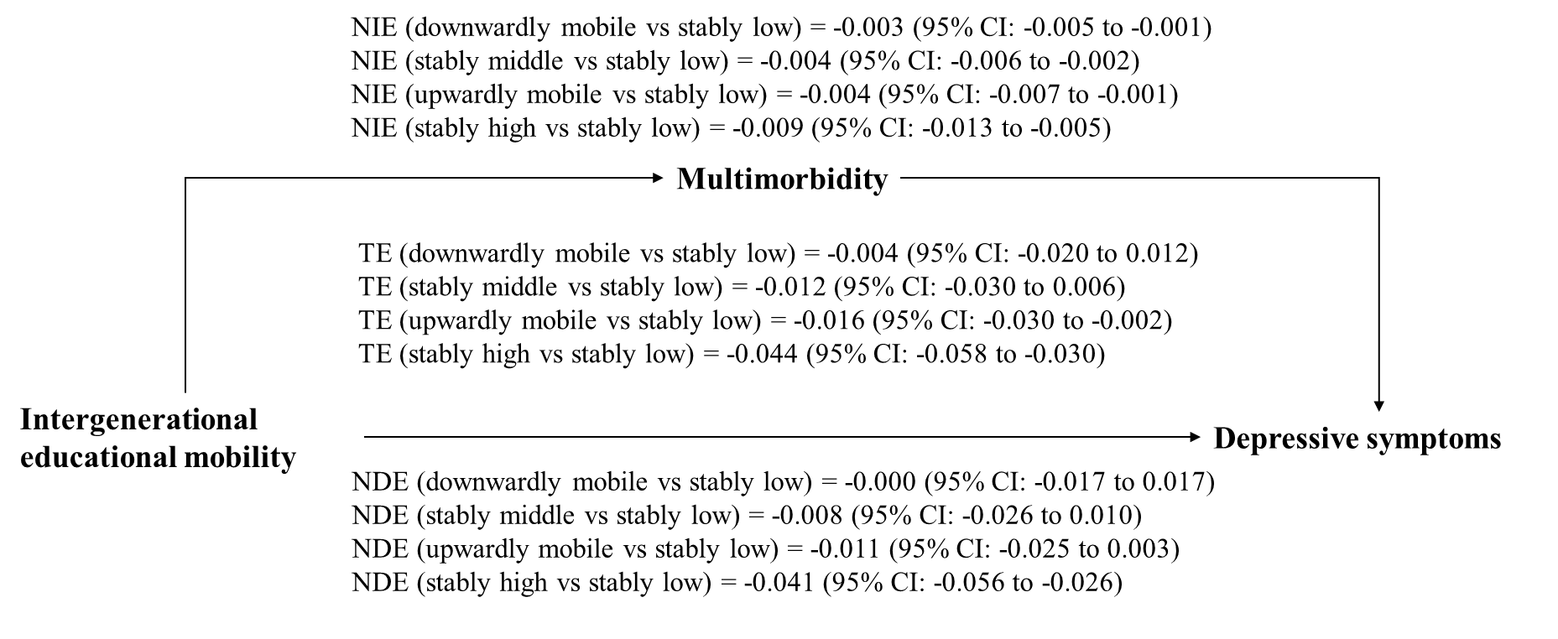
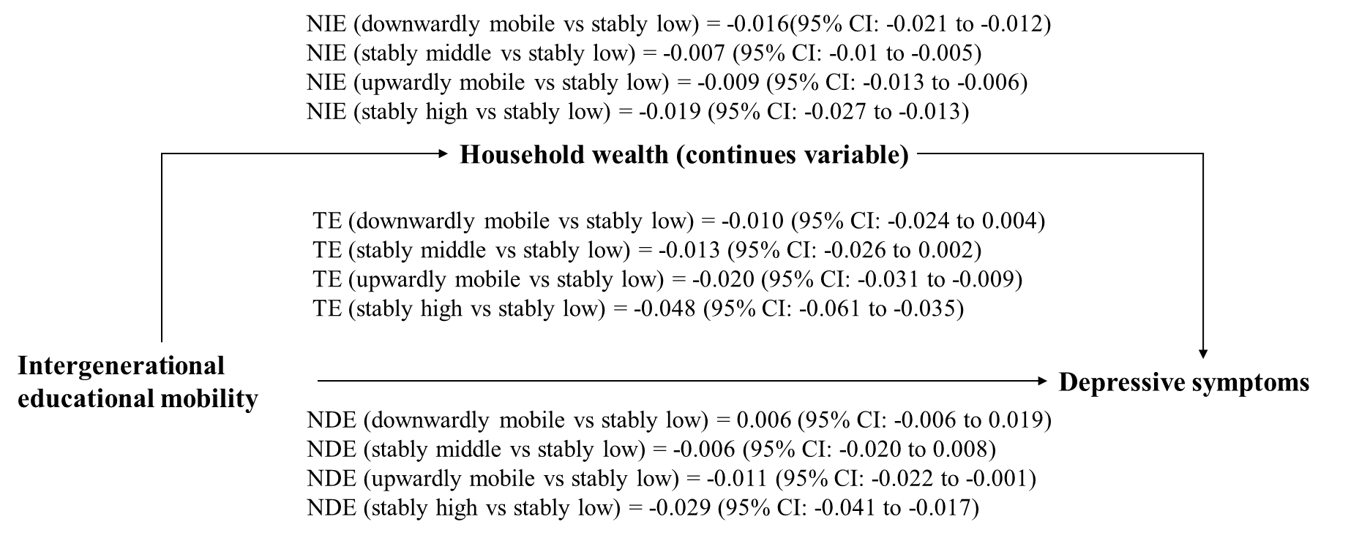

C. European countries
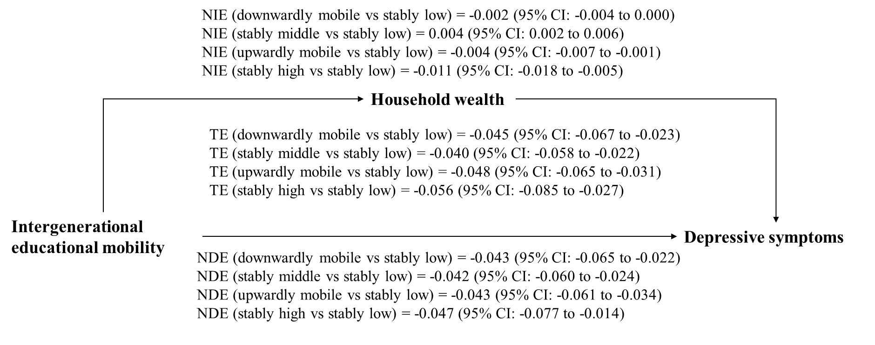
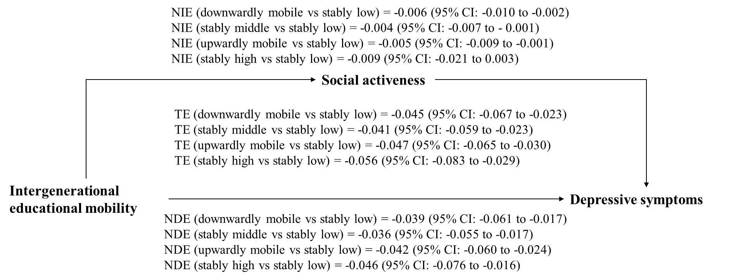
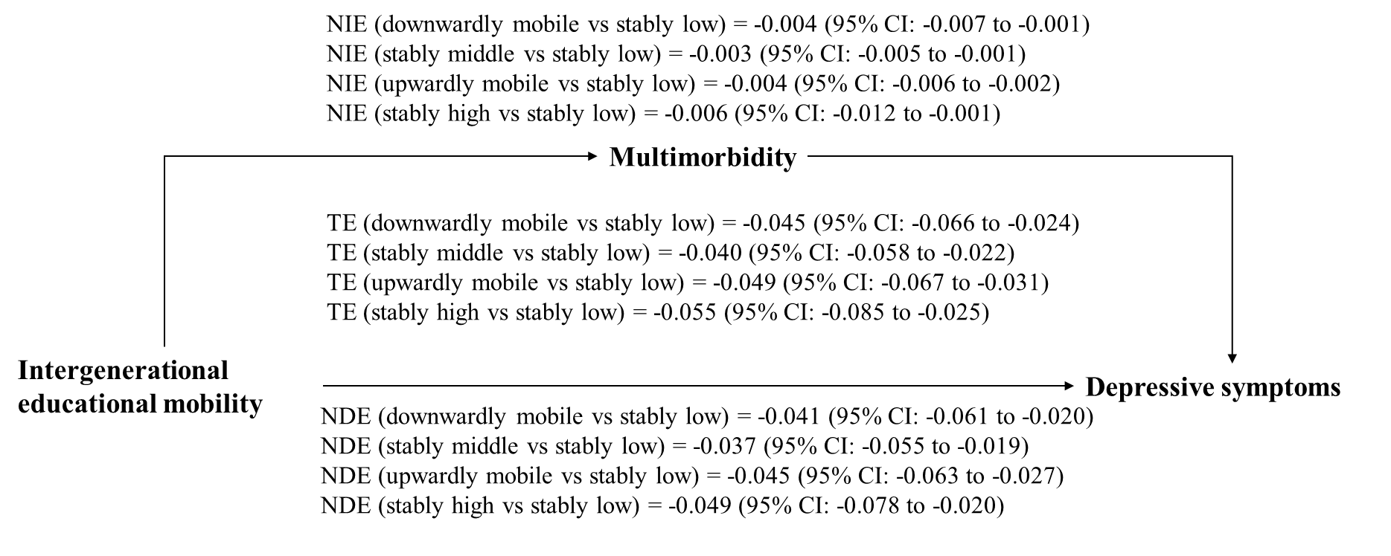
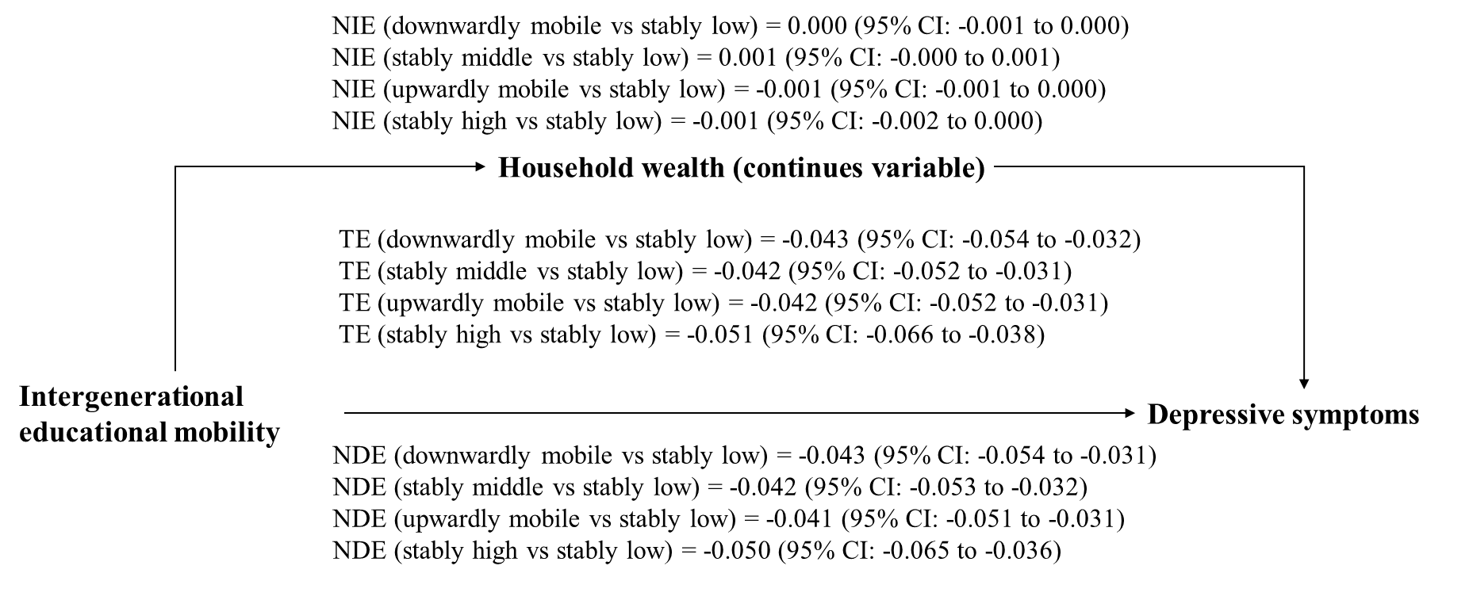
D. South Korea
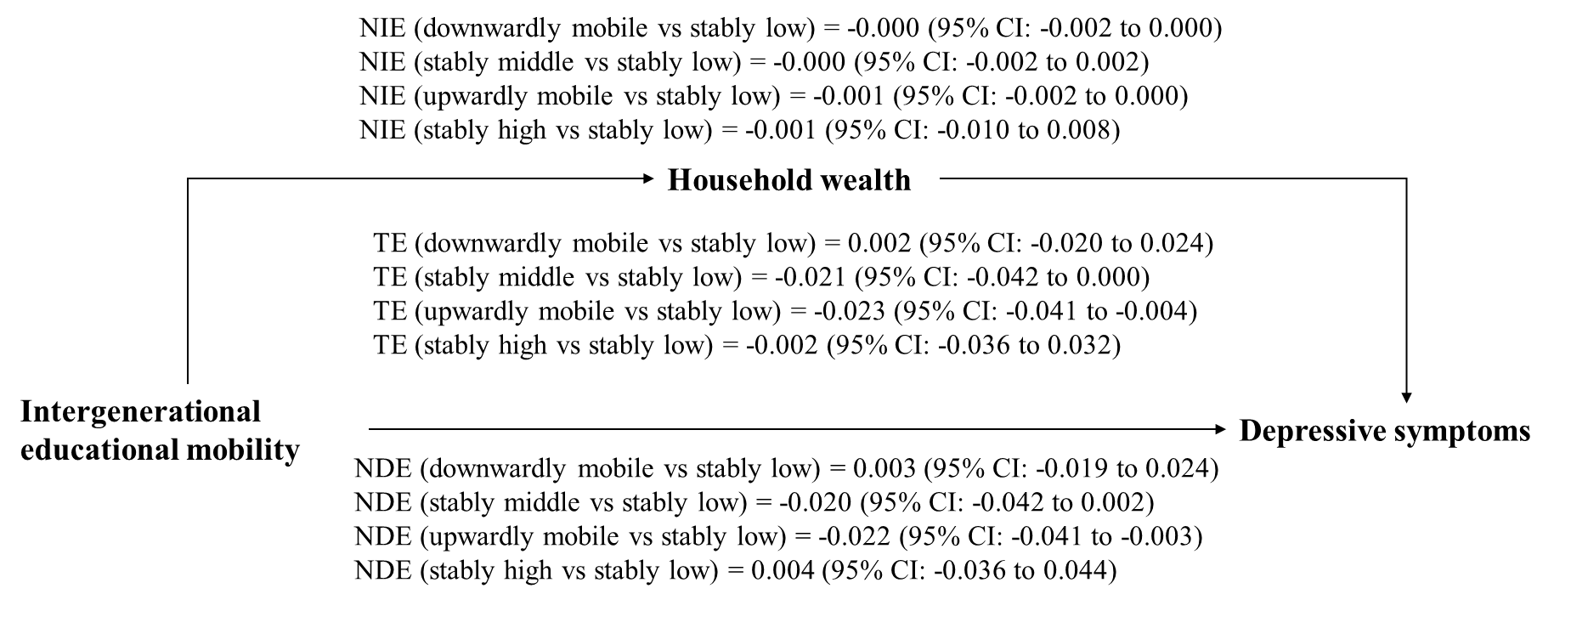
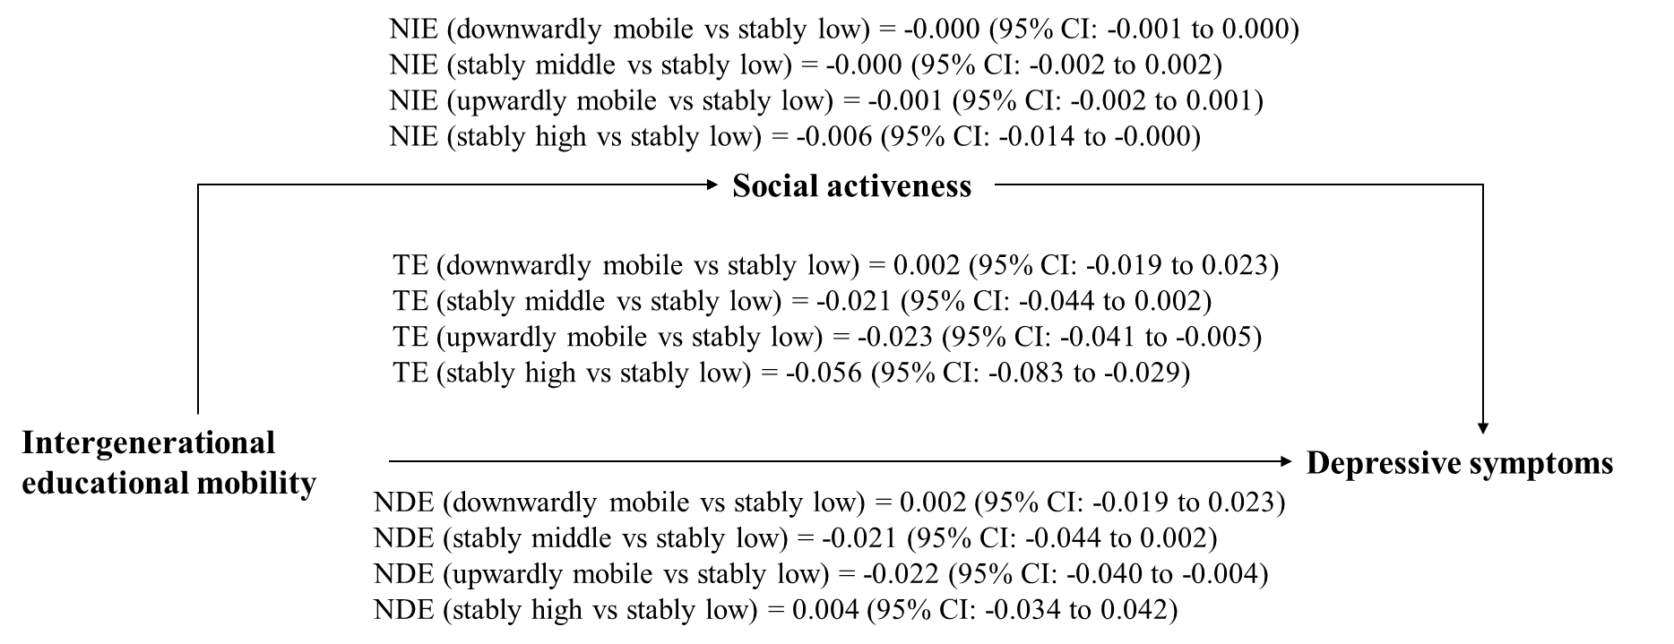
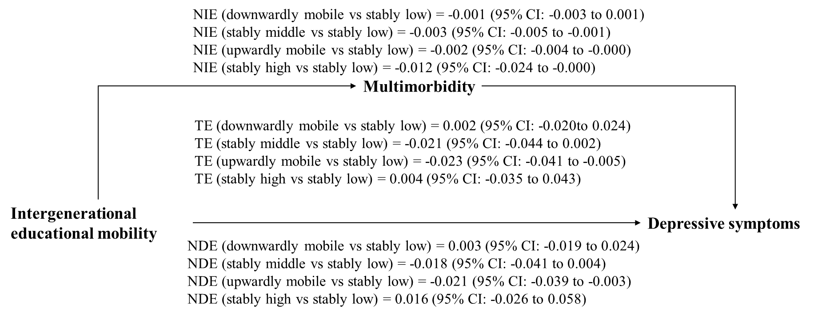
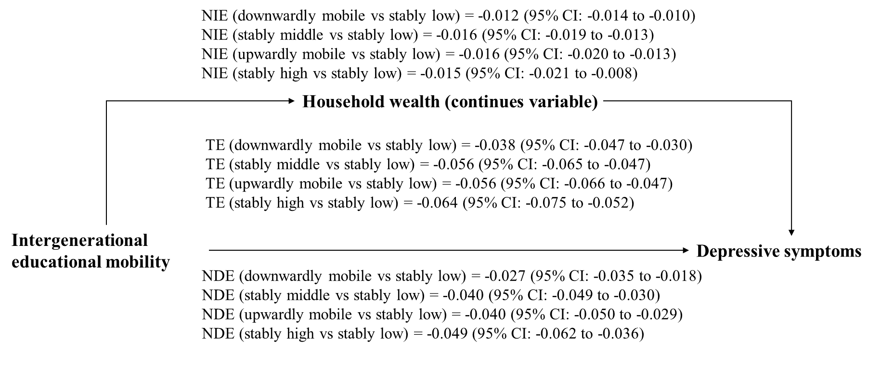

E. Mexico
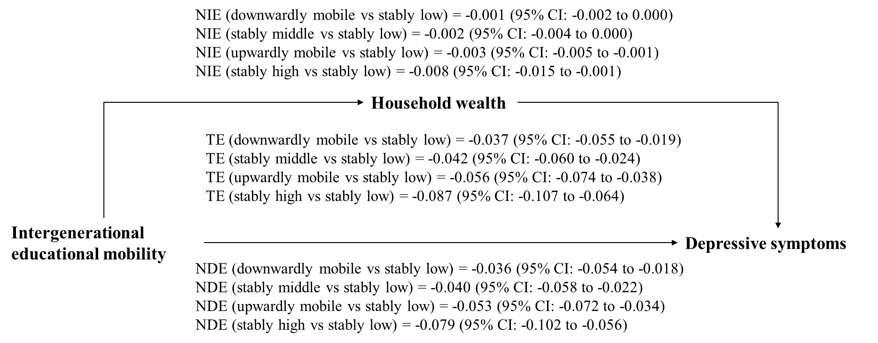
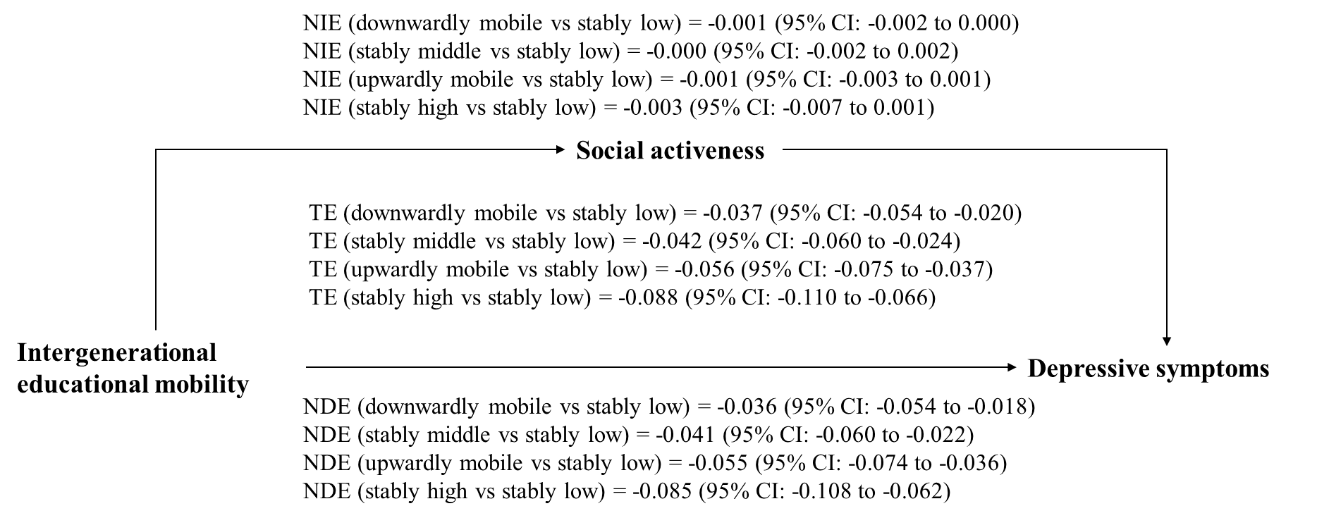
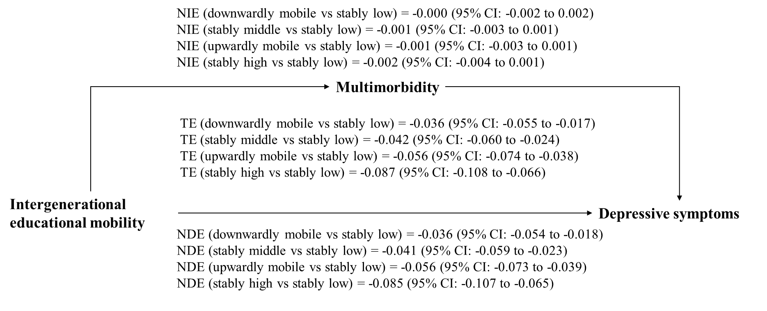
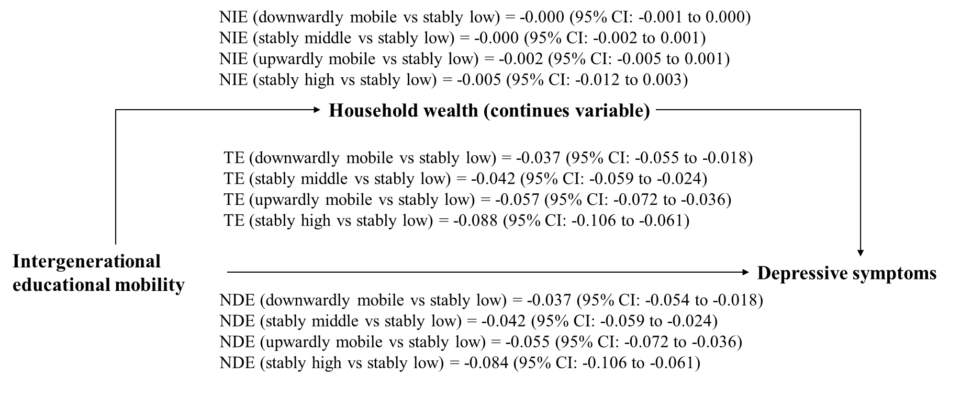

F. China
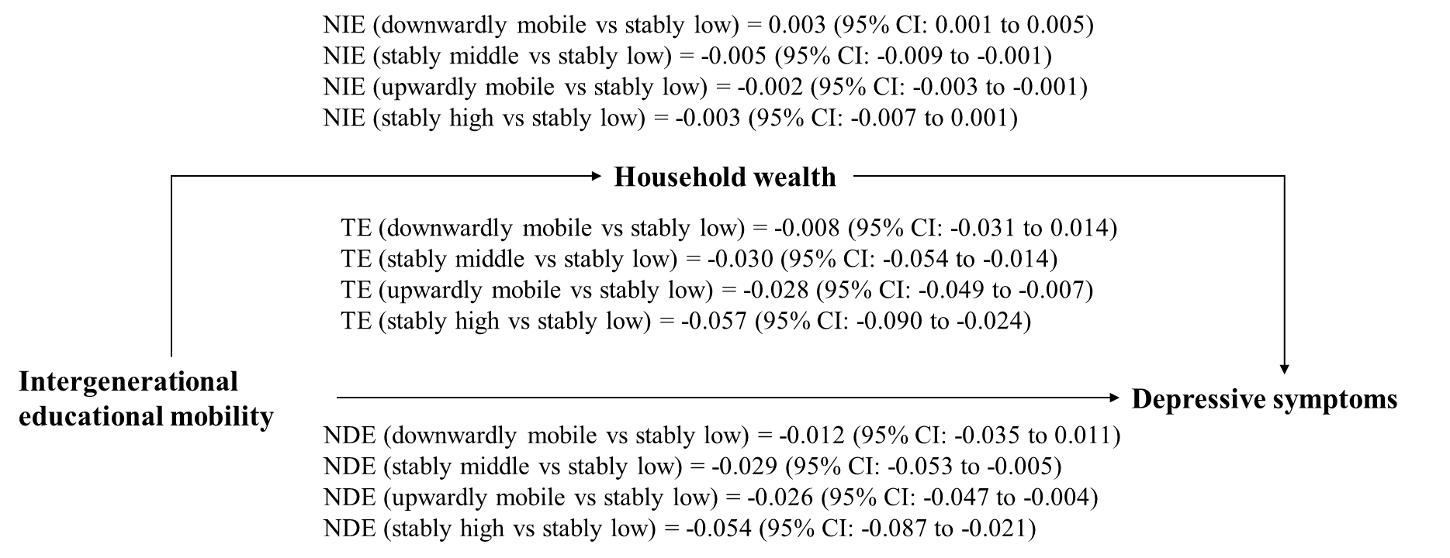
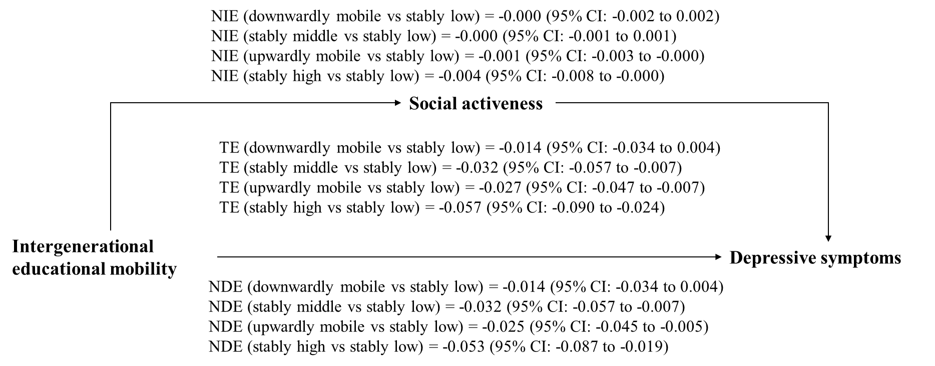
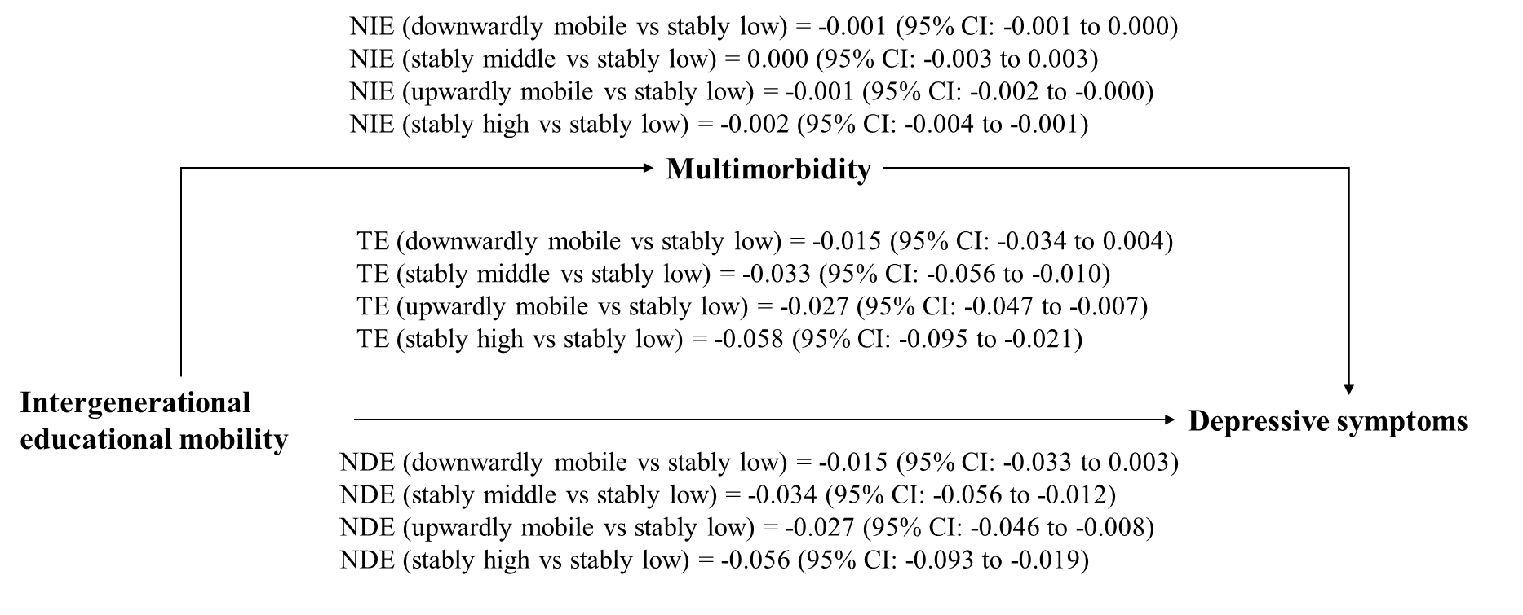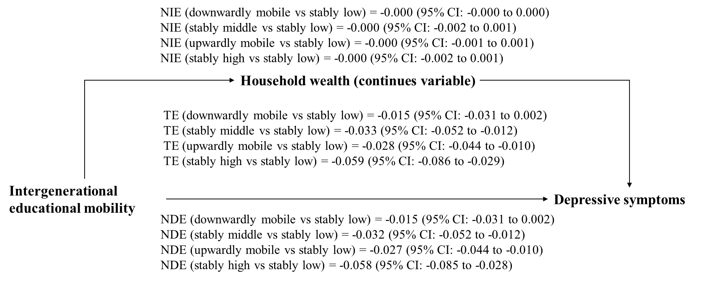
Footnote: The total effect (TE) represents the overall effect of intergenerational educational mobility on depressive symptoms. The natural direct effect (NDE) represents the portion of the total effect that is independent of the mediator. The natural indirect effect (NIE) represents the portion of the total effect that can be explained by the mediator. Household wealth was tested as both a dichotomous and continuous mediator.

Figure S7. The robustness of mediation analysis revealed by bootstrap analysis.
A. US
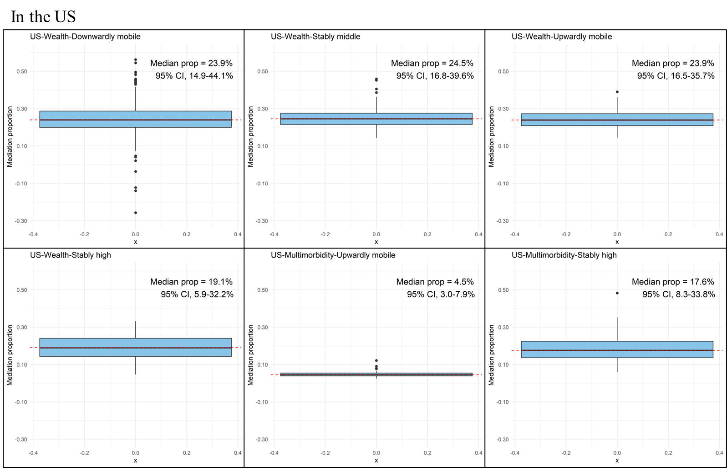
B. England
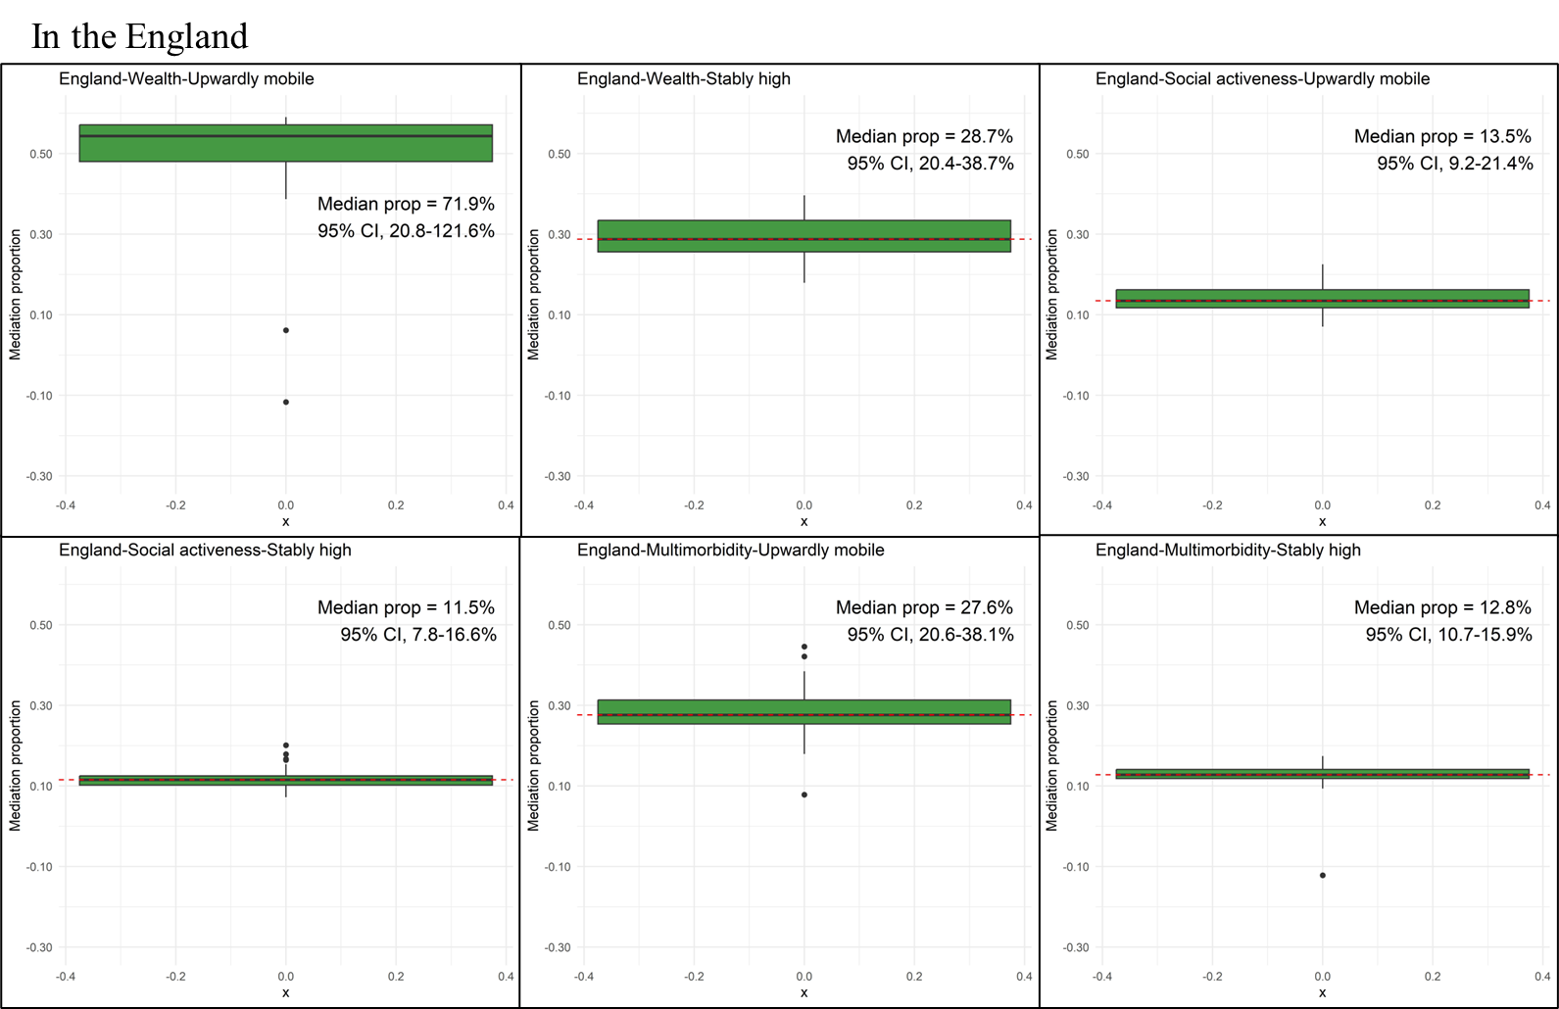

C. European countries
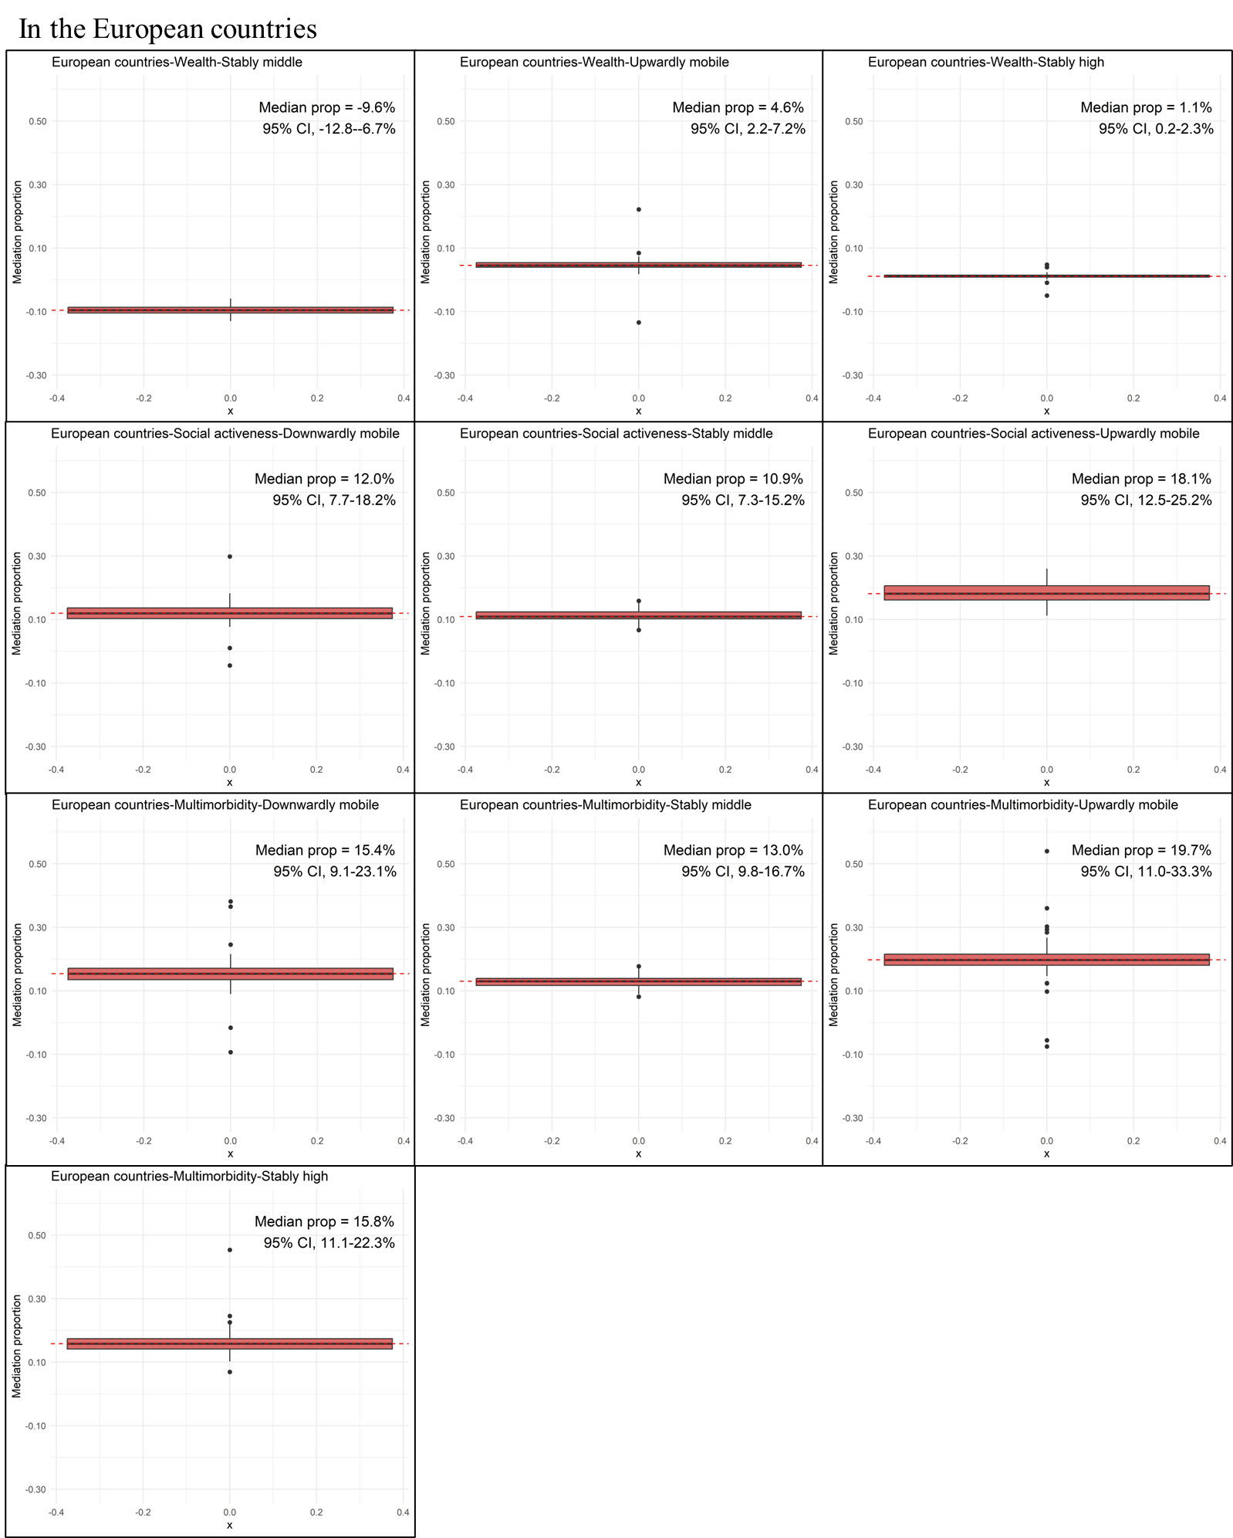

D. South Korea
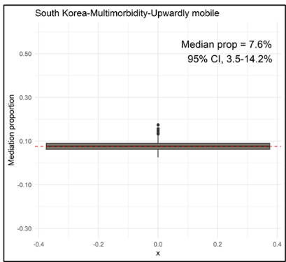
E. Mexico
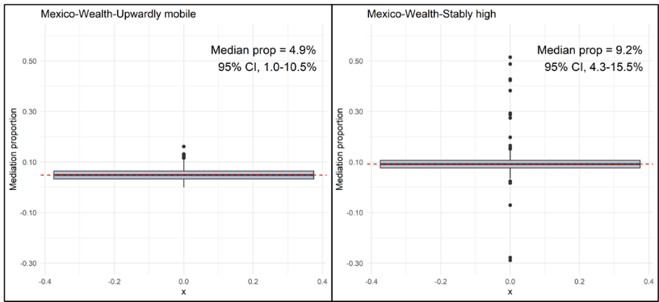
F. China
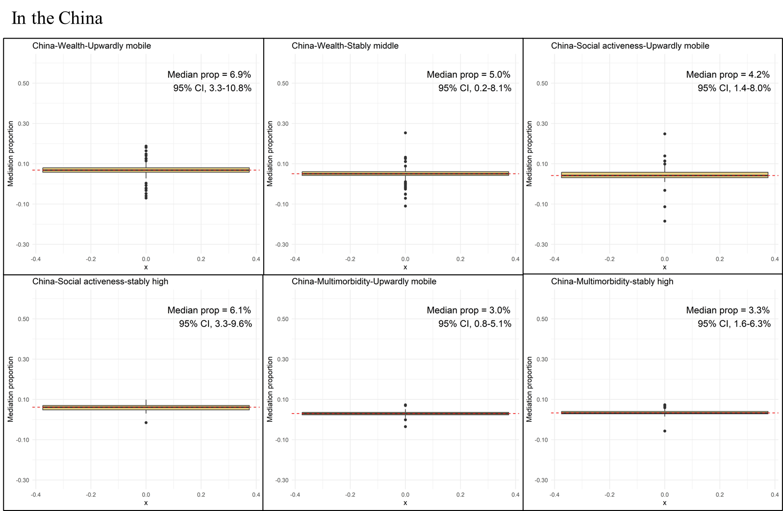
Footnote: Each boxplot title in the bootstrap resampling analysis was structured as "Country - Mediator - Educational Mobility."

Figure S8. Association between absolute educational mobility and depressive symptoms in cohort-specific and pooled cross-sectional meta-analyses (n=94,655).
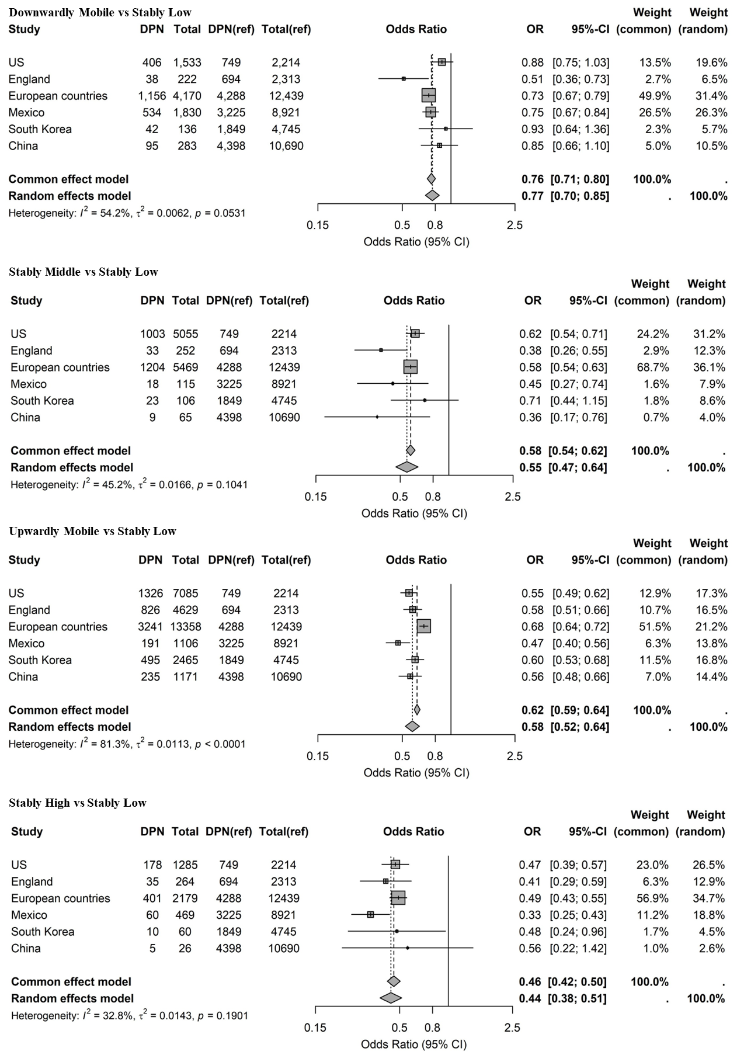
Footnote: DPN, the number of individuals with depressive symptoms; Total, the total number of participants in mobile group. The position of each square represents the association estimate, and the horizontal bars indicate 95% CIs. Size of square represents the weight of each study. In each plot, vertical dashed lines and solid diamonds are summary effect estimates either based on common-effect or random-effects model. All estimates were generated using GLM model and the stably low group as the reference group. All models were fully adjusted.

Figure S9. Association between absolute educational mobility and depressive symptoms in cohort-specific and pooled longitudinal meta-analyses (n=56,550).
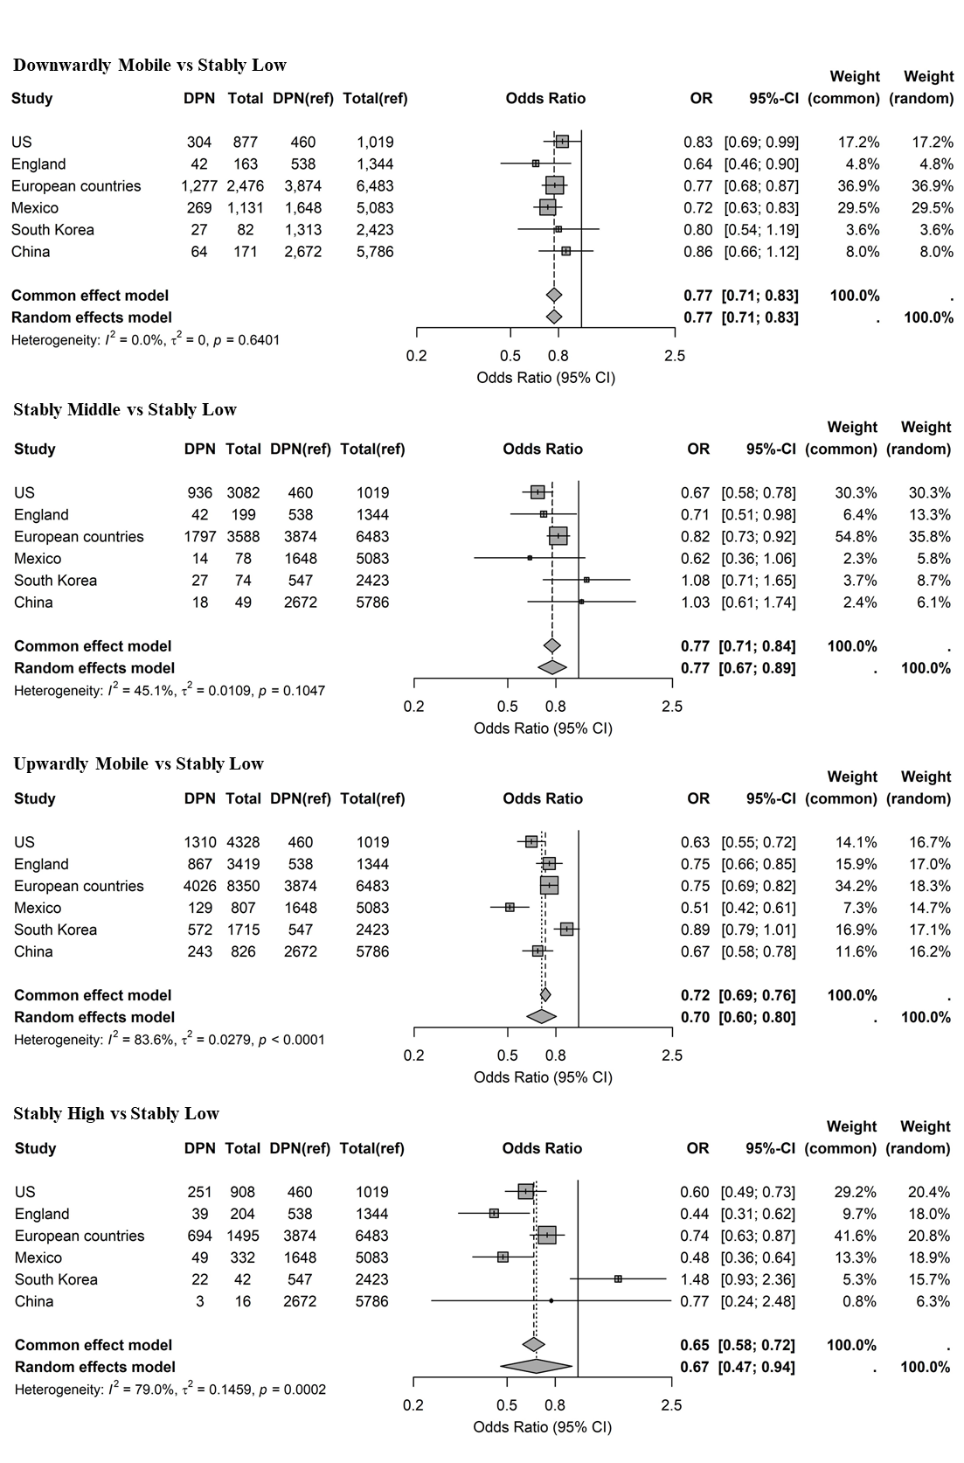
Footnote: DPN, the number of individuals with depressive symptoms; Total, the total number of participants in mobile group. The position of each square represents the association estimate, and the horizontal bars indicate 95% CIs. Size of square represents the weight of each study. In each plot, vertical dashed lines and solid diamonds are summary effect estimates either based on common-effect or random-effects model. All estimates were generated using GEE model and the stably low group as the reference group. All models were fully adjusted.

