Supplementary Appendix
Table of Contents
Table S1. The Uno's concordance index at 5-year 2
Figure S1. The distribution of propensity score and standardized mean difference before and after weighting 3
Figure S2. Kaplan-Meier curves of overall survival without IPW adjustment 4
Figure S3. Calibration and receiver operating characteristic curves of the prediction model at 5-year 5

Table S1. The Uno's concordance index at 5-year
 | Uno's concordance index | 95% CI
5-Year | 0.68 | (0.64, 0.72)
The 95% CI of Uno's concordance index was obtained by 100 perturbations.

Figure S1. The distribution of propensity score and standardized mean difference before and after weighting
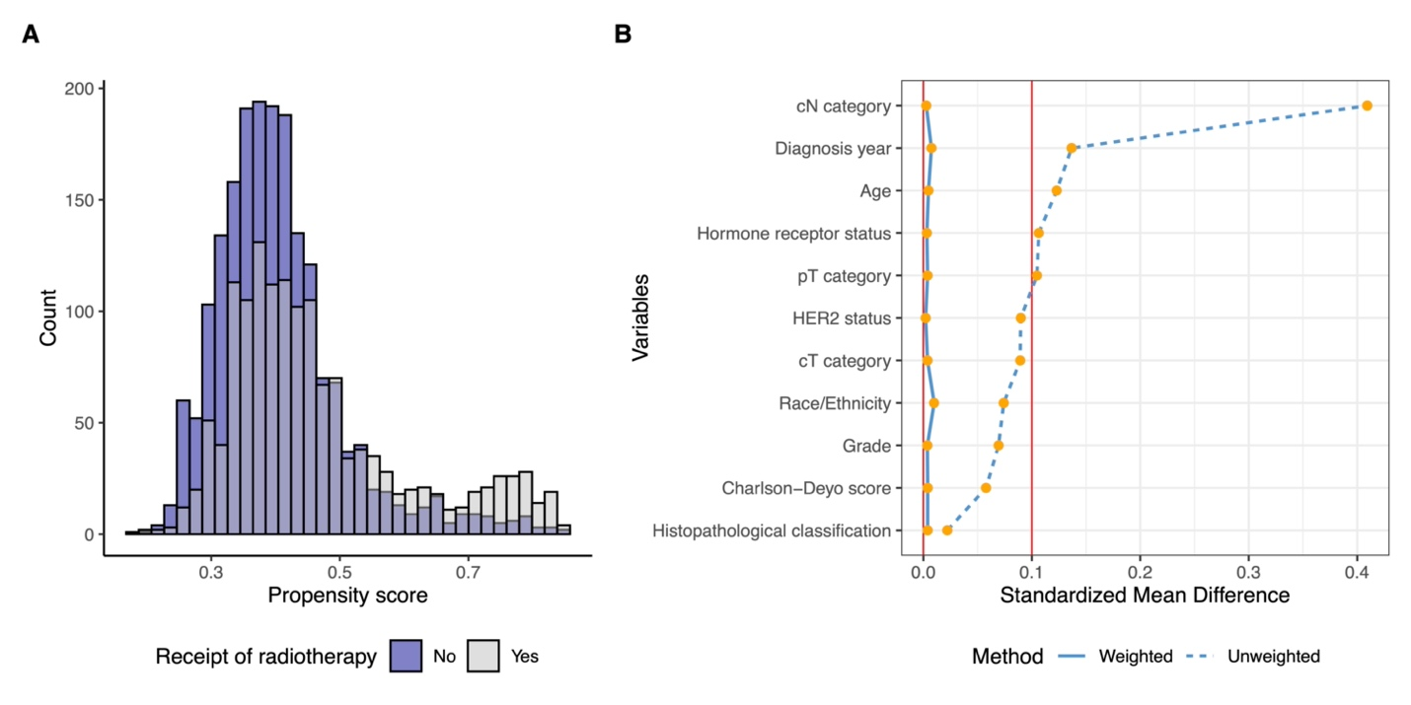
Panel A shows the distribution of propensity score (PS) estimated using multivariable logistic model with variables including age at diagnosis, race, hormone receptor status, HER2 status, Charlson-Deyo score, pathological T stage, tumor grade, tumor histology type, and diagnosis year, which with the minimum PS equaling to 0.179 and maximum PS equaling to 0.850. Panel B shows the change of standardized mean difference (SMD) before and after using inverse probability weighting method and all the SMDs were <0.1 after weighting.

Figure S2. Kaplan-Meier curves of overall survival without IPW adjustment
Abbreviations: IPW, inverse probability weighting; OS, overall survival; RT, radiotherapy.

Figure S3. Calibration and receiver operating characteristic curves of the prediction model at 5-year
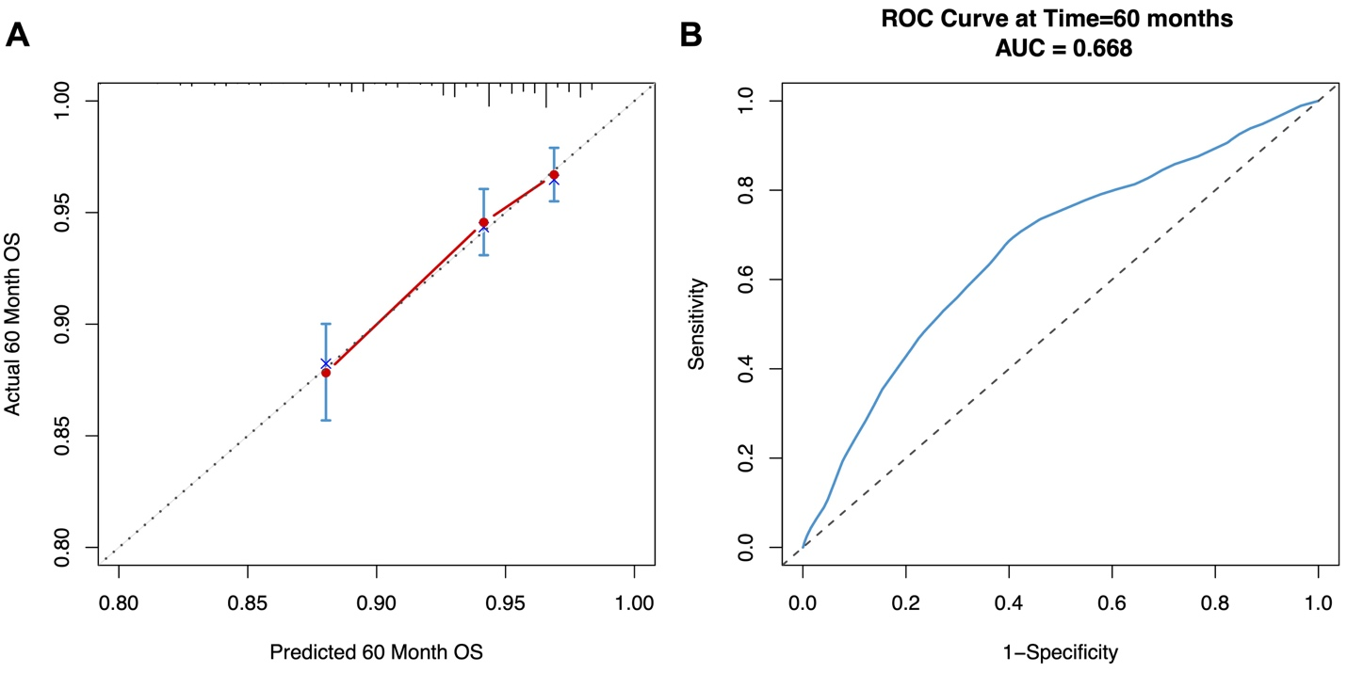

Abbreviations: OS, overall survival; ROC, receiver operating characteristic.
Panel A shows the calibration plot of the prediction model at 5-year; Panel B shows the receiver operating characteristic (ROC) curve at 5-year.

