UnityのAssetあれこれ

■Forest Grounds Texture Pack　 ←草！床！

<https://www.assetstore.unity3d.com/jp/#!/content/303>

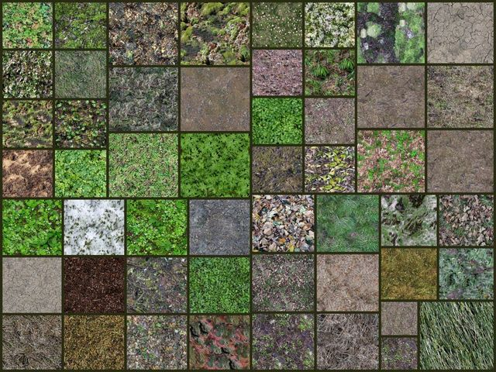

■Block Art Package　 ←祭壇ぽい台

<https://www.assetstore.unity3d.com/jp/#!/content/7063>

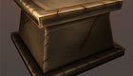

■10 Low-poly medieval models　 ←立方体の箱あるよ！

<https://www.assetstore.unity3d.com/jp/#!/content/30639>

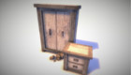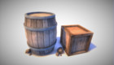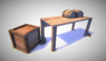

■Wooden Pallet Pack　　←木の質感がいい！パレットだけど

<https://www.assetstore.unity3d.com/jp/#!/content/657>

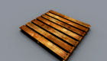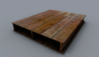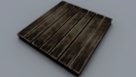

■Ben3d Crate　←理想の箱ではないでしょうか

<https://www.assetstore.unity3d.com/jp/#!/content/7548>

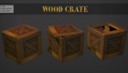

■Props for the Classroom　←　研究所でもありそうな　プロジェクタ、黒板、ファン、PC、モニタ、プリンタ

<https://www.assetstore.unity3d.com/jp/#!/content/5977>

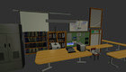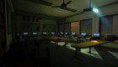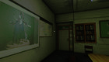

■Books

<https://www.assetstore.unity3d.com/jp/#!/content/3356>　←古風な厚ぼったい本

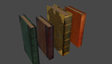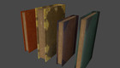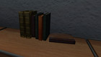

■Terrain Assets

　←木とか　-12 trees-12 bushes　-6 grass types　-22 terrain textures

<https://www.assetstore.unity3d.com/jp/#!/content/6>

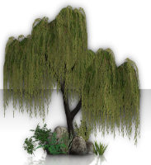

S■hanty Town: Trees　←木（アカシア、サバンナツリー）とか

<https://www.assetstore.unity3d.com/jp/#!/content/44>

Image

■Yughues Free Bushes　←灌木　５種

<https://www.assetstore.unity3d.com/jp/#!/content/13168>

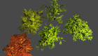

■Worn Bookshelf

<https://www.assetstore.unity3d.com/jp/#!/content/8458>

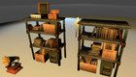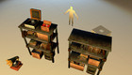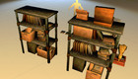

■Robot Lab

<https://www.assetstore.unity3d.com/jp/#!/content/7006>

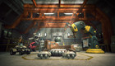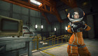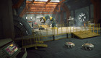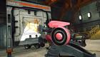

<https://www.assetstore.unity3d.com/jp/#!/content/2249>