**HS Code Usage**

The HS system is used by over 200 countries and other economies around the world for the collection of international trade statistics, and as a basis for customs tariffs. Over 98% of the goods involved in international trade are classified in terms of the HS Code.

In addition to governments, the code is also used by private-sector firms and international organizations. It is utilized to monitor, update, and optimize controlled goods, internal taxes, rules of origin, trade policies, transport statistics, freight tariffs, compilation of national accounts, quota controls, price monitoring, traffic statistics, and economic research as well as analysis.

Thus, the HS code is regarded as an indispensable tool for international trade, universal economic language, and coding for commodities.

**Maintenance and Classification of HS Code**

The Harmonized System is governed by The International Convention on the Harmonized Commodity Description and Coding System. The official interpretation of the HS is given in the Explanatory Notes published by the [WCO](http://www.wcoomd.org/) (World Customs Organization).

The WCO prioritizes the maintenance of HS code. This includes some measures to secure uniform interpretation of the HS code as well as its periodic updates in light of developments in technology and fluctuations in trade patterns.

The WCO manages the entire process through the Harmonized System Committee that represents the Contracting Signatories/Parties to the HS Convection. The Committee takes decisions on classification questions, examines policy matters, settles disputes, and prepares amendments to the Explanatory Notes. This committee also prepares bills that update the HS System every 5-6 years.

HS Classification is the process by which HS codes are assigned. All commodities are classified in the HS by using GRI (General Rules of the Interpretation of the Harmonized System).

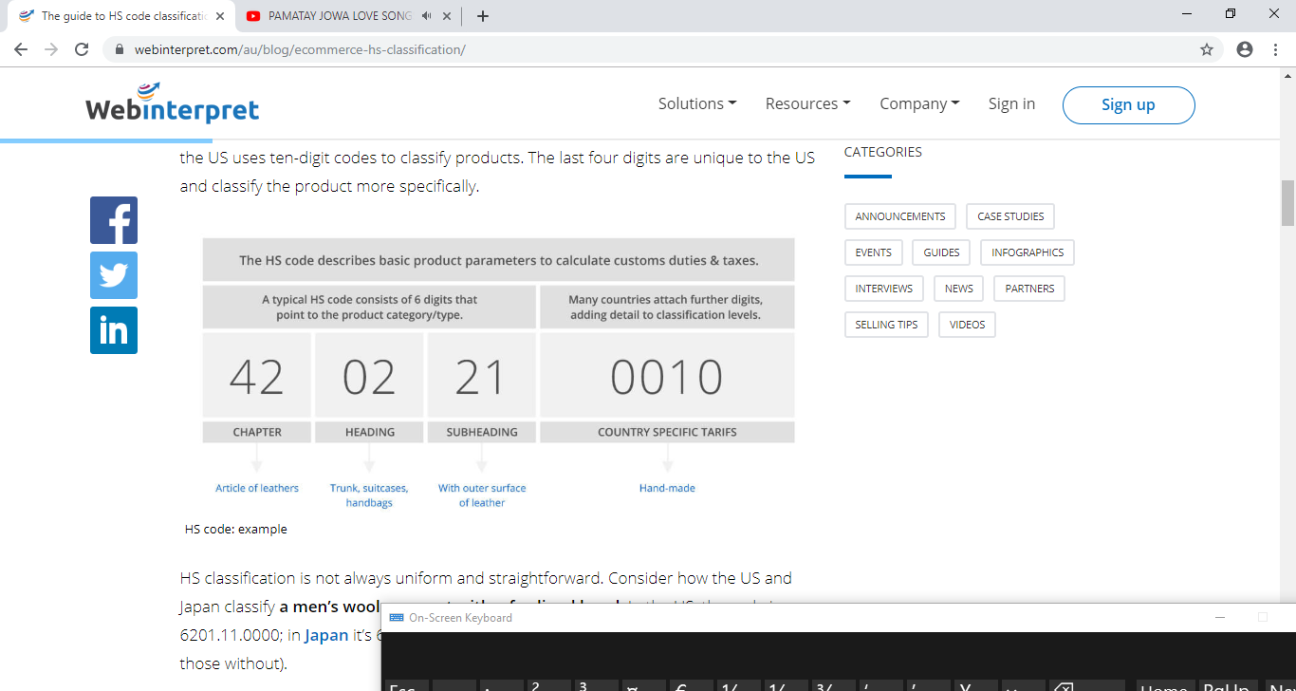

# Determining Duty Rates

The[Harmonized Tariff System (HTS)](http://www.usitc.gov/tata/hts/bychapter/index.htm) provides duty rates for virtually every item that exists. The HTS is a reference manual that is the size of an unabridged dictionary.

Experts spend years learning how to properly classify an item in order to determine its correct duty rate. For instance, you might want to know the rate of duty of a wool suit. A classification specialist will need to know, does it have darts? Did the wool come from Israel or another country that qualifies for duty-free treatment for certain of its products? Where was the suit assembled, does it have any synthetic fibers in the lining?

The U.S. International Trade Commission-[Tariff Database](http://dataweb.usitc.gov/), is an interactive data base that will enable you to get an approximate idea of the duty rate for a particular product. Please be aware that the duty rate you request is only as good as the information you provide. The actual duty rate of the item you import may not be what you think it should be as a result of your research.

CBP makes the final determination of what the correct rate of duty is, not the importer. For very specific duty information on a particular item you may [request a Binding Ruling](https://www.cbp.gov/trade/rulings). You may also receive guidance by calling your [local CBP port](https://www.cbp.gov/contact/ports).

## Why are HS codes and HTS codes important for global trade?

The Harmonized System code for goods, or it’s full name – the Harmonized Commodity Description and Coding System – was adopted by the [World Customs Organisation](http://www.wcoomd.org/) (WCO) in 1983.  It has been used by member countries since then to classify goods in international trade for Customs tariff purposes. The system is reviewed periodically for adjustments to take account for advances in technology.

A HS Code is used primarily to identify goods that are to be cleared through customs in countries around the world.  Apart from that, HS codes are extensively used by governments, international organizations and the private sector for a number of other purposes.  These purposes include trade statistics, internal taxes, trade policies, monitoring of controlled goods, rules of origin, freight tariffs, transport statistics, price monitoring, quota controls, compilation of national accounts, and economic research & analysis.

## Why must shippers understand the harmonized tariff schedule and harmonized tariff code?

Shippers must correctly identify and classify goods so that the correct import duty rate will be applied in the country of import.  Therefore, if the incorrect classification of goods is made then shippers can be paying a higher or lower rate of import duty.  As a result, customs authorities will issue fines and financial penalties for incorrect classification of goods.  On top of that, additional costs for wharf and storage charges can also be incurred if there are delays due to incorrect classification.

## What are import duties?

Customs formalities are a major part of international trade; any goods which leave, enter or pass through a country will be subject to customs clearance procedures. This is true for all goods leaving the United Kingdom, apart from sales which are destined for a market within the European Union, which is a free market for movement of goods and services, and generally free of customs formalities (except for goods which are subject to excise duties – such as alcohol, tobacco, fuel oils, or perfumes).

Export customs formalities are largely carried out for statistical and export control purposes – (although they are no less important because of this!); however when goods are imported and customs cleared in a destination country, they may be subject to customs duties. These are a tax imposed by countries on goods imported unto that country, and are often calculated as a percentage of the value of the goods. Although import duty is most often paid by the importer; this can nevertheless affect the final selling price of your goods.

## Calculating import duties using tariff codes

Import duties are assessed based on the customs tariff codes which relate to the goods. If you do not know the customs tariff codes for your goods, you should check this out urgently, by visiting the [UK trade tariff website](https://www.gov.uk/trade-tariff). There is also further guidance on [tariff classification](https://www.gov.uk/classification-of-goods).

Although customs tariffs vary from country to country, most tariffs are based on the Harmonized System (H.S.) of classification, which means that the first six digits of a tariff number are the same in any country which uses the Harmonized System.

Once you find the correct tariff for your goods, you can find out what the import duty is likely to be in any overseas market by visting the [EU Market Access Database](http://madb.europa.eu/madb/datasetPreviewFormATpubli.htm?datacat_id=AT&from=publi).

One important point to remember is that it is a legal obligation in the UK and most countries, to declare goods correctly and accurately in any customs declaration; i.e.; by using the correct tariff number which most accurately represents your goods, using a series of General Rules. Therefore it is not an option to use a tariff number which offers a low rate of import duty but which is not correct, and serious legal consequences can follow.

Import duty can be a significant factor affecting the market price of goods; some countries, especially in emerging or developing markets may have high rates of import duty, which can act as a barrier to trade. Other countries have reduced import duty rates to encourage trade. Trade agreements with individual countries or trading blocs play an important part in this process, and it is often possible for goods to attract a lower (or even zero) rate of duty, if they originate from a country which has a trade agreement with the country of importation: these are called “preferences”.

This Open to Export article describing what [harmonised codes](http://opentoexport.com/article/what-is-a-harmonised-code/) are may be useful for further reading.

## What is my country of origin

The origin of goods can be a complex factor, so if your goods are not manufactured, grown or produced in the UK, or are made from components or ingredients from outside the EU, you should check carefully whether you or your buyer are able to claim “EU origin” and benefit from any preferential import duty rate. More details can be found in an [HMRC notice, number 828](https://www.gov.uk/government/publications/notice-828-tariff-preferences-rules-of-origin-for-various-countries).

## Do overseas countries charge VAT and how does it affect me?

Many overseas countries charge an equivalent of Value Added Tax (VAT); in many cases, the basic procedures are similar to the UK, although other countries operate different systems. Rates of VAT will vary from country to country.

Most countries will require VAT, or its equivalent, to be paid when goods are customs cleared on arrival at destination. This extra charge will also add to the end selling price of your goods in the destination market, although any competitor products sold in the same country, whether imported or locally produced, should also be subject to VAT at the same rate.

## How big is a Shipping Container?

* Standard ISO shipping containers are 8ft (2.43m) wide, 8.5ft (2.59m) high and come in two lengths; 20ft (6.06m) and 40ft (12.2m).
* Extra tall shipping containers called high-cube containers are available at 9.5ft (2.89m) high.
* Smaller 10ft (2.99m) and 8ft (2.43m) containers are also available but cannot be shipped in the same way as 20ft and 40ft containers.
* A standard ISO 20ft shipping container has a capacity of 33.1m3 – enough room for almost 100 household washing machines!

**Other shipping container designs include (but are not limited to):**

* Tunnels – with double doors at both ends.
* Open-sided – with doors down one complete side.
* Double Open-sided – with doors down both complete sides.
* Open-tops – with a removable tarpaulin roof.
* Refrigerated – for frozen or perishable cargoes
* Flat racks – for oversized cargoes – no roof, no side panels and collapsible end frames.
* Pallet wide containers – 2.5 meters wide internally.
* Half height containers – mostly used for heavy bulk cargoes such as coal.
* Tank containers – for liquids.
* Bulkers – for granular cargoes.
* Coil carriers – for coil cargoes.
* Car carriers – a collapsible rack for transporting cars inside a dry van container.

### **What is a Bill of Lading?**

The Bill of Lading, or BOL, is one of the most important freight shipping documents because it fulfills three purposes: 1) it acts as evidence of a contract between the shipper and the carrier; 2) it serves as a receipt of freight services and goods; and 3) it is a document of title, or ownership, of goods.