necessary files
文件结构
game.exe 执行程序
On Windows, run the “game” or “game.exe” program to start the game.

saE.swf
必备文件,文件名一般不更改,如需要更改,同步修改META-INF/air/application.xml
saE.swf : required file.
Edit the corresponding part if the file is renamed


设置与运行库
the runtime and setting files of adobe Air

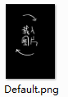
移动设备中的载人画面
the loading imagine file in a mobile device.

in the forder “setting”

游戏与ui设置
Main configuration files. The init file is used to define the game style, variables, layers and the first reading scenario file.


cg欣赏，不随存档变化
the CG configuration file. Define the CG which can be collect in games.
this file will be copy to the folder “document” while the game is running the first time, and will be update automatically while the game have a new update.


不随存档读档改变的变量，用于记录例如关卡通过情况，游戏次数等
The variables won’t change when save and load.
Usually be used to keep records which have been unlocked or the game settings.
this file will be copy to the folder “document” while the game is running the first time, and will be update automatically while the game have a new update.

不可删除，用于保存游戏设置，在[setdurtime]功能中使用
NEVER delete the node <speed/>.
set ratio of the speed of imagine or background fade out, , also set the speed of the menu bar hade and show.

 手动存档文件自动存档文件
初次运行时会创建Documents文件夹,用于储存变量和存档文件
游戏版本更新时，cg和staticvar中的新增内容会自动写入document
The save file of this engine.
this file will be copy to the folder “document” while the game is running the first time.
save.xml will update when click the save button on the menu bar.
autosave.xml while update when use the [autosave] script.

init.xml

interval of time时间间隔
设定游戏中的时间间隔，单位毫秒
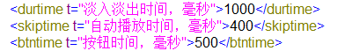
<durtime/>
Set the speed of imagine or background fade out, and the speed of the menu bar hide and show.
<skiptime/>
Set the speed of jump to the next line when the “skip” is on.
<btntime/>
the sensitivity of buttons. Set <btntime>5000</btntime> means a button can be click once in 5 seconds.

GUI Customization游戏UI
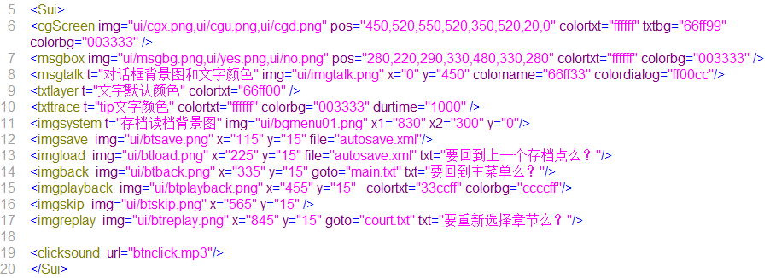
不可删减
NEVER delete nodes and attributes in the node <Sui></Sui>.
The images used in the node <Sui><.Sui> can be found in the “ui” directory as the path show.

the style of CG gallery cg欣赏：
<cgScreen img="关闭按钮图片路径,下一页图片路径,上一页图片路径"
pos="关闭按钮x, 关闭按钮y,下一页x,下一页y,上一页x,上一页y,文字x,文字y"
colortxt="文字颜色" txtbg="文字背景色" colorbg="半透明背景颜色" />
半透明背景透明度0.4
颜色使用16进制
cgScreen: Define the look of the CG screen. Include the path of imagine files of button, the button position and the color of text and background.
img="path of the exit button, path of the page down button, path of the page up button" pos="Position X of exit button, Position Y of exit button, Position X of page down button, Position Y of page down button, Position X of page up button, Position Y of page up button position of the title of CG imagine, Position Y of the title of CG imagine”
colortxt="color of the title of imagine"
txtbg="color of the background of the title"
colorbg="color of the background"

alert or message box对话框:
<msgbox img="对话框背景图路径,确定按钮路径,取消按钮路径"
pos="对话框x,对话框y,确定x,确定y,取消x,取消y,文字y"
colortxt="文字颜色" colorbg="背景色" />
文字居中,半透明背景透明度0.4, 颜色使用16进制
msgbox: Define the look of the message box. Include the path of imagine files of button, the button position and the color of text. The text of message box is at the center. The message box will show with a translucent background.
img=" path of the message box background, path of the submit button, path of the cancel button”
pos=" Position X of the message box background, Position Y of the message box background, Position X of the submit button, Position Y of the submit button, Position X of the cancel button, Position Y of the cancel button, Position Y of the text”
colortxt="color of the text of message box"
colorbg="color of the background when showing the message box "

dialog人物对话
<msgtalk img="路径" x=" x坐标" y=" y坐标"
colorname="人物名字文字颜色" colordialog="对话文字颜色"/>
文字左侧对齐,颜色使用16进制
msgtalk : Define the look of the dialog frame. Include the path and position of the background imagine file, the color of the character name and line, the default font size of text.
img=" path of the dialog frame background”
x=" Position X of the dialog frame background”
y="Position Y of the dialog frame background”
colorname="text color of the character name"
colordialog=" text color of the dialog line”
sizetxt="default font size"

simple text文字
<txtlayer colortxt="文字默认颜色" />
颜色使用16进制
txtlayer: Define the look of the text. Include the default color and font size.
colortxt="default text color"
sizetxt="default font size"

tips 提示文字
<txttrace colortxt="文字颜色" colorbg="文字背景色" durtime="显示到消失时间" />
颜色使用16进制
txttrace : Define the look of the tips bar. Include the text and background color and the time the tip bar fade out.
colortxt=" text color "
colorbg=" background color "
durtime="the time tip bar stay"

Main Menu Background 菜单栏背景
<imgsystem t=注释 img=图片路径 x1=收缩在屏幕边缘的坐标 x2=展开时坐标 y=y坐标/>
imgsystem: Define the look of the menu. Include the path of background imagine and the position .
img=" path of the menu background "
x1="default Position X when the menu is hide"
x2="Position X when menu is shown"
y="position Y of the menu”

save button on main menu存档按钮
<imgsave img="ui/btsave.png" x="相对位置x" y="相对位置y" file="autosave.xml"/>
file定义存档文件,默认save.xml，当脚本设置为不可存档时显示为不可用
imgsave: the save button. Include the path of background imagine, position on menu and the name of the save file. this button will become half transparency when the script [disablesave] is on.
img=" path of the button background imagine"
x="position X in coordinates of menu"
y="position Y in coordinates of menu”
file="filename, will use save.xml if unset"

load button on main menu读档按钮
<imgload img="ui/btload.png" x="相对位置x " y="相对位置y" file="autosave.xml" txt="提示文字"/>
file默认autosave.xml，点击后弹出包含提示文字的对话框
imgload: the quick load button. Include the path of background imagine, position on menu and the name of the save file. lead to the last autosave point.
img=" path of the button background imagine"
x="position X in coordinates of menu"
y="position Y in coordinates of menu "
file="filename of the autosave file, will use autosave.xml if unset "
txt="some text on the message box to confirm the operation "

scenario jumping button 跳转按钮1/跳转按钮2
<imgback img=图片路径x=相对于菜单栏的x坐标 y=相对于菜单栏的y坐标 goto=跳转到脚本 txt=提示文字/>
<imgreplay img=图片路径x=相对于菜单栏的x坐标 y=相对于菜单栏的y坐标 goto=跳转到脚本 txt=提示文字/>

imgback: the quick-call-scenario button. Can be hide if do not want to use it. Include the path of background imagine, position on menu and the filename of a scenario file. This button can lead to some special scenario file such as main interface.
img=" path of the button background imagine"
x="position X in coordinates of menu"
y="position Y in coordinates of menu "
file="filename of the scenario file"
txt="some text on the message box to confirm the operation "

imgreplay: the quick-call-scenario button. Can be hide if do not want to use it. Include the path of background imagine, position on menu and the filename of a scenario file. This button can lead to some special scenario file such as main interface.
img=" path of the button background imagine"
x="position X in coordinates of menu"
y="position Y in coordinates of menu "
file="filename of the scenario file"
txt="some text on the message box to confirm the operation "

playback button剧情回顾按钮
<imgplayback img="图片路径" x="相对位置x" y="相对位置y" colortxt="文字颜色" colorbg="背景色"/>
颜色使用16进制，点击显示之前的文字

imgplayback: the playback button. Include the path of background imagine, position on menu and the text and background color. Click to see the last few lines.
img=" path of the button background imagine"
x="position X in coordinates of menu"
y="position Y in coordinates of menu”
colortxt=" text color”
colorbg=" background color”

skip button自动播放按钮
<imgskip img="ui/btskip.png" x="相对位置x" y="相对位置y" />
点击后自动播放，点击屏幕及其他按钮是结束
imgskip: the skip button. Include the path of background imagine, position on menu and the text and background color. Click to auto play,and stop at the script [ask].
img=" path of the button background imagine"
x="position X in coordinates of menu"
y="position Y in coordinates of menu”

the sound fx when a button is clicked按钮音效
<clicksound url="btnclick.mp3"/>
点击选项按钮的音效，适用于菜单和选项按钮
clicksound: Define the sound of the buttons.the buttons on menu and [ask] button use the same sound file.
url=" path of a mp3 file"

variable变量
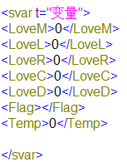
随存档改变的变量
<变量名>值,可以是数字或字符</变量名>
variable:will be save on the script [autosave] or click the save button.all the variables the user want to save should be placed in the node <svar></svar>

<variable name>value, can be number or some text</variable name>

layers图层
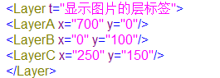
显示人物立绘等的图层
<图层名称/>
显示深度自下而上
layers: layers to show characters or imagines. all the layer node should be placed in the node <Layer></Layer> . sequence as the depth, the last layer node will be on top.
<layername/>
no attributes needed

playingat
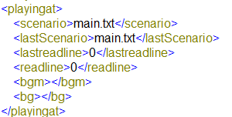
playingat: some other initialize setting of the game
<scenario> the first scenario filename</scenario>
as the default scenario file,the script [autosave] and the skip button cannot be used.
在默认脚本中不能使用autosave和skip
<readline> the first line number in the scenario file</readline>
The game will start at this line of script, usually set to 0.

<lastScenario>the last scenario filename</lastScenario>
not needed in the init file, but used in save files.

<lastreadline> the last line number in the scenario file </lastreadline>
not needed in the init file, but used in save files.
record the last script line in scenarios while the script [call] is used.
记录跳转前的脚本和位置

<bgm> path of the default music</bgm>
not needed in the init file, but used in save files.

<bg> path of the default background imagine </bg>
not needed in the init file, but used in save files.

cg.xml
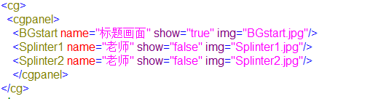
<cg名称 name="在cg欣赏中显示的文字" show=是否获得true/false img=图片路径,在ui文件夹下/>
<name_of_CG name="some text will display on the top the imagine" show= "true or false while true means the CG is collected" img="path of the imagine file"/>
The path of the imagine file is under the ui directory. the attributes “show” will become “true” on the script [getCG], all the setting in cg.xml will not change with the save/load operation.
The CG gallery will display on the script [showCG], all the CG can be opened while the attributes “show” is “true”.

if the script [initsavefile] is used, the cg.xml and staticvar.xml will roll back to the first status.
已经获得的cg中show="true",未获得show="false"
写入后不随存档读档改变
初次运行时会创建Documents文件夹,用于储存cg,
游戏版本更新时，cg和staticvar中的新增内容会自动写入document
使用[initsavefile]恢复默认

staticvar.xml
不随存档读档而改变的变量

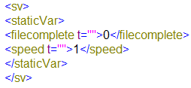
<变量名 t=注释>值</变量名>
在游戏过程中修改此种变量,将不随着存档读档变化
用于记录结局的收集状态等，可以使用清除存档功能恢复到初始状态
在init.xml中的变量将写入到存档和自动存档中
当documents中的存档文件与初始存档条目不同时，自动追加缺少的条目
保留<speed/>存储淡入淡出时间，搭配[setdurtime]使用

Place the variables in the node <staticVar> </staticVar>. The variables won’t change when save and load.
The node <speed></speed> should not be removed.

save.xml autosave.xml
存档和自动存档

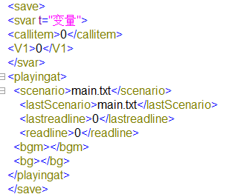
变量部分与init.xml中相同
<scenario>正在使用的脚本文件</scenario>
<readline>行号</readline>
<lastScenario>main.txt</lastScenario>
<lastreadline>0</lastreadline> 记录跳转前的脚本和位置
<bgm>当前背景音乐<bgm/>
<bg>当前背景图</bg>

As the template of the save files, same as init.xml, include the node <svar/> and <playingat>.
You can simply copy from the init file.

script guide
脚本说明

脚本文件在scenario文件夹下
脚本中可使用//注释
忽略空行

All the scenario files can be found in the scenario directory, saved as txt file.
you can place comment after “//”
blank lines will not be read.

---------------------------

text

the script [text] goes with one five or six parameters , you need click to read the next line of script, or use an automation parameter to read the next line automatically .

[text Type| posX| posY| Width| Text| Automation ]
Type:
new: all the text exist will be clean and the new text will be placed at the beginning
add: new text will add after the old ones
clear: clean all the text
posX: the position where the text field display horizontal
posY: the position where the text field display vertical
Width: the width of the text field
Text: some text you want to show in the screen
Automation : write an “auto” to make the next line of text show itself automatically. Not a necessary parameter.

A Simple text Game
[text new|0|20|100|Hello!]
[text new|0|20|200|welcome to sakusaku engine!|auto]
[text add|0|20|100|It is a very simple text game]
[text add|0|20|100|after this line, all the text will be removed]
[text clear]

dialog

The script [dialog] goes with two or three parameters , you need click to read the next line of script, or use an automation parameter to read the next line automatically .

[dialog Name | Text | Automation ]
Name: The name of the character who is talking.
Text: Some words the character says.
Automation: write an “auto” to make the next line of text show itself automatically. Not a necessary parameter.

[dialogadd Text]
The script [dialogadd] goes only one parameter, the Text you want to add a new line after the last words the character said.

A Simple dialog
[dialog Bunny |Hello there!]
[dialogadd I am a cute animal in this forest!]

The script [dialog] and [text] support some HTML tags.
<i>italics</i>
<b>bold</b>
<br>line break
The last example look the same as this
[dialog Bunny |Hello there! <br> I am a cute animal in this forest!]

The script [dialog] and [text] also support color tags and a herf tag.

[dialog Bunny |I have <font color="#ff0000">Red</font> eyes]
[dialog Bunny |Click <A HREF="http://somehere.com">Here</A> to see my photo]

while the HTML tags can be used ,you need to write the angle brackets with &lt; and &gt;

clr
The script [clr] hides the dialog frame and remove all the dialog text, read the next line of script automatically.

msghide/msgshow
Different with the script [clr], just hide or show the dialog frame while do not r remove the dialog text, read the next line of script automatically.

[msghide]: hide the dialog frame
[msgshow] :show the dialog frame

img
The script [img] goes with four or five parameters, read the next line of script automatically.

[img Filename| posX| posY| Layer| Time]
Filename: The filename of the imagine, all the file can be found in the role directory. IF the filename parameter is empty or an “unload”, the layer will be cleaned
posX: the position where the imagine display horizontal. Change the position to make the layer move.
posY: the position where the imagine display vertical . Change the position to make the layer move.

Layer: the name of the layer where the imagine placed on.
Time: if you want the imagine fade in/out or move in some time longer. Not a necessary parameter.

A Simple imagine show
[img avatar.png|0|240|LayerC]
[dialog Bunny |Hello there!]
[img avata2.png|50|240|LayerC|1000]
[dialog Bunny |I have <font color="#ff0000">Red</font> eyes]
[img unload|100|240|LayerC]

The script [img] supports some swf files; you can show small animations with this.

clearimg
The script [clearimg] will clean all the imagines in all layers. It is a faster way to remove all the imagines on the screen instead of unloading them one by one. Read the next line of script automatically.

△askdialog
[askdialog 名字,台词,头像url,400,200,层标签] 图片在role/文件夹,仅使用在选项出现时
[askdialog 名字,台词]无头像,之前有头像则保持显示
可使用部分html标签

△background
[background 图片url] 更换背景图,图片在ui/文件夹
[background clear] 清除背景图
直接进行下一条脚本

△label
[label LL] 跳转标签,与goto搭配使用

△ask
[ask 文字,x坐标,y坐标,跳转标签,按钮背景图]
[ask 文字,270,400,跳转标签,按钮背景图]
[askdialog 名字,文字] 按钮图片在ui/文件夹
不需要显示对话框时
[ask 文字,500,400,跳转标签,按钮背景图]
[ask 文字,720,400,跳转标签,按钮背景图]
[waitclick]
否则直接进行下一条脚本,直到出现waitclick,dialog,text, askdialog 等脚本
点击选项后,全部按钮清除
跳转标签可使用script:readnote
ios中不能使用带有as的swf

文字居中
△btn
[btn 文字,x坐标,y坐标,跳转标签,按钮背景图]不影响dailog,text,waitclick
[removebtn]清除btn
点击选项后,全部按钮清除
ios中不能使用带有as的swf

△goto
[goto 跳转标签] 跳转标签,与label搭配使用

△if
[if (@变量名 >7)]
解析if条件 (a>b&&c>b)||(a>b),支持变量,变量使用 @[变量名][空格]
[end if] 判断未通过,跳转到这里, 直接进行下一条脚本
运算符支持==,!=,>=,<=,>,<
不支持多个[if][end if]嵌套
支持整数和字符串

△eval
[eval @变量名 ,+,3] 变量赋值,使用 @[变量名][空格] 运算支持+-=
变量支持整数和字符串
static中的变量赋值后会自动保存
未声明的变量不会写入存档

△sound
[sound 音频url] 文件在sound/
△bgm
[bgm 音频url] 文件在sound/
[bgmstop] 停止背景音乐

△call
[call 文件名]在scenario\文件夹
例如[call leo.txt]
[call 文件名,label]跳转到新脚本标签处

△wait
[wait 数字]等待xx毫秒后继续，
[waitclick]等待点击

△save
△[enablesave]允许存档
△[disablesave]禁止存档

△autosave
[autosave]自动存档,存储在autosave.xml
△load
[load 文件名.xml]读档,在Documents文件夹下

△cg
[getcg 名字]
结合cg.xml使用
<名字 name="标题" show="true" img="BGstart.jpg"/>未收集到则show为false

[showcg]进入cg欣赏画面
cg和存档不关联

△showtip
[showtip 文字]画面左上角出现文字,文字中支持读取变量,显示时间5秒钟

△[initsavefile]
初始化所有cg和存档
使用根目录下的默认存档文件覆盖Documents文件夹下的文件
cg.xml autosave.xml save.xml staticvar.xml

△[return]
从script回到脚本,从脚本回到前一个脚本文件中call的位置
不可多次返回

△[setdurtime]
staticvar.xml中需要有speed字段
将立绘和背景等的默认淡入淡出时间，默认等待时间设置为init中durtime与speed相乘/10
Speed为整数

△[script]
script.txt
<!
[iscript aaaa]
[dialog q11, 1qaswed]
[dialog q22, 2aswadasa]
[endiscript aaaa]
>
在脚本中[script aaaa]
在按钮中[btn ,0,380,script:readnote,readnote.png]
允许
showtip
showcg getcg
load
text dialog dialogadd
img background
clearimg
clr msghide msgshow
goto
if end eval
sound bgm bgmstop
return call
waitclick
initsavefile

不允许
ask btn askdialog removebtn
label，save，wait
enablesave，disablesave

