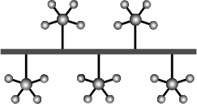
1. A person who writes computer software for running the hardware of a computer is called a . (2mks)

A. Systems analyst
B. Programmer
C. Systems designer
D. Data processor
Answer: B
2. The purpose of computer software is to turn data into . (2 marks)
A. Information
B. Program
C. Knowledge
D. Object
Answer: A
3. A set of parallel wires or electronic pathway used to transmit data, address and control signals in between the CPU and other components of the motherboard are known as . (2 marks)
A. Bus
B. Register
C. Processor
D. Port
Answer: A

