**DCL AND TCL statements in SQL**

**Objective:**

✓ **To be familiar with DCL and TCL statements in SQL.**

**Demonstration:-**

* Open MySQL and Apache xampp control panel
* Open the command prompt
* Change directory to xampp\mysql\bin
* Now, xampp\mysql\bin>mysql –u root –p –h localhost and it will ask for password
* Press Enter
* Now, you can perform below operations

1. **Create a database named eemc \_db**

C:\Users\Sax_yam\q1.png

1. **Select database named eemc\_db**

**C:\Users\Sax_yam\q2.png**

1. **Create a table named employee info with following columns and data type**

|  |  |  |  |  |
| --- | --- | --- | --- | --- |
| **Eid** | **Name** | **Address** | **Department** | **Salary** |
| Int | Varchar(30) | Varchar(30) | Varchar(30) | Decimal(10,2) |

create table employee\_info(eid int,name varchar(30),address varchar(30),department varchar(30),salary decimal (10,2));

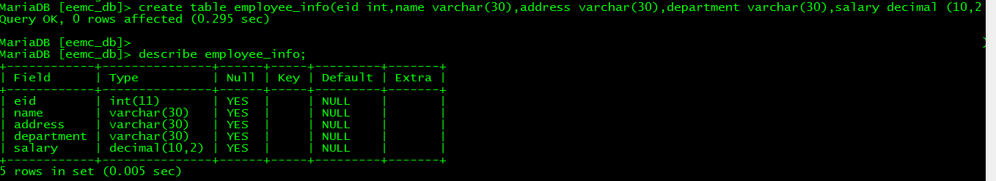

* **For use of commit and rollback**

1. **Now insert some records into table named employee\_info**

Start transaction;

insert into employee\_info values(1,'SAK', 'Bhairawa','Civil',56780.35);

insert into employee\_info values(2,'Mira', 'Surkhet','Computer',345670.25);

insert into employee\_info values(3,'Lazima', ’KTM' ,'Computer',45345.45);

insert into employee\_info values (4,'Ananya','Butwal','IT',23345.15);

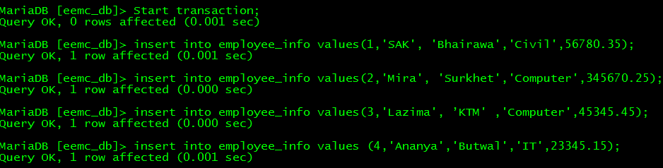

//you can see that no any changes is reflected in database while opening localhost phpMyAdmin

//But changes is made locally, you can see this by using following query

select \* from employee\_info;

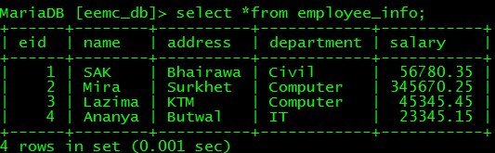

Now commit the transaction

commit;

C:\Users\Sax_yam\q6.png

Now, you can see changes is reflected in database while opening localhost phpMyAdmin

**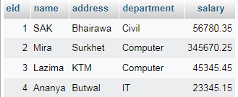**

1. **Now insert another 1 record**

start transaction;

insert into employee\_info values(5,'Smarika','Pokhara',’Computer',34452.89);

To see records

select \* from employee\_info;

Note: insertion is not reflected in database, which we can see through localhost/phpMyAdmin

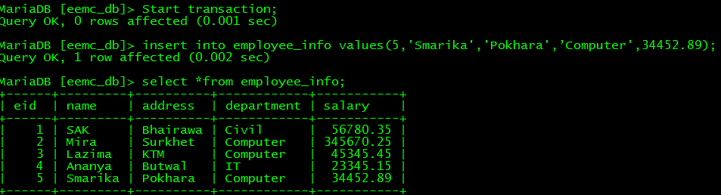

1. **Now revert the operation of step(4)**

rollback;

//Rollback operation will cancelled the above operation

To see records

select \* from employee\_info;

//We can see the previous record that is not committed

(similarly test with update and delete operations as well)

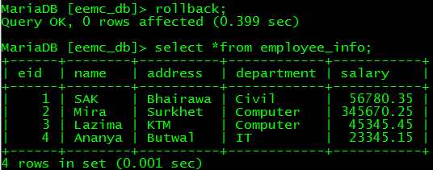

* **For use of savepoint**

1. **Update the address of employee to kathmandu whose name is ‘SAK’**

Start transaction;

update employee\_info set address='kathmandu' where name='SAK';

savepoint update\_SAK;

//We can see the information is updated but it is not reflected in database

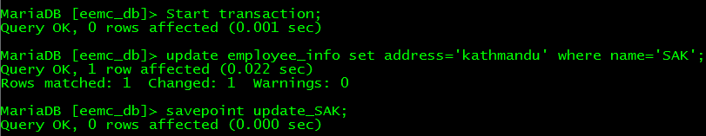

1. **Delete the information of employee whose department is civil**

delete from employee\_info where department='civil';

savepoint delete\_civil;

select \*from employee\_info;

//We can see the information is deleted but it is not reflected in database

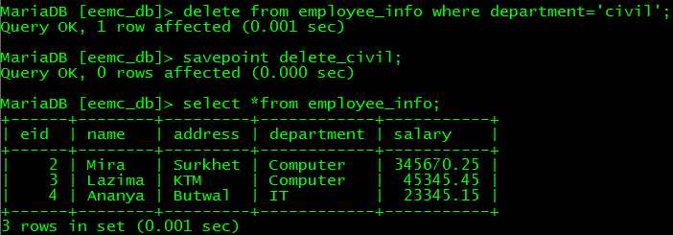

1. **Rollback the transaction to step(8)**

Rollback to update\_SAK;

C:\Users\Sax_yam\q12.png

1. **Commit the transaction**

Commit;

//We can see that information of SAK is updated and reflected in database but above deletion operation have been cancelled.

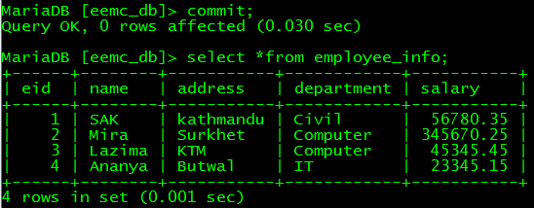

1. **Create two users named Rupesh and Shreya with following privilege to performing operations on database**

Rupesh: SELECT, UPDATE, INSERT

Shreya: SELECT, DELETE

Step1: Exit the maridb shell

exit;

Step2: Reconnect to the mariadb server

mysql -u root -p

Step3: create two users with name Rupesh and Shreya

Syntax:

CREATE USER 'username'@'localhost' IDENTIFIED BY 'password';

Note :For all host this syntax can be modified as

CREATE USER 'username'@'%' IDENTIFIED BY 'password';

CREATE USER 'Rupesh' @'%' IDENTIFIED BY 'rupesh234';

CREATE USER 'Shreya' @'%' IDENTIFIED BY 'shreya234';

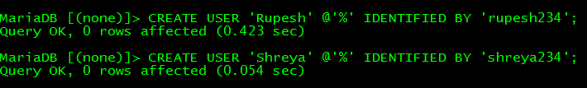

Step4: Give above mentioned privileges to two users with name Rupesh and Shreya

GRANT SELECT,UPDATE,INSERT ON eemc\_db.employee\_info TO Rupesh;

GRANT SELECT,DELETE ON eemc\_db.employee\_info TO Shreya;

Step5: Exit the mariadb shell

exit;

Step5: Reconnect mariadb server with user named Rupesh

mysql -u Rupesh –p

rupesh234

Step6: select the database named eemc\_db

use eemc\_db;

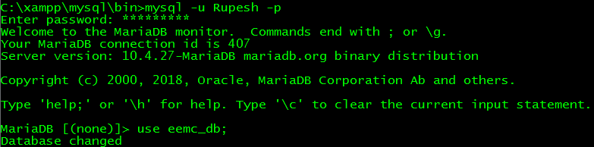

1. **Now, try to perform the above operations that is given privilege to user Rupesh**

insert into employee\_info values(6,'Mukunda','Surkhet','Computer',75000.55);

(Insert operation will be performed successfully)

C:\Users\Sax_yam\q16.png

1. **Try to perform the above operations that is not given privilege to user Rupesh**

delete from employee\_info where eid=3;

(delete operation is not allowed for rupesh so it cannot be performed)

C:\Users\Sax_yam\q17.png

Now, switch to another user named Shreya

Step1: Exit the mariadb shell

exit;

Step2: Reconnect mariadb server with user named Shreya

mysql -u Shreya –p

shreya234

Step3: select the database named eemc\_db

use eemc\_db;

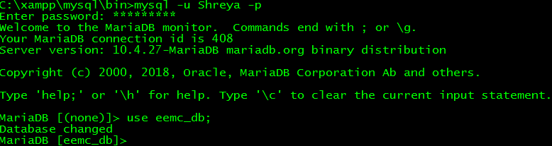

1. **Now, try to perform the above operations that is given privilege to user Shreya**

delete from employee\_info where eid=3;

(Delete operation is executed successfully for user shreya)

C:\Users\Sax_yam\q19.png

1. **Try to perform the above operations that is not given privilege to user Shreya**

update employee\_info set deparment='civil' where address='Butwal';

(Update operation cannot be performed for user Shreya)

C:\Users\Sax_yam\q20.png

1. **Revoke delete operation that is given to Shreya.**

(Note you must switch with user root)

quit;

mysql -u root –p

revoke delete on eemc\_db.employee\_info from Shreya;

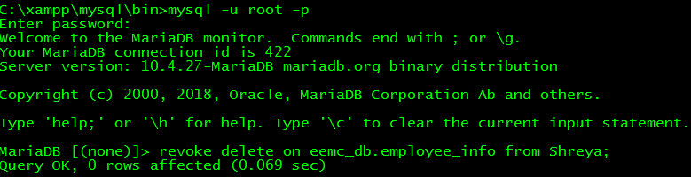

1. **Now again try to perform delete operation by Shreya**

(Note you must switch with user Shreya)

quit;

mysql –u Shreya -p

shreya234

use eemc\_db;

delete from employee\_info where eid=2;

(Now, delete operation cannot be performed for user shreya)

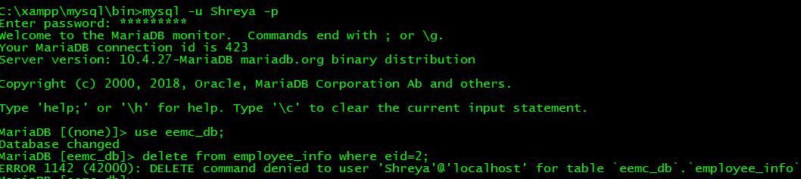

**OUTPUT:-**

**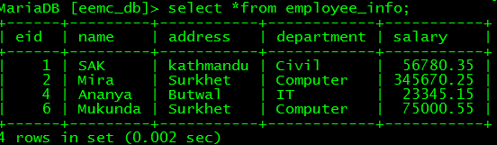**

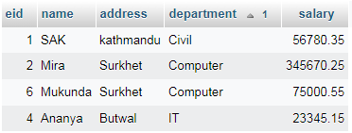

**CONCLUSION:-**

Hence, I have learned the use of commit and revoke command. I have also learned about the use of save point in database management system. Furthermore, I have created two different users and gave them privileges of select, update, delete and insert using grant operation. After then, I withdrew their privileges by using revoke operation. Finally, in this lab, I have learned about the use of DCL (Data Control Language) and TCL (Transaction Control Language).

**\*\*\*\*\*\*\*Thank You\*\*\*\*\*\*\***