**Problems with its Solutions:**

1. **Create a database named customers\_db**



1. **Create a table named customers with following columns adding constraints following constraints**

**Customer\_id: Primary key**

**Name: not null**

|  |  |  |  |  |
| --- | --- | --- | --- | --- |
| **customer\_id** | **name** | **Email** | **Age** | **address** |
| **Int** | **Varchar(30)** | **Varchar(30)** | **Int** | **Varchar(30)** |

CREATE TABLE customers(customer\_id int,name varchar(30) NOT NULL,email varchar(255),age int,address varchar(30),PRIMARY KEY(customer\_id));

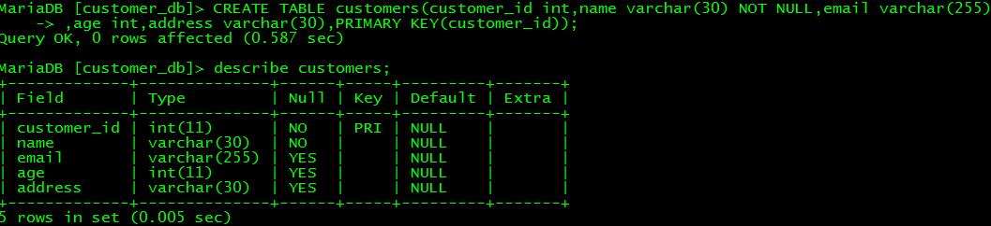

1. **Now insert 2 records of customer with and without violating constraints**

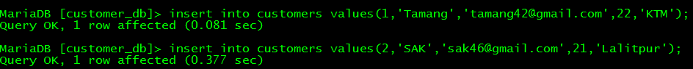

insert into customers values(2,'Ananya','ananya23@gmail.com',22,'KTM');

C:\Users\Sax_yam\Videos\DBMS LAB3\q4.png

This cannot inserted because customer\_id is primary key which should be unique and not null

insert into customers(customer\_id,email,age,address) values (3,'mira@gmail.com',20,'Surkhet');

select \*from customers;

//Now we cannot see NULL in column named name which we have left empty

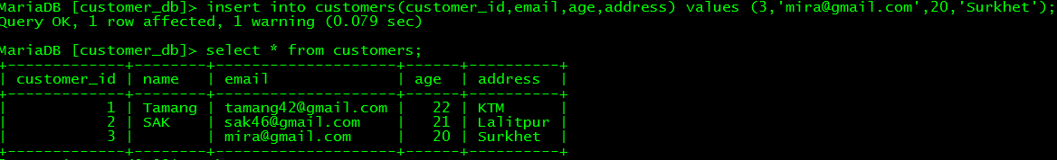

insert into customers (customer\_id,name,age,address) values (4,'TAPATAP',25,'India');

select \*from customers;

//But We can see now NULL value at email

**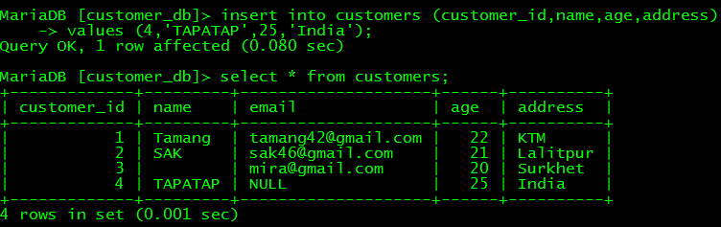**

1. **Now add the following constraint to the table named customer**

* Email must be unique of each customer

alter table customers add unique(email);

* Age must be greater than 18

alter table customers add constraint age\_check CHECK (age>18);

OR

alter table customers add CHECK (age>18);

* The default value of address must be Kathmandu

alter table customers alter address SET DEFAULT 'kathmandu';

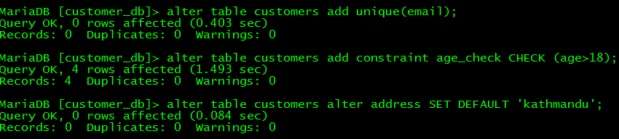

1. **Try to insert data to violate the above constraints**

insert into customer values (5,'Sujan', 'sak46@gmail.com',20,'Dolpa');

//this will not work age must be greater than 18

insert into customer values (5,”Ram”, 'sak46@gmail.com',19,'Dolkha');

//this will not work because Duplicate entry 'ram@gmail.com' for key 'email'

****

1. **Write a query to show illustrate default constraint works**

insert into customers(customer\_id,name,email,age) values(5,'Shreya','shreya@gmail.com',26);

//Here default address will set to Kathmandu

**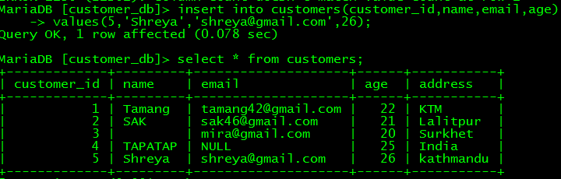**

1. **Create table orders with following columns**

|  |  |  |  |  |
| --- | --- | --- | --- | --- |
| **Customer\_id** | **Name** | **Email** | **age** | **Address** |
| **Int** | **Varchar(30)** | **Varchar(30)** | **Int** | **Varchar(30)** |

|  |  |  |  |
| --- | --- | --- | --- |
| **Order\_id** | **Product\_name** | **Price** | **Customer\_id** |
|  |  |  |  |

And order\_id is primary key and customer\_id as foreign key for customer

create table orders(order\_id int,product\_name varchar(30),price int,customer\_id int,primary key(order\_id),foreign key (customer\_id) references customers(customer\_id));

**OR**

create table orders(order\_id int,product\_name varchar(30),price int,customer\_id int,CONSTRAINT order\_pk primary key(order\_id),CONSTRAINT custorder\_fk foreign key (customer\_id) references customers(customer\_id));

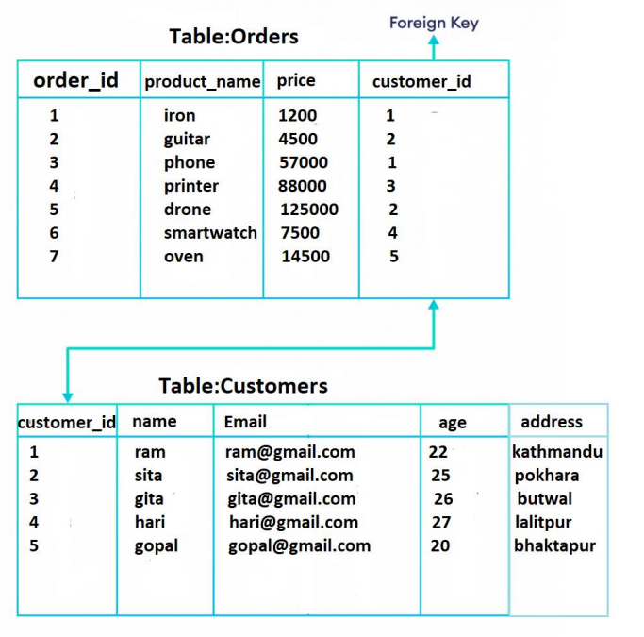

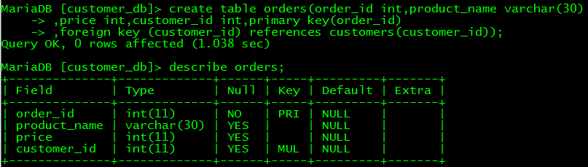

Now,

update customers set name='Mira' where customer\_id=3;

update customers set email='tapatap@gmail.com' where customer\_id=4;

update customers set address='bhaktapur' where customer\_id=5;

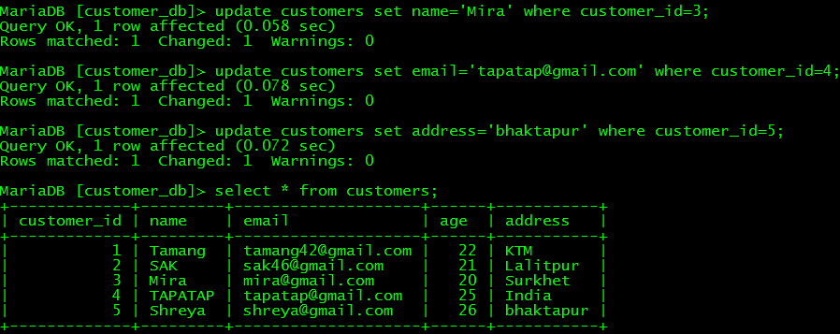

insert into orders values(1,'iron',1200,1);

insert into orders values(2,'guitar',4500,2);

insert into orders values (3,'phone',57000,1);

insert into orders values(4,'mouse',700,2);

insert into orders values(5,'printer',88000,3);

insert into orders values(6,'drone',120000,2);



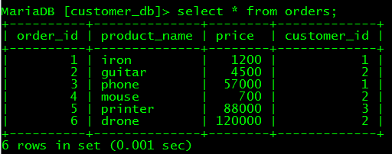

Try to insert customer\_id in orders table that does not exist in customers table

insert into orders values(6,'drone',120000,6);

C:\Users\Sax_yam\Videos\DBMS LAB3\q13.png

This cannot be inserted

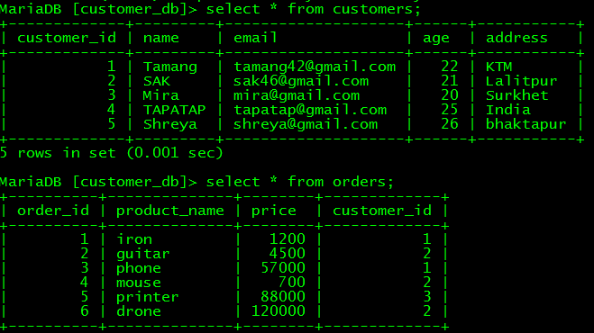

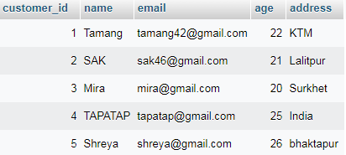

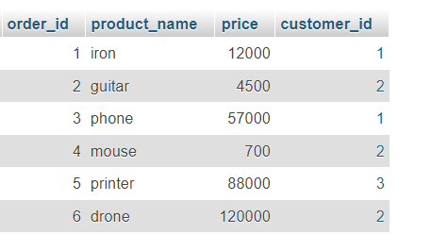

**CONCLUSION:**

In this Lab, we have learned and got familiar with SQL Constraints. Some Constraints we learned in this lab are NOT NULL, UNIQUE, PRIMARY KEY, FOREIGN KEY, CHECK and DEFAULT.