- VB:
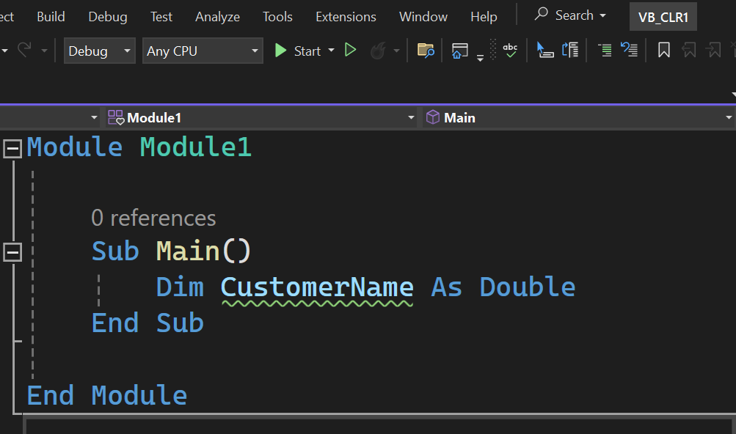
- C#:
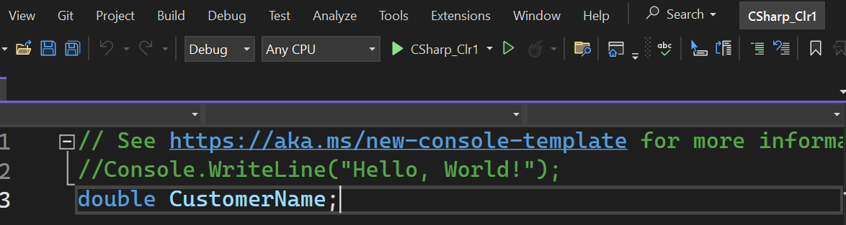

- Developer Command Prompt for VS 2022:
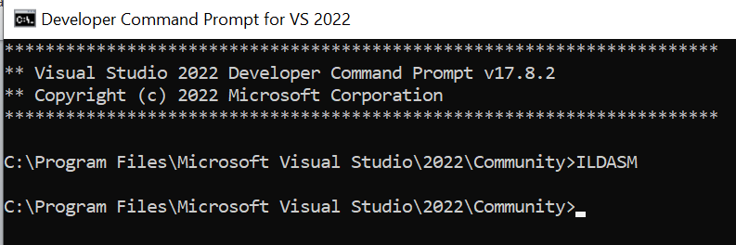

VB:
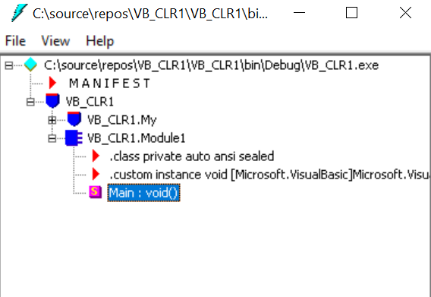
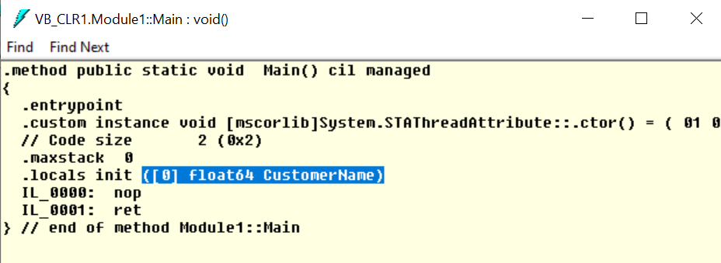

C#:
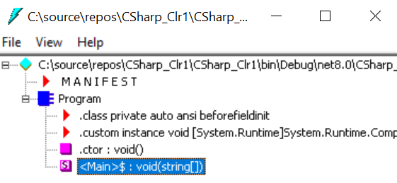
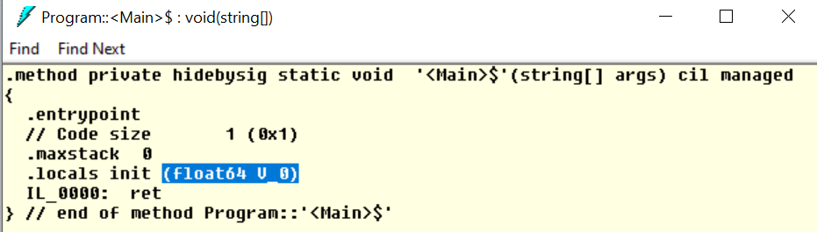

Discussion:
Here, in our PROGRAMMING TECHNOLOGY (PT)-Lab 5, we explored the Common Language Runtime (CLR) in .NET, which is like the "brain" behind the scenes that helps run our programs smoothly.
Moreover, in this lab, we dived into the Common Language Runtime (CLR) in .NET using C# and VB.NET. We learned how to declare a variable with the double data type in both languages. In C#, it's as simple as writing "double" followed by the variable name, while in VB.NET, we use "Dim" and specify "As Double" after the variable name. This hands-on experience helped us see the language differences in declaring double variables and reinforced our understanding of how CLR supports various languages within the .NET framework.

Conclusion:
Hence, this lab helped us to understand the practical aspects of how the "CLR" makes our DOT NET applications work effectively and securely.

