Music Playlist Management System Using Singly Linked List

Data Structures and Algorithms Lab / Industrial Practice Mini Project

Student Name: Sakshi
Course: Data Structures & Algorithms Lab / Industrial Practice
GitHub Repository: https://github.com/sakxhy/music-playlist-dsa
Live Demo Link: https://sakxhy.github.io/music-playlist-dsa/simple.html

1. Project Overview
The Music Playlist Manager is an interactive web-based application designed to demonstrate the practical, real-world application of a Singly Linked List.
In commercial audio streaming platforms such as Spotify or Apple Music, users frequently perform playlist actions such as:
- Adding a song to play immediately next (“Play Next”).
- Appending a song to the end of the line (“Add to Queue”).
- Removing a track from anywhere in the playlist.
- Skipping forward through tracks sequentially one by one.
- Inverting the playback order (“Reverse Playlist”).
In computer science, a Singly Linked List is the natural data structure to model this behavior because songs are played one after another through pointer connections rather than fixed index numbers.

2. Implementation of Singly Linked List
A Singly Linked List is a linear data structure where each element is stored in a separate object called a Node. Unlike arrays, nodes are not stored in continuous memory blocks; instead, each node contains a reference pointer (next) that links it to the subsequent node.

2.1 The Song Node (SongNode)
Every song in the playlist is represented as an independent node containing two parts:
- Data Fields: Stores the song metadata, which includes title (Song Name), artist (Artist Name), and duration (Song Length in mm:ss).
- Pointer Field (next): Stores a reference linking to the next song node in the playlist. If there is no next song, it points to null.
+-------------------------------------------------------------+
| SongNode |
+-------------------------------------------------------------+
| Data: title, artist, duration |
| Pointer: next ───> (points to the next SongNode or NULL) |
+-------------------------------------------------------------+
class SongNode {
constructor(title, artist, duration) {
this.title = title; // Song Title
this.artist = artist; // Artist Name
this.duration = duration; // Duration
this.next = null; // Pointer to next song node
}
}

2.2 The Playlist Manager Structure
The playlist is managed by a controller class (PlaylistManager) that maintains key reference pointers:
- head: Points to the very first song in the playlist. If head is null, the playlist is empty.
- currentTrack: Points to the specific song node currently playing.
- size: A counter tracking the total number of songs in the playlist.
HEAD TAIL
[Song 1] ────.next────> [Song 2] ────.next────> [Song 3] ────.next────> NULL
(Active) (Next Up) (Last Song)
class PlaylistManager {
constructor() {
this.head = null; // Start of playlist
this.currentTrack = null; // Currently playing track
this.size = 0; // Total song count
}
}

3. Basic Operations and Working

3.1 Insertion Operations

A. Insertion at Head (“Play Next”)
This operation adds a new song to the very beginning of the playlist so that it plays next.
- A new node is created with the song title, artist, and duration.
- The new node’s .next pointer is set to point to the current head.
- The head pointer is updated to point to this new node.
- The playlist size is incremented by 1.
insertAtHead(title, artist, duration) {
const newNode = new SongNode(title, artist, duration);
newNode.next = this.head;
this.head = newNode;
this.size++;
if (!this.currentTrack) {
this.currentTrack = this.head;
}
}

B. Insertion at Tail (“Add to Queue”)
This operation appends a song to the end of the playlist.
- A new song node is created.
- If the playlist is empty (head is null), the head is set to the new node.
- If not empty, a temporary pointer starts at head and traverses forward until it reaches the last node (where next is null).
- The last node’s .next pointer is linked to the new node.
insertAtTail(title, artist, duration) {
const newNode = new SongNode(title, artist, duration);
if (!this.head) {
this.head = newNode;
this.currentTrack = newNode;
} else {
let temp = this.head;
while (temp.next !== null) {
temp = temp.next;
}
temp.next = newNode;
}
this.size++;
}

C. Insertion at a Specific Position
This operation inserts a song at any custom position (index) chosen by the user.
- If the index is 0, insertion at head is performed.
- Otherwise, the list is traversed to reach the node right before the desired position (index - 1).
- The new node’s .next pointer is linked to the following node.
- The previous node’s .next pointer is updated to point to the new node.
insertAtPosition(title, artist, duration, index) {
if (index < 0 || index > this.size) return false;
if (index === 0) {
this.insertAtHead(title, artist, duration);
return true;
}
const newNode = new SongNode(title, artist, duration);
let prev = this.head;
for (let i = 0; i < index - 1; i++) {
prev = prev.next;
}
newNode.next = prev.next;
prev.next = newNode;
this.size++;
return true;
}

3.2 Deletion Operations

A. Deletion from Head
This operation removes the first song from the playlist.
- If the playlist is empty, no action is taken.
- The head pointer is advanced to head.next.
- The previous head node is unlinked from the list.
deleteHead() {
if (!this.head) return false;
const deletedNode = this.head;
this.head = this.head.next;
if (this.currentTrack === deletedNode) {
this.currentTrack = this.head;
}
this.size--;
return true;
}

B. Deletion by Position / Specific Song
This operation removes a song from anywhere in the playlist when the user clicks the Delete button on that song card.
- If the target song is at index 0, deletion from head is performed.
- The list is traversed using two pointers (prev and curr) until the target song is reached.
- The node is bypassed by connecting prev.next = curr.next.
- The playlist size is decremented.
Before Deletion:
[Song A] ───.next───> [Song B (Target)] ───.next───> [Song C]
After Deletion (Bypassing Song B):
[Song A] ────────────────────.next──────────────────> [Song C]
deleteAtPosition(index) {
if (!this.head || index < 0 || index >= this.size) return false;
if (index === 0) return this.deleteHead();
let prev = null;
let curr = this.head;
for (let i = 0; i < index; i++) {
prev = curr;
curr = curr.next;
}
prev.next = curr.next;
if (this.currentTrack === curr) {
this.currentTrack = curr.next || this.head;
}
this.size--;
return true;
}

3.3 Traversal and Playback Operations

A. Sequential Playback (“Next Song”)
When the current song finishes or the user clicks “Next Song”, playback advances forward.
- The system checks the currently active song’s .next pointer.
- If a next node exists, currentTrack is updated to currentTrack.next.
- If next is null, playback stops because the end of the playlist has been reached.
playNext() {
if (this.currentTrack && this.currentTrack.next) {
this.currentTrack = this.currentTrack.next;
return true;
}
return false; // Reached end of playlist (NULL)
}

B. Display Traversal
To display the playlist on the screen, a pointer starts at head and visits every node in order. It renders each song card, displays a pointer arrow (── .next ──>) pointing to the following card, and renders a terminal [NULL] indicator when it reaches the end of the chain.

C. Search Operation
To find a song by title or artist, a search pointer traverses the list node-by-node starting from head. If a matching song is found, that card is highlighted and scrolled into view.

3.4 In-Place Playlist Reversal
This operation inverts the playback order so that the last song becomes the first song.
- Three pointers are used: prev = null, curr = head, and next = null.
- As the list is traversed:
  - The reference to the next node is saved (next = curr.next).
  - The current node’s pointer is reversed to point backward (curr.next = prev).
  - Pointers shift forward (prev = curr, curr = next).
- Once all pointers are reversed, head is updated to point to the last node (head = prev).
Initial Order: [Song 1] ────> [Song 2] ────> [Song 3] ────> NULL
Reversed Order: [Song 3] ────> [Song 2] ────> [Song 1] ────> NULL
reverse() {
let prev = null;
let curr = this.head;
let next = null;
while (curr !== null) {
next = curr.next; // 1. Save next node
curr.next = prev; // 2. Reverse pointer
prev = curr; // 3. Move prev forward
curr = next; // 4. Move curr forward
}
this.head = prev; // 5. Update head to former tail
}

3.5 Repeat Mode and Loop Handling
When repeat mode is turned on, the last song connects back to the first song (tail.next = head), creating a continuous cycle. To ensure safety and prevent infinite loops during webpage rendering, Floyd’s Cycle-Finding Algorithm (Tortoise and Hare) is used to detect cycles using slow and fast pointers.

4. User Interface and Screenshots
The project includes a clean visual interface designed specifically for easy demonstration during viva evaluations:
- Visual Node Cards: Each song is displayed as a clean card showing the Song Title, Artist, and Duration.
- Pointer Arrows: Explicit visual arrows (── .next ──>) connect each node card to the next card.
- Status Badges: The starting node is clearly marked with a HEAD badge, and the actively playing track is highlighted with a PLAYING badge.
- NULL Marker: Displays a clear NULL (End of Chain) terminator box at the end of the linear list.
- 1-Click Presets: Instant buttons (Believer, As It Was, Stay, Flowers) allow adding songs with a single click during demonstration.
- Interactive Controls: Buttons to Play, Pause, Next Song, Restart from Head, and Delete songs dynamically.

Figure 1: Singly Linked List Chain Visualizer

Figure 1: Singly Linked List Chain Visualizer

Figure 2: Operations Panel, Presets, Search & Concept Cards
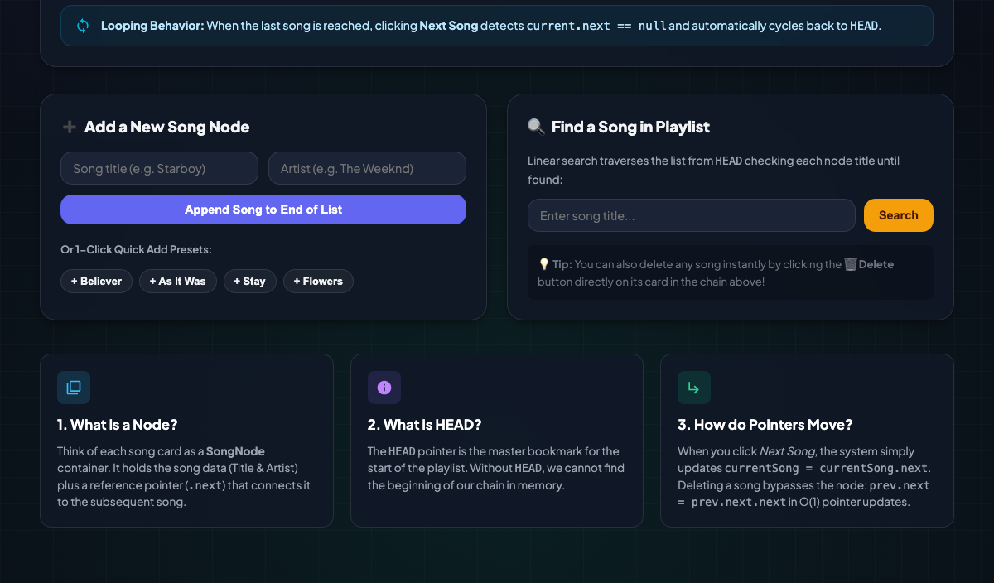
Figure 2: Operations Panel, Presets, Search and Concept Cards

5. Conclusion
This mini project demonstrates the practical application of a Singly Linked List in a real-world software system. By mapping songs to linked list nodes and playback progression to pointer traversals, it clearly illustrates dynamic node allocation, pointer manipulation, sequential traversal, insertion, and deletion.

