**Calculator**

Calculator is a basic arithmetic calculator which performs the four following mathematical operations...

**Features**

- Addition

- Subtraction

- Multiplication

- Division

**Installation**

- Clone and pull source code from provided github repository.

- Compile source code with Java Compiler.

- Run with Java Runtime Environment.

**Code**

https://github.com/salabha77/Calculator

**Usage**

Once run, the console will welcome and prompt the user for the desired mathematical operation they wish to perform.

[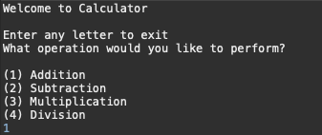](https://github.com/nicholas-auyeung/Calculator/blob/master/screenshots/welcome.png)

The user will then be prompted to enter two numbers that they wish to perform the desired operation on.

[](https://github.com/nicholas-auyeung/Calculator/blob/master/screenshots/two_num.png)

The correct result will then be outputted.

[](https://github.com/nicholas-auyeung/Calculator/blob/master/screenshots/result.png)

Calculator will then reprompt the user for another mathematical operation.

If user is done with the application, enter any letter to exit.

[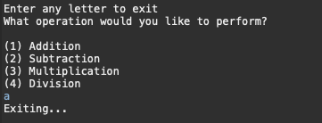](https://github.com/nicholas-auyeung/Calculator/blob/master/screenshots/exit.png)