**Project objective:**

As a Full Stack Developer, complete the features of the application by planning the development in terms of sprints and then push the source code to the GitHub repository. As this is a prototyped application, the user interaction will be via a command line.

**Background of the problem statement:**

Company Lockers Pvt. Ltd. hired you as a Full Stack Developer. They aim to digitize their products and chose LockedMe.com as their first project to start with. You’re asked to develop a prototype of the application. The prototype of the application will be then presented to the relevant stakeholders for the budget approval. Your manager has set up a meeting where you’re asked to present the following in the next 15 working days (3 weeks):

* Specification document - Product’s capabilities, appearance, and user interactions
* Number and duration of sprints required
* Setting up Git and GitHub account to store and track your enhancements of the prototype
* Java concepts being used in the project
* Data Structures where sorting and searching techniques are used.
* Generic features and three operations:
  + Retrieving the file names in an ascending order
  + Business-level operations:
    - Option to add a user specified file to the application
    - Option to delete a user specified file from the application
    - Option to search a user specified file from the application
    - Navigation option to close the current execution context and return to the main context
  + Option to close the application

The goal of the company is to deliver a high-end quality product as early as possible. 

**The flow and features of the application:**

* The first option should return the current file names in ascending order. The root directory can be either empty or contain few files or folders in it
* The second option should return the details of the user interface such as options displaying the following:
  + Add a file to the existing directory list
    - You can ignore the case sensitivity of the file names
  + Delete a user specified file from the existing directory list
    - You can add the case sensitivity on the file name in order to ensure that the right file is deleted from the directory list
    - Return a message if FNF (File not found)
  + Search a user specified file from the main directory
    - You can add the case sensitivity on the file name to retrieve the correct file
    - Display the result upon successful operation
    - Display the result upon unsuccessful operation
  + Option to navigate back to the main context
* There should be a third option to close the application

**FLOW CHART**

DISPLAY SUB MENU &

INPUT USER OPTIONS

DISPLAY ALL FILES

MAIN OPTION

As a Full Stack Developer, complete the features of the application by planning the development in terms of sprints and then push the source code to the GitHub repository. As this is a prototyped application, the user interaction will be via a command line.

Background of the problem statement:

Company Lockers Pvt. Ltd. hired you as a Full Stack Developer. They aim to digitize their products and chose LockedMe.com as their first project to start with. You’re asked to develop a prototype of the application. The prototype of the application will be then presented to the relevant stakeholders for the budget approval. Your manager has set up a meeting where you’re asked to present the following in the next 15 working days (3 weeks):

Specification document - Product’s capabilities, appearance, and user interactions

Number and duration of sprints required

Setting up Git and GitHub account to store and track your enhancements of the prototype

Java concepts being used in the project

Data Structures where sorting and searching techniques are used.

Generic features and three operations:

Retrieving the file names in an ascending order

Business-level operations:

Option to add a user specified file to the application

Option to delete a user specified file from the application

Option to search a user specified file from the application

Navigation option to close the current execution context and return to the main context

Option to close the application

The goal of the company is to deliver a high-end quality product as early as possible.

The flow and features of the application:

Plan more than two sprints to complete the application

Document the flow of the application and prepare a flow chart

List the core concepts and algorithms being used to complete this application

Code to display the welcome screen. It should display:

Application name and the developer details

The details of the user interface such as options displaying the user interaction information

Features to accept the user input to select one of the options listed

The first option should return the current file names in ascending order. The root directory can be either empty or contain few files or folders in it

The second option should return the details of the user interface such as options displaying the following:

Add a file to the existing directory list

You can ignore the case sensitivity of the file names

Delete a user specified file from the existing directory list

You can add the case sensitivity on the file name in order to ensure that the right file is deleted from the directory list

Return a message if FNF (File not found)

Search a user specified file from the main directory

You can add the case sensitivity on the file name to retrieve the correct file

Display the result upon successful operation

Display the result upon unsuccessful operation

Option to navigate back to the main context

There should be a third option to close the application

Implement the appropriate concepts such as exceptions, collections, and sorting techniques for source code optimization and increased performance

DISPLAY MAIN MENU &

INPUT USER OPTIONS

OPTION==3 OPTION==1

OPTION==2

SUB OPTION

OPTION==a OPTION==C

OPTION==d OPTION==b

DELETE A FILE

SEARCH A FILE

CREATE NEW FILE

**Program Functionality:**

**MAIN MENU**

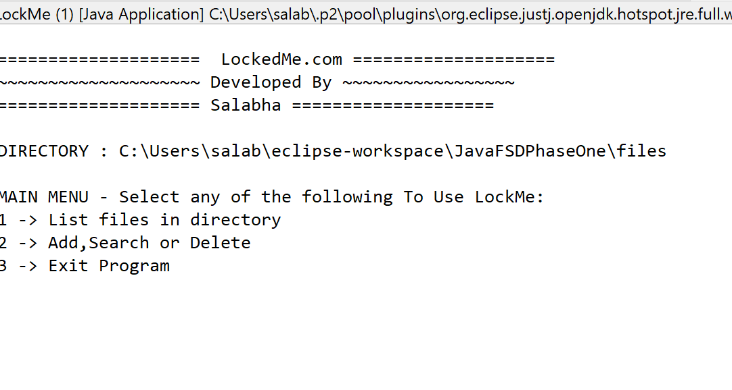

1. **List files in directory**

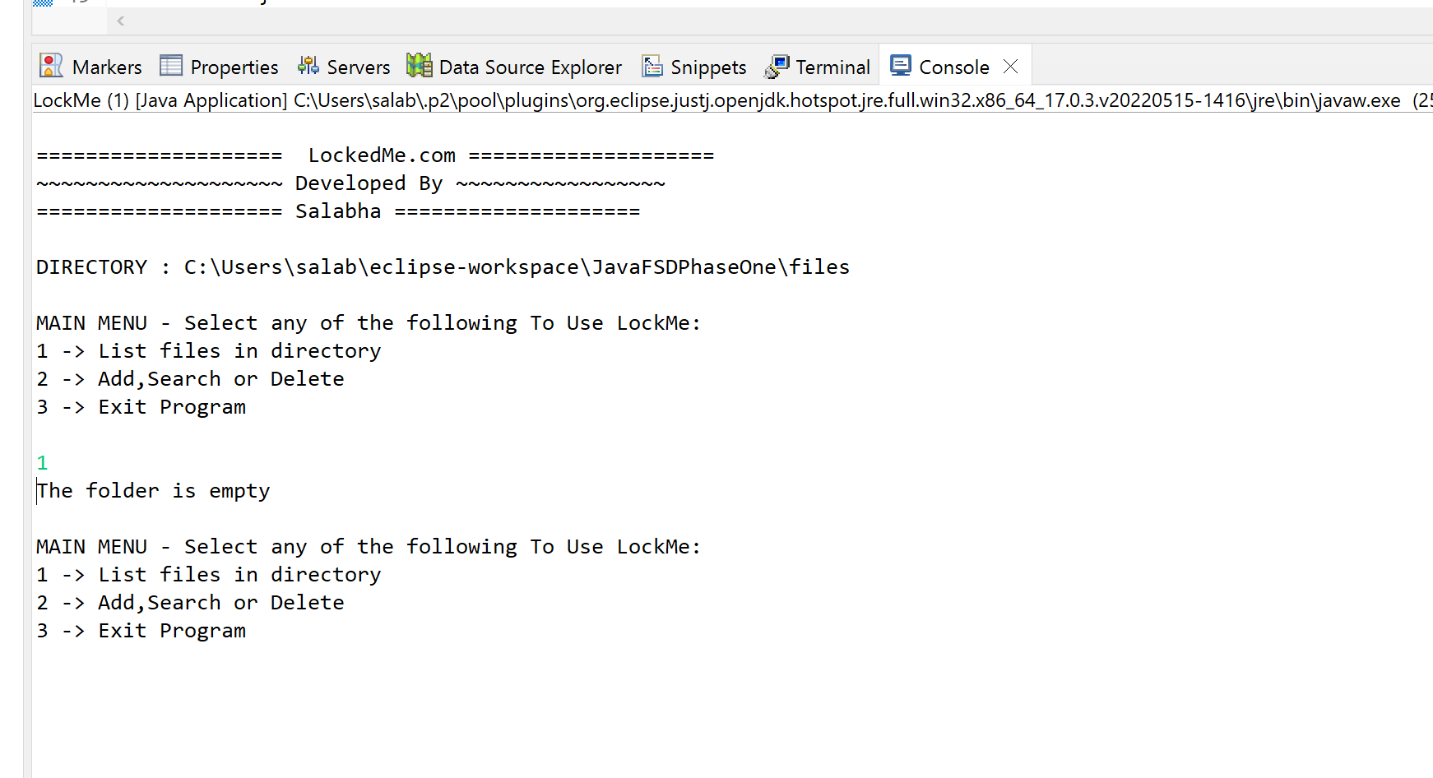

1. **Add,Search or Delete**

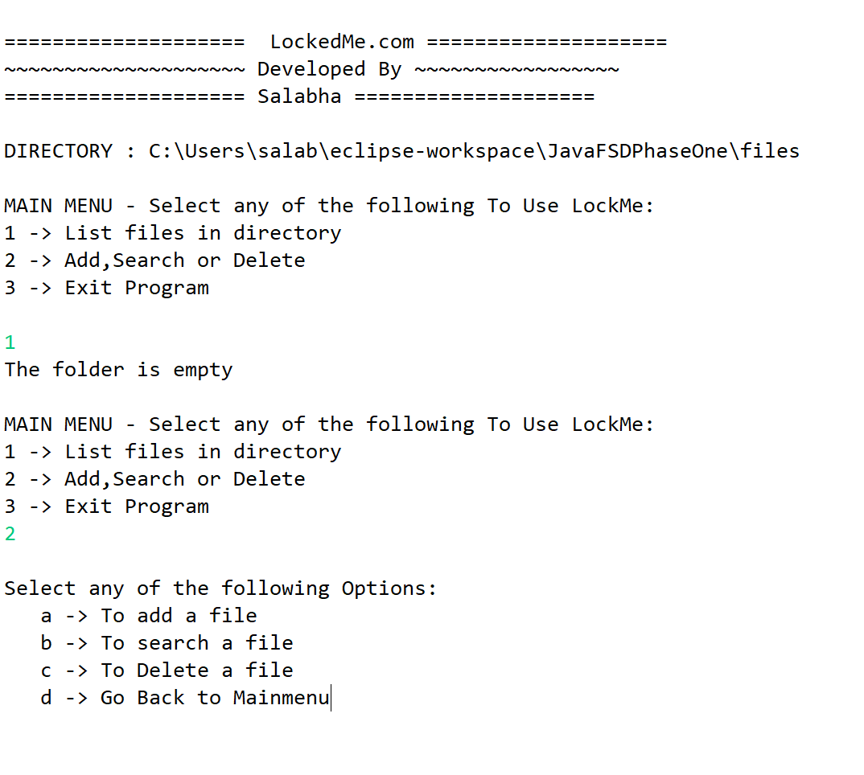

**2.a. To add a file**

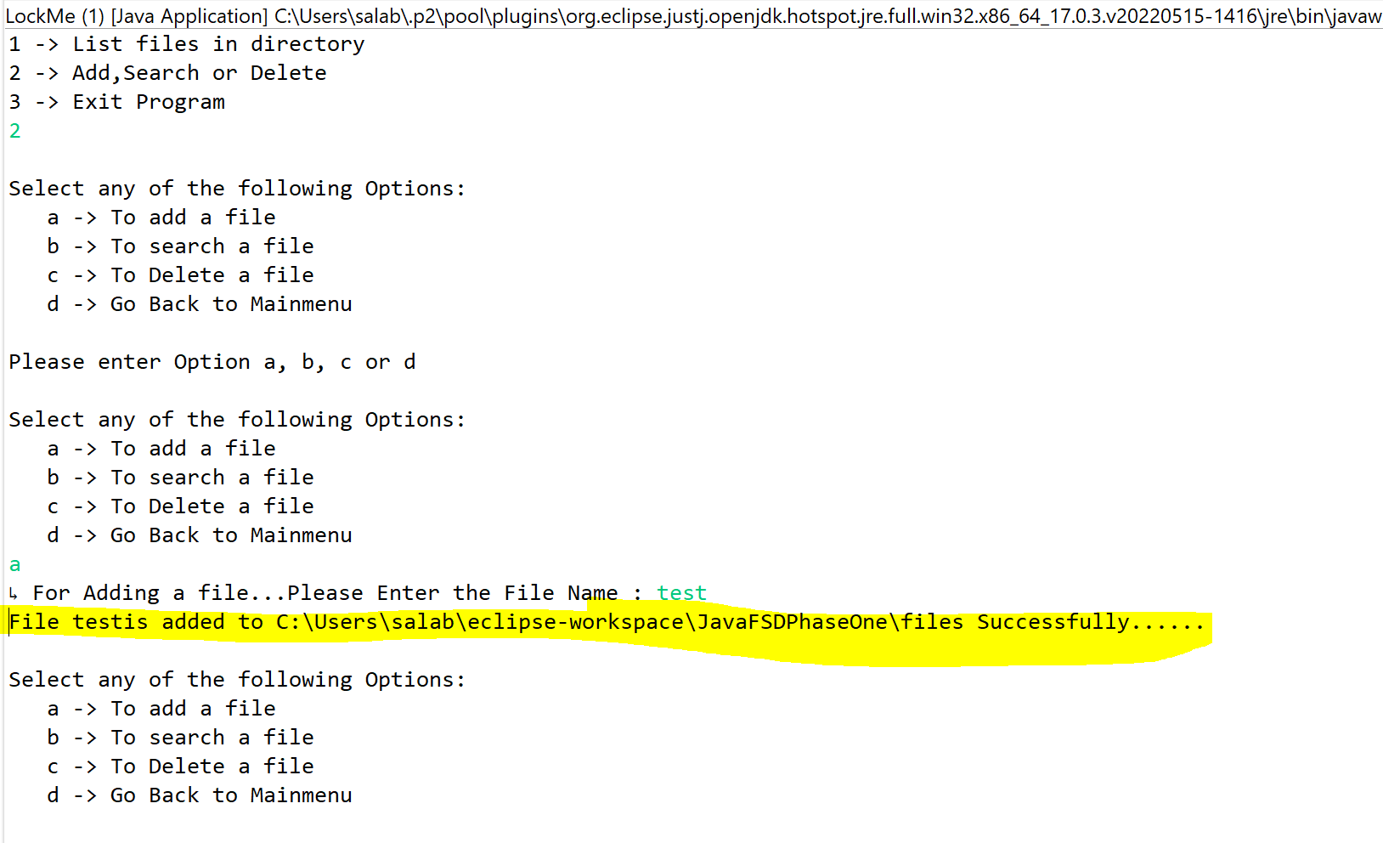

**2.b. To search a file**

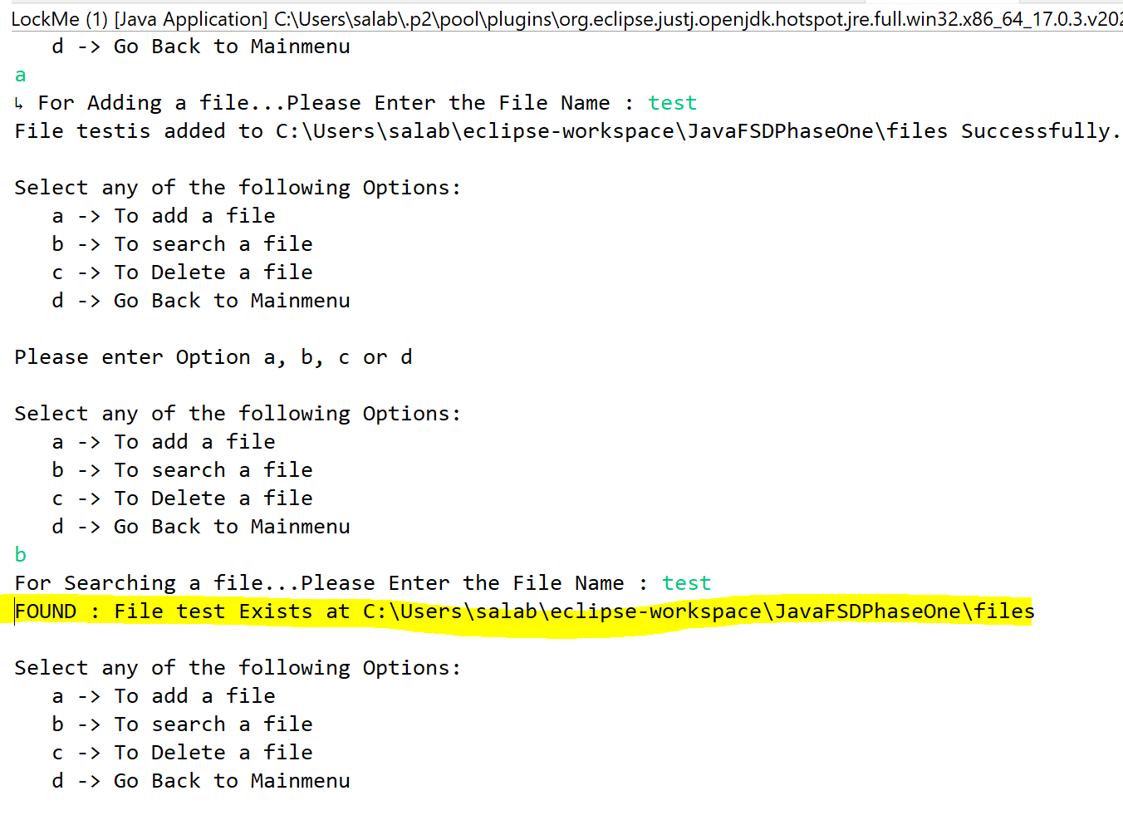

**2.c. To delete a file**

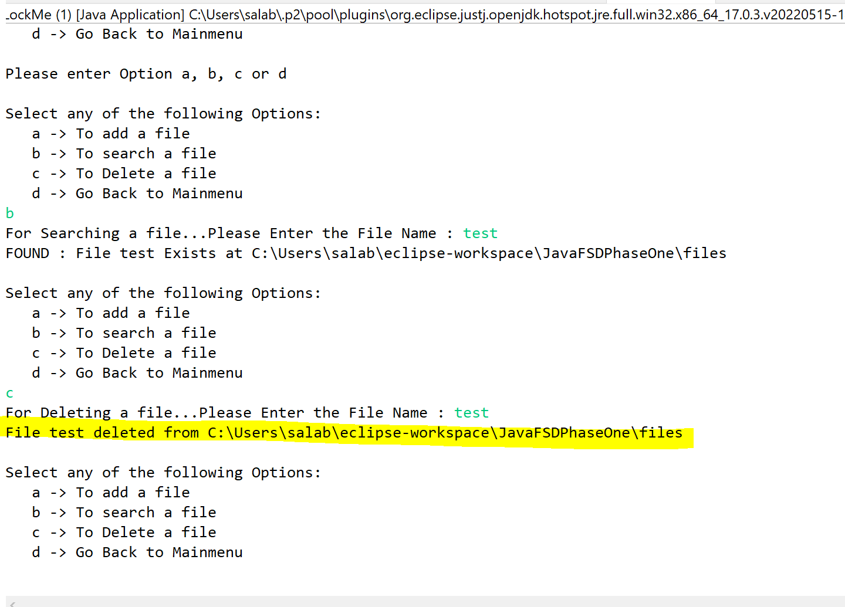

1. **EXIT**

