**Team-Budget-Planner**

**DESCRIPTION**

As a developer, write a program using JavaScript to decide the budget of a specific team. Background of the problem statement: As a developer, you are assigned to a project. You need to develop a website where program managers of a specific team will add details of professional deals they want to have with vendors. The finance team will check expenses of those teams and will decide their annual budget. You must use the following:

Visual Studio Code: An IDE to code for the application JavaScript: A programming language Git: To connect and push files from the local system to GitHub GitHub: To store the application code and track its versions JavaScript concepts: Functions, prototypes, primitives, objects, IIFEs, promises, async, and webpack Following requirements should be met: Versions of the code should be tracked on GitHub repositories Team Budget Planner should work properly

**List of technologies used in this project:**

1. HTML5
2. CSS3
3. Java Script
4. Font Awesome CDN
5. Bootstrap 5
6. swal(sweetalert)
7. GitHub
8. Visual Studio Code
9. Live Server

**JavaScript concepts used:**

functions,Objects, arrays, variables, local storage, JSON.parse(), DOM, loop

**APP Screenshot**

[](https://user-images.githubusercontent.com/84631708/155014322-3187d5ad-d7d0-41ca-876a-59ad117bfcb5.png)

[](https://user-images.githubusercontent.com/84631708/155014470-b0b97a15-3a6f-437d-bc15-a08f01bae898.png)

[](https://user-images.githubusercontent.com/84631708/155014523-c0e8f48d-6427-426a-b153-7037fc03de7d.png)

[](https://user-images.githubusercontent.com/84631708/155014550-87ad214c-8f26-4445-9106-5c6de5fe1d13.png)

[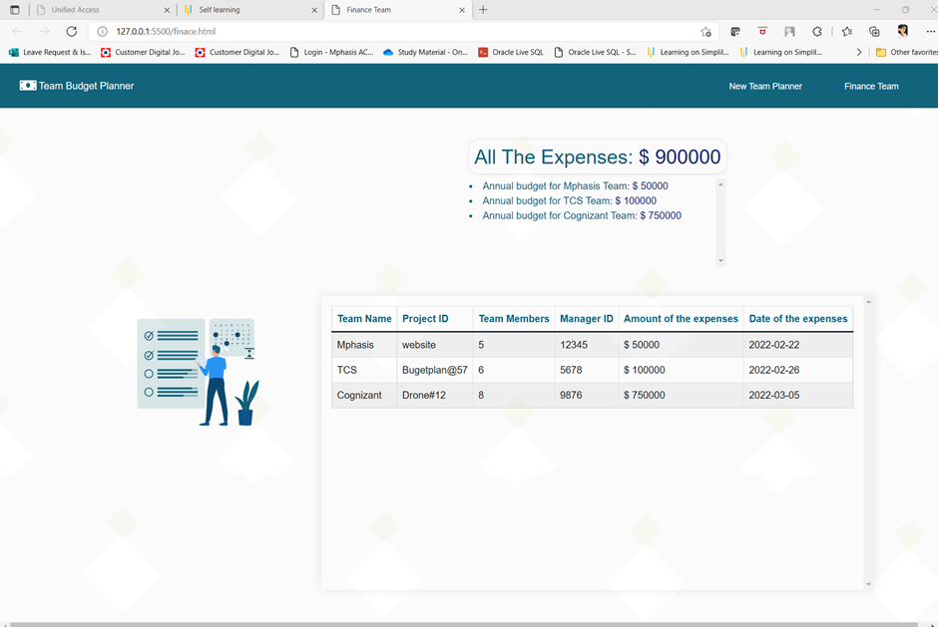](https://user-images.githubusercontent.com/84631708/155014580-e85f75c6-beaf-4a4f-b0cd-d84ea865bcdb.png)