# portefeuilles BUSINESS rules

A portefeuille represents a ministry or an institution that’s relevant from the law of finance(LF) & ministry of finances point of view

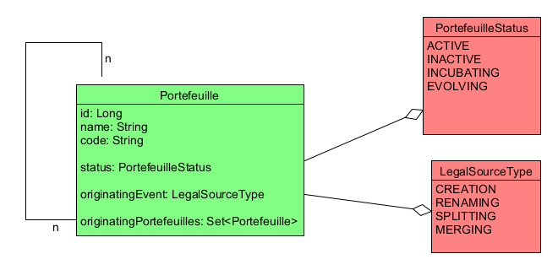

## relationship beetween portefeuilles

Portefeuille can have a parent-child relationship to keep history. The legal sources of parent-child relation are renaming, splitting (one parent--many children), merging (many parent--one child)

## portefeuille status

Portefeuille status represents the relevancy of a given portefeuille.

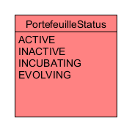

### ACTIVE

A portfeuille that isn’t subject to renaming, splitting, renaming.

### EVOLVING

A portefeuille that’s a subject to splitting or merging.

### INCUBATING

A portefeuille that’s a product of splitting or merging

### INACTIVE

A portefeuille that’s no longer relevant and only kept for historical reasons

## PORTEFEUILLE LEGAL SOURCE

Legal source type represents how that portefeuille was created

## 

### CREATION

A portefeuille that was created and has no parent

### RENAMING

A portefeuille that was created after renaming a portefeuille

### SPLITTING

A portefeuille that was created after splitting a parent portefeuille

### MERGING

A portefeuille that was created after merging a two or more parent portefeuille

## portefeuille name

* Only one active portefeuille can have a given name
* Two portefeuille A, B can have the same name iff:
  1. A is a parent portefeuille to B;
  2. A is EVOLVING and B is INCUBATING;
  3. When legal matters get finalized, A become INACTIVE and B become ACTIVE.

## portefeuille CODE

* Only one active portefeuille can have a given code
* Two portefeuille A, B can have the same name iff:
  1. A is a parent portefeuille to B;
  2. A is EVOLVING and B is INCUBATING;
  3. When legal matters get finalized, A become INACTIVE and B become ACTIVE.

## creating a portefeuille

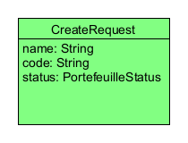

* It must not be null
* It must not have null name/code
* It must not have name/code associated to a portefeuille with status(active, evolving, incubating)

## renaming a portefeuille

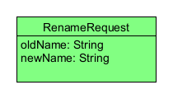

* It must not be null
* It must not have null oldName/newname
* It must have an old name that’s associated to an active portefeuille
* It must not have a new name associated to a portefeuille with status(active, evolving, incubating)

## Splitting A protefeuille

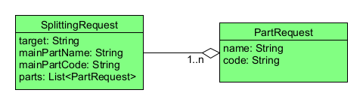

* It must not be null;
* Its field must not be null;
* Its parts must not be null;
* Its parts must not contain any null elements;
* Its parts must have a size greater or equal to 1;
* Its target must be a portefeuille with:
  1. Status: ACTIVE
* Its mainPartName/mainPartCode must either:
  1. Equals to target or;
  2. It must not be associated with any portefeuille with a status (active, evolving, incubating)
* Every part request in its parts must be valid such:
  1. Its filed must not be null;
  2. Its name/code must not be associated with any portefeuille