Start documentEND of Doc.

Start document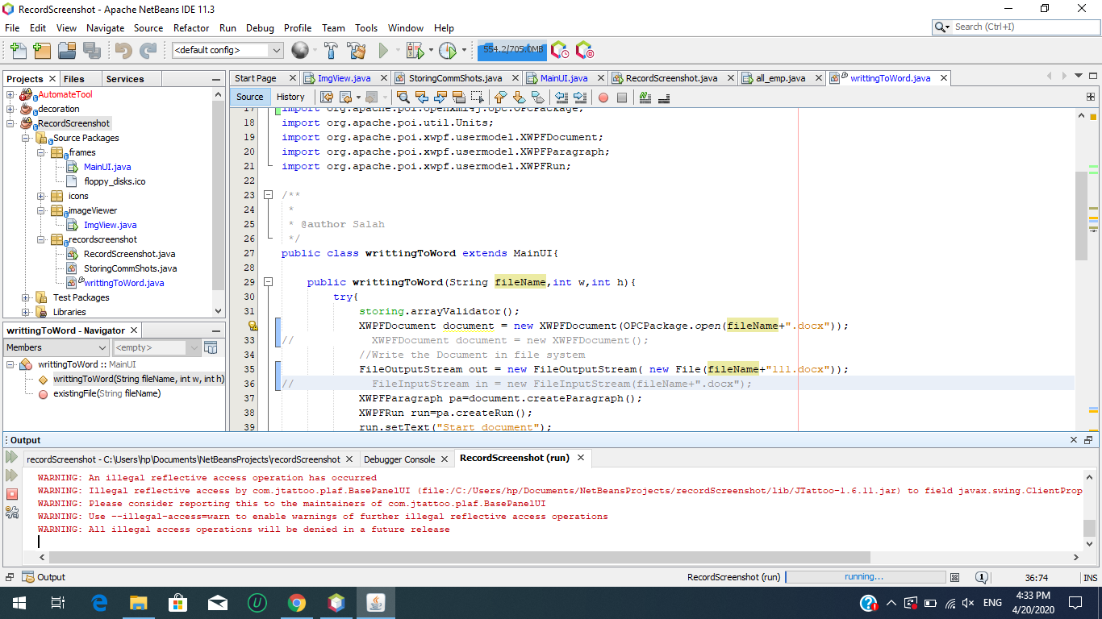END of Doc.