**GPS Driver & Hardware Integration Report**

Task: GPS Module

Author: Salah Eldin Hassen

Date: 22-04-2025

GitHub repo: https://github.com/salah0eldin/GPS_Module_STM32

────────────────────────────────────────

**Driver Development (Home Phase)**

* Wrote a bare-metal UART driver in C to parse NMEA sentences from a 9600 baud GPS.
* Worked exclusively on real hardware; no simulation tools were used.
* Lacking a physical GPS, emulated one by flashing a spare ESP32 board to stream continuous NMEA-like strings over UART at 9600 baud.
* Verified that the STM32 received and parsed all test sentences correctly.
* Pushed all source code, and a minimal README to GitHub (see link above).

**Initial Bench Test with the Real GPS Module (At collage)**

* Connected the GPS module to a laptop through its on-board USB bridge.
* Expected full NMEA frames (GGA, RMC, etc.), but only partial sentences appeared—most numeric fields were blank.
* Suspected poor satellite lock → moved outdoors under open sky; output remained unchanged.

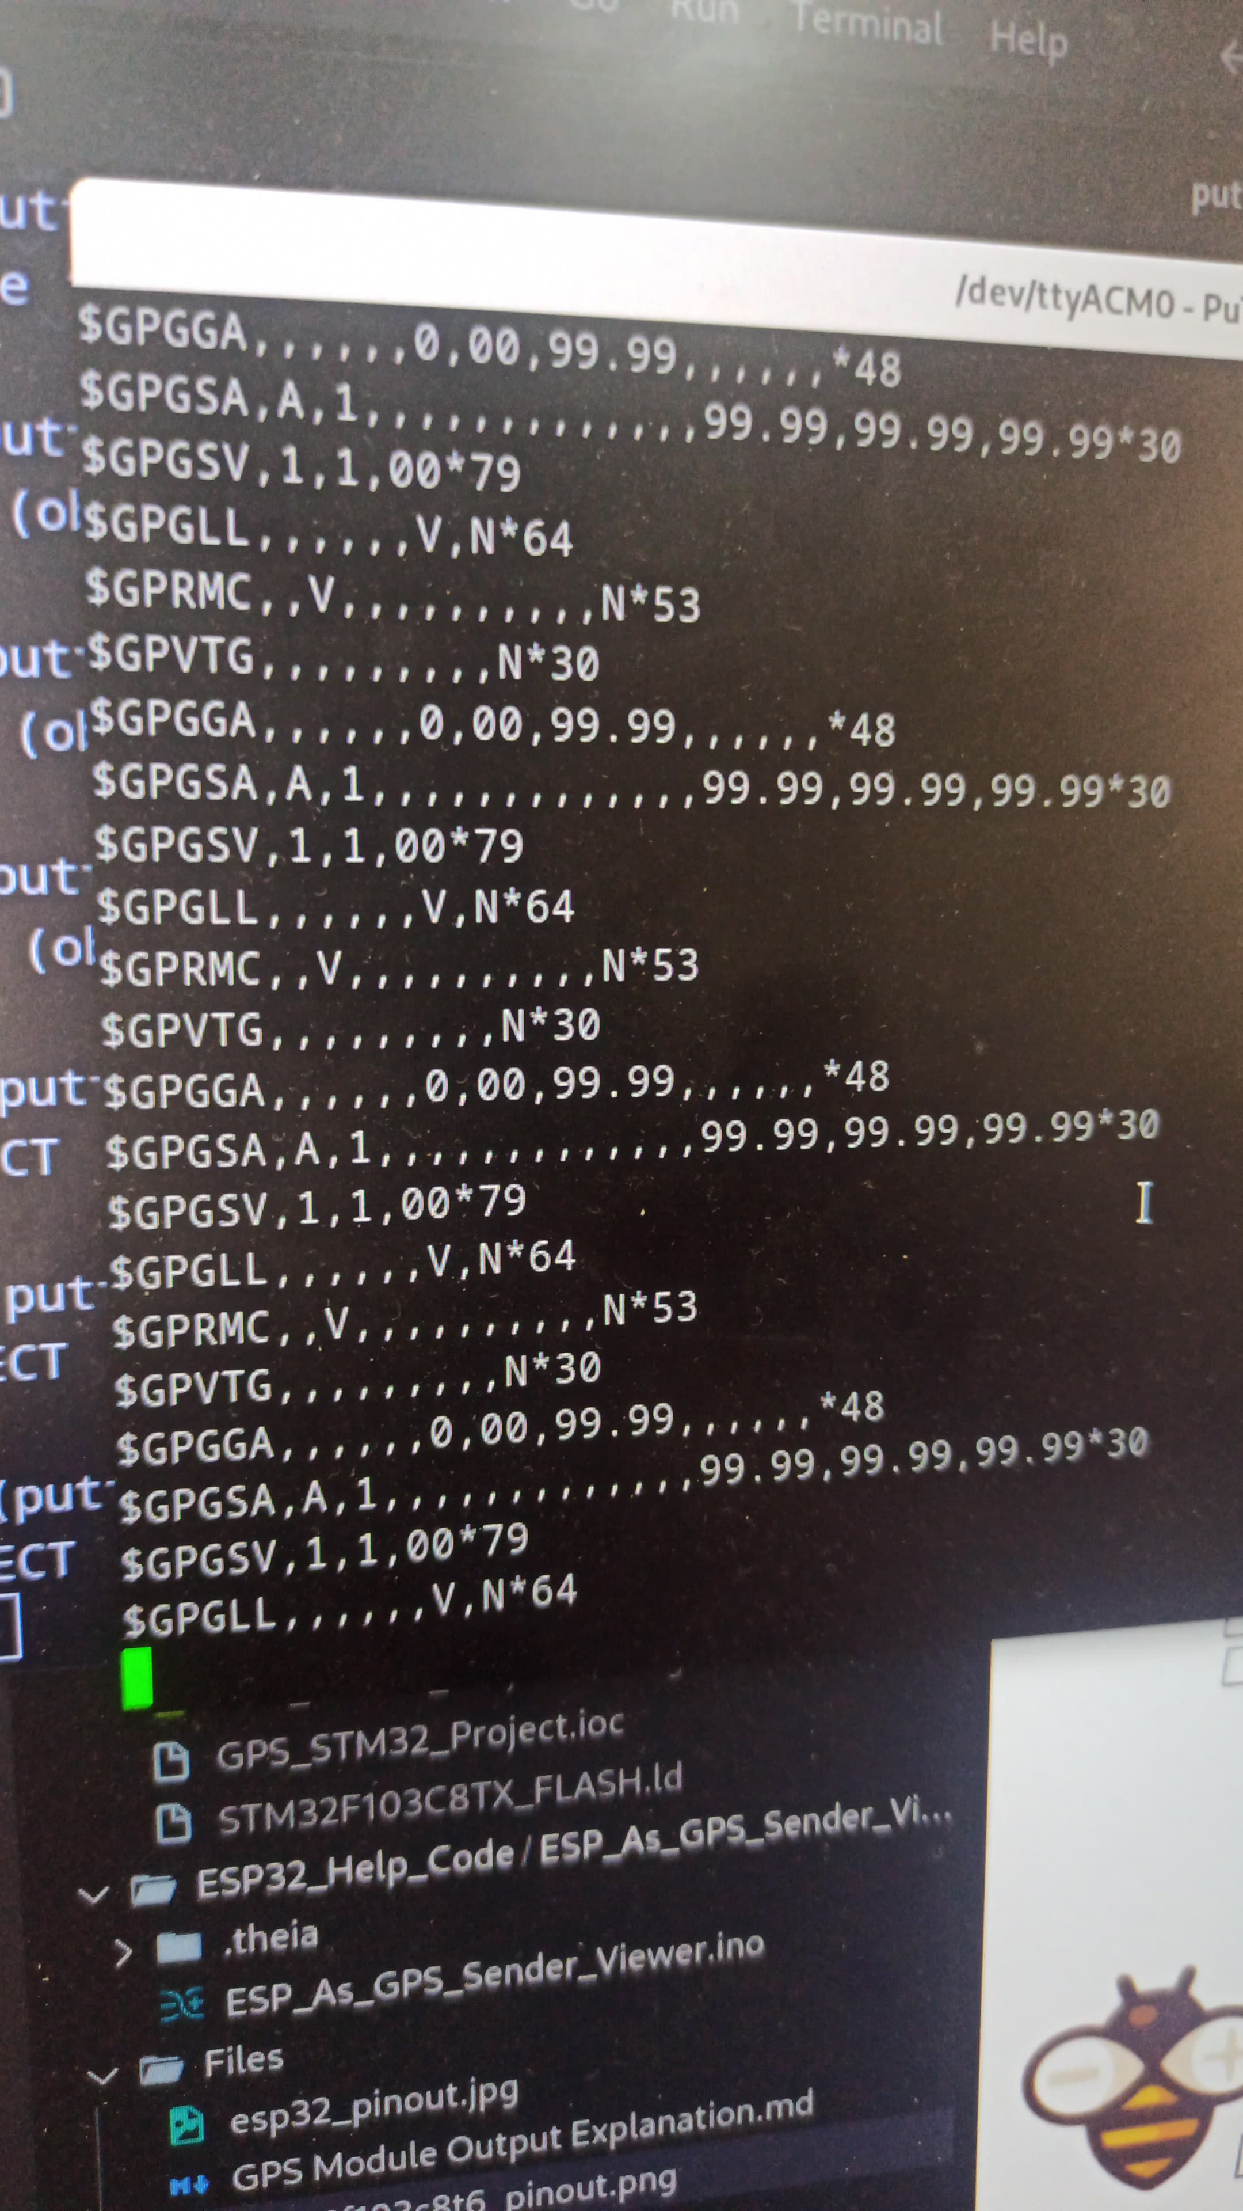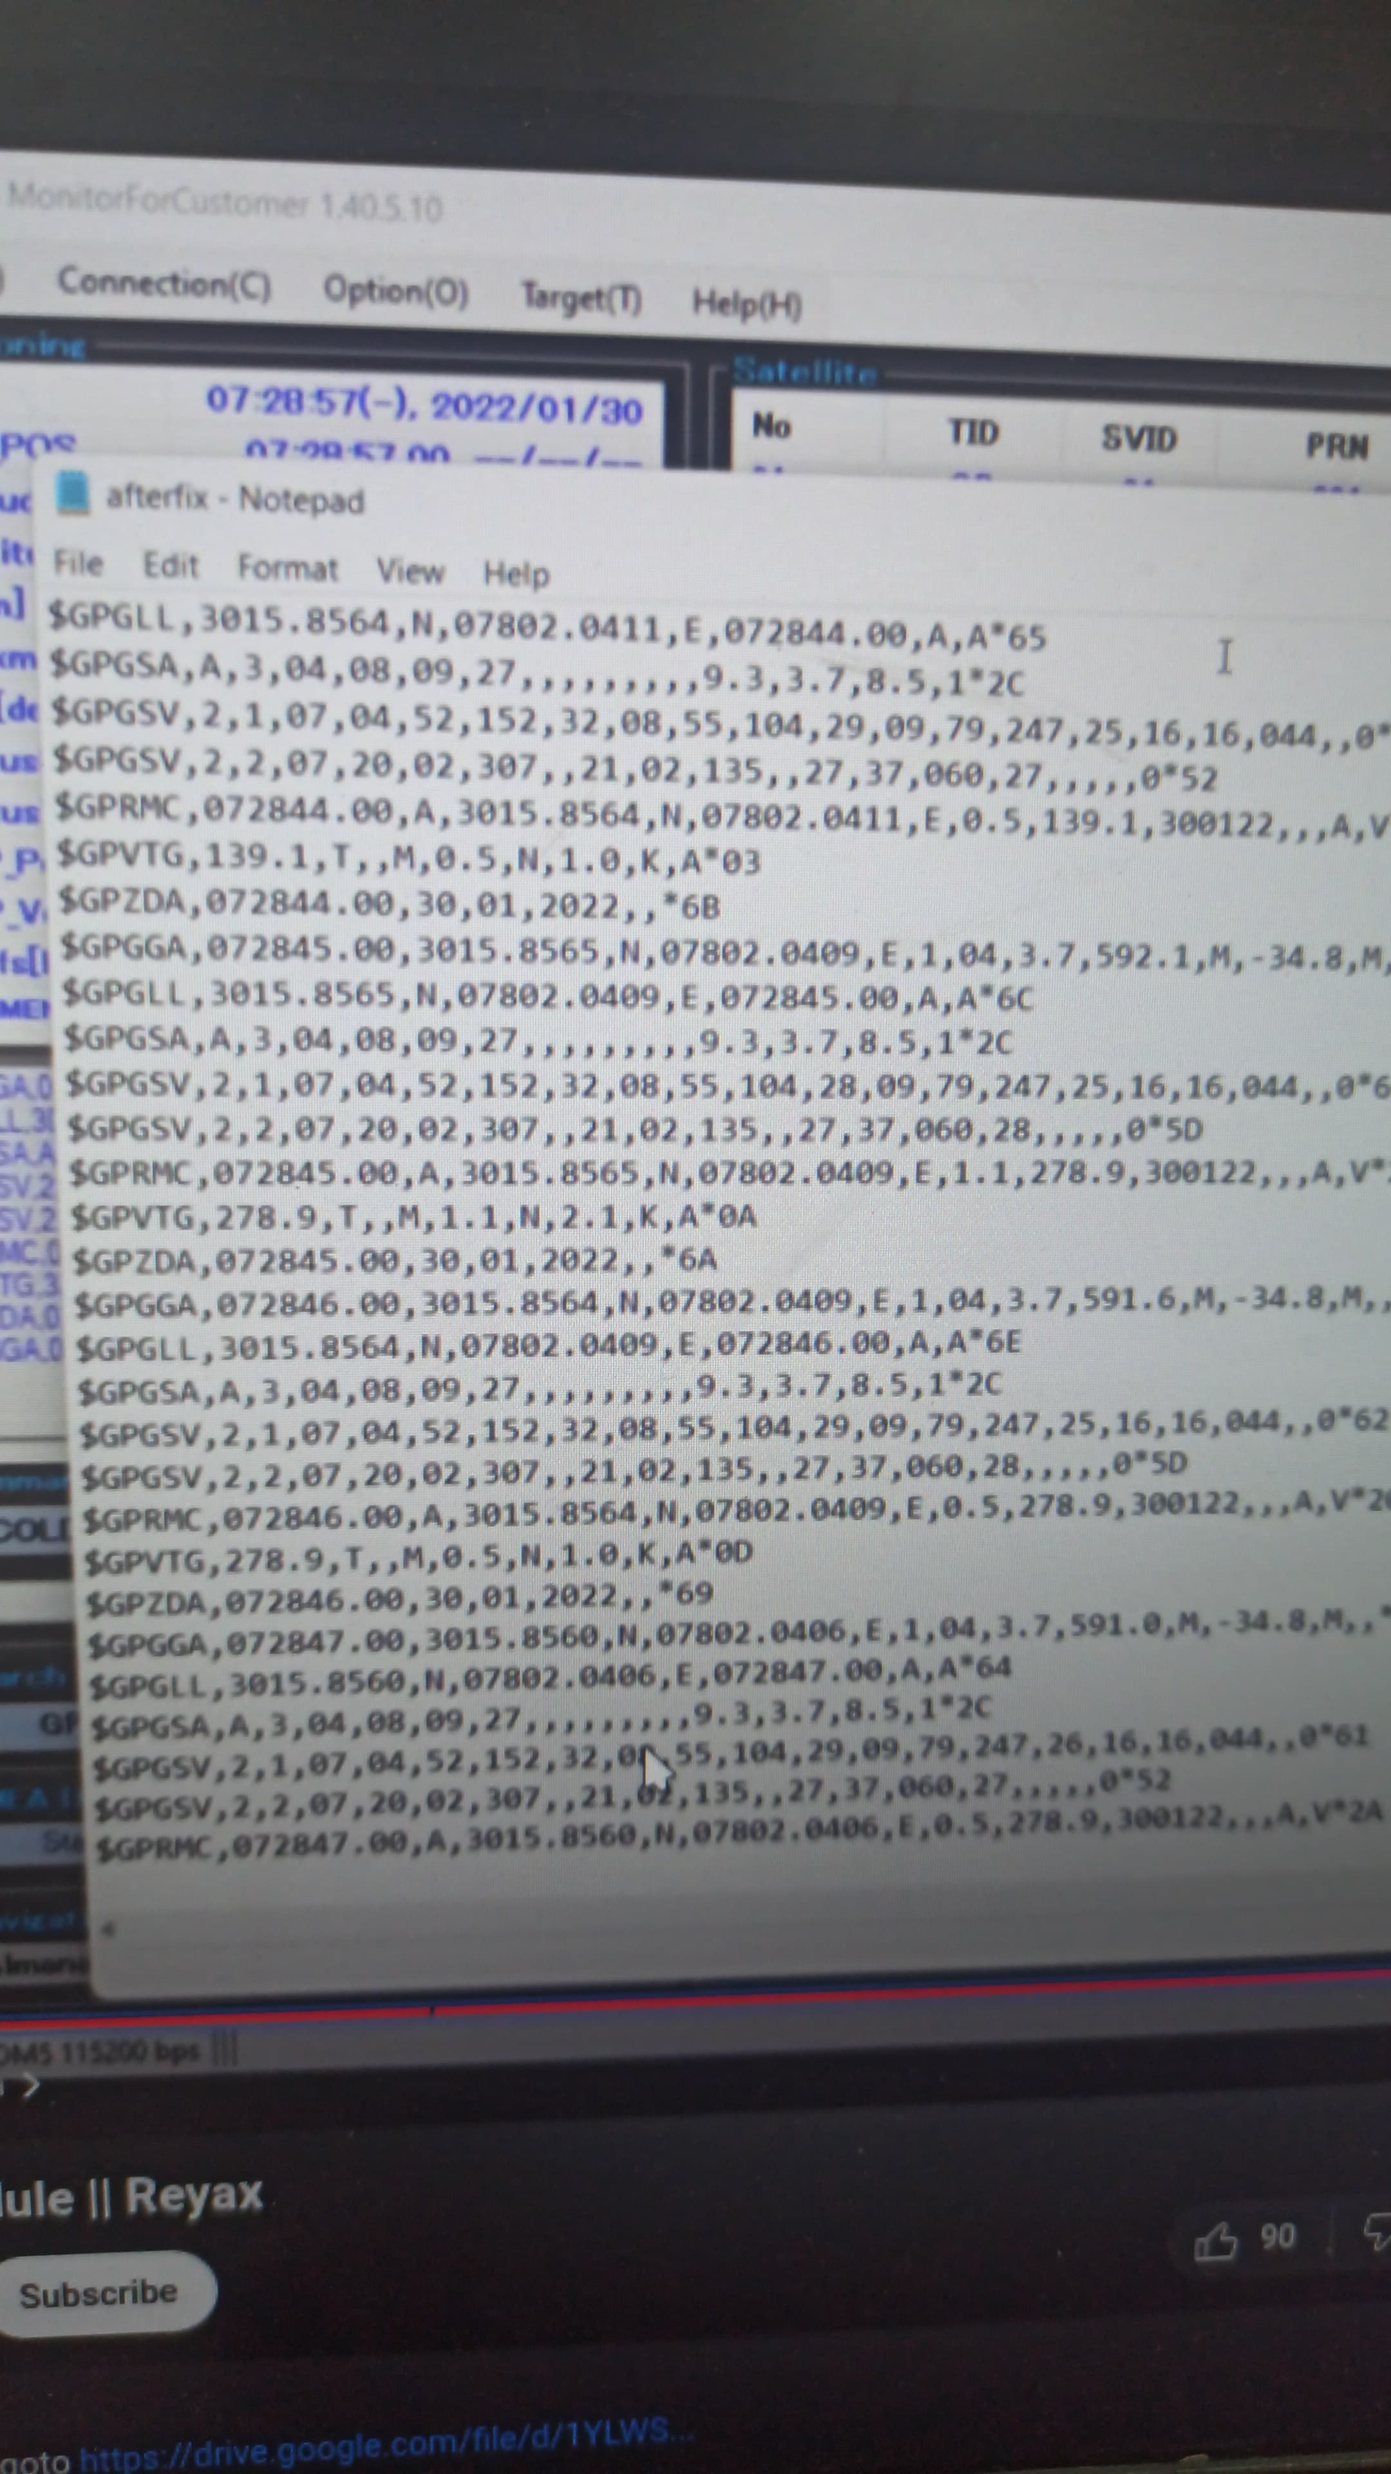

Figure 1 Output is the black one and Expected is the white one

**MCU-Side Verification**

* Wired the GPS module to the STM32’s USART1 (PA9/PA10) at 9600 baud.
* Driver showed no incoming bytes, confirming the issue was on the GPS side, not the MCU firmware.

────────────────────────────────────────

**Conclusion**

* All evidence points to a defective GPS module (corrupted serial output).
* Firmware and MCU UART are confirmed functional through emulated-GPS testing.

────────────────────────────────────────

**Quick-Look Handover Summary**

* UART driver (9600 baud, NMEA) is finished and verified with a self-made emulator.
* Current GPS hardware on hand is almost certainly dead; replace it.
* No firmware changes are needed once a healthy module is available.