**EDF Scheduler Implementation in FreeRTOS**

Tasks:

Task 1: ""Button_1_Monitor"", {Periodicity: 50, Deadline: 50}

Task 2: ""Button_2_Monitor"", {Periodicity: 50, Deadline: 50}

Task 3: ""Periodic_Transmitter"", {Periodicity: 100, Deadline: 100}

Task 4: ""Uart_Receiver"", {Periodicity: 20, Deadline: 20}

Task 5: ""Load_1_Simulation"", {Periodicity: 10, Deadline: 10}, Execution time: 5ms

Task 6: ""Load_2_Simulation"", {Periodicity: 100, Deadline: 100}, Execution time: 12ms

1. Using analytical methods calculate the following for the given set of tasks:
   * Hyperperiod = 100ms
   * CPU load = (0.015/50) + (0.015/50) + (0.015/20) + (0.15/100) + (5/10) + (12/100) = 62.3%
   * Check system schedulability using URM and time demand analysis techniques:

URM:

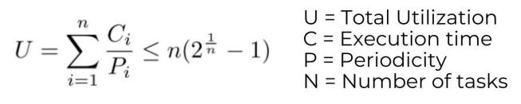

|  |  |
| --- | --- |
|  |  |
| L.H.S (U) | = CPU load = 0.62285 |

1

R.H.S (URM) = n ( 2𝑛 -1) = 6 ( 2 -1) = 0.73477

Since, U < URM

Therefore, The system is Schedulable.

Time Demand Analysis:

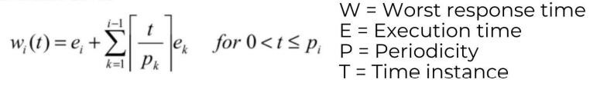

+ + (100/10) ∗ 5 = 62.285 <100

Therefore, The system is Schedulable.

|  |  |
| --- | --- |
| Load1: | 𝑊5(10) = 5 + 0 = 5 <10 |
| UART: | 𝑊4(20) = 0.015 + (20/10) ∗ 5 = 10.015 <20 |
| BTN1 & BTN2: | 𝑊1,2(50) = 0.015 ∗ 2 + (50/20) ∗ 0.015 + (50/10) ∗ 5 = 25.0675 <50 |
| Load2 & periodic: | 𝑊3,6(100) = 0.15 + 12 + (100/50)∗0.015 + (100/50)∗0.015 + (100/20)∗0.015 |

1. Using Simso offline simulator, simulate the given set of tasks assuming:

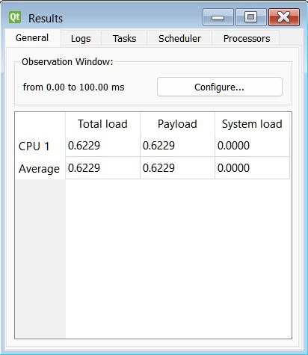

Hyperperiod (100ms):

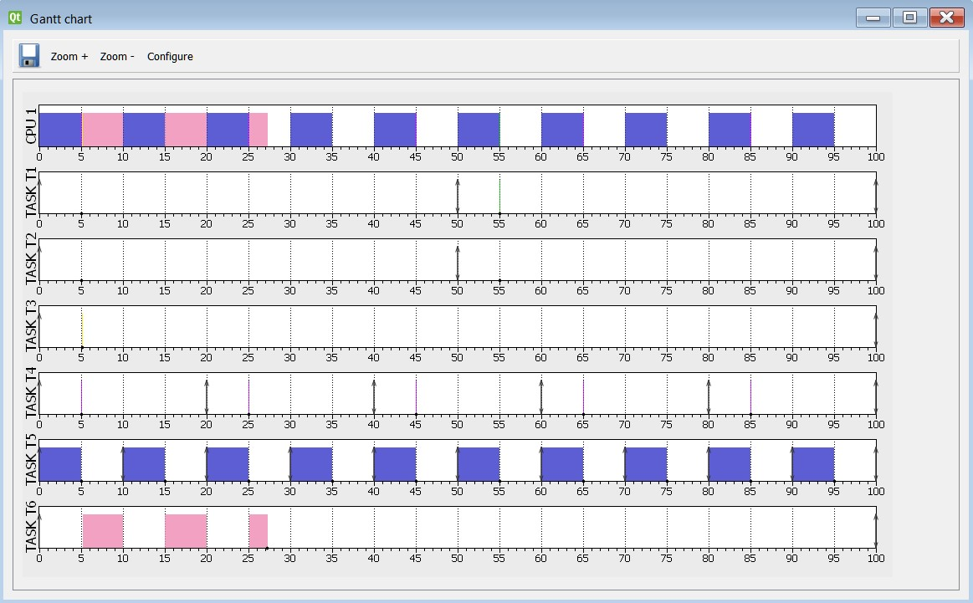

Zoom(5ms):

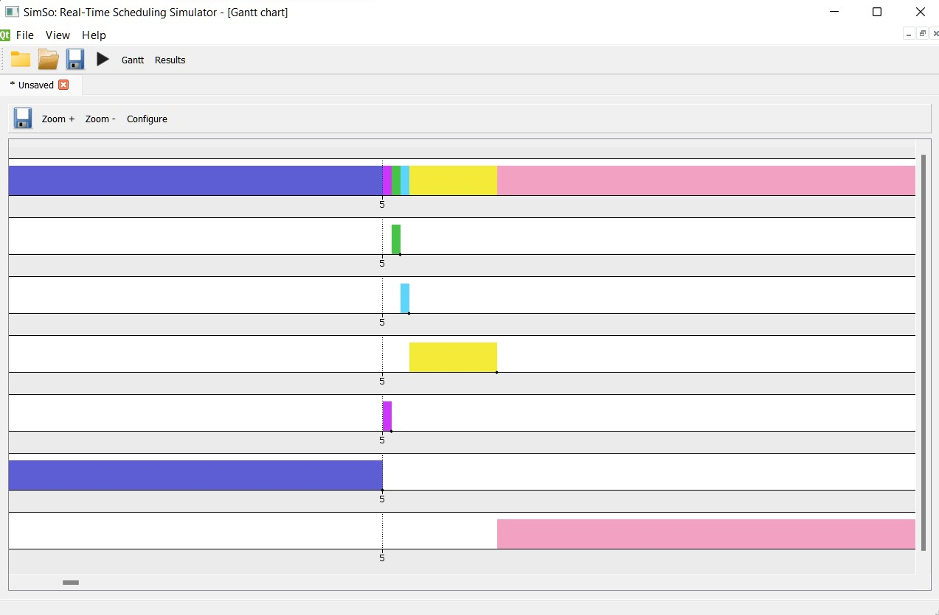

Hyperperiod (100ms):

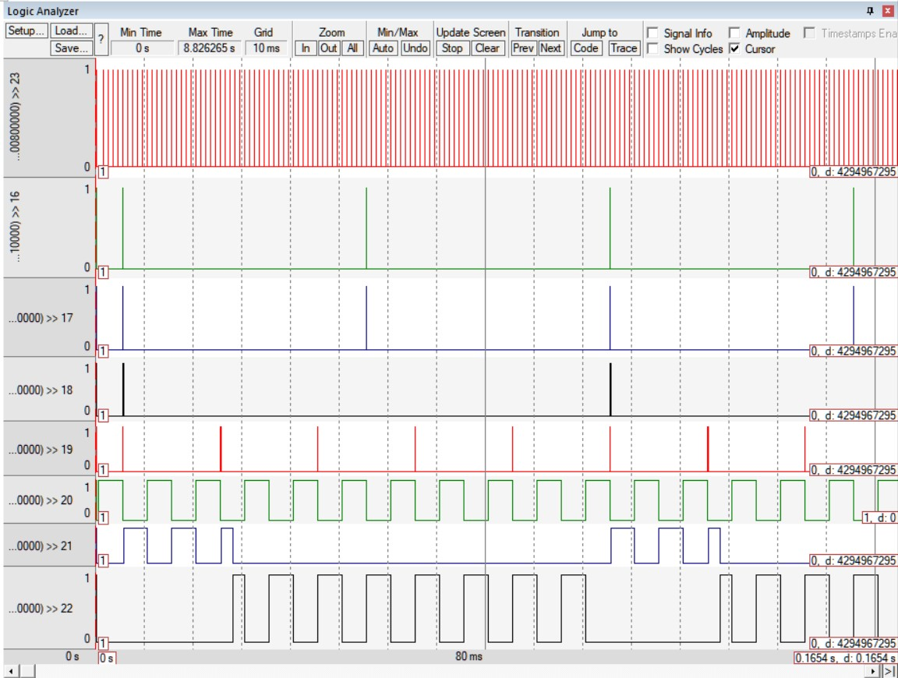

Zoom(5ms):

