Prince of Persia: The Two Thrones on Android
Simple step-by-step guide - Winlator 11.2 - October 2026
❗ Can this game become an Android APK?
No. This is a Windows PC game from 2005. It is made only of Windows program files (.exe and .dll), and there is no source code. So nobody can convert it into a real Android APK.
But you CAN play it on your phone. Winlator is a free Android app (an APK) that runs Windows games. You install Winlator, copy the game folder to your phone, and start the game inside Winlator. This guide shows every step.

Files I added to the game folder for you:
• 00 ANDROID - PLAY GAME.bat - starts the game with one tap. It also sets the registry keys that the game needs.
• 00 ANDROID - touch controls.icp - on-screen touch buttons made for this game.
• 00 ANDROID - HOW TO PLAY (guide) - this guide.

What you need
• An Android phone with a 64-bit processor. Snapdragon phones (Adreno graphics) work best. Other phones (MediaTek, Exynos, Google Tensor) can also work.
• 4 GB RAM or more (6 - 8 GB is better).
• About 5 GB of free space. The game is about 1.5 GB.
• Optional: a Bluetooth game controller. It makes the game much easier to play.

Step 1 - Install Winlator
1. On your phone, open: https://github.com/brunodev85/winlator/releases
2. Under Assets, tap Winlator_11.2.apk (about 157 MB) to download it. If you see a newer version, take the newest one.
3. Open the downloaded file and tap Install. If Android asks, allow Install unknown apps.
4. Open Winlator and wait until Installing System Files... is finished.
⚠ Be careful
Download Winlator only from the GitHub page above. Many "Prince of Persia APK" files on other websites are fake or contain viruses.

Step 2 - Copy the game to your phone
The game folder is princ of percia in your Google Drive (about 1.5 GB). Copy the whole folder to your phone.
Way A - with a computer (easiest)
1. On the computer, open https://drive.google.com
2. Right-click the folder princ of percia and choose Download. Google makes a .zip file (a big folder can become 2 zip files).
3. Connect your phone with a USB cable. Copy the zip file(s) into the phone's Download folder.
Way B - phone only
1. Open Chrome and go to drive.google.com. Tap ⋮ (the three dots, top right) and turn on Desktop site.
2. Long-press the folder princ of percia and choose Download.
Then unzip it
1. Open the zip file with a file app, for example Files by Google or ZArchiver, and tap Extract. If there are 2 zip files, extract both into the same place.
2. Check that the game files are here: Internal storage > Download > princ of percia > PrinceOfPersia.exe, pop3.exe, pop3.bf ...
3. If you see a princ of percia folder inside another princ of percia folder, move the inner one up into Download.
💡 Good to know
Winlator shows your Download folder as drive D:. So the game will be at D:\princ of percia.

Step 3 - Create a container (a small "Windows PC" inside Winlator)
1. Open Winlator. Tap ☰ (menu) > Containers > + (add).
2. Set these options:
Setting | Choose this
Name | Prince of Persia
Screen Size | 1280x720 (16:9). Older or slower phone: 854x480 (16:9)
Wine Version | Leave it as it is
Graphics Driver | Vulkan: Turnip - Snapdragon phones.  Vulkan: Vortek - all other phones.  Leave OpenGL as it is.
DX Wrapper | Direct3D: DXVK. Then tap the settings button on the Direct3D row:  Frame Rate = 60 (very important). Keep Version as it is. Tap OK.  Leave DirectX 12 as it is.
Audio Driver | ALSA (if you have no sound later: PulseAudio)
HUD Mode | Simple FPS (optional - shows the game speed)
Advanced tab > Box64 Preset | Performance (if the game crashes: Intermediate, then Stability)

3. Tap ✓ to save. Wait until the container is ready.
❗ Why Frame Rate 60?
This game has bugs above 60 FPS: it can freeze on loading screens, jumps can fail, and the sound can go out of sync. Frame Rate 60 stops this.

Step 4 - Add the touch controls
1. In Winlator, tap ☰ > Input Controls.
2. Tap the Import button > Open File.
3. Go to Download > princ of percia and choose 00 ANDROID - touch controls.icp.
4. The profile Prince of Persia - The Two Thrones is now in the list.

Step 5 - Start the game
1. Tap ☰ > Containers. Next to Prince of Persia, tap ⋮ (three dots) > File Manager.
2. Open D:, then open princ of percia (tap the folder icon or its Open button).
3. Find 00 ANDROID - PLAY GAME.bat and tap its Run button (or its icon). A black window shows for a moment, then the game launcher opens.
4. Tap Play in the launcher. The first time, the launcher checks the system - just wait a few seconds.
💡 Faster next time
Tap ⋮ (three dots) next to 00 ANDROID - PLAY GAME.bat > Add to Favorites. Next time open File Manager > Favorites and tap it.

Step 6 - Show the buttons on the screen
1. While the game is running, press your phone's Back button (or swipe in from the left edge). The Winlator menu opens.
2. Tap Input Controls, choose Prince of Persia - The Two Thrones, turn on Show Touchscreen Controls, and tap OK.
3. The first time, the game asks for a player name. Open the Winlator menu again > Keyboard, type a name, and press Enter.

Step 7 - Settings inside the game (Options)
• Graphics - Basic > Resolution: the same as your container (for example 1280x720), or the closest one.
• Graphics - Advanced > V-Sync: On.
• If the game is slow: Shadow Effects low or off, Water Effects off.

The touch buttons
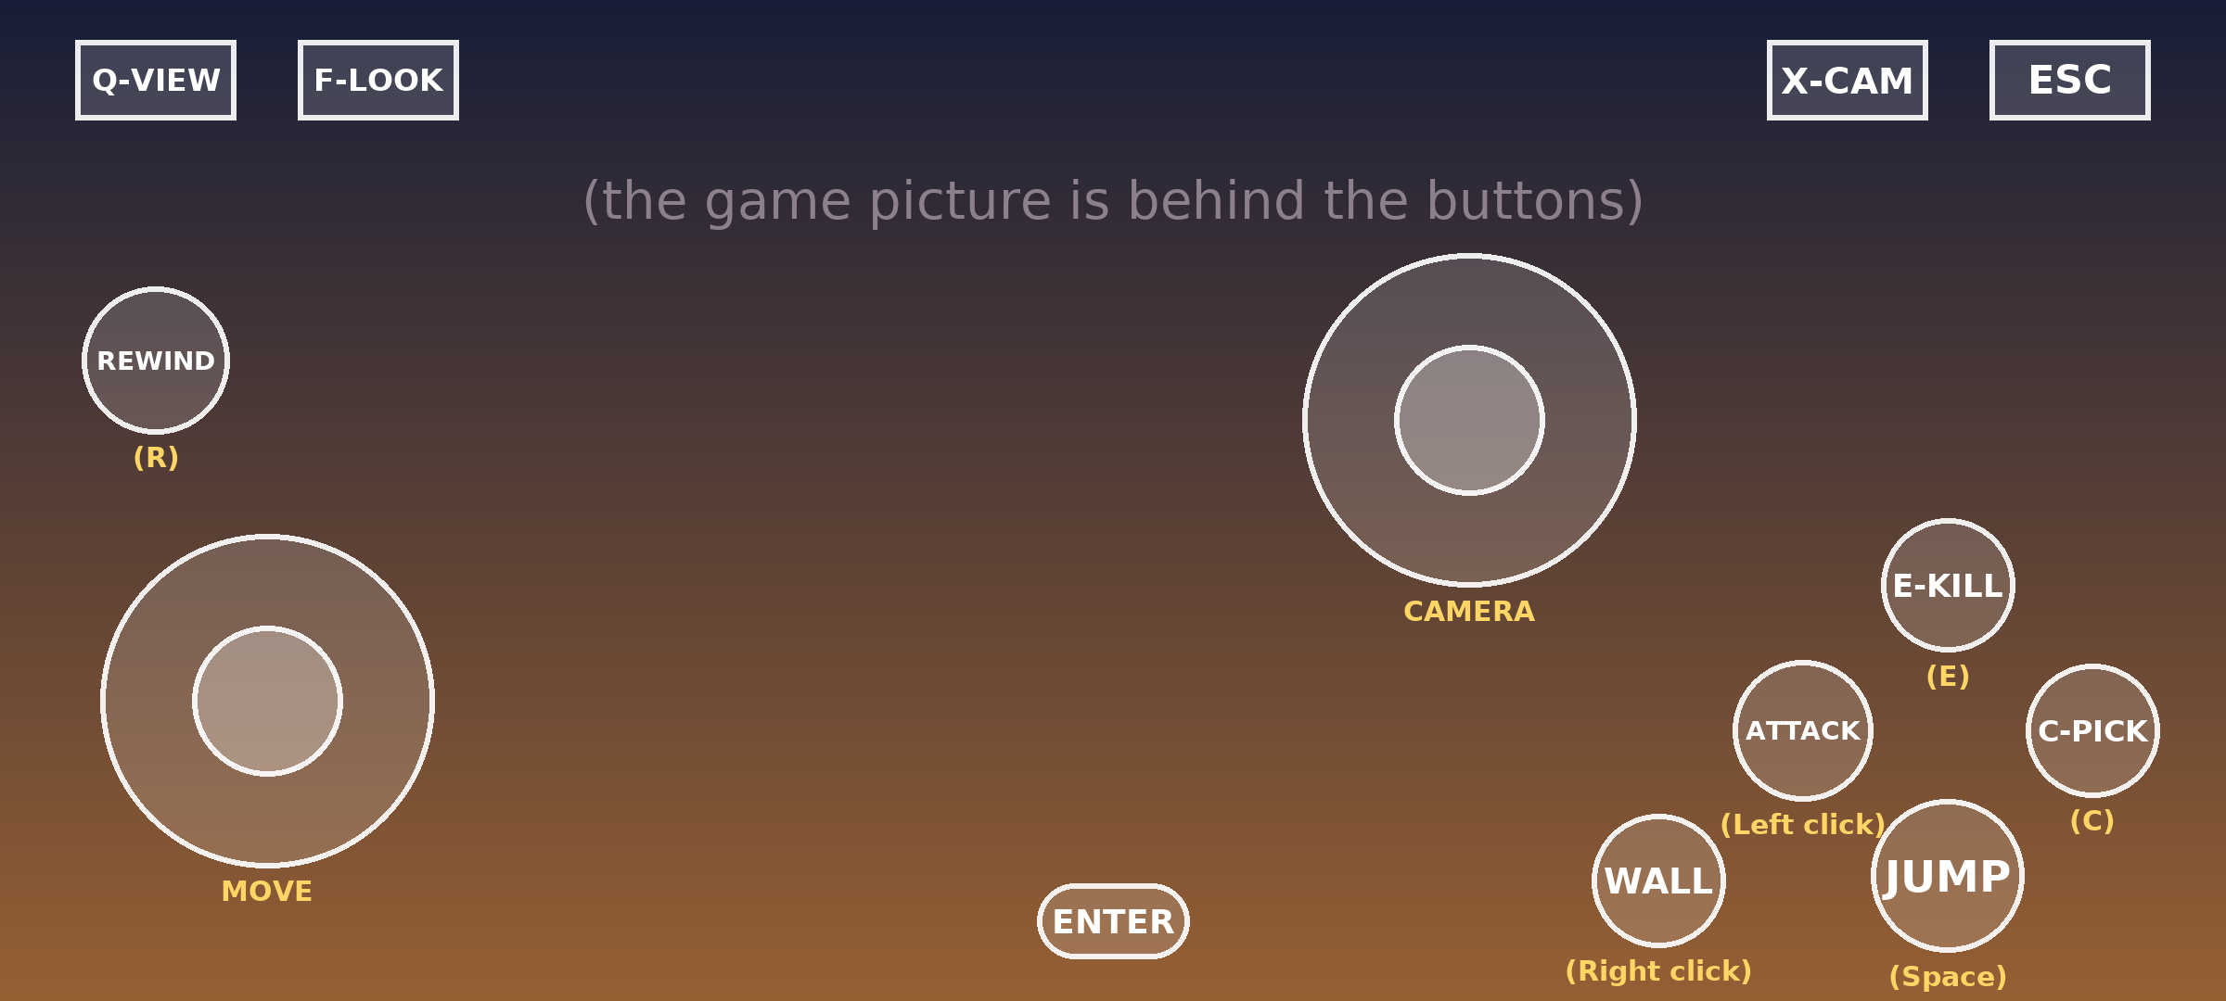
Yellow text = notes for you. It is not shown in the game.
Button | What it does | PC key
MOVE (left stick) | Walk and run. Also moves in menus. | W A S D
CAMERA (right stick) | Turns the camera. | Mouse
JUMP | Jump, roll, climb up. | Space
ATTACK | Dagger attack, finish a Speed Kill. | Left mouse
E-KILL | Start a Speed Kill, use the second weapon, grab. | E
C-PICK | Pick up or throw a weapon, climb down. | C
WALL | Run on walls, swing on bars, push / pull, drink water, block. | Right mouse
REWIND | Hold = rewind time. Tap = slow motion. | R
F-LOOK | Look around (first-person view). | F
Q-VIEW | Wide view of the area. | Q
X-CAM | Put the camera behind the Prince. | X
ESC | Pause menu / go back. | Esc
ENTER | OK / select in menus. | Enter

• The game's help messages show PC keys (for example "Space" or "E"). Use the table to find the button.
• In menus: choose with the MOVE stick, press ENTER to select, ESC to go back.
• You can also swipe on an empty part of the screen to turn the camera. (A short tap on an empty part = attack.)
• To move or resize buttons: ☰ > Input Controls > choose the profile > Controls Editor.
• Camera too slow or too fast? ☰ > Input Controls > change Cursor Speed.

Playing with a game controller (optional)
1. Pair the controller in Android Settings > Bluetooth first.
2. Start the game. In the game, open Options > Controls - Gamepad and set the buttons you like.
3. If the game does not react to the controller: open the container settings > Wine Configuration > DirectInput Mapper Type and try the other choice.
4. On Xbox-style controllers this game cannot use the two triggers (LT / RT) correctly. Put important actions on other buttons.

Problems and fixes
"DXVK settings" = container settings > DX Wrapper > the settings button on the Direct3D row.
Problem | Try this
Black screen, or the game closes at the start | DXVK settings > Version 1.10.3 (or 1.7.2).  Or switch the Vulkan driver (Turnip <> Vortek).  Or Box64 Preset: Intermediate, then Stability.
The launcher says your video card is not supported | DXVK settings > Custom Device > choose an NVIDIA card, for example NVIDIA GeForce GTX 480.
Freezes on a loading screen, jumps fail, sound is out of sync | Check DXVK settings > Frame Rate = 60. In the game, turn V-Sync on.
The game is slow | Screen Size 854x480 or 800x600 (and the same resolution in the game). Turn off shadows and water effects. Close other apps.
No sound, or crackling sound | Audio Driver: PulseAudio.
The camera turns by itself, or does not turn | Container settings > Wine Configuration > Mouse Warp Override > Force (or Enable).  Or, while playing: Winlator menu > Input Controls > turn on Relative Mouse Movement.
Nothing happens when you tap the .bat file | Tap RUN THIS FIX FIRST.bat once. Wait 30 seconds, then close it. Now tap PrinceOfPersia.exe to play.
"PrinceOfPersia.exe was not found" | The .bat file must stay inside the game folder, next to PrinceOfPersia.exe.

Good to know
• Your saved games are kept inside the game folder (Download > princ of percia). Do not delete this folder.
• Players report: Snapdragon 8 Elite - stable 60 FPS. Snapdragon 870 - playable. Even a mid-range MediaTek Helio G99 phone (8 GB RAM) was playable at 800x600 in a test.
• You can ignore these files on the phone: "Launch Prince of Persia The Two Thrones.lnk", "AnkerGames - Free Pre-installed PC Games.url", "Read Me.txt".
• More help about Winlator: https://github.com/brunodev85/winlator

