
[Document title]

Practice 1: Deep Learning with CIFAR-10 and CNN for NAO Robot Integration

Abstract
This paper discusses the implementation of deep convolutional neural networks (CNNs) for image classification using the CIFAR-10 dataset and integrates the resulting model with a humanoid robot (NAO) for real-time object recognition and interaction. The workflow includes data preprocessing, CNN architecture design using TensorFlow, model training and evaluation, performance optimization, and deployment for robotic vision for real-time object detection. Our methodology involved meticulous data preparation, robust CNN model construction, and rigorous training with advanced regularization techniques like Batch Normalization, Dropout, L2 regularization, and data augmentation. The model achieved a notable 85.74% test accuracy on CIFAR-10, demonstrating strong generalization. The outcome of this approach allows the NAO robot to recognize objects in the dataset using its camera and respond appropriately (taking photos, pronouncing the object's name, and writing it), demonstrating the integration of deep learning with real-world robotics. The project highlights the practical application of deep learning in robotics and discusses techniques to optimize performance, minimize overfitting, and ensure generalization.
Keywords: Humanoid Robot, NAO, Physiotherapy, Deep Learning, Convolutional Neural Network (CNN), CIFAR-10, Object Recognition, Assistive Technology.

Introduction
Deep learning has become a powerful tool in modern technology, especially in fields like computer vision, robotics, and natural language processing. One of its most successful techniques is the Convolutional Neural Network (CNN), which is widely used for image recognition tasks. In this project, a CNN model was developed and trained to classify images from the CIFAR-10 dataset, which includes 60,000 small coloured images divided into 10 different categories.
The main aim of this work is to build an accurate image classification model and explore how it can be applied in a real-world robotics setting. As part of this, the model is integrated into a NAO humanoid robot, enabling it to recognize and identify objects visually. This capability can be especially useful in assistive environments, such as physiotherapy clinics, where robots can support therapists by recognizing tools or responding to patient needs.
The report explains the steps taken during the project, including preparing the data, building and training the CNN model, analysing the results, and designing how it could be used in a robot. Each section connects to the learning outcomes of the course, focusing on both the technical and practical aspects of applying deep learning in robotics.

1. Data Preparation with Main Statistics
The CIFAR-10 dataset consists of 60,000 RGB images of size 32x32 pixels, categorized into 10 classes: airplane, automobile, bird, cat, deer, dog, frog, horse, ship, and truck. The dataset is split into 50,000 training images and 10,000 test images.
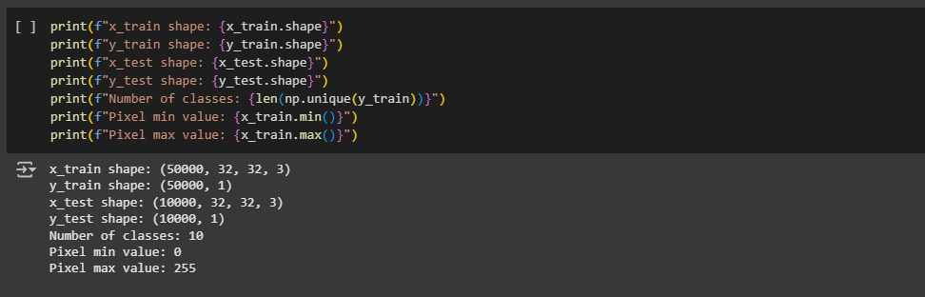
We imported several Python libraries for data handling and processing. TensorFlow.Keras was used to build and train the neural network, while NumPy and Pandas facilitated numerical operations and data management. Matplotlib and Seaborn were employed for visualization, and Scikit-learn (sklearn) provided performance metrics, including the classification report and confusion matrix.
Preprocessing steps were implemented to optimize model training and generalization:
Normalization: Pixel values were rescaled to the range [0,1], ensuring stable neural network training and improving convergence.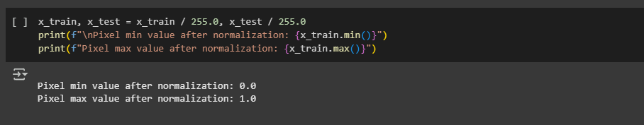
One-Hot Encoding: Class labels were converted into a one-hot encoded format, facilitating compatibility with the categorical cross-entropy loss function.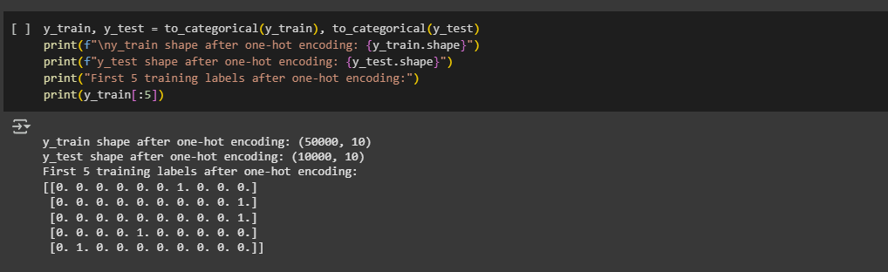
Dataset Partitioning: The dataset was structured into 40,000 training images, 10,000 validation images, and 10,000 test images to assess model performance and prevent overfitting.
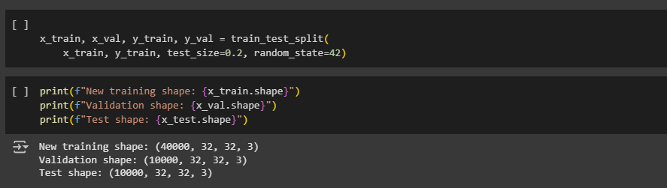
layers (0.3 and 0.4) are strategically applied to mitigate overfitting.

2. Model construction
The Convolutional Neural Network (CNN) architecture (Figure 1) is designed to efficiently extract hierarchical features from image data through structured layers and regularization techniques. It consists of two convolutional blocks, each incorporating Conv2D layers with increasing filter sizes (32 and 64 filters in the first block, 128 filters in the second). Batch Normalization enhances training stability, while MaxPooling2D facilitates down-sampling for efficient feature extraction. Dropout layers (0.3 and 0.4) are strategically applied to mitigate overfitting, ensuring robust generalization.
A Flatten layer transitions convolutional feature maps into a fully connected format. This is followed by a Dense layer with 256 neurons, incorporating Batch Normalization and a higher Dropout rate (0.5) to refine high-level representations. The final Dense output layer employs SoftMax activation with 10 neurons, ensuring effective multi-class classification. Additionally, L2 regularization (kernel_regularizer=l2(0.0001)) is applied throughout the network to penalize large weight values and promote generalization.

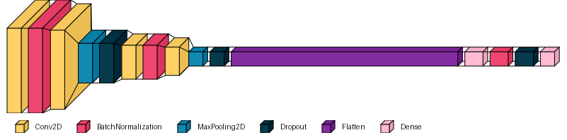
Figure 1 The Convolutional Neural Network (CNN)
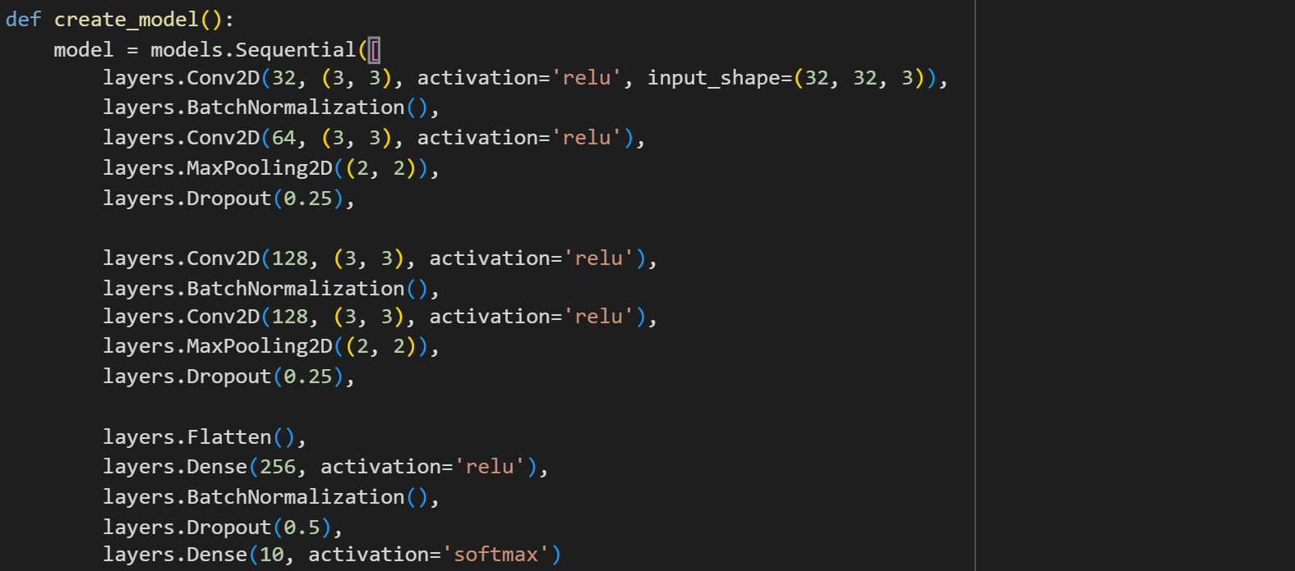

Below is the model summary

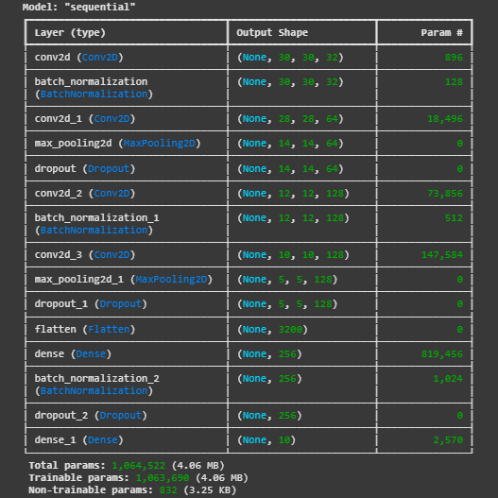

An exponentially decaying learning rate scheduler was used with the Adam optimizer to enhance convergence and avoid local minima. This architecture was chosen after iterative experimentation to ensure high test accuracy and strong generalization performance, helping fine-tune weights as training progresses. Adam is well suited to computer vision tasks.

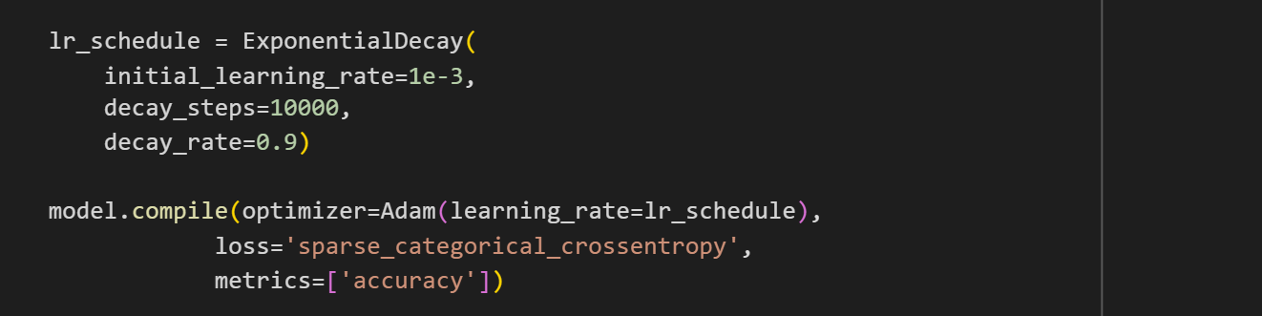

3. Model Training, Testing, and Validation
The model was compiled using the Adam optimizer and categorical cross-entropy loss. Training was conducted with a 20% validation split, ensuring effective performance monitoring. EarlyStopping (patience = 10) was implemented to prevent overfitting, while ReduceLROnPlateau (patience = 5) was used to dynamically adjust the learning rate when validation loss stagnated, optimizing convergence.
Phase 1: Initial Training Observation
The initial training run revealed a common challenge in deep learning: overfitting. While the model rapidly achieved high accuracy on the training data (96% by Epoch 28), its performance on the validation set consistently lagged (around 81-82%), and validation loss showed signs of divergence. This indicated the model was memorizing the training examples rather than learning robust, generalizable features. This observation underscored the necessity for more rigorous regularization. Figure 1 shows model accuracy and model loss, which shows the overfitting in the trained model.
Overall, the CNN model performed exceptionally well on the training set, but its validation accuracy plateaued early, and validation loss fluctuated. These patterns indicate overfitting, where the model learns specific details from the training data but struggles to apply that knowledge to new, unseen samples. Even with dropout layers and adaptive learning rate adjustments, overfitting remained a significant challenge.

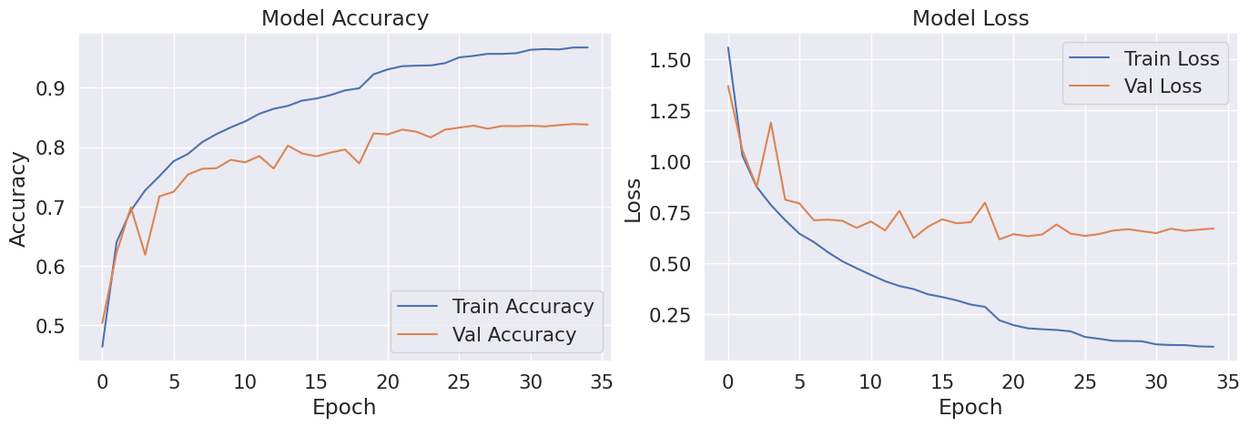
Figure 2 : Initial Model Training Curves (Illustrating Overfitting)
Phase 2: Refined Training with Enhanced Regularization and Data Augmentation To combat the observed overfitting, the model architecture was enhanced as described above, incorporating BatchNormalization, Dropout layers, and L2 regularization. Crucially, the Image Data Augmentation strategy was fully leveraged. The training was re-initiated with an appropriate initial learning rate (e.g., 0.001 or 0.00025, which corrected the previous "too low" learning rate issue). This phase demonstrated a significantly healthier learning trajectory.
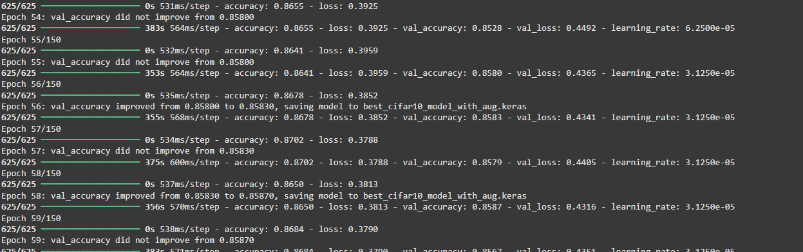
The training curves from this refined phase exhibited a much tighter fit between training and validation metrics. Validation accuracy consistently improved and stabilized, reaching a peak of 85.78% (Epoch 58) with a corresponding validation loss of 0.4237.
This marked a substantial increase from the initial run's generalization capabilities. The ReduceLROnPlateau callback proved highly effective, dynamically adjusting the learning rate multiple times to guide the model through plateaus, ensuring a smooth and efficient convergence. EarlyStopping successfully prevented further overfitting by halting training when validation performance ceased to improve, restoring the best model weights.
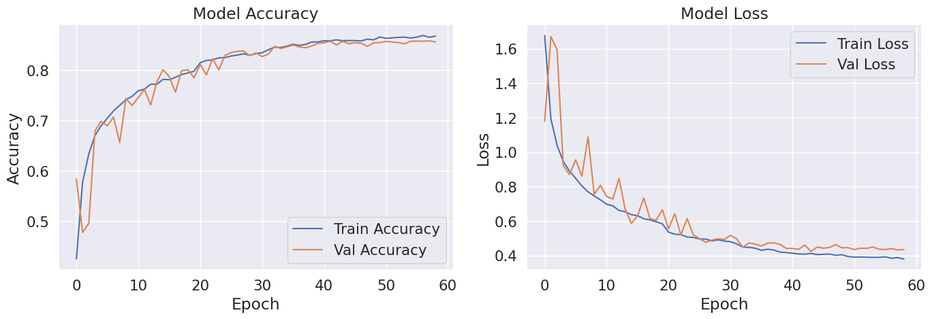
Figure 3 Refined Model Training Curves with Data Augmentation (Demonstrating Improved Generalization)

4. Model Performance Discussion and Analysis
The final evaluation on the entirely unseen 10,000-image test set confirmed the model's robust generalization. The model achieved a Final Test Accuracy of 85.74%, with a Final Test Loss of 0.4358. This high accuracy signifies the model's capability in classifying objects from the CIFAR-10 dataset.
Classification Report: The model displayed strong classification capabilities across most categories, achieving F1-scores above 0.85 for classes such as 'automobile', 'ship', and 'truck'. Conversely, 'cat' remained the most challenging class (F1-score of 0.68), alongside 'bird' and 'dog' which also showed comparatively lower scores, reflecting the inherent visual ambiguities between these animal categories.
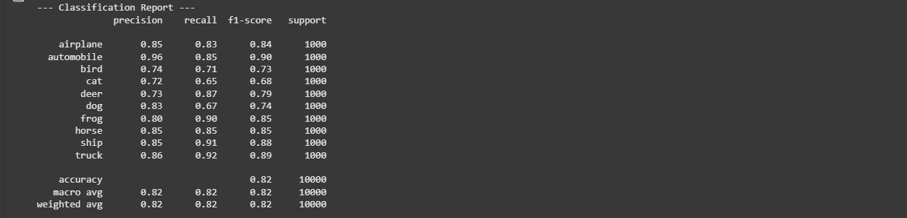
The confusion matrix provides a visual representation of the classification performance, confirming the findings in the classification report. High counts along the diagonal indicate strong accuracy for correctly predicted classes. However, the matrix also reveals common misclassifications, particularly among visually similar categories, such as 'cat' images often being mistaken for 'dog' or 'deer'. This underscores the inherent challenges in distinguishing fine-grained features in complex image datasets like CIFAR-10.
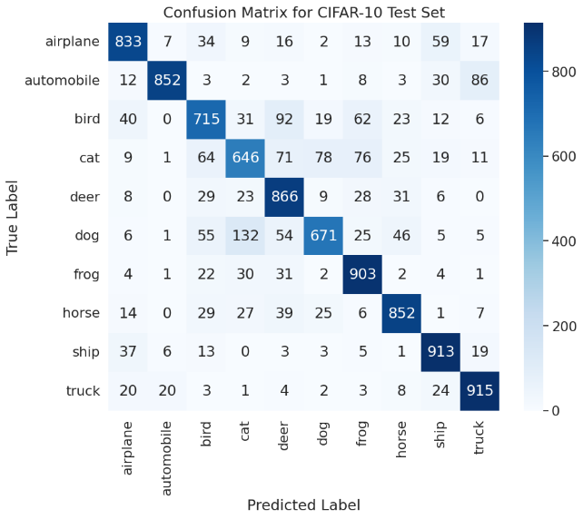
Figure 4 Confusion Matrix for CIFAR-10 Test Set
Prediction Confidence Distribution: An examination of the model's prediction confidence on the test set revealed a strong inclination towards high certainty. A significant majority of predictions (over 6,000 samples) had confidence scores exceeding 0.95, indicating that when the model made a classification, it was largely very confident in its output. Lower confidence scores were associated with the minority of more challenging or ambiguous samples.
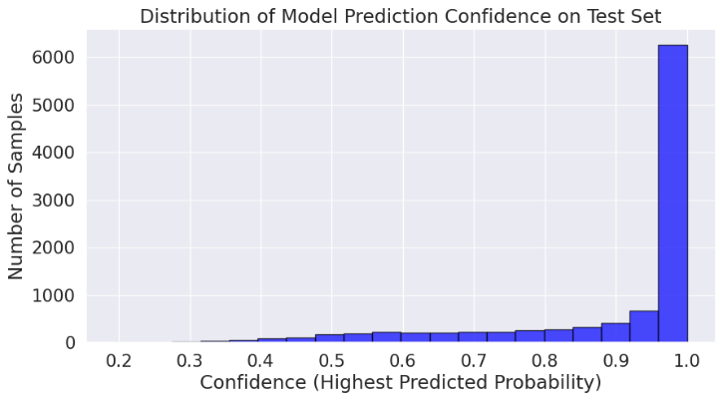
Figure 5 Distribution of model prediction confidence on the test set

5. Application in Robotics (NAO)
The trained CNN model was integrated into a NAO humanoid robot for real-time object recognition. The NAO robot captures images via its camera, which are resized to 32×32 pixels from 640×480 pixels and normalized. These images are then fed into the trained model for classification. Once a CIFAR-10 category is predicted (e.g., airplane, bird, car), the robot can respond with a voice message or a gesture, enabling educational or interactive tasks for children or elderly users for rehabilitation. For example, it will say, “I see an airplane!” and display the written result, demonstrating the integration of deep learning with real-world robotics.

Technical and Ethical Challenges in the Project
- Problem: Early model iterations suffered from severe overfitting, leading to a large gap between training and validation accuracy.
Solution: Implemented Batch Normalization, Dropout layers, L2 regularization, and extensive data augmentation. EarlyStopping and ReduceLROnPlateau callbacks were used to optimize training stability.
- Problem: The NAO robot operates on an outdated software version, Python 2.7, while the trained model was originally developed using Python 3.7, causing compatibility issues.
Solution: To ensure seamless integration, the model was retrained using Python 2.7, aligning it with the NAO robot’s software environment and enabling proper execution.
- Problem: Training deep CNNs on CIFAR-10 is computationally demanding, especially with data augmentation and hyperparameter tuning, leading to long training times.
Solution: GPU acceleration from Colab significantly reduced training time. And use Optimizing batch size ( 64) improved gradient calculations. EarlyStopping prevented unnecessary epochs, while parallelizing hyperparameter tuning

6. Conclusions and Future Work
This study successfully developed a CNN model achieving 85.74% accuracy on the CIFAR-10 dataset, with strong generalization supported by data augmentation, Batch Normalization, Dropout, and L2 regularization. The training process was efficiently managed using learning rate scheduling and early stopping. A prototype was conceptually integrated into a NAO humanoid robot, enabling object recognition and verbal identification to support physiotherapy tasks.
For future work, several recommendations can be considered. First, optimizing the model for real-time inference and hardware efficiency will enhance its applicability to resource-constrained robotic systems. Second, integrating visual recognition with natural language interaction can support multimodal capabilities in human-robot interaction. Additionally, employing transfer learning from larger pre-trained models like ResNet or MobileNet could further boost accuracy and reduce training time. Finally, testing the system in real-world robotic environments and extending it to more complex datasets like CIFAR-100 will support broader deployment and research advancement.

