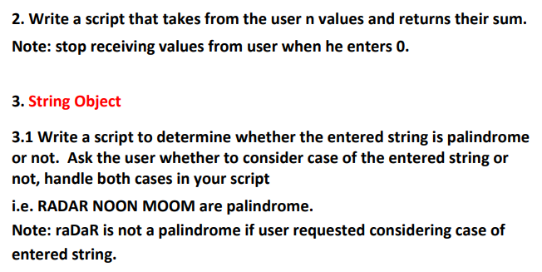

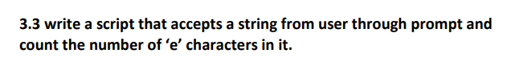

# 4. Write a function to Check if a Number is Odd or Even