|  |
| --- |
| **Homework 1****COSC 6342: Machine Learning****University of Houston****Department of Computer Science****Sent on: Sept. 3, 2019; Due: Sept. 13, 2019 (midnight)** |

|  |
| --- |
| Name(s): |

**Concept Learning**

Machine Learning by Tom Mitchell, Chapter 2.

**Question 2.4. (25 points)**

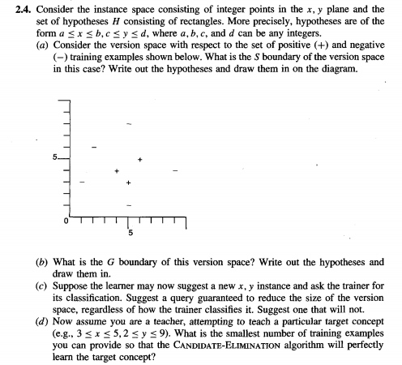

**Question 2.5. (25 points)**

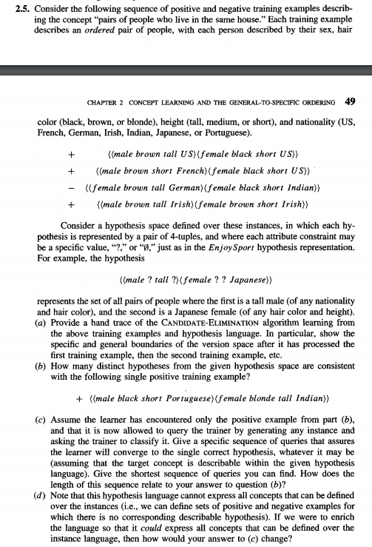

**Probabilistic Learning**

Pattern Classification by Duda, Hart, and Stork Chapter 2.

**Question 12 (a) and (b) only. (25 points)**

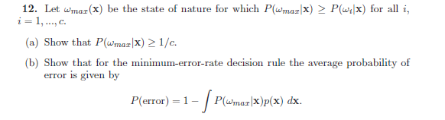

**Question 13. (25 points)**

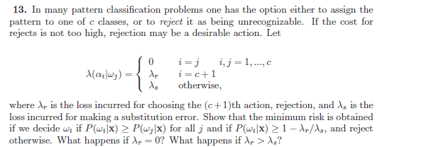

**Total: 100 points**