|  |
| --- |
| **Homework 1** |

|  |
| --- |
| Name(s):   1. S M Salah Uddin Kadir ID: 1800503 2. Rubayat Jinnah |

**Concept Learning**

Machine Learning by Tom Mitchell, Chapter 2.

**Question 2.4. (25 points)**

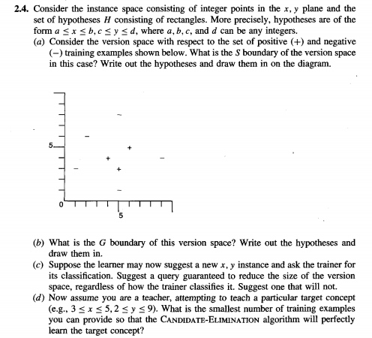

**Solution:**

(a)

**Question 2.5. (25 points)**

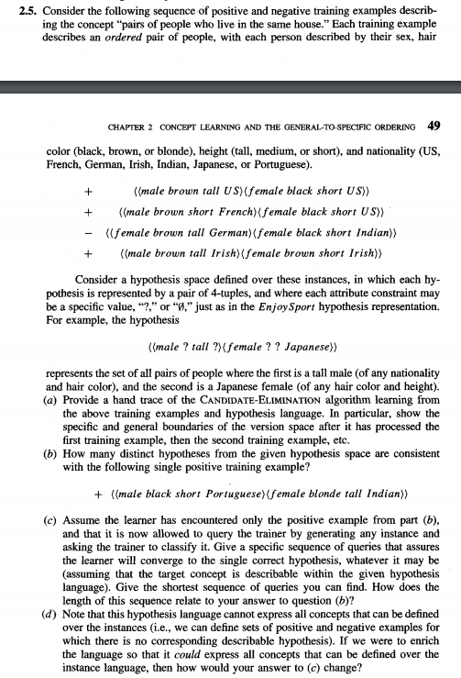

**Solution:**

(a)

We have,

+ ((male brown tall US) (female black short US))

+ ((male brown short French) (female black short US))

- ((female brown tall German) (female black short Indian))

+ ((male brown tall Irish) (female brown short Irish))

Let the hypothesis,

S: ((0, 0, 0, 0) (0, 0, 0, 0))

G: (?, ?, ?, ?) (?, ?, ?, ?))

Adding the first pair which is positive,

S: ((male, brown, tall, US) (female, black, short, US))

G: ((?, ?, ?, ?) (?, ?, ?, ?))

Adding the second pair which is positive,

S: ((male, brown, ?, ?) (female, black, short, US))

G: ((?, ?, ?, ?) (?, ?, ?, ?))

Adding the third pair which is negative,

S: ((male, brown, ?, ?) (female, black, short, US))

G: ((male, ?, ?, ?) (?, ?, ?, ?) ), ( (?, ?, ?, ?) (?, ?, ?, US))

Adding the fourth pair which is positive,

S: ((male, brown, ?, ?) (female, black, short, ?))

G: ((male, ?, ?, ?) (?, ?, ?, ?) )

**(b)**

**Probabilistic Learning**

**Question 12 (a) and (b) only. (25 points)**

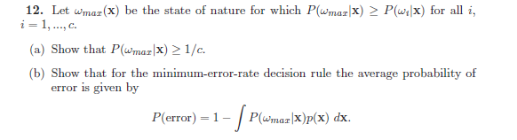

**Solution:**

**(a)**

We know, summation of all probability is 1,

= 1

Now, if the distribution of all probability is equal that,

P(Wi | X) = P(Wj | X)

then we can write,

P(Wi | X) = P(Wj | X) = 1/c.

So the maximum probability will be also 1/c that,

P(Wmax | X) = 1/c

Now, if any probability is less than 1/c then some others probability will be increased to make it 1. In that case, our maximum probability will be,

P(Wmax | X) > 1/c.

So, applying both cases, we can say that

P(Wmax | X) >= 1/c.

**(b)**

We know,

P(error) = ∫ P(error, x) dx = ∫ P(error | x) p(x) dx

and if for every x we minimize the error then P(error | x) is as small as it can be.

We also know that,

Probability of error = 1 – Probability of correct.

So,

P(error) = 1 - ∫ P(Wmax | X) p(x) dx

**Question 13. (25 points)**

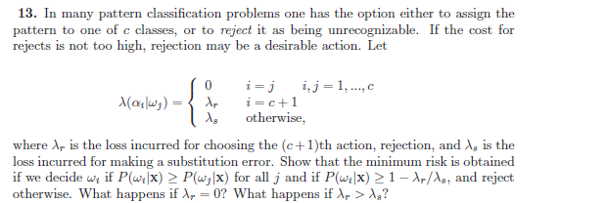

**Solution:**

For i = 1,...,c,

R(αi | x) =

= λ­­­s

= λ­s [1 − P(ωi | x)] .

For i = c + 1,

R(αc+1 | x) = λr

Therefore, the minimum risk is achieved

If, we decide ωi if R(αi | x) ≤ R(αc+1|x),

i.e., P(ωi | x) ≥ 1 – λr / λs , and reject otherwise.

If, λr = 0, we always reject.

If, λr > λs, we will never reject