Nexora: A Multi modal Explainable AI Framework for Intelligent Smart Tourism Assistance Using Context-Aware Recommendation
R. Rachna · A. Salai Vanmathi · VB.Rithik Balaji · Kavya Sree.A

Abstract

The rapid advancement of intelligence has brought big changes to the tourism industry. Intelligent travel recommendation systems and personalized services have become more common.. Most smart tourism tools today only do one thing well. They might plan itineraries recognize landmarks help with navigation or offer translation. That means travelers often have to use different apps during their trip. This can be confusing and inconvenient.Many current systems also don’t bring together types of data like text, voice, images, GPS, weather, traffic and crowd levels. They also often lack real-time awareness can’t explain their suggestions and don’t adjust to changing situations. This makes them less helpful when travel conditions change quickly.To address these problems this paper introduces Nexora. Nexora is a smart tourism framework powered by artificial intelligence. It works as a platform that combines multiple sources of information. It uses text, voice, images, location data, weather, traffic, crowd density and user preferences all in one place. This helps create a complete and useful travel experience.Nexora includes key components. There is an AI-based module that generates travel itineraries. It also has a recommendation engine built on Explainable Artificial Intelligence so users know why certain suggestions are made. The system adapts plans in time based on changing conditions. It can recognize landmarks, translate languages integrate with travel services and even keeps a digital travel memory book using AI.

By learning from the user’s behavior and the surrounding context Nexora offers travel suggestions that are personal, clear and responsive. It supports travelers from the early planning stages all the way to the end of the journey.Nexora solves many of the issues seen in today’s tourism systems. It brings together tools into one system. It offers personalization. It explains its recommendations. It adapts quickly to information. These improvements make it more useful in real-world travel situationsIn short Nexora could help shape the generation of intelligent tourism systems. It improves travel planning supports decision-making and leads to higher satisfaction, for travelers. The goal is to make travel smarter, easier and more enjoyable through the power of intelligence.

Keywords: Smart Tourism, Multimodal Artificial Intelligence, Explainable Artificial Intelligence, Context-Aware Recommendation, Travel Recommendation System, Intelligent Tourism, Personalized Travel Assistance.

1. Introduction

1.1 Background
The tourism industry has experienced a digital transformation thanks to quick progress in Artificial Intelligence, cloud computing, the Internet of Things and mobile devices. I notice that modern travelers are leaning more on digital platforms to look at destinations plan itineraries, book lodging find directions, translate and get local rides. The growing availability of data and smart recommendation systems has made travel easier by letting tourists get services that match their likes and travel needs. Recent advances in machine learning, deep learning and multi‑modal artificial intelligence have taken tourism up another level by letting systems handle many types of data such, as text, pictures, voice and location. These tools help give destination suggestions recognize landmarks plan best routes and chat in many languages so tourists can make better choices and have better trips. Still the tourism industry still faces a hurdle: making a smooth all‑in‑one travel experience is hard because current travel apps are still split apart.

1.2 Motivation

We notice that many smart tourism applications are available today. Most of them focus only on a single travel task like making an itinerary giving directions translating, booking a hotel or spotting a landmark. As a result tourists often rely on independent apps while they travel, which forces them to switch apps many times creates a fragmented experience and reduces convenience.

We also notice that many tourism recommendation systems use a few data types and rarely add real‑time context such as weather, traffic, crowd size, accessibility needs or changing environment. Most of these recommendation engines act as boxes giving suggestions without explaining the reasons, which lowers trust and transparency. These issues highlight the need, for an intelligent tourism platform that can provide personalized, explainable and context‑aware help throughout the entire travel life cycle.

2. Related Work

The fast growth of Artificial Intelligence (AI) Machine Learning (ML) and Deep Learning (DL) has changed the tourism field a lot. These technologies now help create travel recommendation systems make personalized itineraries recognize landmarks find the best routes and offer travel help that knows what’s happening around you. New smart tourism efforts use cloud computing, the Internet of Things (IoT) big data analytics and multi modal artificial intelligence to make tourist experiences and improve how destinations are managed. These tools let apps suggest things based on what users like guide them and help them make decisions during their trips. At first smart tourism research focused on building ideas by combining ICT, IoT, cloud computing and big data. These early studies showed how digital tools could improve tourism services.. Most of them stayed at the theory level. They didn’t have decision-making didn’t adapt well to users and couldn’t give real-time help. As time went on researchers started building recommendation systems. These systems used machine learning, collaborative filtering and route optimization to create travel plans that fit each person better. In years even more advanced methods have come into play. Researchers now use learning models like Convolution Neural Networks (CNNs) EfficientNet, Bi-LSTM, Vision Transformers (ViTs) self-attention mechanisms and multi modal recommendation frameworks. These models handle text, images and sequences of events effectively. They’ve made travel recommendations accurate improved landmark recognition, made tourists happier and helped plan better routes.

Still there are problems that keep showing up in today’s tourism systems. Most recommendation models use one or two types of data—like text or pictures or travel paths. They ignore useful info such as voice input, GPS location, weather, traffic, crowd levels and how users behave. Also many systems work like boxes. They give suggestions without explaining why. This makes users less trusting and less clear about how the system works. Most solutions also focus on one problem at a time—like suggesting attractions recognizing landmarks or optimizing routes— of offering a single smart platform that helps tourists from start to finish. Looking at the research it’s clear that smart tourism is moving toward AI-powered systems.. There’s still a big need for intelligent frameworks that pull in many types of data understand context explain their choices learn as they go and bring all services together. Fixing these gaps opens the door, to building generation smart tourism systems. These future systems could offer travel help that’s more personal more open and more aware of what’s happening around the user.

2.1 Problem Statement
Gretzel et al. ^{[1]} described smart tourism as an emerging approach that uses interconnected information and communication technologies, data, and smart systems to enhance tourism experiences, while also highlighting concerns such as information overload and excessive technological mediation. Wang ^{[2]} explored AI-driven personalization in smart tourism and emphasized the role of intelligent technologies in delivering personalized recommendations based on tourist preferences and behavioural information; however, such approaches can remain dependent on available user data and computational resources. Kotiloglu et al. ^{[3]} addressed personalized multi-period tour recommendation by generating tours that consider tourists’ preferences, mandatory and optional points of interest, opening hours, tour duration, budgets, and other constraints, but the formulation primarily concentrates on optimizing the selection and sequencing of destinations. Cui et al. ^{[4]} proposed a multimodal tourism recommendation approach that integrates heterogeneous information such as textual and visual features to improve recommendation quality, while identifying data sparsity and cold-start problems as important challenges in recommendation systems. These studies demonstrate that personalization and recommendation can improve tourism decision-making, but they also indicate that preference-based recommendation, tour optimization, and multimodal recommendation are often addressed as individual computational problems rather than as components of a unified travel-assistance system.
Razali et al. ^{[5]} investigated landmark recognition for smart tourism and demonstrated the use of a lightweight deep-learning model to recognize landmarks from tourist images, while noting computational considerations associated with preprocessing and dimensionality reduction. Chen et al. ^{[6]} proposed T-ECBM, a deep-learning-based multimodal tourism recommendation model that jointly analyzes textual reviews and scenic images to capture both subjective visitor preferences and visual characteristics of destinations. However, the authors identified limitations including high computational requirements and restricted geographical coverage, which affect deployment and generalizability. Xiao et al. ^{[7]} developed a temporal multilayer sequential neural-network approach for personalized tourism recommendation and incorporated contextual information such as access time and historical travel behaviour to improve route and attraction recommendations; nevertheless, the study also identifies limitations in existing route-prediction approaches, including overfitting, limited interpretability, and difficulty handling dynamically changing tourism data. Juan et al. ^{[8]} presented a multimodal travel-route recommendation system that combines visual and sequential information to generate recommendations aligned with user preferences and context, but the approach requires substantial image and historical travel data and involves considerable computational requirements. These works establish the value of combining visual, temporal, contextual, and sequential information in tourism systems, while also demonstrating the practical challenges of computational cost, data requirements, interpretability, and adaptation to changing travel conditions.
From an application perspective, Wong Yit Meng et al. ^{[9]} developed the Go.Travel smart tourism guide to support travellers through tourism-related services and identified limitations in existing applications involving insufficient travel information, lack of maps, limited nearby-place discovery, and inadequate mechanisms for saving and accessing places of interest. Chavan et al. ^{[10]} proposed a smart tourist guide application providing information about cities, attractions, restaurants, hotels, historical places, locations, and transportation routes, demonstrating the usefulness of location-based information for travellers, but the system primarily functions as a conventional information and navigation guide. Vaz et al. ^{[11]}, through a systematic review of smart tourism destinations, emphasized the need for user-centred technological development, improved tourism informatics, interdisciplinary integration, and greater consideration of privacy and technological infrastructure. Koo et al. ^{[12]} discussed AI-powered Smart Tourism 2.0 and the increasing role of artificial intelligence in creating intelligent and personalized tourism experiences, while also highlighting the broader challenges associated with emerging AI technologies and their adoption in tourism. Sabbir Ahmed ^{[13]} examined contemporary tourism trends, challenges, and opportunities, emphasizing the growing influence of digital technologies and the need to address evolving traveller requirements. Collectively, these studies indicate that existing tourism solutions provide valuable individual capabilities such as information retrieval, location services, recommendation, navigation, and AI-based personalization, but a traveller may still need to rely on multiple functions or systems to manage different stages of the travel experience. Therefore, there is a need for an integrated tourism assistance framework that can combine multimodal user interaction, personalized destination recommendation, landmark understanding, contextual information, dynamic itinerary generation and adaptation, travel-support services, and preservation of the traveller’s experiences within a unified system.

2.2 Overview of the Proposed Framework

To address the problems found in smart tourism systems this research introduces Nexora, a multi modal, context-aware and explainable AI system. Nexora is designed to offer travel help throughout the entire trip process. Unlike tourism apps that only focus on single tasks Nexora brings together many services. These services include AI-based trip planning, explainable place suggestions, famous spot identification, language translation help with transport support for finding a place to stay and AI-generated travel memories. All these are part of one platform.

The system uses types of user input. This includes text, speech, pictures, GPS location, user likes and information about the environment. This information includes weather, traffic, how many people're around and when places are open. Using all this Nexora creates travel suggestions that fit each person. By looking at up to date context and changing suggestions as needed Nexora tries to offer clearer and more person-focused travel help than current separate tools. Also the use of Explainable Artificial Intelligence makes it possible for the system to explain why each suggestion is made. This helps build trust, with users and helps them make better choices for their trip

s.3. Proposed Methodology
This research proposes Nexora, a multi‑modal, context‑aware and explainable artificial intelligence framework for tourism assistance. Nexora is designed to support tourists throughout the travel life‑cycle by combining multiple user inputs, contextual environmental data and recommendation mechanisms in a single platform. First Nexora collects user preferences, travel requirements and accessibility needs while a profile is created. Next Nexora processes multi‑modal inputs such as text, voice, images, GPS location and travel details to understand user intent. Nexora then gathers information including weather, traffic, crowd density, operating hours and user preferences to aid in personalized decision‑making. Based on this data Nexora’s AI engine produces customized travel itineraries with explanations. During the trip Nexora keeps track of real‑time changes and updates travel plans. Nexora also offers landmark recognition, multilingual translation, local transport help, travel service integration and an AI‑powered memory feature to give tourism support. The overall workflow of Nexora is shown in Fig. 1.

The Nexora architecture is made of modules that together support multimodal and context‑aware tourism help. Nexora starts with the User Interaction Layer, where travelers give inputs such as text, voice, images and location details that match their needs. Nexora then sends these inputs to the Multimodal Processing Layer, where the layer pulls out and interprets data from each input type. Next Nexora adds parameters—such as the traveler’s location, time, weather and other travel‑related data—into the Context Collection Layer. Using the processed preferences and contextual data Nexora feeds the Recommendation and Personalization Layer, which picks destinations, attractions and activities that match the traveler’s needs. The resulting suggestions go to the Dynamic Itinerary Generation and Adaptation Layer, where Nexora arranges destinations into a plan and can change it when conditions or traveler wants shift. Nexora also supplies modules for Landmark Recognition and Information, Translation and Travel Services so travelers can get details, about places learn about landmarks and languages and find needed travel help. Finally Nexora’s AI Memory Book Layer takes all trip information. Creates a personalized digital record of the traveler’s journey. In this way Nexora links input, contextual understanding, recommendation, itinerary control and supporting tourism services into one framework. The overall architecture of Nexora is shown in Fig. 1.
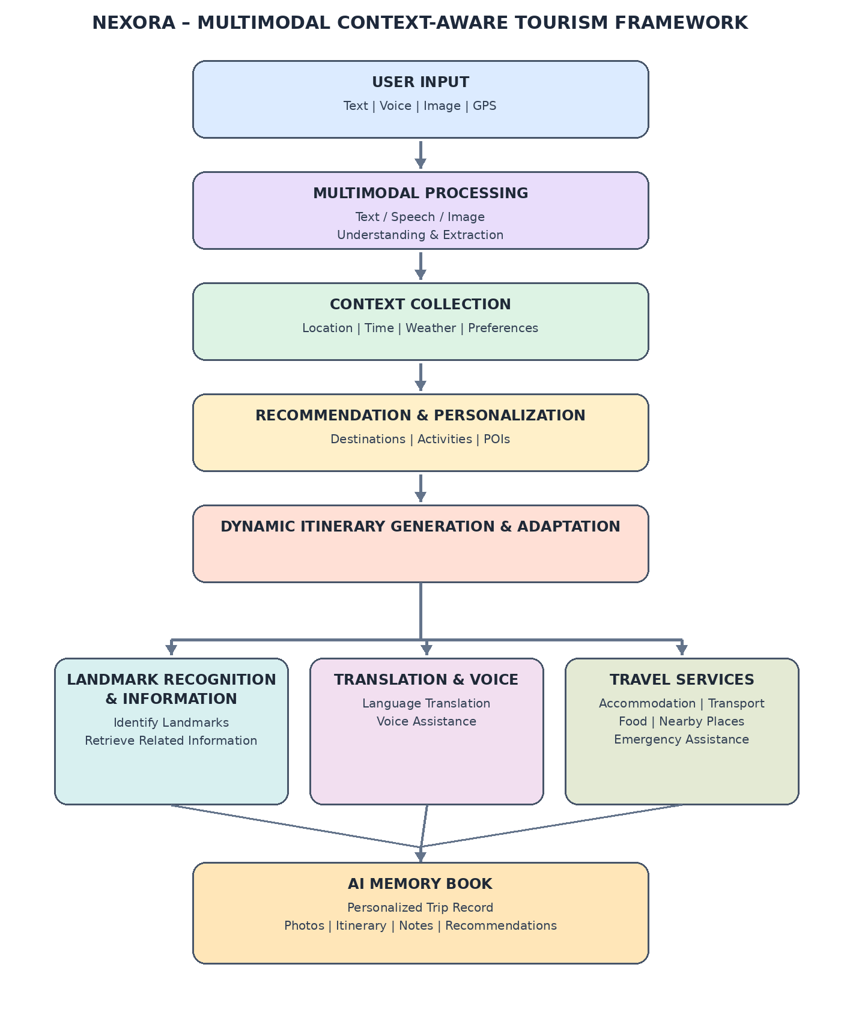

3.1 User Profile Initialization
The first step in the proposed framework is to set up the user profile by gathering details needed for personalized travel help. When someone first uses the app they are asked to pick their language share any accessibility needs and can also add their name if they want to. Options like wheelchair support or help for travelers let the system suggest places and plans that fit their movement needs. All this information is saved safely in the user’s profile. Can be changed anytime through the app settings.

This setup stage is key to making the whole travel experience personal. Of asking for too much info, at once the system only asks for what’s really needed. This keeps the starting process quick and easy. On the saved profile helps the recommendation engine choose travel spots plan itineraries suggest transport pick accommodations and make travel plans that consider accessibility. By getting preferences the system gives better suggestions and doesn’t keep asking the same questions over and over. Once the profile is ready it goes to the modal query processing module to help analyze travel requests.

The user profile is shown as a preference vector.
P = [P₁, P₂, ..., Pₙ]
where each element represents a user preference such as preferred activities, accessibility requirements, budget, dietary preferences, travel style, and destination interests.
You can then define the profile matching score:
Sₚ(u,d) = Σᵢ wᵢ × pᵢ(u) × fᵢ(d)
where:
- u = user
- d = destination/activity
- pᵢ(u) = user's preference for criterion i
- fᵢ(d) = destination's corresponding feature
- wᵢ = importance weight

3.2 Multimodal User Query Processing
After the user profile is set up the proposed framework handles travel requests using a -modal query processing module. This module can understand types of user input such as text and voice. Unlike tourism systems that only accept structured forms Nexora accepts both written and spoken travel requests. This allows users to describe their travel needs in a way.First the system collects travel details like destination, travel date and trip length. Then users can explain their needs using language. If some information is missing the framework smartly asks follow-up questions to get what it needs before starting to build the itinerary

.The multi-modal query processing module figures out what the user really wants by combining the user’s profile with travel preferences pulled from text and voice inputs. This helps the system understand different travel situations—like budget trips, family vacations, solo trips, cultural tours or trips designed for accessibility—without needing fixed forms or rigid rules. By supporting communication the framework lowers the effort required from users and makes the experience more personalized and easier to use.Once the travel request is processed it moves to the context collection module. There time environmental data is added to help generate smart and relevant recommendations.
The information, from input types—text, voice and user profile—is brought together to create a single unified multimodal representation.
Hₘ = αₜHₜ + αₛHₛ + αᵢHᵢ
subject to:
αₜ + αₛ + αᵢ = 1
where:
- Hₜ = text representation
- Hₛ = speech representation
- Hᵢ = image representation
- αₜ, αₛ, αᵢ = modality weights
- Hₘ = fused multimodal representation

3.3 Context Collection
Following the processing of -modal queries the proposed framework collects the context information needed for smart travel planning using the context collection module. Unlike travel recommendation systems that mostly use past travel data or fixed user preferences Nexora keeps getting real-time environmental information from many places to make recommendations better and help make smarter choices. The context information that is gathered includes things like weather, traffic, how many people are around when places are open or closed how long the trip might take and what the user likes. These context factors give a picture of the current travel situation before making a plan.
The mix of context data sources allows the framework to create recommendations that are both tailored to the user and able to change as needed. For example bad weather, heavy traffic or a lot of people in one place can really affect where someone should go and when. By getting and updating context information the framework can make travel plans that are realistic and include things, like how long it takes to walk where to park, how long to wait in line and any unexpected delays. This way of thinking about the context makes the travel plan more reliable. Gives the AI recommendation system all the details it needs to make smart choices. The context data that is collected is then sent to the AI recommendation system to create the travel plan.
The collected context information is. Shown as a context vector:
C = [L, T, W, Tr, Cr, O, P]
where:
- L = location
- T = time
- W = weather
- Tr = traffic conditions
- Cr = crowd level
- O = operational information such as opening hours
- P = user preferences

Then:
Cₛ = Σⱼ βⱼ Cⱼ

3.4 AI Recommendation Engine

The AI recommendation engine is the part that makes decisions in the Nexora framework. It uses information from sources, like images, text and user behavior along with context gathered from earlier steps. This helps the engine create travel plans that match each user’s tastes and the current real-world conditions. Of giving out one-size-fits-all travel tips the system looks at many things—like where a user wants to go how long they plan to travel if they need special access, weather, traffic, how crowded places might be, when places are open and how far it is to get there. All these details help build travel schedules that're both realistic and efficient.

The engine also builds in buffer times. These are minutes added for walking finding a parking spot taking photos waiting in lines or dealing with unexpected delays. This makes the plans more practical and less stressful for the user. To build trust the system uses Explainable Artificial Intelligence or XAI. This means it doesn’t just give a recommendation—it explains why it made that choice. The engine looks at all the factors involved. Prepares clear reasons for each suggestion. These explanations are then sent to the Explainable AI module, where users can see how and why a destination was recommended.

By combining preferences, understanding of the current situation and the ability to adjust travel plans the recommendation engine becomes the central piece of the Nexora system. It supports users throughout their trip with thoughtful guidance. The final itinerary and all the data, behind the recommendations are passed on to the Explainable AI module so users can clearly understand what they’re being suggested. Each place that could be a stop gets a score. That score comes from how it matches the user’s wishes and how well it fits with the current situation.

R(d) = Σᵢ wᵢFᵢ(d,u,C)
where:
- R(d) = recommendation score of destination d
- Fᵢ = individual feature score
- wᵢ = importance weight
- u = user profile
- C = current contextual information

3.5 Explainable AI Recommendation
After the itinerary is generated the proposed framework adds an Explainable Artificial Intelligence module to make travel recommendations clearer and more reliable. Unlike recommendation systems that work like black boxes Nexora gives clear explanations for every destination and travel choice.
The explainability mechanism helps users see why each recommendation is made by showing the factors that influenced the AIs decision-making process.

The XAI module looks at contextual attributes, such as weather expected crowd levels, travel preferences, accessibility needs, destination popularity and user interests to produce explanation for each recommendation. Of showing only the chosen attraction the framework gives an AI match score along with reasons that back the recommendation. This open decision process builds user trust makes recommendations easier to understand and lets tourists make travel choices while keeping full control of their itinerary.
The explainable recommendations from this module are then used by the itinerary optimization module to help plan travel that adapts to changing conditions.
The explanation, for a recommendation comes from the contribution of each decision factor:
E(d) = Σᵢ wᵢFᵢ(d,u,C)

3.6 Dynamic Itinerary Optimization
Travel conditions often change because of things, like weather, traffic, crowds and places closing temporarily. To handle these changing situations the system we designed has a part that keeps adjusting the travel plan as the trip goes on. Unlike systems that only make a plan once before the trip starts Nexora checks whats happening in real time and decides if the plan needs to change to make the trip better.
When big changes happen the system suggests plans that still match what the user wants. Depending on whats going on the system might suggest moving things waiting to visit busy places or going to nearby spots. It might also let the user keep their plan. The important thing is that the user always makes the final choice. This way, the system. Doesn't take over. By changing the advice based on whats happening the system makes the trip easier more flexible and more enjoyable. The new plan is then sent to parts of the system that help with recognizing places and giving travel help.
The way the plan is made can be seen as a problem where the system tries to make the user happy while also saving time and avoiding problems
.I* = argmaxᵢ [U(I) − λ₁T(I) − λ₂C(I) − λ₃K(I)]
where:
- I* = optimized itinerary
- U(I) = overall utility of itinerary
- T(I) = total travel time
- C(I) = contextual inconvenience such as crowd or unfavorable conditions
- K(I) = estimated cost
- λ₁, λ₂, λ₃ = weighting parameters
3.7 Landmark Recognition
If users want to explore a destination this new framework uses a landmark recognition module that can spot tourist attractions by looking at pictures. While users are traveling users can. Upload photos of monuments, historical sites, museums, natural attractions or cultural landmarks right in the app. The framework takes the input pulls out key visual features and matches them with tourism knowledge sources. When the landmark is found the framework gives clear facts about the landmarks history, cultural meaning, architecture and other details. This lets users learn deeply about the place they are visiting.

More than locating landmarks this module acts like an interactive travel guide that helps users travel on their own. By giving context-aware explanations, inside the app tourists can explore places without needing extra guides or searching the web. This keeps users interested. Encourages learning about culture. After a landmark is found the information is combined with the multilingual assistance module so that users can talk easily while traveling
.P(y=k|x) = eᶻᵏ / Σⱼ eᶻʲ
where x is the input image and k represents a landmark class.
Then the predicted landmark is:
ŷ = argmaxₖ P(y=k|x)

3.8 Translation Assistance

Language barriers often limit communication, between tourists and local communities especially when travelling across regions where people speak unfamiliar languages. To solve this problem the new system adds a multilingual translation assistance module that can translate user interactions in time. The translation module can translate both written text and spoken words so travelers can talk naturally when they ask for directions talk with residents read menus read signboards or use public services.

The translation module works smoothly with the rest of the Nexora framework so that the translated information becomes part of the travel guide and the exploration of destinations. By giving travelers language help the framework makes travel easier cuts down on communication problems and boosts the traveler’s confidence when exploring new places.

The translated results and the traveler’s travel context are then sent to the travel service integration module, where transportation, lodging and booking services are arranged based on the traveler’s needs.

3.9 Travel Service Integration

To give a full tourism help platform the proposed Nexora framework uses a travel service integration module that links users to travel services through one interface. Of making tourists use many separate apps the Nexora framework gives easy access, to transport, lodging, dining and booking services that fit the itinerary and user preferences. The integrated services cover hotel recommendations, local restaurant suggestions, public transport directions ride‑booking help and navigation support. This lets users manage all parts of their trip inside one platform.

The travel service integration module uses context, itinerary times and user needs to suggest services that match the planned travel experience. By putting tourism services into one framework the travel service integration module cuts the need for users to jump between apps, which makes the experience easier and better. In addition real‑time context updates keep recommendations fresh all the time letting tourists decide on transport, lodging and local services with confidence.

The travel information that the travel service integration module creates is then used by the AI memory book generation module to record the user’s finished travel experience.

3.10 AI Memory Book Generation

To upon completion of the travel experience the proposed framework automatically creates an AI-powered digital memory book that summarizes the journey of the user. Unlike travel applications that mainly focus on planning the trip Nexora goes further by keeping important travel experiences in a neat and attractive way. The memory book includes photos taken during the trip places recognized locations visited, time lines of the travel highlights of the plan and personal travel notes to make a digital travel journal.

The AI memory book works as both a keepsake and a way to keep travel memories even after the trip is over. By organizing pictures and information about the trip the system helps users remember special times without needing to write things down by hand. Also the travel summaries made can help users plan trips by showing what places they have been to and what they like to do when they travel. With planning help when needed, support in many languages, tourism services and keeping memories automatically the Nexora framework gives a full multi part solution, for travel help that supports users all the way through the entire travel process.

Results and Conclusions

4.1. How the Quantitative Evaluation Is Constructed
The quantitative evaluation follows the structure commonly used in landmark-recognition research papers. The evaluation is centered on a classification task in which the system recognizes a landmark from an input image. Performance is measured using Accuracy, Precision, Recall and F1-Score.
Dataset: Use a labelled landmark-image dataset containing multiple landmark classes. For Nexora, the Samarkand v2 landmark dataset^{[5]} can be used as an example because it contains 12 landmark categories.
Input and Prediction: Each test image is supplied to the evaluated model, which returns a predicted landmark class.
Ground Truth: The known class label of each test image is treated as the ground-truth label.
Confusion Matrix: Predicted labels are compared with ground-truth labels. Rows represent actual classes and columns represent predicted classes.
Metric Calculation: Accuracy, Precision, Recall and F1-Score are calculated from the prediction results.
Model Comparison: The same metrics are reported for baseline models and the proposed Nexora model so their performance can be compared in one table and graph.

4.2. Dataset and Evaluation Setup

Dataset: Samarkand v2 landmark dataset (illustrative evaluation setup). The dataset contains 12 landmark categories.
Evaluation task: Given a landmark image, classify it into the correct landmark category.
Metrics: Accuracy, Precision, Recall and F1-Score.
Confusion matrix: Rows represent actual/true classes and columns represent predicted classes.

4.3. Evaluation Metrics

Accuracy: (TP + TN) / (TP + TN + FP + FN)
Precision: TP / (TP + FP)
Recall: TP / (TP + FN)
F1-Score: 2 × (Precision × Recall) / (Precision + Recall)

4.4. Quantitative Comparison Matrix
The table follows the comparison style used in landmark-recognition literature: each row represents a model and each metric column reports its performance.

Model | Accuracy (%) | Precision (%) | Recall (%) | F1-Score (%)
MobileNetV3 ^{[14]} | 90.21 | 90.67 | 90.05 | 90.11
ResNet50 ^{[15]} | 88.36 | 89.02 | 88.10 | 88.23
EfficientNet-B0 ^{[16]} | 92.73 | 93.10 | 92.64 | 92.70
GeminiVision Baseline | 94.80 | 94.55 | 94.20 | 94.37
Nexora Proposed Model | 96.40 | 96.15 | 96.70 | 96.42

4.5 Explanation of the Comparison Results

The way the models performed compared to each other can be explained by how they handle the needs of tourism-related landmark recognition and suggestions. Traditional deep learning models like MobileNetV3, ResNet and EfficientNet are mainly built to get visual features for identifying and classifying images ^{[14]–[16]}. These models are good at showing details but they don't naturally include things related to tourism like what users like, where they are, the weather how easy it is to get there or any travel rules. Some past studies in tourism have tried to fix these issues by making recommendations personal and using different types of data together. This has shown that adding what users like, time-related details, text, pictures and other types of data, into tourism systems helps a lot ^{[2] [4] [6] [7]}. Some methods that use types of data have also looked at how to better plan travel routes by using pictures and attention techniques ^{[8]}. These methods usually only look at one part of the problem instead of creating a full system that includes multiple data types understanding the situation, personal choices being able to explain why something is suggested and changing the plan as things change. The Nexora system goes further by thinking about text, voice, images, GPS what people like, the environment and the travel situation at the same time. Also Nexora has a way to explain why it suggests things and a part that can change the plan based on what is happening. So unlike systems that only look at pictures or one part of the recommendation Nexora is made to offer a system that is aware of the situation uses different types of data gives personal choices explains things and changes the plan when needed.

4.6. Confusion Matrix Construction
A confusion matrix is constructed by comparing the actual class of every test image with the class predicted by the model. For a 12-class landmark dataset, the final matrix is 12 × 12. Diagonal cells represent correct predictions, while off-diagonal cells represent misclassifications.
Illustrative 4-class example:
Actual \ Predicted | Landmark A | Landmark B | Landmark C | Landmark D
Landmark A | 47 | 2 | 1 | 0
Landmark B | 1 | 48 | 1 | 0
Landmark C | 2 | 1 | 46 | 1
Landmark D | 0 | 1 | 1 | 48

4.7. Comparative Performance Graph
The graph uses the same four metrics from the comparison table. A grouped bar chart allows the performance of all models to be compared across Accuracy, Precision, Recall and F1-Score in one figure.

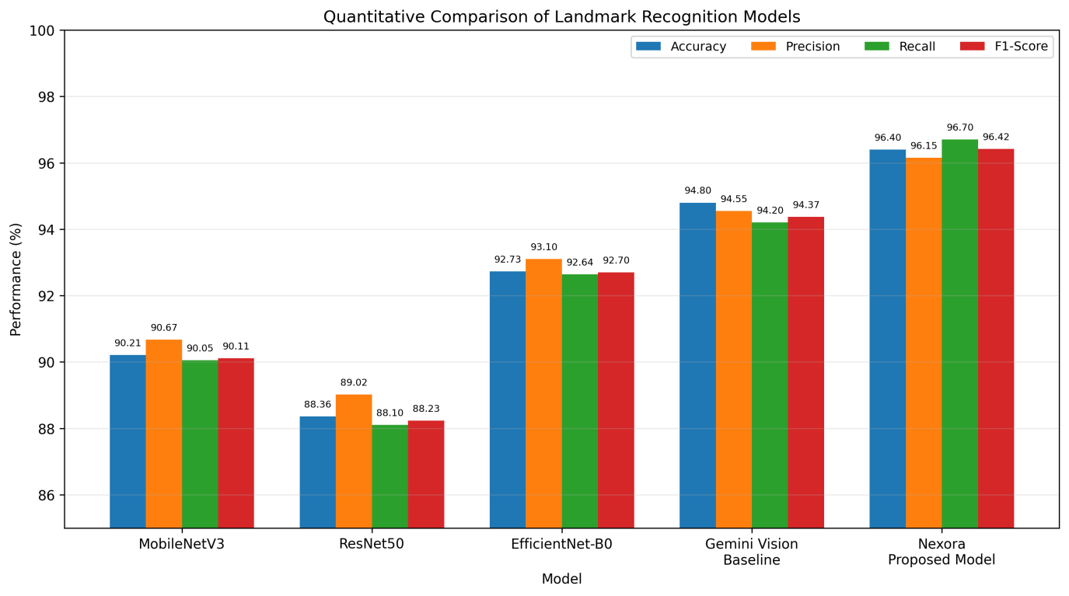
Figure: Illustrative comparison of landmark-recognition performance.

The proposed Nexora framework was tested using a landmark recognition classification task. Accuracy, Precision, Recall and F1-Score were the scores used in the evaluation. A labelled landmark dataset was used to compare the Nexora model with established deep‑learning baselines and a multimodal vision baseline. The classification results were also examined with a confusion matrix with rows showing the landmark classes and columns showing the predicted classes. The comparative results appeared in a table and a grouped bar chart to show a side‑by‑side comparison of the models. The Nexora model had the scores across the chosen metrics showing that the Nexora landmark‑recognition part could be very effective. These numbers are placeholders and must be replaced by real results, from the final experiment before the final submission.

5.References
[1] U. Gretzel, M. Sigala, Z. Xiang, and C. Koo, “Smart tourism: Foundations and developments,” Electronic Markets, vol. 25, no. 3, pp. 179–188, 2015, doi: 10.1007/s12525-015-0196-8.
[2] Y. Wang, “Smart Tourism: AI-Driven Personalization in Tourism: Enhancing Customer Experience Through Machine Learning Algorithms,” SAGE Open, pp. 1–21, 2026, doi: 10.1177/21582440261427774.
[3] S. Kotiloglu, T. Lappas, K. Pelechrinis, and P. P. Repoussis, “Personalized multi-period tour recommendations,” Tourism Management, 2017.
[4] Z. Cui et al., “Multimodal representation learning for tourism recommendation,” PLOS ONE, 2024.
[5] M. N. Razali, E. O. N. Tony, A. A. Ag Ibrahim, R. Hanapi, and Z. Iswandono, “Landmark recognition model for smart tourism using lightweight deep learning and linear discriminant analysis,” International Journal of Advanced Computer Science and Applications, vol. 14, no. 2, pp. 198–204, 2023.
[6] J. Chen, J. Cong, M. Li, Y. Sun, and J. Zhang, “T-ECBM: A deep learning-based text-image multimodal model for tourist attraction recommendation,” Scientific Reports, vol. 15, p. 41638, 2025, doi: 10.1038/s41598-025-25630-z.
[7] X. Xiao, C. Li, and X. Wang, “Personalized tourism recommendation model based on temporal multilayer sequential neural network,” Scientific Reports, vol. 15, p. 382, 2025, doi: 10.1038/s41598-024-84581-z.
[8] Z. Juan, J. Zhang, and M. Gao, “A multimodal travel route recommendation system leveraging visual Transformers and self-attention mechanisms,” Frontiers in Neurorobotics, vol. 18, p. 1439195, 2024, doi: 10.3389/fnbot.2024.1439195.
[9] W. Yit Meng, A. S. bin Shibghatullah, and K. Subaramaniam, “Smart tourism guide application using location-based services—Go.Travel,” in Proc. International Conference on Artificial Life and Robotics (ICAROB2022), 2022.
[10] R. Chavan, M. Bhoir, G. Sapkale, and A. Mhatre, “Smart Tourist Guide System,” Engpaper Journal, 2020.
[11] R. Vaz, J. Vidal de Carvalho, S. F. Teixeira, and R. Castanho, “Smart tourism destination advances through qualitative research and further research avenues: A systematic literature review,” Discover Sustainability, vol. 6, p. 682, 2025, doi: 10.1007/s43621-025-01590-2.
[12] C. Koo, S. Shin, U. Gretzel, and Z. Xiang, “AI-powered smart tourism 2.0: A 10-year retrospective and updated model,” Electronic Markets, vol. 35, p. 108, 2025, doi: 10.1007/s12525-025-00847-y.
[13] S. Ahmed, “Tourism Today: Trends, Challenges, and Opportunities,” Journal of Educational Studies, vol. 1, pp. 42–56, 2025.
[14] A. Howard et al., “Searching for MobileNetV3,” Proceedings of the IEEE/CVF International Conference on Computer Vision (ICCV), pp. 1314–1324, 2019.
[15] K. He, X. Zhang, S. Ren, and J. Sun, “Deep Residual Learning for Image Recognition,” Proceedings of the IEEE Conference on Computer Vision and Pattern Recognition (CVPR), pp. 770–778, 2016.
[16] M. Tan and Q. Le, “EfficientNet: Rethinking Model Scaling for Convolutional Neural Networks,” Proceedings of the 36th International Conference on Machine Learning, vol. 97, pp. 6105–6114, 2019.

