Project Report On
Olympic Data Analysis
Submitted By
P Gnana Sai (R170458),
Prawal Singh Baghel (R170063),
P Salahuddin (R170059).

Under The Guidance of
Ms. E. Sushmitha
Assistant Professor
Department of Computer Science Engineering



Rajiv Gandhi University Of Knowledge Technologies(RGUKT)
R.K Valley , Kadapa , Andhra Pradesh
1
Rajiv Gandhi University Of Knowledge Technologies(RGUKT)
R.K Valley , Kadapa , Andhra Pradesh
CERTIFICATE

This is to certify that the project work titled ”Olympic Data Analysis” is a bonafied project work submitted by P Gnana Sai, Prawal Singh , P Salahuddin in the department of COMPUTER SCIENCE AND ENGINEERING in partial fulfillment of requirements for the award of degree of Bachelor of Technology in Computer science and engineering for the year 2020-2021 carried out the work under the supervision.

GUIDE HEAD OF THE DEPARTMENT
E. Sushmitha P. Harindha

2

ACKNOWLEDGEMENT

The satisfaction that accompanies the successful completion of any task would be incomplete without the mention of the people who made it possible and whose constant guidance and encouragement crown all the efforts success.
I am extremely grateful to our respected Director, Prof. K. SANDHYA RANI for fostering an excellent academic climate in our institution. I also express my sincere gratitude to our respected Head of the Department Mr. P. Harinadha for his encouragement, overall guidance in viewing this project a good asset and effort in bringing out this project.
I would like to convey thanks to our guide at college Ms. E. Sushmitha for his guidance, encouragement, co-operation and kindness during the entire duration of the course and academics.

My sincere thanks to all the members who helped me directly and indirectly in the completion of project work . I express my profound gratitude to all our friends and family members for their encouragement.

3
INDEX

S.No | INDEX | PAGE NUMBER
1 | Abstract
2 | Introduction
3 | Purpose
4 | Software Requirements
5 | Evaluation
6 | Sample code
7 | Future Scope
8 | Conclusion

4
Abstract

Data Analysis is the process of working with data to glean useful information
which can be used to make informed decisions. Data Analysis is nothing but
analysing the data to get useful insights which can answer our queries.
Olympic Data Analysis is also a project that uses latest data analysis
techniques to produce insights on Olympics through dashboards and graphs.
Any information or statistics you want to know about Olympics that are
being conducted over past few decades can be given by this analysis of the
Olympic data.

5

Introduction

Olympics are considered to be world's foremost sports competition has more than 200
nations participating across the summer and winter games alternating by occurring every four
years but two years apart. so to understand the trends and statistics of the Olympics we have
done a extensive data analysis on the Olympic data. Through which many insights can be
concluded on Athletes and nations participating in the Olympics. We considered different
features in the data and provided easy-to-understand dashboards which gives us useful
insights into the nations and players participating.

6

Purpose

It is proposed to understand the worlds best sport competition in a better way. To understand the
trends in the Olympics and its events over the years. Throughout this project , we will explore the
Olympics data and try to understand different countries and their players participation. To
understand a country's overall performance in the Olympics over the years. And also to
understand athlete-wise analysis of the Olympics participation. To understand the Athletes and
their features relationship with respect to the medals won over the years in Olympics. At last to
understand the overall analysis of the Olympics conducted over the last few decades in the
comparison of Medals, countries , Athletes and their features. All of these results of the analysis
will be visualised in the form of tables ,dashboards and graphs.

7

Requirements
Hardware Configuration
Client Side:
Ram | 512MB
Hard disk | 10GB
Processor | 1.0GHz

Server side:
Ram | 1GB
Hard disk | 20GB
Processor | 2.0GHz

8

Software Requirements:
Frontend | Streamlit
Web server | Firefox , Google Chrome or any compatible browser
Operating System | Ubuntu ,Windows or any equivalent OS
Software | Pandas, numpy, seaborn, matplotlib


Streamlit is an open source app framework in Python language. It helps us create web apps for data science and machine learning in a short time. It is compatible with major Python libraries such as scikit-learn, Keras, PyTorch, SymPy(latex), NumPy, pandas, Matplotlib etc.

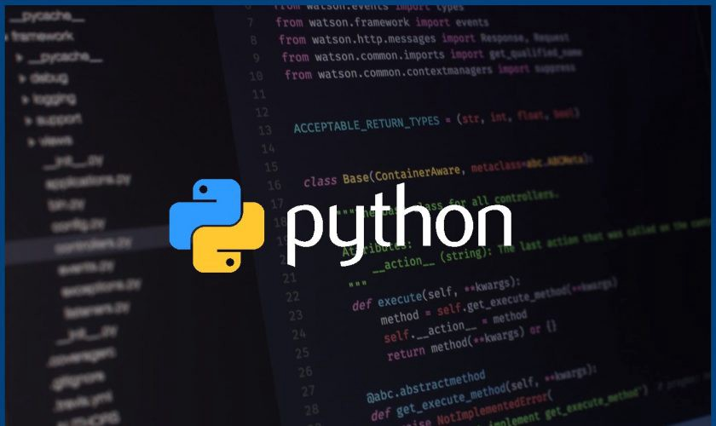
Python is a high-level, general-purpose programming language. Its design philosophy emphasizes code readability with the use of significant indentation. Python is dynamically-typed and garbage-collected. It supports multiple programming paradigms, including structured, object-oriented and functional programming.
9

Pandas is an open source Python package that is most widely used for data science/data analysis and machine learning tasks. It is built on top of another package named Numpy, which provides support for multi-dimensional arrays. pandas is a software library written for the Python programming language for data manipulation and analysis. In particular, it offers data structures and operations for manipulating numerical tables and time series. It is free software released under the three-clause BSD license.

NumPy is a Python library used for working with arrays. It also has functions for working in domain of linear algebra, fourier transform, and matrices. NumPy was created in 2005 by Travis Oliphant. It is an open source project and you can use it freely. NumPy stands for Numerical Python.

Matplotlib is a cross-platform, data visualization and graphical plotting library for Python and its numerical extension NumPy. As such, it offers a viable open source alternative to MATLAB. Developers can also use matplotlib's APIs (Application Programming Interfaces) to embed plots in GUI applications.
10

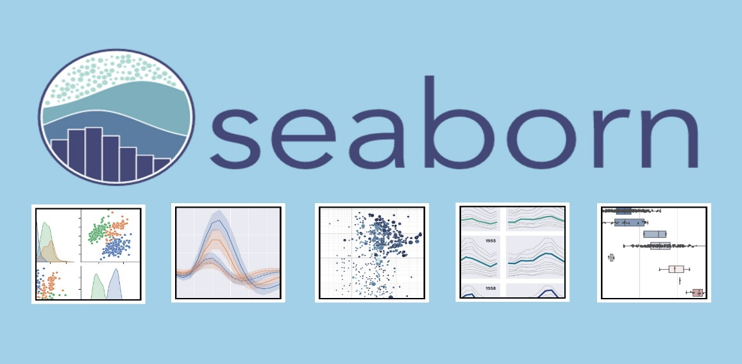

Seaborn is a Python data visualization library based on matplotlib. It provides a high-level interface for drawing
Attractive and informative statistical graphics. For a brief introduction to the ideas behind the library, you can
read the introductory notes or the paper. Seaborn is a library for making statistical graphics in Python. It builds
on top of matplotlib and integrates closely with pandas data structures. Seaborn helps you explore and
understand your data.

Future cope
Apply ML algorithms and taking different features of the player into consideration and
predict the chances of the player winning the Olympic medal.

11

Evaluation

Project URL: http://localhost/8051
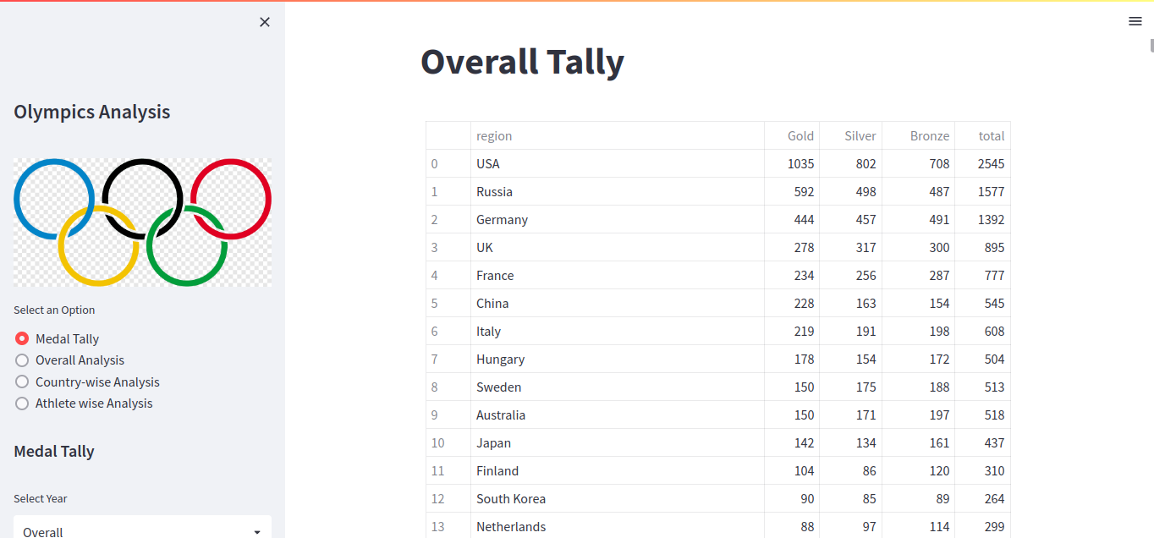

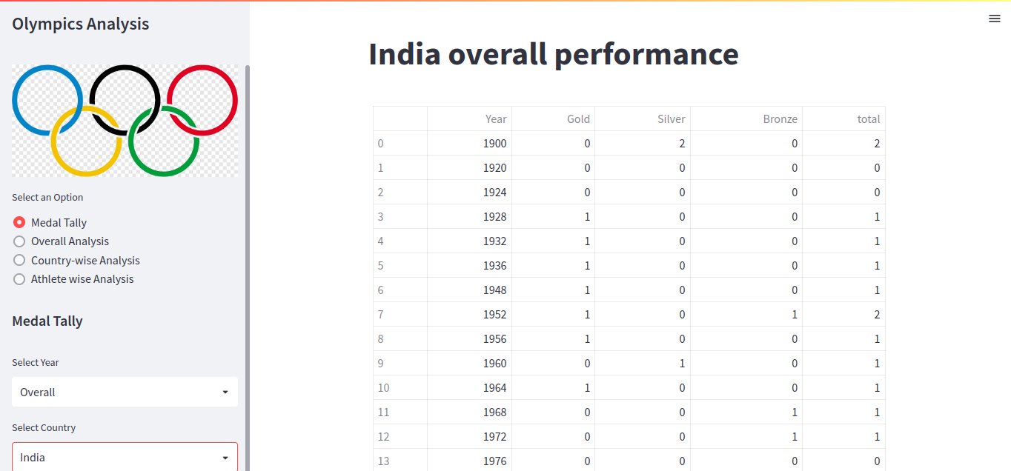

12
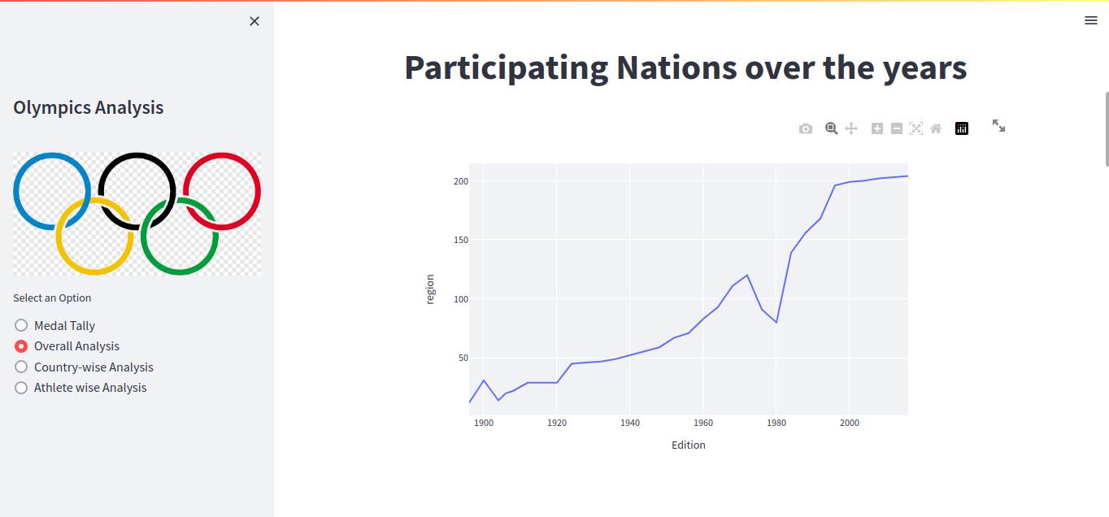

Country Wise Analysis

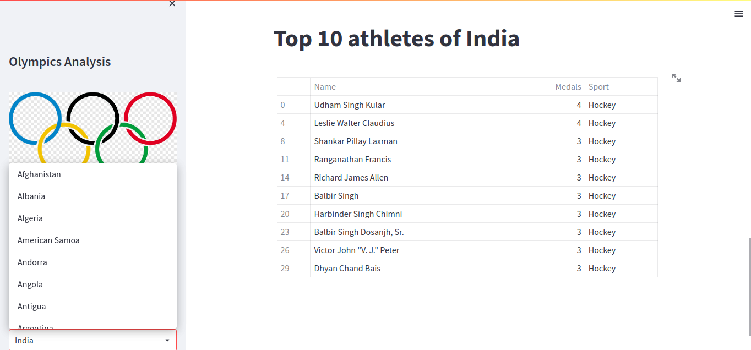

13

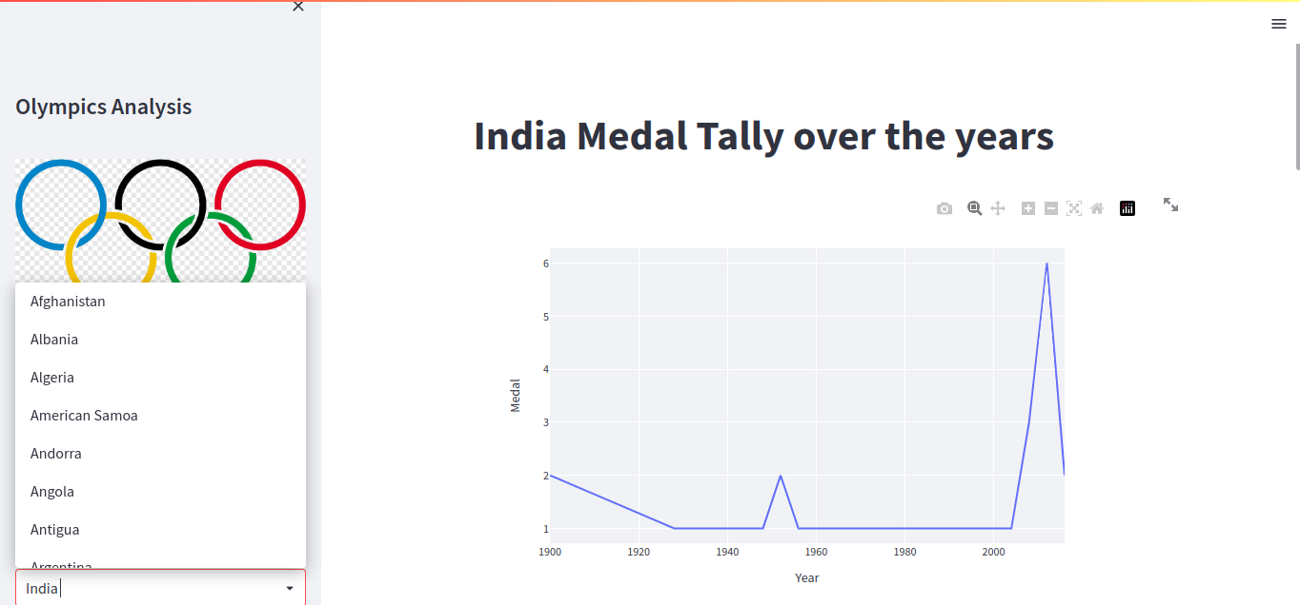

Athlete Wise Analysis
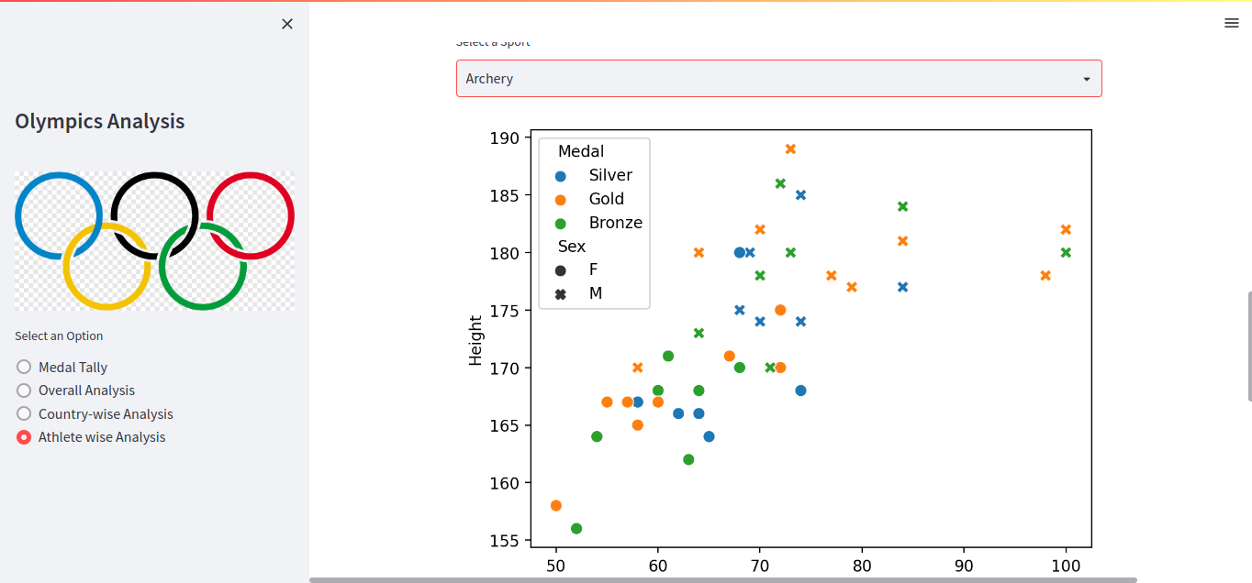

14

Sample Code

App.py
import streamlit as st
import pandas as pd
import preprocessor,helper
import plotly.express as px
import matplotlib.pyplot as plt
import seaborn as sns
import plotly.figure_factory as ff
df = pd.read_csv('athlete_events.csv')
region_df = pd.read_csv('noc_regions.csv')
df = preprocessor.preprocess(df,region_df)
st.sidebar.title("Olympics Analysis")
user_menu = st.sidebar.radio(
'Select an Option',
('Medal Tally','Overall Analysis','Country-wise Analysis','Athlete wise Analysis')
)
if user_menu == 'Medal Tally':
st.sidebar.header("Medal Tally")
years,country = helper.country_year_list(df)
selected_year = st.sidebar.selectbox("Select Year",years)
selected_country = st.sidebar.selectbox("Select Country", country)
st.title("Medal Tally")
medal_tally = helper.fetch_medal_tally
(df,selected_year,selected_country)
if selected_year == 'Overall' and selected_country == 'Overall':
st.title("Overall Tally")
if selected_year != 'Overall' and selected_country == 'Overall':
st.title("Medal Tally in " + str(selected_year) + " Olympics")
if selected_year == 'Overall' and selected_country != 'Overall':
st.title(selected_country + " overall performance")
if user_menu == 'Overall Analysis':
editions = df['Year'].unique().shape[0] - 1
cities = df['City'].unique().shape[0]
sports = df['Sport'].unique().shape[0]
events = df['Event'].unique().shape[0]
athletes = df['Name'].unique().shape[0]
nations = df['region'].unique().shape[0]
st.title("Overall Olympics Analysis")
st.title("Top Statistics") 15
col1,col2,col3 = st.beta_columns(3)
with col1:
st.header("Editions")
st.title(editions)
with col2:
st.header("Hosts")
st.title(cities)
with col3:
st.header("Sports")
st.title(sports)
helper.py
import numpy as np
def fetch_medal_tally(df, year, country):
medal_df = df.drop_duplicates
(subset= ['Team', 'NOC', 'Games', 'Year', 'City', 'Sport', 'Event', 'Medal'])
flag = 0
if year == 'Overall' and country == 'Overall':
temp_df = medal_df
if year == 'Overall' and country != 'Overall':
f lag = 1
temp_df = medal_df[medal_df['region'] == country]
if year != 'Overall' and country == 'Overall':
temp_df = medal_df[medal_df['Year'] == int(year)]
if year != 'Overall' and country != 'Overall':
temp_df = medal_df[(medal_df['Year'] == year) &
(medal_df['region'] == country)]
if flag == 1:
x = temp_df.groupby('Year').sum()[['Gold', 'Silver', 'Bronze']].
else:
x = temp_df.groupby('region').sum()
[['Gold', 'Silver', 'Bronze']].sort_values
('Gold',ascending=False).reset_index()
x['total'] = x['Gold'] + x['Silver'] + x['Bronze']
x['Gold'] = x['Gold'].astype('int')
x['Silver'] = x['Silver'].astype('int')
x['Bronze'] = x['Bronze'].astype('int')
x['total'] = x['total'].astype('int')
return x
def country_year_list(df):
years = df['Year'].unique().tolist()
years.sort()
years.insert(0, 'Overall')
country = np.unique(df['region'].dropna().values).tolist()
country.sort()
country.insert(0, 'Overall')
return years,country
def data_over_time(df,col):
nations_over_time = df.drop_duplicates(['Year', col])['Year'].valu
nations_over_time.rename(columns={'index': 'Edition', 'Year': co
return nations_over_time

preproccesr.py

import pandas as pd
def preprocess(df,region_df):
df = df[df['Season'] == 'Summer']
df = df.merge(region_df, on='NOC', how='left')
df.drop_duplicates(inplace=True)
df = pd.concat([df, pd.get_dummies(df['Medal'])], axis=1)
return df

17
Conclusion
It is a web application which provides extensive insights on

Olympics that are being conducted over the past few decades. Here ,

we have used dashboards and graphs to depict or show the insights

of Olympics by using latest Data Analysis Techniques.

References
For Frontend Technologies:
https://www.kaggle.com/heesoo37/120-years-of-olympic-history-athletes-and-results,
Streamlit official docs,
pandas , numpy and seaborn official docs

18

19

