SYSC 4906G: Methodologies for Discrete-Event
Modeling and Simulation

Instructor: Dr. Gabriel A. Wainer

Asymmetric Cell-DEVS Modeling of Information
Diffusion in Social Networks

Term Project
Salama Noureldean
Student ID: 101154365
salamanoureldean@cmail.carleton.ca
19/04/2026

1. Introduction
1.1 Motivation
Information diffusion in social systems is a useful problem for discrete-event modeling because large-scale behavior often emerges from repeated local interactions between individuals. A message, opinion, or idea usually does not spread instantaneously across an entire population. Instead, it propagates gradually through neighbor-to-neighbor influence, and its global impact depends on the accumulation of many small local state changes over time. This makes the problem well suited to Cell-DEVS, where local interactions, explicit timing, and spatial relationships can be modeled directly [2].
In Assignment 2, information diffusion was modeled using a symmetric 20 × 20 wrapped Cell-DEVS grid. In that baseline model, each cell represented one individual in a social network, all cells shared the same von Neumann neighborhood structure, and neighboring influence was treated uniformly. The model was successful in showing how information could spread locally and how individuals could progress from receiving a message to agreeing with it. However, the model assumed a uniform interaction structure across the entire grid, which limited its ability to represent non-uniform social relationships or barriers between groups [1].
Real social systems are rarely uniform. Individuals often belong to communities that are more strongly connected internally than externally, and communication across group boundaries may be weaker, more selective, or concentrated along a few specific paths. Because of this, a symmetric lattice model is not always sufficient to capture the effect of heterogeneous connectivity on diffusion. This project was motivated by the need to move beyond uniform neighborhood structure and study how weighted and asymmetric relationships affect the spread of information [2].
1.2 Goals
The main goal of this project is to extend the original symmetric Cell-DEVS information diffusion model into an asymmetric Cell-DEVS model implemented in Cadmium. The project preserves the overall three-state diffusion process from the baseline model, but replaces uniform neighbor counting with weighted influence and explicitly defined neighborhood relationships. In this way, the implementation remains conceptually connected to the original model while allowing the simulation of more realistic and heterogeneous interaction structures [1], [2].
More specifically, the project aims to:
- preserve the original interpretation of each cell as one individual in a social network,
- preserve the three-state progression of uninformed, informed, and agreement,
- represent the social space as four communities with different interaction strengths,
- use weighted asymmetric neighborhoods to model heterogeneous influence, and
- compare how diffusion changes across multiple scenario configurations under the same simulation logic.
The emphasis of the project is not on changing the local rules for every experiment, but rather on studying how different asymmetric structures affect diffusion when the underlying model implementation is kept fixed.
1.3 Contributions
First, it extends the Assignment 2 symmetric Cell-DEVS model into an asymmetric Cell-DEVS formulation. While the original model relied on a regular wrapped grid with uniform neighborhood treatment, the new model uses explicitly defined weighted neighborhoods so that influence depends on both connectivity and interaction strength [1], [2].
Second, the project introduces a community-based structure in which the 20 × 20 social space is partitioned into four groups. This allows the simulation to distinguish between stronger same-community interactions and weaker or more restricted inter-community interactions, thereby making the diffusion process dependent on network structure rather than only on spatial placement.
Third, four asymmetric scenarios were designed and simulated: a Base Asymmetric Scenario, a Weak Bridges Scenario, a Strong Cross-Community Scenario, and a Boundary-Seed Scenario. These scenarios were built using the same underlying implementation and differed only in their scenario configuration, including seed placement, cross-community coupling, and the presence or absence of explicit bridge links.
Finally, the project demonstrates that under a fixed Cell-DEVS implementation, diffusion behavior is strongly shaped by the relationship between topology, weighted influence, and threshold-based transitions. The results show that weak inter-community connectivity can confine spread to seeded communities, while stronger or more structured inter-community connections can enable broader diffusion across community boundaries.

2. Background
Cellular modeling is widely used to study systems whose global behavior emerges from repeated local interactions. In these models, each cell represents a small part of the system, and the overall dynamics arise from the application of local state-transition rules over space and time. Traditional cellular automata are one of the most common approaches for this kind of modeling, but they are typically defined over regular lattices and use synchronous state updates on a discrete-time base. While this structure is useful for many applications, it can become restrictive when more realistic timing behavior or heterogeneous relationships between cells must be represented [2].
To address these limitations, Cell-DEVS combines cellular modeling with the DEVS formalism. Instead of forcing all cells to update simultaneously, Cell-DEVS allows cells to change state asynchronously over a continuous time base, with explicit timing delays associated with state changes. This improves simulation accuracy and avoids unnecessary computations in situations where many cells remain unchanged at a given moment. Because Cell-DEVS is built on DEVS, it also supports a more modular and extensible simulation structure than traditional cellular automata [2], [3].
The starting point for this project was the symmetric Cell-DEVS model developed in Assignment 2. In that baseline model, the system was represented as a wrapped 20 × 20 grid in which each cell modeled one individual in a social network. A von Neumann neighborhood of range 1 was used, meaning that each cell interacted with its four direct neighbors. Every cell could be in one of three states: state 0 for uninformed, state 1 for informed, and state 2 for agreement. The model used a transport delay of 100 simulation time units, and the local transition rules were based on the number of active neighboring cells. An uninformed cell could become informed when it received sufficient local exposure, and an informed cell could later progress to agreement when neighborhood support became stronger [1].
That baseline model was useful for demonstrating local information spread and agreement formation, but it assumed that the structure of the social space was uniform. All cells used the same neighborhood structure, and neighboring influence was effectively treated in the same way throughout the grid. This is a simplification that becomes limiting when the system being modeled contains heterogeneous communities or unequal relationships between groups. In real social settings, communication within a group may be stronger than communication across group boundaries, and some interactions may occur only through a few special connectors rather than uniformly across the space. A symmetric grid cannot easily capture these effects [1], [2].
For this reason, the project adopts the asymmetric Cell-DEVS formalism as its main modeling framework. In asymmetric Cell-DEVS, cells are not restricted to a single uniform lattice interpretation. Instead, each cell may have its own explicitly defined neighborhood, and each neighboring relationship may have its own vicinity factor, which describes how strongly one cell influences another. In this sense, the model can be viewed as a directed weighted graph in which cells correspond to nodes and influence relationships correspond to weighted edges [2].
This idea is central to the current project. Although the scenario is still visualized on a 20 × 20 grid for clarity and comparison with the Assignment 2 baseline, the implemented diffusion process no longer depends only on a uniform neighbor-counting rule. Instead, each cell computes its behavior from the weighted influence of explicitly defined neighbors. This allows the model to represent stronger intra-community coupling, weaker inter-community boundaries, explicit bridge connections, and other asymmetric structures while preserving the same simulation engine and core cell logic across all scenarios [2].
Another important aspect of the asymmetric Cell-DEVS approach is its support in the Cadmium simulator. Cadmium allows the logic of the cell model to be implemented once in C++, while the specific simulation scenario is configured separately through a JSON file. This is especially useful for the present study because it means that different experimental cases can be explored by changing scenario configuration rather than rewriting the model implementation. As a result, comparisons between scenarios can focus on the effect of topology, weights, and seed placement, while the underlying simulation logic remains fixed [2].
Based on this background, the current project can be understood as a structured extension of the Assignment 2 work. The original model established a symmetric information diffusion process over a regular wrapped grid. The new work keeps the same general idea of local propagation and staged state progression, but extends it into an asymmetric setting in which diffusion depends on weighted influence and community-based connectivity. This makes it possible to study not only how information spreads, but also how the structure of the network affects whether spread remains localized, becomes bottlenecked, or diffuses broadly across the full space [1], [2].
3. Models Defined
3.1 Conceptual Model
The system modeled in this project represents information diffusion in a social network using an asymmetric Cell-DEVS approach. As in the Assignment 2 baseline, each cell represents one individual, and the overall state of the system emerges from repeated local interactions over time [1]. However, unlike the original symmetric model, the new model does not assume that all individuals are connected in the same way. Instead, the social space is divided into communities, and the effect of one individual on another depends on explicitly defined weighted neighborhood relationships [2].
The model uses a 20 × 20 visual layout for consistency with the original Assignment 2 work, but the actual diffusion logic is no longer based only on a regular implicit grid neighborhood. Instead, each cell is treated as a node in a weighted interaction structure. In this setting, the grid serves mainly as a convenient spatial arrangement for visualization, while the behavior of the system is determined by the connectivity and influence weights assigned to each cell [2].
Each individual can be in one of three states:
- state 0: uninformed,
- state 1: informed,
- state 2: agreement.
The conceptual meaning of these states is the same as in the baseline model. A person who has not yet received the message is in state 0. Once sufficient exposure is received from neighboring individuals, that person becomes informed and moves to state 1. If support from neighboring individuals becomes strong enough, the person progresses further to state 2, representing agreement with the message [1].
To study how network structure affects diffusion, the cell space is divided into four communities: A, B, C, and D. This partition allows the model to distinguish between stronger internal influence within a group and weaker or more selective influence across group boundaries. As a result, the model can represent different types of asymmetric diffusion behavior, such as localized spread inside communities, bottlenecked inter-community propagation, broad cross-community coupling, and boundary-driven growth [2].
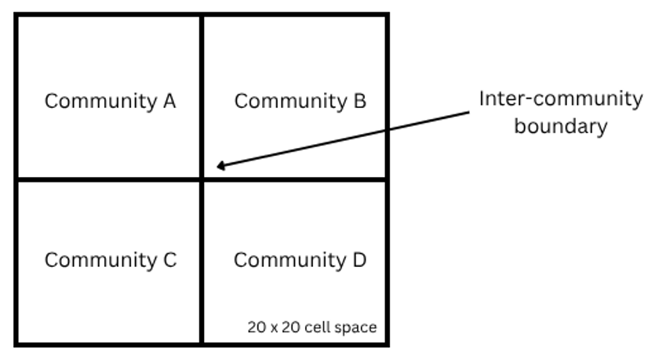
Figure 1. Partition of the asymmetric 20×20 social space into four communities used in the model.
Conceptually, the project studies a threshold-based information diffusion process on a weighted social structure. The main research question is not simply whether information spreads, but how the strength and arrangement of connections influence whether diffusion remains localized, crosses boundaries only through a few paths, or spreads broadly across the full network.
3.2 Formal Specification
3.2.1 Baseline Symmetric Model
The Assignment 2 model was defined as a Cell-DEVS model over a wrapped 20 × 20 grid with a von Neumann neighborhood of range 1 and transport delay of 100 simulation time units [1]. Let the baseline model be represented as:
$$CD_{sym}=⟨X,Y,I,S,θ,N,d,δ_{int},δ_{ext},τ,λ,D⟩$$
where:
- $S=\{0,1,2\}$is the state set,
- $I=\{(i,j)∣0≤i<20, 0≤j<20\}$is the set of cells,
- $N(i,j)$is the von Neumann neighborhood of cell $\left(i , j\right)$,
- $d=100$is the transport delay.
The baseline state meanings are:
- $0$: uninformed,
- $1$: informed,
- $2$: agreement.
Let $m(i,j)$be the number of neighbors of cell $\left(i , j\right)$whose state is either 1 or 2. Then the local transition logic in the baseline model is summarized as follows [1]:
$$0→1 \text{if }m(i,j)≥1 \\ 1→2 \text{if }2≤m(i,j)≤4$$
Otherwise, the cell remains in its current state. This model provided the original symmetric reference point for the term project [1].
3.2.2 Asymmetric Model
The asymmetric extension follows the general structure of asymmetric Cell-DEVS, in which the model is described as a coupled DEVS structure with explicitly defined cell relationships [2]:
$$CD_{asym}=⟨X, Y, C, EIC, IC, EOC⟩$$
where:
- $X$is the set of external inputs,
- $Y$is the set of outputs,
- $C$is the set of cells,
- $EIC$, $IC$, and $EOC$define the external input, internal, and external output couplings, respectively [2].
Each cell $C_{i}∈C$is associated with:
- a local state,
- a neighborhood set,
- a local computation rule,
- a delay behavior [2].
In this project, each cell is identified by a string ID of the form c_r_c, and the full 20 × 20 system contains 400 cells. The state set remains:
$$S=\{0,1,2\}$$
with the same interpretation as in the baseline model.
Unlike the symmetric model, the neighborhood of each cell is explicitly defined as a weighted set of incoming neighbors. Following the asymmetric Cell-DEVS formalism, a neighborhood can be represented as [2]:
$$N_{i}=\{⟨C_{j},V_{i}^{j}⟩\}$$
where $C_{j}$is a neighboring cell and $V_{i}^{j}$ is the vicinity factor describing the influence of $C_{j}$on $C_{i}$.
Thus, the behavior of a cell depends not only on which neighbors exist, but also on how strongly each one influences it. This allows the model to be interpreted as a directed weighted graph of cells [2].

3.2.3 Weighted Influence Function
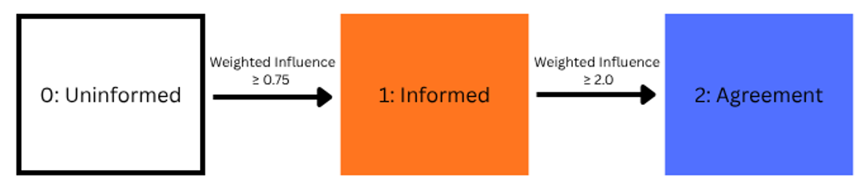
Figure 2. State progression used in the asymmetric diffusion model, showing a cell moving from uninformed to informed when weighted influence is at least 0.75, and from informed to agreement when weighted influence is at least 2.0.

Let $A_{i}$be the set of active neighbors of cell $C_{i}$, where an active neighbor is any neighbor whose state is 1 or 2. Then the weighted influence on cell $C_{i}$is:
$$I_{w}(C_{i})=\sum_{C_{j}∈A_{i}}{V_{i}^{j}}$$
This weighted sum replaces the simple neighbor count used in the baseline model. The local transition rules used in all asymmetric scenarios are:
$$0→1 \text{if }I_{w}(C_{i})≥0.75 \\ 1→2 \text{if }I_{w}(C_{i})≥2.0$$
Otherwise, the cell remains in its current state.
A transport delay of 100 simulation time units is used in all scenarios, preserving the same delayed propagation mechanism as the original model while changing the way influence is computed.

3.2.4 Community Structure
For the asymmetric simulations, the 20 × 20 layout is partitioned into four communities:
- A: top-left,
- B: top-right,
- C: bottom-left,
- D: bottom-right.
This partition is used to assign different interaction strengths within and across communities. In the base asymmetric configuration, same-community influence is stronger than cross-community influence, which makes diffusion easier inside a group than across group boundaries. Different scenario configurations then modify this structure to represent weak bridges, stronger cross-community coupling, or different seed placement patterns.
3.3 Computational Implementation in Cadmium
Each cell was implemented as an asymmetric Cell-DEVS cell whose state consists of a single integer value representing the diffusion state. The local computation function evaluates the weighted influence received from neighboring cells and applies the threshold-based transition rules described earlier. A neighboring cell contributes to the weighted influence only if it is active, meaning that its state is either 1 or 2. The computed weighted influence is then compared against the two fixed thresholds used throughout the project.
The scenarios were instantiated using JSON configuration files. In these files, each cell was assigned:
- an initial state,
- a delay type,
- a model identifier,
- and an explicit neighborhood.
For asymmetric scenarios, neighborhoods were defined as key-value structures in which the key identified a neighboring cell and the value represented its vicinity factor. This made it possible to define different strengths of influence for different neighbor relationships, as well as to modify scenario connectivity without changing the C++ implementation [2].
The same asymmetric diffusion mechanism was reused across all final scenarios, allowing the comparison to focus on the effect of topology, community structure, and seed placement.
3.4 Scenario Definitions
Four final asymmetric scenarios were used in the project. All of them used the same state space, weighted influence logic, and transport delay. The differences between scenarios were introduced only through scenario configuration.
3.4.1 Base Asymmetric Scenario
The Base Asymmetric Scenario served as the default asymmetric reference case. It used:
- same-community weight = 1.0,
- cross-community weight = 0.30,
- wrapped local neighborhood structure,
- two initial seed cells located in communities A and D.
The purpose of this scenario was to observe diffusion when community boundaries act as relatively weak channels of communication. Because same-community influence is much stronger than cross-community influence, this scenario was expected to favor internal diffusion within seeded communities and reduce the likelihood of broad spread into neighboring groups.
3.4.2 Weak Bridges Scenario
The Weak Bridges Scenario replaced general cross-community local interaction with a small number of explicit bridge connections. In this scenario:
- same-community weight = 1.0,
- bridge weight = 0.80,
- general cross-community links were removed,
- only a few explicit inter-community bridge links were retained,
- two initial seed cells were again placed in communities A and D.
This scenario was designed to model bottlenecked inter-community spread. Instead of allowing diffusion to cross boundaries broadly, crossing was restricted to a limited number of specific locations.
3.4.3 Strong Cross-Community Scenario
The Strong Cross-Community Scenario preserved the same seed placement as the base asymmetric case, but increased inter-community coupling across the whole grid. It used:
- same-community weight = 1.0,
- cross-community weight = 0.80,
- wrapped local neighborhood structure,
- two initial seed cells in communities A and D.
This scenario was intended to represent a case in which group boundaries are much more permeable. Since the cross-community links were strong enough to satisfy the activation requirement more easily, diffusion was expected to spread much more broadly across the full space.
3.4.4 Boundary-Seed Scenario
The Boundary-Seed Scenario kept the weaker cross-community influence of the base asymmetric model, but changed the location of the initial active cells. In this scenario:
- same-community weight = 1.0,
- cross-community weight = 0.30,
- wrapped local neighborhood structure was preserved,
- seed cells were placed near the interfaces between communities.
The purpose of this scenario was to study whether placing the initial message sources on inter-community boundaries would be sufficient to produce wider diffusion into neighboring communities, even when the cross-community influence remained relatively weak.
3.5 Summary of the Modeling Approach
The main modeling contribution of the project is not the use of different local transition rules for each scenario, but the use of one fixed asymmetric Cell-DEVS implementation across multiple network configurations. The same three-state diffusion process, weighted influence logic, and timing behavior were preserved throughout the study. The scenarios differed only in their topology, link weights, and seed placement.
This design makes the comparison between scenarios more meaningful. Since the implementation was held constant, the differences observed in the simulations can be attributed to asymmetric structure and weighted connectivity rather than to changes in the core logic of the model. In this way, the project directly reflects the purpose of asymmetric Cell-DEVS: to study how different neighborhood structures and influence relationships affect the evolution of a system under a common simulation framework [2].
4. Simulation Results
All scenarios were executed in Cadmium using the same asymmetric Cell-DEVS implementation described in the previous section. The local state space, weighted influence logic, and transport delay were kept fixed across all asymmetric experiments. As a result, differences in behavior can be attributed to scenario configuration rather than to changes in the core model implementation. The main variables that changed between scenarios were the strength of cross-community influence, the presence or absence of explicit bridge links, and the placement of the initial seed cells.
For all simulations, the 20 × 20 cell space was visualized using the Cell-DEVS Web Viewer. In the visual output, state 0 (white) represents uninformed cells, state 1 (orange) represents informed cells, and state 2 (blue) represents cells that have progressed to agreement. The results were analyzed by observing both the geometric spread of diffusion over time and the final pattern reached by the system.
Before discussing the asymmetric scenarios individually, it is useful to recall the main difference between this project and the Assignment 2 baseline. In the original symmetric model, diffusion was driven by uniform local neighborhoods on a wrapped lattice, and all neighbor relationships were treated equally [1]. In the asymmetric model, diffusion depends on weighted neighborhood structure, which means that the same local rule can produce different large-scale behaviors depending on community boundaries and connectivity [2].
4.1 Base Asymmetric Scenario
The Base Asymmetric Scenario was used as the default asymmetric reference case. In this configuration, same-community influence was set to 1.0 and cross-community influence was set to 0.30, while the initial seeds were placed inside communities A and D. This scenario was designed to study diffusion when communities are internally well connected but weakly connected across their boundaries.
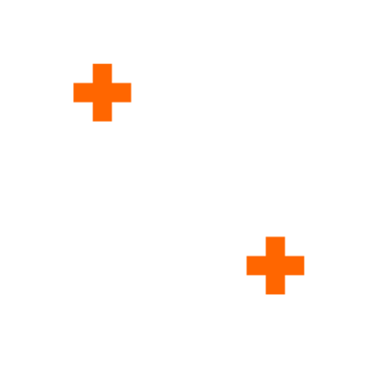
Figure 3: Base Asymmetric Scenario at t = 0
At the beginning of the simulation, the two seed cells appear as isolated sources of information in communities A and D. Because these seeds are placed well inside their communities rather than on the interfaces, the first phase of growth occurs independently in two separate regions.
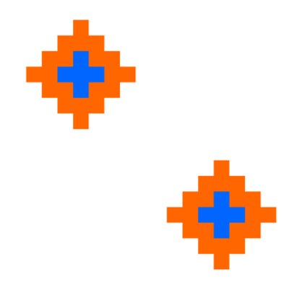
Figure 4: Base Asymmetric Scenario at early time at t = 200
During the early stages, the pattern expands outward from each seed in a layered structure. The informed state appears first at the outer frontier, while the agreement state develops in the interior after repeated reinforcement. This is consistent with the threshold-based transition rules of the model. Since same-community links are stronger than cross-community links, cells inside the seeded communities receive enough influence to activate and then progress to agreement relatively easily.
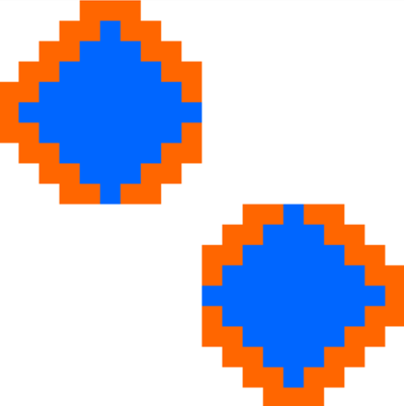
Figure 5: Base Asymmetric Scenario at mid time t = 500
As the simulation continues, diffusion remains concentrated inside communities A and D. The weak cross-community links are generally not strong enough to support broad activation into the neighboring quadrants. As a result, the growth pattern becomes dominated by expansion within the seeded communities rather than by crossing into B and C. This shows that weak inter-community coupling can act as an effective structural barrier even when the local rule itself remains unchanged.
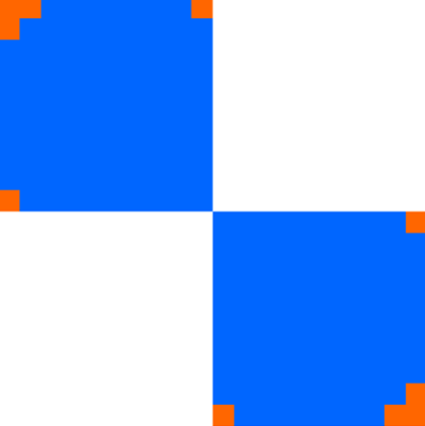
Figure 6: Base Asymmetric Scenario at late time t = 900
The late-stage configuration confirms this interpretation. Most of the activity is concentrated in the originally seeded communities, while the neighboring quadrants remain much less affected. Therefore, the Base Asymmetric Scenario demonstrates that under low cross-community coupling, diffusion tends to remain localized even though the model uses the same local state-transition logic as the other scenarios.
4.2 Weak Bridges Scenario
The Weak Bridges Scenario modified the inter-community structure by removing general cross-community local links and replacing them with a small number of explicit bridge connections. These bridges acted as the only paths through which diffusion could move between communities. The purpose of this scenario was to study diffusion across bottlenecks.
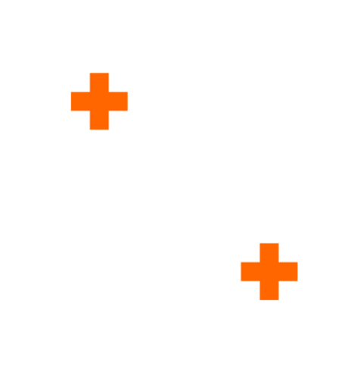
Figure 7: Weak Bridges Scenario at t = 0
Initially, the seeds again appear in communities A and D, and the earliest spread resembles the base asymmetric case in that activity develops first within those two communities. However, the main difference in this scenario is that crossing is no longer governed by broad weak coupling across full boundaries. Instead, inter-community propagation is restricted to a few specific bridge locations.
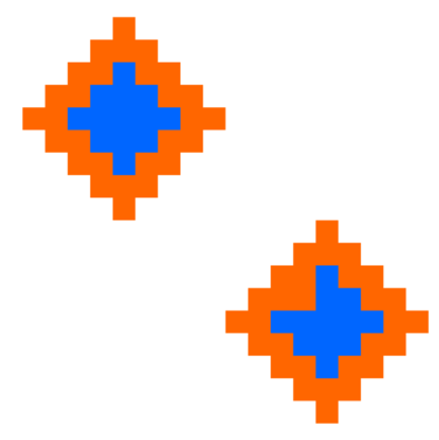
Figure 8: Weak Bridges Scenario at t = 300
During the intermediate stages, the effect of the bridges becomes visible. Rather than observing uniform penetration across community interfaces, diffusion moves through narrow paths associated with the explicit connections. This creates a bottleneck effect. Spread is not completely blocked, but it is spatially constrained and occurs only where the scenario provides a crossing mechanism.
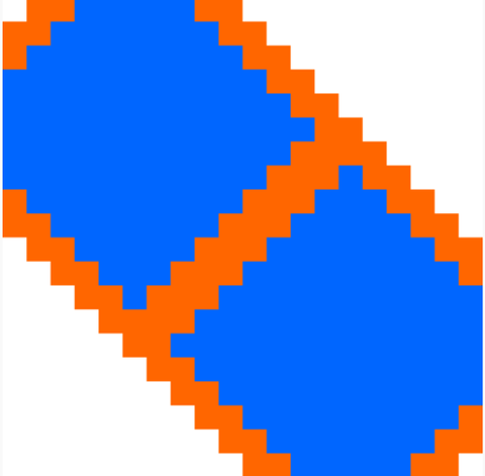
Figure 9: Weak Bridges Scenario at mid time t = 800
The resulting geometry differs from the base asymmetric case. In the base case, weak cross-community interaction suppresses broad crossing almost everywhere. In the weak bridges case, crossing becomes possible, but only at a few selected points. Therefore, the topology does not simply weaken or strengthen diffusion uniformly, it directs it.

Figure 10: Weak Bridges Scenario at late time t = 1400
The late-stage pattern confirms that this is a bottlenecked diffusion process. Communities can become connected through the bridge points, but the propagation remains strongly shaped by those narrow structural channels. This scenario shows that even when the same weighted-threshold logic is used, limiting the number of valid inter-community connections can substantially change the macroscopic spread pattern.
4.3 Strong Cross-Community Scenario
The Strong Cross-Community Scenario kept the same seed placement as the base asymmetric case, but increased the strength of all cross-community links to 0.80. This scenario was designed to study what happens when community boundaries are no longer major barriers to diffusion.
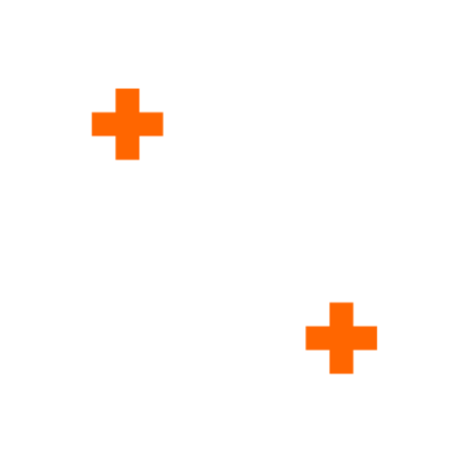
Figure 11: Strong Cross-Community Scenario at t = 0
The initial stage is similar to the earlier scenarios in that the seeds begin as isolated active cells in communities A and D. However, because the cross-community links are now much stronger, cells near community boundaries can receive enough influence to activate much earlier than in the base asymmetric case.
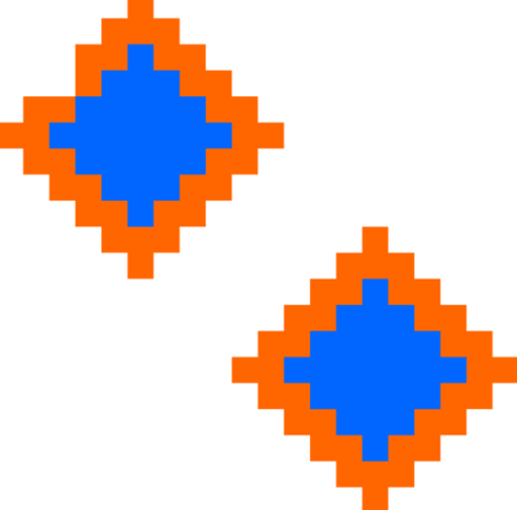
Figure 12: Strong Cross-Community Scenario at t = 400
As diffusion progresses, the effect of the stronger inter-community coupling becomes very clear. Instead of remaining confined to the seeded communities or moving only through bottlenecks, the spread begins to cross boundaries broadly. New active regions appear outside the originally seeded quadrants, and the distinction between internal and cross-boundary growth becomes much weaker than in the previous cases.
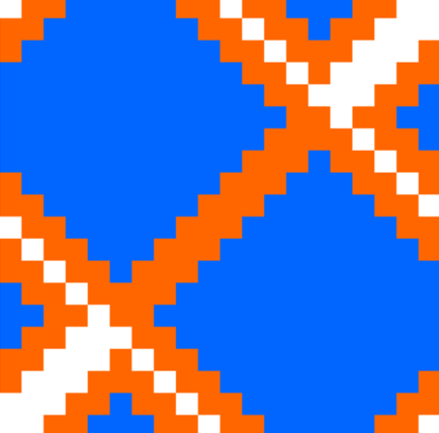
Figure 13: Strong Cross-Community Scenario at mid time t = 800
At the mid stage of the simulation, diffusion is no longer localized. The model shows broad inter-community spread, and activity expands across most or all of the social space. This behavior contrasts sharply with the Base Asymmetric Scenario, in which the weaker boundary links prevented large-scale crossing, and with the Weak Bridges Scenario, in which the spread was still forced through narrow bottlenecks.

Figure 14: Strong Cross-Community Scenario at end of simulation, t = 1300
By the final stage, the entire grid is dominated by the agreement state. This indicates that when cross-community influence is sufficiently strong, the model transitions from localized community-based spread to near-global diffusion. The Strong Cross-Community Scenario therefore highlights the decisive role of inter-community edge strength in determining whether diffusion remains regional or becomes widespread.
4.4 Boundary-Seed Scenario
The Boundary-Seed Scenario preserved the weaker cross-community weight of 0.30, but moved the seed cells to positions near the interfaces between communities. This scenario was designed to study whether placing the message sources directly on community boundaries would be enough to produce broader spread.

Figure 15: Boundary-Seed Scenario at t = 0
At time zero, the four seeds are positioned near the boundaries rather than deep inside the quadrants. This gives the initial configuration a very different spatial layout from the Base Asymmetric and Strong Cross-Community scenarios. Instead of two isolated seeds inside communities A and D, the system begins with sources already located near the interfaces.
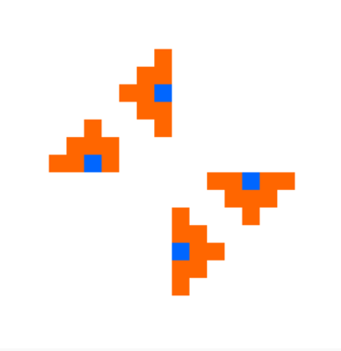
Figure 16: Boundary-Seed Scenario at early time t = 100
In the early stages, the spread develops outward from those interface positions. However, although the seeds are closer to the community boundaries, the cross-community links remain weak. As a result, the diffusion does not immediately penetrate deeply into the neighboring communities. Instead, the growth tends to follow directions where same-community support is stronger.
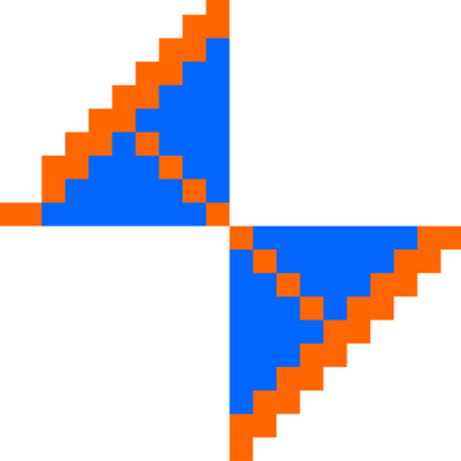
Figure 17: Boundary-Seed Scenario at t = 400
This produces a characteristic skewed or wedge-like growth pattern. The active regions do not form the same centered expansion seen when seeds are located farther inside a quadrant. Instead, the spread is shaped by the combination of boundary placement and the weak cross-community threshold barrier. In other words, the source location changes the geometry of the spread, but not necessarily the fact that crossing remains difficult.
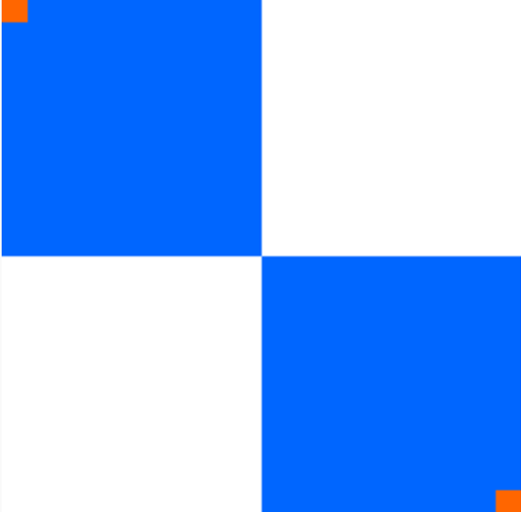
Figure 18: Boundary-Seed Scenario at end of simulation, t = 1400
The late-stage result confirms that placing seeds on the boundary is not, by itself, sufficient to guarantee broad inter-community spread. Because the cross-community influence remains below the effective level needed for widespread activation, diffusion still tends to remain dominated by same-community expansion. This scenario therefore demonstrates that source placement affects the direction and shape of growth, but boundary strength still plays the decisive role in determining whether diffusion crosses into neighboring communities.
4.5 Cross-Scenario Comparison
The four scenarios show that asymmetric structure changes the diffusion process in several distinct ways, even though the same implementation was used in every case.
The Base Asymmetric Scenario demonstrates that weak cross-community coupling can confine diffusion to the initially seeded communities. The Weak Bridges Scenario shows that inter-community spread can be enabled while still being heavily constrained by specific structural bottlenecks. The Strong Cross-Community Scenario shows the opposite extreme, where stronger boundary coupling permits broad spread across the entire grid. Finally, the Boundary-Seed Scenario shows that even when sources are
placed directly at community interfaces, weak cross-community influence can still prevent widespread penetration into neighboring groups.

Scenario | Boundary Strength | Boundary Crossing Behavior | Overall Spread Pattern | Main Observation
Base Asymmetric Scenario | Weak cross-community coupling | Very limited crossing | Mostly confined to communities A and D | Weak inter-community connectivity keeps diffusion localized
Weak Bridges Scenario | Restricted to a few explicit bridge points | Crossing occurs only through bottlenecks | Directed and narrow inter-community spread | Structure does not only weaken spread, it channels it through specific paths
Strong Cross-Community Scenario | Strong cross-community coupling | Broad and early crossing | Near-global diffusion across the full grid | Increasing inter-community edge strength enables widespread diffusion
Boundary-Seed Scenario | Weak cross-community coupling, but seeds placed at interfaces | Crossing still remains limited | Skewed or wedge-shaped growth from boundaries | Seed placement changes growth geometry, but weak boundaries still restrict penetration

Table 1: Cross-scenario comparison of structure and observed behavior

Taken together, these results show that under the asymmetric Cell-DEVS framework, diffusion does not depend only on the location of active cells or on the existence of neighboring activity. It depends strongly on how influence is weighted and on how communities are connected. In this sense, the project demonstrates that network structure is not merely a visual feature of the model, it is a primary driver of the resulting diffusion dynamics.

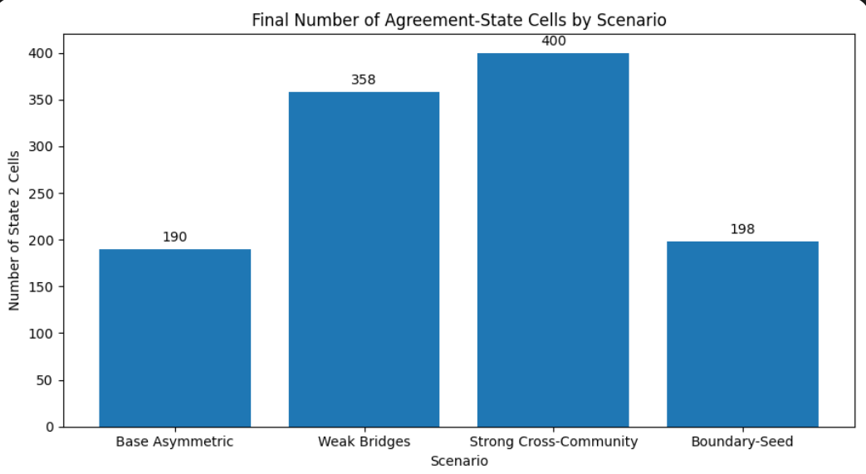
Figure 19. Final number of agreement-state cells (state 2) for each asymmetric scenario.
Figure 19 reinforces the observations from the scenario screenshots. The Base Asymmetric Scenario and the Boundary-Seed Scenario both ended with fewer agreement-state cells than the Weak Bridges and Strong Cross-Community scenarios. This confirms that weak inter-community influence tends to confine diffusion, even when seed placement is changed. By contrast, the Strong Cross-Community Scenario reached complete agreement across the grid, showing that stronger boundary coupling fundamentally changes the scale of diffusion. The Weak Bridges Scenario occupies an intermediate position, since diffusion can cross into additional regions, but only through specific structural bottlenecks.
5. Conclusion
This project presented an asymmetric Cell-DEVS extension of the symmetric information diffusion model developed in Assignment 2. The original model represented diffusion on a uniform wrapped 20 × 20 grid in which all cells followed the same neighborhood structure and neighboring influence was treated uniformly. In contrast, the new model used explicitly defined weighted neighborhoods, allowing the simulation to represent communities, boundary effects, and selective inter-community connectivity while preserving the same general three-state diffusion process [1], [2].
Four final asymmetric scenarios were implemented and analyzed: the Base Asymmetric Scenario, the Weak Bridges Scenario, the Strong Cross-Community Scenario, and the Boundary-Seed Scenario. All scenarios used the same asymmetric Cell-DEVS implementation, weighted-threshold transition logic, and transport delay. The scenarios differed only in their configuration, including seed placement, cross-community influence strength, and the presence or absence of explicit bridge connections. This design made it possible to attribute observed differences in diffusion behavior directly to network structure rather than to changes in the underlying model logic.
The results showed that asymmetric structure has a strong impact on the evolution of diffusion. In the Base Asymmetric Scenario, weak cross-community influence confined most of the spread to the seeded communities. In the Weak Bridges Scenario, inter-community propagation became possible, but only through a few structural bottlenecks. In the Strong Cross-Community Scenario, stronger inter-community links enabled broad crossing and eventually full-grid diffusion. In the Boundary-Seed Scenario, placing sources on community interfaces changed the geometry of the spread, but weak cross-community influence still prevented broad penetration into neighboring groups. Together, these results show that under a fixed implementation, diffusion behavior depends strongly on how communities are connected and how influence is weighted across their boundaries.
The project therefore achieved its main goal: to extend a symmetric Cell-DEVS diffusion model into an asymmetric Cell-DEVS framework capable of representing heterogeneous social connectivity. More broadly, the project demonstrates that asymmetric Cell-DEVS is a useful modeling approach for studying systems in which local interactions are not uniform and where boundaries, bottlenecks, and weighted connectivity affect how information spreads. Future extensions of this work could include more complex influence functions, dynamic or time-varying inter-community weights, or integration with external DEVS components that represent broader environmental or social effects [2].

6. References
[1] S. Noureldean, “Using DEVS and CELL-DEVS for Modelling of Information Impact on Individuals in Social Network,” Assignment 2 Report, SYSC 4906G, Carleton University, Ottawa, ON, Canada, Mar. 2026.
[2] R. Cárdenas and G. Wainer, “Asymmetric Cell-DEVS Models with the Cadmium Simulator,” Simulation Modelling Practice and Theory, 2022.
[3] G. Wainer and N. Giambiasi, “Application of the Cell-DEVS paradigm for cell spaces modelling and simulation,” Simulation, vol. 76, no. 1, pp. 22–39, 2001.

