SYSC 5104: Methodologies for Discrete-Event Modeling and Simulation
Instructor: Prof. Gabriel A. Wainer

Using DEVS and CELL-DEVS for Modelling of
Information Impact on Individuals in Social Network

ASSIGNMENT 2

Pankti Vyas
Student ID : 101080924
panktivyas@cmail.carleton.ca

November 24th, 2017

Conceptual Model
The proposed model represents the spread of information among individuals in a social network using a simplified cell-based structure. Each individual is modeled as a cell, and the interactions between individuals are represented through neighborhood connections. The purpose of the model is to study how a message propagates through a group and how individuals move from simply receiving the message to agreeing with it.
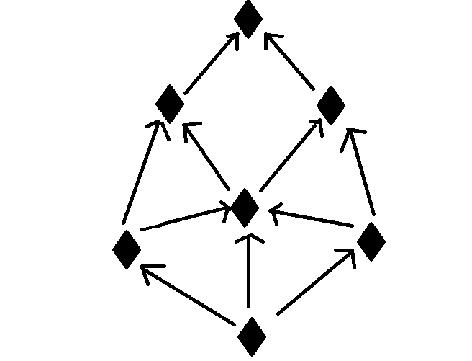
Figure 1. Conceptual model of individual impact in a social network.
Figure 1 shows the conceptual structure of the model. The nodes represent individuals, and the arrows represent directed influence or communication paths between them. An individual may receive a message from one or more connected neighbors. Once the message is received, the individual can in turn influence nearby individuals, allowing the information to spread through the network over time. This process captures the idea that information diffusion is not isolated to a single sender but instead emerges from repeated local interactions among connected members of the group.
In the implemented cellular version of the model, each individual is represented by a cell in a 20×20 grid, and each cell interacts with its immediate neighbors. Each cell can be in one of three states:
State 0, where the individual has not received the message, State 1, where the individual has received the message, and State 2, where the individual agrees with the message.
The behavior of the model is governed by two main rules. The first rule describes message reception where if an individual is currently in state 0 and at least one neighboring individual already carries the message, then that individual receives the message and changes to state 1. This represents the first level of social influence where exposure to an informed neighbor is enough to make the message spread.
The second rule describes agreement formation where if an individual is currently in state 1 and the number of neighboring message-carrying individuals is between 2 and 4 then the individual changes to state 2. This represents a stronger level of social influence where repeated or reinforced exposure causes the individual to receive the message and agree with it. If neither of these conditions is satisfied then the individual remains in its current state.
Thus, the behavior of the model follows this progression:
0 → 1 where an uninformed individual receives the message due to local exposure, 1 → 2 where a receiving individual agrees with the message due to stronger local support, and otherwise the state remains unchanged. In this way, the model demonstrates information propagation and opinion formation (agreement). This conceptual model is used as the basis for the formal Cell-DEVS specification and for the Cadmium implementation of the simulation.

Formal Specifications
This project uses a Cell-DEVS model to represent information propagation in a social network. The model is adapted from the original information-impact work which uses DEVS and Cell-DEVS to study how information spreads among individuals in a networked population. In Cell-DEVS, each cell is an atomic component with a local state and a local transition rule, while the overall grid is represented as a coupled cell space.

Cell-DEVS Model Definition
The cellular model is defined as:
CD = < X, Y, I, S, θ, N, d, δint, δext, τ, λ, D >

State Space
Each cell represents one individual in the social network. The state set is:
S = {0, 1, 2}
- 0 = the individual has not received the message
- 1 = the individual has received the message
- 2 = the individual agrees with the message

Cell Space and Index Set
The model uses a two-dimensional cell space of size 20 × 20 so the index set is:
I = {(i, j) | 0 ≤ i < 20, 0 ≤ j < 20}
This gives a total of 400 cells where each cell corresponds to one individual in the abstract social network. The original paper also uses a 20 × 20 mesh to study information propagation.

Neighborhood Definition
A Von Neumann neighborhood with range 1 is used. Therefore, each cell interacts with its four direct neighbors:
N(i, j) = {(i−1, j), (i+1, j), (i, j−1), (i, j+1)}
The grid uses wrapped borders meaning that cells on one edge are connected to the opposite edge. This allows border cells to interact across the boundaries.

Delay and Time Base
The model uses a transport delay with delay value:
d = 100
This means that when a state change is computed it is then propagated after 100 simulation time units.

Local Computing Function
The local computing function τ defines how each cell updates its state based on neighboring message-carrying individuals.
Let m(i, j) be the number of neighbors of cell (i, j) whose state is either 1 or 2. So m(i, j) counts the neighboring individuals that already carry the message or agree with it.
The transition rules are:
- Reception rule
If a cell is currently in state 0 and it has at least one neighboring message holder, it changes to state 1 after delay 100.
τ : 1 100 { (0,0) = 0 and m(i,j) ≥ 1 }
- Agreement rule
If a cell is currently in state 1 and the number of neighboring message holders is between 2 and 4, it changes to state 2 after delay 100.
τ : 2 100 { (0,0) = 1 and 2 ≤ m(i,j) ≤ 4 }
- Default rule
Otherwise, the cell remains in its current state.
τ : {(0,0)} 0 { t }
These rules define a two stage diffusion process. A person first receives a message when exposed to at least one active neighbor and later moves to agreement when local neighborhood support becomes strong enough.

Internal and External Transition Functions
δint: automatically derived by the Cell-DEVS simulator
δext: automatically derived by the Cell-DEVS simulator
λ: automatically derived by the Cell-DEVS simulator

Simulation Execution

Experimental Frame
The experimental frame for this study consisted of a 20 × 20 Cell-DEVS grid using wrapped boundaries, a Von Neumann neighborhood, and transport delay with a time advance of 100 simulation units per update. In the Web Viewer output, state 0 (white) represents uninformed cells, state 1 (orange) represents cells that have received the message, and state 2 (blue) represents cells that have progressed to agreement. All simulation runs were executed under the same model rules and the experimental conditions were varied only through the initial placement and number of seed cells. This will show the behavior of the model under different input configurations while keeping the underlying transition logic unchanged. Graphical outputs were captured using the Cell-DEVS Web Viewer and CSV execution logs were also generated for each run showing the observed state changes over time.

Base Scenario Execution and Analysis
In the Web Viewer output, state 0 (white) represents uninformed individuals, state 1 (orange) represents individuals that have received the message, and state 2 (blue) represents individuals that have progressed to agreement.

Experimental Frame and Scenario Setup
The base scenario was used as the reference experiment for evaluating the behavior of the social information diffusion model. All cells were initialized to state 0 by default representing individuals that had not received the message. Three seed cells were placed at different regions of the grid to initiate the spread of information. These seeds acted as the initial message sources and allowed the simulation to demonstrate how information propagates simultaneously from multiple separated starting points. The base case shows how the model behaves under the default configuration.

Early Propagation Behavior
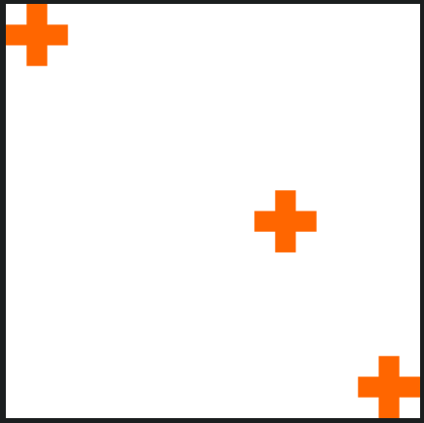
Figure 2. Initial state of the base scenario at t = 0, showing the three separated seed cells used to initiate diffusion.
At the beginning of the simulation, the three seed cells are isolated from one another and occupy distant parts of the wrapped grid. Because the initial sources are distributed rather than clustered, the spread begins independently in three separate regions.

Behavior at T = 100:

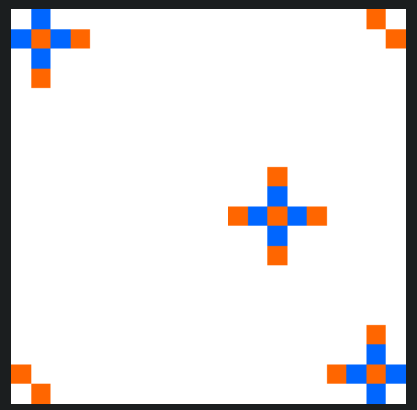
Figure 3. Base scenario at t = 100, showing the first neighborhood-level spread from the three initial seed cells under the interaction rules.
By t = 100, the effect of the three initial seed cells is visible, but the spread remains localized around each source. This is consistent with the model specification since propagation occurs only through local interactions within the neighborhood. Because each cell can influence only its four direct neighbors, the earliest stage of diffusion appears as small cross shaped expansions rather than diagonal or circular growth. The center seed shows this most clearly with newly affected cells appearing directly above, below, left, and right of the original source.
This pattern confirms that the model is following its first transition rule correctly. Cells that were initially in state 0 begin changing only when they are exposed to the required neighboring influence, so the spread does not jump across the grid or appear in disconnected regions. Instead, the message advances one neighborhood layer at a time from each seed. The orange cells at the outer edge of each cluster represent this first wave of propagation, while the blue cells closer to the source indicate cells that have already progressed further in the state sequence.
This also shows that the model is already preserving the structure of diffusion. The three seeds do not instantly generate large influenced areas but instead each source begins a controlled expansion whose growth depends on repeated updates over time. Also, the clusters located near the boundaries begin to hint at the wrapped topology of the grid, since their growth is not constrained by the edges and can continue across opposite borders in later stages.
Thus, the snapshot verifies that the simulation is behaving as intended during the earliest phase of execution: propagation is local, directional, delayed, and driven strictly by the neighborhood-based transition rules.

Behavior at T = 200:
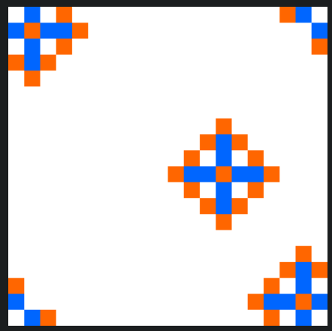
Figure 4. Base scenario at t = 200, showing diffusion with an expanding state 1 (orange) region surrounding more established state 2 (blue) regions.
By t = 200, the diffusion pattern is no longer just the first reaction to the seed cells. Around the central source, the blue cells (state 2) form a stable inner cross while the surrounding orange cells (state 1) create an outer ring of newer propagation. This layered structure shows that cells do not all change at once, but inner cells have already received enough neighboring support to advance further, while outer cells represent the current propagation front.
The shape of the clusters also matches the specification. Because influence is limited to the neighborhood, spread occurs through the four orthogonal directions rather than diagonally, producing cross shaped growth. At the same time, the clusters in the corners show that the wrapped topology is working correctly since activity continues across the grid boundaries instead of stopping at the edges.

Mid-Simulation Development
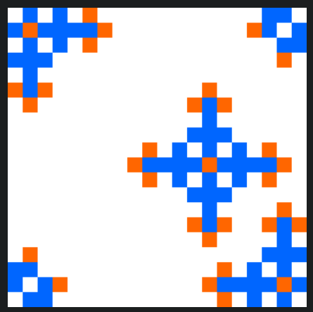
Figure 5. Mid-stage diffusion in the base scenario at t = 400, showing larger clusters and expansion across the grid.

By t = 400, the diffusion pattern shows a more mature stage of the model’s behavior. Each of the three original seed locations has developed into a larger region of influence, and the distinction between earlier and later state changes is now much easier to observe. In the central cluster, the blue cells (state 2) form a wider core, while the surrounding orange cells (state 1) define the active outer front where propagation is still continuing. This layered structure indicates that the spread is occurring progressively over multiple updates where cells closer to the source were influenced earlier and have already advanced further, whereas cells at the perimeter represent more recent transmission.

The geometry of the pattern also remains consistent with the model specification. Since interaction is limited to the neighborhood, expansion continues through the north, south, east, and west directions rather than diagonally. This produces the cross-shaped growth seen around the central source and the similarly structured edge clusters. The result therefore reflects the intended local transition mechanism rather than a general outward filling of space.

The clusters near the boundaries show that the wrapped topology is working correctly. Their growth is not cut off at the edges of the grid but instead activity continues across opposite borders, allowing those regions to develop in the same way as interior cells. This is important because it shows that the boundary condition is influencing the observed behavior exactly as intended in the experimental frame.

Final Configuration (t = 1600)
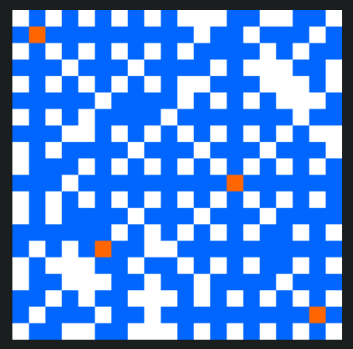
Figure 6. Base scenario at t = 1600, showing the configuration with state 2 (blue) dominating the grid and only a few remaining state 1 (orange) and state 0 (white) cells.
By t = 1600, the base scenario has reached a near-steady-state configuration in which most of the grid is occupied by blue cells (state 2), with only a few isolated orange cells (state 1) and scattered white gaps (state 0) remaining. Compared with earlier stages, the active propagation front is now very limited, which indicates that most cells that could be influenced under the local rules have already progressed through the reception stage and into agreement. This shows the completed long-term behavior of the model.
The pattern remains consistent with the specification. Diffusion has accumulated gradually through repeated neighbor-to-neighbor interactions, and the final distribution still reflects the structure imposed by the neighborhood. The remaining white pockets show that the model does not force complete uniform conversion of the grid but instead final outcomes depend on local neighborhood composition and the sequence of previous state changes. Also, the small number of orange cells indicates that a limited amount of active propagation is still present at the edges of some local regions, but the system as a whole has stabilized.
This result confirms that three initially separated seed cells are sufficient to generate long term diffusion across the wrapped 20 × 20 social space. It also shows that the model approaches widespread agreement without requiring every cell to end in the same state.

Interpretation of Results
The base scenario behaved as expected for a diffusion experiment starting with 3 seed cells. The simulation began with three independent message sources, produced early localized spread around each one, and gradually evolved into a broad pattern of transmission. The progression from isolated seeds to large scale influence shows the purpose of the model which is to present how information can move through a population over time through local interactions.

Clustered Scenario Execution and Analysis

Experimental Frame and Scenario Setup
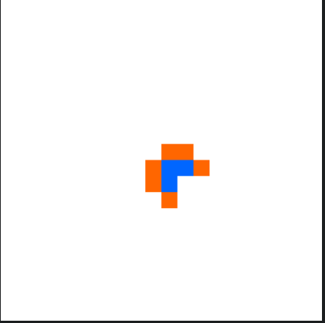
Figure 7. Initial state of the clustered scenario at t = 0
The clustered scenario was designed to examine how diffusion changes when the initial message sources are placed adjacent to one another instead of being distributed across the grid. In this experiment, the simulation was run on the same 20 × 20 wrapped Cell-DEVS grid with a Von Neumann neighborhood and transport delay, but the initial seeds were concentrated near the center of the space. In the Web Viewer output, state 0 (white) represents uninformed cells, state 1 (orange) represents cells that have received the message, and state 2 (blue) represents cells that have progressed to agreement.
This scenario increases local reinforcement at the start of the simulation. Because the seeds begin in direct proximity, neighboring cells are exposed to multiple active influences much earlier than in the base scenario.

Early Propagation Behavior (t = 100)
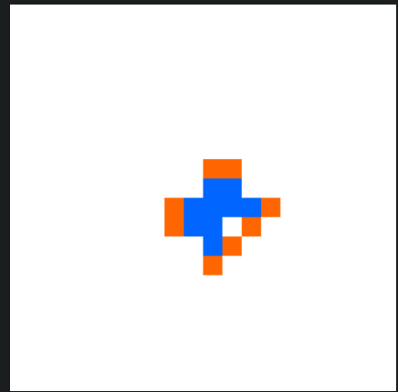
Figure 8. Early propagation in the clustered scenario at t = 100
By t = 100, the influence of clustering is already visible. Instead of three separate local fronts developing independently, the adjacent seeds immediately generate a single connected region of activity. The blue cells (state 2) form a central core, while the surrounding orange cells (state 1) mark the current propagation boundary. This shows that nearby active cells reinforce one another much earlier than in the base scenario, allowing cells near the center to progress more quickly into the agreement state.
The shape of the pattern follows the model rules where growth occurs through the four orthogonal directions of the neighborhood, so the earliest expansion remains cross-like rather than circular. However, because the seeds begin next to each other, their combined influence produces a thicker and more unified structure than the base scenario at the same time.

Structured Growth Under Local Reinforcement (t = 300)
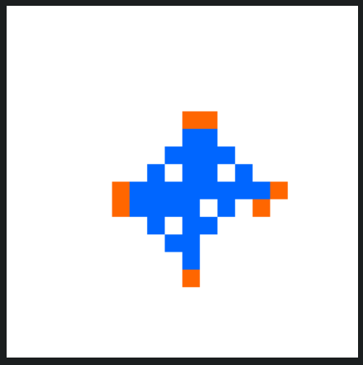
Figure 9. Clustered scenario at t = 300, showing a dense blue interior and orange outer front produced by overlapping local influence from adjacent seeds.
By t = 300, the clustered source has developed into a much larger and more coherent diffusion region. The blue cells (state 2) dominate the interior of the cluster, while orange cells (state 1) remain concentrated at the outer edge. This layered pattern shows that the model is following its staged progression correctly where cells nearer the center were influenced earlier and have already advanced further, while cells at the perimeter represent newer spread.
Compared with the base scenario, the clustered case shows stronger local reinforcement and less fragmentation at this point in time. Since the initial seeds are adjacent, the surrounding cells receive overlapping influence much sooner, which accelerates the transition from reception to agreement. The result is a denser central blue region.

Mid-Simulation Behavior (t = 600)
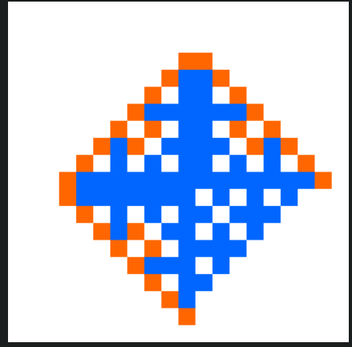
Figure 10. Mid-simulation state of the clustered scenario at t = 600
By t = 600, the cluster has expanded substantially. The pattern remains diamond-like and cross-shaped because diffusion continues to occur through the orthogonal neighborhood. At this stage, the blue region has become dominant within most of the cluster, indicating that many cells have already received enough support from neighboring active cells to progress into the agreement state. The orange cells remain concentrated near the outside, showing that propagation is still active but increasingly pushed toward the boundary of the influenced region.
This figure demonstrates the effect of clustered initialization. Because the simulation began with multiple adjacent seeds, the model produced a strong central agreement zone much earlier than in the base scenario. Rather than creating several disconnected regions that expand separately, the clustered setup generates a single reinforced growth front, which leads to faster consolidation of state 2 in the middle of the grid.

Late-Stage Behavior (t = 900)
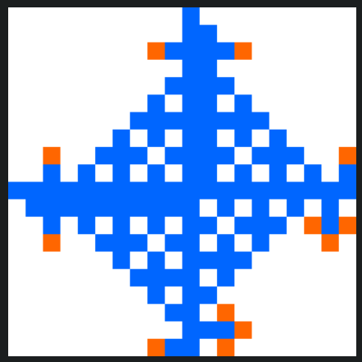
Figure 11. Late-stage behavior of the clustered scenario at t = 900, showing a dominant blue central region and a thin orange propagation frontier.
By t = 900, the clustered scenario has produced a broad and highly consolidated region of diffusion centered on the original seed location. Most of the interior has transitioned into blue cells (state 2), while only a thin outer layer of orange cells (state 1) remains active. White cells (state 0) persist mainly outside the reach of the cluster, showing that diffusion is extensive but still depends on repeated local interactions and has not yet filled the entire grid.
This late stage result is consistent with the intended model behavior. The clustered scenario demonstrates that when initial seeds are adjacent, the model advances toward agreement more quickly in the central region than when the sources are separated.

Interpretation of Results
Overall, the clustered scenario confirms that initial seed placement has an impact on the rate and structure of diffusion. When the message sources are adjacent, the model produces immediate overlap in local influence, which accelerates the transition from message reception to agreement. This leads to a stronger central blue region much earlier in the run than in the base scenario, where the separated seeds first spread independently and only later develop broader influence.

Edge-Wrap Scenario Execution and Analysis

Experimental Frame and Scenario Setup
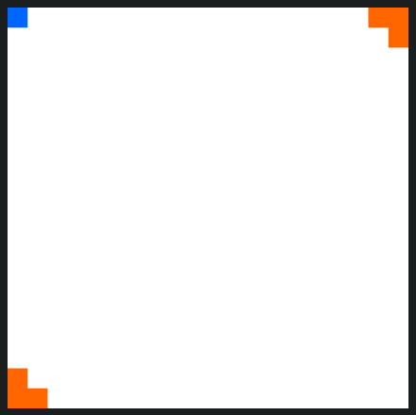
Figure 12. Initial state of the edge-wrap scenario at t = 0 showing seeds placed at the outer boundaries of the wrapped grid.
The edge-wrap scenario tests whether the model correctly applies the wrapped boundary condition. Instead of placing the initial message sources in the interior of the grid, this experiment places them on and near the outer borders. In the Web Viewer output, state 0 (white) represents uninformed cells, state 1 (orange) represents cells that have received the message, and state 2 (blue) represents cells that have progressed to agreement.
This scenario is important because the wrapped topology should allow cells on one edge of the 20 × 20 grid to interact with cells on the opposite edge as if the space were continuous. As a result, message propagation should not stop at the boundaries. Instead, the corner and edge seeds should begin influencing cells across the opposite sides of the grid, producing diffusion patterns that confirm correct wraparound behavior.

Early Propagation Behavior (t = 100)
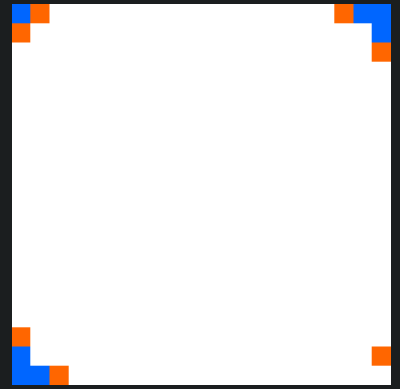
Figure 13. Early propagation in the edge-wrap scenario at t = 100, showing that edge and corner cells begin spreading without being blocked by the grid boundaries.
By t = 100, the first stage of propagation is already visible. The seed near the upper-left corner has begun influencing neighboring cells along both the top row and the left column, while the seeds near the upper-right and lower-left regions show similar early outward growth. This is important because those cells are not expanding into a larger borderless plane but are expanding under the wrapped topology, where edge cells remain connected to cells across the opposite side of the grid.
Specific cells near the corners behave as expected under this rule. For example, activity originating near the upper-left corner does not appear cut off by the top or left boundaries. Instead, the pattern begins to develop around the corner in a way that is only possible if the cell still has valid neighbors through the wraparound connection. The same is true for the seed near the lower-left boundary, where the first orange cells appear around the corner-adjacent region rather than stopping at the edge.

Early Wraparound Development (t = 200)
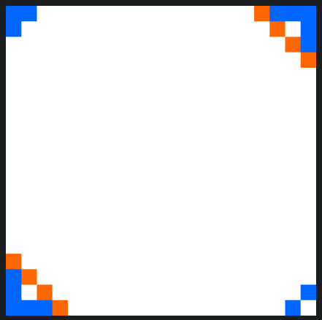
Figure 14. Edge-wrap scenario at t = 200, showing clear corner and boundary growth.
By t = 200, the wraparound effect is much clearer. The clusters near the upper-left, upper-right, lower-left, and lower-right portions of the grid have all grown in ways that show opposite sides are interacting. For example, the upper-right activity now extends along the top boundary and also downward along the right edge, while the lower-left cluster expands upward and rightward from the corner-adjacent region. These are exactly the kinds of local patterns expected when edge cells are allowed to treat opposite-border cells as neighbors.
The behavior of the corner regions is especially important here. Rather than forming truncated shapes, the clusters develop connected orthogonal growth around the boundaries, showing that the model is still applying the Von Neumann neighborhood correctly even at the edges. Cells near the corners continue to influence neighbors across the wrap which confirms that the boundary condition is being handled consistently rather than replaced by a fixed edge.

Mid-Simulation Behavior (t = 600)

Figure 15. Mid-simulation state of the edge-wrap scenario at t = 600, showing spread caused by repeated propagation across wrapped boundaries.
By t = 600, the edge-driven clusters have expanded enough to form a large ring-like structure around the perimeter of the grid, while the center remains mostly uninfluenced. This is evidence that the wrapped topology is functioning correctly. Since the initial seeds were placed on the outer boundaries, repeated local propagation causes the outer rows and columns to reinforce one another across the wrap, allowing agreement regions to develop around the full perimeter before the center is reached.
Specific parts of the grid show this clearly. The upper-left and upper-right regions are no longer isolated clusters, both have grown into larger blue areas connected by boundary-following spread across the top edge. Similarly, the lower-left and lower-right regions expand upward and inward while still remaining linked through the bottom and side boundaries. The orange cells along the inner boundary of this ring mark the active front of propagation, while the blue cells behind them show regions that have already received enough support to progress into agreement.

Late-Stage Behavior (t = 900)
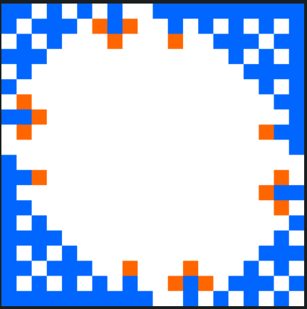
Figure 16. Late-stage behavior of the edge-wrap scenario at t = 900, showing a dominant blue perimeter and an inward-moving orange front surrounding the remaining white center.
By t = 900, the edge-wrap scenario has produced a broad outer agreement region with most of the perimeter occupied by blue cells (state 2), while the center remains a large white area (state 0) surrounded by an orange frontier (state 1). This result is fully consistent with the initial seed placement. Because all message sources were located on the edges, the earliest reinforcement occurred near the boundaries, and diffusion therefore advanced inward from the outside rather than outward from the center.
The behavior of the boundary cells confirms that the model is operating correctly. Cells along the top row, bottom row, left column, and right column continue to participate in propagation instead of acting like dead ends. The pattern is growth that remains active because opposite boundaries are connected. The remaining orange cells around the inner boundary of the white central region indicate that the propagation front is still moving inward, while the blue outer ring shows the long-term accumulation of agreement in the regions that were reached first.

Interpretation of Results
The edge-wrap scenario confirms that the wrapped boundary condition is implemented correctly. The corner and border seeds do not produce blocked diffusion patterns but instead cells at the outer boundaries continue to influence cells across the opposite sides of the grid, which allows message spread to remain continuous around the perimeter. This is visible from the earliest stages and becomes especially clear by the mid and late stages of the run.
The results show that the wrapped topology changes the large scale shape of diffusion by allowing spread to develop around the perimeter and then move inward.

Single-Seed Scenario Execution and Analysis

Experimental Frame and Scenario Setup
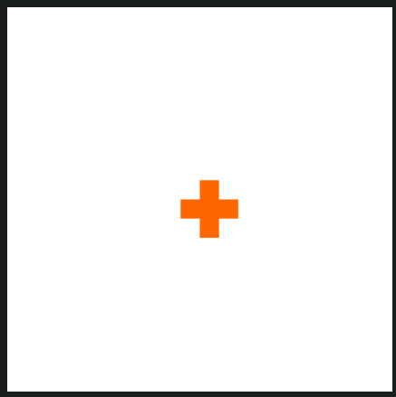
Figure 17. Initial state of the single-seed scenario at t = 0, showing one central message source.
The single-seed scenario was designed to examine how the model behaves when diffusion begins from only one message source. In the Web Viewer output, state 0 (white) represents uninformed cells, state 1 (orange) represents cells that have received the message, and state 2 (blue) represents cells that have progressed to agreement.

Early Propagation Behavior (t = 100)
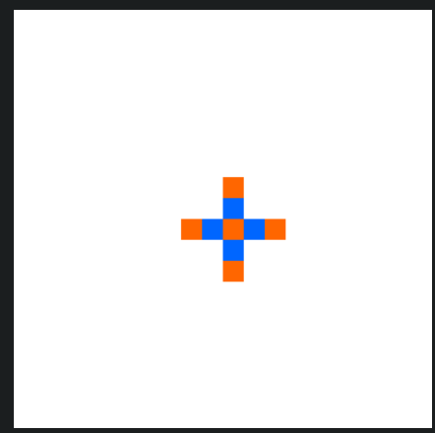
Figure 18. Early propagation in the single-seed scenario at t = 100, showing the first cross-shaped expansion from the central source.
By t = 100, the first spread is visible around the central seed. The cells directly above, below, left, and right of the origin have changed, producing the expected cross-shaped pattern associated with the neighborhood. This is confirmation that the model is applying local influence correctly.
The behavior of the central cells also matches the intended staged progression. The original source remains at the center of the cluster, while the adjacent cells begin forming the first visible propagation layer. Because there is only one seed, the cluster remains small currently. Compared with the base and clustered scenarios, the region of influence is narrower which is what should happen when the model has fewer initial sources.

Early-to-Mid Development (t = 300)
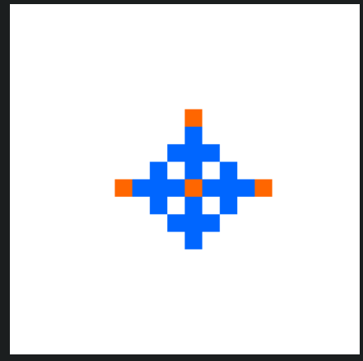
Figure 19. Single-seed scenario at t = 300, showing a near-symmetric blue interior and orange cells produced by local spread from one source.
By t = 300, the single-seed cluster has grown into a larger and symmetric structure. The blue cells (state 2) dominate the interior around the center, while the orange cells (state 1) are concentrated along the outer boundary. This shows that the model is following its two stage progression correctly where cells closest to the source were reached earlier and have already advanced while cells at the perimeter represent more recent propagation.
Specific cells in the pattern illustrate this behavior clearly. The central cell and its nearest orthogonal neighbors form the most established part of the cluster, while the top, left, and right cells remain orange because they are at the newest active front. Since there is only one seed, the cluster expands evenly from the center instead of forming multiple interacting regions.

Mid-Simulation Behavior (t = 600)
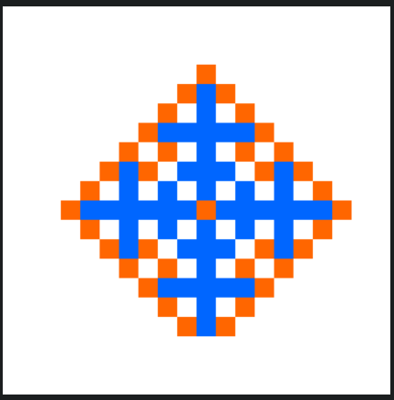
Figure 20. Mid-simulation state of the single-seed scenario at t = 600, showing symmetric growth and a blue interior produced by repeated local reinforcement.
By t = 600, the cluster has expanded substantially but the overall shape remains centered and symmetric. The blue agreement area occupies most of the interior, while the orange cells continue to grow along the outer edge. This indicates that the model is progressing as intended over time where previously influenced cells accumulate enough neighborhood support to move into state 2 while newly reached cells appear in state 1.
The top, bottom, left, and right edges of the cluster extend farther than the diagonal directions showing that diffusion is still constrained by the orthogonal neighborhood. The center also remains the most progressed part of the pattern since it was reached first and has experienced the longest period of reinforcement.

Late-Stage Behavior (t = 900)
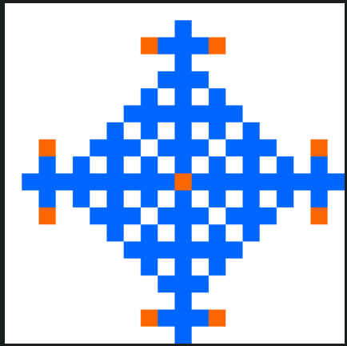
Figure 21. Late-stage behavior of the single-seed scenario at t = 900, showing a blue agreement region surrounded by a thin orange propagation region.
By t = 900, the single-seed scenario has produced a much larger influenced region, but the pattern still reflects its single-source origin. The cluster remains centered and symmetric, with blue cells (state 2) dominating the interior and orange cells (state 1) appearing mainly at the outer tips of the expanding arms. White cells (state 0) still occupy a large portion of the surrounding grid, showing that diffusion has progressed steadily but has not reached the same overall coverage as the multi-seed scenarios.
This behavior is consistent with the model specification. The spread remains local, orthogonal, and cumulative, and the outer orange cells show that propagation is still ongoing at the boundary of the cluster. Specific edge cells at the top, bottom, left, and right tips remain in the active frontier state because they were reached most recently, while the center has long since stabilized into agreement. The result demonstrates that a single seed is sufficient to generate sustained diffusion, but the overall rate and reach of that diffusion are lower when no additional starting sources are available to reinforce early growth.

Interpretation of Results
The single-seed scenario confirms that the model can generate consistent diffusion when propagation begins from only one source. State changes accumulate gradually over time and the cluster develops from a small central origin into a larger structured region of agreement.
At the same time, this scenario shows the influence of initial source count where compared with the base and clustered experiments, the single-seed case spreads more slowly and covers less of the grid within the same simulation window.

Variations from the Original Specification
The original specification defined the social diffusion model using a fixed Cell-DEVS structure and a set of transition rules for message spread and agreement. In this project, that core specification was preserved but the experimental runs introduced variations in the initial input to study how different starting conditions affected the resulting diffusion patterns. These variations did not change the grid size, neighborhood definition, delay type, or state transition logic. Instead, they changed only the number and placement of the initial seed cells.
The base scenario is the default configuration, with three separated seed cells placed in different regions of the grid to observe multiple source diffusion alongside the standard setup. The clustered scenario varied this by placing the same number of seed cells adjacent to one another near the center of the grid. The edge-wrap scenario introduced another variation by positioning the seed cells on outer boundaries of the wrapped grid to test if propagation continued correctly across opposite edges. The single-seed scenario reduced the number of initial active cells to one to observe how diffusion behaves when all spread originates from a single source.
These variations were introduced to extend the original specification into a broader study. It made it possible to evaluate whether the model behaved correctly according to its rules, and how sensitive its behavior was to different initial conditions.

